**Practical-5**

Aim: Creation of custom forms for the social media application. Apply concepts of Form Class, Model Form. Ensure appropriate models are considered for the various forms.

**Code:**

jobs/models.py:

from django.db import models

class JobPosting(models.Model):

    title = models.CharField(max_length=100)

    description = models.TextField()

    location = models.CharField(max_length=100)

    salary = models.DecimalField(max_digits=10, decimal_places=2)

    deadline = models.DateField()

    created_at = models.DateTimeField(auto_now_add=True)

    def __str__(self):

        return self.title

jobs/forms.py:

from django import forms

from .models import JobPosting

class JobPostingForm(forms.ModelForm):

    class Meta:

        model = JobPosting

        fields = ['title', 'description', 'location', 'salary', 'deadline']

    def __init__(self, *args, **kwargs):

        super().__init__(*args, **kwargs)

        self.fields['description'].widget = forms.Textarea(attrs={'rows': 4})

jobs/urls.py:

from django.urls import path

from . import views

urlpatterns = [

    path('job_postings/', views.job_postings, name='job_postings'),

    path('create_job_posting/', views.create_job_posting, name='create_job_posting'),

    path('job_posting/<int:job_posting_id>/', views.job_posting_detail, name='job_posting_detail'),

]

Jobs/views.py:

from django.shortcuts import render, redirect, get_object_or_404

from .models import JobPosting

from .forms import JobPostingForm

def create_job_posting(request):

    if request.method == 'POST':

        form = JobPostingForm(request.POST)

        if form.is_valid():

            job_posting = form.save(commit=False)

            job_posting.save()

            return redirect('job_postings')

    else:

        form = JobPostingForm()

    return render(request, 'create_job.html', {'form': form})

def job_postings(request):

    job_postings = JobPosting.objects.all()

    return render(request,'jobPosting.html',{'job_postings': job_postings})

def job_posting_detail(request, job_posting_id):

    job_posting = get_object_or_404(JobPosting, pk=job_posting_id)

    return render(request, 'job_posting_detail.html', {'job_posting': job_posting})

**Output:**

Home page (jobs posting):

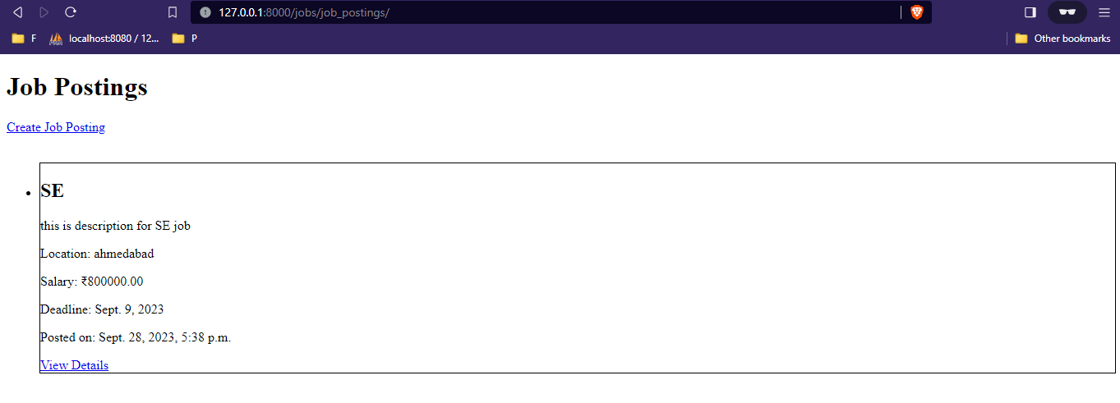

After clicking on “Create Job Posting”.

Filling details.

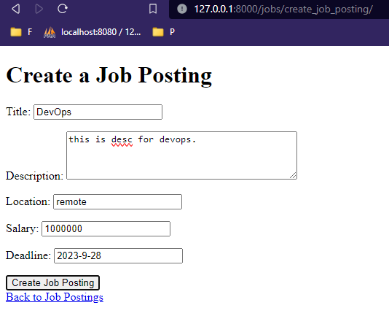

After clicking “Create Job Posting”.

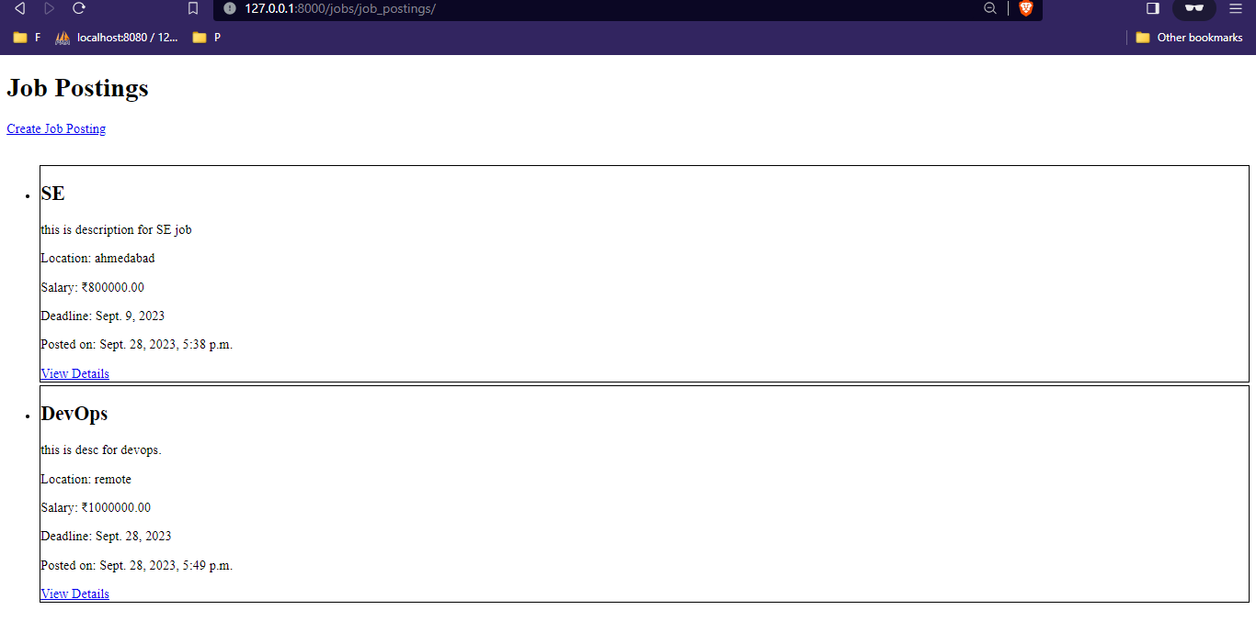

Clicking on “View Details”.

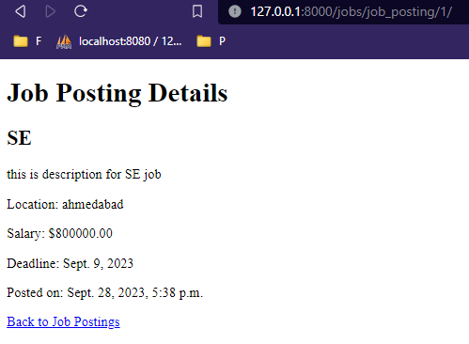

Use of 404 not found:

In settings.py file

DEBUG = False

ALLOWED_HOSTS = ["http://127.0.0.1:8000/"]

In jobs/views.py file.

def job_posting_detail(request, job_posting_id):

    job_posting = get_object_or_404(JobPosting, pk=job_posting_id)

    return render(request, 'job_posting_detail.html', {'job_posting': job_posting})

