**Practical-6**

Aim: Apply concepts of Custom SQL query execution for all forms of the Social Media Application. Ensure that all queries (Select, Insert, Delete, Update etc.) are demonstrated.

**Code:**

Jobs/views.py:

from django.shortcuts import render, redirect, get_object_or_404

from .models import JobPosting

from .forms import JobPostingForm

from django.db import connection

def create_job_posting(request):

    if request.method == 'POST':

        form = JobPostingForm(request.POST)

        if form.is_valid():

            job_posting = form.save(commit=False)

            job_posting.save()

            return redirect('job_postings')

    else:

        form = JobPostingForm()

    return render(request, 'create_job.html', {'form': form})

def job_postings(request):

    job_postings = JobPosting.objects.all()

    return render(request,'jobPosting.html',{'job_postings': job_postings})

def job_posting_detail(request, job_posting_id):

    job_posting = get_object_or_404(JobPosting, pk=job_posting_id)

    return render(request, 'job_posting_detail.html', {'job_posting': job_posting})

def custom_job_posting(request):

    custom_sql_query = """

    SELECT id, title, description, created_at FROM jobs_jobposting ORDER BY created_at DESC;"""

    with connection.cursor() as cursor:

        cursor.execute(custom_sql_query)

        columns = [col[0] for col in cursor.description]

        job_postings = [dict(zip(columns, row)) for row in cursor.fetchall()]

    return render(request, 'custom_job_postings.html', {'job_postings': job_postings})

def add_salary(request):

    with connection.cursor() as cursor:

        cursor.execute("UPDATE jobs_jobposting SET salary = salary * 1.10")

    return redirect('job_postings')

def dec_salary(request):

    with connection.cursor() as cursor:

        cursor.execute("UPDATE jobs_jobposting SET salary = salary - (salary * 0.10)")

    return redirect('job_postings')

def delete_job_posting(request, job_posting_id):

    job_posting = get_object_or_404(JobPosting, pk=job_posting_id)

    if request.method == 'POST':

        with connection.cursor() as cursor:

            cursor.execute("DELETE FROM jobs_jobposting WHERE id = %s", [job_posting_id])

        return redirect('job_postings')

    return render(request, 'delete_job_posting.html', {'job_posting': job_posting})

**Output:**

Job listing

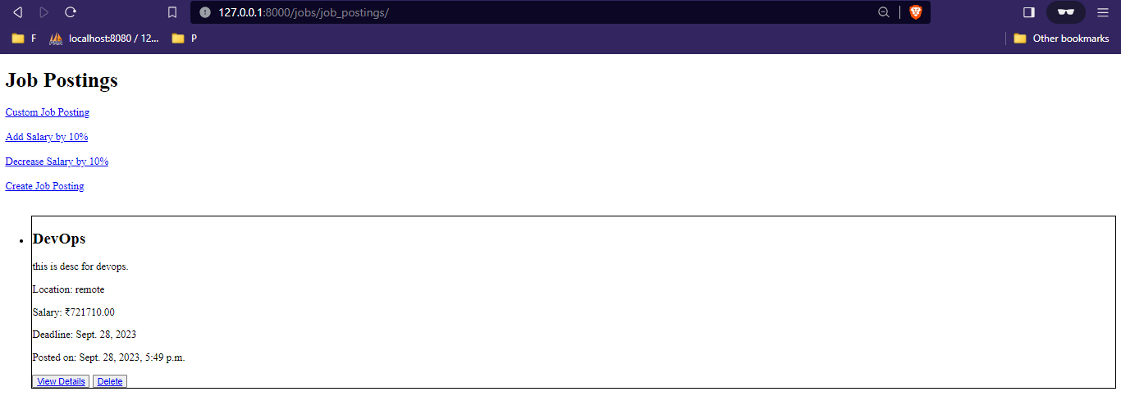

After clicking on “Add Salary by 10%”.

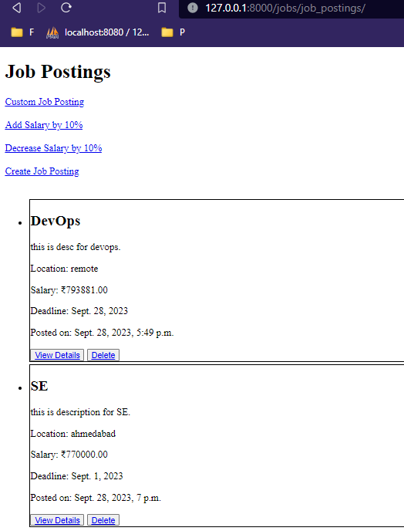

After clicking on “Decrease Salary by 10%”.

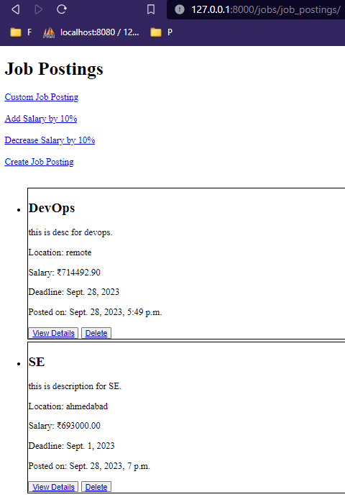

After clicking on “Custome Job Posting”.

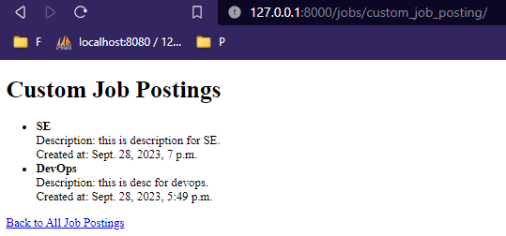

After clicking on “Delete” button of DevOps job.

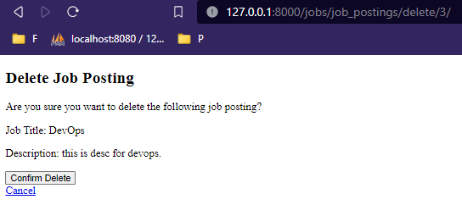

Confirm Delete.

