

MediPlus
13.11.2017
─
Kaustubh Verma (B16021)
Akul Gupta (B16006)
Arpit Batra (B16047)
Rakshit Raj (B16074)

Project Statement

MediPlus is a web based site to provide aids in medical fields. This site is made for the persons across the globe who ignores simple symptoms thinking that it’s nothing and are actually suffering from a big disease. Medical students can also use this site for study purpose-they can read about any detail of a disease-its symptoms,its severity and commonness(on a scale of 1 to 10), it’s home made remedies and its medicines.
The basic function of MediPlus is that one can find any disease according to the symptoms provided by him.
This site can be used either directly (without signing up/without registering) or after registering(and hence getting some advanced use).
To the one without registering site provides mainly two function: the user will input the symptoms he is being suffering (max 5 symptoms) and site will provide the disease he is being suffering from and user can also get any details of any disease he select from the provided list.
For the registered users site provide much more facilities apart from the above mentioned two facilities. As doctors are to registered to our site so the user(the patient) will come to know the corresponding doctor (from the nearest locality) for that particular disease and same happens with the doctor(that he came to know about the patient) and both can now interact with each other and hence, patient can see his progress details for that disease on this site which is being filled by that particular doctor.

ER Model
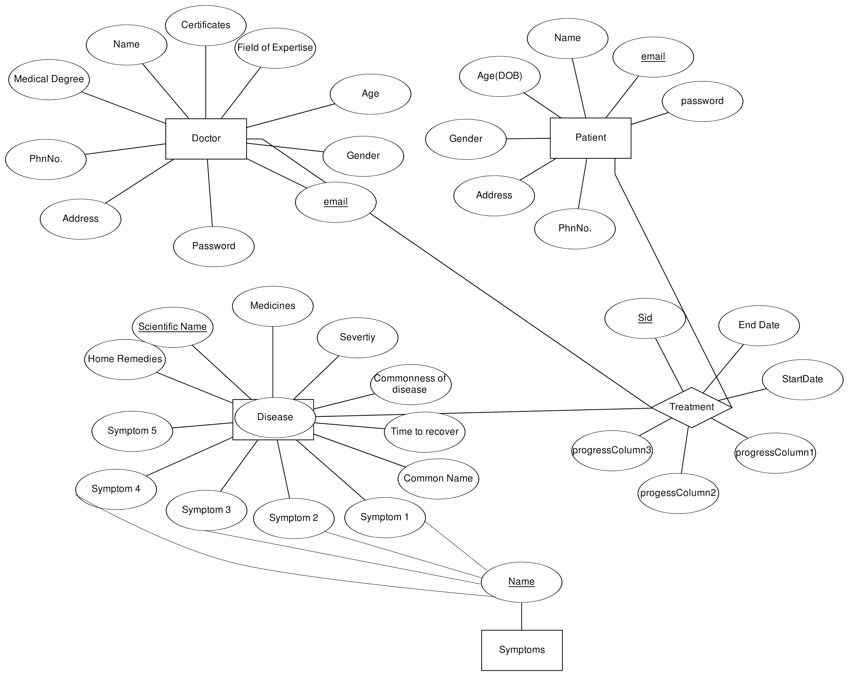

Relational Schema
.

Tables
- Country - Contains c_id (Country id) and c_name (Country Name)
- State - Contains s_id (State id) and s_name (State Name)
- District - Contains d_id (District id) and d_name (District Name)
- Disease - This table contains details about all the diseases. There Name, Medicines, Severity, Commonness(On the scale of 1 to 10), Time to Recover, Home Remedies and at max 5 symptoms related to the disease. When the user enters symptoms they are searched in this table and the details of the disease are displayed.
- Doctor - This table maintains a record of all the registered doctors. Name, Email, Password, DOB, Gender, Address, Phone_no.
- Patient - This table maintains a record of all the registered patients. Name, Email, Password, DOB, Gender, Address, Phone_no.
- Symptoms - The symptoms in disease table and foreign keys of this table's primary key. It has only one column that contains name of the symptoms.
- Treatment - This table maintains record of which patient is being treated by which doctor and for which disease and doctor maintains a record of the progress made by the patient.

Intended User Groups
This webapp targets users that are suffering from some disease but are unaware due to lack of awareness. The app helps the user to know the disease, it’s medicines, it’s home remedies so that they can atleast get first aid treatment. The app also helps the medical students to learn about numerous diseases. It also helps the doctors to remain in contact with their patients and record their progress.

Features

Symptom Checker
The main features of this webapp is the symptom checker.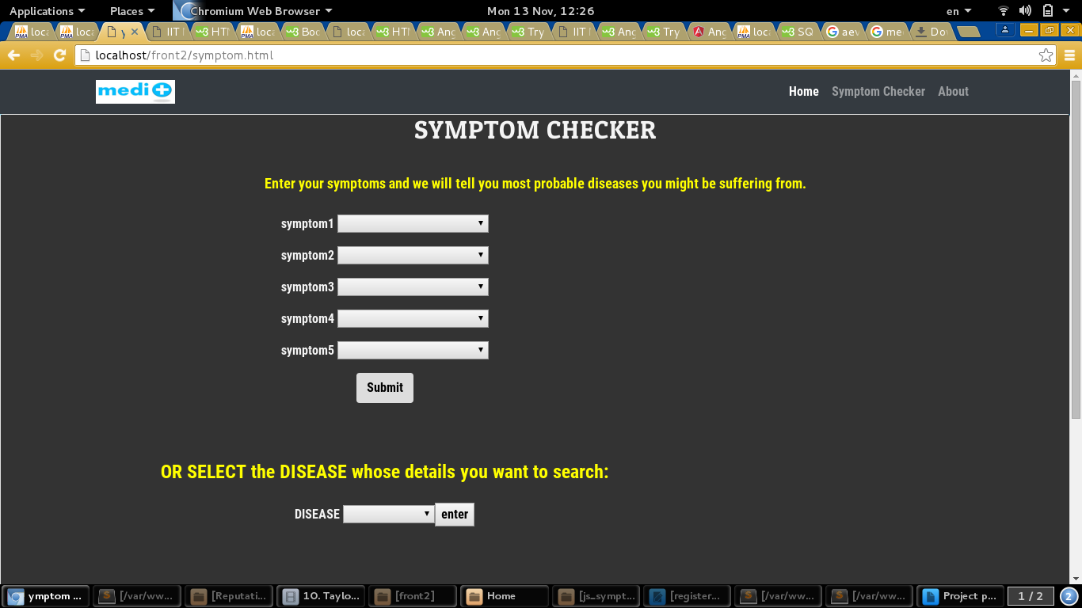
The user is displayed list of all diseases that match the symptoms he choose.

Study about diseases
user is provided with the list of all diseases and when he selects a disease,all kind of details of that selected disease are being provided.

Try it for free
The app also helps non registered users to check their disease and study about various diseases.

Consult a doctor
If a registered user finds that he is suffering from a disease. It is linked to a particular doctor which tracks the progress made by the patient and hence patient can see his progress report.

Front End Design
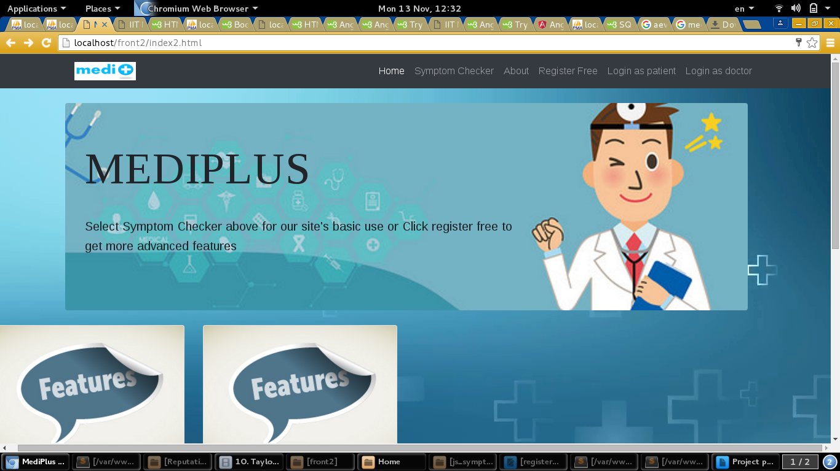
This html page uses css to display the frontend. The image is displayed in a jumbotron and the features are written in cards .
All the login and registration forms are displayed as modals. All these features are implemented with the help of bootstrap.

Few Complex Queries
many comaplex queries were used to make this website.Some of them are:
- "select name,medicines from disease where (symptom1='".$s1."' or symptom2='".$s1."' or symptom3='".$s1."' or symptom4='".$s1."' or symptom5='".$s1."') and (symptom1='".$s2."' or symptom2='".$s2."' or symptom3='".$s2."' or symptom4='".$s2."' or symptom5='".$s2."') and (symptom1='".$s3."' or symptom2='".$s3."' or symptom3='".$s3."' or symptom4='".$s3."' or symptom5='".$s3."') and (symptom1='".$s4."' or symptom2='".$s4."' or symptom3='".$s4."' or symptom4='".$s4."' or symptom5='".$s4."') and (symptom1='".$s5."' or symptom2='".$s5."' or symptom3='".$s5."' or symptom4='".$s5."' or symptom5='".$s5."')"
- "select disease_name,patient_email,progress1,progress2,progress3 from treatment where doctor_email='".$doctor_name."'"
- "select name from doctor where email = '".$contact_name."' and password = '".$pass."'"
- "update treatment set progress1 = '".$prog1."',progress2 = '".$prog2."',progress3 = '".$prog3."' where patient_email = '".$patient_name."'"
- "select d_id from district where d_name = '".$data->angular_var2."' and s_id = '".$data->angular_var1."'"

Performance Checks

Worked planned but not done
- To link patient with doctors on the basis of address and advice the best nearest doctor to the patient. Patient is displayed list of doctors living in the same district.
- Doctor receives a request when patient select him for his treatment.
- A chatbox between a doctor and his patient for better communication between them.
- A page where doctors can post blog related to healthy lifestyle and a better life and patient can post their queries.

Your experience of doing mini Project
This was the first webapp development project for all four of us. So, we learnt a lot of new things like using php to connect database, using javascript to display things dynamically and sending data from php to javascript and vice versa using ajax.
As mentioned above to make a complete functional website,we searched a lot through internet and involved following procedure:
1.Using Html and css for front display,along with use of bootstrap as a css guide.
2.Using ANGULAR js as a front end framework to allow interaction with backend in PHP to allow data interaction between front end and back end.
3.Using AJAX request between front and back end.
4.JSON as file format system between angular and php.
This project will be a motivation for all of us to improve our development skill in the future.

