Software Requirements Specification

for

TurfBooker

Version 1.0 approved

|  |  |
| --- | --- |
| **Student ID** | **Student Name** |
| 220340320008 | Aditya Nagle |
| 220340320045 | Harshwardhan Bhise |
| 220340320049 | Kaustubh Bande |
| 220340320064 | Nayan Barhate |
| 220340520084 | Sagar Vyas |

CDAC, Mumbai

August 8th, 2022

Table of Contents

Table of Contents ii

1. Introduction 4

1.1 Purpose 4

1.2 Document Conventions 4

1.3 Intended Audience and Reading Suggestions 4

1.4 Project Scope 4

1.5 References 4

2. Overall Description 5

2.1 Product Perspective 5

2.2 Product Features 5

2.3 User Classes and Characteristics 5

2.4 Operating Environment 6

2.5 Design and Implementation Constraints 6

2.6 User Documentation 6

2.7 Assumptions and Dependencies 6

3. System Features 7

3.1 Registration 7

3.2 Booking of Turf/Court 7

3.3 Payment Gateway 7

4. External Interface Requirements 8

4.1 User Interfaces 8

4.2 Hardware Interfaces 8

4.3 Software Interfaces 8

4.4 Communications Interfaces 8

5. Other Nonfunctional Requirements 10

5.1 Performance Requirements 10

5.2 Safety Requirements 10

5.3 Security Requirements 10

5.4 Software Quality Attributes 10

6. System Design 11

6.1 ER Diagram 11

6.2 Use Case Diagram 12

6.3 Sequence Diagram 13

6.4 DataFlow Diagram 14

6.5 Activity Diagram 17

Future Scope 20

7. Other Requirements 21

Appendix A: Glossary 21

Appendix B: Analysis Models 21

**List of Figures**

|  |  |  |
| --- | --- | --- |
| **Figure No** | **Figure Name** | **Page No** |
| 1 | ER Diagram | 11 |
| 2 | Use Case Diagram | 12 |
| 3 | Sequence Diagram | 13 |
| 4 | Admin DataFlow Diagram | 14 |
| 5 | Manager DataFlow Diagram | 15 |
| 6 | User DataFlow Diagram | 16 |
| 7 | Admin Activity Diagram | 17 |
| 8 | Manager Activity Diagram | 18 |
| 9 | User Activity Diagram | 19 |

# Introduction

## Purpose

The purpose of this software is to allow users to book the available turfs and reduce the hassle for acquiring the court according to their convenience.

## Document Conventions

## The document is prepared using Microsoft Word 2019 and has the font type 'Times New Roman'. The fixed font size that has been used to this document is 12pt with 1.0 line spacing. It has used the bold property to set the headings of the document. Use case scenario is written according to Alistair Cockburn's template. UML diagram have been created according to UML 2.0 std. Standard IEEE template is the template used to organized the appearance of the document and its flow.

## Intended Audience and Reading Suggestions

This SRS is intended for anyone who want to understand the know-how of this project i.e. for whom the software is useful, what is the flow of the software, it’s use cases, it’s sequence and flow of the project.

## Project Scope

The purpose of this project is to avail folks to be able to book Court/Turf of their choice in advance with the timings of their convenience and skip the hassle of physically booking the Court/Turf and also, they can pay online for their bookings

## References

* <https://www.youtube.com/>
* <https://krazytech.com/projects/sample-software-requirements-specificationsrs-report-airline-database>
* <https://t4tutorials.com/external-interface-requirements-srs/>
* <https://www.sporloc.com/delhi/sports-ground-on-rent/all-sports-ground/>
* <https://www.thelifeclub.in/>
* <https://bookmyturf.com/pages/turf/20/PLAY>

# Overall Description

## Product Perspective

## This website provides a simple and effective way for Online Booking (Renting) and Managing of Turf's (Artificial Playgrounds). Customers (Athletes) can book or cancel their reservation very easily. It also features a very simple GUI for managing payments and customer bookings for the Turf Manager. The Manager can check all the customer payment history which makes it easier to manage the business.

## Product Features

THE ADMIN SHOULD BE ABLE TO

* Manage Turfs/Courts and their fare charts.
* Add/Remove Managers for particular Turf/Court.
* View Bookings of various Turfs/Courts.
* Booking History of a particular User.

A MANAGER SHOULD BE ABLE TO

* Look up Bookings
* View Booking history

A USER SHOULD BE ABLE TO

* Search and Select the turf location, Sports in Turf/Court.
* Choose the preferable time slot.
* Make the Booking and pay via Payment Gateway.
* To get a mail about the confirmation of the turf reservation
* Locate the turf using Google maps in the website.

## User Classes and Characteristics

### Admin

* Admin has been granted full access with complete permissions towards the system.
* Admin can add turf location and manager of the respective Turf/Court location.
* Admin can add price rate per slot for the respective Turfs/Courts.
* Admin can view booking done and the user details.

### Manager

* The manager can log in with the credentials provided by the user.
* The manager can check rates for the respective location turf.
* Manager can check previous booking history.

### Customer

* Customers can check for turf from nearby locations and check out their availability and pricing structure.
* Customer can provide the date, time and other personal details for booking the Turf/Court and can also do the payment.
* Customer can cancel the booking.

## Operating Environment

### Operating environment for the Turf booking system is as following

#### Hardware Platform:

* Processor: Above Ryzen 3/Intel 10th gen, with clock speed of 2.5 GHz and above.
* RAM: 8GB or Above.
* Hard Disk: Free disc space above 512GB SSD.

#### Software Platform:

* Front End: ReactJS / JSP, HTML, CSS, Bootstrap.
* Back End: MySQL, Spring and Spring Boot Framework, Hibernate.

#### Supported Tools:

* MySQL Workbench, Eclipse, STS4.
* Web Server: Apache Tomcat 9.0.

## Design and Implementation Constraints

* Only Admin should be able to add/remove Turf/Court and Manager.
* Manager should not be able to make changes in the bookings but can only view them.
* User should not be able to book more than 2 bookings in a day i.e. not more than 2 slots in a day.

## User Documentation

## User manual provided to the client will give a clear idea of interacting with the system. It will be written in a simple understandable language which will cover up the inner complexity of the system. A hard copy of the user manual will be delivered to the client with the delivery of the system

## Assumptions and Dependencies

* The website is assumed to run on latest version of various browsers and is not compatible with older versions of Internet Explorer.
* The website should be run on Systems having Windows 7 or higher version.
* It is assumed that the client is ready to purchase the software and able to pay the cost of the software. Client won't change that decision on the next phases of the software development.
* Otherwise if client use an open source operating system, there is a need of changing the SRS accordingly.

# System Features

The System Features of the website are as follows.

## Registration

### Description and Priority

This feature has the highest priority as it is one of the main purposes of the system.

### Stimulus/Response Sequences

Customers have to register to the page. After registration, customer will have their email and password (input by them while registration) as their login credentials. As the data of that customers is already been stored in the Database so that it will be linked to the requested result and remaining things will be done by the system*.*

### Functional Requirements

Function requirement for the Website is that User’s data must be stored in the Database and they must be allowed to access the information.

## Booking of Court/Turf

### Description and Priority

This feature has the highest priority as it is one of the main purposes of the system.

### Stimulus/Response Sequences

Customers will get an information about timeslot availability of the Courts/Turfs. Customer will also be provided information about the total fare structure of the Court/Turf.

### Functional Requirements

Functional requirement of the system is that, the information available for the Turf/Court availability, total fare structure of the Court/Turf and time in the database will be fetch as per the Customer requirement.

## Payment Gateway

### Description and Priority

This feature has the less priority as we compare with the above two option.

### Stimulus/Response Sequences

After booking the court/ turf on a particular date and time , customer will be redirected to the payment gateways page. Customer can pay a payment via Credit Card, Debit card to the admin account. Cash option is also available for physical bookings.

### Functional Requirements

Functional requirement for the system is that customer will get generated payment bill

# External Interface Requirements

## User Interfaces

## The application will be accessed through a browser interface. The interface would be viewed best using 1024 x 768 and 800 x 600 pixels resolution settings. The software would be fully compatible with Microsoft Internet Explorer for version 10 and above, Chrome, Mozilla, Safari, Brave.

## Hardware Interfaces

### Supported Device types

The software is developed for Windows 32-bit or 64-bit.

### ****Nature of the data and control interactions between the software and the hardware****

Turf Booking website identifies the user only through User email and Password.

## Software Interfaces

### ****Describe the connections of your software with other operating systems****

The software is developed for windows 7, windows 8, windows 10, windows 11.

### ****Describe the connections of your software with other libraries****

* Maven
* Axios

### Software Requirement

|  |  |
| --- | --- |
| **Technology** | **J2SE and J2EE, Hibernate Spring Boot** |
| Web-Technologies | React, CSS, JavaScript |
| Web Server | Tomcat 9.0 |
| Java Version | JAVA Version 8 |
| Backend Database | MySQL 8.0 |
| IDE | Eclipse |

## Communications Interfaces

### ****Web browser****

The website will be run on latest versions of Browsers like, Mozilla, Safari, Chrome, Edge, Internet Explorer, Brave.

### ****Communication standards and Network server communications protocols****

HTTP and HTTPS.

### ****Electronic forms****

HTML Forms to get registration data from the user.

# Other Nonfunctional Requirements

## Performance Requirements

The system should store all the database records of each of Administrator, Manager and Customer. The website should be available for all users. Like-wise, the website should be user-friendly through an appropriate user interface so that it is easy for users to understand. For the convenience of the user, the option should be placed at an appropriate place and in easily understandable language.

## Safety Requirements

1. In order to prevent data loss in case of system failure, the user information must be saved in the Database, for the system to keep information secure
2. In case the Admin detects any security lapse in the system, he should be able to shut down the server and close all connections immediately while preserving the already stored data.
3. The system should be capable of gracefully recovering from earlier crashes and keep all the information safe.

## Security Requirements

Passwords of the Admin, Managers and Users should be protected for privacy using whatever constraints required in the database or the application. User’s password should be saved in encrypted format so that the intruder cannot know the password of the user. All passwords should be stored as a secure hash of the administrator password.

## Software Quality Attributes

### Usability

The user interface of the application is very easily understandable.

### Transparency

Users should be able to possess confidentiality of the Turf/Court.

### Accuracy

The system shall record and keep all the users and shall do so correctly.

### Eligibility

Every Individual with a valid email ID should be able to register.

### Cost-effectiveness

Turf booking system should be affordable and efficient.

# System Design

## ER Diagram

# 

Fig 1: ER Diagram

## Use-Case Diagram

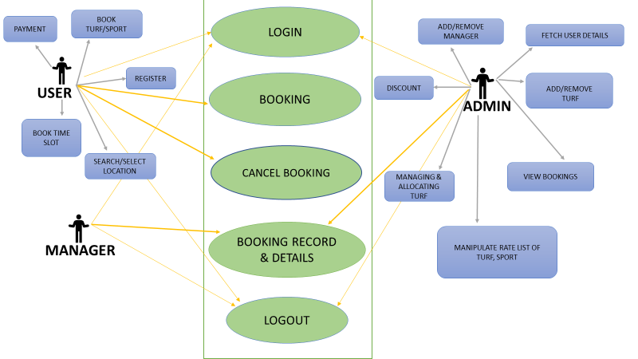

Fig 2: Use Case Diagram

## Sequence Diagram

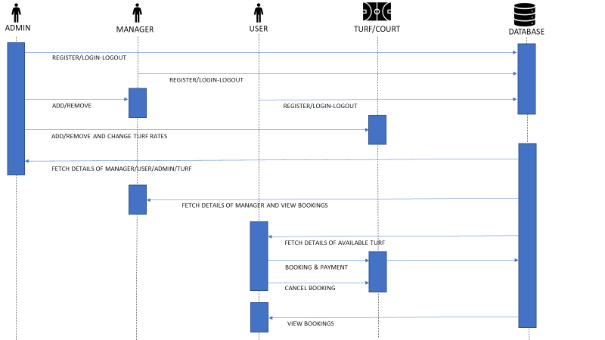

Fig 3: Sequence Diagram

## Data Flow Diagram

### Admin DFD

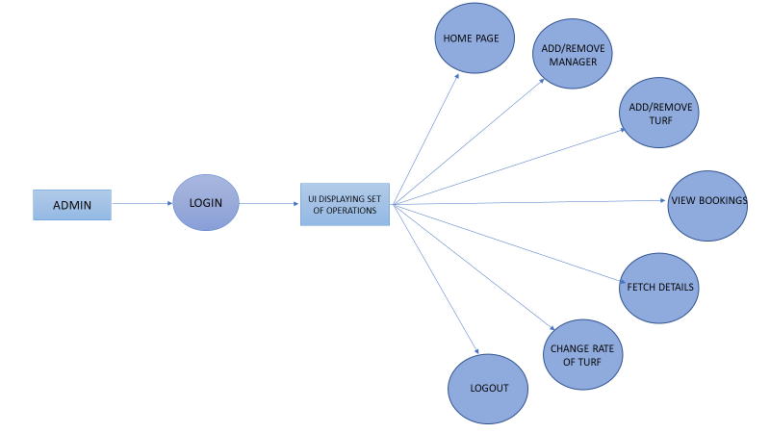

Fig 4: Admin Data Flow Diagram

### Manager DFD

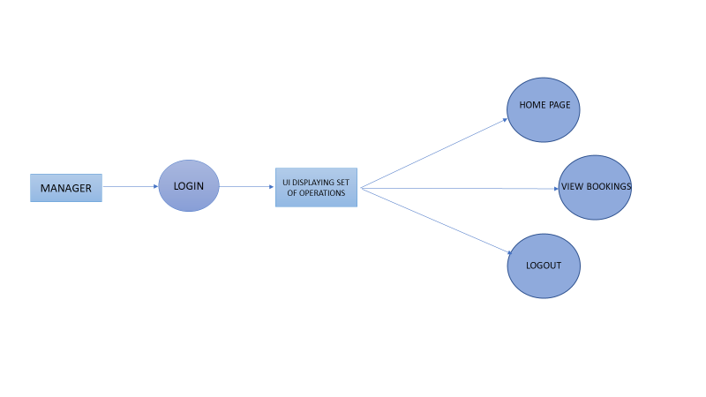



Fig 5: Manager Data Flow Diagram

### User/Customer DFD

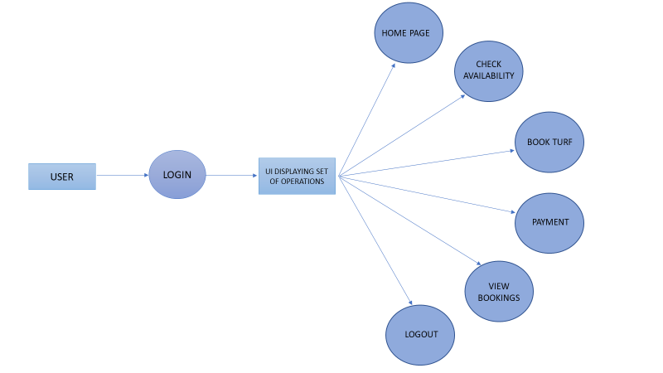

Fig 6: User Data Flow Diagram

## Activity Diagram

### Admin Activity Diagram

## 

Fig 7: User Activity Diagram

### Manager Activity Diagram

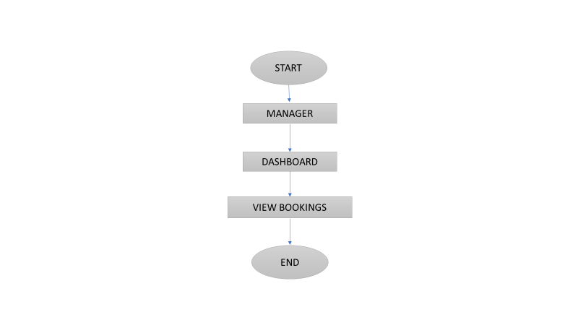

Fig 8: Manager Activity Diagram

### User Activity Diagram

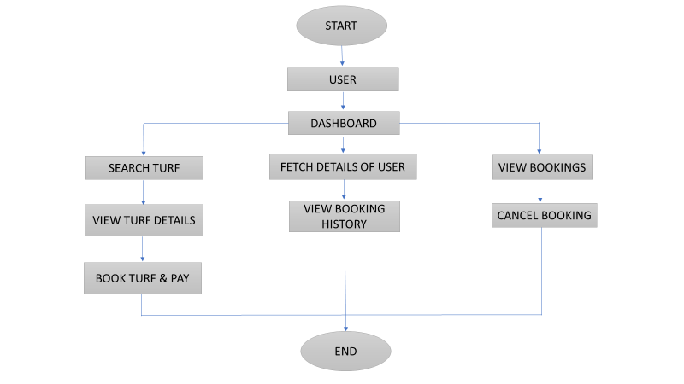

Fig 9: User Activity Diagram

**Future Scope**

Some of the functionalities that can be developed in future are as follows

* We can include various indoor sports like Badminton, Table tennis and integrate them in the website.
* Currently the site includes only one City. In future, we can include multiple Cities in it.
* Currently the site uses only one type of Payment Gateway. In future, Payment could be made through multiple Payment Gateway APIs like PhonePe, Google Pay, Paytm, etc.

# Other Requirements

Appendix A: Glossary

|  |  |
| --- | --- |
| **Usage** | **Meaning** |
| DB | MySQL Database |
| Java | Java Programming Language |
| Turf | Playground used for playing |
| Admin | Owner of the website |
| Manager | Manager of a particular Turf |
| User | Individuals who want to book the Court/Turf |
| SRS/Document | Software Requirement Specification document |
| Project | Software being developed |
| IDE | Integrated Development Environment |
| ER Diagram | Entity Relationship Diagram |
| STS4 | Spring Tool Suite 4 |

Appendix B: Analysis Models

1. ER Diagram gives us the idea about How many Tables are going to be created in the Database and how are they related to each other i.e. Foreign Key constraints.
2. Use Case Diagram gives information about the different functionalities each role can perform.
3. Sequence Diagram gives information about the sequence of actions each role would perform and whom it is going to be performed on.
4. Data Flow Diagram gives information about what functions would a particular role would be able to perform while using the website/software.