**5330: Database Systems I Spring Semester 2015**

**Project 1**

**Name: Kaustubh Mohgaonkar ID: 1001101770**

***TASK1:***

**A. Make a list of the entities for the above process**

Answer: The following are the entities for the process:

|  |  |
| --- | --- |
| Entities | Description |
| Author_Names | Stores author names |
| Book_Authors | Intermediate table to allow many to many relation between authors and books |
| Book_Edition | Stores the edition and publication details of books |
| Book_Names | Stores the title and description of books |
| Book_Ratings | Stores read status and the ratings of read books |
| Book_Theme | Intermediate table to allow many to many relation between themes and books |
| Collection_Table | Stores details about user's collection |
| Publisher_Names | Stores publisher names with id |
| Thematic_Names | Stores theme names with id |

**B. For each entity define the required attributes and the data type of each of those attributes. You can add any attributes you believe that should be included.**

|  |  |  |
| --- | --- | --- |
| Entity | Attribute | Data Type |
| Author_Names | Author_ID | INT |
| Author_Name | VARCHAR(30) |
| Book_Authors | Author_ID | INT |
| Book_ID | INT |
| Book_Edition | Edition_ID | INT |
| Pub_ID | INT |
| Book_ID | INT |
| Edition | INT |
| Pages | INT |
| Book_Names | Book_ID | INT |
| Title | VARCHAR(45) |
| Book_Desc | VARCHAR(60) |
| Release_Year | YEAR |
| Book_Ratings | Book_ID | INT |
| Read_Status | INT |
| Book_Rating | INT |
| Book_Theme | Book_ID | INT |
| Category_ID | INT |
| Collection_Table | Coll_ID | INT |
| Edition_ID | INT |
| Condition | VARCHAR(5) |
| H/S_Copy | VARCHAR(5) |
| Price | DECIMAL(10) |
| Txn_Date | DATE |
| Publisher_Names | Pub_ID | INT |
| Publisher_Name | VARCHAR(45) |
| Thematic_Names | Category_ID | INT |
| Category | VARCHAR(10) |

***TASK2:***

**A. Design the database schema (diagram) using arrows to define the references, based on the description. Your schema should be handwritten at this point.**

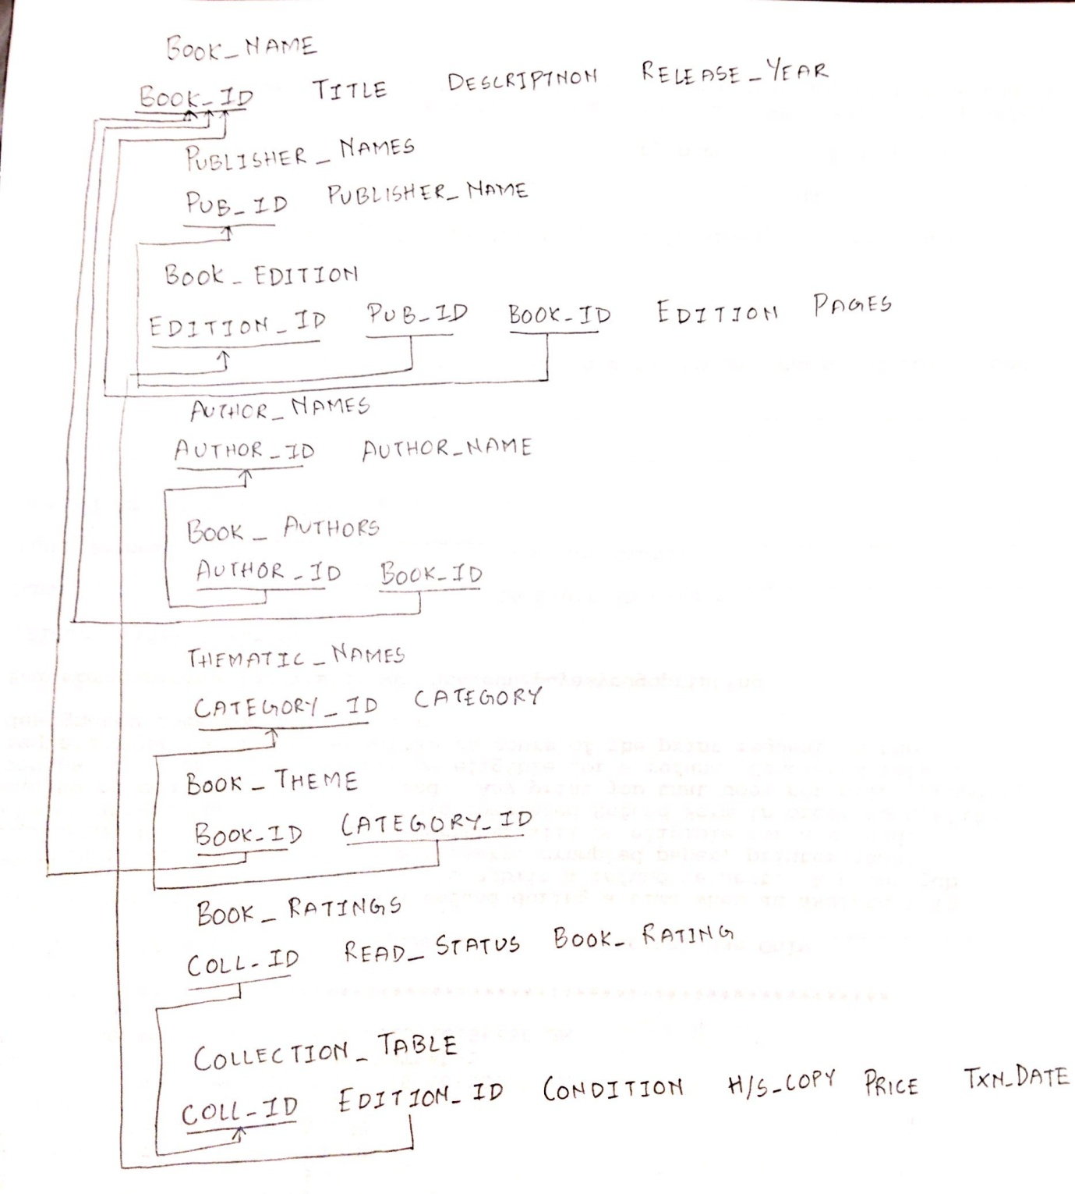

**B. Explain why you took specific decisions regarding:**

**The relations you have created.**

1. Author_Names

Attributes:

* Author_ID
* Author_Name

This table lists author names with each of them assigned an author id. The author id is the primary key in this table as it uniquely identifies all authors. This table is kept separate from the Book_Authors table to enable assigning one or more authors to a single book.

1. Book_Authors

Attributes:

* Author_ID
* Book_ID

Here Author_ID and Book_ID combine to form a composite key which is the primary key for this table.

1. Book_Edition

Attributes:

* Edition_ID
* Pub_ID
* Book_ID
* Edition
* Pages

This table describes the different editions of a book based on its publisher. Here Pub_ID, Book_ID and Edition are combined to form a primary key. Pages attribute signifies pages for each edition.

1. Book_Names

Attributes:

* Book_ID
* Title
* Book_Desc
* Release_Year

This table describes the book details. Book_ID is the primary key in this table. A single book can be published more than once, but the title and book description remains the same.

1. Book_Ratings

Attributes:

* Book_ID
* Read_Status
* Book_Rating

This status allows user to rate his book and also label read or not read as per user preference. Book_ID is the primary key here.

1. Book_Theme

Attributes:

* Book_ID
* Category_ID

In this table Book_ID and Category_ID are combined to form a composite key. Creation of this table enables assignment of one or more theme to a single book.

1. Collection_Table

Attributes

* Coll_ID
* Edition_ID
* Condition
* H/S_Copy
* Price
* Txn_Date

This table stores all the books that the user actually owns. Condition field signifies if the book is in poor, good, mint, etc. condition. The HS field denotes if the books has hard cover or a soft cover. Price and Txn_Date fields denote the complete transaction details of the purchased book. Coll_ID is the primary key here.

1. Publisher_Names

Attributes:

* Pub_ID
* Publisher_Name

This table denotes the list of all publisher names. Pub_ID is the primary key here.

1. Thematic_Names

Attributes:

* Category_ID
* Category

This table lists all the themes of the book. These can be History, Novel, Poetry and Science. The Category_ID is the primary key.

|  |  |  |  |
| --- | --- | --- | --- |
| **Sr. No.** | **Constraint Name** | **Type** | **Information** |
| 1 | Book_ID | Entity Integrity Constraint | Primary Key for Book_Names Table |
| 2 | Pub_ID | Entity Integrity Constraint | Primary Key for Publisher_names Table |
| 3 | Edition_ID | Entity Integrity Constraint | Primary Key for Book_Edition table |
| 4 | Author_ID | Entity Integrity Constraint | Primary Key for Author_names table |
| 5 | Category_ID | Entity Integrity Constraint | Primary Key for Thematic_names table |
| 6 | Coll_ID | Entity Integrity Constraint | Primary Key for Collection_names table |
| 7 | Book_ID | Referential Integrity | Foreign Key for Book_Edition table references Book_names table |
| 8 | Pub_ID | Referential Integrity | Foreign Key for Book_Edition table references Publisher_names table |
| 9 | Author_ID | Referential Integrity | Foreign Key for Book_Authors references Author_names table |
| 10 | Book_ID | Referential Integrity | Foreign Key for Book_Authors references book_names table |
| 11 | Book_ID | Referential Integrity | Foreign Key for Book_theme references book_names table |
| 12 | Category_ID | Referential Integrity | Foreign Key for Book_theme references thematic_names table |
| 13 | Book_ID | Referential Integrity | Foreign Key for Book_theme references book_names table |
| 14 | Edition_ID | Referential Integrity | Foreign Key for Collection_names references book_names table |
| 15 |  | Not Null | Indicates that a column cannot store NULL value |

**C. The cardinality of the relationships and the references you made.**

|  |  |  |
| --- | --- | --- |
| Cardinality of Relationships | | |
| Author_ID | Book_ID | Many to Many |
| Category_ID | Book_ID | Many to Many |
| Book_ID | Edition_ID | One to Many |
| Book_ID | Pub_ID | Many to Many |

***TASK3:***

**A. SQL CODE for SCHEMA:**

|  |
| --- |
| SET @OLD_UNIQUE_CHECKS=@@UNIQUE_CHECKS, UNIQUE_CHECKS=0;  SET @OLD_FOREIGN_KEY_CHECKS=@@FOREIGN_KEY_CHECKS, FOREIGN_KEY_CHECKS=0;  SET @OLD_SQL_MODE=@@SQL_MODE, SQL_MODE='TRADITIONAL,ALLOW_INVALID_DATES';  -- -----------------------------------------------------  -- Schema mydb  -- -----------------------------------------------------  -- -----------------------------------------------------  -- Schema book_system  -- -----------------------------------------------------  CREATE SCHEMA IF NOT EXISTS `book_system` DEFAULT CHARACTER SET utf8 ;  USE `book_system` ;  -- -----------------------------------------------------  -- Table `book_system`.`author_names`  -- -----------------------------------------------------  CREATE TABLE IF NOT EXISTS `book_system`.`author_names` (  `Author_ID` INT(11) NOT NULL AUTO_INCREMENT,  `Author_Name` VARCHAR(45) NULL DEFAULT NULL,  PRIMARY KEY (`Author_ID`))  ENGINE = InnoDB  AUTO_INCREMENT = 7  DEFAULT CHARACTER SET = utf8;  -- -----------------------------------------------------  -- Table `book_system`.`book_names`  -- -----------------------------------------------------  CREATE TABLE IF NOT EXISTS `book_system`.`book_names` (  `Book_ID` INT(11) NOT NULL AUTO_INCREMENT,  `Title` VARCHAR(45) NULL DEFAULT NULL,  `Book_Desc` VARCHAR(60) NULL DEFAULT NULL,  `Release_Year` YEAR NULL DEFAULT NULL,  PRIMARY KEY (`Book_ID`))  ENGINE = InnoDB  AUTO_INCREMENT = 26  DEFAULT CHARACTER SET = utf8;  -- -----------------------------------------------------  -- Table `book_system`.`book_authors`  -- -----------------------------------------------------  CREATE TABLE IF NOT EXISTS `book_system`.`book_authors` (  `Author_ID` INT(11) NOT NULL,  `Book_ID` INT(11) NOT NULL,  PRIMARY KEY (`Author_ID`, `Book_ID`),  INDEX `Book_ID_idx` (`Book_ID` ASC),  CONSTRAINT `Author_ID`  FOREIGN KEY (`Author_ID`)  REFERENCES `book_system`.`author_names` (`Author_ID`)  ON DELETE CASCADE  ON UPDATE CASCADE,  CONSTRAINT `Book_ID`  FOREIGN KEY (`Book_ID`)  REFERENCES `book_system`.`book_names` (`Book_ID`)  ON DELETE CASCADE  ON UPDATE CASCADE)  ENGINE = InnoDB  DEFAULT CHARACTER SET = utf8;  -- -----------------------------------------------------  -- Table `book_system`.`publisher_names`  -- -----------------------------------------------------  CREATE TABLE IF NOT EXISTS `book_system`.`publisher_names` (  `Pub_ID` INT(11) NOT NULL AUTO_INCREMENT,  `Publisher_Name` VARCHAR(45) NULL DEFAULT NULL,  PRIMARY KEY (`Pub_ID`))  ENGINE = InnoDB  AUTO_INCREMENT = 13  DEFAULT CHARACTER SET = utf8;  -- -----------------------------------------------------  -- Table `book_system`.`book_edition`  -- -----------------------------------------------------  CREATE TABLE IF NOT EXISTS `book_system`.`book_edition` (  `Edition_ID` INT(11) NOT NULL AUTO_INCREMENT,  `Pub_ID` INT(11) NULL DEFAULT NULL,  `Book_ID` INT(11) NULL DEFAULT NULL,  `Edition` INT(11) NULL DEFAULT NULL,  `Pages` INT(11) NULL DEFAULT NULL,  `Pub_Year` YEAR NULL DEFAULT NULL,  PRIMARY KEY (`Edition_ID`),  INDEX `Pub_ID_idx` (`Pub_ID` ASC),  INDEX `Book_ID_idx` (`Book_ID` ASC),  CONSTRAINT `Book_ID1`  FOREIGN KEY (`Book_ID`)  REFERENCES `book_system`.`book_names` (`Book_ID`)  ON DELETE CASCADE  ON UPDATE CASCADE,  CONSTRAINT `Pub_ID1`  FOREIGN KEY (`Pub_ID`)  REFERENCES `book_system`.`publisher_names` (`Pub_ID`)  ON DELETE CASCADE  ON UPDATE CASCADE)  ENGINE = InnoDB  AUTO_INCREMENT = 24  DEFAULT CHARACTER SET = utf8;  -- -----------------------------------------------------  -- Table `book_system`.`collection_table`  -- -----------------------------------------------------  CREATE TABLE IF NOT EXISTS `book_system`.`collection_table` (  `Coll_ID` INT(11) NOT NULL AUTO_INCREMENT,  `Edition_ID` INT(11) NULL DEFAULT NULL,  `Condition` VARCHAR(10) NULL DEFAULT NULL,  `H/S_Copy` VARCHAR(5) NULL DEFAULT NULL,  `Price` FLOAT NULL DEFAULT NULL,  `Txn_Date` DATE NULL DEFAULT NULL,  PRIMARY KEY (`Coll_ID`),  INDEX `Edition_ID_idx` (`Edition_ID` ASC),  CONSTRAINT `Edition_ID1`  FOREIGN KEY (`Edition_ID`)  REFERENCES `book_system`.`book_edition` (`Edition_ID`)  ON DELETE CASCADE  ON UPDATE CASCADE)  ENGINE = InnoDB  AUTO_INCREMENT = 36  DEFAULT CHARACTER SET = utf8;  -- -----------------------------------------------------  -- Table `book_system`.`book_ratings`  -- -----------------------------------------------------  CREATE TABLE IF NOT EXISTS `book_system`.`book_ratings` (  `Coll_ID` INT(11) NOT NULL,  `Read_Status` CHAR(3) NULL DEFAULT NULL,  `Book_Rating` VARCHAR(2) NULL DEFAULT NULL,  PRIMARY KEY (`Coll_ID`),  CONSTRAINT `Coll_ID1`  FOREIGN KEY (`Coll_ID`)  REFERENCES `book_system`.`collection_table` (`Coll_ID`)  ON DELETE CASCADE  ON UPDATE CASCADE)  ENGINE = InnoDB  DEFAULT CHARACTER SET = utf8;  -- -----------------------------------------------------  -- Table `book_system`.`thematic_names`  -- -----------------------------------------------------  CREATE TABLE IF NOT EXISTS `book_system`.`thematic_names` (  `Category_ID` INT(11) NOT NULL AUTO_INCREMENT,  `Category` VARCHAR(45) NULL DEFAULT NULL,  PRIMARY KEY (`Category_ID`))  ENGINE = InnoDB  AUTO_INCREMENT = 5  DEFAULT CHARACTER SET = utf8;  -- -----------------------------------------------------  -- Table `book_system`.`book_theme`  -- -----------------------------------------------------  CREATE TABLE IF NOT EXISTS `book_system`.`book_theme` (  `Book_ID` INT(11) NOT NULL,  `Category_ID` INT(11) NOT NULL,  PRIMARY KEY (`Book_ID`, `Category_ID`),  INDEX `Book_ID_idx` (`Book_ID` ASC),  INDEX `Category_ID_idx` (`Category_ID` ASC),  CONSTRAINT `Book_ID2`  FOREIGN KEY (`Book_ID`)  REFERENCES `book_system`.`book_names` (`Book_ID`)  ON DELETE CASCADE  ON UPDATE CASCADE,  CONSTRAINT `Category_ID`  FOREIGN KEY (`Category_ID`)  REFERENCES `book_system`.`thematic_names` (`Category_ID`)  ON DELETE CASCADE  ON UPDATE CASCADE)  ENGINE = InnoDB  DEFAULT CHARACTER SET = utf8;  SET SQL_MODE=@OLD_SQL_MODE;  SET FOREIGN_KEY_CHECKS=@OLD_FOREIGN_KEY_CHECKS;  SET UNIQUE_CHECKS=@OLD_UNIQUE_CHECKS; |

**B. Reverse Engineered Diagram from MySQL:**

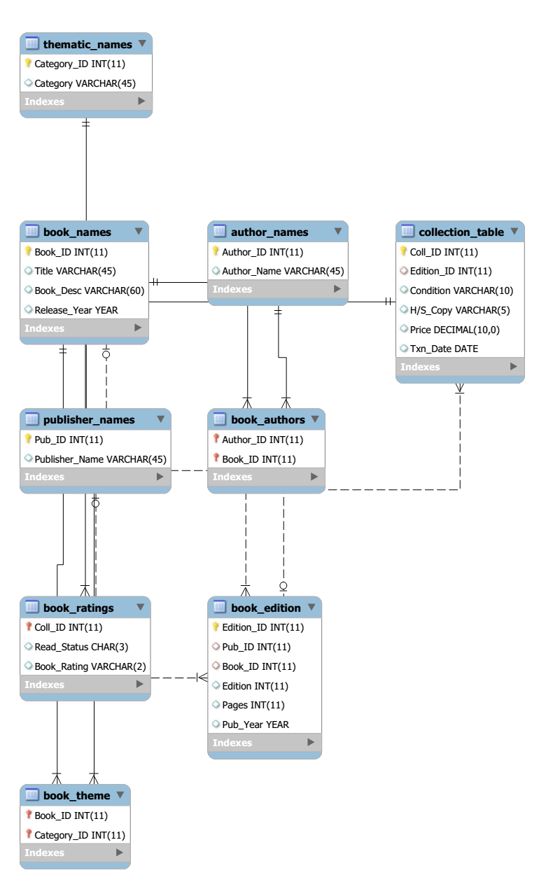

**C. INSERT Statements:**

|  |
| --- |
| -- Author_Names Table  INSERT INTO author_names (Author_ID, Author_Name) VALUES (1,'John Terry');  INSERT INTO author_names (Author_ID, Author_Name) VALUES (2,'Eden Hazard');  INSERT INTO author_names (Author_ID, Author_Name) VALUES (3,'Diego Costa');  INSERT INTO author_names (Author_ID, Author_Name) VALUES (4,'Petr Cech');  INSERT INTO author_names (Author_ID, Author_Name) VALUES (5,'Oscar');  INSERT INTO author_names (Author_ID, Author_Name) VALUES (6,'Willian');  -- Book_Authors Table  INSERT INTO book_authors (Author_ID, Book_ID) VALUES (1,1);  INSERT INTO book_authors (Author_ID, Book_ID) VALUES (6,1);  INSERT INTO book_authors (Author_ID, Book_ID) VALUES (2,2);  INSERT INTO book_authors (Author_ID, Book_ID) VALUES (5,2);  INSERT INTO book_authors (Author_ID, Book_ID) VALUES (3,3);  INSERT INTO book_authors (Author_ID, Book_ID) VALUES (4,3);  INSERT INTO book_authors (Author_ID, Book_ID) VALUES (3,4);  INSERT INTO book_authors (Author_ID, Book_ID) VALUES (4,4);  INSERT INTO book_authors (Author_ID, Book_ID) VALUES (2,5);  INSERT INTO book_authors (Author_ID, Book_ID) VALUES (5,5);  INSERT INTO book_authors (Author_ID, Book_ID) VALUES (5,6);  INSERT INTO book_authors (Author_ID, Book_ID) VALUES (6,6);  INSERT INTO book_authors (Author_ID, Book_ID) VALUES (1,7);  INSERT INTO book_authors (Author_ID, Book_ID) VALUES (4,7);  INSERT INTO book_authors (Author_ID, Book_ID) VALUES (2,8);  INSERT INTO book_authors (Author_ID, Book_ID) VALUES (3,8);  INSERT INTO book_authors (Author_ID, Book_ID) VALUES (2,9);  INSERT INTO book_authors (Author_ID, Book_ID) VALUES (3,9);  INSERT INTO book_authors (Author_ID, Book_ID) VALUES (1,10);  INSERT INTO book_authors (Author_ID, Book_ID) VALUES (4,10);  INSERT INTO book_authors (Author_ID, Book_ID) VALUES (5,11);  INSERT INTO book_authors (Author_ID, Book_ID) VALUES (6,12);  INSERT INTO book_authors (Author_ID, Book_ID) VALUES (1,13);  INSERT INTO book_authors (Author_ID, Book_ID) VALUES (2,14);  INSERT INTO book_authors (Author_ID, Book_ID) VALUES (3,15);  INSERT INTO book_authors (Author_ID, Book_ID) VALUES (4,16);  INSERT INTO book_authors (Author_ID, Book_ID) VALUES (5,17);  INSERT INTO book_authors (Author_ID, Book_ID) VALUES (6,18);  INSERT INTO book_authors (Author_ID, Book_ID) VALUES (1,19);  INSERT INTO book_authors (Author_ID, Book_ID) VALUES (2,20);  INSERT INTO book_authors (Author_ID, Book_ID) VALUES (3,21);  INSERT INTO book_authors (Author_ID, Book_ID) VALUES (4,22);  INSERT INTO book_authors (Author_ID, Book_ID) VALUES (5,23);  INSERT INTO book_authors (Author_ID, Book_ID) VALUES (6,24);  INSERT INTO book_authors (Author_ID, Book_ID) VALUES (1,25);  -- book_edition table  INSERT INTO book_edition (Edition_ID, Pub_ID, Book_ID, Edition, Pages, Pub_Year) VALUES (1,5,1,1,900,2001);  INSERT INTO book_edition (Edition_ID, Pub_ID, Book_ID, Edition, Pages, Pub_Year) VALUES (2,5,1,2,950,2002);  INSERT INTO book_edition (Edition_ID, Pub_ID, Book_ID, Edition, Pages, Pub_Year) VALUES (3,5,1,3,1200,2003);  INSERT INTO book_edition (Edition_ID, Pub_ID, Book_ID, Edition, Pages, Pub_Year) VALUES (4,7,2,1,500,2004);  INSERT INTO book_edition (Edition_ID, Pub_ID, Book_ID, Edition, Pages, Pub_Year) VALUES (5,7,2,2,700,2005);  INSERT INTO book_edition (Edition_ID, Pub_ID, Book_ID, Edition, Pages, Pub_Year) VALUES (6,4,2,1,520,2006);  INSERT INTO book_edition (Edition_ID, Pub_ID, Book_ID, Edition, Pages, Pub_Year) VALUES (7,4,2,2,600,2007);  INSERT INTO book_edition (Edition_ID, Pub_ID, Book_ID, Edition, Pages, Pub_Year) VALUES (8,4,2,3,700,2008);  INSERT INTO book_edition (Edition_ID, Pub_ID, Book_ID, Edition, Pages, Pub_Year) VALUES (9,3,3,1,486,2009);  INSERT INTO book_edition (Edition_ID, Pub_ID, Book_ID, Edition, Pages, Pub_Year) VALUES (10,2,4,1,600,2010);  INSERT INTO book_edition (Edition_ID, Pub_ID, Book_ID, Edition, Pages, Pub_Year) VALUES (11,8,3,1,789,2011);  INSERT INTO book_edition (Edition_ID, Pub_ID, Book_ID, Edition, Pages, Pub_Year) VALUES (12,1,5,1,460,2012);  INSERT INTO book_edition (Edition_ID, Pub_ID, Book_ID, Edition, Pages, Pub_Year) VALUES (13,1,5,2,580,2013);  INSERT INTO book_edition (Edition_ID, Pub_ID, Book_ID, Edition, Pages, Pub_Year) VALUES (14,1,6,1,100,2014);  INSERT INTO book_edition (Edition_ID, Pub_ID, Book_ID, Edition, Pages, Pub_Year) VALUES (15,2,7,1,200,2015);  INSERT INTO book_edition (Edition_ID, Pub_ID, Book_ID, Edition, Pages, Pub_Year) VALUES (16,3,8,1,300,2014);  INSERT INTO book_edition (Edition_ID, Pub_ID, Book_ID, Edition, Pages, Pub_Year) VALUES (17,4,9,1,400,2013);  INSERT INTO book_edition (Edition_ID, Pub_ID, Book_ID, Edition, Pages, Pub_Year) VALUES (18,5,10,1,500,2012);  INSERT INTO book_edition (Edition_ID, Pub_ID, Book_ID, Edition, Pages, Pub_Year) VALUES (19,5,1,4,1250,2013);  INSERT INTO book_edition (Edition_ID, Pub_ID, Book_ID, Edition, Pages, Pub_Year) VALUES (20,3,11,1,150,1999);  INSERT INTO book_edition (Edition_ID, Pub_ID, Book_ID, Edition, Pages, Pub_Year) VALUES (21,2,15,1,250,1998);  INSERT INTO book_edition (Edition_ID, Pub_ID, Book_ID, Edition, Pages, Pub_Year) VALUES (22,3,20,1,350,1997);  INSERT INTO book_edition (Edition_ID, Pub_ID, Book_ID, Edition, Pages, Pub_Year) VALUES (23,2,25,1,450,1998);  -- book_names table  INSERT INTO book_names (Book_ID, Title, Book_Desc, Release_Year) VALUES (1,'Databases','Basics of database',1990);  INSERT INTO book_names (Book_ID, Title, Book_Desc, Release_Year) VALUES (2,'Economics','Basics of Economics',2001);  INSERT INTO book_names (Book_ID, Title, Book_Desc, Release_Year) VALUES (3,'Computer Science','Basics of Computer Science',1988);  INSERT INTO book_names (Book_ID, Title, Book_Desc, Release_Year) VALUES (4,'History','Basics of History',1995);  INSERT INTO book_names (Book_ID, Title, Book_Desc, Release_Year) VALUES (5,'Law Fundamentals','Basics of Law and order',1999);  INSERT INTO book_names (Book_ID, Title, Book_Desc, Release_Year) VALUES (6,'Cloud Computing','Basics of Cloud',2010);  INSERT INTO book_names (Book_ID, Title, Book_Desc, Release_Year) VALUES (7,'Algorithms','Basics of Algorithms',2014);  INSERT INTO book_names (Book_ID, Title, Book_Desc, Release_Year) VALUES (8,'Management Information Systems','Basics of Management Information Systems',1984);  INSERT INTO book_names (Book_ID, Title, Book_Desc, Release_Year) VALUES (9,'Engineering Management','Basics of Engineering Management',1986);  INSERT INTO book_names (Book_ID, Title, Book_Desc, Release_Year) VALUES (10,'Business Analytics','Basics of Business Analytics',2003);  INSERT INTO book_names (Book_ID, Title, Book_Desc, Release_Year) VALUES (11,'All the Light We Cannot See ','Good Novel',1981);  INSERT INTO book_names (Book_ID, Title, Book_Desc, Release_Year) VALUES (12,'Yes Please','Basics of database',1982);  INSERT INTO book_names (Book_ID, Title, Book_Desc, Release_Year) VALUES (13,'The Blood of Olympus','Novel 13',1983);  INSERT INTO book_names (Book_ID, Title, Book_Desc, Release_Year) VALUES (14,'The Storied Life of A.J. Fikry','Novel 14',1984);  INSERT INTO book_names (Book_ID, Title, Book_Desc, Release_Year) VALUES (15,'The Silkworm (Cormoran Strike, #2)','Novel 11',1985);  INSERT INTO book_names (Book_ID, Title, Book_Desc, Release_Year) VALUES (16,'The Bone Clocks','Novel 16',1981);  INSERT INTO book_names (Book_ID, Title, Book_Desc, Release_Year) VALUES (17,'The Girl with All the Gifts','Novel 17',1982);  INSERT INTO book_names (Book_ID, Title, Book_Desc, Release_Year) VALUES (18,'Love Letters to the Dead','Novel 18',1983);  INSERT INTO book_names (Book_ID, Title, Book_Desc, Release_Year) VALUES (19,'Leaving Time','Novel 19',1984);  INSERT INTO book_names (Book_ID, Title, Book_Desc, Release_Year) VALUES (20,'The Miniaturist','Novel 20',1986);  INSERT INTO book_names (Book_ID, Title, Book_Desc, Release_Year) VALUES (21,'The Paying Guests','Novel 21',1934);  INSERT INTO book_names (Book_ID, Title, Book_Desc, Release_Year) VALUES (22,'Cruel Beauty','Novel 22',1935);  INSERT INTO book_names (Book_ID, Title, Book_Desc, Release_Year) VALUES (23,'The Good Girl','Novel 23',1936);  INSERT INTO book_names (Book_ID, Title, Book_Desc, Release_Year) VALUES (24,'Revival','Novel 24',1937);  INSERT INTO book_names (Book_ID, Title, Book_Desc, Release_Year) VALUES (25,'The One & Only','Novel 25',1938);  -- book_ratings table  INSERT INTO book_ratings (Coll_ID, Read_Status, Book_Rating) VALUES (1,'1','5');  INSERT INTO book_ratings (Coll_ID, Read_Status, Book_Rating) VALUES (2,'1','5');  INSERT INTO book_ratings (Coll_ID, Read_Status, Book_Rating) VALUES (3,'1','5');  INSERT INTO book_ratings (Coll_ID, Read_Status, Book_Rating) VALUES (4,'1','5');  INSERT INTO book_ratings (Coll_ID, Read_Status, Book_Rating) VALUES (5,'1','5');  INSERT INTO book_ratings (Coll_ID, Read_Status, Book_Rating) VALUES (6,'1','5');  INSERT INTO book_ratings (Coll_ID, Read_Status, Book_Rating) VALUES (7,'0','NA');  INSERT INTO book_ratings (Coll_ID, Read_Status, Book_Rating) VALUES (8,'0','NA');  INSERT INTO book_ratings (Coll_ID, Read_Status, Book_Rating) VALUES (9,'0','NA');  INSERT INTO book_ratings (Coll_ID, Read_Status, Book_Rating) VALUES (10,'0','NA');  INSERT INTO book_ratings (Coll_ID, Read_Status, Book_Rating) VALUES (11,'0','NA');  INSERT INTO book_ratings (Coll_ID, Read_Status, Book_Rating) VALUES (12,'0','NA');  INSERT INTO book_ratings (Coll_ID, Read_Status, Book_Rating) VALUES (13,'1','5');  INSERT INTO book_ratings (Coll_ID, Read_Status, Book_Rating) VALUES (14,'1','2');  INSERT INTO book_ratings (Coll_ID, Read_Status, Book_Rating) VALUES (15,'1','2');  INSERT INTO book_ratings (Coll_ID, Read_Status, Book_Rating) VALUES (16,'1','2');  INSERT INTO book_ratings (Coll_ID, Read_Status, Book_Rating) VALUES (17,'1','3');  INSERT INTO book_ratings (Coll_ID, Read_Status, Book_Rating) VALUES (18,'1','3');  INSERT INTO book_ratings (Coll_ID, Read_Status, Book_Rating) VALUES (19,'0','NA');  INSERT INTO book_ratings (Coll_ID, Read_Status, Book_Rating) VALUES (20,'0','NA');  INSERT INTO book_ratings (Coll_ID, Read_Status, Book_Rating) VALUES (21,'0','NA');  INSERT INTO book_ratings (Coll_ID, Read_Status, Book_Rating) VALUES (22,'0','NA');  INSERT INTO book_ratings (Coll_ID, Read_Status, Book_Rating) VALUES (23,'0','NA');  INSERT INTO book_ratings (Coll_ID, Read_Status, Book_Rating) VALUES (24,'0','NA');  INSERT INTO book_ratings (Coll_ID, Read_Status, Book_Rating) VALUES (25,'1','1');  INSERT INTO book_ratings (Coll_ID, Read_Status, Book_Rating) VALUES (26,'1','1');  INSERT INTO book_ratings (Coll_ID, Read_Status, Book_Rating) VALUES (27,'1','4');  INSERT INTO book_ratings (Coll_ID, Read_Status, Book_Rating) VALUES (28,'1','4');  INSERT INTO book_ratings (Coll_ID, Read_Status, Book_Rating) VALUES (29,'1','4');  INSERT INTO book_ratings (Coll_ID, Read_Status, Book_Rating) VALUES (30,'1','4');  INSERT INTO book_ratings (Coll_ID, Read_Status, Book_Rating) VALUES (31,'1','NA');  INSERT INTO book_ratings (Coll_ID, Read_Status, Book_Rating) VALUES (32,'1','4');  INSERT INTO book_ratings (Coll_ID, Read_Status, Book_Rating) VALUES (33,'1','4');  INSERT INTO book_ratings (Coll_ID, Read_Status, Book_Rating) VALUES (34,'0','NA');  INSERT INTO book_ratings (Coll_ID, Read_Status, Book_Rating) VALUES (35,'0','NA');  -- book_theme table  INSERT INTO book_theme (Book_ID, Category_ID) VALUES (1,1);  INSERT INTO book_theme (Book_ID, Category_ID) VALUES (1,3);  INSERT INTO book_theme (Book_ID, Category_ID) VALUES (1,4);  INSERT INTO book_theme (Book_ID, Category_ID) VALUES (2,2);  INSERT INTO book_theme (Book_ID, Category_ID) VALUES (2,3);  INSERT INTO book_theme (Book_ID, Category_ID) VALUES (3,2);  INSERT INTO book_theme (Book_ID, Category_ID) VALUES (3,3);  INSERT INTO book_theme (Book_ID, Category_ID) VALUES (4,3);  INSERT INTO book_theme (Book_ID, Category_ID) VALUES (4,4);  INSERT INTO book_theme (Book_ID, Category_ID) VALUES (5,1);  INSERT INTO book_theme (Book_ID, Category_ID) VALUES (5,2);  INSERT INTO book_theme (Book_ID, Category_ID) VALUES (6,2);  INSERT INTO book_theme (Book_ID, Category_ID) VALUES (7,3);  INSERT INTO book_theme (Book_ID, Category_ID) VALUES (8,4);  INSERT INTO book_theme (Book_ID, Category_ID) VALUES (9,1);  INSERT INTO book_theme (Book_ID, Category_ID) VALUES (10,2);  -- collection_table table  INSERT INTO collection_table (Coll_ID, Edition_ID, Condition, `H/S_Copy`, Price, Txn_Date) VALUES (1,1,'mint','hard',125,'2010-01-01');  INSERT INTO collection_table (Coll_ID, Edition_ID, Condition, `H/S_Copy`, Price, Txn_Date) VALUES (2,1,'mint','hard',125,'2011-01-01');  INSERT INTO collection_table (Coll_ID, Edition_ID, Condition, `H/S_Copy`, Price, Txn_Date) VALUES (3,1,'mint','hard',125,'2012-01-01');  INSERT INTO collection_table (Coll_ID, Edition_ID, Condition, `H/S_Copy`, Price, Txn_Date) VALUES (4,1,'mint','hard',125,'2013-01-01');  INSERT INTO collection_table (Coll_ID, Edition_ID, Condition, `H/S_Copy`, Price, Txn_Date) VALUES (5,1,'mint','hard',125,'2014-01-01');  INSERT INTO collection_table (Coll_ID, Edition_ID, Condition, `H/S_Copy`, Price, Txn_Date) VALUES (6,2,'good','soft',150,'2014-11-01');  INSERT INTO collection_table (Coll_ID, Edition_ID, Condition, `H/S_Copy`, Price, Txn_Date) VALUES (7,3,'good','soft',175,'2015-01-01');  INSERT INTO collection_table (Coll_ID, Edition_ID, Condition, `H/S_Copy`, Price, Txn_Date) VALUES (8,4,'poor','soft',50,'2006-05-01');  INSERT INTO collection_table (Coll_ID, Edition_ID, Condition, `H/S_Copy`, Price, Txn_Date) VALUES (9,5,'poor','hard',60,'2006-06-01');  INSERT INTO collection_table (Coll_ID, Edition_ID, Condition, `H/S_Copy`, Price, Txn_Date) VALUES (10,6,'acceptable','soft',100,'2011-04-01');  INSERT INTO collection_table (Coll_ID, Edition_ID, Condition, `H/S_Copy`, Price, Txn_Date) VALUES (11,6,'poor','hard',0.50,'2005-06-01');  INSERT INTO collection_table (Coll_ID, Edition_ID, Condition, `H/S_Copy`, Price, Txn_Date) VALUES (12,7,'poor','hard',0.75,'2005-04-01');  INSERT INTO collection_table (Coll_ID, Edition_ID, Condition, `H/S_Copy`, Price, Txn_Date) VALUES (13,8,'poor','soft',0.80,'2005-06-01');  INSERT INTO collection_table (Coll_ID, Edition_ID, Condition, `H/S_Copy`, Price, Txn_Date) VALUES (14,9,'poor','hard',0.55,'2005-04-01');  INSERT INTO collection_table (Coll_ID, Edition_ID, Condition, `H/S_Copy`, Price, Txn_Date) VALUES (15,10,'very good','soft',200,'2013-06-01');  INSERT INTO collection_table (Coll_ID, Edition_ID, Condition, `H/S_Copy`, Price, Txn_Date) VALUES (16,11,'poor','hard',220,'2014-04-01');  INSERT INTO collection_table (Coll_ID, Edition_ID, Condition, `H/S_Copy`, Price, Txn_Date) VALUES (17,12,'very good','soft',240,'2014-06-01');  INSERT INTO collection_table (Coll_ID, Edition_ID, Condition, `H/S_Copy`, Price, Txn_Date) VALUES (18,13,'very good','hard',260,'2015-01-01');  INSERT INTO collection_table (Coll_ID, Edition_ID, Condition, `H/S_Copy`, Price, Txn_Date) VALUES (19,13,'very good','hard',260,'2015-01-01');  INSERT INTO collection_table (Coll_ID, Edition_ID, Condition, `H/S_Copy`, Price, Txn_Date) VALUES (20,13,'very good','hard',260,'2015-01-01');  INSERT INTO collection_table (Coll_ID, Edition_ID, Condition, `H/S_Copy`, Price, Txn_Date) VALUES (21,4,'mint','soft',350,'2014-05-01');  INSERT INTO collection_table (Coll_ID, Edition_ID, Condition, `H/S_Copy`, Price, Txn_Date) VALUES (22,5,'very good','hard',360,'2014-06-01');  INSERT INTO collection_table (Coll_ID, Edition_ID, Condition, `H/S_Copy`, Price, Txn_Date) VALUES (23,14,'poor','soft',75,'2013-01-01');  INSERT INTO collection_table (Coll_ID, Edition_ID, Condition, `H/S_Copy`, Price, Txn_Date) VALUES (24,15,'poor','soft',80,'2013-01-02');  INSERT INTO collection_table (Coll_ID, Edition_ID, Condition, `H/S_Copy`, Price, Txn_Date) VALUES (25,16,'poor','soft',85,'2013-01-03');  INSERT INTO collection_table (Coll_ID, Edition_ID, Condition, `H/S_Copy`, Price, Txn_Date) VALUES (26,17,'good','hard',90,'2013-01-04');  INSERT INTO collection_table (Coll_ID, Edition_ID, Condition, `H/S_Copy`, Price, Txn_Date) VALUES (27,18,'good','soft',95,'2013-01-05');  INSERT INTO collection_table (Coll_ID, Edition_ID, Condition, `H/S_Copy`, Price, Txn_Date) VALUES (28,14,'good','hard',100,'2013-01-06');  INSERT INTO collection_table (Coll_ID, Edition_ID, Condition, `H/S_Copy`, Price, Txn_Date) VALUES (29,15,'acceptable','soft',105,'2013-01-07');  INSERT INTO collection_table (Coll_ID, Edition_ID, Condition, `H/S_Copy`, Price, Txn_Date) VALUES (30,16,'acceptable','hard',110,'2013-01-08');  INSERT INTO collection_table (Coll_ID, Edition_ID, Condition, `H/S_Copy`, Price, Txn_Date) VALUES (31,19,'mint','hard',150,'2015-01-02');  INSERT INTO collection_table (Coll_ID, Edition_ID, Condition, `H/S_Copy`, Price, Txn_Date) VALUES (32,20,'mint','hard',210,'2011-01-03');  INSERT INTO collection_table (Coll_ID, Edition_ID, Condition, `H/S_Copy`, Price, Txn_Date) VALUES (33,21,'good','soft',220,'2013-07-03');  INSERT INTO collection_table (Coll_ID, Edition_ID, Condition, `H/S_Copy`, Price, Txn_Date) VALUES (34,22,'very good','hard',230,'2012-04-03');  INSERT INTO collection_table (Coll_ID, Edition_ID, Condition, `H/S_Copy`, Price, Txn_Date) VALUES (35,23,'very good','soft',240,'2011-01-03');  -- publisher_names table  INSERT INTO publisher_names (Pub_ID, Publisher_Name) VALUES (1,'Arcade Publishing');  INSERT INTO publisher_names (Pub_ID, Publisher_Name) VALUES (2,'Arkham House');  INSERT INTO publisher_names (Pub_ID, Publisher_Name) VALUES (3,'Cisco Press');  INSERT INTO publisher_names (Pub_ID, Publisher_Name) VALUES (4,'CRC Press');  INSERT INTO publisher_names (Pub_ID, Publisher_Name) VALUES (5,'Exact Change');  INSERT INTO publisher_names (Pub_ID, Publisher_Name) VALUES (6,'Houghton Mifflin');  INSERT INTO publisher_names (Pub_ID, Publisher_Name) VALUES (7,'John Lane');  INSERT INTO publisher_names (Pub_ID, Publisher_Name) VALUES (8,'Kensington Books');  INSERT INTO publisher_names (Pub_ID, Publisher_Name) VALUES (9,'Llewellyn Worldwide');  INSERT INTO publisher_names (Pub_ID, Publisher_Name) VALUES (10,'Medknow Publications');  INSERT INTO publisher_names (Pub_ID, Publisher_Name) VALUES (11,'Marion Boyars Publishers');  INSERT INTO publisher_names (Pub_ID, Publisher_Name) VALUES (12,'NavPress');  -- thematic_names table  INSERT INTO thematic_names (Category_ID, Category) VALUES (1,'history');  INSERT INTO thematic_names (Category_ID, Category) VALUES (2,'novel');  INSERT INTO thematic_names (Category_ID, Category) VALUES (3,'poetry');  INSERT INTO thematic_names (Category_ID, Category) VALUES (4,'science'); |

**D. List of 'on update' and 'on delete' constraints**

|  |  |  |  |
| --- | --- | --- | --- |
| Table Name | Constraint Name | On Update | On Delete |
| book_authors | ba_Author_ID | CASCADE | CASCADE |
| ba_Book_ID | CASCADE | CASCADE |
| book_edition | be_Book_ID | CASCADE | CASCADE |
| be_Pub_ID | CASCADE | CASCADE |
| book_ratings | br_Coll_ID | CASCADE | CASCADE |
| book_theme | bt_Book_ID | CASCADE | CASCADE |
| bt_Category_ID | CASCADE | CASCADE |
| collection_table | ct_Edition_ID | CASCADE | CASCADE |

**E. The initial state of the schema will contain the following items:**

* **Relations**
* **Attributes of relations**
* **Constraints**
  + Entity Integrity Constraint
  + Referential Integrity Constraints
* **Sample Data**

***TASK 4:***

A. Show a list of the books you own sorted alphabetically based on the title

|  |
| --- |
| select book_names.Title  from book_names, collection_table, book_edition  where collection_table.Edition_ID = book_edition.Edition_ID  and book_edition.Book_ID = book_names.Book_ID  order by book_names.Title ASC; |

Output:

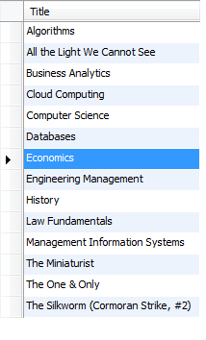

B. Show the total number of your books

|  |
| --- |
| select count(collection_table.Coll_ID) as 'Total Number of Books'  from collection_table |

Output:



C. Show for each book the number of times you own it

|  |
| --- |
| select book_names.Title,book_edition.Edition , count(book_names.Title) as NumberOfBooks  from collection_table, book_edition, book_names  where collection_table.Edition_ID = book_edition.Edition_ID  and book_edition.Book_ID = book_names.Book_ID  group by book_names.Title, book_edition.edition; |

Output:

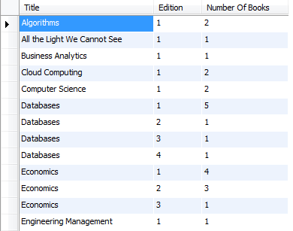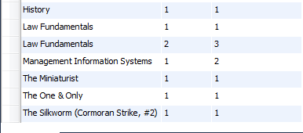

D. Show your unique publications. More specifically the query should return each book of the same publisher and same edition only once, even though you might own it more than once.

|  |
| --- |
| select book_names.Title, book_edition.Edition  from book_names, collection_table, book_edition  where collection_table.Edition_ID = book_edition.Edition_ID  and book_edition.Book_ID = book_names.Book_ID  group by book_names.Title, book_edition.Edition; |

Output:

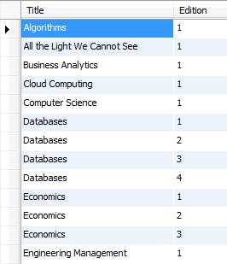

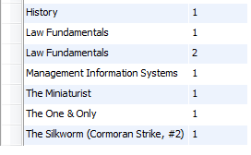

E. Show only those books you own more than once

|  |
| --- |
| select book_names.Title, publisher_names.Publisher_Name, book_edition.Edition , count(collection_table.Edition_ID)  from book_names, collection_table, book_edition, publisher_names  where book_names.Book_ID = book_edition.Book_ID  and book_edition.Edition_ID = collection_table.Edition_ID  and book_edition.Pub_ID = publisher_names.Pub_ID  group by collection_table.Edition_ID  having count(collection_table.Edition_ID) > 1; |

Output:

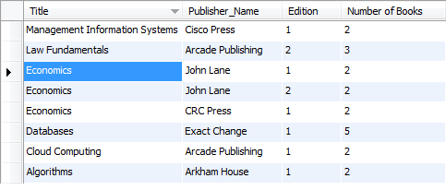

F. Show the publisher for whom you have the largest number of books

|  |
| --- |
| select pub.Publisher_Name, count(be.Pub_ID) as Number_Of_Books  from collection_table c, book_edition be, publisher_names pub  where c.Edition_ID = be.Edition_ID and be.Pub_ID = pub.Pub_ID  group by be.Pub_ID  order by Number_Of_Books desc limit 1; |



G. Show the book with the most edition updates which you have still not read (but you own).

|  |
| --- |
| select book_edition.Edition_ID, book_names.Title, book_edition.Edition  from book_names, book_edition, collection_table, book_ratings  where book_edition.Edition_ID = collection_table.Edition_ID  and book_names.Book_ID = book_edition.Book_ID  and collection_table.Coll_ID = book_ratings.Coll_ID  and book_ratings.Read_Status = 'No'  group by book_names.Title, book_edition.Edition  order by book_edition.Edition desc limit 1; |



H. Show the books purchased after a given year (you decide) with a thematic category “science” or “history”.

|  |
| --- |
| select book_names.Title, thematic_names.Category, collection_table.Txn_Date  from book_names, thematic_names, book_theme, collection_table, book_edition  where book_names.Book_ID = book_edition.Book_ID  and book_edition.Edition_ID = collection_table.Edition_ID  and book_theme.Book_ID = book_names.Book_ID  and book_theme.Category_ID = thematic_names.Category_ID  group by collection_table.Edition_ID, book_names.Title, thematic_names.Category  having year(Txn_Date) > 2011 and (Category = 'history' or Category = 'science') ; |

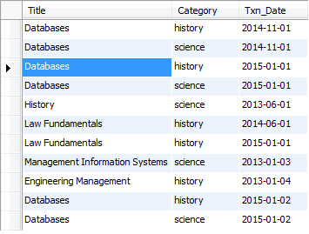

I. Show a list of your books with more than one thematic categories. Show the books with more categories first.

|  |
| --- |
| select distinct book_names.Title, thematic_names.Category  from book_names, thematic_names, book_theme, collection_table, book_edition  where book_names.Book_ID = book_edition.Book_ID  and book_edition.Edition_ID = collection_table.Edition_ID  and book_theme.Book_ID = book_names.Book_ID  and book_theme.Category_ID = thematic_names.Category_ID  group by collection_table.Edition_ID, book_names.Title, thematic_names.Category  having count(category) > 1 ; |

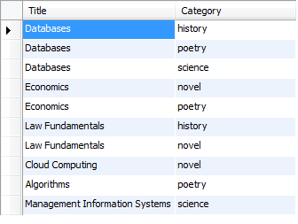

J. Show the average price you have paid per publisher. Consider that all your books need to be taken into account, even the duplicates.

|  |
| --- |
| select pb.publisher_name, avg(ct.Price) as AveragePrice  from publisher_names as pb, book_edition as be, collection_table as ct  where ct.Edition_id = be.Edition_ID  and be.Pub_ID = pb.Pub_ID  group by pb.Publisher_name; |

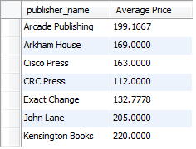

K. Show the most expensive book per thematic category.

|  |
| --- |
| select thematic_names.Category, max(collection_table.price) as MaxPrice  from book_names, thematic_names, collection_table, book_theme, book_edition  where collection_table.Edition_ID = book_edition.Edition_ID  and book_names.Book_ID = book_edition.Book_ID  and thematic_names.Category_ID = book_theme.Category_ID  and book_theme.Book_ID = book_names.Book_ID  group by thematic_names.Category; |

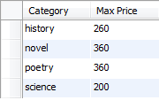

L. Show the least expensive book which is in mint condition.

|  |
| --- |
| select book_names.Title, collection_table.Condition , min(collection_table.Price) as MinPrice  from collection_table, book_names, book_edition  where collection_table.Edition_ID = book_edition.Edition_ID  and book_names.Book_ID = book_edition.Book_ID  group by collection_table.Condition  having collection_table.Condition = 'mint'; |



M. Show how many mint books you have for each publication year

|  |
| --- |
| select book_edition.Pub_Year, collection_table.Condition , count(collection_table.Condition) as 'No Of Books'  from collection_table, book_edition  where collection_table.Edition_ID = book_edition.Edition_ID  group by book_edition.Pub_year, collection_table.Condition  having collection_table.Condition = 'mint'; |

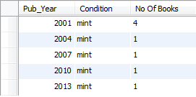

N. What percentage (%) of your single-author books have you read and rated with more than three stars?

|  |
| --- |
| select sum(a.Read_Status)/count(*) * 100 as Percentage  from (select book_names.Title, author_names.Author_Name, book_ratings.Read_Status  from book_names, author_names, book_authors, book_edition, collection_table, book_ratings  where book_names.Book_ID = book_authors.Book_ID  and collection_table.Edition_ID = book_edition.Edition_ID  and book_names.Book_ID = book_edition.Book_ID  and book_authors.Author_ID = author_names.Author_ID  and collection_table.Coll_ID = book_ratings.Coll_ID  group by book_authors.Book_ID  having count(book_authors.Book_ID) = 1) a |



O. If each leaf of the book (1 leaf=2 pages) weights 0.5 gr, show the weight of your second edition books in kilos. Do not consider the hardcover for this query.

|  |
| --- |
| select book_names.Title, book_edition.Edition, book_edition.Pages, ((book_edition.Pages * 0.25)/1000) as 'Weight In Kgs'  from book_names, book_edition, collection_table  where collection_table.Edition_ID = book_edition.Edition_ID  and book_names.Book_ID = book_edition.Book_ID  group by book_names.Title, book_edition.Edition  having book_edition.Edition = 2; |

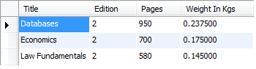

***TASK 5:***

A. Write a query which would update the number of pages: increase by 10 pages for those books which were written after the year 2000.

|  |
| --- |
| update book_edition  set book_edition.Pages = book_edition.Pages - 10  where book_edition.Pub_Year > 2000; |

Table Output Before update query:

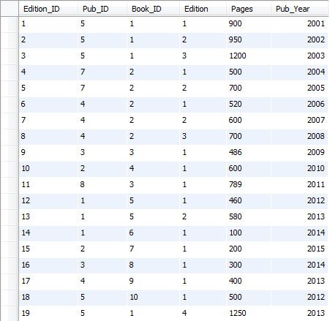

Table output after update query:

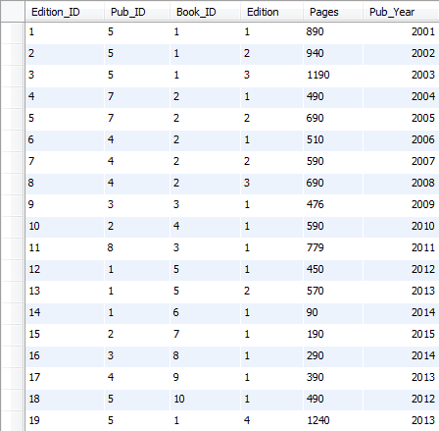

B. Write a query which would delete all books that you bought in 2005 in "poor" condition and a cost less than $1.00

|  |
| --- |
| delete from collection_table  where year(Txn_Date) = 2005  and collection_table.Condition = 'poor'  and price < 1; |

Output of Select Query before delete query:

|  |
| --- |
| select * from collection_table  where year(Txn_Date) = 2005  and collection_table.Condition = 'poor'  and price < 1; |

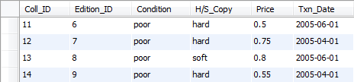

Output of Select Query after delete query:

|  |
| --- |
| select * from collection_table  where year(Txn_Date) = 2005  and collection_table.Condition = 'poor'  and price < 1; |



C. Write a query which would delete the relation which stores the information about the authors

|  |
| --- |
| ALTER TABLE `book_system`.`book_authors`  DROP FOREIGN KEY `ba_Book_ID`,  DROP FOREIGN KEY `ba_Author_ID`; |

D. Write a query which would create an extra attribute in the appropriate relation and name it ‘classic’ which automatically takes values ‘true’ if the book was written before 1950 and ‘false’ if the book was written after 1950

|  |
| --- |
| update book_names set classic = 'Yes'  where Release_Year < 1950  update book_names set classic = 'No'  where Release_Year > 1950 |

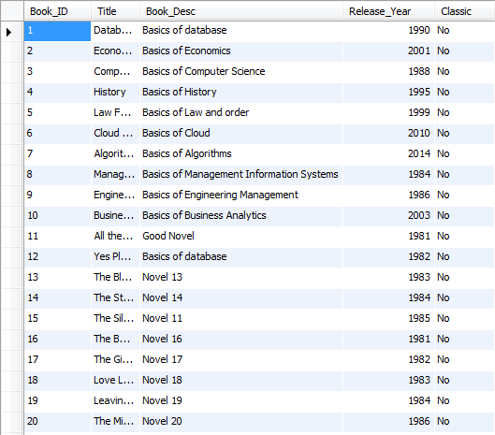 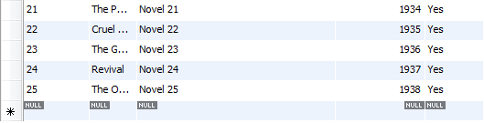

CREATE VIEWS for below queries:

E. The book title with the money paid and the author(s).

|  |
| --- |
| create view Book_Details_View  as (select distinct collection_table.Edition_ID, book_names.Title, author_names.Author_Name, collection_table.Price  from book_names, book_edition, author_names, book_authors, collection_table  where book_names.Book_ID = book_authors.Book_ID  and book_authors.Author_ID = author_names.Author_ID  and book_names.Book_ID = book_edition.Book_ID  and book_edition.Edition_ID = collection_table.Edition_ID  order by collection_table.Edition_ID); |

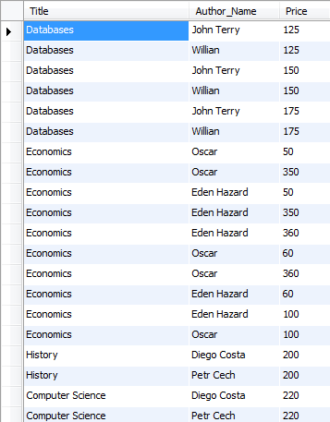 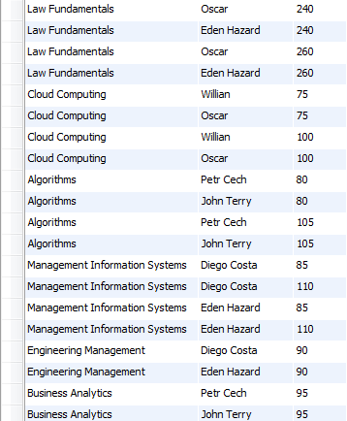 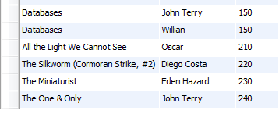

F. The book title with the thematic category and the condition.

|  |
| --- |
| create view book_det_thematic as  (select collection_table.Coll_ID, book_names.Title, thematic_names.Category, collection_table.Condition  from collection_table, book_edition, book_theme, thematic_names, book_names  where collection_table.Edition_ID = book_edition.Edition_ID  and book_edition.Book_ID = book_names.Book_ID  and book_theme.Book_ID = book_names.Book_ID  and thematic_names.Category_ID = book_theme.Category_ID  group by collection_table.Coll_ID); |

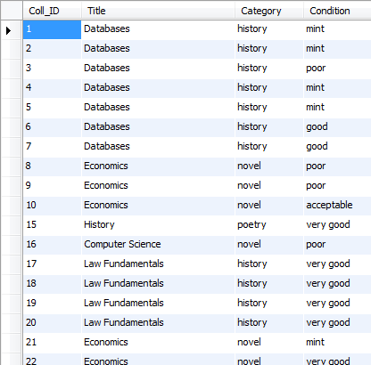 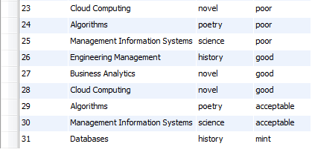

G. The average amount of money paid for each unique book, alongside with info about the thematic category

|  |
| --- |
| create view Book_name_AVGPRice as  (select book_names.Title,thematic_names.Category , AVG(collection_table.Price) as 'Average Price'  from collection_table, book_names, thematic_names, book_theme, book_edition  where collection_table.Edition_ID = book_edition.Edition_ID  and book_edition.Book_ID = book_names.Book_ID  and book_names.Book_ID = book_theme.Book_ID  and book_theme.Category_ID = thematic_names.Category_ID  group by book_names.Title); |

