Assignment – 2
-Kaustubh Prakash 2016MT10647
-Abhay Saxena 2016MT60648

Objective: Make OS Process Scheduler Simulator

Simulator Parameters:
- Processes (Input at run-time)
  - Number of Processes (=5)
  - Mean Inter-arrival time (=3)
  - Mean Burst-time (=8)
- Scheduler (Defined in code)
  - RR Timeslice (=1)
  - MLFQ number of queues (=3)
  - MLFQ timeslice for each queue (= {1, 2, 3} )
  - MLFQ reset time (=10)

FIFO
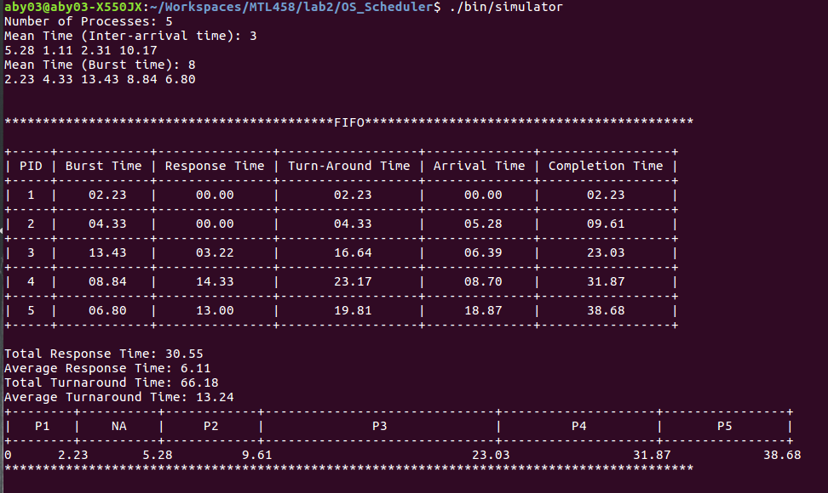
Conclusion: Processes are completed in the order of their arrival time

Round Robin

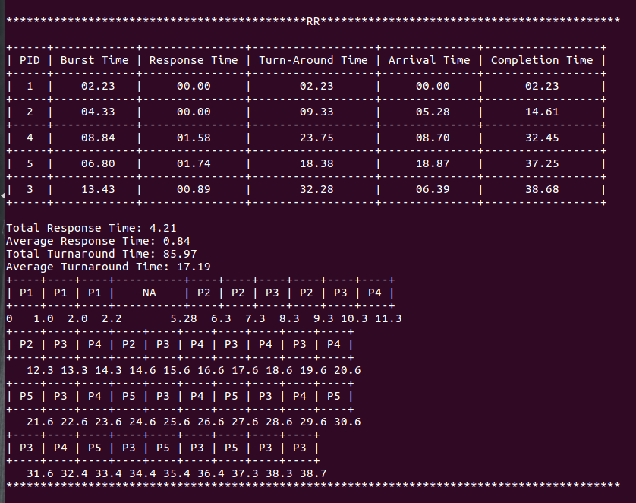
Conclusion: Round Robin has better response time as compared to FIFO but worse turnaround time

SJF

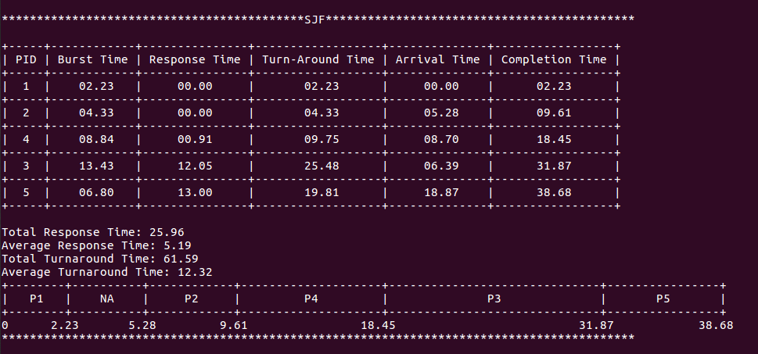
Concusion: SJF has worse response time but better turnaround time

SRTF
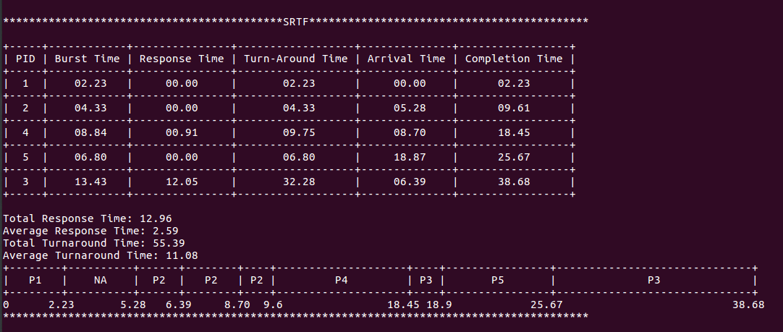
Conclusion: SRTF has least completion and turn-around time for processes

MLFQ
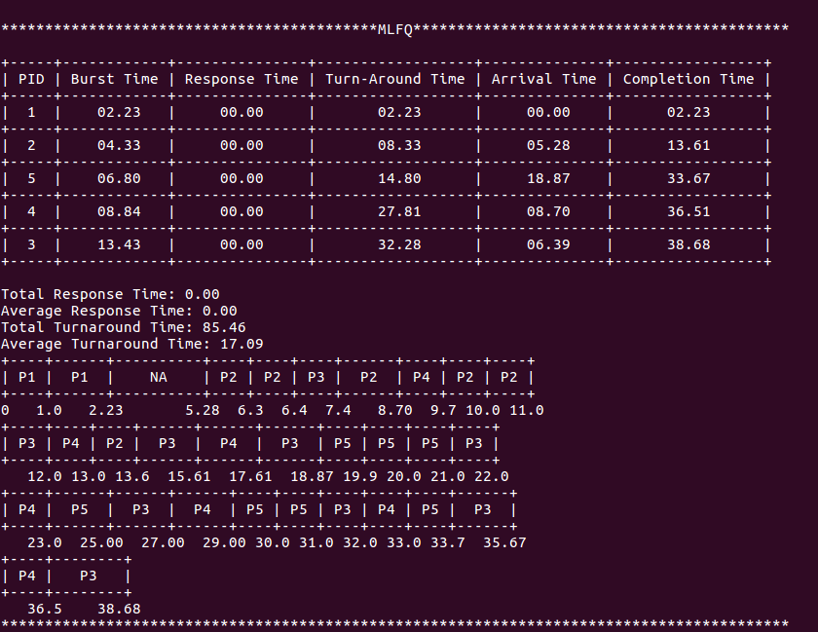
Conclusion: MLFQ has the least response time amongst all

Final Conclusions
Average Response Time: MLFQ < RR < SRTF < SJF < FIFO
Average Turnaround Time: SRTF < SJF < FIFO < MLFQ < RR
Average Completion Time: SRTF < SJF < FIFO < MLFQ < RR

