TY B.Tech. (CSE) – II [ 2024-25 ]
6CS371 : Advanced Database System Lab.

Assignment No. 2

Name : Ritesh Ramchandra Patil
PRN : 22510044
Bacth : T3

- MySQL / PSM Review :

1)Create a table called test_table with 2 columns RecordNumber (type : Number(3)) and CurrentDate (type : Date)). Write a procedure in PSM which will insert 50 records into test_table. Insert the current date value into the table.

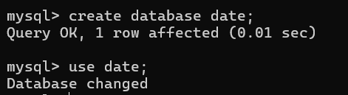
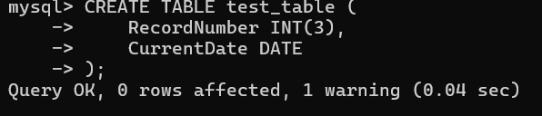

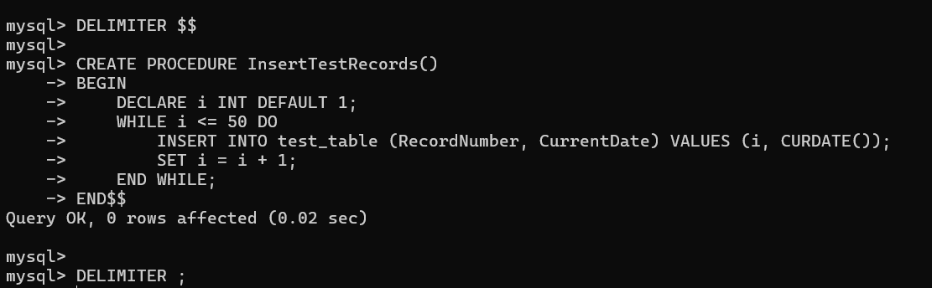



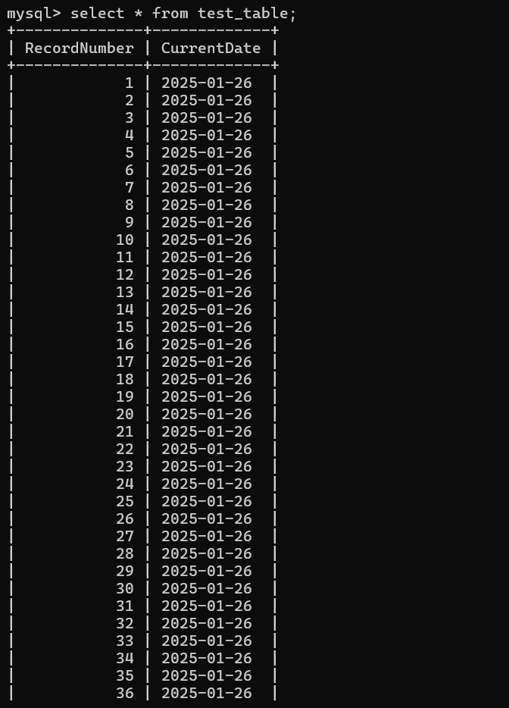
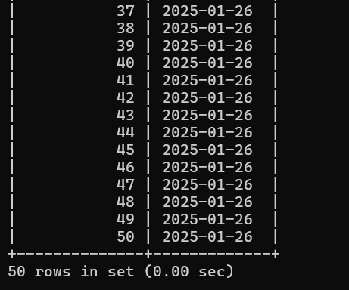

2)Create a products table products(ProductID number(4),category char(3),detail varchar2(30),price number(10,2),stock number(5)).

- Insert the sample data.
- Write PSM procedure with two arguments X & Y which will increase price by X% for all products in category Y. X and Y will be given by user.

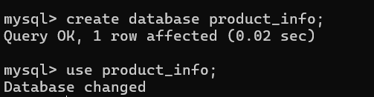

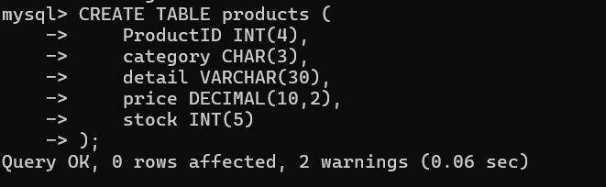

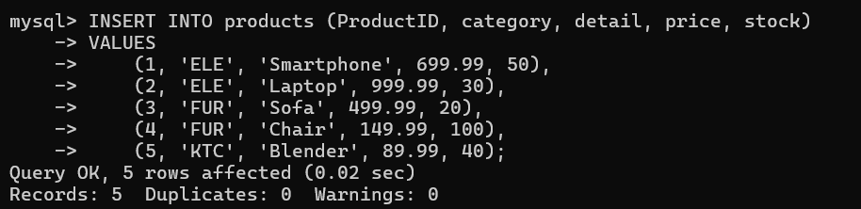

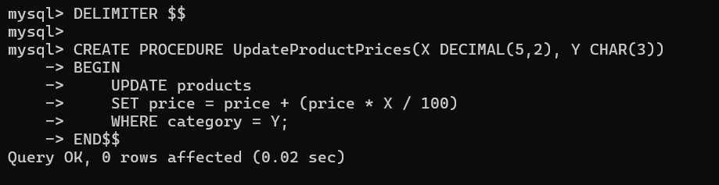

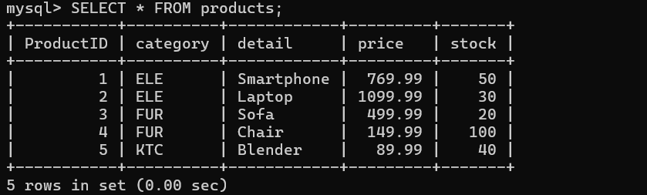

- Object Relational Databases:

a)Create Object Table containing field “name” of size 50 characters and member function “countNoOfWords” which returns the no. of words in “name” field.

Demonstrate the working by entering different data.

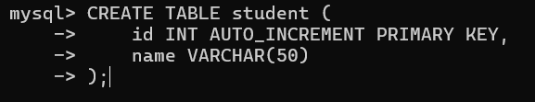

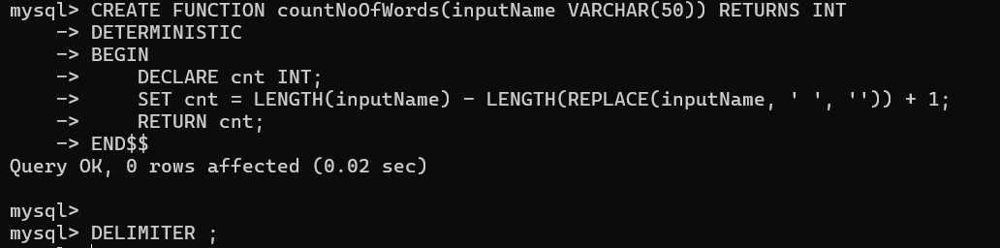

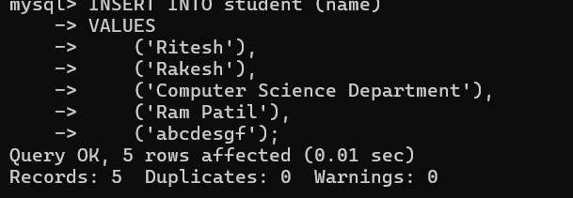

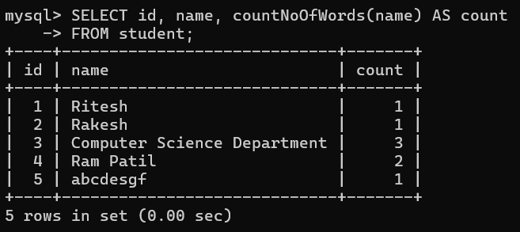

b) Create an address type with the following attributes : address, city, state & pincode. Include the following methods

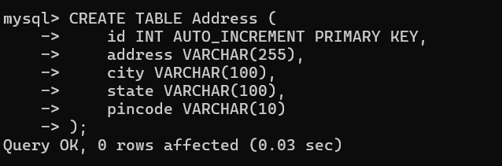
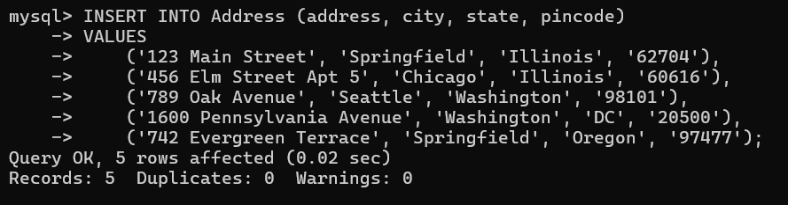

- to extract the addresses based on given keyword.

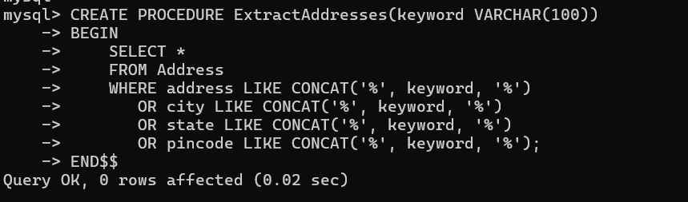

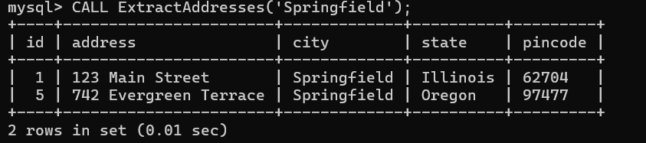

- to return the no. of words in each given field (method should accept the name of attribute/field)

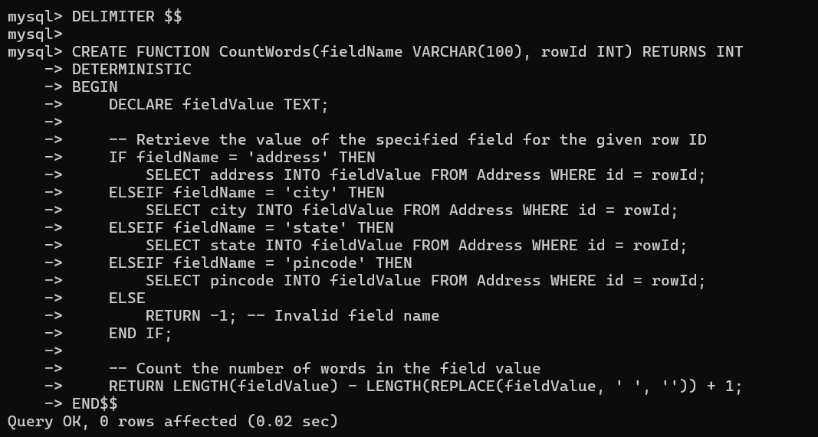

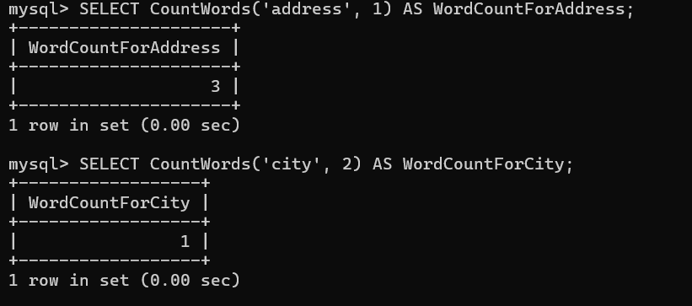

c) Create a user defined data type course_Type with 2 attributes course_id, description :

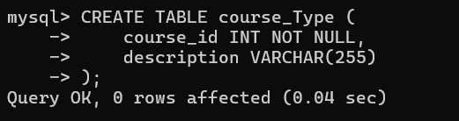

- Create an object table based on the type created.
- Insert rows into the table

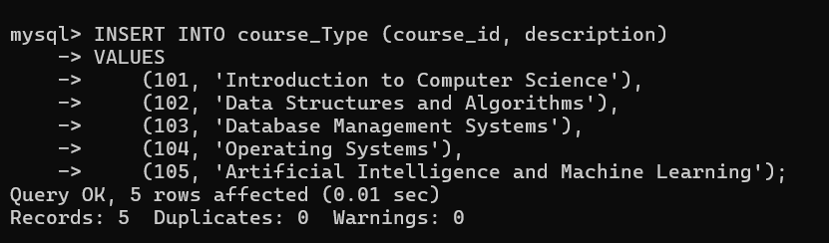

a) Display All Data:

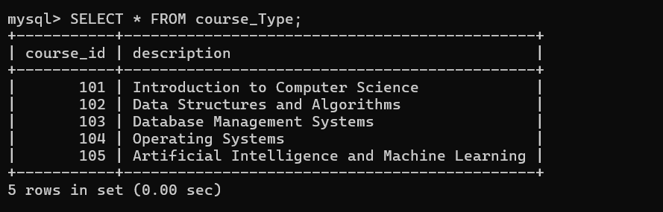

b)Filter Courses by Keywords in the Description:

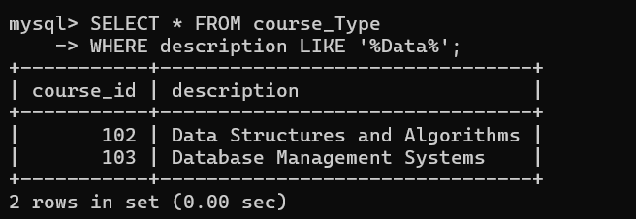

c) Update a Course Description:

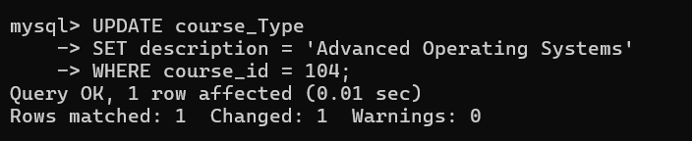

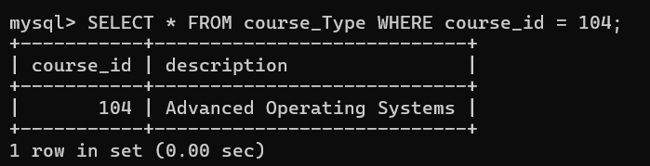

d) Count the Number of Words in Descriptions:

