

Department

of

Computer

Engineering

|  |  |
| --- | --- |
| **Academic Year : 2020-21** | |
| **SUBJECT: Software Engineering CLASS:**SE (I) **SEMESTER:** IV | |
| **ERP NO**:- 34  Teams No:- 20 | **NAME**: Kaustubh Shrikant Kabra |
| **ASSIGNMENT NO**.: 4 | **DATE OF SUBMISSION**: 31/05/2021 |

**Title of assignment:** Draw block diagram/architecture diagram and flow chart of your mini project.

**Theory:**

**Architecture Diagram:-**

An architectural diagram is a diagram of a system that is used to abstract the overall outline of the software system and the relationships, constraints, and boundaries between components. It is an important tool as it provides an overall view of the physical deployment of the software system and its evolution roadmap.

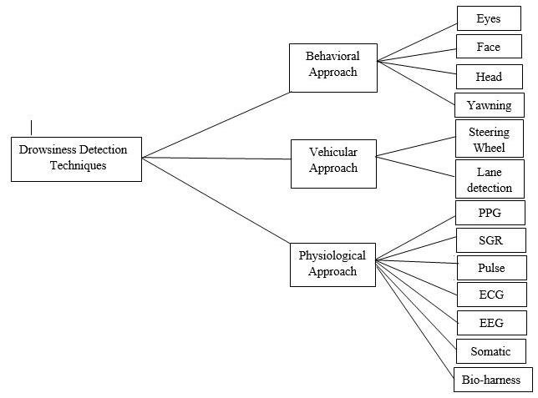

**Block Diagram:-**

**Step1:** Real Time Image Capture using camera.

**Step2:** Converting real time image to suitable Brightness and Contrast.

**Step3:** Face Detection (using OpenCV in our project).

**Step4:** Eye Detection

**Step5:** Detection of Eye, Head, Mouth Coordinate(using Dlib for our project).

**Step6:** Determination of Coordinates of Eyes, Head and Mouth.

**Step7:** Calculation of using coordinate to detect Eye is open or close, Head is bend or not, user is Yawning or not.

**Step8:** As per calculations system Judge the Drowsiness of Driver.

**Step9:** If system judge that Driver have Drowsiness them Alarm is set on.

**Step10:** if not then repeat all steps again.

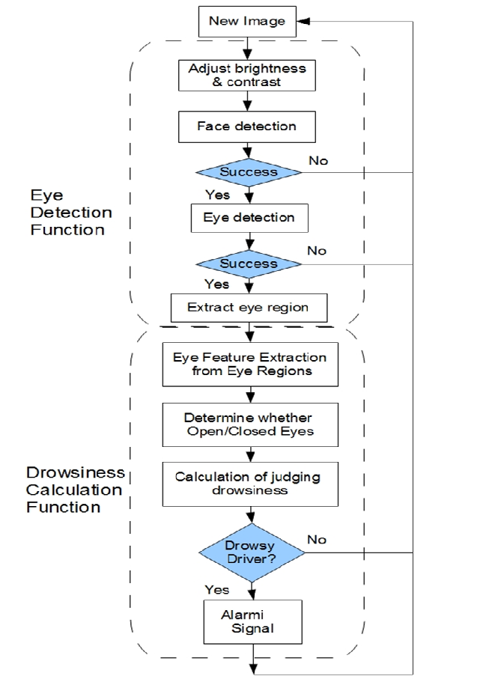

**Activity Diagram:-**

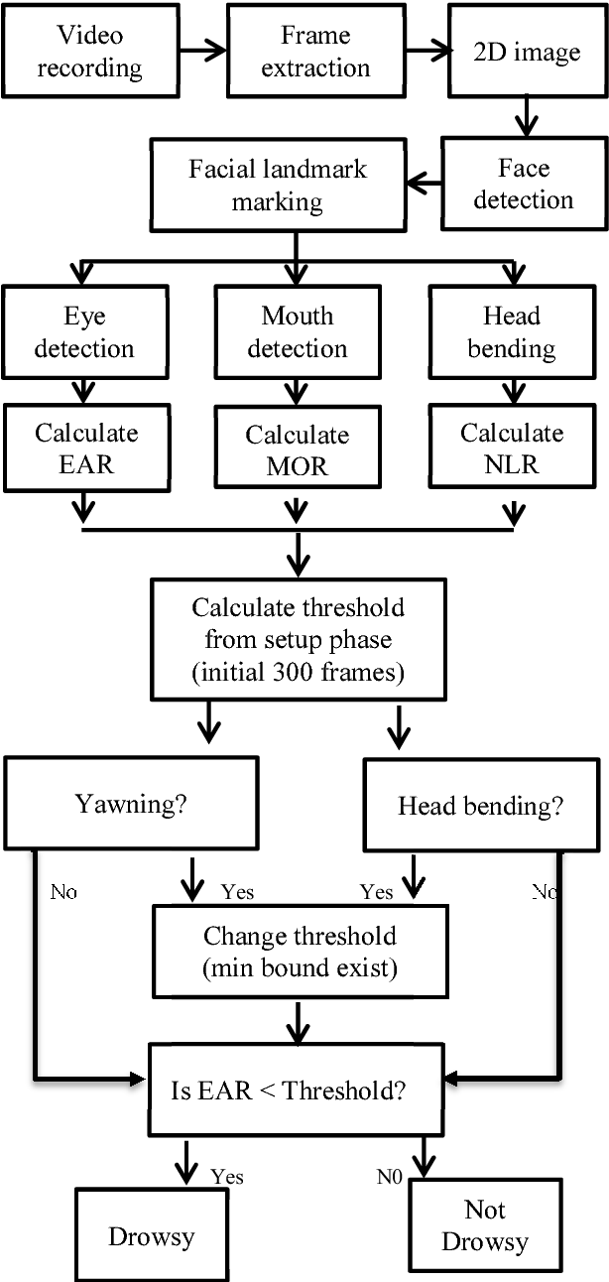

**Conclusion:** Thus, we have studied the step wise execution as well as the architecture of our driver drowsiness system.