Limiting User Application’s CPU Utilization
Some user applications use a lot of CPU memory even when they are running in the background, thus slowing the overall user interface. Though Linux allows many ways of interacting with a particular process, it cannot reduce the CPU utilization of a process on its own. This script allows the user to limit the CPU usage of a particular process.
Description:
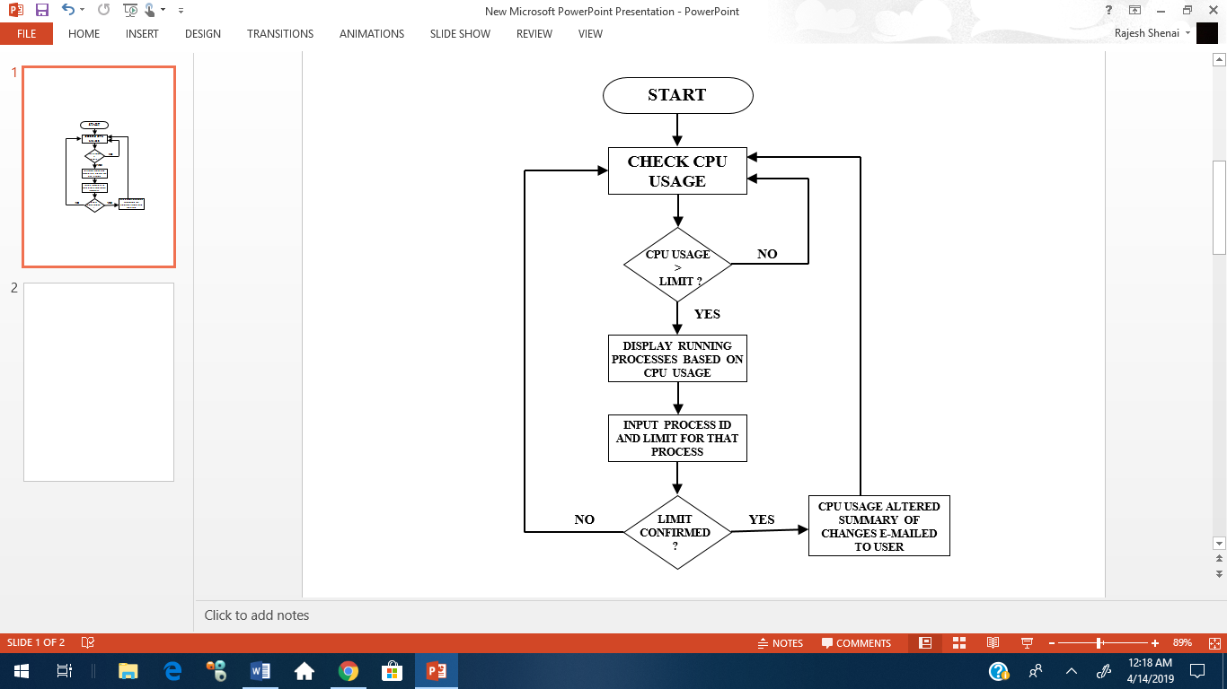
The checking script is scheduled to be executed every hour (using crontab).If the usage is more than the limit, the list of processes consuming more CPU is displayed on a new konsole. The user can then enter the CPU limit and the process id of the concerned process. Once the details are confirmed, the cpulimit is enforced on the process and a notification is sent. Information like the list of processes before the limit is added, the initial state of the concerned process, the state of the process after the limit is added and the decrease in the total CPU usage by the user are captured in one text file and sent to the user’s email id (using ssmtp and mpack).

Crontab
0 * * * * /home/kkekre/Desktop/memoryCheck.sh

Output:

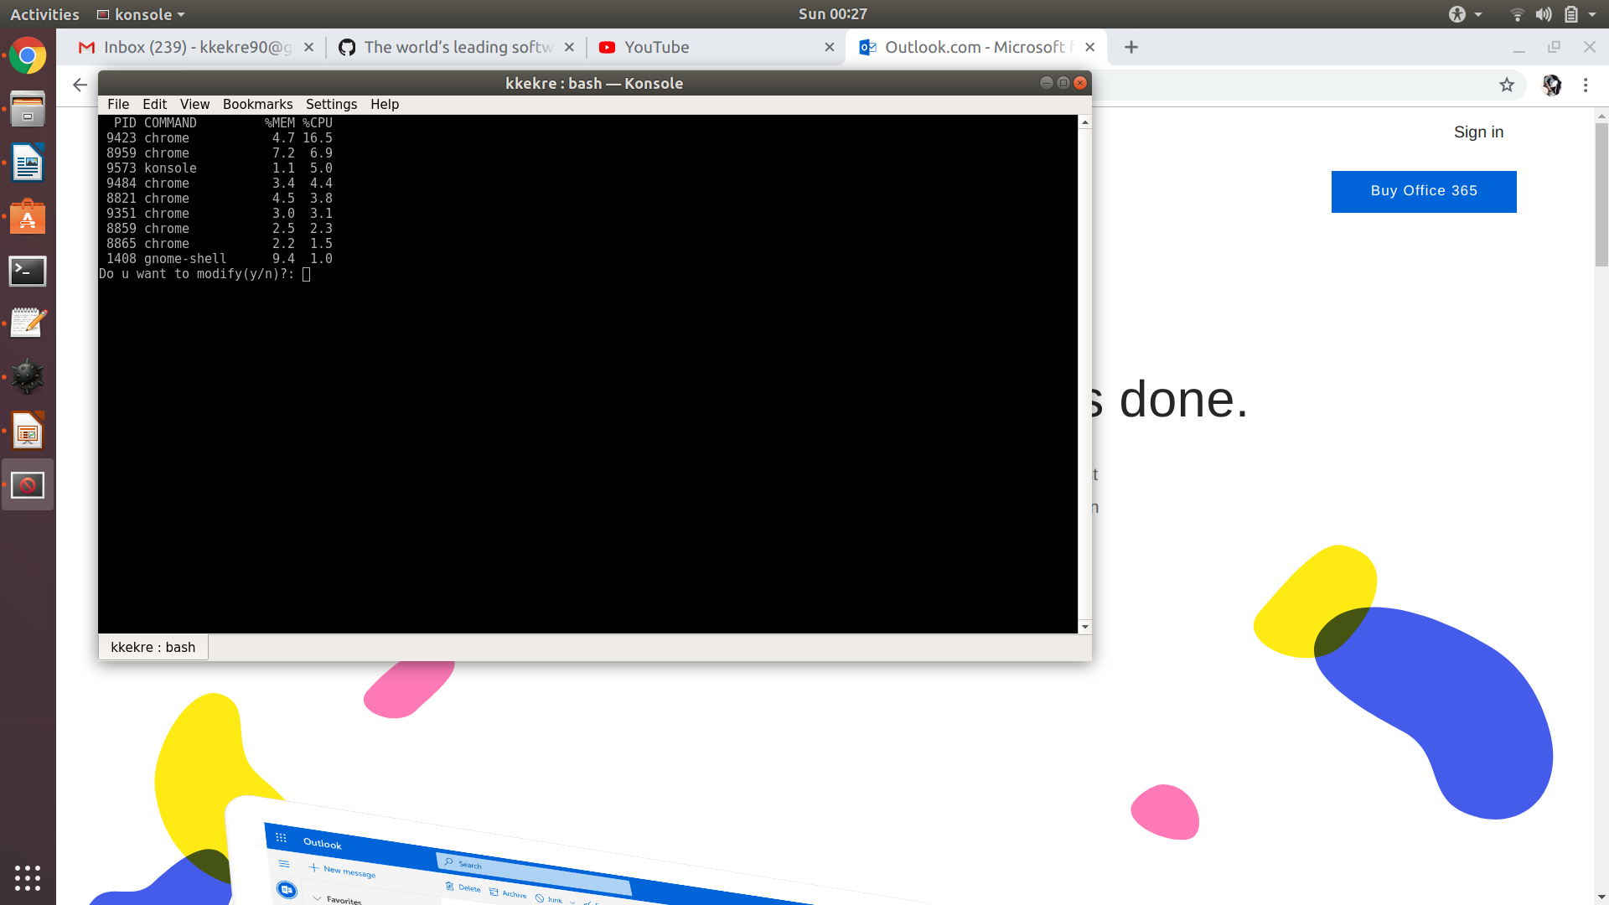

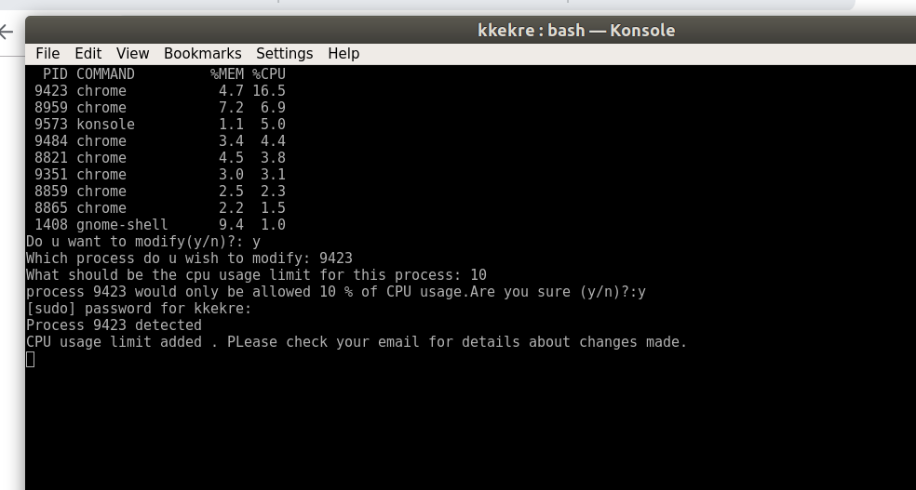

Notification


E-mail
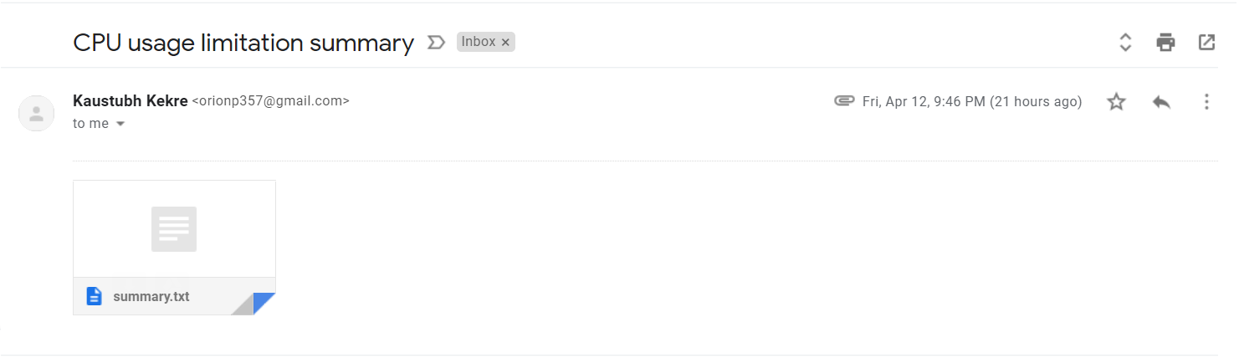

Outcome of the Project-The total CPU usage by user is reduced as shown
