Crud operation for user in txt file
- create
Code:-
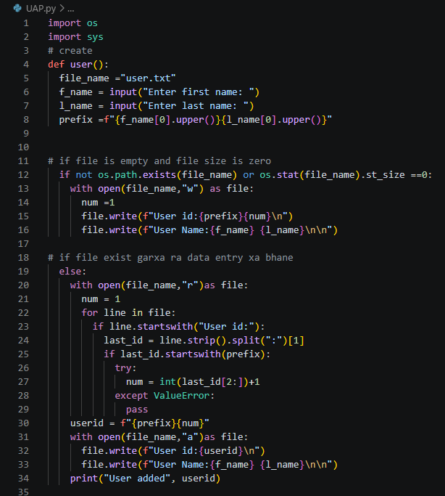
Output:

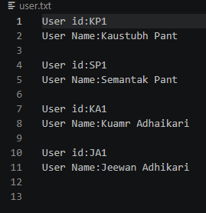
Logic:
- taking input from user “ first name” and “last name “
- creating id using from the first letter of “First name “ and “ last name” and adding number to it
- if the

