Abstract

Constructing machine learning models from first principles, without reliance on pre-built frameworks, provides an invaluable opportunity to unravel the inner workings of complex algorithms. This research explores this concept through the development and evaluation of a neural network entirely from scratch, targeting the canonical MNIST digit recognition task. Comprising thousands of labeled handwritten digit images, the MNIST dataset represents a foundational challenge in image classification. This study involves designing and implementing a multilayer neural network architecture consisting of critical components like convolutional layers for automated feature extraction, pooling layers for spatial dimensionality reduction, fully connected layers for high-level reasoning, and dropout regularization to prevent overfitting. Through iterative training leveraging techniques including gradient descent and backpropagation to minimize cost, the network parameters are optimized to accurately classify the input digits. Rigorous analysis quantifies the model’s performance on recognizing and categorizing the diverse range of handwritten samples within the dataset. The findings provide key insights into the efficacy of neural networks crafted from the ground up, without reliance on specialized libraries. By illuminating the core mechanics behind neural network training and evaluation, this research enables practitioners to better comprehend the integral concepts underpinning deep learning.

Introduction

Image recognition is a core problem in computer vision with extensive real-world applications. However, classifying image content manually is extremely time consuming and impractical for large datasets. In response, machine learning techniques like neural networks have emerged as powerful automated approaches for image classification tasks.

Neural networks comprise interconnected layers that can learn complex patterns from pixel data. Their ability to learn distributed representations makes them well-suited for image recognition problems. This research aims to evaluate the use of neural network models for classifying handwritten digits using the canonical MNIST dataset.

The MNIST dataset consists of thousands of 28x28 pixel grayscale images of handwritten digits 0-9. The study implements convolutional neural network architectures from scratch in Python without reliance on specialized libraries. The models apply techniques like convolution layers, pooling, and fully connected layers to extract visual features and patterns from the images.

Various neural network architectures are evaluated using performance metrics such as accuracy, precision, and recall. Additionally, hyperparameters including learning rate, layers, and nodes are tuned to identify optimal configurations.

This research provides insights into designing and training neural network models for automated digit recognition. The findings demonstrate the capabilities of neural networks for learning robust feature representations from image data. The results have significant implications for deploying machine learning solutions for real-world image analysis and computer vision problems.

FOR random initialization

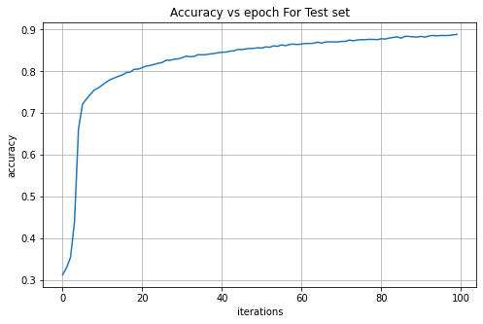

Epoch 99, Loss: 2.0668, Validation Accuracy : 88.83%,Test Accuracy: 87.90%

For he initialization