Roll No. 0
Name: Kaustubh Gulwade
Division: D2
Batch: B6
Practical No.: 2
Date: 29/07/2026
________________________________________________________________

Title: Create Feature Engineering Pipeline

Objectives:
- To perform feature engineering on a real-world dataset using Scikit-learn.
- To preprocess numerical and categorical features using a pipeline.
- To train and evaluate a machine learning model after feature transformation.
Problem Statement / Practical Description:
Raw datasets often contain missing values and categorical features that cannot be directly used by machine learning models. This practical implements a complete feature engineering pipeline that handles missing values, encodes categorical data, scales numerical features, and trains a classification model to predict whether a person's annual income is greater than \$50K.
Tools & Technologies Used:
Tool | Purpose
Python | Programming language
Pandas | Data loading and analysis
Scikit-learn | Preprocessing, Pipeline & ML model
NumPy | Numerical operations

Dataset Details:
- Dataset Name: Adult Income Dataset (Census Income)
- Dataset Source: UCI Machine Learning Repository
- Number of Records: 48,842
- Number of Features: 15 (14 input + 1 target)

Important Attributes:
Attribute | Description
age | Age of individual
workclass | Employment category
education | Highest education level
occupation | Job type
hours_per_week | Weekly working hours
capital_gain | Capital profit
income | Target variable (<=50K / >50K)

Methodology / Implementation:
- Load the Adult Income dataset using Pandas.
- Inspect dataset structure and identify missing values.
- Separate numerical and categorical features.
- Handle missing values using imputation.
- Encode categorical variables using One-Hot Encoding.
- Scale numerical features with StandardScaler.
- Combine preprocessing steps using ColumnTransformer and Pipeline.
- Train the classifier and evaluate it using accuracy and classification report.
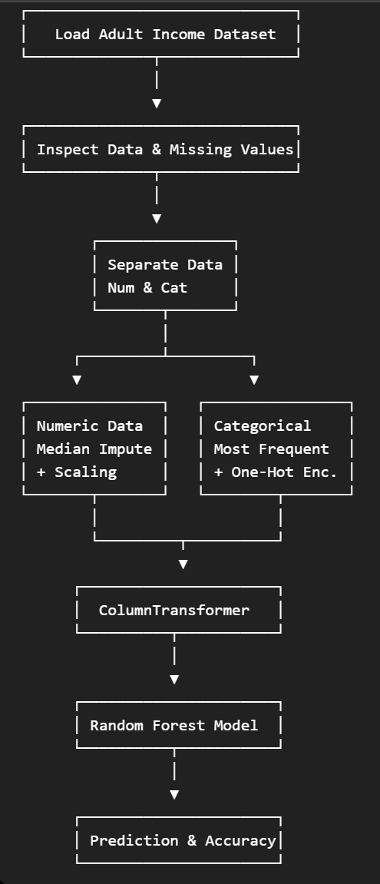
Source Code:
import pandas as pd
from sklearn.model_selection import train_test_split
from sklearn.compose import ColumnTransformer
from sklearn.pipeline import Pipeline
from sklearn.impute import SimpleImputer
from sklearn.preprocessing import OneHotEncoder, StandardScaler
from sklearn.ensemble import RandomForestClassifier
from sklearn.metrics import accuracy_score, classification_report

# Load dataset
df = pd.read_csv("adult.csv")

# Separate features and target
X = df.drop("income", axis=1)
y = df["income"]

# Identify column types
num_cols = X.select_dtypes(include=["int64", "float64"]).columns
cat_cols = X.select_dtypes(include=["object"]).columns

# Numeric pipeline
numeric_pipeline = Pipeline([
("imputer", SimpleImputer(strategy="median")),
("scaler", StandardScaler())
])

# Categorical pipeline
categorical_pipeline = Pipeline([
("imputer", SimpleImputer(strategy="most_frequent")),
("encoder", OneHotEncoder(handle_unknown="ignore"))
])

# Feature engineering pipeline
preprocessor = ColumnTransformer([
("num", numeric_pipeline, num_cols),
("cat", categorical_pipeline, cat_cols)
])

# Complete ML pipeline
model = Pipeline([
("preprocessor", preprocessor),
("classifier", RandomForestClassifier(random_state=42))
])

# Split data
X_train, X_test, y_train, y_test = train_test_split(
X, y, test_size=0.2, random_state=42
)

# Train model
model.fit(X_train, y_train)

# Prediction
y_pred = model.predict(X_test)

# Evaluation
print("Accuracy:", accuracy_score(y_test, y_pred))
print(classification_report(y_test, y_pred))

Output / Results:
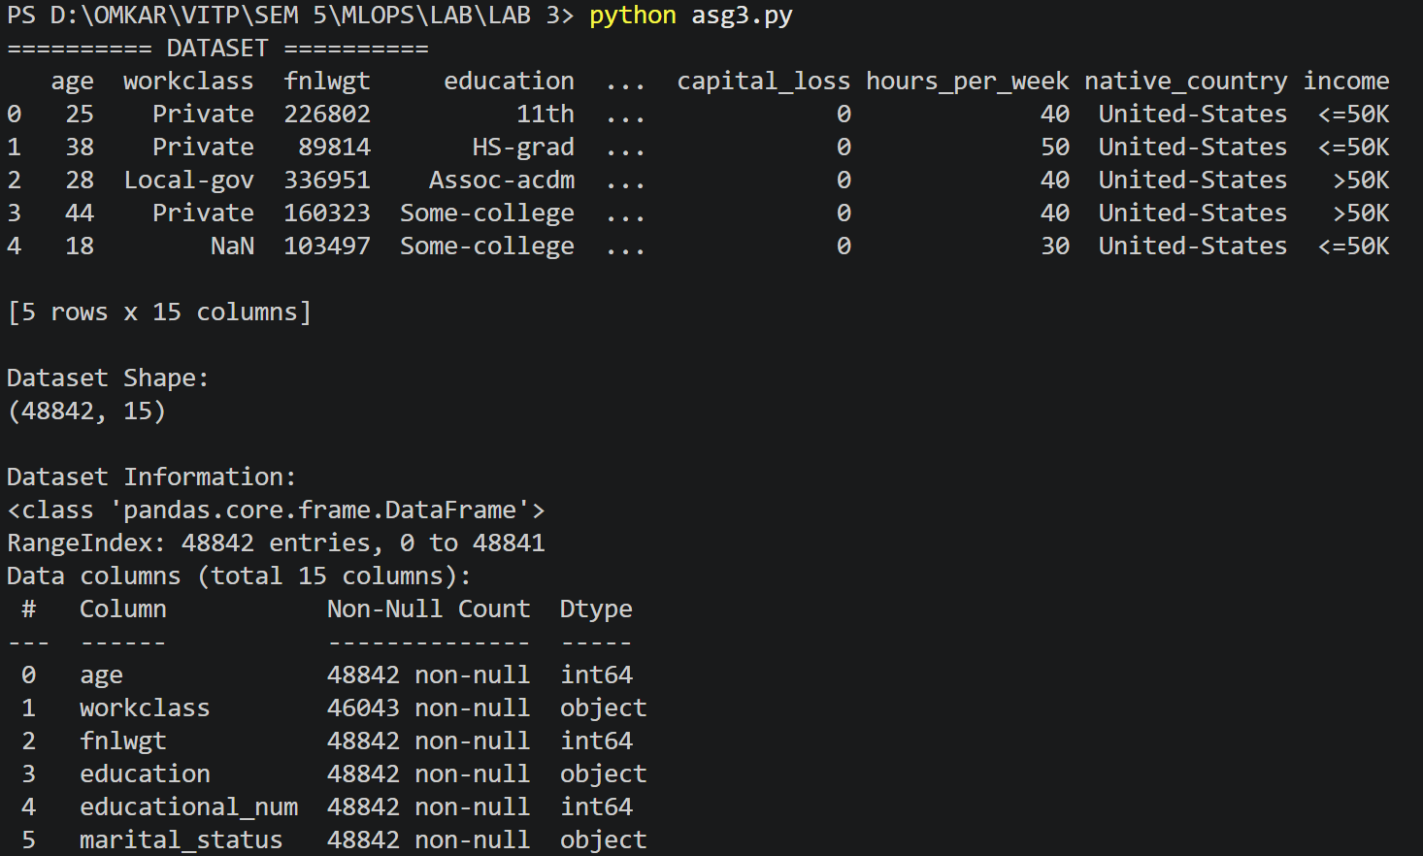

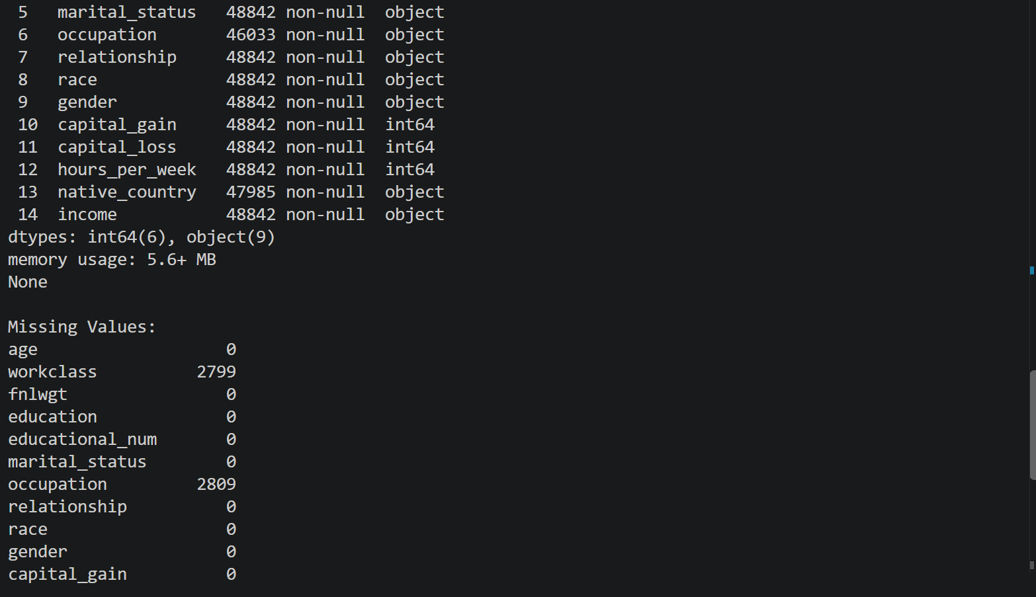
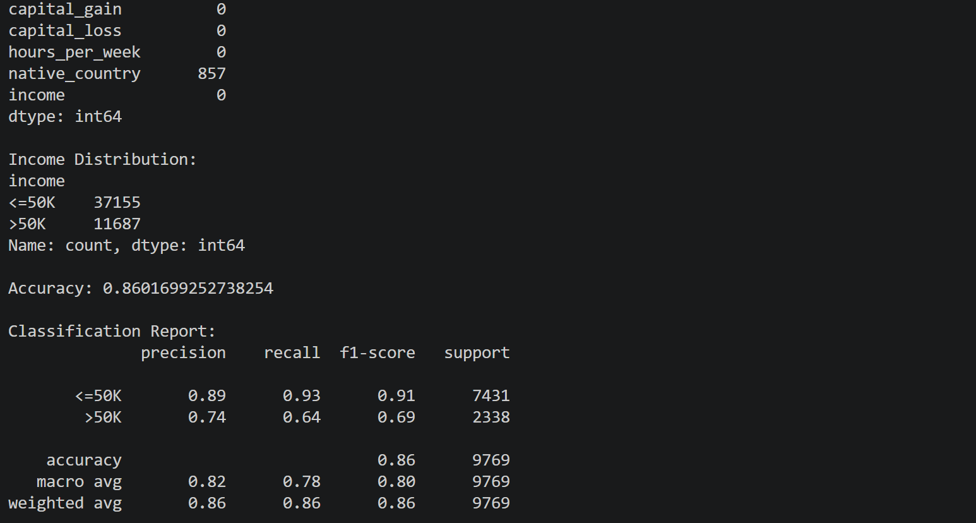

- Dataset Information
- Missing Value Analysis
- Model Accuracy & Classification Report
Result Analysis:
- The feature engineering pipeline successfully handled missing values and categorical encoding.
- The Random Forest classifier achieved 86.0% accuracy on the test dataset.
- The classification report shows strong performance for predicting the <=50K class, while the >50K class achieved satisfactory precision and recall.
Conclusion:
A complete feature engineering pipeline was successfully implemented using Scikit-learn Pipelines and ColumnTransformer. The preprocessing steps improved data quality and enabled effective model training, resulting in an overall classification accuracy of approximately 86%.

