COMP 7300/7306 Advanced Computer Architecture

Programming Assignment 3 (Group, 100 pts)

IMPORTANT:
A late submission will get a 50% penalty if submitted after the deadline. One day after the deadline, the submission will be worthless. Penalty will be 75% if submission is made within one hour after the deadline.

IMPORTANT:
- Your code will be evaluated, tested, and graded using Engineering Unix machines (tuxXX).
- You are free to choose any language of your choice. But, your grade will depend on the EXECUTION time of your program. Choose wisely your programming language.
- One submission per group.
- Writing and presentation of your report are considered to grade your lab.
- The quality of your code will be evaluated. Separated, clean and commented functions are expected.

Programming Assignment Advice: for a professional looking report, use Latex.

Lab 3: Impact of locality

The objective of this lab is to explore the impact of the spatial and temporal locality on the execution of a program. This lab was inspired by this email:

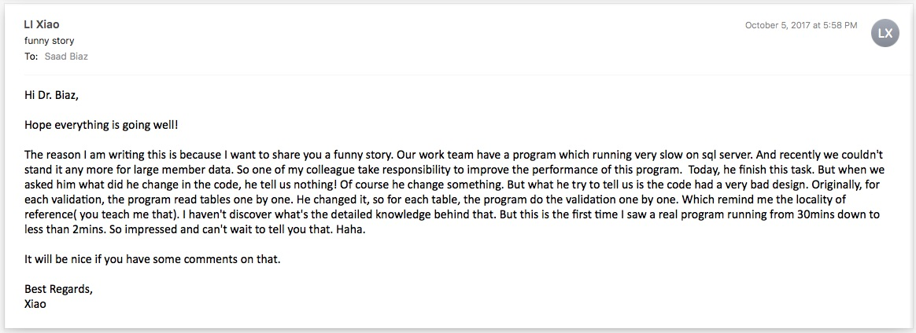

Part I:
Part I introduces you to the issue of spatial and temporal locality. Download the program myInitializeMatrix.c. Compile this program with “cc myInitializeMatrix.c -o myInitializeMatrix” Execute (be patient!), study, and analyze the program myInitializeMatrix. This program is designed to perform 12 tests. Each test consists of initializing a matrix row-wise first and then column-wise. After each test, the first 12 lines/columns are displayed just to check. Each matrix initialization is timed. The execution time does not include the time to display the matrix. Let us define a RUN as the execution of the program myInitializeMatrix. In other words, a run is launch of ./myInitializeMatrix from the command prompt. This program collects and displays the max, min, and average execution time after each test. The program provides the test # that produced a maximum or a minimal.
Task 1) Modify this program to execute 7 tests only. Execute your modified program five times. You must have five RUNs. Make sure to EXECUTE your modified program FIVE times. Do NOT add an outer loop to run the test seven times: this would count as ONE run. I would advise you to automate this task to avoid wasting time. Collect the max, min, and average for each run for row-wise and column-wise. Analyze your results. Do you observe oddities or patterns? If yes, can you explain them?

Task 2) Think about experiments or strategies that would allow you to find out the size of the cache, the page size, and any other pertinent information for this lab

Part II:
Part II consists of writing code that will have the SAME structure as the program I provided you (myInitializeMatrix.c).
- Rewrite the initialization code to improve/optimize (if possible) the initialization of the matrix such that the execution time is minimal (recall that we time only the initialization, not the displaying).
- Write an optimal code that transposes the same matrix (that you just initialized) (swap(&Matrix[i][j],&Matrix[j][i]). “Optimizing” means that we want the smallest execution time to initialize the matrix and transpose it (we time only the initialization and transposition, not the displaying). Use exactly the same structure as the program provided. One test will consist of optimally initializing the matrix and then (optimally) transpose it. Your program must run 7 tests and collect the max, min, and average as well as the test numbers that yiels minimal or maximal values. Your program will be judged based on the average execution time.

Grading:
- (50 points) Optimal code: the group who achieves the smallest average PUBLICIZED execution time will receive 50 points. An execution time is deemed publicized if it was announced/publicized on Piazza at least 3 days before the deadline. The best NON publicized execution time will receive at most 43 points. Your score will depend on how far you are from the best time. A group execution time within a given range will receive n points as described in this table:
Range | Points (n)
10% | 45
10%⁺-15% | 40
15%⁺-20% | 35
20%⁺-25% | 30
25%⁺-30% | 25
30%⁺-35% | 20
35%⁺-40% | 15
40%⁺-45% | 10
45%⁺-50% | 5
Beyond | 0

2) (50 points) Quality of the writing reporting, describing, and analyzing your results.
a) (10 points) for the abstract and conclusion.
b) (10 points) the quality of analyzing the results of Part I
c) (15 points) the quality of the explanations about your strategy to minimize the execution time for Part II.
d) (15 points) the quality of the collection and analysis of the results for Part II. You must show how your results match the actions you took to optimize your code.
e) Refer to Appendix about writing. Appropriate graphs, good writing, and overall quality are critical.

What to turn in?
- Electronic copy of your report (standalone) and source code (zipped) of your program(s). All programming files (source code) must be put in a zipped folder named lab1-name1-name2 where name1 and name2 are the last names of two teammates. Zip the folder and post it on Canvas. Submit separately (not inside the zipped folder) the report as a Microsoft or PDF file. A penalty of 10 points will be applied if these instructions are not followed.

- Your report must meet the requirements outlined above. I repeat below the requirement for your convenience:

(50 points) Quality of the writing, reporting, describing, and analyzing your results
a) (10 points) for the abstract and conclusion.
b) (10 points) the quality of analyzing the results of Part I
c) (15 points) the quality of the explanations about your strategy to minimize the execution time for Part II.
d) (15 points) the quality of the collection and analysis of the results for Part II. You must show how your results match the actions you took to optimize your code.
e) Refer to Appendix about writing. Appropriate graphs, good writing, and overall quality are critical.

If the TA is unable to access/compile/execute your work, no credit will be awarded.
If the turnin instructions are not followed, 25 pts will be deducted.

IMPORTANT:
A late submission will get a 50% penalty if submitted after the deadline. One day after the deadline, the submission will be worthless. Penalty will be 75% if submission is made within one hour after the deadline.
Appendix

A paper, a thesis, a report all will have these following elements:

Abstract
Introduction
Body
Conclusion.

The abstract, introduction and conclusion share common items: they all will provide:
1) Context
2) A problem description
3) A reference to previous who tried before or a reference to a solution, the best before
your proposition
4) the key/rationale of your solution/contribution
5) the methods used to evaluate your solution/contribution (formal analysis, implementation. simulation or a mix)
6) Conclusions : announce the key results

Abstract, Introduction, and conclusion will have ALL these above elements.
How do they differ: they differ by the space dedicated, and the precision.

For the abstract, the reader may not be familiar with the problem, then you must use general terms and you are very limited in space

For the introduction, you more space, and you still have to INTRODUCE the reader, an extra element will the oaverall organization of your document

For the conclusions, the reader knows all the elements, so you can be more precise or nuanced on the results.

The body describes your work (experiment, theory if applicable), the parameters, and metrics. The body will describe your results and discuss them.

