

Asbestos Register

Davis Station

File [CM9] Ref:  CD14/49 [v5] | Responsible Officer:  Infrastructure Engineer | Authorising Officer:  General Manager Support and Operations | Authorisation Date:  8/11/2018
Version Number: 5 |  |  | Reviewed Date:  16/06/2021
Location of Hard Copies/Points of Use: Antarctic Infrastructure Kingston, Davis station

Contents
1. Asbestos at Davis 1
2. What is the asbestos register? 1
3. Asbestos Management Plan 1
4. Limitations of the asbestos register 1
5. Disturbing or changing buildings 1
6. What to do before commencing work which may involve asbestos 1
7. Sample information 2
8. Risk assessment criteria 2
9. Asbestos free buildings and structures 3
10. Buildings and structures where asbestos has not been identified 4
11. Buildings and structures which contain asbestos 5
12. Inspection record 6
13. Further information 6
14. Asbestos register table 7
15. Photos 11

Asbestos at Davis
Asbestos was used as a building product at Davis from 1957 through to the late 1980s. It is still present in a number of the current station buildings and field huts and in the old tip site. Australia has now banned the use of asbestos but existing asbestos must be managed to ensure that it does not become a health risk. The AAD’s Antarctic Infrastructure section is responsible for managing asbestos in Antarctica and at Macquarie Island. The station trades team, supported by head office, carries out maintenance and management activities to safely manage the asbestos at Davis.

Materials which can contain asbestos include cement sheet floors and walls or roof cladding, gaskets, and vinyl tiles. Heritage items, for example old electronic equipment may also contain asbestos.

What is the asbestos register?
This asbestos register is a list of all of the known asbestos containing material or material which is presumed to contain asbestos at the station and in the station operating area. This includes station buildings and infrastructure, field huts, heritage sites and abandoned tip sites. The register contains information about the location and condition of asbestos containing material. The register is used to help people at the station work safely around asbestos and is also used to help ensure that asbestos is safely managed and maintained.

Asbestos Management Plan
The Asbestos Management Plan is a comprehensive source of information which defines the AAD’s methods and practices for safely managing asbestos in Antarctica and the subantarctic. Any work which involves asbestos must follow the requirements and procedures contained in the Asbestos Management Plan.

Limitations of the asbestos register
The asbestos register lists known and presumed asbestos containing material. The station has been inspected to identify asbestos, however it is possible that there is asbestos which does not appear in the register. The absence of an entry in the register is not a guarantee that a building or area is free from asbestos.

Disturbing or changing buildings
Precautions need to be taken when doing any work on a building. Work on buildings may only be carried out by authorised personnel. Details of precautions and authorisations are covered in the AAD standard operating procedure Changing or Disturbing the Fabric of a Building.

What to do before commencing work which may involve asbestos
All work which involves asbestos must be carried out in accordance with the procedures outlined in the Asbestos Management Plan. You should read the relevant sections of the plan and ensure that you assess the risks and comply with the requirements.

Sample information
This asbestos register has been prepared based upon inspections and upon analysis of asbestos samples. Information on samples and results is kept by the Antarctic Infrastructure section and is available on request to the Infrastructure Engineer at Kingston. Samples which test negative for asbestos are useful in determining whether asbestos precautions are required when working on a building. These sample results are not presented in this register however they are available on request to the Antarctic Infrastructure section.

Risk assessment criteria
The following criteria are used to rate asbestos risk in this register.

Condition Assessment

- Good – Asbestos or asbestos containing material in a stable matrix, sealed or firmly bonded to substrate. Undamaged. The material is not considered vulnerable to damage, degradation, or uncontrolled fibre release.
- Fair – Asbestos or asbestos containing material shows evidence of exposure, damage or deterioration to small areas. Further damage not likely. Inadvertent exposure to asbestos fibres is possible but unlikely. More frequent monitoring of the condition of these materials is recommended.
- Poor – Asbestos or asbestos containing materials that is exposed, damaged or deteriorating. Although fibre exposure may not be occurring, remedial action is recommended to prevent inadvertent exposure or uncontrolled fibre release.
- Unknown – Asbestos or asbestos containing materials are suspected to be present however the area is inaccessible or the material cannot be sampled without unacceptable damage e.g. interior or fire door.

Friability

- Bonded – Bonded asbestos material is any asbestos containing material other than friable asbestos material.
- Friable – Any material that contains asbestos and is in a form of a powder or can be crumbed, pulverised or reduced to powder by hand pressure when dry.
- Damaged - The material or its covering has become damaged, deteriorated or delaminated due to factors such as changes in building use, changes in operation and maintenance practices, changes in occupancy, or recurrent damage.
- Weathered – Continued exposure to weather and to acid rain results in particles and fibres being dispersed into air and water.

Disturbance Potential

- Low – Material is in good condition, non-friable and well-encapsulated e.g. painted soffit, wall/ceiling lining. Minimal likelihood of damage or disturbance to occur under normal conditions. Potential for fibre exposure and/or transfer of fibres to other areas is unlikely unless the material is damaged or disturbed during maintenance, refurbishment, renovation or demolition.
- Medium – Material is non-friable and in fair condition. Material is in an exposed location having potential for disturbance. No evidence or <10% area damage. There is potential for further damage or disturbance to occur under normal conditions, or potential for fibre exposure and/or transfer of fibres to other areas.
- High – Material is in poor condition or friable. Likelihood exists of further damage or disturbance to materials under normal conditions. Fibre exposure and/or transfer of fibres to other areas is likely.

Risk Rating

- Risk Rating 1 – High, immediate rectification required.
Asbestos materials are damaged or subject to continual disturbance and are unstable. There is an increased potential for fibre exposure and/or transfer of fibres to other areas. Prompt abatement required.
- Risk Rating 2 – Medium risk potential.
Asbestos is unstable and there is a potential for disturbance, or material is accessible and when disturbed may present a short-term exposure risk, or disturbance due to maintenance, refurbishment, renovation, demolition is likely to occur, or disturbance of asbestos cement debris at soil surface in accessible areas is likely to occur. Control measures to be taken at earliest possible time.
- Risk Rating 3 – Low risk, potential hazard during refurbishment.
Friable asbestos is stable and has low disturbance potential, or non-friable asbestos with no or <10% area damage and no exposure risk unless disturbed, or loose cement debris in low access area. Defer action unless disturbance is possible due to maintenance, refurbishment, renovation or demolition.
- Risk Rating 4 – Negligible risk.
Non-friable asbestos material is stable. Low potential for disturbance and does not present a risk unless cut, drilled, sanded or abraded. Defer action unless disturbance due to maintenance, refurbishment or demolition.

Asbestos free buildings and structures
These buildings are asbestos free. They have been constructed entirely from asbestos free materials.

Building or Structure | Maximo Number
Air Operations Office (Pineapple) | L1120
Aviation Fuel Storage Area | L3258
Boat Shed | L1784
Concrete Batching Plant | L1137
Container (Emergency Food Store) | L1945
Detonator Magazine | L1943
Emergency Helipad | L1135
Emergency Vehicle Shelter | L1130
Explosives Magazine | L1769
Field Equipment Store | L1783
Gas Storage Platform | L1121
Hangar | L3014
Hazardous Goods Store | L1122
Helipad No. 1 | L1865
Helipad No. 2 | L1866
Hobby Hut | L1108
Hydroponics | L1519
Incinerator Building | L1128
Infrasound | L4052
Law Base | L1336
LIDAR Building | L1158
Living Quarters (New) | L1408
Magnetometer Hut | L1156
Met Theodolite Hut | L1149
MFSA Radar Hut | L1424
Old Balloon Building | L1150
Old Living Quarters | L1095
Post Office (Rawin Hut) | L1161
Quarry | L1790
Ring Main Unit No. 1 | L1090
Ring Main Unit No. 2 | L1091
Ring Main Unit No. 3 | L1092
Ring Main Unit No. 4 | L1093
Ring Main Unit No. 5 | L1094
Ring Main Unit No. 6 | L3393
Sansom Island Huts | L1349
Skiway Emergency Accommodation Yellow Hut | L3023
Smokers Hut | L1162
SPMA Science Projects Marshalling Area | L1887
Summer Accommodation Module (SAM) | L1527
TAD Summer Accommodation | L1425
Tarbuck Crag Comms Repeater | L1369
Trajer Ridge Hut | L1350
Transformer Yard | L4200
ULP & Oil Drum Storage Area | L3259
Utilities Building | L2710
Vehicle Refuelling Point | L1136
Water Supply Building | L1126
Water Storage Tank No. 1 | L1939
Water Storage Tank No. 2 | L1940
Water Storage Tank No. 3 (under construction) | L1941
Watts Lake Bridge | L3253
Wharf | L1133

Buildings and structures where asbestos has not been identified
The following buildings and structures have been inspected and no asbestos has been found. They are not listed as asbestos free buildings because there is a possibility that they may contain asbestos which has not been discovered. Many of these buildings are old and there may be uncertainty around the types of materials which were used in their construction. All work which may disturb the fabric of these buildings must still consider the risk of asbestos.

Building or Structure | Maximo Number
Ace Lake Hut | L4206
ANARESAT Radome | L1117
Bandit’s Hut | L1329
Beach House | L1098
Climate Process and Change Building | L1155
Container (Met Store) | L1151
Crooked Lake Hut | L1333
Filla Island Hut | L1423
Helihuts | L1139
Hop Island Hut | L1422
Ionosonde Hut | L1157
Marine Plain Hut | L1338
Meteorology Building | L1148
Operations Building | L1112
Platcha Hut | L1344
Prince Charles Mountains Beaver Lake Huts | L1345
Receiver Antenna Farm | L1116
Receiver Building | L1115
Rookery Lake Hut | L1348
Science Building | L1154
Services Building (Tankhouse) | L1127
Transmitter Antenna Farm | L1114
Transmitter Building | L1113
VHF Radar Hut | L1434

Buildings and structures which contain asbestos
The following buildings and structures contain or are presumed to contain asbestos. This table is intended as a summary. Details are given in the asbestos register table.

Building or Structure | Maximo Number
Brookes Hut | L1331
Emergency Powerhouse | L1089
Fuel Farm | L1938
Green Store | L1119
Incinerator Fuel Tank | L1144
Main Powerhouse | L1088
MPH Fuel Settling Tank | L1142
Old Garage Site | -
Old Tip Site | -
Slab adjacent to beach house | -
Site Services | L1132
Sleeping and Medical Quarters | L1096
SMQ Fuel Tank | L1145
Store Fuel Tank | L1146
Water Supply Building Fuel Tank | L1147
Watts Hut | L1351
Workshop | L1118

Inspection record
The following asbestos inspections have been carried out.

Inspection Details (Maximo work order number) | Person | Date
Initial inspection, sampling and preparation of asbestos register. | M. Watson (register prepared by H. Cook) | August 2004
Condition inspection. | K. Smith | June 2008
Condition inspection. | M. Thums | January 2010
Condition inspection. | D. Brett | February 2012
Condition inspection (WD360027). | D. Brett | February 2015
Condition inspection (WD362984). | B. Sambrooks | October 2016
Condition inspection (WD367777). | R. Francis | March 2017
Condition inspection (WD373049). | G. Pretious | February 2018
Condition inspection (WD381146). | G. Freeman | March 2019
Condition Inspection (WD389559). | R. Jackson | February 2020
Condition Inspection (WD397477). | D. Christie | January 2021
?
?
?
?
Condition Inspection (WD444988). | S. Lewis | January 2026

Further information
If you have questions about asbestos or you are unsure how to interpret the information in this register, please contact you station Engineering or Building Services Supervisor, the AAD’s Work Health and Safety Manager or the Infrastructure Engineer at Kingston.

- Infrastructure Engineer – Sara Pearce, ph: (03) 6232 3476
- WHS Manager – (TBA) ph: (03) 6232 3341

Asbestos register table
Location &  Maximo  Number | Item | Sample  Number | Date  Identified | Condition | Friability | Disturbance  Potential | Risk  Rating | Comments | Action Required | Inspection Notes
Brookes Hut  L1331 | Kitchen module exterior cladding (photo L133101). | L133102 | 11/03/2010 | Poor | Weathered  Damaged | Medium | 3 | Some holes where sheet is exposed.  Painting commenced in 2018/19 season - 2 walls remain. | Check label and re-inspect annually.  Complete exterior painting W356189. | Paint intact and sealing well. No additional disturbances, cracks noted.  Sean Lewis 23/02/2026
Brookes Hut  L1331 | Kitchen module interior lining (photo L133102). | L133103 | 11/03/2010 | Good | Bonded | Low | 3 | Painting commenced in 2018/19 season. | Check label and re-inspect annually.  Complete exterior painting W356189. | Paint intact and sealing well. No additional disturbances, cracks noted.  Internal lining of Outhouse is exposed and recommend to line with ply and seal around edges. Asbestos in reasonable order but is exposed to disturbances. Was given a treatment of hairspray to dubious areas. Work order DW373655 for sealing.  Sean Lewis 23/02/2026
Emergency Powerhouse L1089 | Internal walls (photo L108901/ 02/ 03). | M107/04 | 24/12/2004 | Fair | Bonded | Medium | 3 | Unpainted cement sheet with damaged areas.  Generally in good condition.  Several penetrations were sealed in 2018 (WD366248). | Check label and re-inspect annually. | Condition remains fair. No new penetrations or disturbances found. Replaced peeling stickers and added some near existing penetrations for future works awareness.  Sean Lewis 28/01/2026
Emergency Powerhouse L1089 | Exhaust Manifolds | Not sampled | 06/02/2020 | Good | Friable | High | 3 | Previously identified prior to 2020. Material clearly labelled. | Check Label. Continue to monitor and avoid disturbance. | Condition remains good. No evidence of disturbance. Stickers intact. Additional stickers added at wall penetrations for future works awareness.  Sean Lewis 28/01/2026
Emergency Powerhouse L1089 | External panels & roofing panels (photo L108904). | Not sampled | 01/02/2004 | Fair | Bonded | Low | 4 | Painted in 2018, still in fair condition. | Check label and re-inspect annually. | Paint starting to deteriorate around sharp edges of structure. Bottoms of panels starting to lose adhesion. Photos attached to work order. Sticker added near electrical outlets for future works awareness.  Sean Lewis 28/01/2026
Fuel Farm L1938 | Gaskets in tank access hatch covers. | Not sampled | 09/11/2018 | Good | Bonded | Low | 4 | Gaskets may contain asbestos. Take precautions when handling gaskets. | Inspect when hatch lids are removed. | Annual inspection is not required.
Green Store L1119 | Floor sheets of mezzanine level (gym area only, the storage mezzanine is asbestos free) (photo L111901/ 02). | M107/04 | 24/12/2004 | Good | Bonded | Low | 4 | Labelled. Space between top of freezers and gym floor has been enclosed – precautionary measure. | Check label and re-inspect annually. | Labelling intact on enclosure. Enclosure inspected and has no traces of manipulation or degradation.  Sean Lewis 28/01/2026
Incinerator Fuel Tank L1144 | Gasket in tank access hatch cover. | Not sampled | 09/11/2018 | Good | Bonded | Low | 4 | Gasket may contain asbestos. Take precautions when handling gasket. | Inspect when hatch lid is removed. | Annual inspection is not required.
Main Powerhouse L1088 | All wall sheets up to 2.2m height except rear wall (photo L108801/ 02). | M107/04 | 24/12/2004 | Fair | Bonded | Low | 4 | Sampled tested for rear wall – no asbestos present. Other walls do contain asbestos. | Check label and re-inspect annually. | Linings all intact and remain in fair condition. No traces of new penetrations or degradation. Additional stickers placed around potential work areas where labelling isn’t clear. MPH kept in immaculate cleanliness and order.  Sean Lewis 28/01/2026
Main Powerhouse L1088 | All gaskets. | D17-17 | 30/01/2018 | Fair | Bonded | Low | 3 | Analysis indicated asbestos present in exhaust system gasket (now removed) from Genset 4. Other asbestos-containing gaskets may still be present. | Treat all gaskets as potentially asbestos- containing.  Replace gaskets with known asbestos free gaskets when next accessed. | Given provided register is out of date, concrete information regarding prevalence of asbestos containing gaskets is minimal. Station-wide trades notice has been provided to ensure all future works are aware of the potential of asbestos in the exhaust. Appropriate ACM handling PPE will be implemented with future works.  Sean Lewis 28/01/2026
MPH Fuel Settling Tank L1142 | Gaskets in tank access hatch covers. | Not sampled | 09/11/2018 | Good | Bonded | Low | 4 | Gaskets may contain asbestos. Take precautions when handling gaskets. | Inspect when hatch lids are removed. | Annual inspection is not required.
Old Garage Site | Asbestos containing building material (photo Garage). | D17-1 | 19/01/2017 | Poor | Bonded | Medium | 2 | Area needs to be searched thoroughly for loose ACM. | Scheduled for removal D371346. | It would appear that the old garage site has been removed since last register. No traces of asbestos remain.  Sean Lewis 28/01/2026
Old Tip Site | Asbestos containing building material. | Not sampled | 27/09/2016 | Fair | Bonded | Low | 4 | Tip is contained in soil. | No inspection required. Risk assessment is required before disturbing the tip site. | Not inspected as per ‘actions required’.  Sean Lewis 28/01/2026
Site Services L1132 | Old form work around the foundations (photo L113201). | D17-1 to D17-13 | 01/02/2004 | Good | Bonded | Low | 4 | Formwork around concrete footings is weathering and has potential to become friable without maintenance. Recommend removal of damaged material and encapsulation of the remainder. | Scheduled for removal D366249.  Apply 1 coat of thinned Emer Proof Aquabarrier (Part A & B) and ensure this thoroughly soaks in. Then 2 x coats Emerclad Façade. | Coating applied by Mal McMillan of the 78th ANARE. Inspection shows coating intact and holding firm.  Sean Lewis 28/01/2026
Site Services L4759  J1 - North Central Junction | Potential asbestos containing material was identified on the base of the concrete stairs on the bridge over the site services that is adjacent to service Junction 1 | Not sampled | 31/01/19 | Fair | Bonded | Medium | 4 | Refer to Maximo w/o for photos/location details.  Formwork around concrete footings is weathering and has potential to become friable without maintenance. Recommend removal of damaged material and encapsulation of the remainder. | Scheduled for removal W361400.  Apply 1 coat of thinned Emer Proof Aquabarrier (Part A & B) and ensure this thoroughly soaks in. Then 2 x coats Emerclad Façade. | Coating applied by Mal McMillan of the 78th ANARE. Inspection shows coating intact and holding firm.  Sean Lewis 28/01/2026
Sleeping and Medical Quarters  L1096 | Main plant room, asbestos coating on structural steel (photo L109601). | D15-1 | 29/9/2015 | Good | Friable | Low | 3 | Steel member is at high level, away from potential disturbance.  Painted and labelled. | Check label and re-inspect annually. | Label intact and in clear view. Structural steel appears to be undisturbed.  Sean Lewis 28/01/2026
SMQ Fuel Tank  L1145 | Gasket in tank access hatch cover. | Not sampled | 09/11/2018 | Good | Bonded | Low | 4 | Gasket may contain asbestos. Take precautions when handling gasket. | Inspect when hatch lid is removed.  Replace gaskets with known asbestos free gaskets when next accessed. | Annual inspection is not required.
Slab adjacent to beach house  L1098 | Possible ACM was identified on a slab adjacent to the beach hut | Not sampled | 07/02/19 | Poor | Bonded | Low | 3 | Surrounding area needs to be searched thoroughly for loose ACM. | Scheduled for removal DW361469 | Slab appears to have been removed.  Sean Lewis 28/01/2026
Store Fuel Tank  L1146 | Gasket in tank access hatch cover. | Not sampled | 09/11/2018 | Good | Bonded | Low | 4 | Gasket may contain asbestos. Take precautions when handling gasket. | Inspect when hatch lid is removed. | Annual inspection is not required.
Water Supply Building Fuel Tank  L1147 | Gasket in tank access hatch cover. | Not sampled | 09/11/2018 | Good | Bonded | Low | 4 | Gasket may contain asbestos. Take precautions when handling gasket. | Inspect when hatch lid is removed. | Annual inspection is not required.
Watts Hut L1351 | Cold porch interior wall lining (photo L135101). | L135101 | 11/03/2010 | Fair | Bonded | Medium | 3 | Fully patched and painted in 2019. | Check label and re-inspect annually. | Asbestos in reasonable condition. Paint seems consistent.  Sean Lewis 28/01/2026
Watts Hut L1351 | Kitchen interior wall lining (photo L135102). | L135102 | 11/03/2010 | Good | Bonded | Low | 4 | Fully patched and painted in 2019. | Check label and re-inspect annually. | Asbestos in reasonable condition. Paint seems consistent.  Sean Lewis 28/01/2026
Watts Hut L1351 | External wall cladding (photo L135103). | L135103 | 11/03/2010 | Good | Bonded | Low | 4 | Painted 2018. | Check label and re-inspect annually. | DW372629 Carried out. Crack in external cladding now sealed, painted.  Sean Lewis 28/01/2026
Watts Hut L1351 | Pieces lying around hut. | L135104 | 11/03/2010 | Poor | Weathered | Medium | 3 | Area inspected and no sign of loose pieces – G. Pretious Feb 2018.  Inspected in 2019 (WD366251) and no additional loose pieces were found. | Continue to monitor during summer. | Area inspected thoroughly. No sign of loose pieces found.  Sean Lewis 28/01/2026
Workshop L1118 | Internal wall sheets (photo L111801). | M107/04 | 24/12/2004 | Good | Bonded | Low | 4 | Holes seal and labelled in 2019. | Check label and re-inspect annually. | Sheets mostly in good condition. No new penetrations un-sealed. Stickers prevalent throughout workshops. Further sampling to be done as per WD445285.  Sean Lewis 28/01/2026
Workshop L1118 | Trades office floor, vinyl tiles (photo L111802). | 9905002 | 29/9/2015 | Good | Bonded | Low | 4 | Tiles are now covered in modern Regupol floor covering. Warning signs in place on skirting. | Check label and re-inspect annually. | Stickers still affixed. Floor covering still intact, no damage.  Sean Lewis 28/01/2026

Photos
Note that photos are representative of location and are to be used to aid identification of the asbestos items on station. They are not updated each year and are not intended to be a tool for condition assessment.

Photo  Number | Location | Photo
L133101 | Brookes Hut kitchen exterior cladding. | 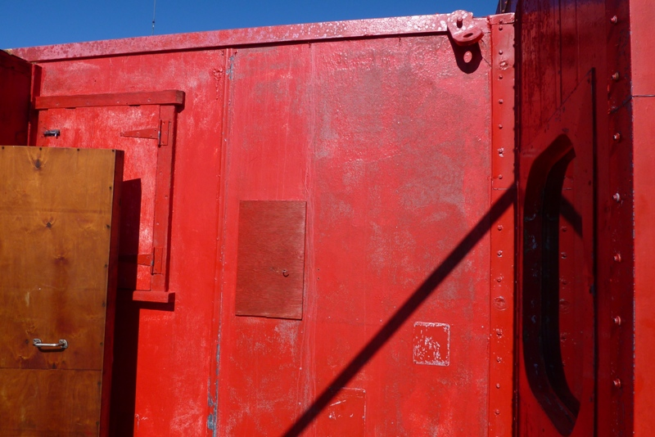
L133102 | Brookes Hut kitchen interior lining (2019).
L108901 | Emergency Powerhouse internal walls (2015). | 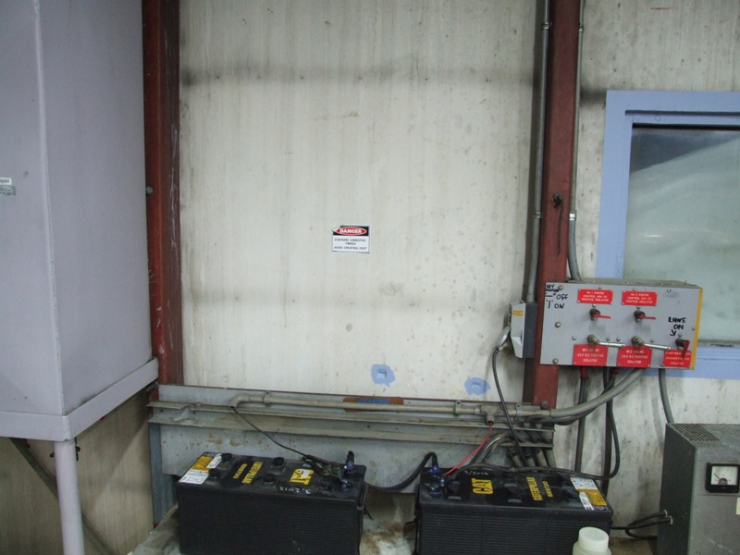
L108902 | Emergency Powerhouse internal walls. | 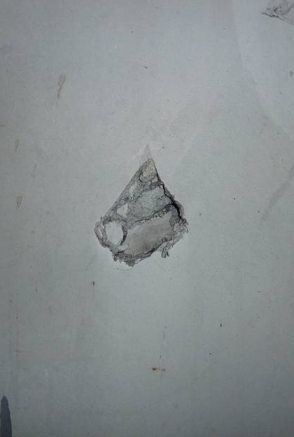
L108903 | Emergency Powerhouse internal walls sealed/patched (2018).
L108904 | Emergency Powerhouse external cladding windward side (2018). | 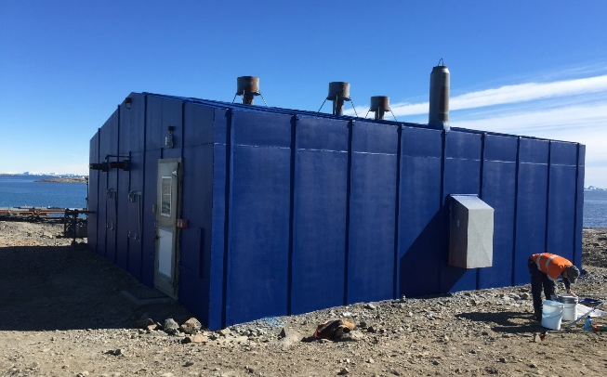
L111901 | Green store mezzanine floor sheets (now enclosed – photo shows inside enclosed area). | 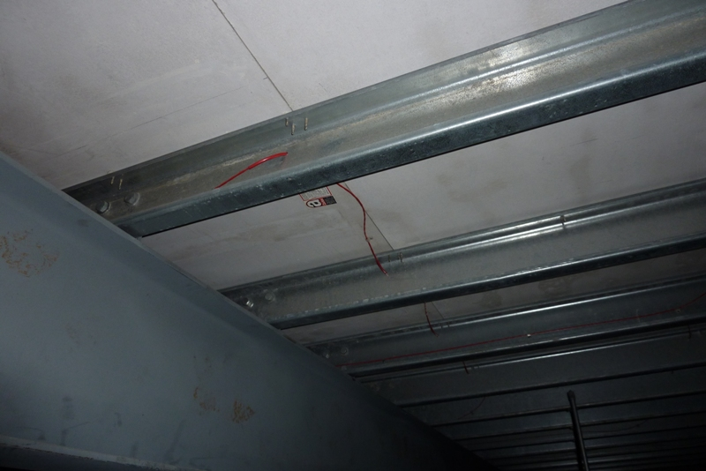
L111902 | Green Store mezzanine floor sheets enclosed (2015). | 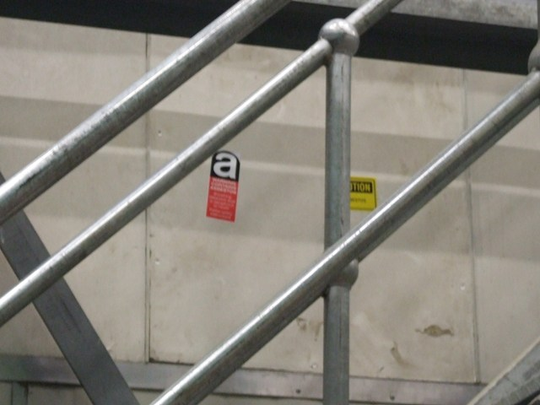
L108801 | Main Powerhouse wall sheets. | 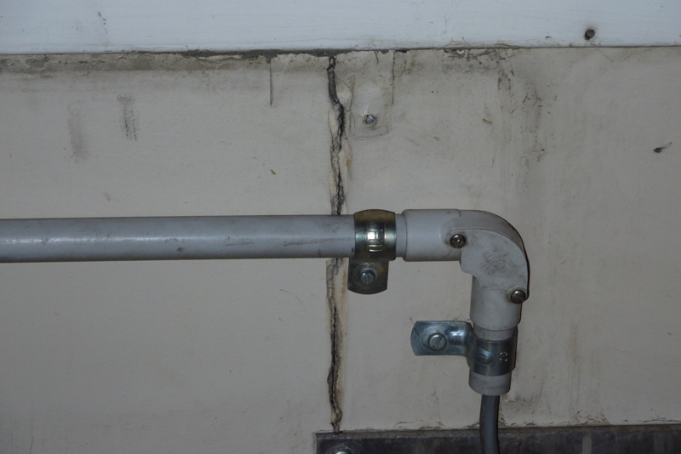
L108802 | Main Powerhouse wall sheets (2015). | 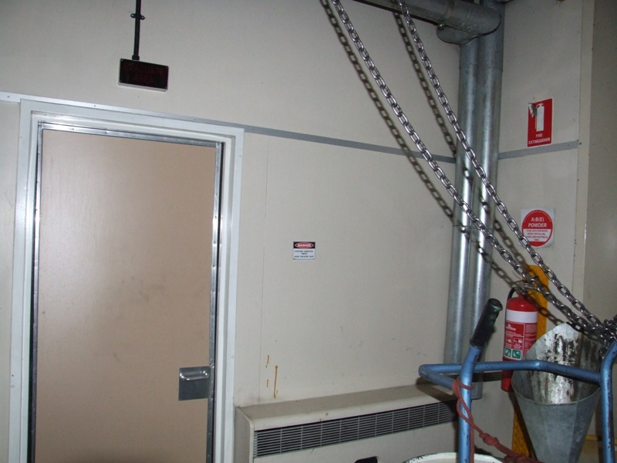
Garage | Old Garage Site. | 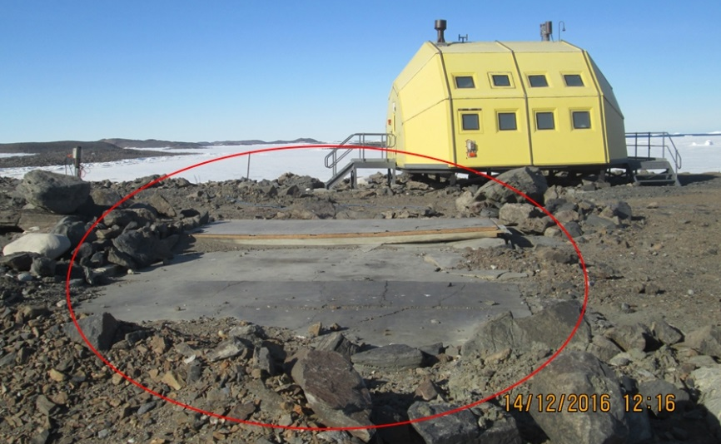
L113201 | Site Services formwork. | 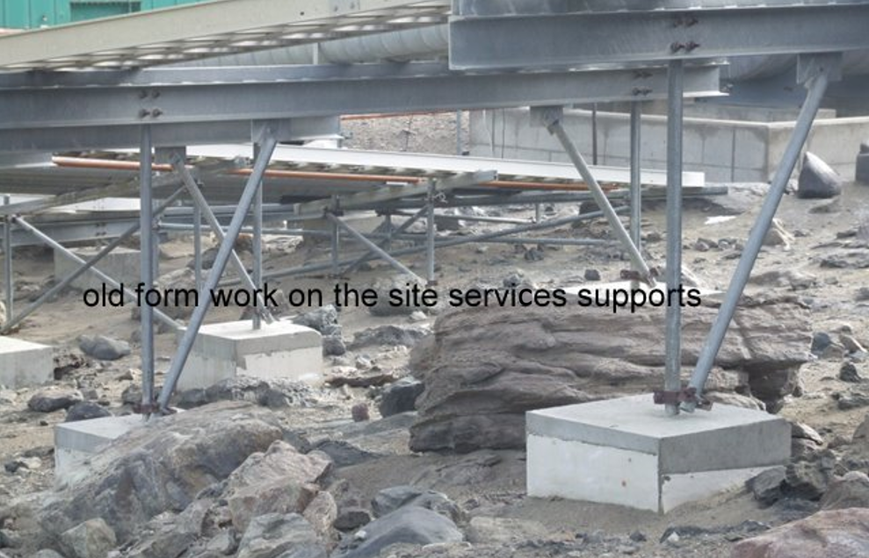
L109601 | Sleeping and Medical Quarters plant room structural steel coating (2015). | 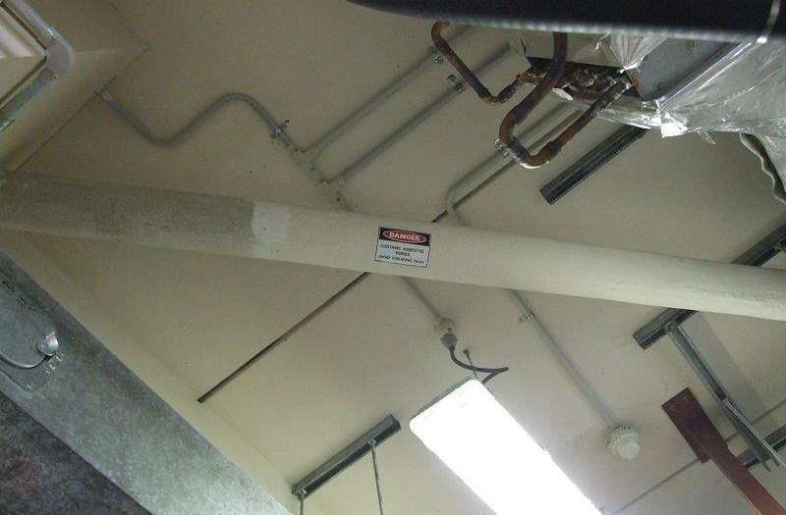
L135101 | Watts Hut cold porch lining (2015). | 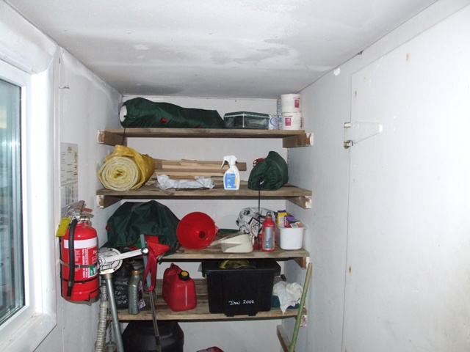
L135102 | Watts Hut kitchen interior lining  (2015). | 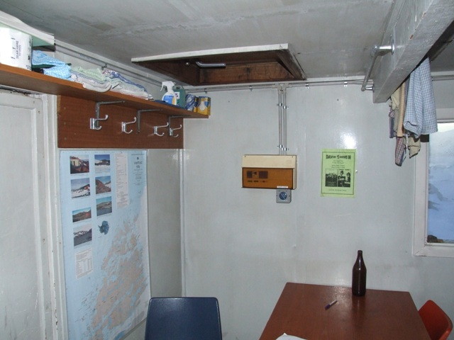
L135103 | Watts Hut external cladding (2018). | 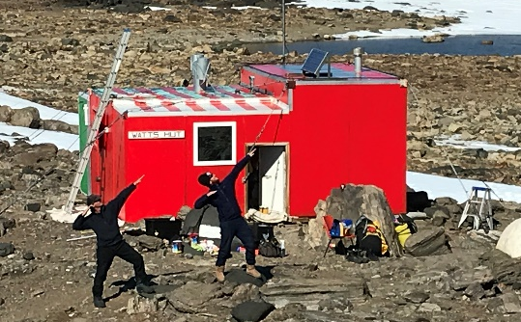
L111801 | Workshop interior lining (2015). | 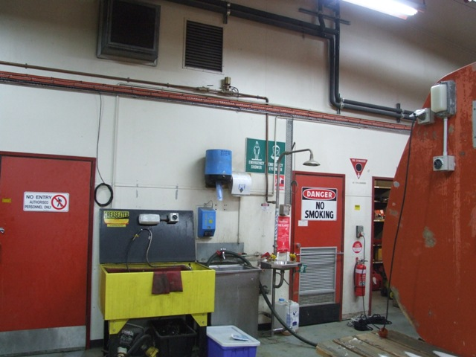
L111802 | Workshop office vinyl floor tiles (shown with new Regupol floor covering partly installed September 2015). | 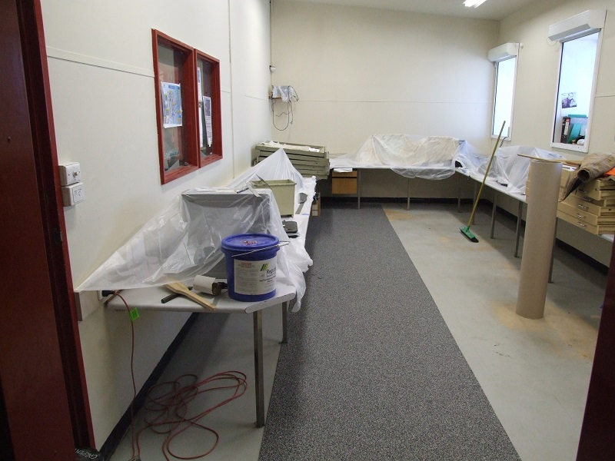
L4759 | Site Services  Potential asbestos containing material was identified on the base of the concrete stairs on the bridge over the site services that is adjacent to service Junction 1 | 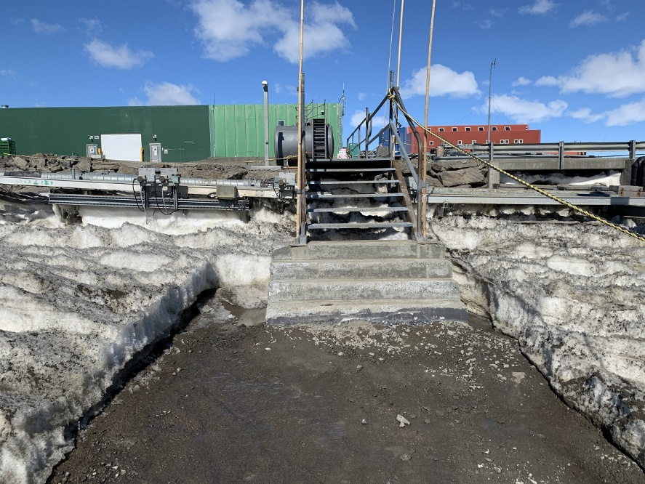
L1088 | MPH - All gaskets
L1089 | EPH – Exhaust Manifold Insulation

