

Asbestos Register

Macquarie Island Station

File [CM9] Ref:  CD14/40[v5] | Responsible Officer:  Infrastructure Engineer | Authorising Officer:  General Manager Support and Operations | Authorisation Date:  26/06/2018
Version Number: 5 |  |  | Reviewed Date:  16/06/2021
Location of Hard Copies/Points of Use: Antarctic Infrastructure Kingston, Macquarie Island station

Contents
1. Asbestos at Macquarie Island 1
2. What is the asbestos register? 1
3. Asbestos Management Plan 1
4. Limitations of the asbestos register 1
5. Disturbing or changing buildings 1
6. What to do before commencing work which may involve asbestos 1
7. Sample information 2
8. Risk assessment criteria 2
9. Asbestos free buildings and structures 3
10. Buildings and structures where asbestos has not been identified 4
11. Buildings and structures which contain asbestos 4
12. Inspection record 5
13. Further information 5
14. Asbestos register table 6

Asbestos at Macquarie Island
Asbestos was used as a building product at Macquarie Island from 1948 through to the late 1980s. It is still present in a number of the current station buildings and field huts and in the old tip site. Australia has now banned the use of asbestos but existing asbestos must be managed to ensure that it does not become a health risk. The AAD’s Antarctic Infrastructure section is responsible for managing asbestos in Antarctica and at Macquarie Island. The station trades team, supported by head office, carries out maintenance and management activities to safely manage the asbestos at Macquarie Island.

Materials which can contain asbestos include cement sheet floors and walls or roof cladding, fibre cement water pipes, gaskets, and vinyl tiles. Some asbestos has been covered with modern materials, for example there is asbestos sheet beneath the timber cladding on the mechanical workshop. From time to time, pieces of asbestos building materials are found in the soil around station during excavation work. Heritage items, for example old electronic equipment may also contain asbestos.

What is the asbestos register?
This asbestos register is a list of all of the known asbestos containing material or material which is presumed to contain asbestos at the station and in the station operating area. This includes station buildings and infrastructure, field huts, heritage sites and abandoned tip sites. The register contains information about the location and condition of asbestos containing material. The register is used to help people at the station work safely around asbestos and is also used to help ensure that asbestos is safely managed and maintained.

Asbestos Management Plan
The Asbestos Management Plan is a comprehensive source of information which defines the AAD’s methods and practices for safely managing asbestos in Antarctica and the subantarctic. Any work which involves asbestos must follow the requirements and procedures contained in the Asbestos Management Plan.

Limitations of the asbestos register
The asbestos register lists known and presumed asbestos containing material. The station has been inspected to identify asbestos, however it is possible that there is asbestos which does not appear in the register. The absence of an entry in the register is not a guarantee that a building or area is free from asbestos.

Disturbing or changing buildings
Precautions need to be taken when doing any work on a building. Work on buildings may only be carried out by authorised personnel. Details of precautions and authorisations are covered in the AAD standard operating procedure Changing or Disturbing the Fabric of a Building.

What to do before commencing work which may involve asbestos
All work which involves asbestos must be carried out in accordance with the procedures outlined in the Asbestos Management Plan. You should read the relevant sections of the plan and ensure that you assess the risks and comply with the requirements.

Sample information
This asbestos register has been prepared based upon inspections and upon analysis of asbestos samples. Information on samples and results is kept by the Antarctic Infrastructure section and is available on request to the Infrastructure Engineer at Kingston. Samples which test negative for asbestos are useful in determining whether asbestos precautions are required when working on a building. These sample results are not presented in this register however they are available on request to the Antarctic Infrastructure section.

Risk assessment criteria
The following criteria are used to rate asbestos risk in this register.

Condition Assessment

- Good – Asbestos or asbestos containing material in a stable matrix, sealed or firmly bonded to substrate. Undamaged. The material is not considered vulnerable to damage, degradation, or uncontrolled fibre release.
- Fair – Asbestos or asbestos containing material shows evidence of exposure, damage or deterioration to small areas. Further damage not likely. Inadvertent exposure to asbestos fibres is possible but unlikely. More frequent monitoring of the condition of these materials is recommended.
- Poor – Asbestos or asbestos containing materials that is exposed, damaged or deteriorating. Although fibre exposure may not be occurring, remedial action is recommended to prevent inadvertent exposure or uncontrolled fibre release.
- Unknown – Asbestos or asbestos containing materials are suspected to be present however the area is inaccessible or the material cannot be sampled without unacceptable damage e.g. interior or fire door.

Friability

- Bonded – Bonded asbestos material is any asbestos containing material other than friable asbestos material.
- Friable – Any material that contains asbestos and is in a form of a powder or can be crumbed, pulverised or reduced to powder by hand pressure when dry.
- Damaged - The material or its covering has become damaged, deteriorated or delaminated due to factors such as changes in building use, changes in operation and maintenance practices, changes in occupancy, or recurrent damage.
- Weathered – Continued exposure to weather and to acid rain results in particles and fibres being dispersed into air and water.

Disturbance Potential

- Low – Material is in good condition, non-friable and well-encapsulated e.g. painted soffit, wall/ceiling lining. Minimal likelihood of damage or disturbance to occur under normal conditions. Potential for fibre exposure and/or transfer of fibres to other areas is unlikely unless the material is damaged or disturbed during maintenance, refurbishment, renovation or demolition.
- Medium – Material is non-friable and in fair condition. Material is in an exposed location having potential for disturbance. No evidence or <10% area damage. There is potential for further damage or disturbance to occur under normal conditions, or potential for fibre exposure and/or transfer of fibres to other areas.
- High – Material is in poor condition or friable. Likelihood exists of further damage or disturbance to materials under normal conditions. Fibre exposure and/or transfer of fibres to other areas is likely.
Risk Rating

- Risk Rating 1 – High, immediate rectification required.
Asbestos materials are damaged or subject to continual disturbance and are unstable. There is an increased potential for fibre exposure and/or transfer of fibres to other areas. Prompt abatement required.
- Risk Rating 2 – Medium risk potential.
Asbestos is unstable and there is a potential for disturbance, or material is accessible and when disturbed may present a short-term exposure risk, or disturbance due to maintenance, refurbishment, renovation, demolition is likely to occur, or disturbance of asbestos cement debris at soil surface in accessible areas is likely to occur. Control measures to be taken at earliest possible time.
- Risk Rating 3 – Low risk, potential hazard during refurbishment.
Friable asbestos is stable and has low disturbance potential, or non-friable asbestos with no or <10% area damage and no exposure risk unless disturbed, or loose cement debris in low access area. Defer action unless disturbance is possible due to maintenance, refurbishment, renovation or demolition.
- Risk Rating 4 – Negligible risk.
Non-friable asbestos material is stable. Low potential for disturbance and does not present a risk unless cut, drilled, sanded or abraded. Defer action unless disturbance due to maintenance, refurbishment or demolition.

Asbestos free buildings and structures
These buildings are asbestos free. They have been constructed entirely from asbestos free materials.

Building or Structure | Maximo Number
ANARESAT Radome | L1263
Boat Shed (2016) | L4163
Brother’s Point Hut | L1362
Clean Air Laboratory | L1293
Compressed Gas Store | L1277
Cumpston’s Cottage | L1256
Davis Point Hut | L3404
Flammable Gas Store | L1276
Helipads | L1289
Incinerator Fuel Tank | L3248
Ionosonde/CADI Shack | L1302
Macerator Pit | L1949
Machinery Shed | L3020
Main Powerhouse | L1953
Mt Elder communications site | L1366
Mt Jeffrey’s Communications Site | L1367
Mt Waite Communications Site | L3391
Multi-Purpose Building | L1266
(Old) Boat Shed including Dry Suit Room | L1287
Ozone Hut | L1303
Paint Store | L1275
Plumbers Store Nissen Hut | L4184
Science Building Fuel Tank | L3247
Tas Parks Nissen Hut | L1298
Tsunami Hut | L3405
VHF Repeater – Wireless Hill | L1264
Water Storage Tanks | L1281, L1922
Waterfall Bay Field Hut | L1365

Buildings and structures where asbestos has not been identified
The following buildings and structures have been inspected and no asbestos has been found. They are not listed as asbestos free buildings because there is a possibility that they may contain asbestos which has not been discovered. Many of these buildings are old and there may be uncertainty around the types of materials which were used in their construction. All work which may disturb the fabric of these buildings must still consider the risk of asbestos.

Building or Structure | Maximo Number
Fuel Hose Reel Building (note Met Tech Office contains asbestos) | L1285
Gadget Gully Dam | L1791
Hurd Point Field Hut | L1364
Hydroponics/Chippies Church | L1250
Incinerator Building, including incinerator door seals | L1282
Magnetic Absolute Hut | L1300
Main Store | L1271
Riometer | L1305
Science Solvent Store | L1278
Seismic Hut | L1296

Buildings and structures which contain asbestos
The following buildings and structures contain or are presumed to contain asbestos. This table is intended as a summary. Details are given in the asbestos register table.

Building or Structure | Maximo Number
Bauer Bay Hut | L1361
Biology Laboratory | L1304
Bulk Fuel Installation | L1284
Comms Building | L1259
Disused Seal Research Hide (eastern side North Head, Seal Bay? First Bay?)
Electrical Distribution Hut | L1247
Emergency Ham Shack | L1265
Emergency Powerhouse | L1245
Fire Hut | L1283
Fire Pump House | L1291
Flammable Liquid Hut | L1273
Fuel Settling Tank | L1292
Garden Cove | L1253
Green Gorge Field Hut | L1363
Hass House | L1252
Hydrogen Generation & Balloon Release Building | L1297
Loading Ramp | L4710
Lusitania Bay Abandoned Field Hut | L4204
Magnetic Variometer Building | L1295
Mechanical Workshop | L1267
Mess/Kitchen | L1251
Meteorology Office | L1294
Meteorology Technician’s Workshop | L1285
Old Tip Site
Post Office | L1270
Proton Processing Magnetometer Hut | L1301
Pump House and Brewery | L1280
Resupply Bunkhouse (Old Gym) | L1255
Sandy Bay Abandoned Field Hut (washed away in 2020) | L4205
Sauna Building | L1258
Science Building | L1299
Site Services | L1286
Southern Aurora Donga (SAD) | L1254
Surgery | L1257
Transmitter Hut | L1260

Inspection record
The following asbestos inspections have been carried out.

Inspection Details (Maximo work order number) | Person | Date
Initial inspection, sampling and preparation of asbestos register. | H. Cook and C. Langley | March 2005
Condition inspection. | S. Wall | September 2007
Condition inspection. | G. Piper and T. Price | August 2008
Condition inspection. | S. Wall | June 2009
Condition inspection. | C. Hill | March 2011
Condition inspection. | D. Brett | October 2013
Condition inspection. | G. Freeman | October 2014
Condition inspection (WQ632658). | J. Ahearn | April 2016
Condition inspection (WQ645230). | J. Ahearn | January 2017
Condition inspection (WQ649907). | D. Brett | January 2018
Condition inspection (WQ653511). | T. Kerr | January 2019
Condition inspection (WQ655768). | P. Layt | January 2020
Condition inspection (WQ658317). | J. Ahearn | January 2021
Condition inspection ( ).

Further information
If you have questions about asbestos or you are unsure how to interpret the information in this register, please contact you station Engineering or Building Services Supervisor, the AAD’s Work Health and Safety Manager or the Infrastructure Engineer at Kingston.

- WHS Manager – ph: (03) 6232 3341
- Infrastructure Engineer – Sara Pearce, ph: (03) 6232 3659

Asbestos register table
Location & Maximo Number | Item | Sample Number | Date Identified | Condition | Friability | Disturbance Potential | Risk Rating | Comments | Action Required | Inspection Notes
Bauer Bay Hut L1361 | Interior wall lining. | MI04/05 L1361 01 | 26/04/2004 | Fair | Bonded | Low | 4 | Painted cement sheet. | Keep painted. Inspect annually.
Bauer Bay Hut L1361 | Interior ceiling liner. | MI04/05 L1361 03 | 26/04/2004 | Fair | Bonded | Low | 4 | Painted cement sheet. | Keep painted. Inspect annually
Biology Laboratory  L1304 | Cement sheet under exterior timber cladding. | MI04/05 L1304 01 | 26/04/2004 | Unknown | Bonded | Low | 4 | Difficult to inspect without damage to cladding. | Inspect annually.
Biology Laboratory  L1304 | Interior wall liner (north wall). | MI04/05 L1304 02 | 26/04/2004 | Good | Bonded | Low | 4 | Painted cement sheet. | Keep painted. Inspect annually.
Biology Laboratory  L1304 | Other cement sheet interior wall linings. | Not sampled (see above). | 26/04/2004 | Good | Bonded | Low | 4 | Painted cement sheet. Assume cement sheet wall liners contain asbestos unless proven otherwise. | Keep painted. Inspect annually.
Biology Laboratory  L1304 | Interior ceiling liner (internal). | MI04/05 L1304 04 | 26/04/2004 | Good | Bonded | Low | 4 | Ceiling is cement sheet and polystyrene sandwich construction. Internal liner is painted. | Keep painted. Inspect annually.
Biology Laboratory  L1304 | Cement sheet ceiling liner (in roof space). | MI04/05 L1304 03 | 26/04/2004 | Unknown | Bonded | Low | 4 | Ceiling is a cement sheet and polystyrene sandwich construction. | Inspect annually.
Bulk Fuel Installation  L1284 | Various gaskets in pipe flanges and in tank access hatch covers. | Not sampled | 26/6/2018 | Good | Bonded | Low | 4 | Gaskets may contain asbestos. Take precautions when handling all gaskets. | Inspect during work on flanges or when gaining access to tanks.
Comm’s Building  L1259 | Wall liner (sked room, southern wall).  All walls and ceiling . | MI04/05 L1259 01 | 22/04/2004 | Good | Bonded | Low | 4 | Painted cement sheet. | Keep painted. Inspect annually.
Comms Building  L1259 | Cement sheet flooring under vinyl tiles. | MI04/05 L1259 06 | 22/04/2004 | Unknown | Bonded | Low | 4 | Unpainted cement sheet. Difficult to inspect without damage. Vinyl tiles are in reasonable condition. Signage indicates asbestos beneath tiles. | Inspect annually.
Disused Seal Research Hide (eastern side North Head, Seal Bay? First Bay?) | Possible asbestos hide at base of steep slope. | Not sampled | 20/08/2016 | Unknown | Unknown |  |  | Site has not been visited recently.  Not inspected in 2020. | Inspection not required. Hide is not used and is not visited. Included in register for awareness and management.
Electrical Distribution Hut  L1247 | Asbestos cement pipe carrying cables from power house. | Not sampled | 22/04/2004 | Unknown | Bonded | Low | 4 | 6 inch pipe emerges into building under the plywood floor panel. | Inspect annually.  Also walk ground between distribution hut and powerhouses to check pipe is not becoming uncovered or exposed.
Emergency Ham Shack  L1265 | Internal ceiling liner. | MI04/05 L1265 01 | 28/04/2004 | Good | Bonded | Low | 4 | Painted cement sheet. | Keep painted. Inspect annually. | roof leaking through to ceiling in the comms room
Emergency Ham Shack  L1265 | Interior wall linings. | MI04/05 L1265 03 | 28/04/2004 | Good | Bonded | Low | 4 | Painted cement sheet. | Keep painted. Inspect annually.
Emergency Ham Shack  L1265 | Cement sheet under living area floor. | Not  sampled | 20/08/2016 | Good | Bonded | Low | 4 | Cement sheet. | Inspect annually.
Emergency Powerhouse L1245 | Internal wall lining. | MI04/05 L1245 01 | 26/04/2004 | Good | Bonded | Low | 4 | Painted cement sheet.  Labelled. | Inspect annually. Keep painted.
Emergency Powerhouse L1245 | Internal ceiling liner. | MI04/05 L1245 03 | 26/04/2004 | Good | Bonded | Low | 4 | Painted cement sheet.  Labelled. | Inspect annually. Keep painted.
Emergency Powerhouse L1245 | External sheeting under window. | Not sampled | 01/10/2013 | Fair | Bonded | Low | 4 | Lower section of cladding on the Eastern side of the EPH has the appearance of ACM. Sheet is painted. Sign installed outside. | Inspect annually. Keep painted. | In need of a fresh coat of paint
Emergency Powerhouse L1245 | Diesel generator gaskets. | Not sampled  (Q05-08) | 26/04/2004 | Unknown | Bonded | Low | 4 | Various manufacturers including Klingerite.  Assume gaskets to contain asbestos. | Assume all gaskets contains asbestos unless advised by manufacturer.  More information regarding gaskets being sent to station to be obtained from AAD Mechanical Division | Labels required.  Organise full survey of gaskets and labelling, replacement and management as appropriate.
Emergency Powerhouse L1245 | Asbestos cement pipe for mains cables from EPH to distribution hut. | Not sampled | 22/04/2004 | Unknown | Bonded | Low | 4 | 6 inch diameter underground asbestos cement pipe. Labelled where it enters switchboard and inspection pits. | Inspect annually.
Emergency Powerhouse L1245 | Load Bank Panel | Not sampled | March 2019 | Good | Bonded | Low | 4 | SGC Safety Report dated March 2019 – “Visually identified as containing asbestos” | Inspect annually.
Emergency Powerhouse L1245 | Generator Cubicle Panel  1 & 2  (Arc Shields) | Not sampled | March 2019 | Good | Bonded | Low | 4 | SGC Safety Report dated March 2019 – “Visually identified as containing asbestos” | Inspect annually.
Fire Hut  L1283 | Exterior sheet lining under cladding. | MI04/05 L1283 01 | 22/04/2004 | Unknown | Bonded | Low | 4 | Inspect when opportunity available. Difficult to inspect without damage to cladding. Exterior timber cladding in fair condition. Signage indicates asbestos beneath cladding. | Inspect annually.
Fire Hut  L1283 | Interior wall lining. | MI04/05 L1283 03 | 22/04/2004 | Good | Bonded | Low | 4 | Painted cement sheet.  Labelled.  Minor patching/sealing carried out in 2019. | Keep painted. Inspect annually. | Ceiling has been made safe with plywood after a recent roof leak
Fire Pump House  L1291 | Interior wall lining. | MI04/05 L1291 01 | 28/04/2004 | Good | Bonded | Low | 4 | Painted cement sheet.  Labelled. | Keep painted. Inspect annually. | Hole in wall behind entry door has been sealed with paint
Fire Pump House  L1291 | Exterior lining under wood cladding. | MI04/05 L1291 02 | 28/04/2004 | Unknown | Bonded | Low | 4 | Inspect when opportunity available. Difficult to inspect without damage to cladding. Exterior timber cladding in fair condition. Signage indicates asbestos beneath cladding. | Inspect annually.
Fire Pump House  L1291 | Interior ceiling liner. | MI05/05 L1291 03 | 28/04/2004 | Good | Bonded | Low | 4 | Painted cement sheet.  Labelled. | Keep painted. Inspect annually. | Possible roof leak as water droplets forming on the ceiling
Flammable Liquid Hut  L1273 | Eaves soffit. | Q16-2 | 01/03/2011 | Fair | Bonded | Low | 4 | Unpainted sheet.  Sign installed outside. Soffits painted Sep 2018 | Inspect annually.
Fuel Settling Tank  L1292 | Various gaskets in pipe flanges and in tank access hatch covers. | Not sampled | 26/6/2018 | Good | Bonded | Low | 4 | Gaskets may contain asbestos. Take precautions when handling all gaskets.  No tank entry work in 2020. | Inspect during work on flanges or when gaining access to tanks.
Garden Cove  L1253 | Internal wall lining – cement sheet in bedrooms and hallway. | MI04/05 L1253 03 | 28/04/2004 | Good | Bonded | Low | 4 | Painted cement sheet liner (internal side of sheet & polystyrene sandwich).  Small patches and sealing undertaken in various spots in 2019.  Asbestos removal undertaken in 2020. | Keep painted. Inspect annually.
Garden Cove  L1253 | Internal ceiling liner – cement sheet in bathroom, toilets, laundry, dark room, drying room & cold porch. | MI04/05 L1253 01 | 28/04/2004 | Good | Bonded | Low | 4 | Painted cement sheet liner (internal side of sheet & polystyrene sandwich).  Small patches and sealing undertaken in various spots in 2019.  Asbestos removal during renovations to bathroom and drying room in 2020. | Keep painted. Inspect annually. | Holes in wall have been treated with paint
Garden Cove  L1253 | Cement sheet underfloor. | MI04/05 L1253 04 | 28/04/2004 | Unknown | Bonded | Low | 4 | Cement sheet under main part of building. Difficult to inspect without damage. Signage indicates asbestos beneath floor covering. | Inspect annually.
Garden Cove  L1253 | Outer cement sheet lining under external cladding. | MI04/05  L1253 02 | 28/04/2004 | Unknown | Bonded | Low | 4 | Cement sheet liner (external side of sheet & polystyrene sandwich). Difficult to inspect without damage. Signage indicates asbestos beneath cladding. | Inspect annually.
Green Gorge Field Hut L1363 | West wall – between the logs and cladding. | Not sampled | 01/06/2008 |  |  |  |  | It is possible that there is asbestos cement sheet between the logs and cladding. Would need to be considered if working on hut – assume positive.  D. Brett 2013 noted: while installing a vent in the western wall there was no indication of ACM, noting this may have been an isolated area. Entry to remain in register. | Inspect annually.
Green Store  L1271 | External western side – small pieces of debris | Not sampled | March 2019 | Poor | Bonded | Low | 3 | SGC Safety Report dated March 2019 – “Visually identified as containing asbestos” | Remove any loose debris located around this building
Hass House  L1252 | Interior wall linings in bedrooms and hall. | MI04/05 L1252 02 | 02/05/2004 | Good | Bonded | Low | 4 | Painted cement sheet.  Labelled. | Keep painted. Inspect annually.
Hass House  L1252 | Ceiling liners in bedrooms and hall. | MI04/05 L1252 02 | 02/05/2004 | Good | Bonded | Low | 4 | Painted cement sheet.  Labelled.  Small patches and sealing undertaken in various spots in 2019. | Keep painted. Inspect annually.
Hass House  L1252 | Eave soffits, cement sheet. | M062/09  L1252-04 | 02/05/2004 | Fair | Bonded | Low | 4 | Painted cement sheet.  Sign installed outside.  Significant amount of mould but stable with no breakdown of sheeting noted in 2019. Consider replacement if planned re-roofing is undertaken. | Keep painted.  Inspect annually.
Hass House  L1252 | East side cold porch wall & ceiling lining. | MI04/05 L1252 01 | 02/05/2004 | Fair | Bonded | Low | 4 | Painted cement sheet.  Sign installed outside.  Cold Porch enclosed in 2020. Timber cladding installed on battens over sheeting and then labelled. | Keep painted. Inspect annually.
Hass House  L1252 | Cement sheet under exterior wood cladding below windows. | MI94/05 L1252 03 | 02/05/2004 | Unknown | Bonded | Low | 4 | Unpainted 20mm cement sheet.  Exterior timber cladding in fair condition. Signage indicates asbestos beneath cladding. | Inspect annually. Consider painting.
Hass House  L1252 | Wall and ceiling liners in laundry and bathrooms. | Not sampled | 01/02/2015 | Good | Bonded | Low | 4 | Painted cement sheet.  Assume asbestos.  Labelled.  There was some asbestos removal undertaken during renovation of the bathroom and laundry area in 2020. | Keep painted.  Inspect annually. Consider sampling at next opportunity.
Hydrogen Generation & Balloon Release Building  L1297 | Cement sheet under timber cladding (balloon shed). | MI04/05 L1297 01 | 28/04/2004 | Unknown | Bonded | Low | 4 | Difficult to inspect without damage to cladding. Exterior timber cladding in fair condition. Signage indicates asbestos beneath cladding. | Inspect annually.
Hydrogen Generation & Balloon Release Building  L1297 | Cement sheet under timber cladding (hydrogen generation) | MI04/05 L1297 07 | 28/04/2004 | Unknown | Bonded | Low | 4 | Difficult to inspect without damage to cladding. Exterior timber cladding in fair condition. Signage indicates asbestos beneath cladding. | Inspect annually.
Hydrogen Generation & Hydrogen Balloon Release Building  L1297 | Balloon building blast panels. | MI04/05  L1297 03/04 | 28/04/2004 | Some weathered | Bonded | Low | 4 | Unpainted cement sheets. Signage indicates asbestos beneath cladding.  Due to storm damage, a panel was replaced in 2020. | Consider painting and/or replacement as required.  Keep records as panels are replaced so that these new sheets are recorded as certain to be asbestos free.
 | Balloon building blast panels. | Notes  Samples of both old and new blast panels tested negative (2004/05), however there is not 100% certainty that these samples are representative of all panels. Given age of building, conservative approach has been adopted.
Loading Ramp  L4710 | Fibre cement water pipe embedded in old concrete blocks inside earth ramp. | Not sampled | 11/11/2016 | Fair | Bonded | Low | 4 | Condition noted as fair/bonded when ramp was constructed. Low disturbance potential. | Inspect annually to check that concrete blocks are not becoming exposed. Further inspection unlikely to be possible. Ensure precautions are in place for any work on the ramp.
Lusitania Bay Abandoned Field Hut | Tar-like roof lining. | MI04/05 LUSI 03 | 28/04/2004 | Poor | Damaged | High | 3 | Hut is not in use.  Exclusion zone – access restricted to authorised personnel for essential tasks only. | ACM was bagged and removed on Voyage 4 2019.  No inspection required.
Lusitania Bay Abandoned Field Hut | Old cement sheet material. Material has been removed from walls | MI04/05 LUSI 01/02 | 28/04/2004 | Poor | Damaged | High | 3 | Hut is not in use.  Exclusion zone – access restricted to authorised personnel for essential tasks only. | ACM was bagged and removed on Voyage 4 2019.  No inspection required.
Magnetic Variometer L1295 | Cold Porch Switchboard | Not Sampled | March 2019 | Poor | Bonded | Low | 4 | SGC Safety Report dated March 2019 – “Visually identified as containing asbestos” | Seal any exposed edges & install label.  Inspect annually.
Mechanical Workshop L1267 | Interior wall lining. | MI04/05 L1267 01 | 22/04/2004 | Fair | Bonded | Low | 4 | Painted cement sheet.  Labelled. | Keep painted. Inspect annually.
Mechanical Workshop L1267 | Cement sheet behind timber fascia soffit in front of roller doors. | Not sampled | 01/03/2011 | Fair | Bonded | Low | 3 | Assume positive. Unpainted cement sheet.  Sign installed outside.  Sheeting has had a coat of sealer applied Sep 2018. | Inspect annually.
Mechanical Workshop L1267 | Exterior wall sheeting beneath timber cladding in tractor/trailer port. | Not sampled | 01/03/2011 | Fair | Bonded | Medium | 3 | Painted cement sheet (paint in poor condition). Assume positive.  Sign installed outside. 2 additional coats of paint applied Sep 2018 | Inspect annually.
Mechanical Workshop L1267 | Interior ceiling lining. | MI05/05 L1267 02 | 22/04/2004 | Poor | Bonded | Low | 3 | Painted cement sheet.  Labelled. | Keep painted. Inspect annually.
Mechanical Workshop L1267 | Ceiling space | Not sampled | 01/07/2014 | Poor | Bonded | Low | 3 | Asbestos pieces (left over from when asbestos roof was replaced with steel) are lying on the ceiling sheets in the ceiling space.  Manhole access is labelled. | Reinspect annually.
Mechanical Workshop L1267 | Office vinyl floor tiles | 190397 | March 2019 | Fair | Bonded | Low | 4 | Identified and sampled by SCG Safety. | Seal any exposed edges & install label.  Inspect annually.
Mess Kitchen Breezeway  L1251 | Interior wall lining. | MI04/05 L1251 02 | 28/04/2004 | Good | Bonded | Medium | 3 | Painted cement sheet.  Labelled.  Small patches and sealing undertaken in various spots in 2019. | Keep painted. Inspect annually.
Mess Pantry  L1251 | Wall between kitchen and pantry (under plaster board). | MI04/05 L1251 01 | 28/04/2004 | Unknown | Bonded | Low | 4 | Painted cement sheeting. Difficult to inspect without damage.  Labelled. | Inspect annually.
Mess Pantry  L1251 | Ceiling above plaster board. | Not sampled | 28/04/2004 | Unknown | Bonded | Low | 4 | Visual inspection indicates cement sheet. Assume positive. Difficult to inspect without damage.  Labelled. | Inspect annually.
Mess Pantry  L1251 | Cement sheeting under vinyl tiles. | Not sampled | 28/04/2004 | Unknown  Vinyl tiles are in good condition (2019) | Bonded | Low | 4 | Assume positive. Could not be sampled without damage.  Signage indicates asbestos beneath tiles. | Inspect annually.
Meteorology Office  L1294 | Interior wall lining. | MI04/05 L1294 01 | 02/05/2004 | Good | Bonded | Low | 4 | Painted cement sheet. | Keep painted. Inspect annually
Meteorology Office  L1294 | Cement sheet lining under external wall cladding. | MI04/05 L1294 04 | 02/05/2004 | Unknown | Bonded | Low | 4 | Difficult to inspect without damage to lining or cladding.  Exterior timber cladding in fair condition. Signage indicates asbestos beneath cladding. | Inspect annually.
Meteorology Office  L1294 | Interior ceiling liner. | MI04/05 L1294 06 & 07 | 02/05/2004 | Good | Bonded | Low | 4 | Painted cement sheet. Assume all cement sheet ceiling liners contain asbestos. | Keep painted. Inspect annually.
Meteorology Technician’s Workshop  L1285 | Internal sheeting under door cladding. | MI04/05 L1285 01 | 22/04/2004 | Unknown | Bonded | Low | 4 | Difficult to inspect without damage to lining or cladding. | Inspect annually.
Meteorology Technician’s Workshop  L1285 | Cement sheet lining under external wall cladding. | MI04/05 L1285 03 | 22/04/2004 | Unknown | Bonded | Low | 4 | Difficult to inspect without damage to lining or cladding.  Several small wall penetrations.  Signage indicates asbestos beneath cladding. | Inspect annually.
Meteorology Technician’s Workshop  L1285 | Cement sheet above ceiling plaster board liner. | MI04/05 L1285 04 | 22/04/2004 | Unknown | Bonded | Low | 4 | Difficult to inspect without damage to lining or cladding. | Inspect annually.
Old Tip Site | Abandoned revegetated tip, south west of the station. | Not sampled | 01/08/2016 | Unknown | Unknown | Low | 4 | Materials containing asbestos are known to be present in the tip. The tip is buried but the edge facing the coast is sometimes eroded by the waves, exposing old rubbish, including asbestos. | Monitor. Exercise care when approaching or working in area.
Post Office  L1270 | Rear Store Area vinyl floor tiles | 190393 | March 2019 | Fair | Bonded | Low | 4 | Identified and sampled by SCG Safety. | Seal any exposed edges & install label.  Inspect annually. | Some minor cracks in the vinyl floor have been sealed
Proton Processing Magnetometer Hut  L1301 | Cement sheet soffit lining | 190396 | March 2019 | Poor | Bonded | Low | 3 | Identified and sampled by SCG Safety. | Label and inspect annually.
Pump House and Brewery L1280 | Pump house interior wall lining. | MI04/05 L1280 01 | 28/04/2004 | Fair | Bonded | Low | 4 | Painted cement sheet.  Labelled. | Keep painted. Inspect annually.
Pump House and Brewery L1280 | Pump house exterior sheet lining under cladding. | MI04/05 L1280 02 | 22/04/2004 | Unknown | Bonded | Low | 4 | Inspect when opportunity available. Difficult to inspect without damage.  Exterior timber cladding in fair condition. Signage indicates asbestos beneath cladding. | Inspect annually.
Pump House and Brewery L1280 | Pump house interior ceiling lining. | Not sampled | 22/04/2004 | Fair | Bonded | Low | 4 | Painted cement sheet. Assume positive.  Labelled. | Keep painted. Inspect annually.
Pump House and Brewery L1280 | Interior wall lining in brewery (western room). | MI04/05 L1280 03 | 28/04/2004 | Fair | Bonded | Low | 4 | Painted cement sheet.  Labelled. Small patches and sealing undertaken in various spots in 2019. | Keep painted. Inspect annually.
Pump House and Brewery L1280 | Interior ceiling liner in brewery (western room). | MI04/05 L1280 04 | 28/04/2004 | Fair | Bonded | Low | 4 | Painted cement sheet.  Labelled.  Small patches and sealing undertaken in various spots in 2019. | Keep painted. Inspect annually.
Pump House and Brewery L1280 | Interior wall lining in brewery (eastern room). | Not sampled | 28/04/2004 | Fair | Bonded | Low | 4 | Material under the timber wall lining may contain asbestos.  Labelled. | Inspect annually.
Pump House and Brewery L1280 | Interior ceiling liner in brewery (eastern room). | Not sampled | 28/04/2004 | Fair | Bonded | Low | 4 | Material under the plasterboard ceiling may contain asbestos.  Labelled. | Inspect annually.
Resupply Bunkhouse (Old Gym)  L1255 | Interior wall linings. | MI04/05 L1255 01 | 26/04/2004 | Good | Bonded | Low | 4 | Painted cement sheet. | Keep painted. Inspect annually.
Resupply Bunkhouse (Old Gym)  L1255 | Cement sheet lining under external wall cladding. | MI04/05 L1255 02 | 26/04/2004 | Unknown | Bonded | Low | 4 | Difficult to inspect without damage to lining or cladding.  Exterior timber cladding in fair condition. Signage indicates asbestos beneath cladding. | Inspect annually.
Resupply Bunkhouse (Old Gym)  L1255 | Interior ceiling liner. | Not sampled | 26/04/2004 | Good | Bonded | Low | 4 | Assume positive.  Painted cement sheet. | Keep painted. Inspect annually.
Sandy Bay Abandoned Field Hut | Veranda walls and ceiling, flat and corrugated cement sheet. | MI04/05 SANDY 01/02 | 26/04/2004 | Poor | Damaged | High | 2 | Veranda walls and ceiling were removed in 2016.  During a storm on the 28 Sept 2020, the hut was washed away. A small amount of debris remains. A clean- up operation should be undertaken around penguin nesting times. | Inspect annually.
Sandy Bay Abandoned Field Hut | Tar-like substance on roof. | Not sampled but may be same as Lusitania Bay. | 26/04/2004 | Poor | Damaged | High | 3 | As above | Inspect annually.
Sauna Building  L1258 | Cement sheet above timber ceiling lining. | MI04/05 L1258 01 | 02/05/2004 | Unknown | Bonded | Low | 4 | Difficult to inspect without damage to timber lining. | Inspect annually.
Sauna Building  L1258 | Cement sheet lining under external wall cladding. | MI04/05 L1258 04 | 02/05/2004 | Unknown | Bonded | Low | 3 | Difficult to inspect without damage to lining or cladding.  Exterior timber cladding in fair condition. Signage indicates asbestos beneath cladding. | Inspect annually.
Sauna Building  L1258 | Cement sheet lining in cold porch. | MI04/05 L1258 05 | 02/05/2004 | Good | Bonded | Low | 4 | Painted cement sheet. | Keep painted. Inspect annually.
Science Building  L1299 | Cement sheet eaves lining. | MI04/05 L1299 01 | 20/08/2016 | Poor | Damaged | Medium | 3 | The eaves in the front entry to the building are in good painted condition. The eaves on the south and north sides are in poor condition, the majority of the surface being covered in mould.  Sign installed outside. | Inspect annually.  Consider painting and/or replacement as required.  Keep records as sheets are replaced so that these new sheets are recorded as certain to be asbestos free.
Science Building  L1299 | Cement sheet eaves lining. | Notes  Sample L1299 01 tested negative, however there is not 100% certainty that this sample is representative of all sheets. Given age of building, conservative approach has been adopted.  Mick Whittle Sept 2011 replaced some eave soffit sheets on south side of science building. 5 off 1800x900mm new cement sheets were installed. Not sure if this is the entire south side replaced.  Joe Ahearn March 2015 replaced two sheets on north east corner with new cement sheet.
Science Building  L1299 | Plant Room air conditioning ductwork – joint mastic | 190402 | March 2019 | Fair | Bonded | Low | 4 | Identified and sampled by SCG Safety. | Label and inspect annually.
Site Services L1286 | Fire hydrant pipe. 100mm diameter asbestos cement pipe. Only remaining section is 4.5m in the ground beneath NW corner of SAD. | Not sampled | 01/08/2016 | Fair | Bonded | Low | 4 | Pipe is beneath building and buried in the ground so inspection is not possible. | Ensure precautions are in place for any work involving disturbance to area.
Southern Aurora Donga (SAD)  L1254 | Eave soffits. | L1254-06 | 25/05/2009 | Poor | Bonded  Weathered | Low | 3 | Painted cement sheet.  Sign installed outside.  Broken soffit was repaired during V4 2018. | Inspect annually.
Southern Aurora Donga (SAD)  L1254 | Internal ceiling liner (also under copper sheeting). | MI04/05 L1254 03 | 28/04/2004 | Fair | Bonded | Low | 4 | Painted cement sheet. | Keep painted. Inspect annually.
Southern Aurora Donga (SAD)  L1254 | Internal wall liners in cubicles, hallway, cold porch etc. | MI04/05 L1254 01 | 28/04/2004 | Fair | Bonded | Low | 4 | Painted cement sheet.  Small patches and sealing undertaken in various spots in 2019. | Keep painted. Inspect annually.
Southern Aurora Donga (SAD)  L1254 | Internal wall liners in bathroom (behind showers, bath) | MI04/05 L1254 04 | 28/04/2004 | Fair | Bonded | Low | 4 | Painted cement sheet.  Asbestos removal undertaken during refurbishment of the bathroom and laundry area in 2020. | Keep painted. Inspect annually.
Surgery  L1257 | Bathroom ceiling liner above plaster board. | MI04/05 L1257 01 | 22/04/2004 | Unknown | Bonded | Low | 4 | Cement sheet and polystyrene sandwich above plasterboard. Difficult to inspect without damage.  Labelled. | Inspect annually.
Surgery  L1257 | Bathroom wall lining behind plaster board. | MI04/05 L1257 04 | 22/04/2004 | Unknown | Bonded | Low | 4 | Cement sheet behind plaster board. Difficult to inspect without damage.  Labelled. | Inspect annually.
Surgery  L1257 | Hospital bed (bedroom) ceiling liner above plaster board. | MI04/05 L1257 02 and  MI04/05 03 | 22/04/2004 | Unknown | Bonded | Low | 4 | Cement sheet and polystyrene sandwich above plasterboard. Difficult to inspect without damage.  Labelled. | Inspect annually.
Surgery  L1257 | Operating Room lining (north & east walls) behind plaster board. | MI04/05 L1257 05  L-1257-2  (IPMA7019)  L-1257-3  (IPMA7020) | 22/04/2004 | Unknown | Bonded | Low | 4 | Cement sheet and polystyrene sandwich above plasterboard. Difficult to inspect without damage.  Labelled. | Inspect annually.
Surgery  L1257 | Storage area under Surgery – painted cement sheet flooring. | 190401 | March 2019 | Good | Bonded | Low | 4 | Identified and sampled by SCG Safety. | Label and inspect annually.
Surgery  L1257 | Storage area under Surgery - (Eastern Wall) cement sheeting behind External Cladding | L1257-1 (IPMA7018) | Dec 2020 | Good | Bonded | Low |  | Identified and sampled in 2021. | Label and inspect annually.
Transmitter Hut  L1260 | Cement sheet under timber cladding. | MI04/05 L1260 03 | 02/05/2004 | Unknown | Bonded | Low | 4 | Difficult to inspect without damage to cladding.  Exterior timber cladding in fair condition. Signage indicates asbestos beneath cladding. | Inspect annually.
Transmitter Hut  L1260 | Internal ceiling and wall liner and cornice. | MI04/05 L1260 02 & 04 | 02/05/2004 | Good | Bonded | Low | 4 | Painted cement sheet. | Keep painted. Inspect annually.
Transmitter Hut  L1260 | Cement sheet flooring under vinyl tiles. | MI04/05 L1260 06 | 02/05/2004 | Good | Bonded | Low | 4 | Painted. Signage indicates asbestos beneath tiles. | Keep painted. Inspect annually.
Transmitter Hut  L1260 | Cement sheet under door cladding. | MI04/05 L1260 07 | 02/05/2004 | Unknown | Bonded | Low | 4 | Difficult to inspect without damaging cladding. | Inspect annually.
Transmitter Hut  L1260 | Zelemite mount board electrical switchboard. | MI04/05 L1260 01 | 02/05/2004 | Fair | Bonded | Low | 4 | Black – zelemite. | Inspect annually.

Attached Photos

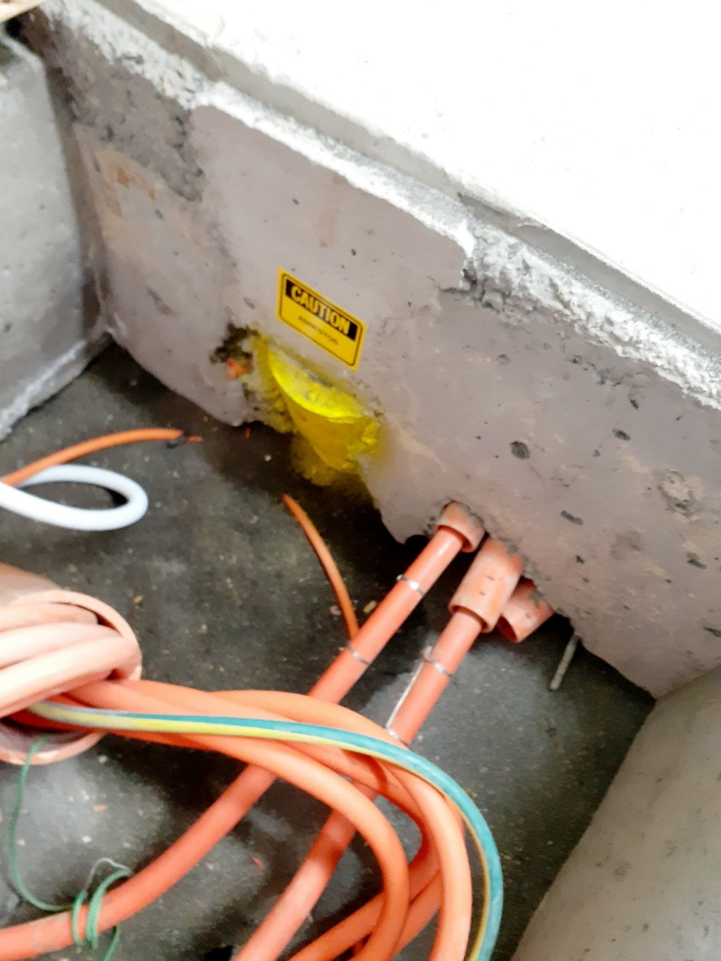

Electrical Distribution Hut L1247. Conduit entering building under the conduit pit.

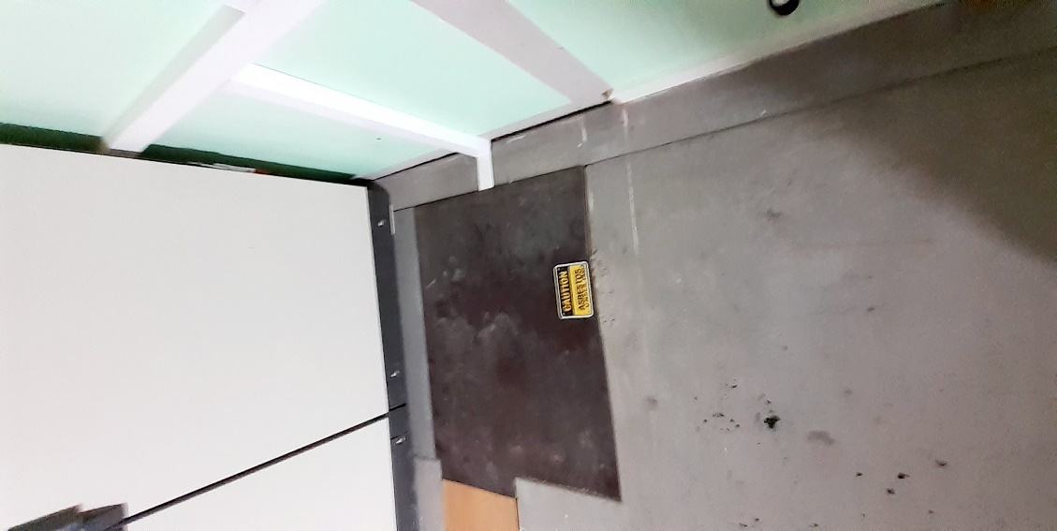
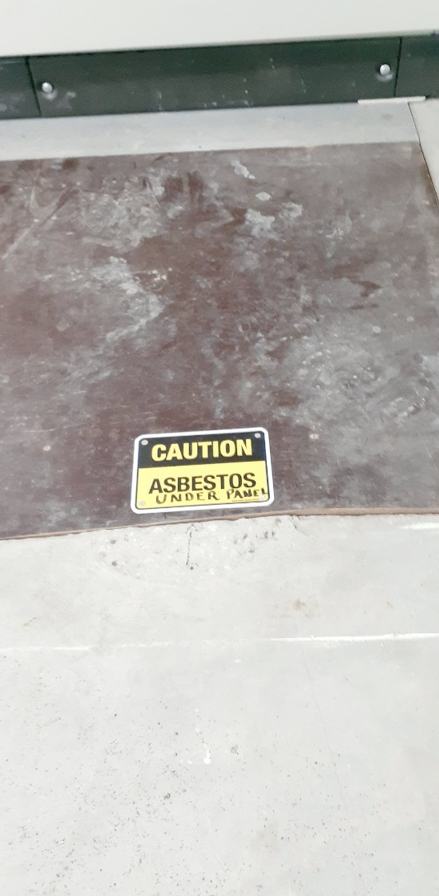

Electrical Distribution Hut L1247. Formply floor panel on top of the conduit pit.

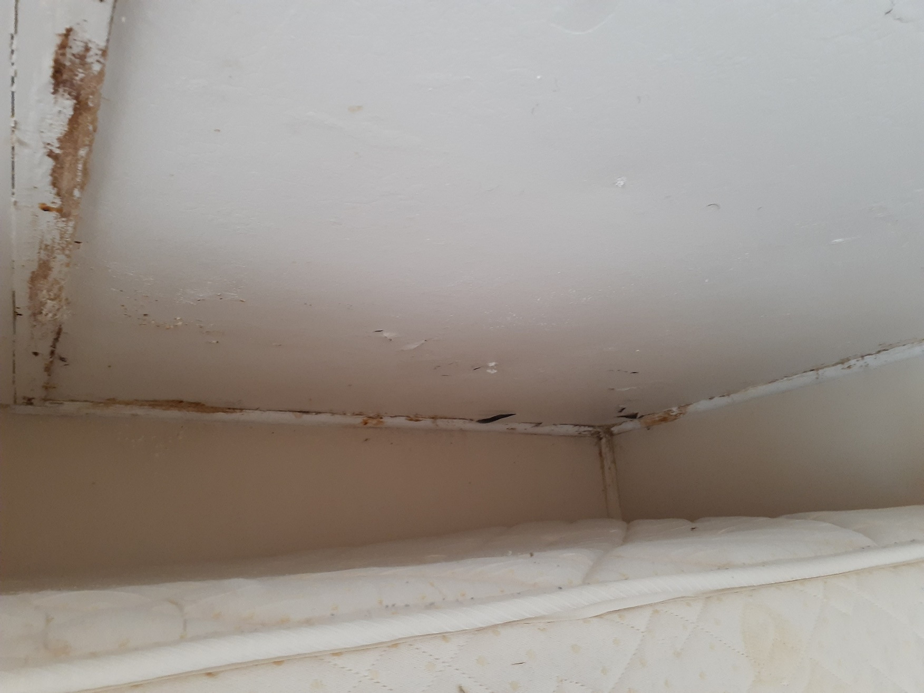

Ham Shack L1265. SW Corner
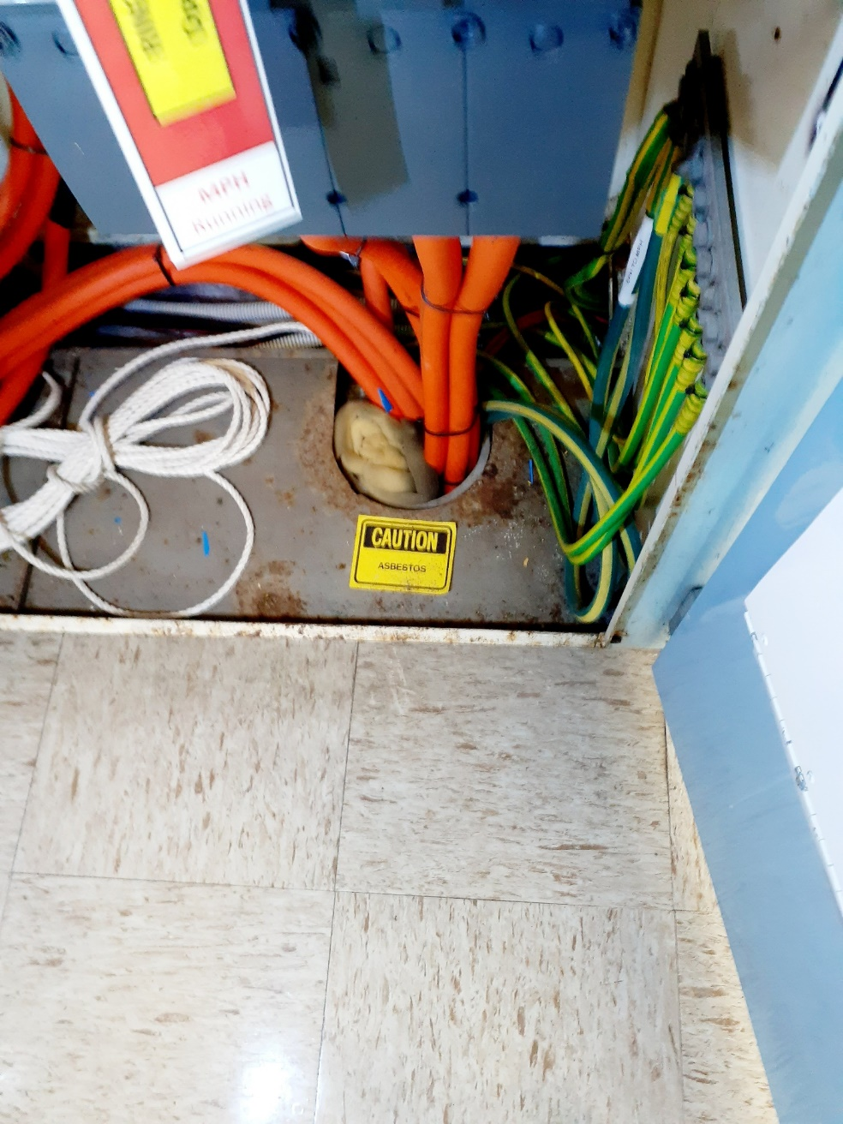

Emergency Powerhouse L1245. Main cable entering switchboard
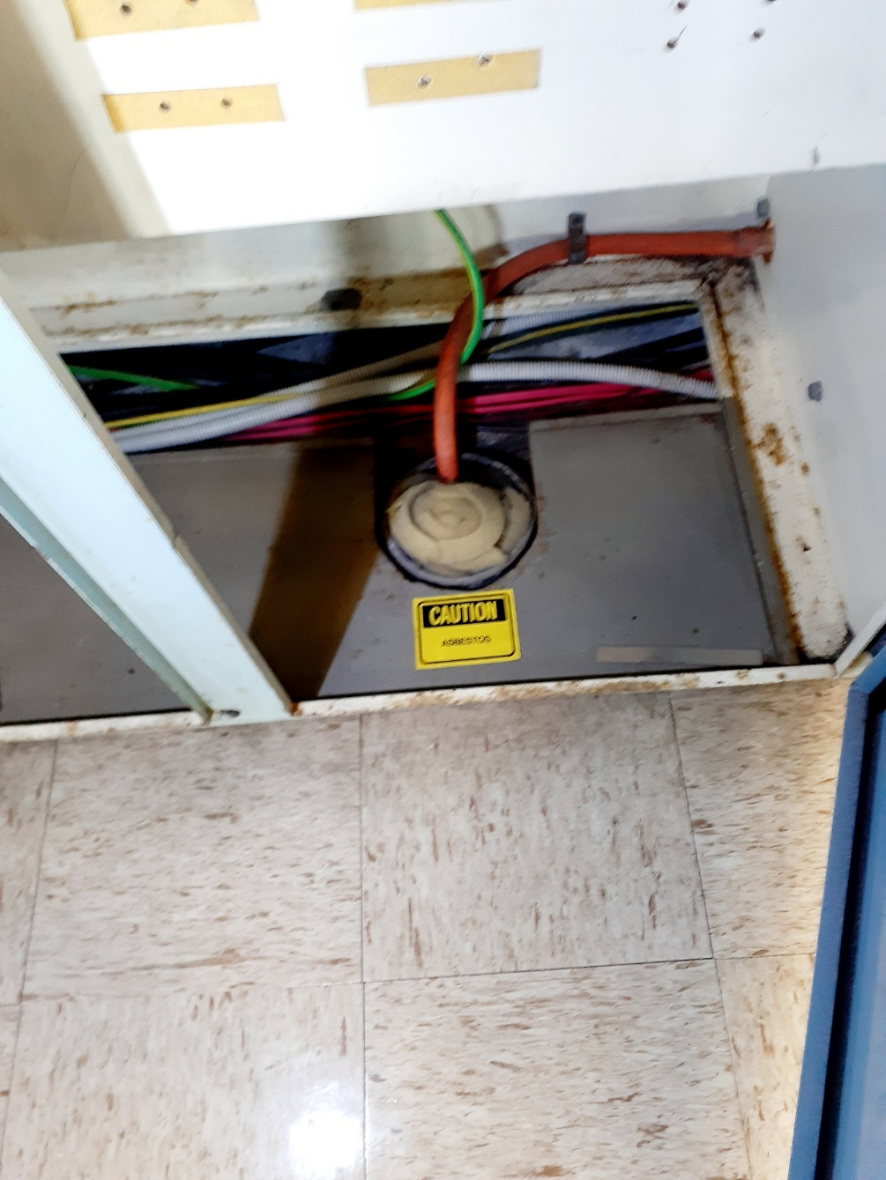

Emergency Powerhouse L1245. Conduit in Load Bank Panel
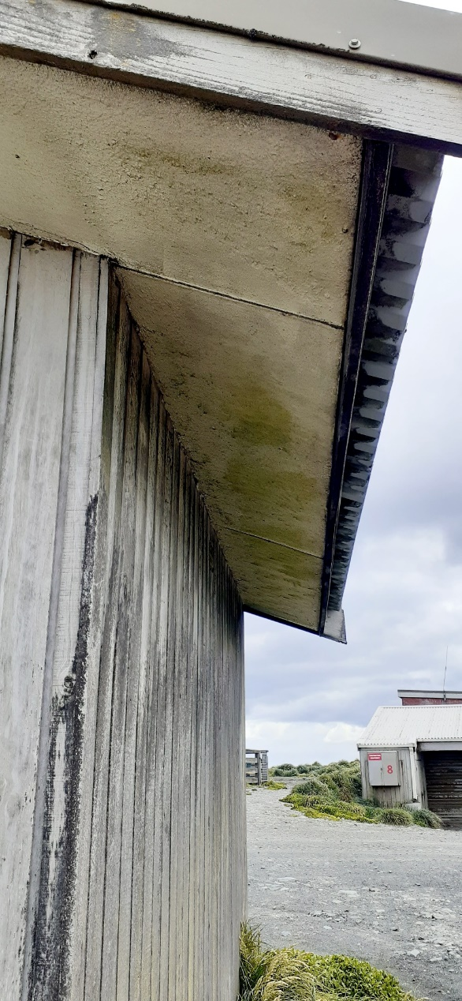

Flammable Liquid Hut L1273. Eave Soffit
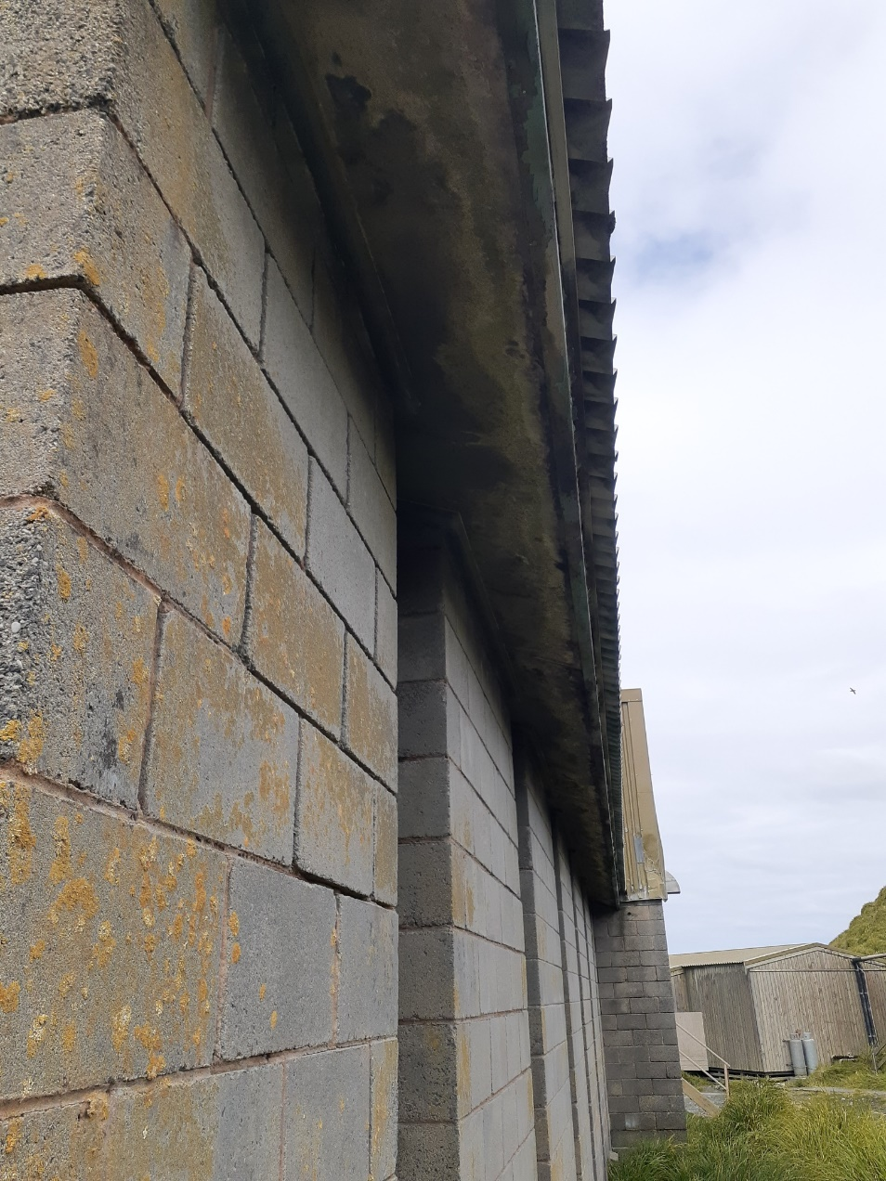

Hass House L1252. Eave Soffit.
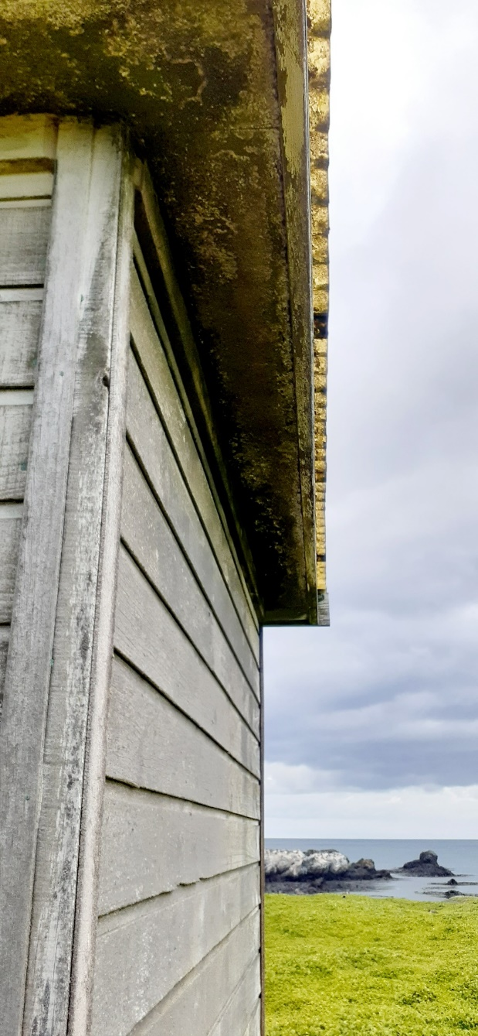

Proton Hut L1301. Eave Soffit
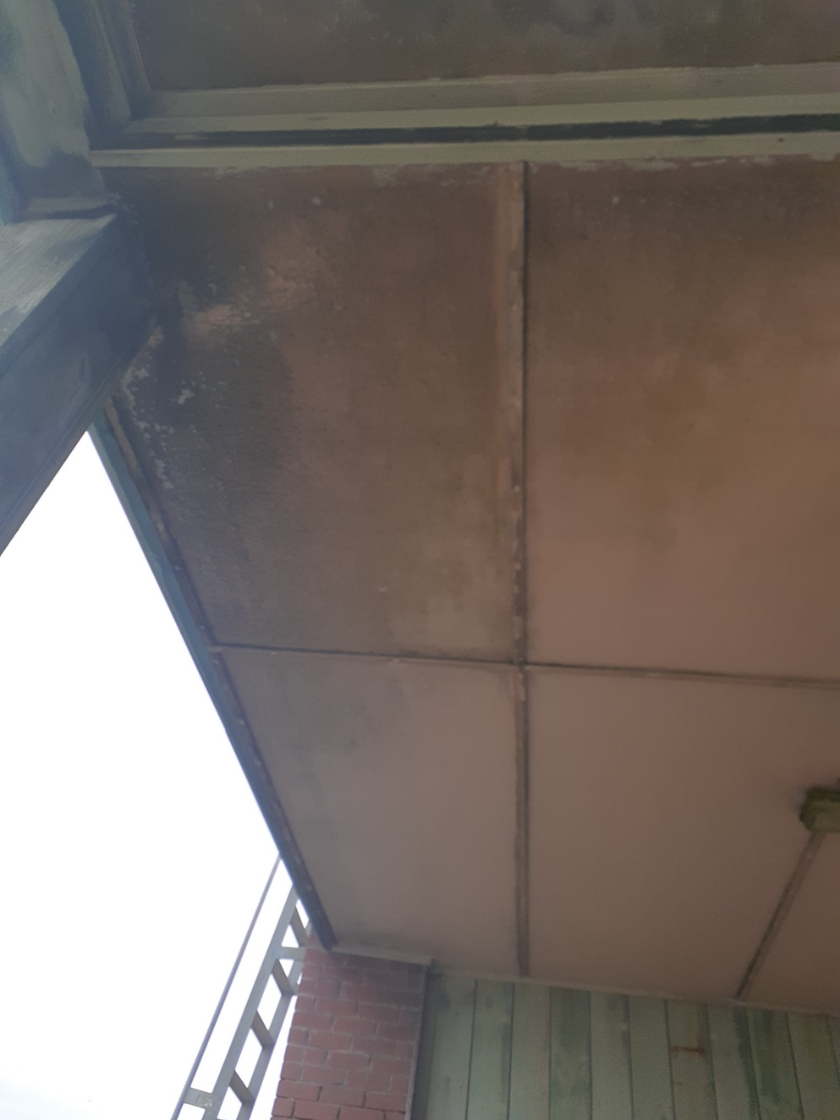

Science Building L1299. Eave Soffit at Entry Porch.
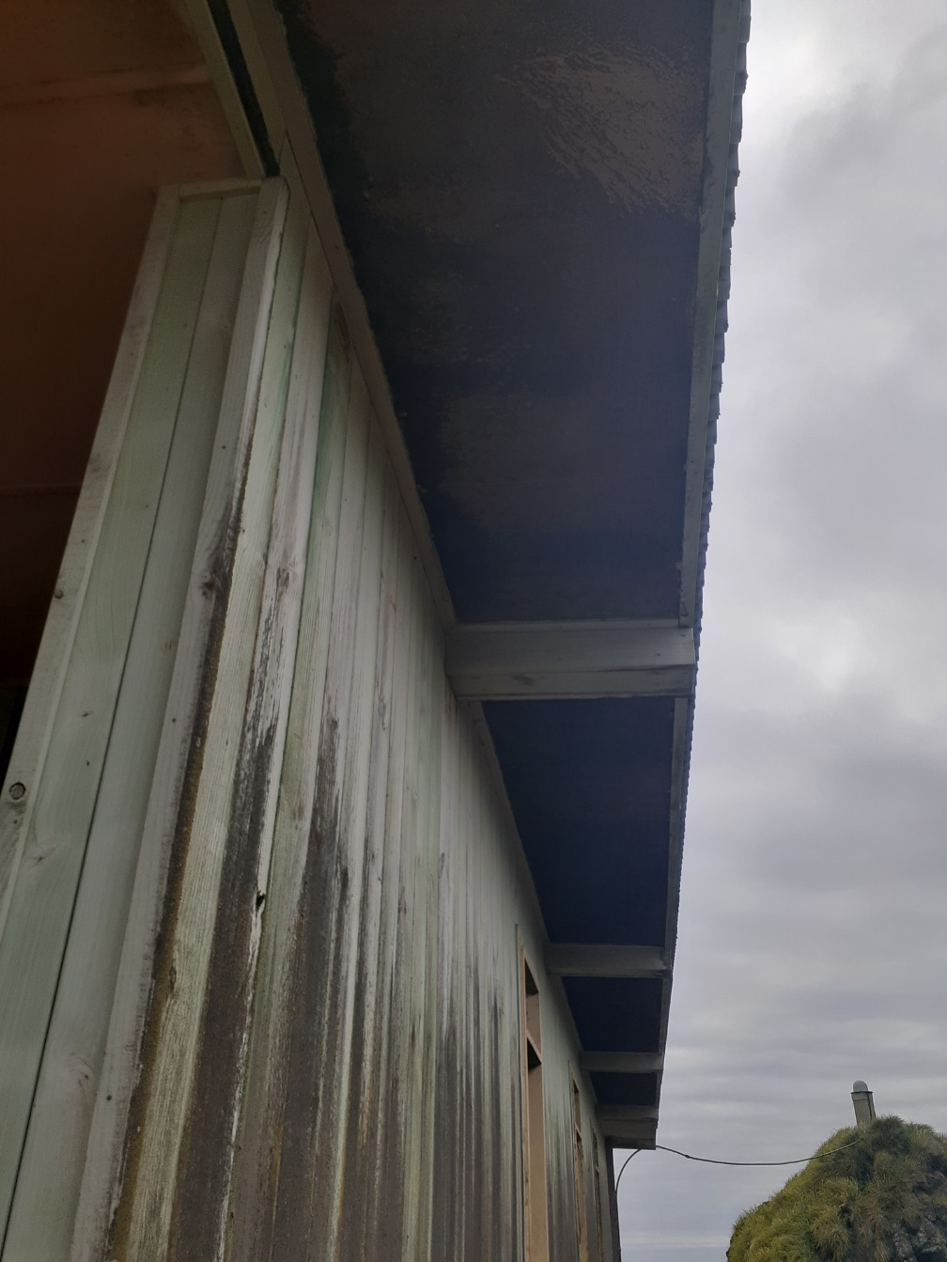

Science Building L1299. Eave Soffit North.
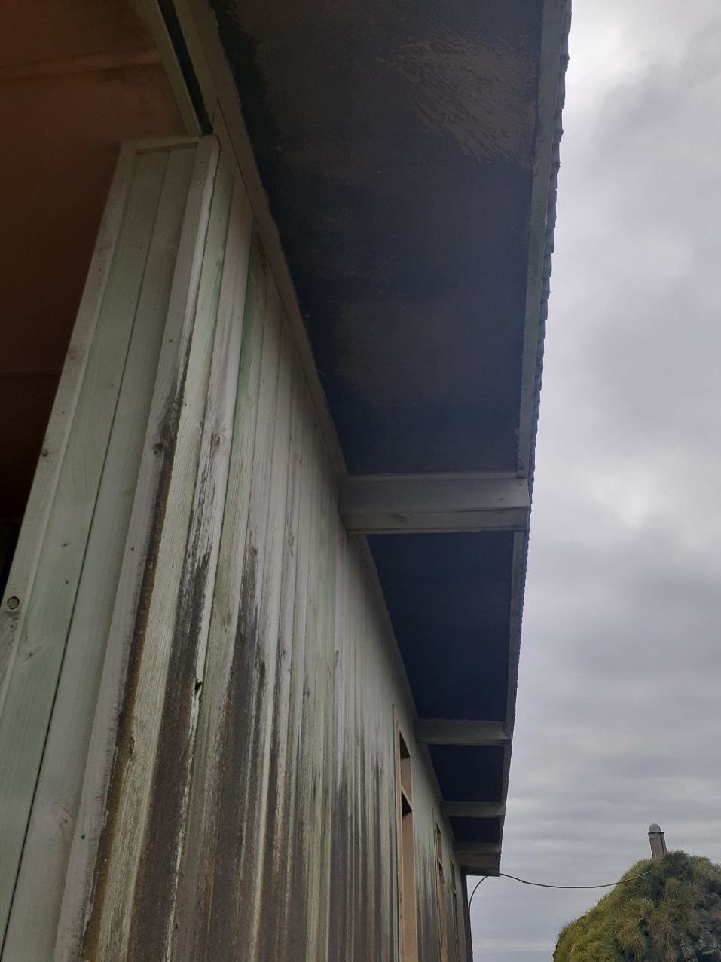

Science Building L1299. Eave Soffit South.
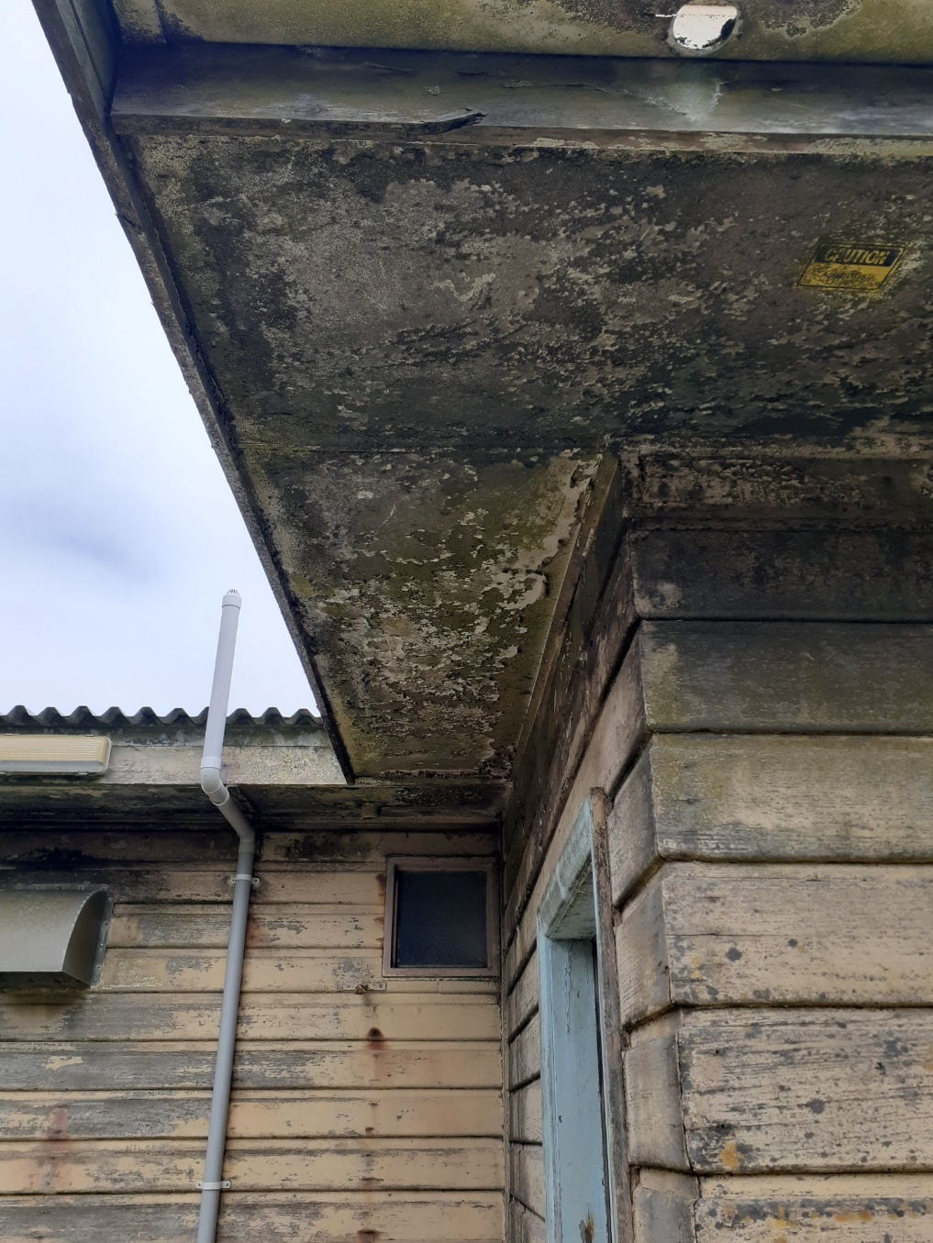

SAD L1254. Eave Soffit.

