# [8-Week SQL Challenge](https://github.com/nduongthucanh/8-Week-SQL-Challenge)

# Case Study #1 - Danny's Diner

[](https://github.com/nduongthucanh/8-Week-SQL-Challenge/blob/main/IMG/org-1.png)

## **Table Contents**

* Problem Statement
* Dataset
* Case Study Questions
* Solution
* Limitations and Assumptions

## **Problem Statement**

Danny wants to use the data to answer a few simple questions about his customers, especially about their visiting patterns, how much money they’ve spent and also which menu items are their favorite. Having this deeper connection with his customers will help him deliver a better and more personalized experience for his loyal customers.

## **Dataset**

Danny has shared with you 3 key datasets for this case study:

* **sales**

The sales table captures all customer_id level purchases with an corresponding order_date and product_id information for when and what menu items were ordered.

| **customer_id** | **order_date** | **product_id** |
| --- | --- | --- |
| A | 2021-01-01 | 1 |
| A | 2021-01-01 | 2 |
| A | 2021-01-07 | 2 |
| A | 2021-01-10 | 3 |
| A | 2021-01-11 | 3 |
| A | 2021-01-11 | 3 |
| B | 2021-01-01 | 2 |
| B | 2021-01-02 | 2 |
| B | 2021-01-04 | 1 |
| B | 2021-01-11 | 1 |
| B | 2021-01-16 | 3 |
| B | 2021-02-01 | 3 |
| C | 2021-01-01 | 3 |
| C | 2021-01-01 | 3 |
| C | 2021-01-07 | 3 |

* **menu**

The menu table maps the product_id to the actual product_name and price of each menu item.

| **product_id** | **product_name** | **price** |
| --- | --- | --- |
| 1 | sushi | 10 |
| 2 | curry | 15 |
| 3 | ramen | 12 |

* **members**

The final members table captures the join_date when a customer_id joined the beta

version of the Danny’s Diner loyalty program.

| **customer_id** | **join_date** |
| --- | --- |
| A | 1/7/2021 |
| B | 1/9/2021 |

## **Case Study Questions**

1. What is the total amount each customer spent at the restaurant?
2. How many days has each customer visited the restaurant?
3. What was the first item from the menu purchased by each customer?
4. What is the most purchased item on the menu and how many times was it purchased by all customers?
5. Which item was the most popular for each customer?
6. Which item was purchased first by the customer after they became a member?
7. Which item was purchased just before the customer became a member?
8. What is the total items and amount spent for each member before they became a member?
9. If each $1 spent equates to 10 points and sushi has a 2x points multiplier - how many points would each customer have?
10. In the first week after a customer joins the program (including their join date) they earn 2x points on all items, not just sushi - how many points do customer A and B have at the end of January?

**Solutions**

-- Q1: What is the total amount each customer spent at the restaurant?

SELECT s.customer_id, sum(m.price) as Total

FROM sales s join menu m

on s.product_id=m.product_id

group by customer_id

order by 2 desc;

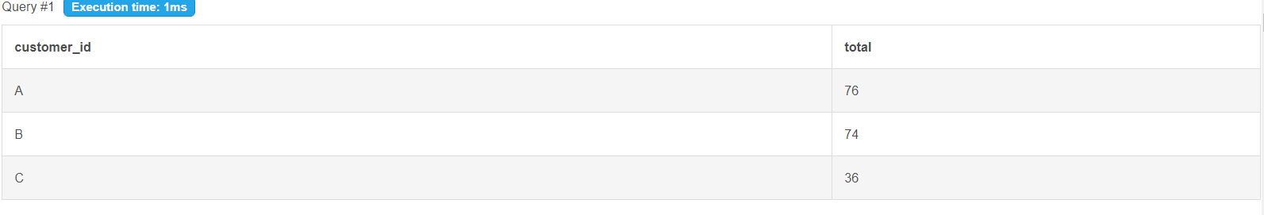

-- Q2: How many days has each customer visited the restaurant?

select customer_id, count(distinct order_date) as Visits

from sales

group by customer_id

order by 2 desc;

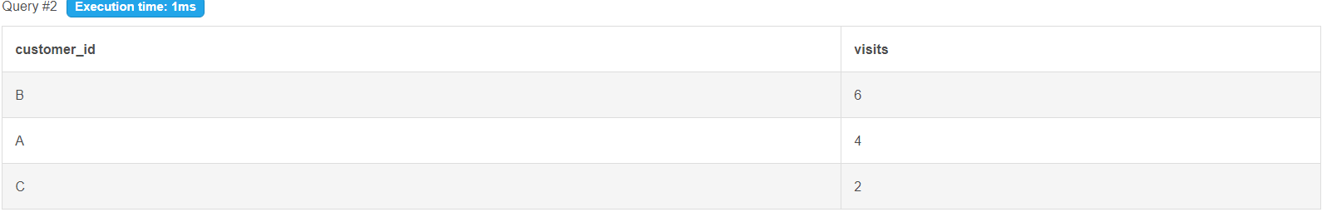

-- Q3: What was the first item from the menu purchased by each customer?

With q1 as (

select customer_id, product_name,

row_number() over(partition by customer_id order by order_date, s.product_id) as rk

from sales s join menu m

on s.product_id=m.product_id)

select customer_id, product_name from q1

where rk = 1;

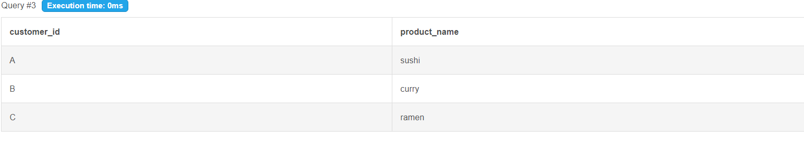

-- Q4: What is the most purchased item on the menu and how many times was it purchased by all customers?

select product_name,

count(s.product_id) as ordered

from sales s join menu m

on s.product_id=m.product_id

group by product_name

order by ordered desc

limit 1;



-- Q5: Which item was the most popular for each customer?

with q1 as

(select customer_id, product_name,

count(s.product_id) as counts

from sales s join menu m

on s.product_id=m.product_id

group by customer_id, product_name

order by customer_id, counts desc)

, q2 as

(select customer_id, product_name, counts,

rank() over(partition by customer_id order by counts desc) as rk

from q1

)

select customer_id, product_name, counts as times_ordered

from q2 where rk = 1;

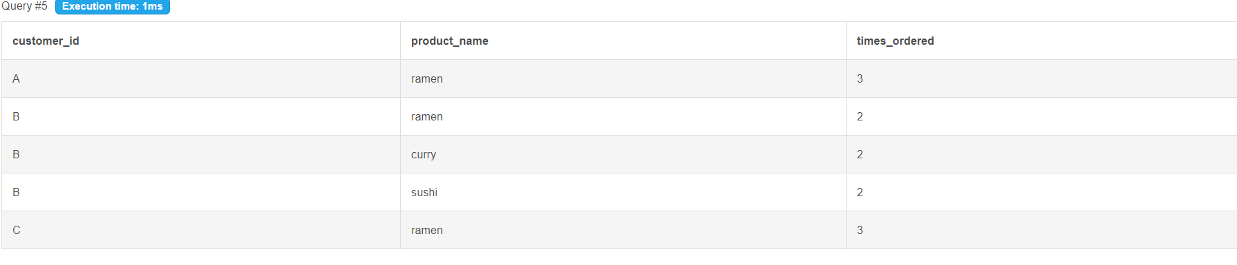

-- Q6: Which item was purchased first by the customer after they became a member?

with q1 as(

select s.customer_id, order_date, product_id

from sales s join members m

on s.customer_id=m.customer_id

where s.order_date >= m.join_date)

, q2 as (

select q1.customer_id, product_name,

rank() over (partition by q1.customer_id order by q1.order_date) as rk

from q1 join menu me

on q1.product_id = me.product_id

)

select customer_id, product_name

from q2

where rk=1;

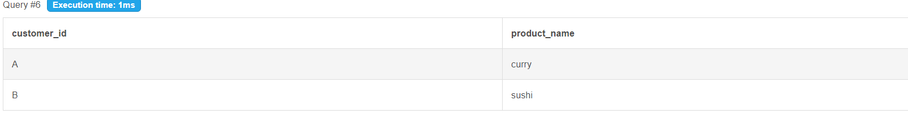

-- Q7: Which item was purchased just before the customer became a member?

with q1 as(

select s.customer_id, order_date, product_id

from sales s join members m

on s.customer_id=m.customer_id

where s.order_date < m.join_date)

, q2 as (

select q1.customer_id, product_name,

rank() over (partition by q1.customer_id order by q1.order_date desc, q1.product_id desc) as rk

from q1 join menu me

on q1.product_id = me.product_id

)

select customer_id, product_name

from q2

where rk=1;

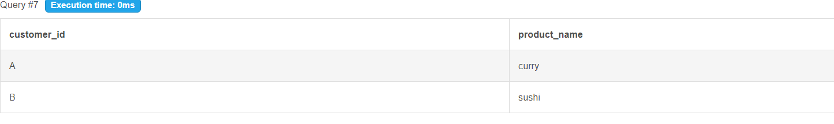

-- Q8. What are the total items and amount spent for each member before they became a member?

select s.customer_id, count(s.product_id) as BeforeMemberordered, sum(price) as BeforeMembertotal

from sales s join members m

on s.customer_id=m.customer_id

join menu me

on s.product_id=me.product_id

where s.order_date < m.join_date

group by 1;

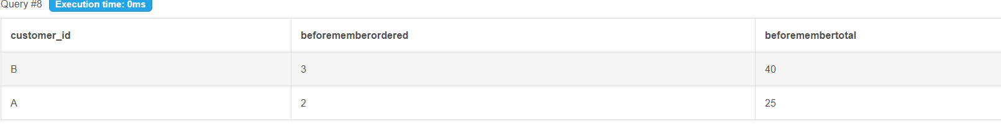

-- 9. If each $1 spent equates to 10 points and sushi has a 2x points multiplier - how many points would each customer have?

select customer_id,

sum(case when s.product_id = 1 then price*20

else price*10 end) as RewardPoints

from sales s join menu m

on s.product_id=m.product_id

group by 1;

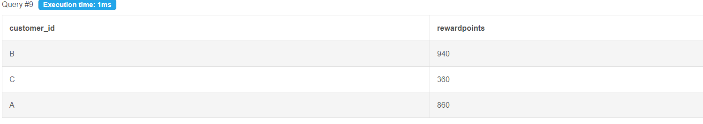

-- 10. In the first week after a customer joins the program (including their join date) they earn 2x points on all items, not just sushi - how many points do customer A and B have at the end of January?

select s.customer_id, sum(

case when (order_date >= join_date) and (order_date < join_date + integer '7') then price*20

else (case when s.product_id=1 then price*20

else price*10 end) end) as RewardPoints

from sales s join menu m

on s.product_id=m.product_id

join members me on s.customer_id=me.customer_id

where order_date <= date '2021-01-31'

group by 1;

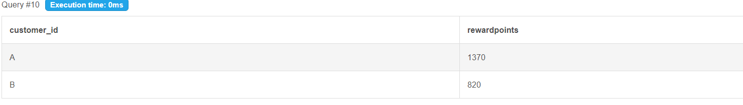

### Q11: Join All the Things

The following questions are related creating basic data tables that Danny and his team can use to quickly derive insights without needing to join the underlying tables using SQL.

Recreate the following table output using the available data:

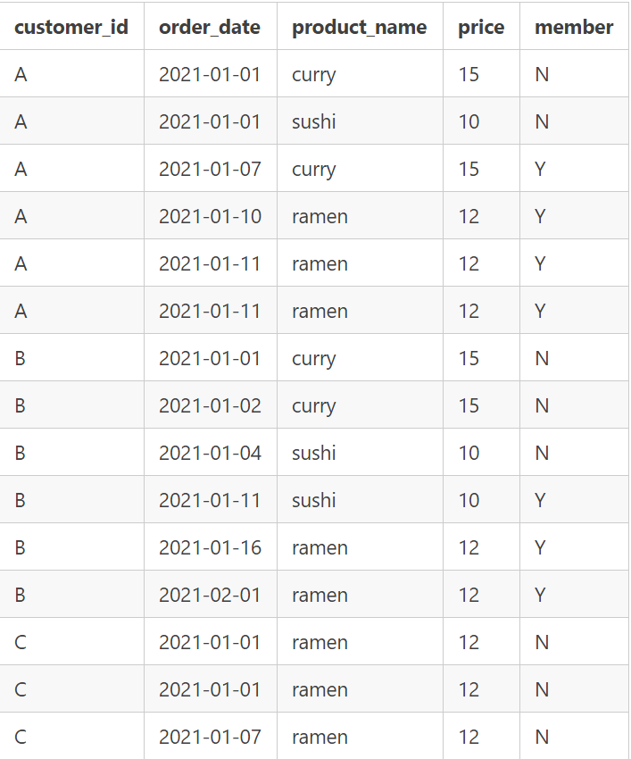

select s.customer_id, order_date, product_name, price,

case when order_date < join_date then 'N'

when order_date >= join_date then 'Y'

else 'N' end as Member

from sales s join menu m

on s.product_id=m.product_id

left join members me

on s.customer_id=me.customer_id

order by customer_id, order_date;

-- Q12: Ranking All Things - Danny also requires further information about the ranking of customer products, but he purposely does not need the ranking for non-member purchases so he expects null ranking values for the records when customers are not yet part of the loyalty program.

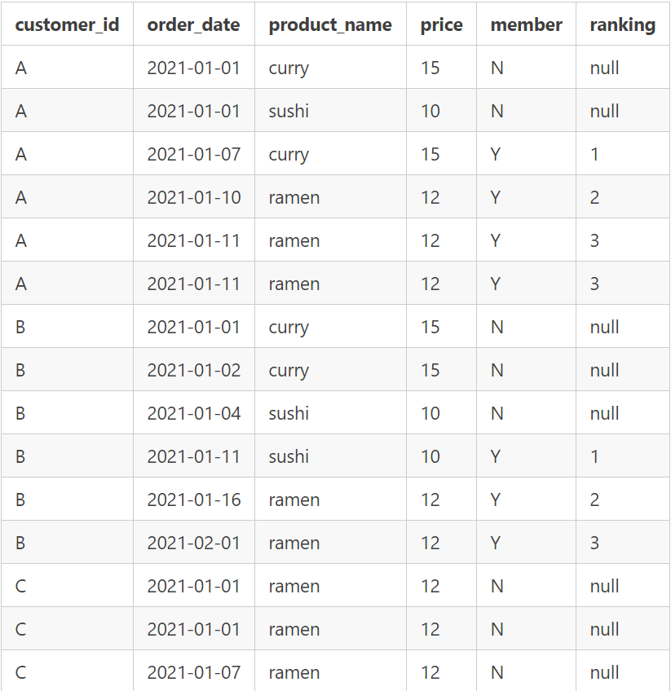

with q1 as(

select s.customer_id, order_date, product_name, price,

case when order_date < join_date then 'N'

when order_date >= join_date then 'Y' else 'N' end as Member

from sales s join menu m on s.product_id=m.product_id

left join members me on s.customer_id=me.customer_id)

select *,

case when Member = 'N' then Null

else rank() over(partition by q1.customer_id, q1.Member order by order_date)

end as ranking from q1

order by customer_id, order_date;

## **Limitations and Assumptions**

This section includes all the limitations in terms of my understanding regarding the question and on the limited data information in response to the question 3, 5, 6, 7 and 10:

### ****Question 3: What was the first item from the menu purchased by each customer?****

The limitation of this question includes:

* Since the **order_date** information does not include details of the purchase time (hours, minute, second, etc.) and those orders purchased **on the same day** are sorted based on the **product_id** instead of time element, it is difficult for me to know which product is purchased first on the same day.

That's why, in this question I will sort the first purchase order by the **product_id**

### ****Question 5: Which item was the most popular for each customer?****

The limitation of this question includes:

* Since there is **no extra information** to provide further conditions for **sorting popular items** for each customer, thus, those products have the same highest purchase counts are considered to be all popular

### ****Question 6: Which item was purchased first by the customer after they became a member?****

The limitation of this question includes:

* Since it is not clear that those orders made during the **join_date** was **after** or **before** the customer joined in the membership program because of the lack of **order_date** and **join_date** information (does not include details of the purchase time), I will assume these orders were made after the customer had already joined the program.

### ****Question 7: Which item was purchased just before the customer became a member?****

The limitation of this question includes:

* Since the **order_date** information does not include details of the purchase time (hours, minute, second, etc.) and those orders purchased **on the same day** are sorted based on the **product_id** instead of time element, it is difficult for me to know which product is last purchased before the customer join in the membership program.

Therefore, the result can be either 1 of those orders made during the last day before the **join_date**

### ****Question 10: In the first week after a customer joins the program (including their join date) they earn 2x points on all items, not just sushi - how many points do customer A and B have at the end of January?****

The limitation of this question includes:

* Since it is not clear that the points in this question is only calculated **after the customer joins in the membership program** or not, I will also include the total points before the **join_date**.