Create Kubernetes cluster

Ref-

<https://github.com/Kavan-Dalwadi/app-fluxCD>

<https://github.com/Kavan-Dalwadi/fluxCD>

Create new git repo on Github which will store all the application k8s manifest file like deployment, statefulset, ingress files. (give a name to repo like **app-fluxCD**)

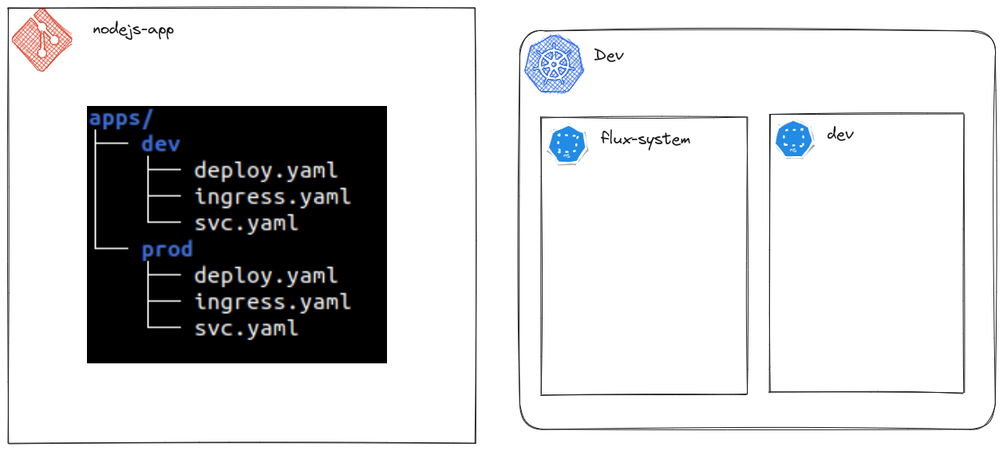

* export GITHUB_TOKEN=

Clone the git repo for flux (name it anything e.g. flux, fluxCD etc)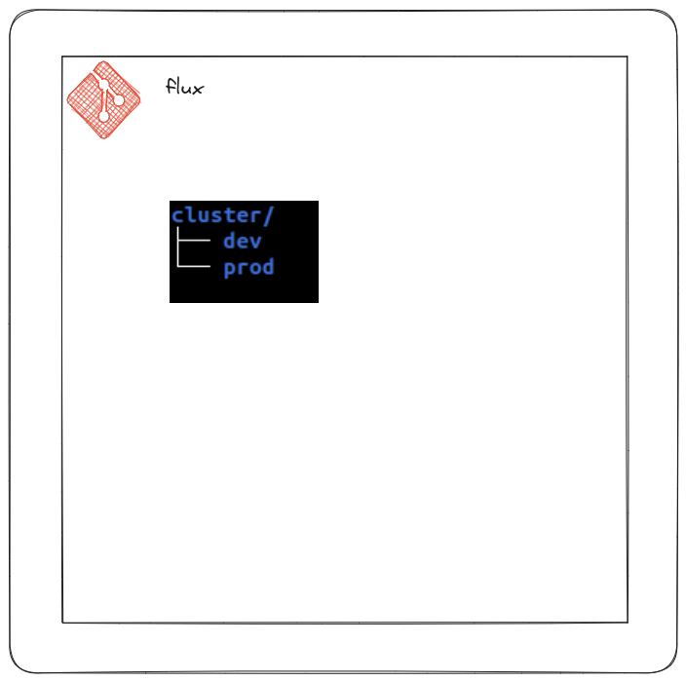

* flux bootstrap github \ --owner=Kavan-Dalwadi \ --repository=fluxCD \ --path=cluster/dev \ --personal

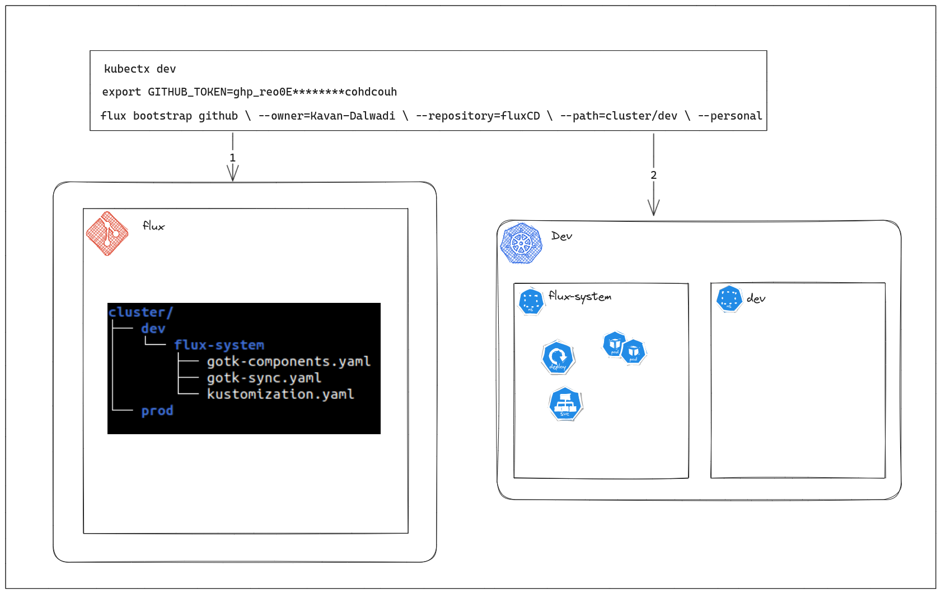

Flux will automatically create flux resources manifest file in your remote git repo (GitHub) & install all its components in the Cluster which is connected.

Now pull the remote changes to local git repo

* git pull
* flux create source git dev --url https://github.com/Kavan-Dalwadi/app-fluxCD --branch main --interval 30s --export | tee cluster/dev/apps/dev.yaml
* flux create kustomization dev --source dev --path "./dev/" --prune true --interval 10m --export | tee cluster/dev/apps/dev.yaml

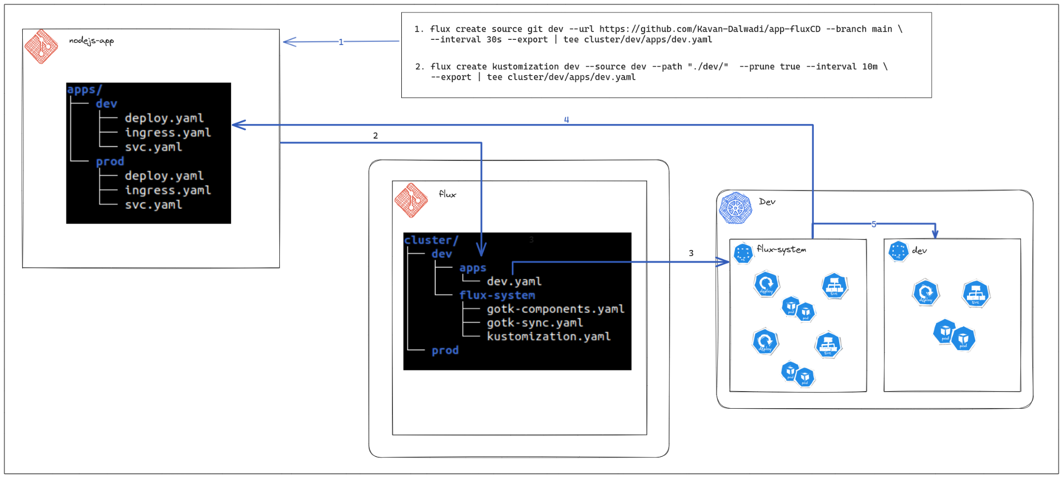

Make any changes to the application git repo (change container image tag etc), those changes will be reflected in the k8s cluster

