**Kubernetes logs monitoring using Prometheus Loki**

**Prerequsists-**

1. Add On - Enable Amazon EBS CNI Driver-

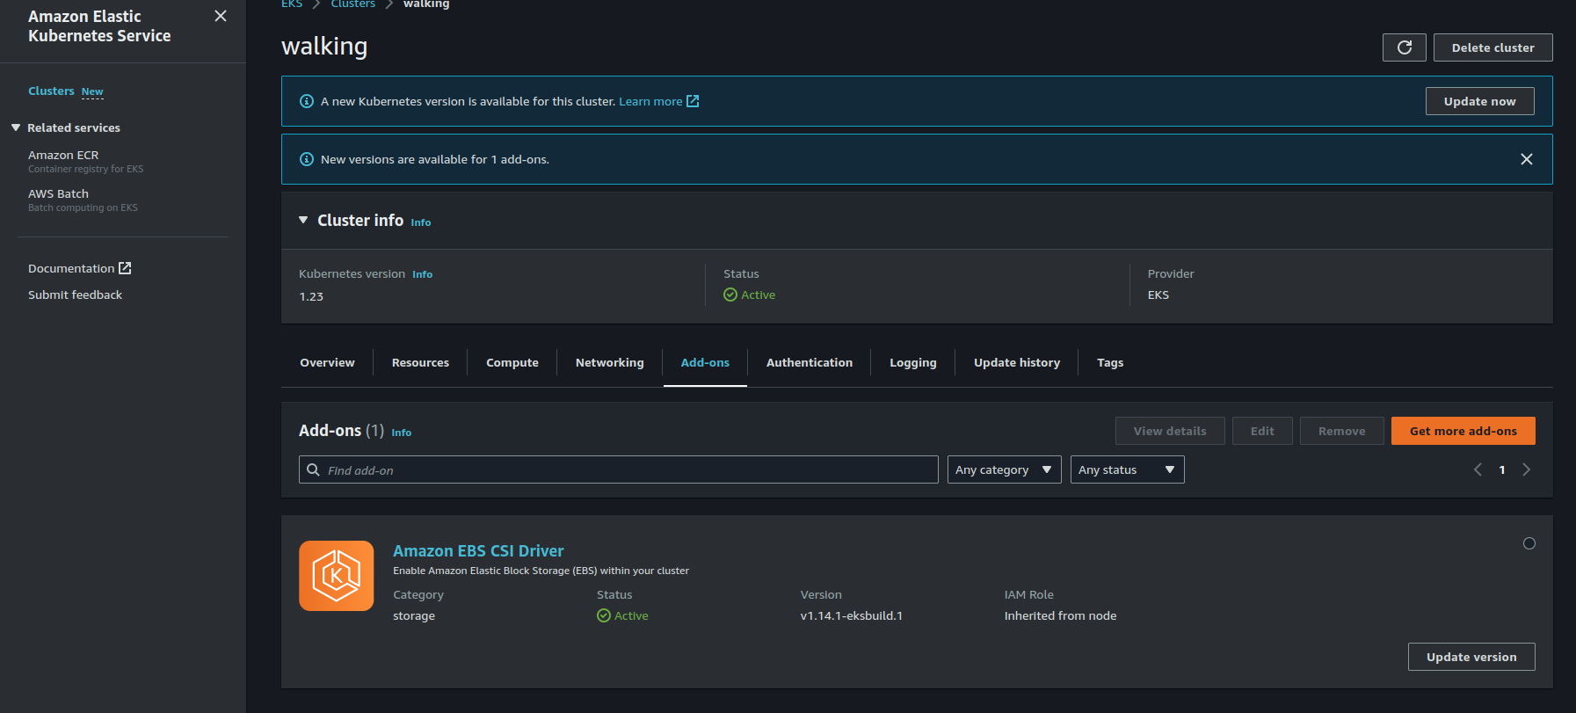

1. Add “[AmazonEBSCSIDriverPolicy](https://us-east-1.console.aws.amazon.com/iam/home#/policies/arn:aws:iam::aws:policy/service-role/AmazonEBSCSIDriverPolicy)” policy to the AWS EKS Node IAM role

**Main Step to perform in K8s cluster -**

1. helm repo add prometheus-community https://prometheus-community.github.io/helm-charts
2. helm repo add grafana https://grafana.github.io/helm-charts
3. kubectl create namespace prometheus
4. kubectl get node
5. kubectl --help
6. kubectl get --help
7. cat ~/.kube/config | grep current
8. kubectl config current-context
9. kubectl create namespace prometheus
10. helm repo update
11. helm repo add prometheus-community https://prometheus-community.github.io/helm-charts
12. helm install prometheus prometheus-community/prometheus --namespace prometheus --set alertmanager.persistentVolume.storageClass="gp2" --set server.persistentVolume.storageClass="gp2"
13. mkdir ./grafana
14. cat << EoF > ./grafana/grafana.yaml

datasources:

datasources.yaml:

apiVersion: 1

datasources:

- name: Prometheus

type: prometheus

url: http://prometheus-server.prometheus.svc.cluster.local

access: proxy

isDefault: true

EoF

1. kubectl create namespace grafana
2. helm install grafana grafana/grafana --namespace grafana --set persistence.storageClassName="gp2" --set persistence.enabled=true --set adminPassword='EKS!sAWSome' --values ./grafana/grafana.yaml --set service.type=LoadBalancer
3. helm repo add loki https://grafana.github.io/loki/charts
4. helm repo update
5. helm upgrade --install loki loki/loki-stack
6. kubectl get svc
7. kubectl get pods

**Kubecost with Prometheus & Grafana**

<https://docs.kubecost.com/install-and-configure/install/custom-prom>

helm upgrade --install kubecost \

--repo https://kubecost.github.io/cost-analyzer/ cost-analyzer \

--namespace kubecost --create-namespace \

--set prometheus.nodeExporter.enabled=false \

--set prometheus.serviceAccounts.nodeExporter.create=false \

--set prometheus.kubeStateMetrics.enabled=false

**OR**

helm upgrade --install kubecost \

--repo https://kubecost.github.io/cost-analyzer/ cost-analyzer \

--namespace kubecost --create-namespace \

--set global.prometheus.fqdn=http://<prometheus-server-service-name>:<port>.<prometheus-server-namespace>.svc \

--set global.prometheus.enabled=false

----------------------------------------------------------------------------------------------

- job_name: kubecost

honor_labels: true

scrape_interval: 1m

scrape_timeout: 10s

metrics_path: /metrics

scheme: http

dns_sd_configs:

- names:

- kubecost-cost-analyzer.kubecost

type: 'A'

port: 9003