**Project1**

**How to install the file.**

Just Run Server file In Server folder on in Terminal by appropriate command.

Now run Client File in Terminal by appropriate command.

For run from Terminal you try command for ex. ./ python3 tcpserver.py 127.0.0.1 13002

Implemented total 4 methods that is:-

1. PUT
2. GET
3. Delete
4. HEAD

It’s implemented using multithreading for Persistent HTTP that is HTTP 1.1.

For Non-Persistent HTTP, which is HTTP1.0, we have used Pipelining Method.

1 step:

User has option for 4 methods.

As user selects the method, operation happens Using HTTP 1.1 or 1.0 as preferred by user.

Below are the screenshot of working code on MacBoook.

**RUN WITH TELNET**

**V1.0**

**V1.1**

**Run WEB**

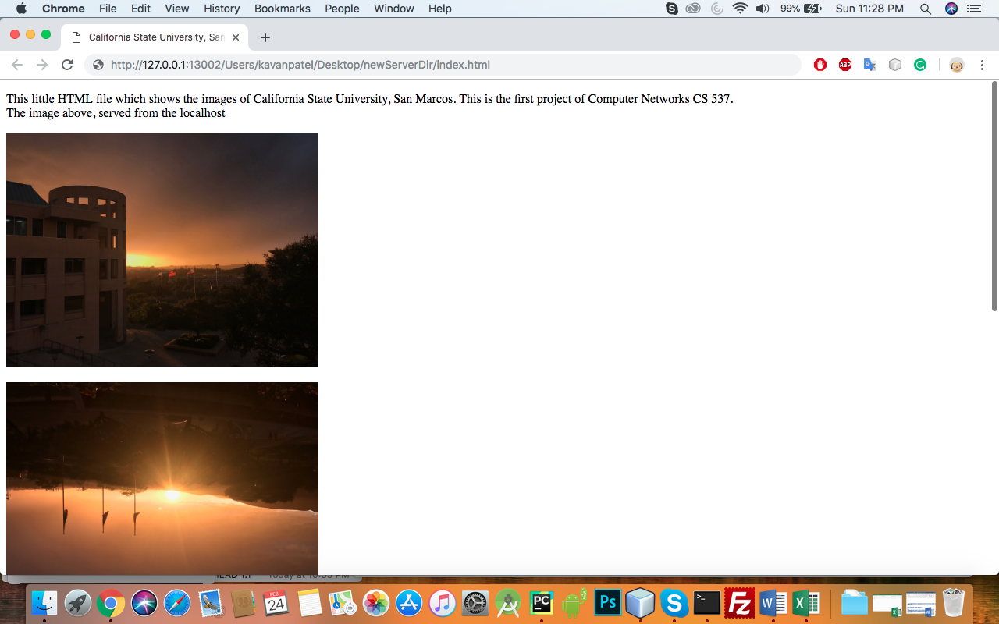

**Server Run:**

/usr/local/bin/python3.7 /Users/kavanpatel/Desktop/CS537/ServerDir/exserver.py

Server Listening on localhost:13002

The server is ready to receive

Accepted connection from 127.0.0.1:65191

HTTP VERSION 1.1

Received b'<!DOCTYPE html>\n<!--\nTo change this license header, choose License Headers in Project Properties.\nTo change this template file, choose Tools | Templates\nand open the template in the editor.\n-->\n\n<html>\n<head>\n<title>California State University, San Marcos</title>\n<meta http-equiv="Content-Type" content="text/html; charset=iso-8859-1">\n</head>\n\n<body bgcolor="#FFFFFF" text="#000000">\n\n<p>This little HTML file which shows the images of California State University, San Marcos. \nThis is the first project of Computer Networks CS 537. <br> The image above, served from the \nlocalhost<br></p>\n<p align="left"><img src="/Users/kavanpatel/Desktop/ClientDir/a.jpg" width="400" height="300"></p>\n<p align="left"><img src="/Users/kavanpatel/Desktop/ClientDir/b.jpg" width="400" height="300"></p>\n<p align="left"><img src="/Users/kavanpatel/Desktop/ClientDir/c.jpg" width="400" height="300"></p>\n<p align="left"><img src="/Users/kavanpatel/Desktop/ClientDir/d.jpg" width="400" height="300"></p>\n</body>\n</html>\n||index.html||put||1.1'

put

Accepted connection from 127.0.0.1:65192

HTTP VERSION 1.1

Received b'<!DOCTYPE html>\n<!--\nTo change this license header, choose License Headers in Project Properties.\nTo change this template file, choose Tools | Templates\nand open the template in the editor.\n-->\n\n<html>\n<head>\n<title>California State University, San Marcos</title>\n<meta http-equiv="Content-Type" content="text/html; charset=iso-8859-1">\n</head>\n\n<body bgcolor="#FFFFFF" text="#000000">\n\n<p>This little HTML file which shows the images of California State University, San Marcos. \nThis is the first project of Computer Networks CS 537. <br> The image above, served from the \nlocalhost<br></p>\n<p align="left"><img src="/Users/kavanpatel/Desktop/ClientDir/a.jpg" width="400" height="300"></p>\n<p align="left"><img src="/Users/kavanpatel/Desktop/ClientDir/b.jpg" width="400" height="300"></p>\n<p align="left"><img src="/Users/kavanpatel/Desktop/ClientDir/c.jpg" width="400" height="300"></p>\n<p align="left"><img src="/Users/kavanpatel/Desktop/ClientDir/d.jpg" width="400" height="300"></p>\n</body>\n</html>\n||index.html||get||1.1'

Data successfully send

Accepted connection from 127.0.0.1:65193

HTTP VERSION 1.1

Received b'<!DOCTYPE html>\n<!--\nTo change this license header, choose License Headers in Project Properties.\nTo change this template file, choose Tools | Templates\nand open the template in the editor.\n-->\n\n<html>\n<head>\n<title>California State University, San Marcos</title>\n<meta http-equiv="Content-Type" content="text/html; charset=iso-8859-1">\n</head>\n\n<body bgcolor="#FFFFFF" text="#000000">\n\n<p>This little HTML file which shows the images of California State University, San Marcos. \nThis is the first project of Computer Networks CS 537. <br> The image above, served from the \nlocalhost<br></p>\n<p align="left"><img src="/Users/kavanpatel/Desktop/ClientDir/a.jpg" width="400" height="300"></p>\n<p align="left"><img src="/Users/kavanpatel/Desktop/ClientDir/b.jpg" width="400" height="300"></p>\n<p align="left"><img src="/Users/kavanpatel/Desktop/ClientDir/c.jpg" width="400" height="300"></p>\n<p align="left"><img src="/Users/kavanpatel/Desktop/ClientDir/d.jpg" width="400" height="300"></p>\n</body>\n</html>\n||index.html||head||1.1'

head

Data successfully send

Accepted connection from 127.0.0.1:65194

HTTP VERSION 1.1

Received b'<!DOCTYPE html>\n<!--\nTo change this license header, choose License Headers in Project Properties.\nTo change this template file, choose Tools | Templates\nand open the template in the editor.\n-->\n\n<html>\n<head>\n<title>California State University, San Marcos</title>\n<meta http-equiv="Content-Type" content="text/html; charset=iso-8859-1">\n</head>\n\n<body bgcolor="#FFFFFF" text="#000000">\n\n<p>This little HTML file which shows the images of California State University, San Marcos. \nThis is the first project of Computer Networks CS 537. <br> The image above, served from the \nlocalhost<br></p>\n<p align="left"><img src="/Users/kavanpatel/Desktop/ClientDir/a.jpg" width="400" height="300"></p>\n<p align="left"><img src="/Users/kavanpatel/Desktop/ClientDir/b.jpg" width="400" height="300"></p>\n<p align="left"><img src="/Users/kavanpatel/Desktop/ClientDir/c.jpg" width="400" height="300"></p>\n<p align="left"><img src="/Users/kavanpatel/Desktop/ClientDir/d.jpg" width="400" height="300"></p>\n</body>\n</html>\n||index.html||delete||1.1'

delete

Successfully deleted!!

Accepted connection from 127.0.0.1:65195

HTTP VERSION 1.1

Received b'<!DOCTYPE html>\n<!--\nTo change this license header, choose License Headers in Project Properties.\nTo change this template file, choose Tools | Templates\nand open the template in the editor.\n-->\n\n<html>\n<head>\n<title>California State University, San Marcos</title>\n<meta http-equiv="Content-Type" content="text/html; charset=iso-8859-1">\n</head>\n\n<body bgcolor="#FFFFFF" text="#000000">\n\n<p>This little HTML file which shows the images of California State University, San Marcos. \nThis is the first project of Computer Networks CS 537. <br> The image above, served from the \nlocalhost<br></p>\n<p align="left"><img src="/Users/kavanpatel/Desktop/ClientDir/a.jpg" width="400" height="300"></p>\n<p align="left"><img src="/Users/kavanpatel/Desktop/ClientDir/b.jpg" width="400" height="300"></p>\n<p align="left"><img src="/Users/kavanpatel/Desktop/ClientDir/c.jpg" width="400" height="300"></p>\n<p align="left"><img src="/Users/kavanpatel/Desktop/ClientDir/d.jpg" width="400" height="300"></p>\n</body>\n</html>\n||index.html||delete||1.1'

delete

File not found!!

Accepted connection from 127.0.0.1:65196

HTTP VERSION 1.0

Received b'<!DOCTYPE html>\n<!--\nTo change this license header, choose License Headers in Project Properties.\nTo change this template file, choose Tools | Templates\nand open the template in the editor.\n-->\n\n<html>\n<head>\n<title>California State University, San Marcos</title>\n<meta http-equiv="Content-Type" content="text/html; charset=iso-8859-1">\n</head>\n\n<body bgcolor="#FFFFFF" text="#000000">\n\n<p>This little HTML file which shows the images of California State University, San Marcos. \nThis is the first project of Computer Networks CS 537. <br> The image above, served from the \nlocalhost<br></p>\n<p align="left"><img src="/Users/kavanpatel/Desktop/ClientDir/a.jpg" width="400" height="300"></p>\n<p align="left"><img src="/Users/kavanpatel/Desktop/ClientDir/b.jpg" width="400" height="300"></p>\n<p align="left"><img src="/Users/kavanpatel/Desktop/ClientDir/c.jpg" width="400" height="300"></p>\n<p align="left"><img src="/Users/kavanpatel/Desktop/ClientDir/d.jpg" width="400" height="300"></p>\n</body>\n</html>\n||index.html||put||1.0'

put

Accepted connection from 127.0.0.1:65197

HTTP VERSION 1.0

Received b'<!DOCTYPE html>\n<!--\nTo change this license header, choose License Headers in Project Properties.\nTo change this template file, choose Tools | Templates\nand open the template in the editor.\n-->\n\n<html>\n<head>\n<title>California State University, San Marcos</title>\n<meta http-equiv="Content-Type" content="text/html; charset=iso-8859-1">\n</head>\n\n<body bgcolor="#FFFFFF" text="#000000">\n\n<p>This little HTML file which shows the images of California State University, San Marcos. \nThis is the first project of Computer Networks CS 537. <br> The image above, served from the \nlocalhost<br></p>\n<p align="left"><img src="/Users/kavanpatel/Desktop/ClientDir/a.jpg" width="400" height="300"></p>\n<p align="left"><img src="/Users/kavanpatel/Desktop/ClientDir/b.jpg" width="400" height="300"></p>\n<p align="left"><img src="/Users/kavanpatel/Desktop/ClientDir/c.jpg" width="400" height="300"></p>\n<p align="left"><img src="/Users/kavanpatel/Desktop/ClientDir/d.jpg" width="400" height="300"></p>\n</body>\n</html>\n||index.html||get||1.0'

Data successfully send

Accepted connection from 127.0.0.1:65198

HTTP VERSION 1.0

Received b'<!DOCTYPE html>\n<!--\nTo change this license header, choose License Headers in Project Properties.\nTo change this template file, choose Tools | Templates\nand open the template in the editor.\n-->\n\n<html>\n<head>\n<title>California State University, San Marcos</title>\n<meta http-equiv="Content-Type" content="text/html; charset=iso-8859-1">\n</head>\n\n<body bgcolor="#FFFFFF" text="#000000">\n\n<p>This little HTML file which shows the images of California State University, San Marcos. \nThis is the first project of Computer Networks CS 537. <br> The image above, served from the \nlocalhost<br></p>\n<p align="left"><img src="/Users/kavanpatel/Desktop/ClientDir/a.jpg" width="400" height="300"></p>\n<p align="left"><img src="/Users/kavanpatel/Desktop/ClientDir/b.jpg" width="400" height="300"></p>\n<p align="left"><img src="/Users/kavanpatel/Desktop/ClientDir/c.jpg" width="400" height="300"></p>\n<p align="left"><img src="/Users/kavanpatel/Desktop/ClientDir/d.jpg" width="400" height="300"></p>\n</body>\n</html>\n||index.html||head||1.0'

head

Data successfully send

Accepted connection from 127.0.0.1:65199

HTTP VERSION 1.0

Received b'<!DOCTYPE html>\n<!--\nTo change this license header, choose License Headers in Project Properties.\nTo change this template file, choose Tools | Templates\nand open the template in the editor.\n-->\n\n<html>\n<head>\n<title>California State University, San Marcos</title>\n<meta http-equiv="Content-Type" content="text/html; charset=iso-8859-1">\n</head>\n\n<body bgcolor="#FFFFFF" text="#000000">\n\n<p>This little HTML file which shows the images of California State University, San Marcos. \nThis is the first project of Computer Networks CS 537. <br> The image above, served from the \nlocalhost<br></p>\n<p align="left"><img src="/Users/kavanpatel/Desktop/ClientDir/a.jpg" width="400" height="300"></p>\n<p align="left"><img src="/Users/kavanpatel/Desktop/ClientDir/b.jpg" width="400" height="300"></p>\n<p align="left"><img src="/Users/kavanpatel/Desktop/ClientDir/c.jpg" width="400" height="300"></p>\n<p align="left"><img src="/Users/kavanpatel/Desktop/ClientDir/d.jpg" width="400" height="300"></p>\n</body>\n</html>\n||index.html||delete||1.0'

delete

Successfully deleted!!

**Client Run**

kavans-MBP:ServerDir kavanpatel$ python3 tcpclient.py 127.0.0.1 13002 1.1

Enter PUT, GET, HEAD, DELETE:

put

b'Message from server : File successfully uploded!!'

kavans-MBP:ServerDir kavanpatel$ python3 tcpclient.py 127.0.0.1 13002 1.1

Enter PUT, GET, HEAD, DELETE:

get

HTTP/1.1 200 OK

Content-Type: text/html

<!DOCTYPE html>

<!--

To change this license header, choose License Headers in Project Properties.

To change this template file, choose Tools | Templates

and open the template in the editor.

-->

<html>

<head>

<title>California State University, San Marcos</title>

<meta http-equiv="Content-Type" content="text/html; charset=iso-8859-1">

</head>

<body bgcolor="#FFFFFF" text="#000000">

<p>This little HTML file which shows the images of California State University, San Marcos.

This is the first project of Computer Networks CS 537. <br> The image above, served from the

localhost<br></p>

<p align="left"><img src="/Users/kavanpatel/Desktop/ClientDir/a.jpg" width="400" height="300"></p>

<p align="left"><img src="/Users/kavanpatel/Desktop/ClientDir/b.jpg" width="400" height="300"></p>

<p align="left"><img src="/Users/kavanpatel/Desktop/ClientDir/c.jpg" width="400" height="300"></p>

<p align="left"><img src="/Users/kavanpatel/Desktop/ClientDir/d.jpg" width="400" height="300"></p>

</body>

</html>

kavans-MBP:ServerDir kavanpatel$ python3 tcpclient.py 127.0.0.1 13002 1.1

Enter PUT, GET, HEAD, DELETE:

head

HTTP/1.1 200 OK

Content-Type: text/html

<!DOCTYPE html>

<!--

To change this license header, choose License Headers in Project Properties.

To change this template file, choose Tools | Templates

and open the template in the editor.

-->

<html>

<head>

<title>California State University, San Marcos</title>

<meta http-equiv="Content-Type" content="text/html; charset=iso-8859-1">

</head>

kavans-MBP:ServerDir kavanpatel$ python3 tcpclient.py 127.0.0.1 13002 1.1

Enter PUT, GET, HEAD, DELETE:

delete

Enter file name which you want to delete : index.html

Successfully deleted!!

kavans-MBP:ServerDir kavanpatel$ python3 tcpclient.py 127.0.0.1 13002 1.1

Enter PUT, GET, HEAD, DELETE:

delete

Enter file name which you want to delete : index.html

File not found!!

kavans-MBP:ServerDir kavanpatel$ python3 tcpclient.py 127.0.0.1 13002 1.0

Enter PUT, GET, HEAD, DELETE:

put

b'Message from server : File successfully uploded!!'

kavans-MBP:ServerDir kavanpatel$ python3 tcpclient.py 127.0.0.1 13002 1.0

Enter PUT, GET, HEAD, DELETE:

get

HTTP/1.1 200 OK

Content-Type: text/html

<!DOCTYPE html>

<!--

To change this license header, choose License Headers in Project Properties.

To change this template file, choose Tools | Templates

and open the template in the editor.

-->

<html>

<head>

<title>California State University, San Marcos</title>

<meta http-equiv="Content-Type" content="text/html; charset=iso-8859-1">

</head>

<body bgcolor="#FFFFFF" text="#000000">

<p>This little HTML file which shows the images of California State University, San Marcos.

This is the first project of Computer Networks CS 537. <br> The image above, served from the

localhost<br></p>

<p align="left"><img src="/Users/kavanpatel/Desktop/ClientDir/a.jpg" width="400" height="300"></p>

<p align="left"><img src="/Users/kavanpatel/Desktop/ClientDir/b.jpg" width="400" height="300"></p>

<p align="left"><img src="/Users/kavanpatel/Desktop/ClientDir/c.jpg" width="400" height="300"></p>

<p align="left"><img src="/Users/kavanpatel/Desktop/ClientDir/d.jpg" width="400" height="300"></p>

</body>

</html>

kavans-MBP:ServerDir kavanpatel$ python3 tcpclient.py 127.0.0.1 13002 1.0

Enter PUT, GET, HEAD, DELETE:

head

HTTP/1.1 200 OK

Content-Type: text/html

<!DOCTYPE html>

<!--

To change this license header, choose License Headers in Project Properties.

To change this template file, choose Tools | Templates

and open the template in the editor.

-->

<html>

<head>

<title>California State University, San Marcos</title>

<meta http-equiv="Content-Type" content="text/html; charset=iso-8859-1">

</head>

kavans-MBP:ServerDir kavanpatel$ python3 tcpclient.py 127.0.0.1 13002 1.0

Enter PUT, GET, HEAD, DELETE:

delete

Enter file name which you want to delete : index.html

Successfully deleted!!

kavans-MBP:ServerDir kavanpatel$

References:

<https://stackoverflow.com/questions/246859/http-1-0-vs-1-1>

www.Google.com