**1. Task Description**

The task involves creating a React-based web application with the following features:

1. A counter component that:
   * Persists its value using localStorage.
   * Maintains the counter value across browser sessions (even after closing and reopening the browser tab).
2. A form component with email and password fields:
   * Uses sessionStorage to temporarily save form values.
   * Clears session data when the tab is closed or the page is refreshed.
3. User Interface (UI) is styled using responsive and modern CSS.

**2. Task Output Screenshot**

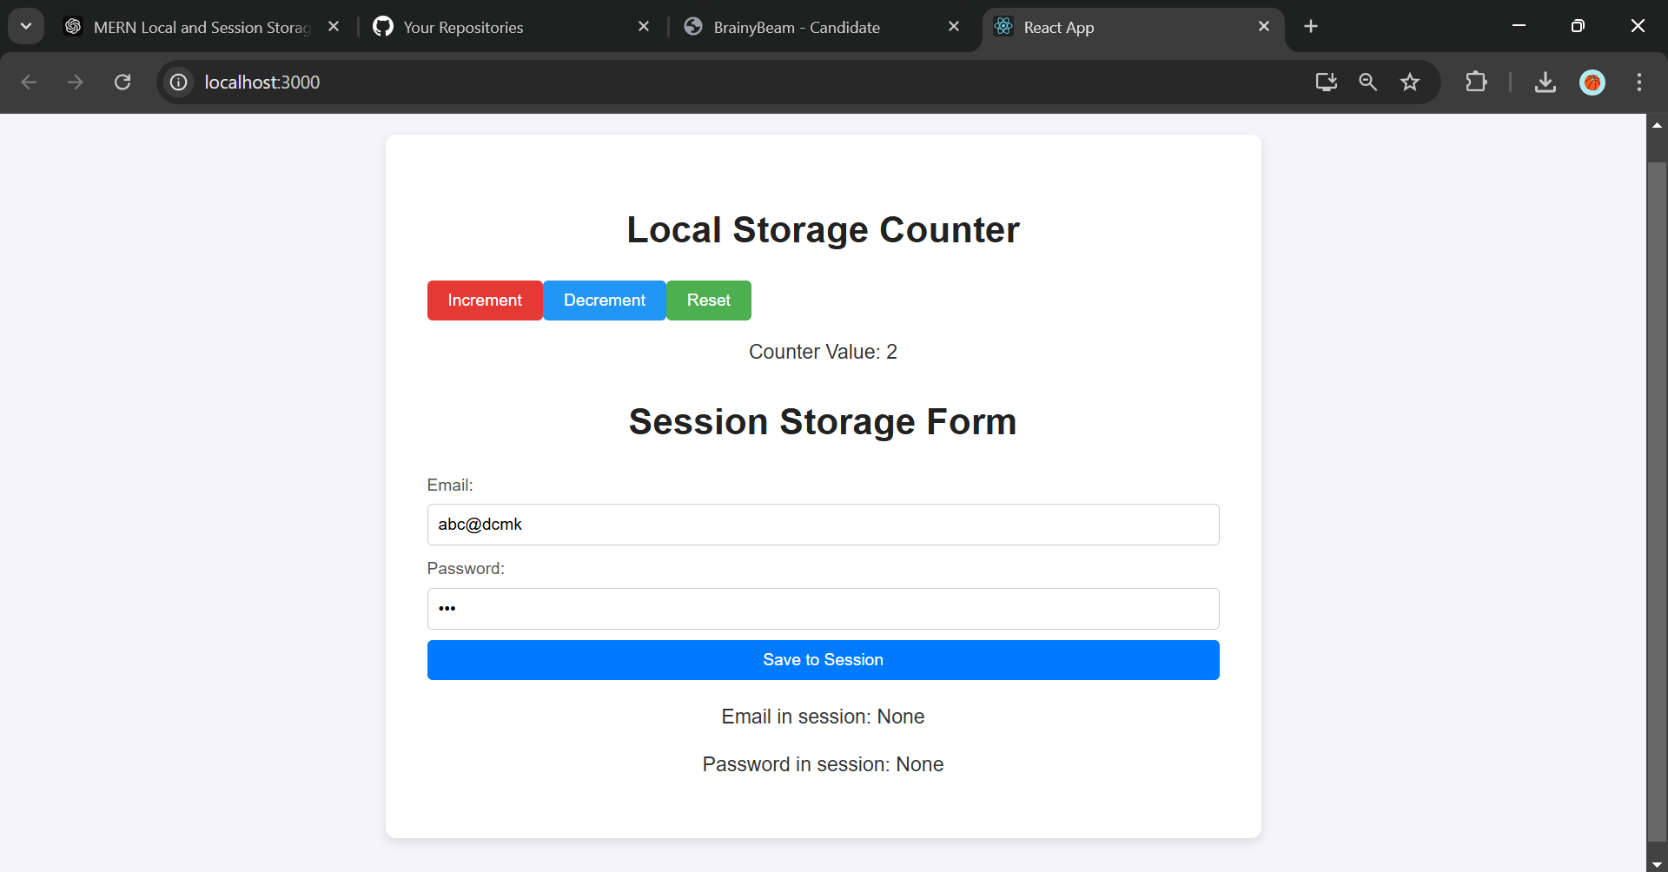

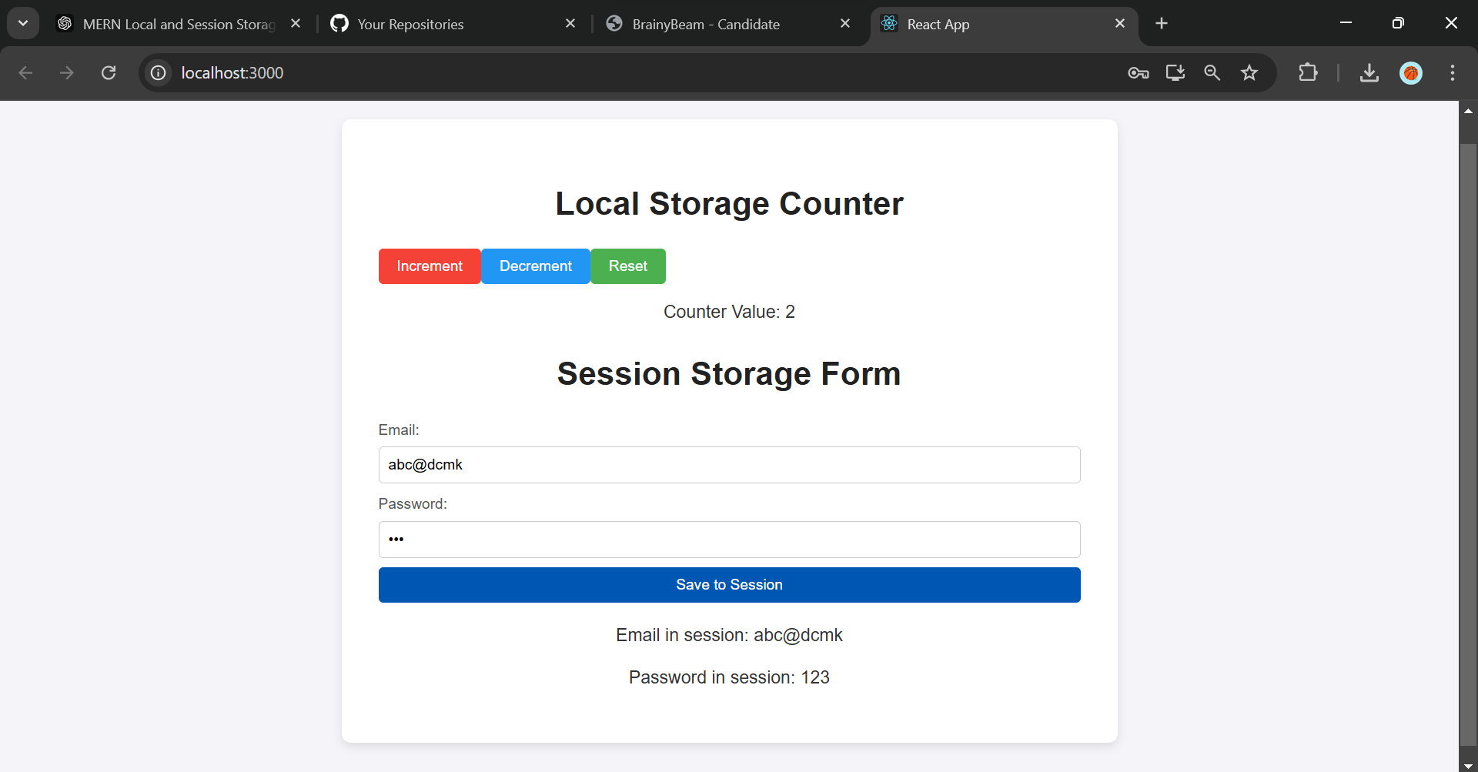

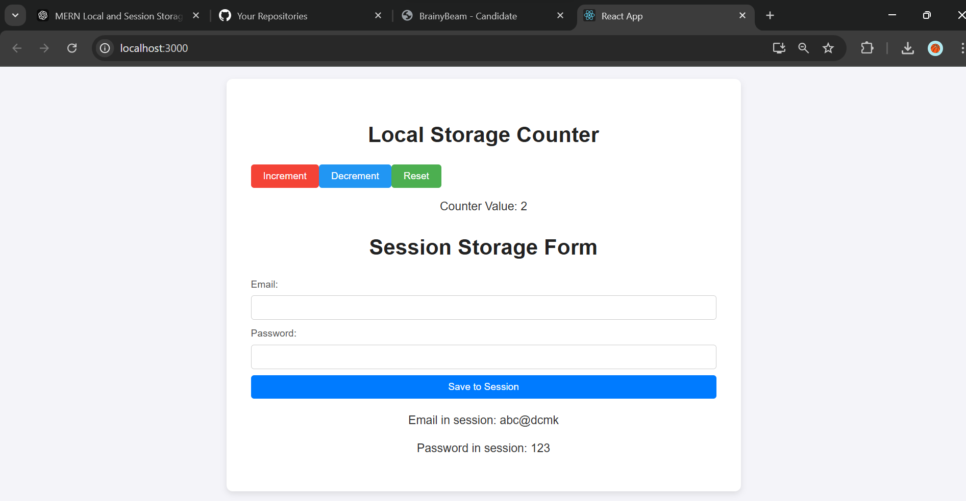

**3. Widgets/Algorithms Used in Task**

* **Counter Component**:
  + **useState** Hook: Used to manage the counter state.
  + **useEffect** Hook: Ensures the counter value is saved and retrieved from localStorage.
  + **localStorage API**: Stores counter value for persistence across sessions.
* **Form Component**:
  + **useState** Hook: Handles the input values for email and password.
  + **sessionStorage API**: Temporarily stores email and password values for the current session.
  + **Form Validation**: Ensures email and password fields are not empty before saving.
* **CSS Styling**:
  + **Flexbox**: Used for layout alignment and responsiveness.
  + **Media Queries**: Ensure the UI adapts to smaller screen sizes.
  + **Button Styling**: Adds hover and active effects for better interactivity.