**1. Task Description**

The task was to create a **Portfolio Website** that showcases personal information, skills, projects, and a contact form. The website consists of the following sections:

* **Home Section**: Displays an introduction with a download resume button and GitHub link.
* **Skills Section**: Lists skills as clickable buttons.
* **Projects Section**: Highlights major projects with brief descriptions.
* **Contact Section**: Contains a form to collect user details (Name, Email, and Message).

Additionally, the website incorporates navigation links to redirect to different sections and applies a smooth scrolling effect for better user experience.

**2. Task Output Screenshot**

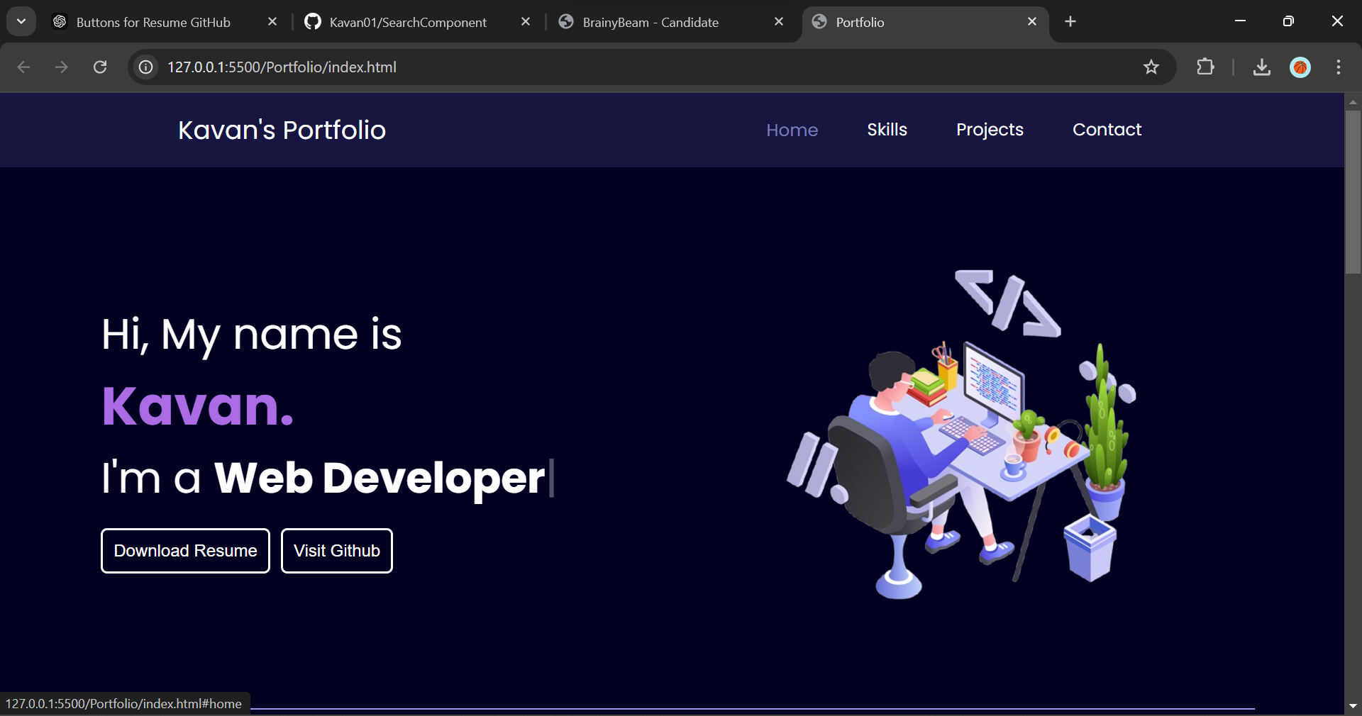

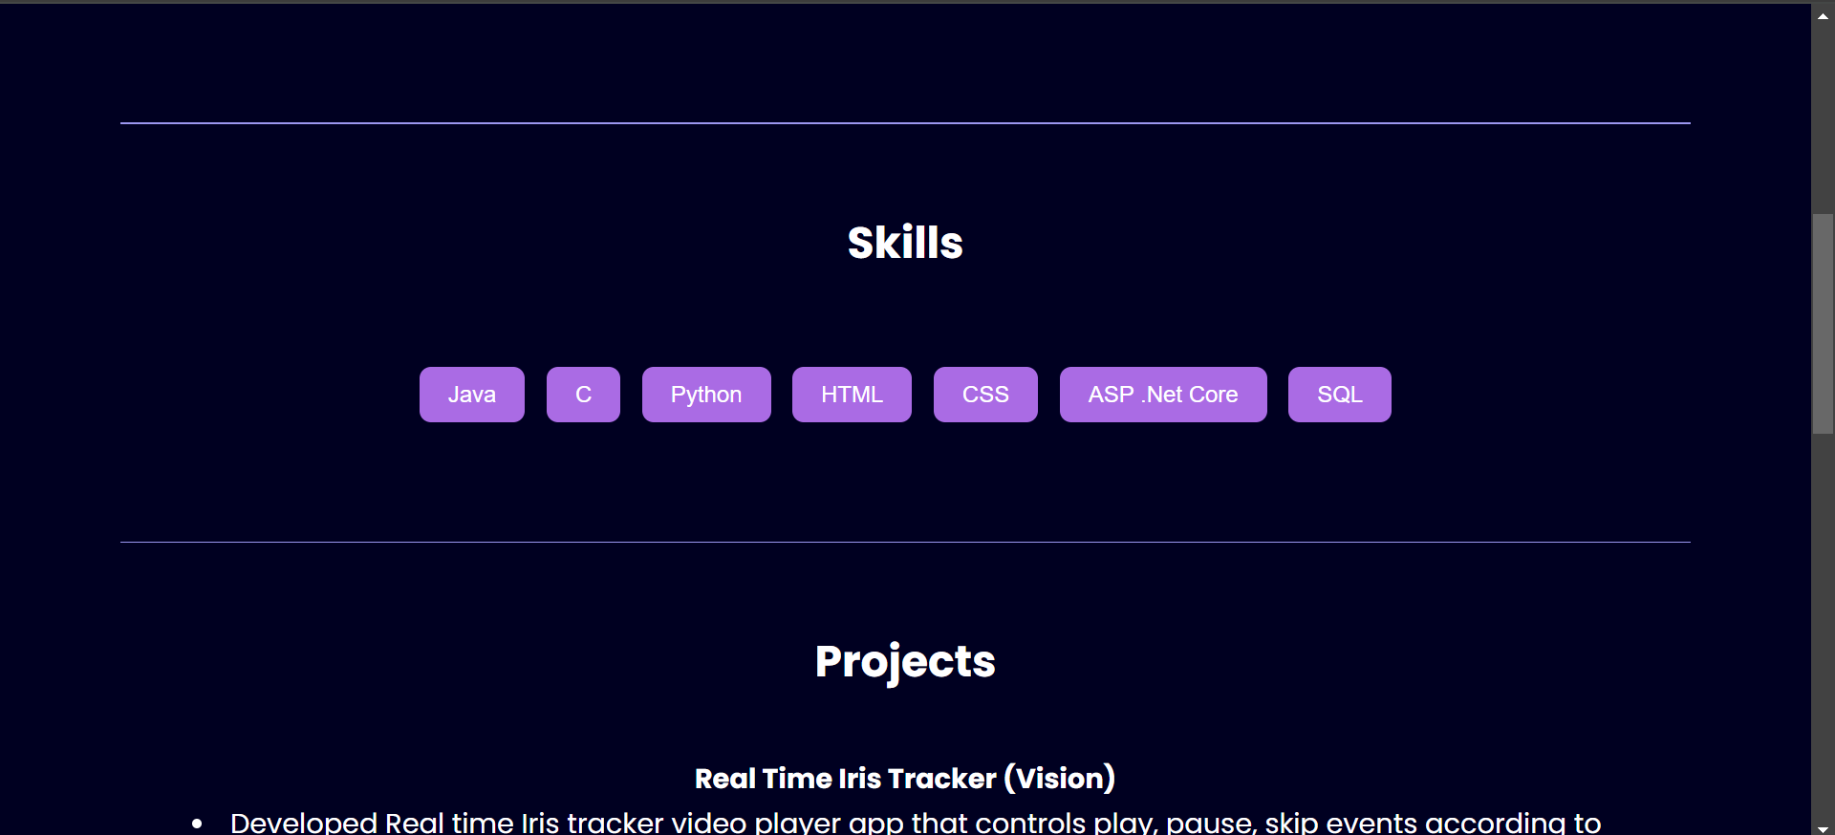

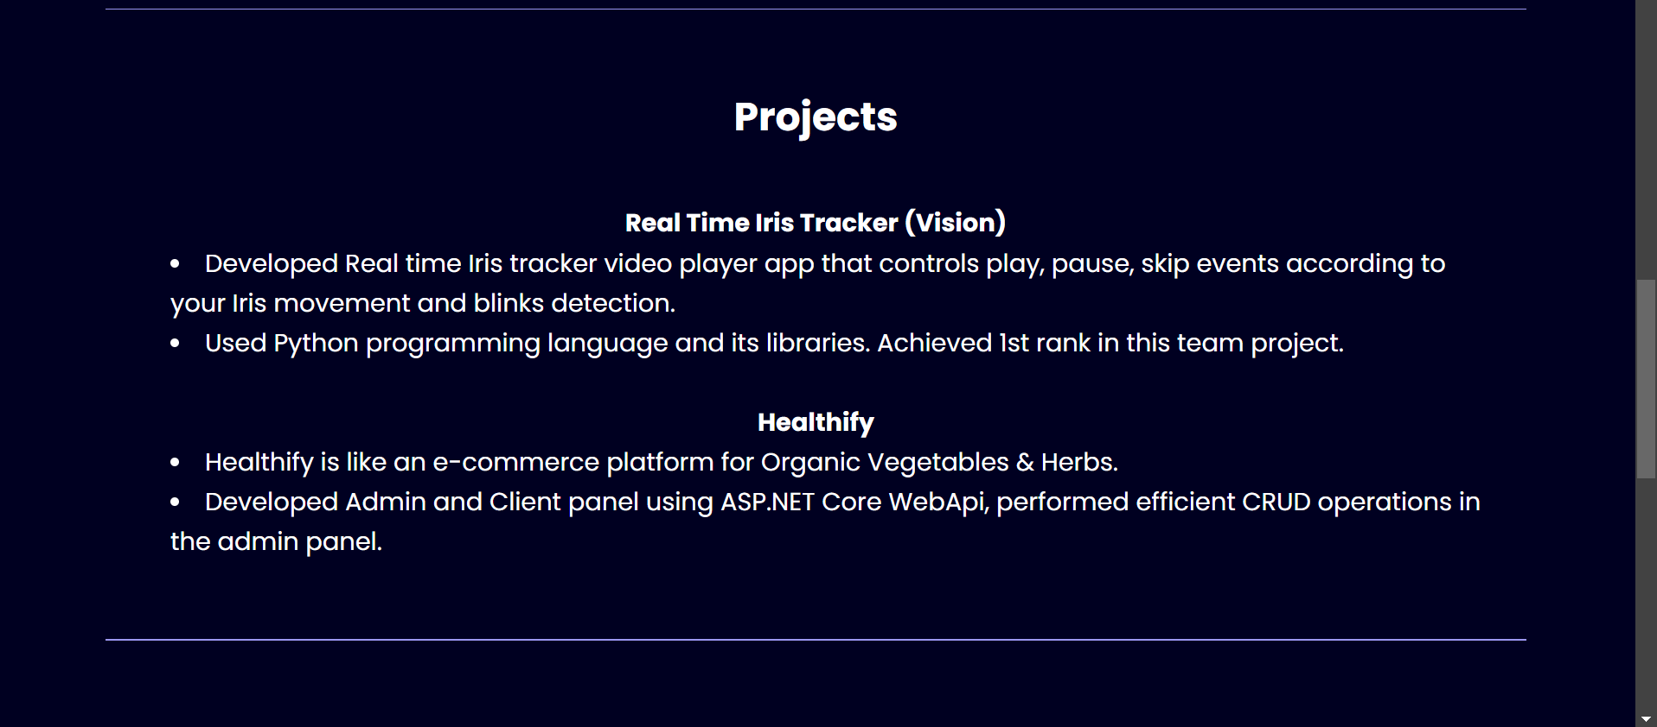

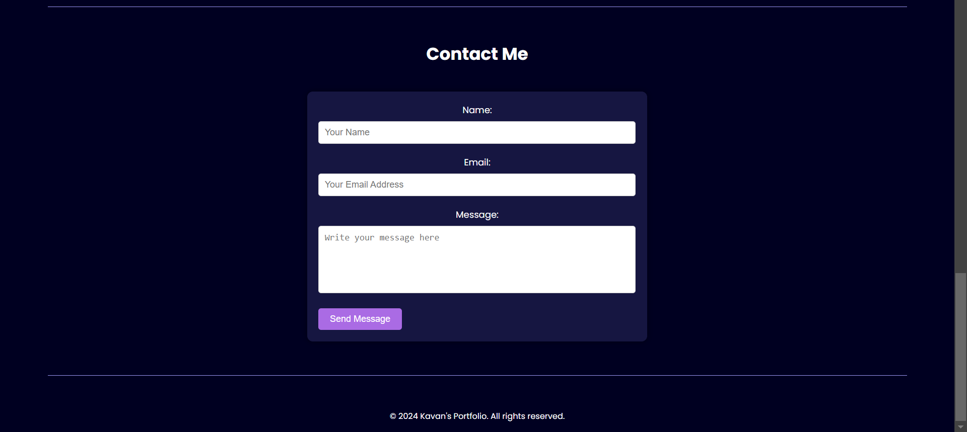

**3. Widgets/Algorithms Used in Task**

**Widgets and Elements Used**

1. **HTML Elements**:
   * header, nav, section, footer: Used to structure the website content into meaningful blocks.
   * ul, li, a: For navigation and linking sections within the page.
   * form, input, textarea, button: Used in the contact form.
2. **CSS Styling**:
   * Applied styles for layout and responsiveness.
   * Used properties like flexbox for alignment and scroll-behavior for smooth scrolling.
3. **JavaScript**:
   * **Typed.js Library**: Used for animating the introduction text in the home section.

**Features Implemented**

* **Button Widget**: Used for creating the "Download Resume" and "Visit GitHub" buttons.
* **Form Validation**: Ensured required fields in the contact form are not empty before submission.
* **Navigation Links**: Redirected users to different sections of the page using id attributes and anchor links.