**1. Task Description**

**Project Objective:** The task was to create a simple movie listing application using the **MERN** stack (MongoDB, Express, React, Node.js). The objective was to build a system that fetches movie details from the **OMDb API** and displays the movies in a structured format on the frontend.

**Steps Followed:**

* Set up the backend using **Node.js** and **Express** to fetch movie data from the **OMDb API**.
* Create API routes to handle movie fetching based on search queries.
* Develop the frontend using **React** to display the movies in a list format.
* Display movie details like title, poster, rating, plot, and year.
* Use **Axios** for HTTP requests and **useState** and **useEffect** hooks to manage data in the frontend.

**2. Task Output Screenshot**

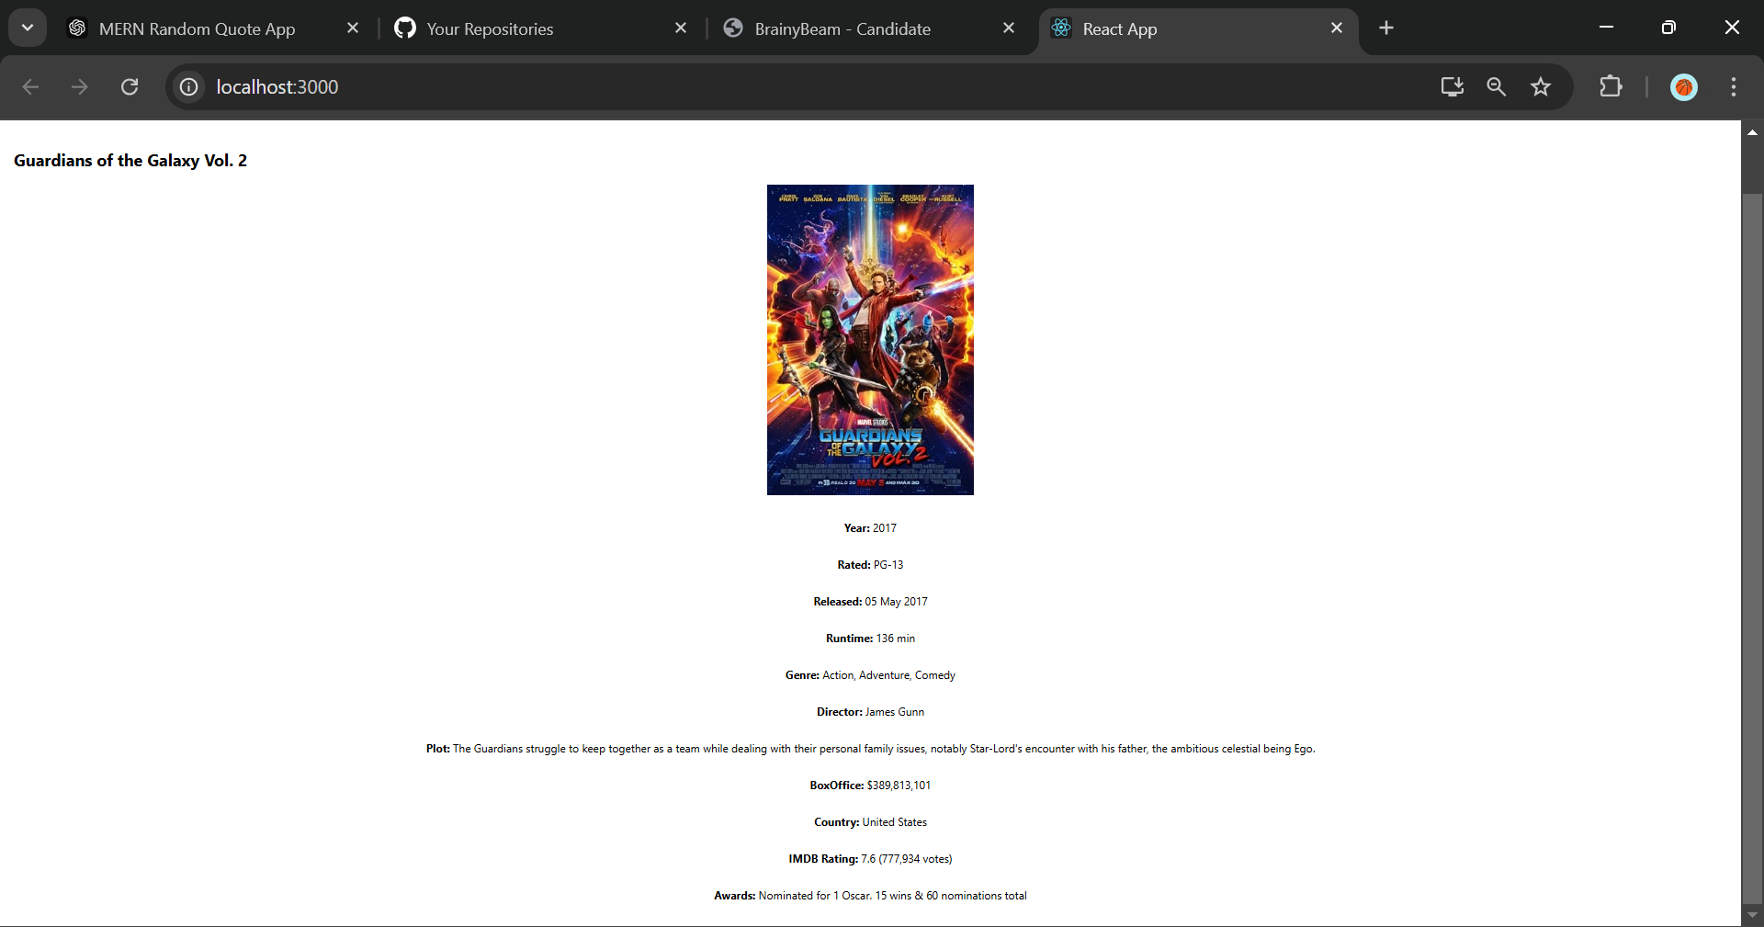

**3. Widget/Algorithm Used In Task**

**Backend:**

* **Axios**: Used to make HTTP requests to the OMDb API and fetch movie data.
* **Express**: Used to create API endpoints that the frontend can call to fetch data.

**Frontend:**

* **useState**: A React hook used to manage the state of movie data.
* **useEffect**: A React hook used to fetch the movie data when the component is mounted.
* **Axios**: Used to make HTTP requests from the frontend to the backend.
* **map()**: Used to iterate over the list of movies and display each movie’s details.

**Widgets Used:**

* **React Components**: The main widget used to structure the application. The MovieList component is responsible for rendering each movie.
* **Image**: Display the movie poster for each movie in the list.
* **Text**: Show details like movie title, year, genre, and rating for each movie.