**1. Task Description**

Create a **Search Component** that filters a list of items (in this case, fruits) based on user input. The component dynamically displays results matching the search term entered by the user. It uses React hooks such as useState for state management and integrates a search input field to provide a real-time filtering experience.

**2. Task Output Screenshot**

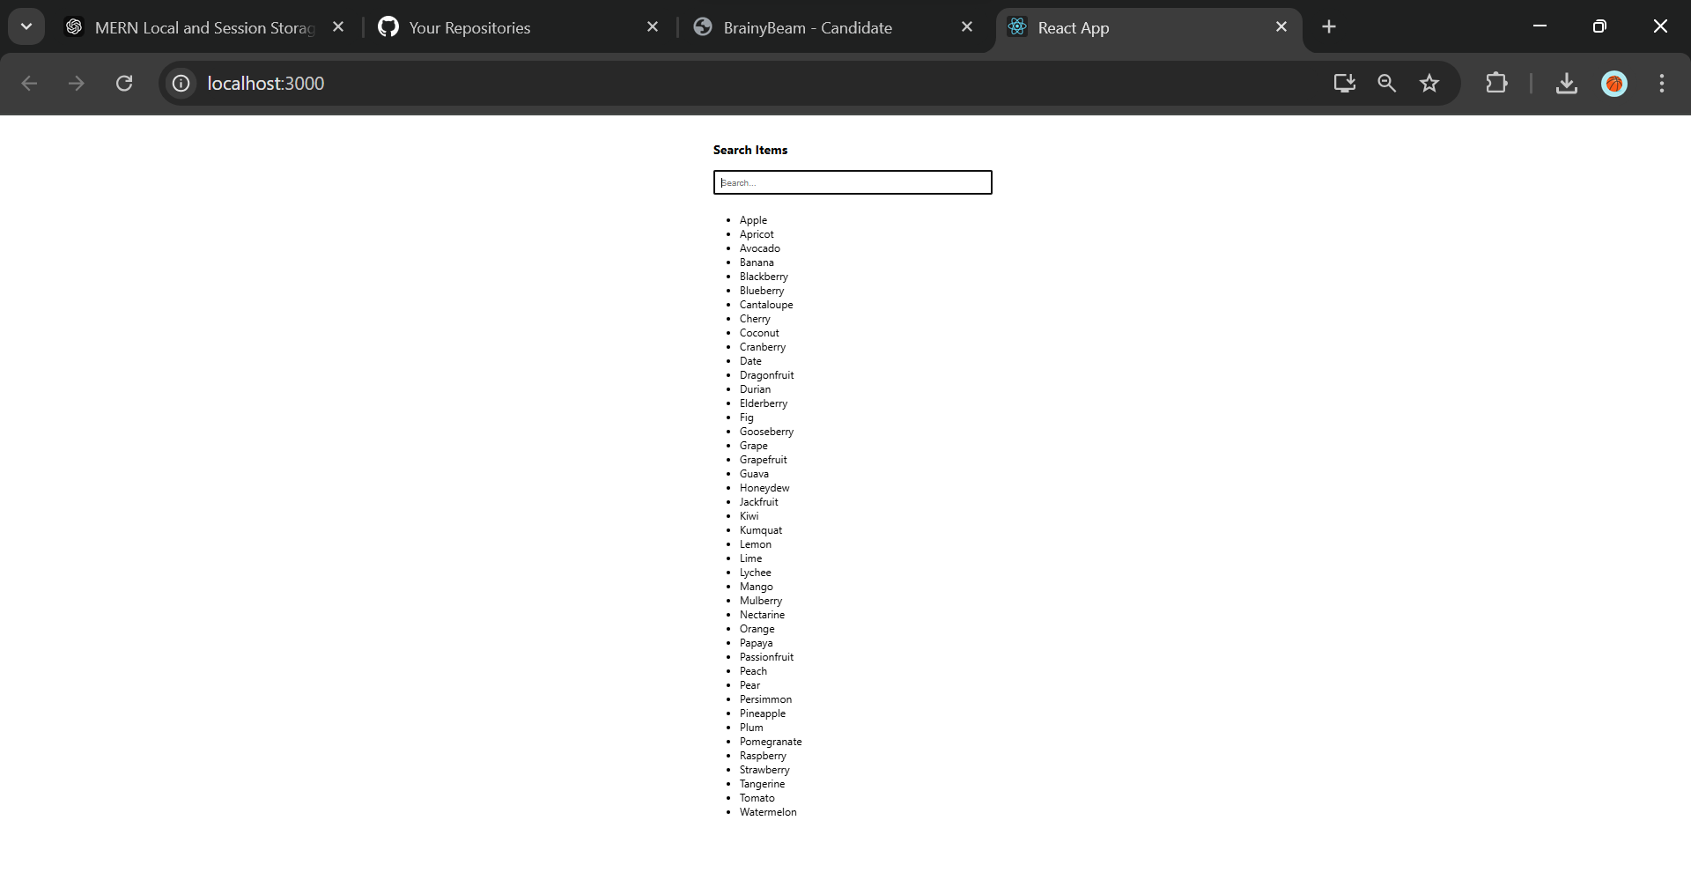

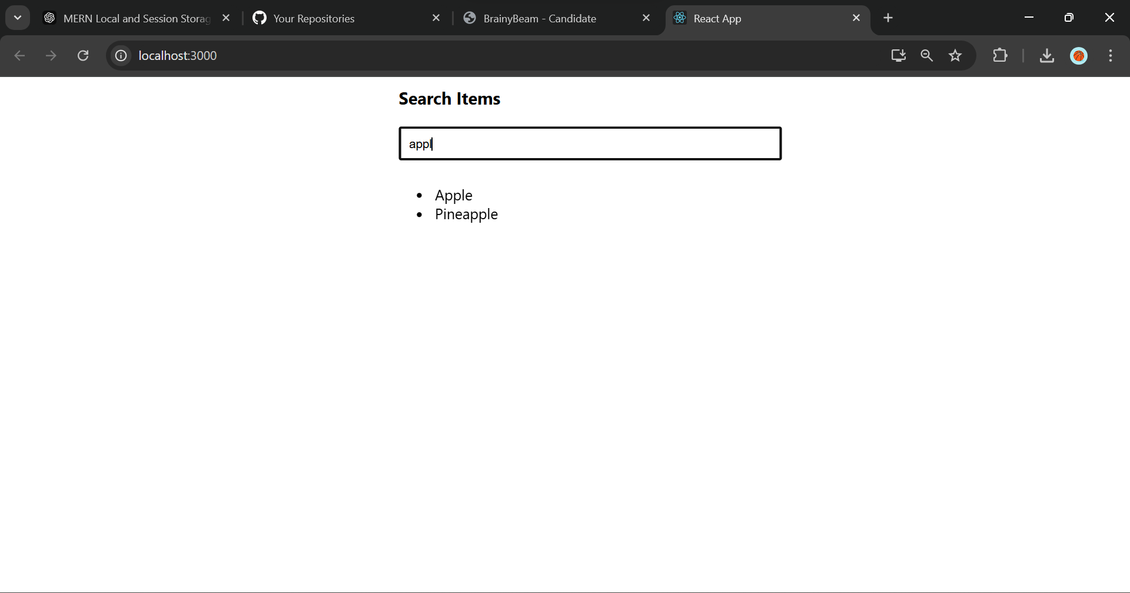

**3. Widget/Algorithm Used in Task**

* **React Components**:
  + Created a functional component SearchComponent to house the search logic.
* **useState Hook**:
  + Used to manage the state of the search term (searchTerm).
* **Filter Algorithm**:
  + The filter method is applied on the list of fruits to return results that match the search term.
* **Input Field**:
  + Provides a real-time interface for the user to type in the search term.
* **Unordered List (<ul>)**:
  + Displays filtered items dynamically in the form of a list.
* **Styling**:
  + Inline styles are used for basic layout and styling, such as input padding and list spacing.