A

Project Report On

**Student Result Management**

Submitted By:

Bhanderi Kavan &

Mathiya Kano

BCA Semester–6

Project Guide:

Prof. Pranav Trivedi

Submitted To:

Geetanjali College Of

Computer Science And Commerce (B.B.A).

Rajkot.

Academic Year: 2024-2025

## Acknowledgement

We Are Happy To Submit Our Idea Of "Student Result Management " Software To Saurashtra University, Rajkot For BCA Course In Computer Branch.

We Are Also Grateful To Prof. Brijesh Shah, The Head of The Department And All The Faculty Members Of The Department Of Computer Science For Their Kind Support Through Out This Journey.

We Take The Privilege To Acknowledge The Elite Authors Of Numerous Books And Papers And Blogs Which We Have Referred During Progress Of The Project.

The Feeling Of Gratefulness To Any One's Help Directly Arises From The Bottom Of Our Heart. A Small But An Important And Timely Help Can Prove To Be A Milestone In One's Life.

# Index

Project Profile 4

Software Development Life Cycle 5

System Requirement (For Development) 12

About the Tool (Tools & Technology used) 13

DFD (Data Flow Diagram) 17

ER (Entity Relationship Diagram) 18

Data Dictionary 19

Screen Shots 20

Limitation 26

Future Enhancement 27

Webliography 28

# Project Profile

* Project Title : Student Result Management
* Development Software : VS Code
* Front End : Python
* Backend : SQL
* Academic Year : 2024-2025
* Developed By : Bhanderi Kavan &

Mathiya Kano

* Submitted To : Geetanjali College
* Documentation Tool : Microsoft Word
* Operating System : Windows
* Language : Python

## System Development Life Cycles

For The Development Of This Project We Have Followed The Simple Waterfall Model Of SDLC.

The Waterfall Model Was The First Process Model To Be Introduced. It Is Also Referred To As A Linear-Sequential Life Cycle Model. It Is Very Simple To Understand And Use. In A Waterfall Model, Each Phase Must Be Completed Before The Next Phase Can Begin And There Is No Overlapping In The Phases.

The Waterfall Model Is The Earliest SDLC Approach That Was Used For Software Development.

The Waterfall Model Illustrates The Software Development Process In A Linear Sequential Flow. This Means That Any Phase In The Development Process Begins Only If The Previous Phase Is Complete. In This Waterfall Model, The Phases Do Not Overlap.

Step :-

1. Project Planning
2. Requirements Gathering
3. System Design
4. Implementation
5. Testing
6. Deployment
7. Maintenance
8. **-** **Requirement Gathering**

Any software development process must include the **Requirement Gathering** stage. After selecting the project topic, one must thoroughly research every criterion needed to construct that specific project.

We began gathering requirements for the **Student Result Management System** by exploring various **student management systems** and **result processing applications** available in the market. In order to learn about the necessary functionalities and features needed for the efficient management of student information and results, we examined different applications that focus on **student registration**, **result management**, and **data presentation**.

We explored various **educational apps** and **school management systems** to understand the required functionalities and layout design, focusing on how they manage student data and generate results.

Features That Are Needed In System For Users Are As Follows:

* 1. **Course Page :**

**Purpose:** This page will manage all the course-related information.

**Fields to be included:**

* **Course Name**: Name of the course (e.g., "Computer Science", "Mathematics").
* **Duration**: Duration of the course (e.g., "3 months", "6 months").
* **Charges**: Course fee (e.g., "1000 USD").
* **Description**: A brief description of the course content.
  1. **Student Page:**

**Purpose:** This page will manage student information, including personal and academic details.

**Fields to be included:**

* **Roll No.**: Unique identifier for the student (e.g., "CS101").
* **Name**: Full name of the student.
* **Email**: Email address of the student.
* **Gender**: Gender of the student (e.g., "Male", "Female", "Other").
* **Date of Birth (DOB)**: Birthdate of the student (in format: DD/MM/YYYY).
* **Contact Number**: Student’s contact number.
* **Admission Date**: Date the student was admitted to the course (in format: DD/MM/YYYY).
* **Course**: The course the student is enrolled in (e.g., "Computer Science").
* **State**: The state where the student resides.
* **City**: The city where the student resides.
* **Pincode**: Postal code for the student’s address.
* **Address**: Full address of the student.
  1. **Result Page:**

**Purpose:** This page will allow the admin to manage student results.

**Fields to be included:**

* **Select Student**: Dropdown or search box to select a student by their roll number or name.
* **Name**: The student’s name (this will auto-fill when the student is selected).
* **Course**: The course the student is enrolled in (this will auto-fill when the student is selected).
* **Marks Obtained**: Marks the student received in the exam (e.g., 80/100).
* **Full Marks**: The total possible marks for the exam (e.g., 100).
  1. **View Student Result Page :**

**Purpose:** This page will allow the admin to view a student’s result by searching using the roll number.

**Fields to be included:**

* **Search Roll No.**: Text box to enter the roll number of the student whose result needs to be viewed.
* **Details Displayed**: Upon searching the roll number, display:
  + Student name.
  + Course name.
  + Marks obtained.
  + Full marks.
  + Grade (calculated based on marks obtained).

1. - **Project Planning**

Once the **Requirement Gathering** phase has been completed, the next step is to create a **Project Plan**. This involves determining the required project modules and selecting the optimal technologies for development.

To Create The Existing Project, Choosing Technologies In This Case Means Selecting Frontend And Backend Technology.

For the **Student Result Management System**, we have chosen to use **Python** with a **GUI framework** for the **User Interface (UI)** development.

For the backend of the Student Result Management System, we will use Python with a SQLite database for storing and managing data.

1. - **System Design**

This Process Can Be Broken Down Into Two Parts: The Preliminary Design And The Final Design. The Project's Basic Layout Is Generated On Paper Or Using Any Design Program During The Preliminary Design Phase, And The Development Team Then Evaluates The Design's Viability.

The Second Phase Is Final Design, In Which The Project's Final Or Nearly Accurate Design Is Constructed After Earlier Concepts Have Been Evaluated For Practicality And Flaws Have Been Identified.

In My Project Each page will have a simple and intuitive layout, with clear fields for input and buttons for actions like "Add", "Update", "Delete", "Save", and "Search".

* **Course Page** will display a table of courses with options to add, update, and delete courses.
* **Student Page** will have a similar layout, with a table showing student information and options to add, update, and delete students.
* **Result Page** will display a form for entering marks and a table to view results.
* **View Result Page** will have a search bar to look up a student’s results by their Roll Number and show their detailed results.
* **Logout** and **Exit** will be simple buttons placed at the top or bottom of the window.

1. - **Coding & Implementation**

The Actual Application Is Coded In The Chosen Programming Language Following The Collection Of All Requirements, Customer Approval Of The Design, And Feasibility Assessment Of The Project.

This phase is considered the longest in the **Software Development Life Cycle (SDLC)**, as it involves writing, testing, and debugging code to develop a fully functional system. The development team ensures that the system is implemented according to the design specifications.

To complete this phase, various tools are required, including **Integrated Development Environments (IDEs), databases, and frameworks**. For the development of the **Student Result Management System**, we have selected **Visual Studio Code** for coding the backend using **Python** and managing the overall project structure.

**Implementation Steps in Python:**

1. **Setting Up the Development Environment:**
   * Install **Visual Studio Code** and configure Python.
   * Install required libraries like **Tkinter** (for GUI) and **SQLite3/MySQL** (for database).
   * Set up a virtual environment if necessary for dependency management.
2. **Developing the Backend (Python & Database):**
   * Create the database and define tables for **Students, Courses, and Results**.
   * Develop Python scripts for **CRUD operations** (Create, Read, Update, Delete).
   * Implement logic for **storing, retrieving, updating, and deleting** student result records.
3. **Building the User Interface (Tkinter for GUI):**
   * Design simple and **intuitive forms** with buttons like **Add, Update, Delete, Save, and Search**.
   * Develop separate pages for **Student Management, Course Management, and Result Entry**.
   * Implement a **View Result Page**, allowing users to search for results by roll number.

**5 - Testing**

After the coding and implementation phase, testing is conducted to ensure that the **Student Result Management System** functions as expected. Testing is a critical phase in the **Software Development Life Cycle (SDLC)** as it helps identify and fix defects before deployment.

The goal of testing is to validate that all modules, such as **Student Management, Course Management, and Result Entry**, work correctly and that the system meets the design specifications.

To complete this phase, various **testing techniques** are applied, including **unit testing, integration testing, and user acceptance testing**.

## System Requirement Specifications

To Develop This Project, The Following System Hardware And Network Are Required:

Minimum Hardware Requirement: For Android Application:

|  |  |
| --- | --- |
| Operating System | Windows OS |
| CPU/Processor | No Specific |
| Ram | 4 GB |

## About The Tools & Technologies

#### Python :

Python is a high-level, open-source programming language known for its simplicity and versatility. It is widely used for developing various applications, including desktop applications, web applications, data analysis, artificial intelligence, and automation. Python provides an extensive set of libraries and frameworks that make development efficient and scalable. Available on Windows, macOS, and Linux, Python has become one of the most preferred languages for modern software development.

Initially introduced in 1991 by Guido van Rossum, Python has undergone continuous evolution. Its simplicity, readability, and extensive community support have contributed to its widespread adoption across industries. The language emphasizes rapid development with features like dynamic typing, automatic memory management, and an extensive standard library, making it ideal for both beginners and experienced developers.

Python's ecosystem includes powerful frameworks and libraries such as Tkinter (for GUI development), Flask/Django (for web development), Pandas (for data processing), and Pytest (for testing). This enables developers to build diverse applications, ranging from desktop GUI-based systems to data-driven applications. Additionally, Python’s integration capabilities with databases, cloud platforms, and APIs make it a robust choice for scalable software solutions.

**Visual Studio:**

Visual Studio Code (VS Code) is a lightweight, open-source, and highly extensible Integrated Development Environment (IDE) developed by Microsoft. It is designed for modern software development, offering a powerful yet user-friendly experience for developers across various programming languages.

VS Code is cross-platform, available for Windows, macOS, and Linux, making it accessible to a wide range of users. It is known for its fast performance, minimal resource usage, and high customizability through extensions. Unlike traditional IDEs, VS Code is optimized for efficiency, ensuring quick startup times and smooth operation.

One of its most notable features is IntelliSense, which provides smart code completion, syntax highlighting, and real-time error detection, enhancing the overall coding experience. The built-in terminal allows developers to run commands and scripts directly within the editor, reducing the need for external command-line tools.

VS Code comes with native Git integration, enabling seamless version control management. Developers can commit changes, push to repositories, and track modifications without leaving the IDE. Additionally, the Live Share feature allows real-time collaboration, making it easy for teams to work together remotely.

The extension marketplace in VS Code offers a vast collection of plugins for various programming languages, frameworks, and tools. Popular extensions include support for Python, JavaScript, C++, HTML/CSS, MySQL, Flask, Django, and more, allowing developers to tailor the IDE to their specific needs.

Debugging in VS Code is efficient and interactive, with features like breakpoints, call stacks, and an interactive console, making it easier to identify and resolve issues. Furthermore, its integration with Jupyter Notebooks enables data scientists and machine learning developers to work seamlessly within the IDE.

With its lightweight nature, extensive customization options, and powerful debugging tools, VS Code has become one of the most widely used IDEs for both beginners and experienced developers. It is an excellent choice for Python development, web development, and cross-platform application development.

#### Tkinter:

Tkinter is the standard GUI (Graphical User Interface) library for Python, allowing developers to create interactive desktop applications with ease. It is a built-in module, meaning it comes pre-installed with Python, eliminating the need for additional installations.

Tkinter provides a simple yet powerful framework for building applications with graphical elements such as windows, buttons, labels, text fields, menus, and more. It follows an event-driven programming model, where user interactions trigger specific actions.

The library is based on Tcl/Tk, a GUI toolkit that has been widely used for many years. It offers a flexible and customizable approach to designing interfaces while maintaining a lightweight footprint. Developers can use grid, pack, and place geometry managers to position UI elements efficiently.

With Tkinter, applications can be designed with a native look and feel, and it supports additional styling through ttk (Themed Tkinter Widgets) for modernized UI components. It also integrates well with databases like SQLite and MySQL, making it a great choice for data-driven applications such as the Student Result Management System.

Due to its ease of use, built-in availability, and cross-platform support (Windows, macOS, and Linux), Tkinter is a popular choice for Python GUI development, especially for beginners and small to medium-sized projects.

#### SQLite:

SQLite is a lightweight, self-contained, and serverless relational database management system (RDBMS). It is widely used for local data storage in applications, making it an ideal choice for small to medium-sized projects. Unlike traditional databases such as MySQL or PostgreSQL, SQLite does not require a separate server process, as it operates through a simple file-based approach.

One of SQLite’s key advantages is its zero-configuration setup, meaning there is no need for database installation or administration. The entire database is stored in a single .sqlite file, which makes it highly portable and easy to integrate with applications.

SQLite supports standard SQL syntax, allowing developers to perform CRUD operations (Create, Read, Update, Delete), indexing, transactions, and complex queries efficiently. It is commonly used in desktop applications, mobile apps, embedded systems, and lightweight web applications.

Python provides built-in support for SQLite through the sqlite3 module, allowing seamless integration with Python projects. For the Student Result Management System, SQLite can be used to store and manage student details, courses, and results without requiring an external database server.

Due to its simplicity, efficiency, and minimal resource usage, SQLite is a popular choice for applications that need a lightweight yet powerful database solution.

#### Microsoft Word:

Microsoft Word is a word processing software developed by Microsoft, widely used for creating, editing, formatting, and sharing text-based documents. It is a part of the Microsoft Office Suite and is available on Windows, macOS, and web-based platforms.

Microsoft Word provides a rich set of features for document creation, including text formatting, tables, images, charts, headers, footers, page layouts, and styles. It also supports spell check, grammar correction, and collaboration tools, making it ideal for both individual and professional use.

With cloud integration via OneDrive, users can store and access their documents from anywhere, ensuring easy sharing and collaboration. Word also supports multiple file formats, including .docx, .pdf, .txt, and .rtf, providing flexibility for different needs.

Due to its user-friendly interface, advanced editing capabilities, and extensive compatibility, Microsoft Word remains one of the most widely used word processors for business, education, and personal document creation.

## Data Flow Diagram

## Entity Relationship Diagram

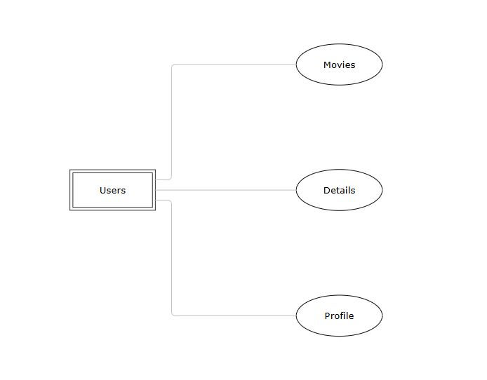

## Data Dictionary

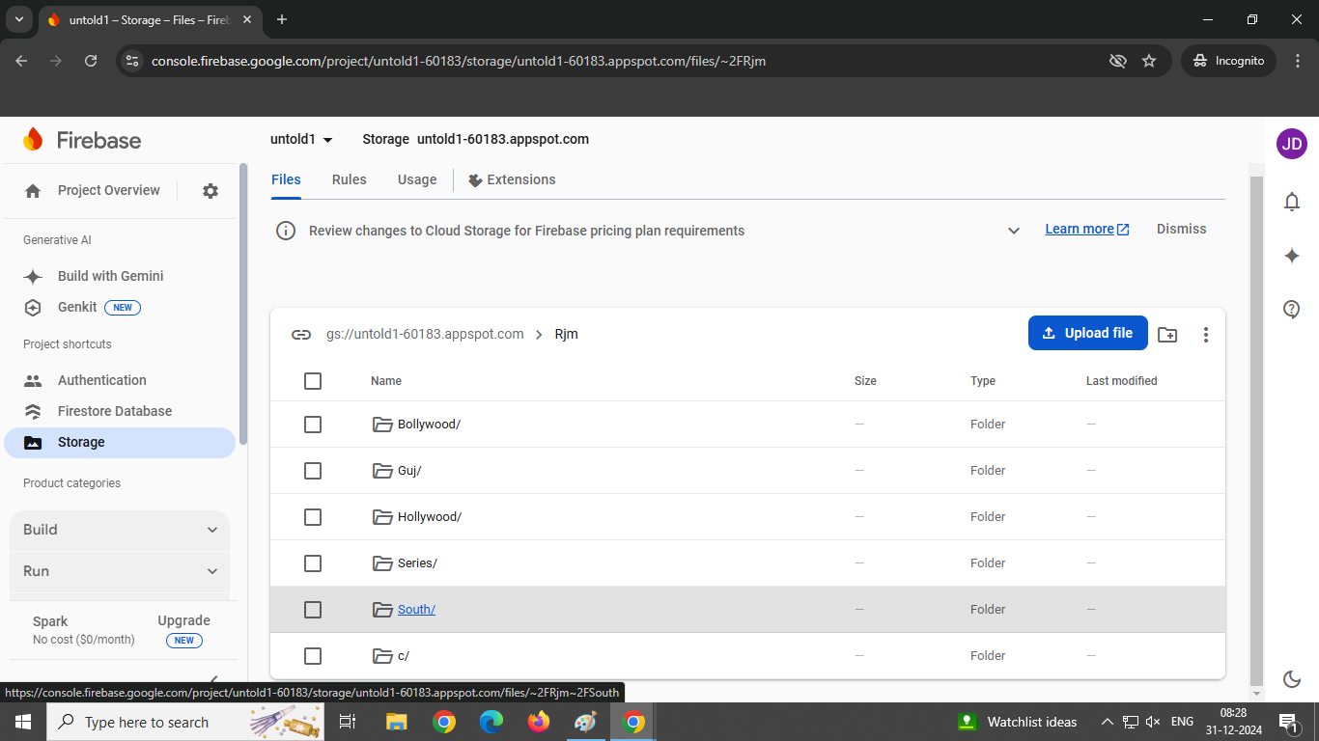

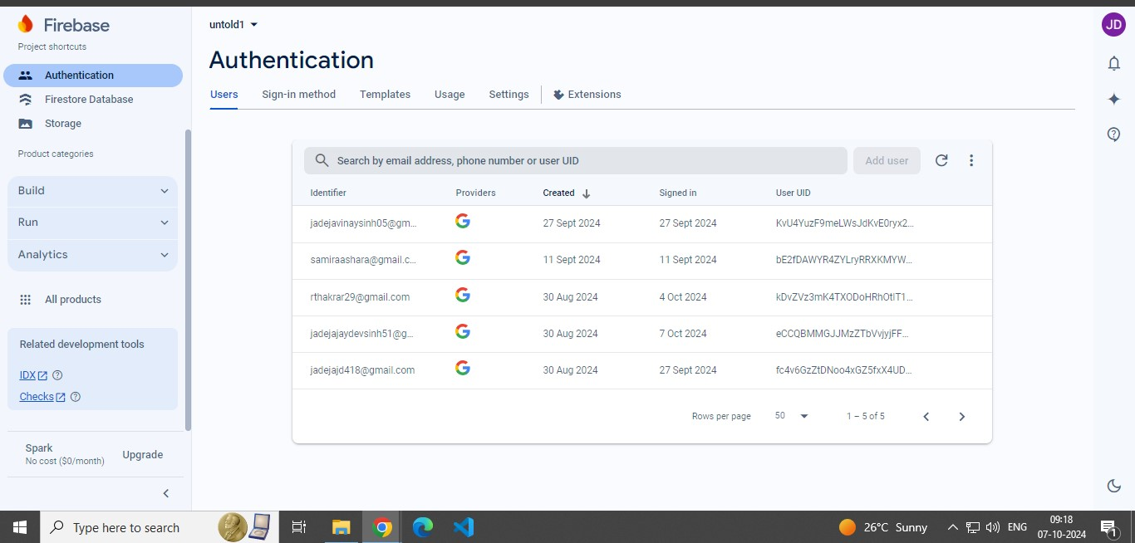

## Screen Shots

## Login Screen:

## 

## 

## These Are The Pages For Login As It Contains The Splash Screen Which Allows You To Login With Google.

## On Clicking The Sign In With Google Button You Will Be Showed Up The Logged In Google Accounts In The Mobile Phone.

## On Selecting The Google Account To Be Logged In With You Will Be Navigated To The Home Screen Of The App.

## Home Screen

## 

## This Is The Home Screen Of The App Which Shows You Latest Movies Which Are A Mixture Of All The Types Of Movies, Which Includes Tollywood, Bollywood, Hollywood, Gujarati, Web Series.

## 

## Category Wise Page

## 

## These Are The Pages Which Are Category Wise Classified , Which Includes Web Series , Hollywood, Gujarati , Bollywood, Tollywood.

## Detail Page

## 

## It Provides The Summary Of The Movie On Which You Tapped.

## It Also Provides Movies Resolution, Its Category, Year Of Release, Ratings.

## Along With The Screenshots Of The Movies And A Download Button Which Directly Navigates User To That Particular Movie Download Section In The Telegram.

## Profile Page:

## 

## This Is The Profile Page In Which The User Details Like The Gmail Photo , The Mail Id And The Username For The Gmail Is Provided.

## And Also You Can Logout Through The Center Bottom Logout Button In Order If You Want To Logout.

## Logging Out Will Navigate You To Login Screen.

## Limitation

* + Though We Tried Our Best In Developing This Application But As Limitations Are Major Parts Of Any App So Are Of Our App. Some Limitations Of RJ Movies Are As Follows:

-The First Limitation Is The Photos From The Database When Retrieved Are Very Slow In Order To Display In The Application.

-As Of Now We Have Noticed That As We Are Only Providing The Few Of The Movies We Are Having In Our Application That Is Those 70,75 Movies Only And We Are Not Able To Display Other Movies

## Future Enhancement

* + To Conclude, Project Data Grid Works Like A Component Which Can Access All The Databases And Picks Up Different Functions By Admin. Trying Remove The Many Limitations. Add Some Functionality In Future Are Shown Below.
    - Improve Application Behavior.
    - Also Make The Google Category Wise Movies.
    - Provide More Functionalities To Use In App.

## Webliography

* <https://flutter.dev/>
* <https://firebase.google.com/>
* <https://dart.dev/>
* <https://pub.dev/>