A Report

on

Micro Project

Employee Payroll Schema

**Subject: Relational Database Management System**

**Subject Code: 4330702**

**Branch: Computer Engineering**



**Government Polytechnic, Ahmedabad**

**Team:**

* **Kavan Bhavsar - 226170307015**
* **Bhavya Bagadia - 226170307004**
* **Khush Panchal - 226170307075**

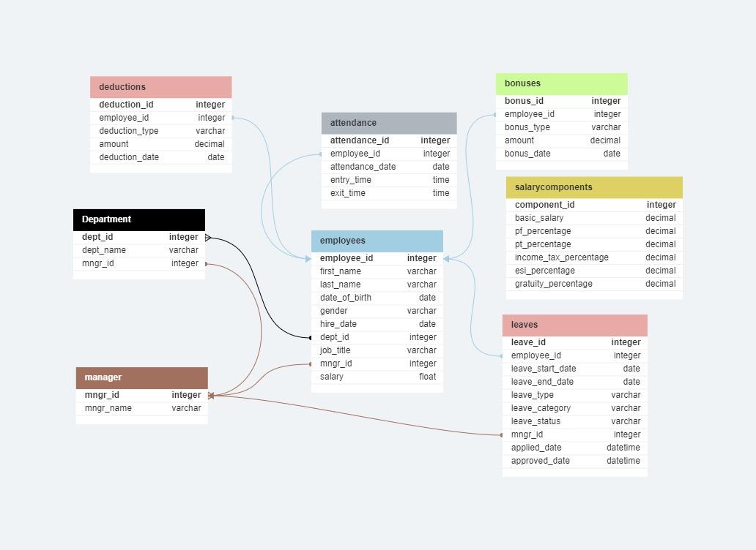

Introduction:

The given database schema comprises several tables that together manage and store information about an employee payroll system. Here's a summary breakdown of each table's purpose:

1. Manager Table (manager):

- Tracks information about managers in the company.

- Attributes: manager ID (unique identifier), manager name.

2. Department Table (department): [Not explicitly created in the provided schema but referenced in the Employees table]

- Holds information about departments in the company.

3. Employees Table (employees):

- Stores details about individual employees.

- Attributes: employee ID (unique identifier), first and last name, date of birth, gender, hire date, department ID (linked to department table), job title, manager ID, salary.

- Foreign key references: department ID links to department table, manager ID references manager table.

4. Leaves Table (leaves):

- Manages employees' leave-related data.

- Attributes: leave ID (unique identifier), employee ID (linked to employees table), leave start and end date, leave type, category, status, manager ID, applied and approved dates.

- Foreign key references: employee ID links to employees table, manager ID references manager table.

5. Deductions Table (deductions):

- Records deductions made from employee salaries.

- Attributes: deduction ID (unique identifier), employee ID (linked to employees table), deduction type, amount, deduction date.

- Foreign key references: employee ID links to employees table.

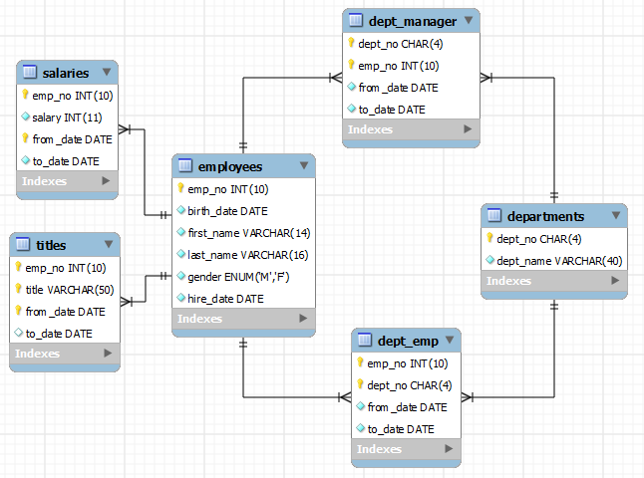

6. Bonuses Table (bonuses):

- Stores information about bonuses given to employees.

- Attributes: bonus ID (unique identifier), employee ID (linked to employees table), bonus type, amount, bonus date.

- Foreign key references: employee ID links to employees table.

7. Attendance Table (attendance):

- Manages employee attendance records.

- Attributes: attendance ID (unique identifier), employee ID (linked to employees table), attendance date, entry and exit times.

- Foreign key references: employee ID links to employees table.

8. Salary Components Table (salarycomponents):

- Stores specific salary components and their percentages.

- Attributes: component ID (unique identifier), basic salary, percentages for PF (Provident Fund), PT (Professional Tax), income tax, ESI (Employee State Insurance), gratuity.

This database setup seems to cover various aspects of managing employee-related data, including their personal details, leaves, attendance, salary components, deductions, bonuses, and managerial information.

# QUERIES:

## To create Database:

    CREATE TABLE manager (

        mngr_id NUMBER(5) PRIMARY KEY,

        mngr_name VARCHAR2(250) NOT NULL

    );

    -- Creating Department Table

    -- Creating Employees Table

    CREATE TABLE employees (

        employee_id NUMBER(5) PRIMARY KEY,

        first_name VARCHAR2(250) NOT NULL,

        last_name VARCHAR2(250) NOT NULL,

        date_of_birth DATE NOT NULL,

        gender VARCHAR2(210) NOT NULL,

        hire_date DATE NOT NULL,

        dept_id NUMBER(5) NOT NULL,

        job_title VARCHAR2(250) NOT NULL,

        mngr_id NUMBER(5) NOT NULL,

        salary FLOAT(10) NOT NULL,

        FOREIGN KEY (dept_id) REFERENCES department(dept_id),

        FOREIGN KEY (mngr_id) REFERENCES manager(mngr_id)

        ON DELETE CASCADE

    );

    -- Creating Manager Table

    -- Creating Leaves Table

    CREATE TABLE leaves (

        leave_id NUMBER(5) PRIMARY KEY,

        employee_id NUMBER(5) NOT NULL,

        leave_start_date DATE NOT NULL,

        leave_end_date DATE NOT NULL,

        leave_type VARCHAR2(50) NOT NULL,

        leave_category VARCHAR2(50) NOT NULL,

        leave_status VARCHAR2(20) NOT NULL,

        mngr_id NUMBER(5) NOT NULL,

        applied_date TIMESTAMP NOT NULL,

        approved_date TIMESTAMP NOT NULL,

        FOREIGN KEY (employee_id) REFERENCES employees(employee_id),

        FOREIGN KEY (mngr_id) REFERENCES manager(mngr_id)

        ON DELETE CASCADE

    );

    -- Creating Deductions Table

    CREATE TABLE deductions (

        deduction_id NUMBER(5) PRIMARY KEY,

        employee_id NUMBER(5) NOT NULL,

        deduction_type VARCHAR2(50) NOT NULL,

        amount DECIMAL(10,2) NOT NULL,

        deduction_date DATE NOT NULL,

        FOREIGN KEY (employee_id) REFERENCES employees(employee_id)

        ON DELETE CASCADE

    );

    -- Creating Bonuses Table

    CREATE TABLE bonuses (

        bonus_id NUMBER(5) PRIMARY KEY,

        employee_id NUMBER(5) NOT NULL,

        bonus_type VARCHAR2(50) NOT NULL,

        amount DECIMAL(10,2) NOT NULL,

        bonus_date DATE NOT NULL,

        FOREIGN KEY (employee_id) REFERENCES employees(employee_id)

        ON DELETE CASCADE

    );

    -- Creating Attendance Table

    CREATE TABLE attendance (

        attendance_id NUMBER(5) PRIMARY KEY,

        employee_id NUMBER(5) NOT NULL,

        attendance_date DATE NOT NULL,

        entry_time TIMESTAMP NOT NULL,

        exit_time TIMESTAMP NOT NULL,

        FOREIGN KEY (employee_id) REFERENCES employees(employee_id)

        ON DELETE CASCADE

    );

    -- Creating SalaryComponents Table

    CREATE TABLE salarycomponents (

        component_id NUMBER(5) PRIMARY KEY,

        basic_salary DECIMAL(10,2) NOT NULL,

        pf_percentage DECIMAL(5) NOT NULL,

        pt_percentage DECIMAL(5) NOT NULL,

        income_tax_percentage DECIMAL(5) NOT NULL,

        esi_percentage DECIMAL(5) NOT NULL,

        gratuity_percentage DECIMAL(5) NOT NULL

    );

## To insert the data:

INSERT INTO deductions VALUES (201, 1001, 'Health Insurance', 150.00, TO_DATE('2023-01-15', 'YYYY-MM-DD'));

INSERT INTO deductions VALUES (202, 1001, '401(k) Contribution', 200.50, TO_DATE('2023-02-20', 'YYYY-MM-DD'));

INSERT INTO deductions VALUES (203, 1005, 'Tax Withholding', 300.75, TO_DATE('2023-03-10', 'YYYY-MM-DD'));

INSERT INTO deductions VALUES (204, 1003, 'Union Dues', 50.00, TO_DATE('2023-04-05', 'YYYY-MM-DD'));

INSERT INTO deductions VALUES (205, 1006, 'Pension Contribution', 180.25, TO_DATE('2023-05-12', 'YYYY-MM-DD'));

INSERT INTO deductions VALUES (206, 1007, 'Education Expenses', 120.00, TO_DATE('2023-06-22', 'YYYY-MM-DD'));

INSERT INTO deductions VALUES (207, 1008, 'Garnishments', 75.50, TO_DATE('2023-07-18', 'YYYY-MM-DD'));

INSERT INTO deductions VALUES (208, 1010, 'Health Savings Account', 250.75, TO_DATE('2023-08-30', 'YYYY-MM-DD'));

INSERT INTO deductions VALUES (209, 1011, 'Charitable Contributions', 30.00, TO_DATE('2023-09-12', 'YYYY-MM-DD'));

INSERT INTO deductions VALUES (210, 1012, 'Child Support', 100.25, TO_DATE('2023-10-05', 'YYYY-MM-DD'));

INSERT INTO deductions VALUES (211, 1011, 'Employee Stock Purchase Plan', 180.00, TO_DATE('2023-11-08', 'YYYY-MM-DD'));

INSERT INTO deductions VALUES (212, 1012, 'Dependent Care FSA', 90.50, TO_DATE('2023-12-20', 'YYYY-MM-DD'));

## PL/SQL block to Find Data:

set serveroutput on;

DECLARE

   v_employee_id NUMBER := &v_employee_id; -- Replace with an actual employee ID

   v_manager_id NUMBER := &v_manager_id;    -- Replace with an actual manager ID

   -- Cursor for employee information

   CURSOR emp_info_cur IS

      SELECT e.employee_id, e.first_name, e.last_name, d.dept_name

      FROM employees e

      JOIN department d ON e.dept_id = d.dept_id

      WHERE e.employee_id = v_employee_id;

   -- Cursor for approved leaves

   CURSOR approved_leaves_cur IS

      SELECT leave_id, leave_start_date, leave_end_date, leave_type, leave_category

      FROM leaves

      WHERE employee_id = v_employee_id AND leave_status = 'Approved';

   -- Cursor for attendance details

   CURSOR attendance_cur IS

      SELECT attendance_date, entry_time, exit_time

      FROM attendance

      WHERE employee_id = v_employee_id;

BEGIN

   -- Retrieve and print employee information

   FOR emp_info_rec IN emp_info_cur

   LOOP

      DBMS_OUTPUT.PUT_LINE('Employee ID: ' || emp_info_rec.employee_id);

      DBMS_OUTPUT.PUT_LINE('First Name: ' || emp_info_rec.first_name);

      DBMS_OUTPUT.PUT_LINE('Last Name: ' || emp_info_rec.last_name);

      DBMS_OUTPUT.PUT_LINE('Department: ' || emp_info_rec.dept_name);

   END LOOP;

   -- Retrieve and print approved leaves

   FOR leaves_rec IN approved_leaves_cur

   LOOP

      DBMS_OUTPUT.PUT_LINE('Leave ID: ' || leaves_rec.leave_id);

      DBMS_OUTPUT.PUT_LINE('Start Date: ' || TO_CHAR(leaves_rec.leave_start_date, 'YYYY-MM-DD'));

      DBMS_OUTPUT.PUT_LINE('End Date: ' || TO_CHAR(leaves_rec.leave_end_date, 'YYYY-MM-DD'));

      DBMS_OUTPUT.PUT_LINE('Leave Type: ' || leaves_rec.leave_type);

      DBMS_OUTPUT.PUT_LINE('Leave Category: ' || leaves_rec.leave_category);

   END LOOP;

   -- Retrieve and print attendance details

   FOR attendance_rec IN attendance_cur

   LOOP

      DBMS_OUTPUT.PUT_LINE('Attendance Date: ' || TO_CHAR(attendance_rec.attendance_date, 'YYYY-MM-DD'));

      DBMS_OUTPUT.PUT_LINE('Entry Time: ' || TO_CHAR(attendance_rec.entry_time, 'HH24:MI:SS'));

      DBMS_OUTPUT.PUT_LINE('Exit Time: ' || TO_CHAR(attendance_rec.exit_time, 'HH24:MI:SS'));

   END LOOP;

END;

/