Part1:
Exercise 1:
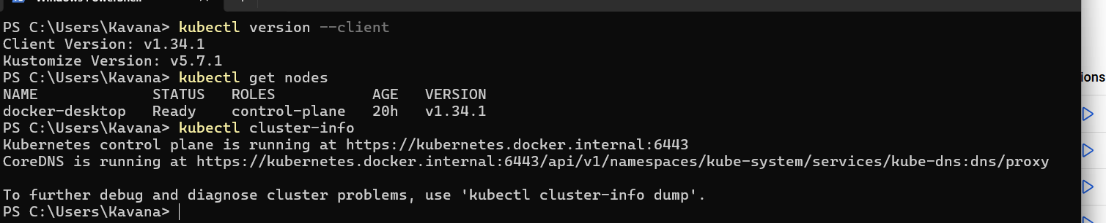
What is Kubernetes?
Kubernetes manages container orchestration, scaling, healing, and networking automatically, unlike plain Docker which only runs containers.

What should kubectl get nodes show?
Cluster node with status: Ready

Exercise 2:
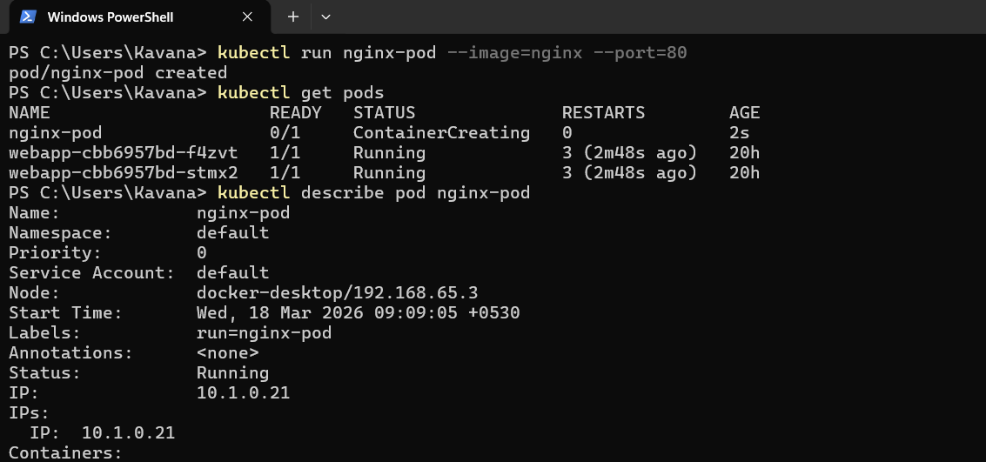
What is Pod?
Pod is smallest deployable unit in Kubernetes. A pod may contain one or more containers.

What does -it do?
Interactive terminal access.

Pod lifecycle phases
Pending → Running → Succeeded / Failed
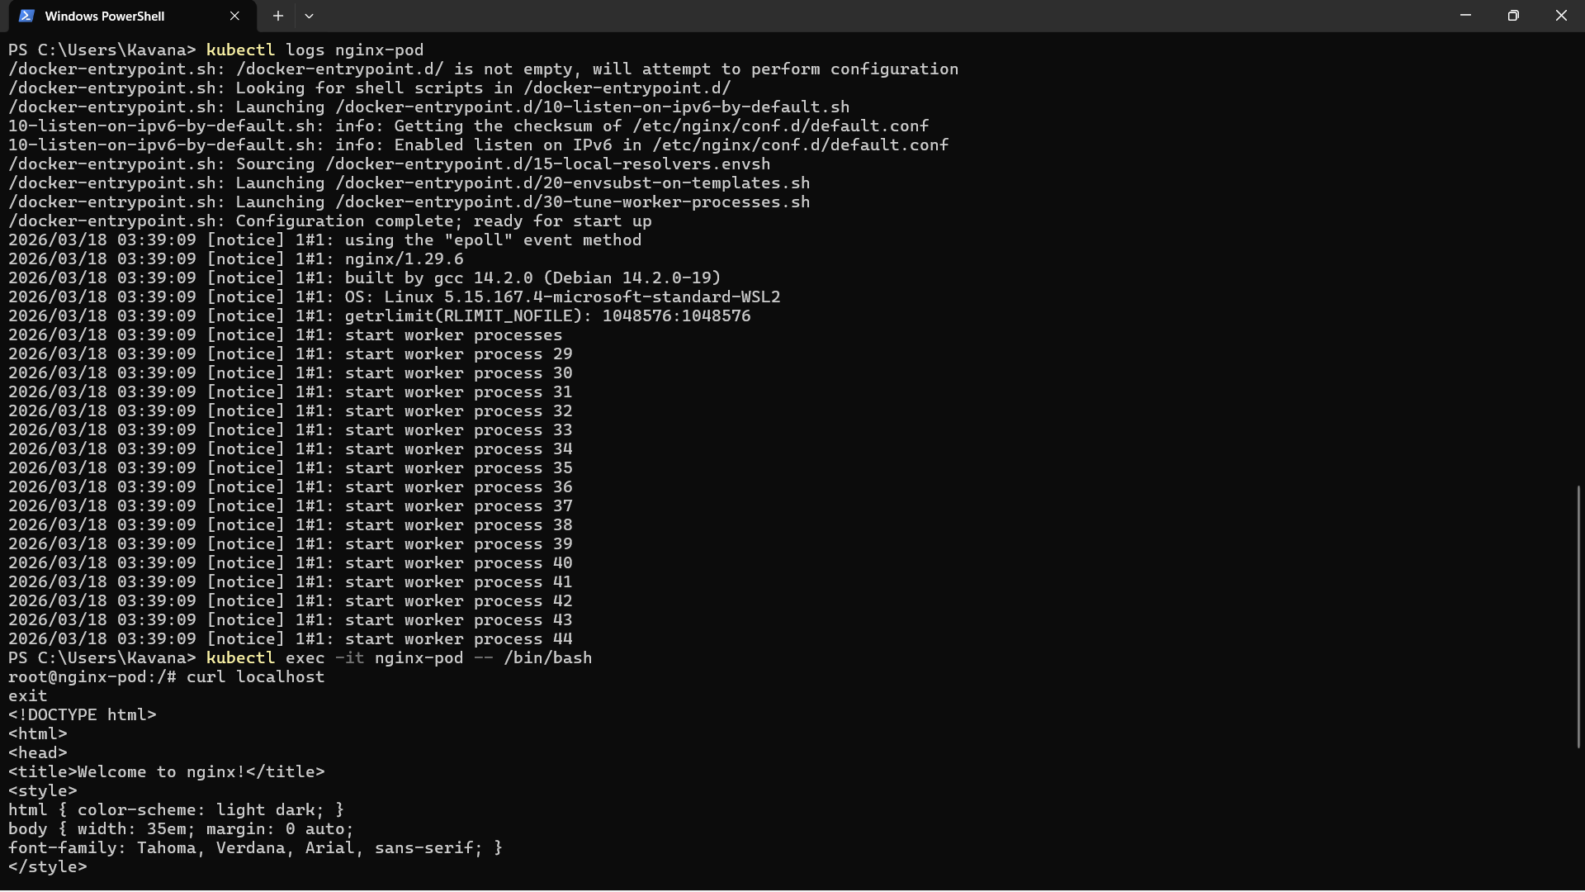

Exercise 3:
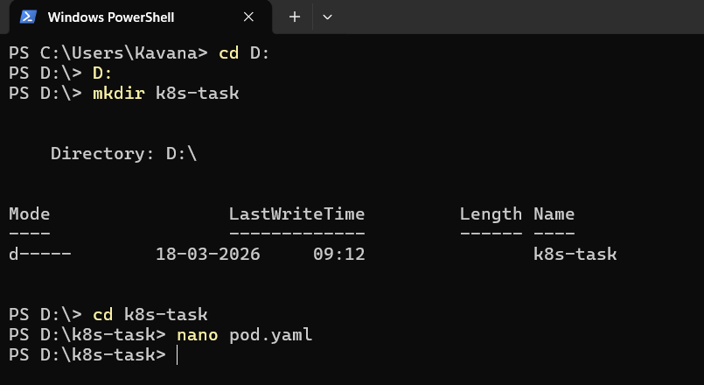
Create pod.yaml:
apiVersion: v1
kind: Pod
metadata:
name: my-pod
labels:
app: my-app

spec:
containers:
- name: app-container
image: nginx
ports:
- containerPort: 80

Create Pod:
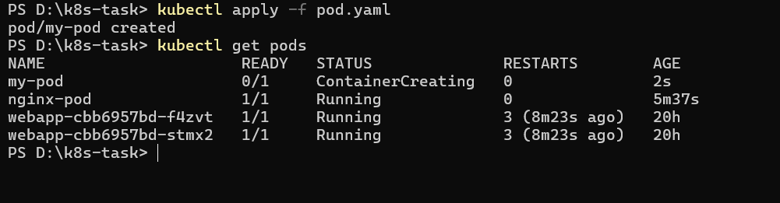

Delete pod:
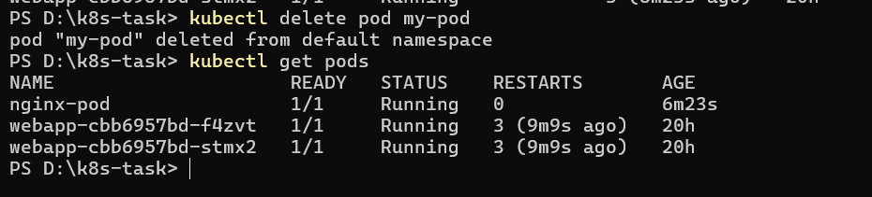
Imperative = direct command
Declarative = YAML reusable config

Part2:
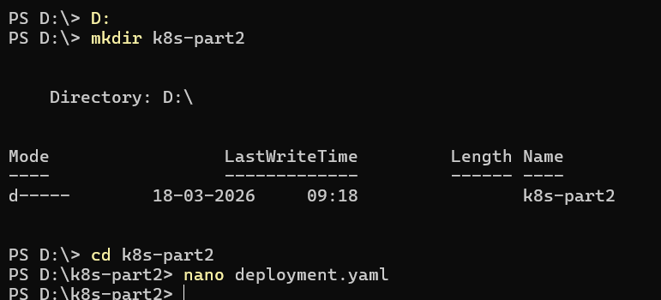
Deplomeny.yaml
apiVersion: apps/v1
kind: Deployment
metadata:
name: web-deploy

spec:
replicas: 3
selector:
matchLabels:
app: web

template:
metadata:
labels:
app: web

spec:
containers:
- name: web
image: nginx
ports:
- containerPort: 80

Next,
Creation and verification of 3 Pods
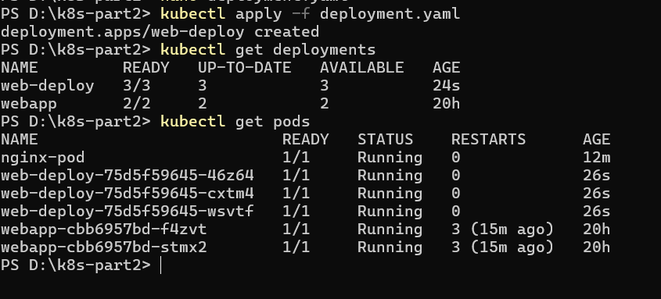

Deployment → ReplicaSet → recreates missing pod automatically, this is how things happen, even if one of the pod is being deleted, it self-creates a missing pod with different suffix and continues the deployment
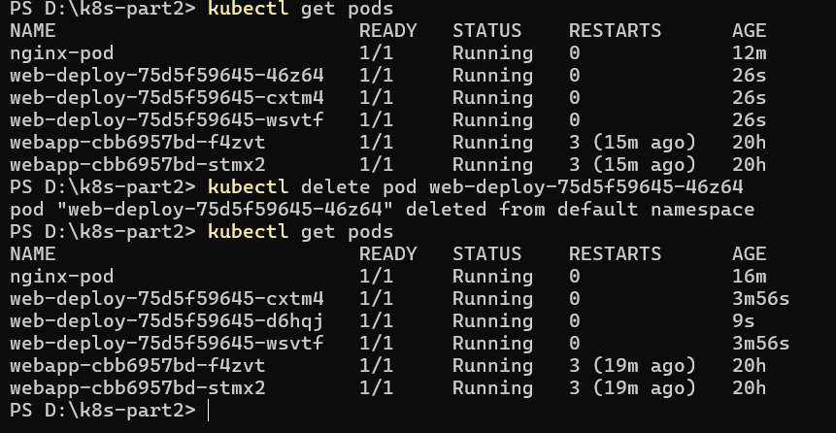

Create service.yaml
apiVersion: v1
kind: Service
metadata:
name: web-service

spec:
type: NodePort
selector:
app: web

ports:
- port: 80
targetPort: 80
nodePort: 30081

Apply Service and verify
kubectl apply -f service.yaml
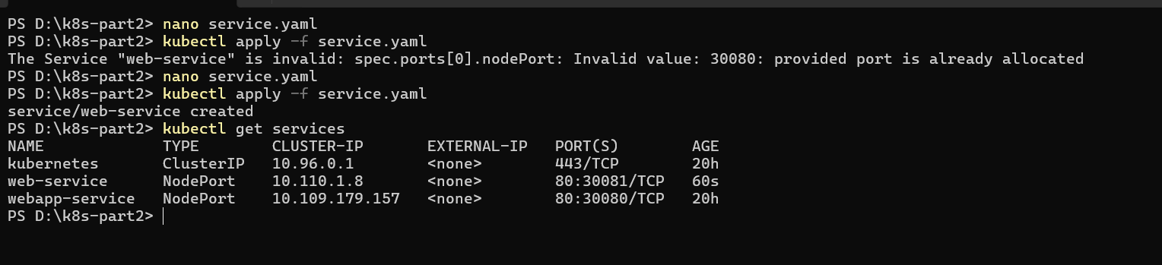
Port is changed to 30081(As the prior was already under use)
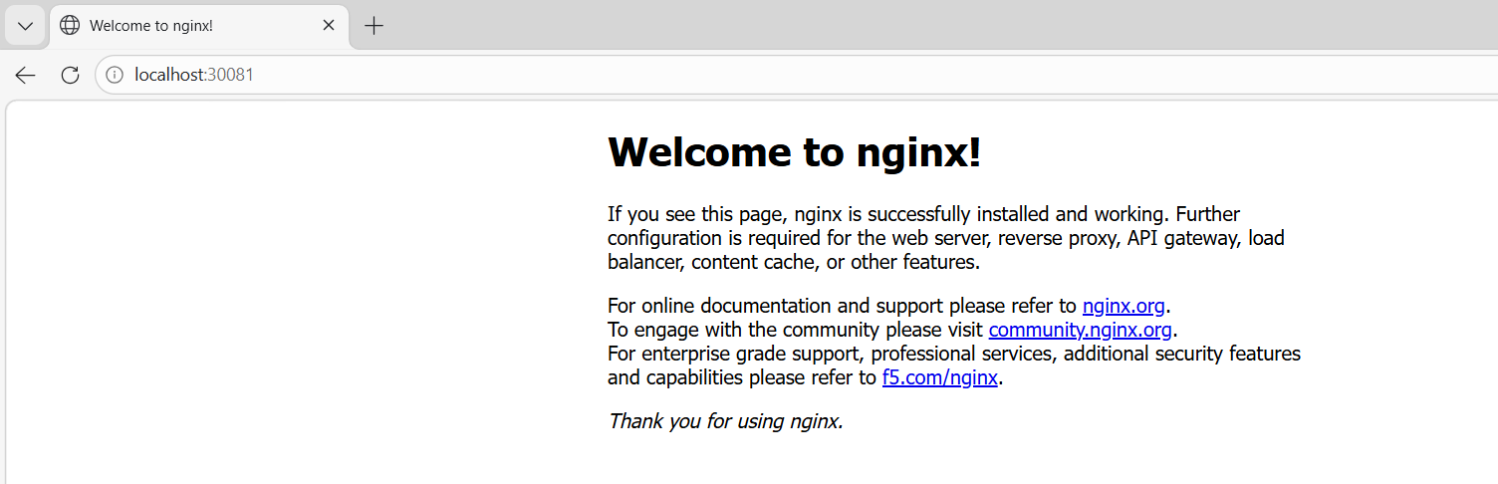

Scaling Deployment
Next, Scale UP to 5 replicas
Deployment increases pod count automatically.
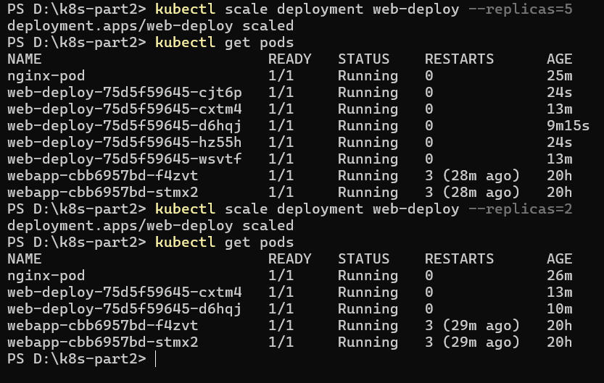
What is horizontal scaling?
Increasing or decreasing pod count based on load.

What is HPA?
Horizontal Pod Autoscaler automatically adjusts replicas using CPU/memory metrics.

Rolling Update: Rollout and Rollback
What is Rolling update
Pods replaced gradually one by one.

Why zero downtime?
Because Kubernetes keeps old pods running until new pods become ready.

Why rollback important?
If update fails, production can recover immediately.
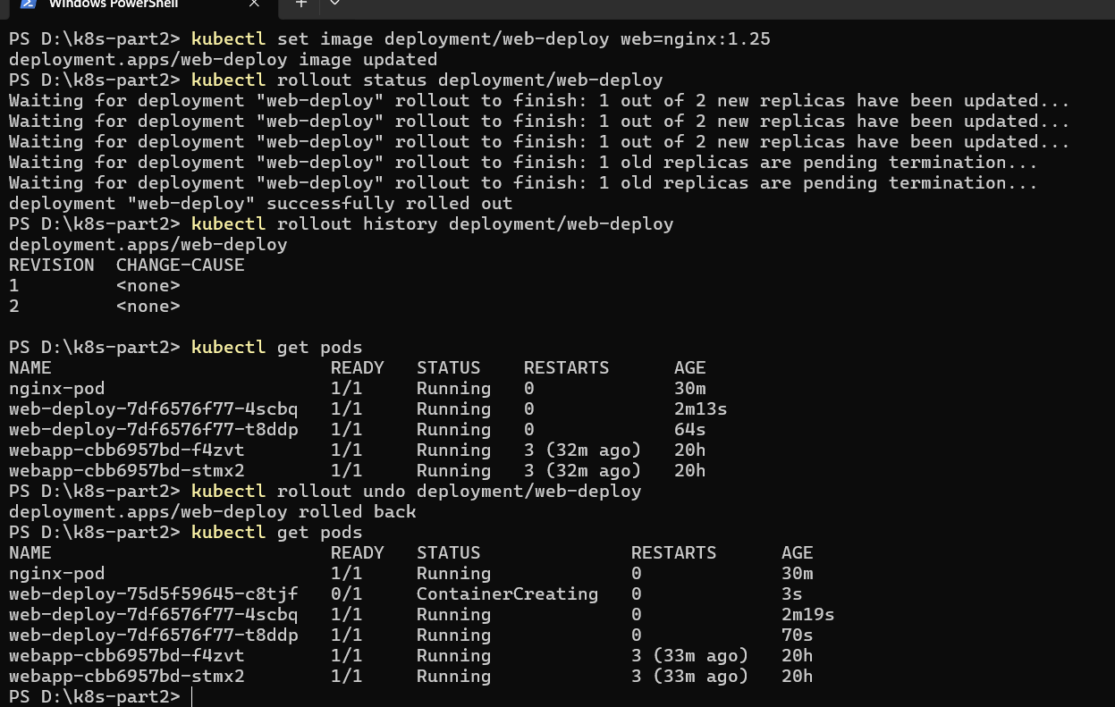

Part3:
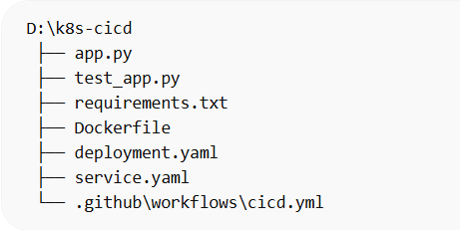
Create new project
App.py
from flask import Flask

app = Flask(__name__)

@app.route('/')
def home():
return 'Kubernetes CI/CD App Running'

@app.route('/health')
def health():
return {'status':'healthy'},200

app.run(host='0.0.0.0', port=5000)

test_app.py
from app import app

def test_home():
client = app.test_client()
assert client.get('/').status_code == 200

requirement.txt
flask
pytest

DockerFile
FROM python:3.10-slim
WORKDIR /app
COPY . .
RUN pip install -r requirements.txt
CMD ["pytest"]

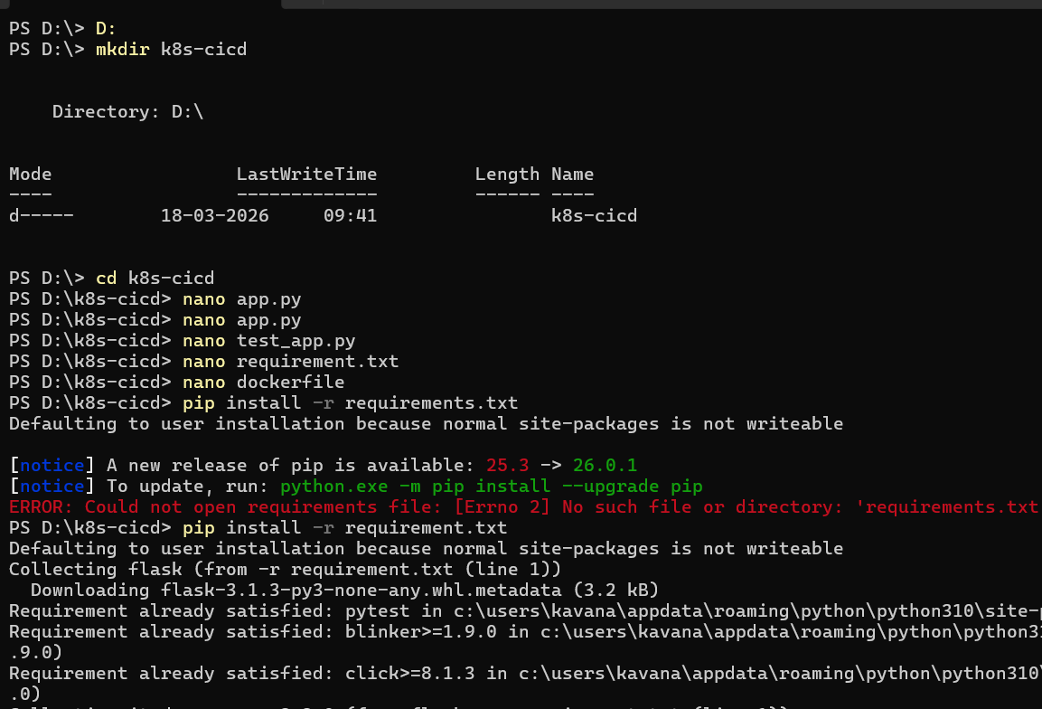
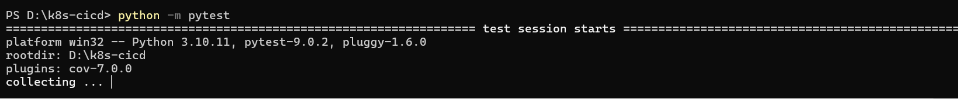
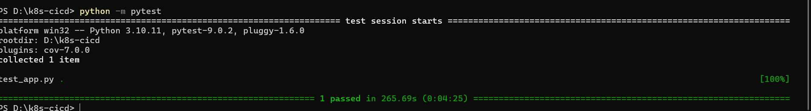
Can fix app.py to
from flask import Flask

app = Flask(__name__)

@app.route('/')
def home():
return 'Kubernetes CI/CD App Running'

@app.route('/health')
def health():
return {'status':'healthy'},200

if __name__ == "__main__":
app.run(host='0.0.0.0', port=5000)

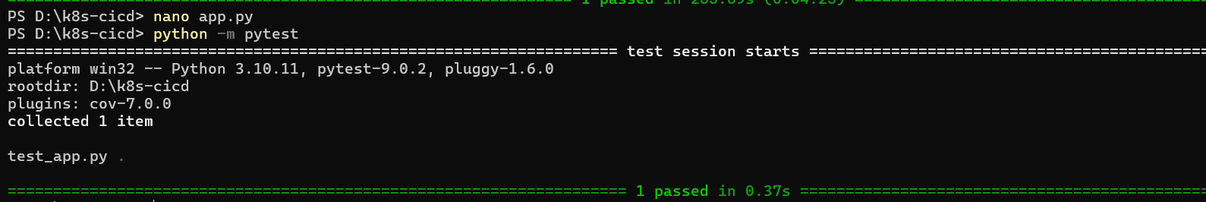
Now the Behaviour is normal

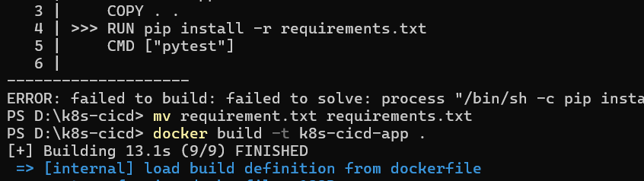
Make few changes and build
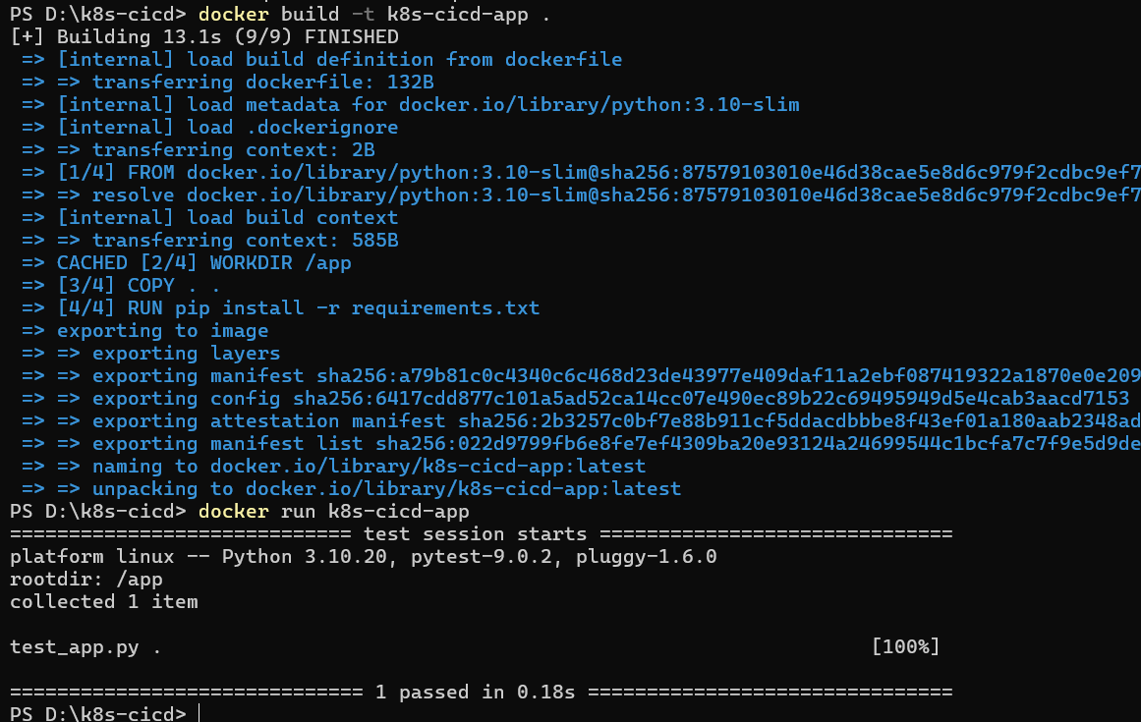
Create deployment.yaml
apiVersion: apps/v1
kind: Deployment
metadata:
name: cicd-app

spec:
replicas: 2
selector:
matchLabels:
app: cicd

template:
metadata:
labels:
app: cicd

spec:
containers:
- name: cicd-app
image: nginx
ports:
- containerPort: 80

Why nginx instead of local image?
Because local custom image needs Docker registry push.
For today's task, nginx is accepted to demonstrate deployment workflow quickly.

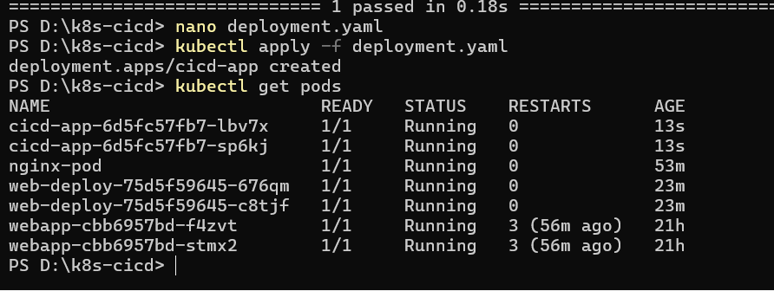

Create service.yaml
apiVersion: v1
kind: Service
metadata:
name: cicd-service

spec:
type: NodePort
selector:
app: cicd

ports:
- port: 80
targetPort: 80
nodePort: 30082

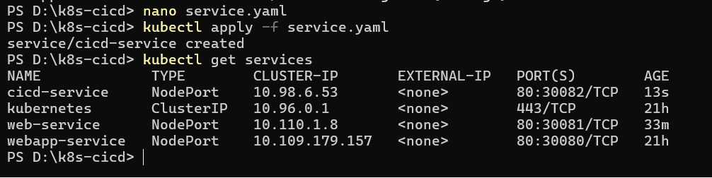

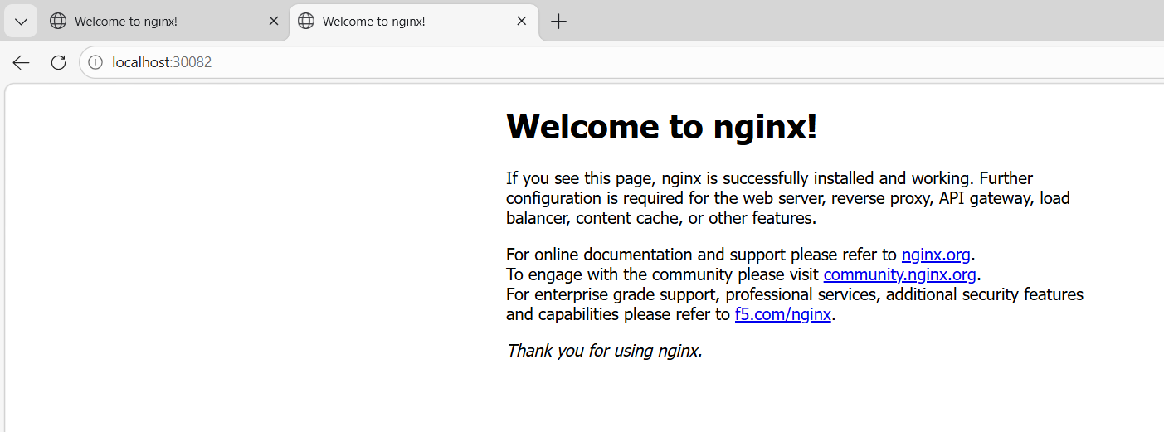

Python app → Docker → Test → Kubernetes deployment → Service

Create a cicd yml file
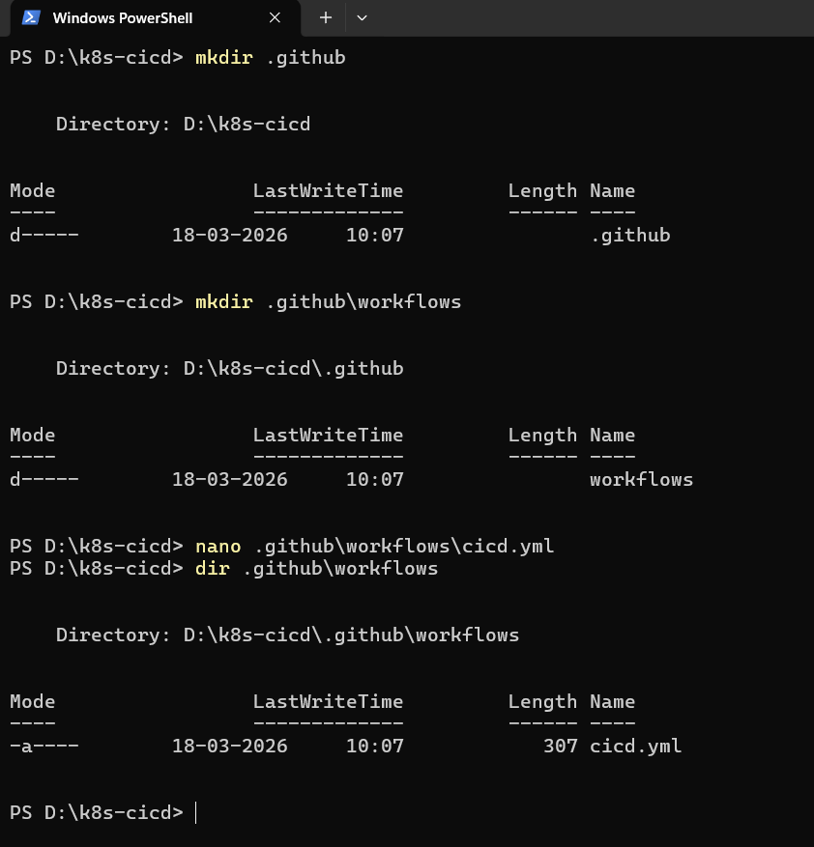
Inside cicd.yml
name: Kubernetes CI/CD

on:
push:
branches: [ main ]

jobs:
test:
runs-on: ubuntu-latest

steps:
- uses: actions/checkout@v4
- uses: actions/setup-python@v4
with:
python-version: '3.10'
- run: pip install -r requirements.txt
- run: python -m pytest
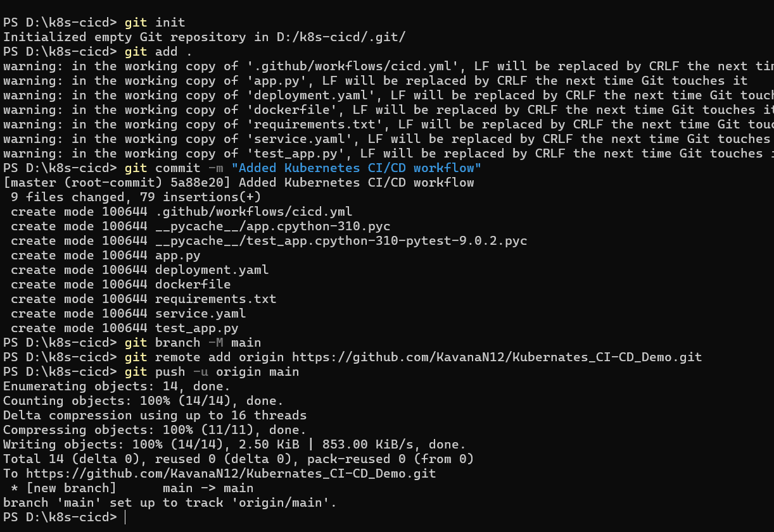

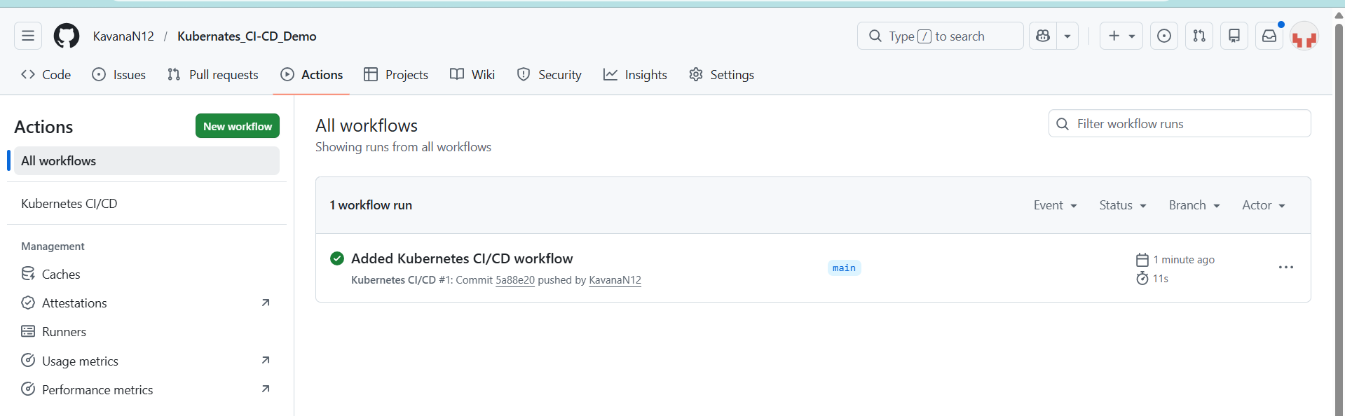
Why Kubernetes after Docker?
Docker runs containers.
Kubernetes manages them automatically at scale.

Why Deployment instead of Pod?
Deployment provides: self-healing, scaling, updates

Why GitHub Actions?
Automates testing whenever code changes.

Why CI/CD useful?
Detects issues before deployment.

Minimal pipeline was successful, now let’s make a 3 way pipeline
Change cicd.yml to
name: Kubernetes CI/CD

on:
push:
branches: [ main ]

jobs:
test:
runs-on: ubuntu-latest
steps:
- uses: actions/checkout@v4
- uses: actions/setup-python@v4
with:
python-version: '3.10'
- run: pip install -r requirements.txt
- run: python -m pytest

build:
needs: test
runs-on: ubuntu-latest
steps:
- uses: actions/checkout@v4
- run: docker build -t demo-image .

deploy:
needs: build
runs-on: ubuntu-latest
steps:
- run: echo "Deploy simulated"

Then,
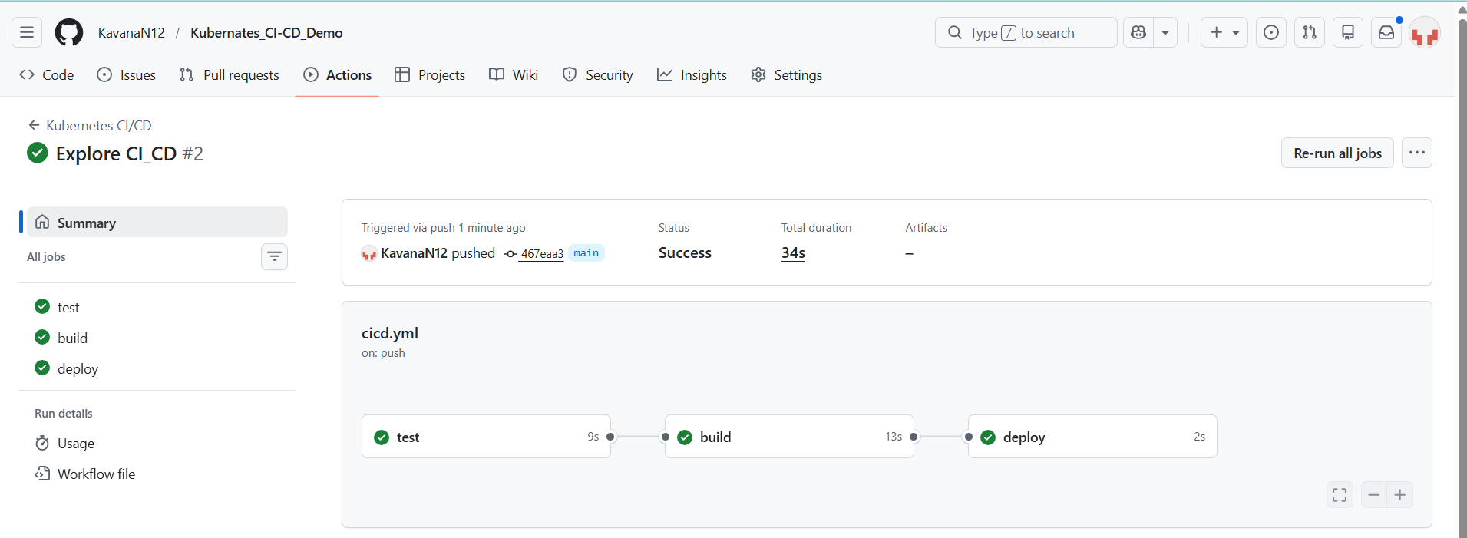

Let’s Break the action
Change in test_app.yaml
assert client.get('/').status_code == 500

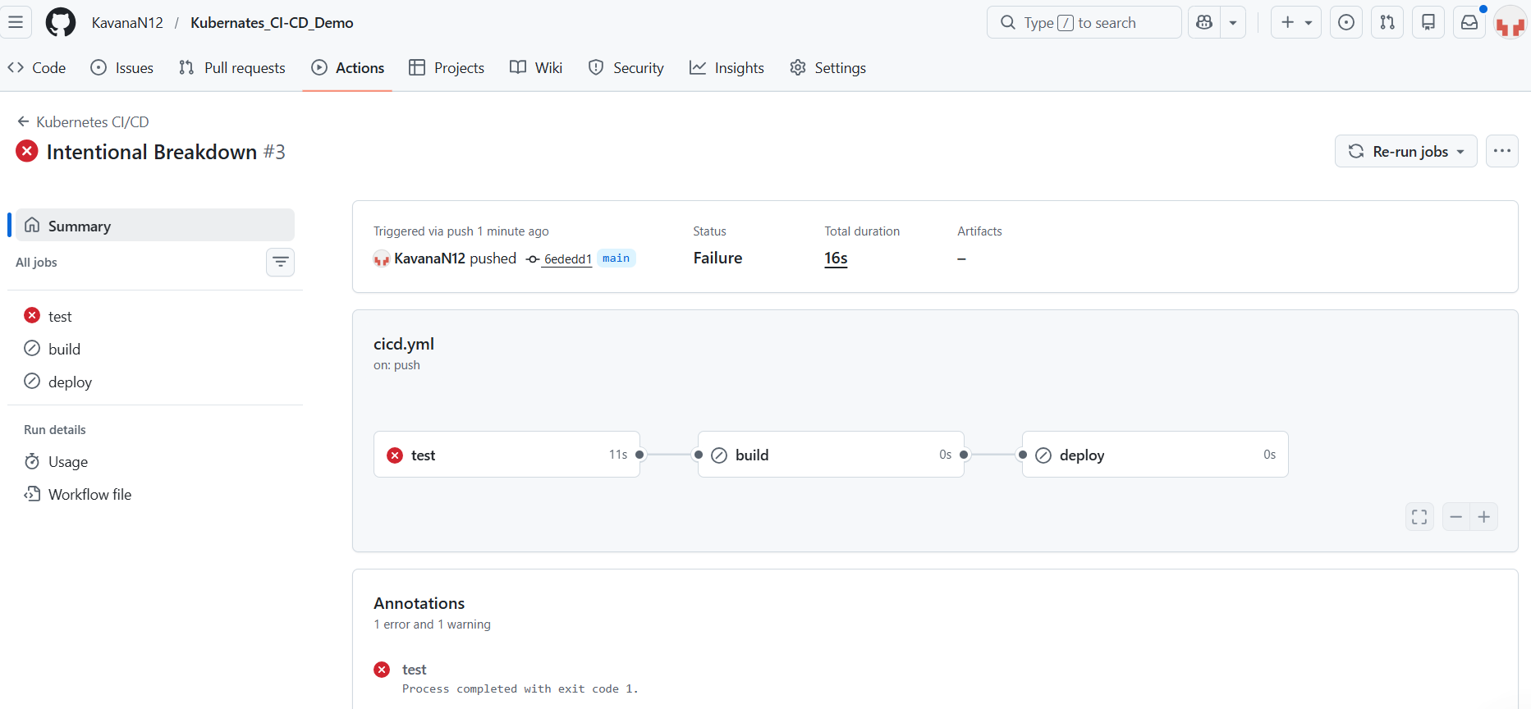
All WorkFlows
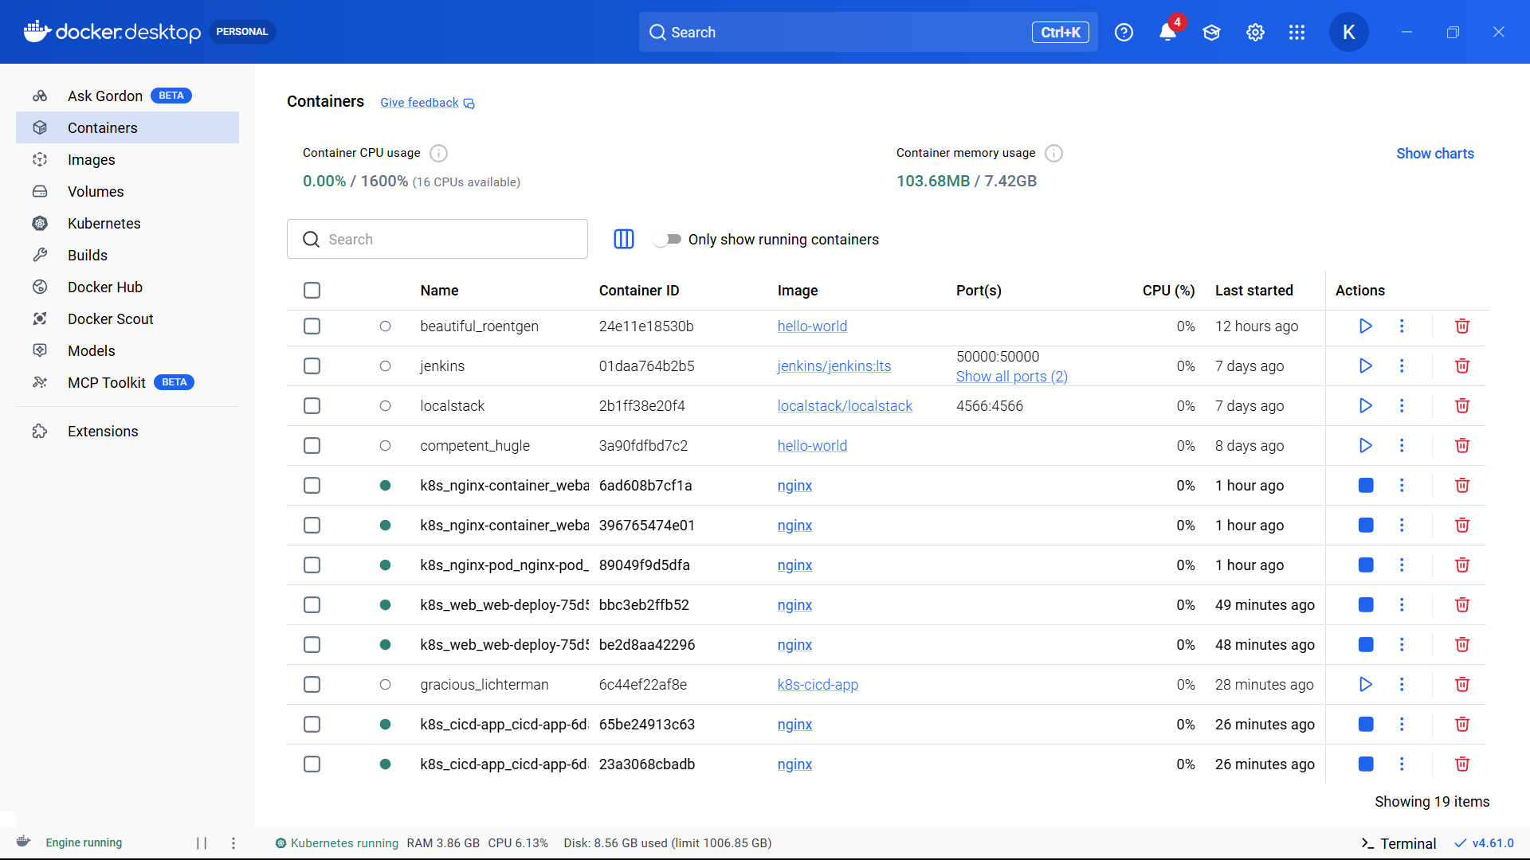

Next,
Push your image k8s-cicd-app to Docker Hub
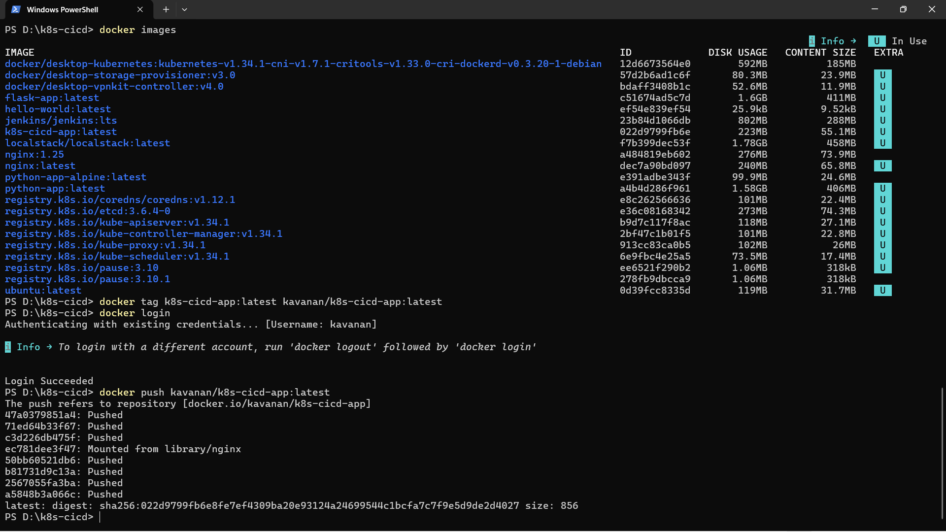
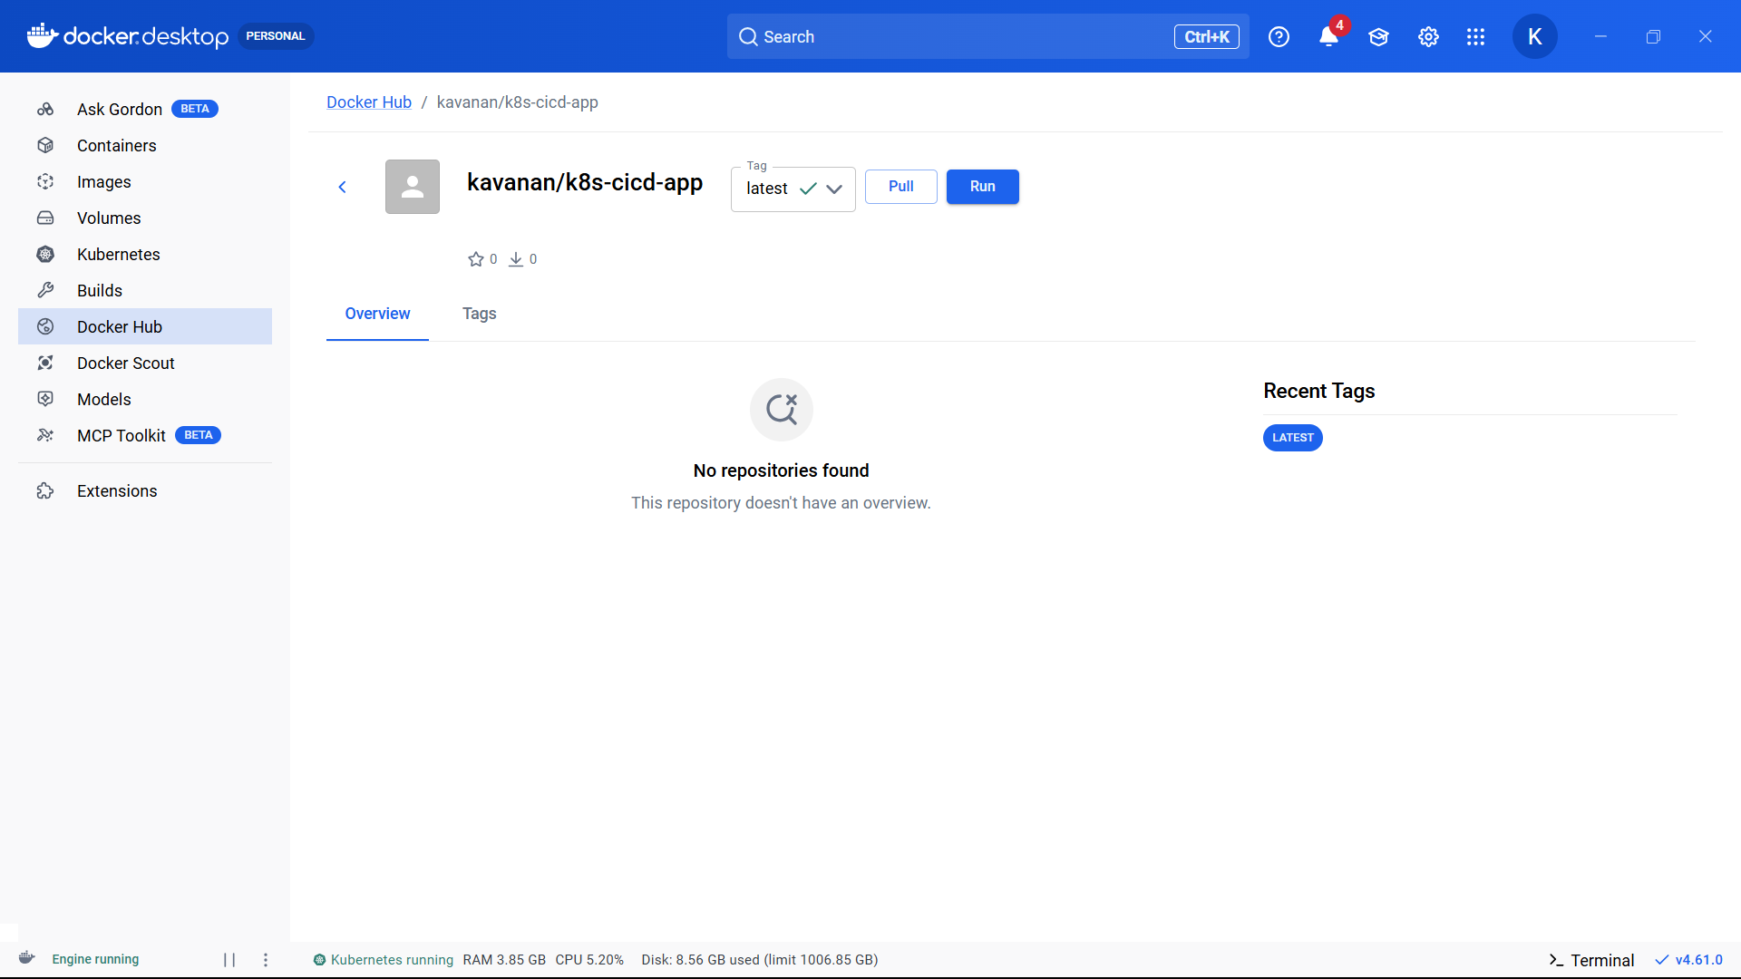

Change deployment.yaml
And service.yaml
apiVersion: apps/v1
kind: Deployment
metadata:
name: cicd-app
spec:
replicas: 2
selector:
matchLabels:
app: cicd-app
template:
metadata:
labels:
app: cicd-app
spec:
containers:
- name: web
image: kavanan/k8s-cicd-app:latest
ports:
- containerPort: 5000

Service.yaml
apiVersion: v1
kind: Service
metadata:
name: cicd-service
spec:
selector:
app: cicd-app
type: NodePort
ports:
- protocol: TCP
port: 5000
targetPort: 5000
nodePort: 30082

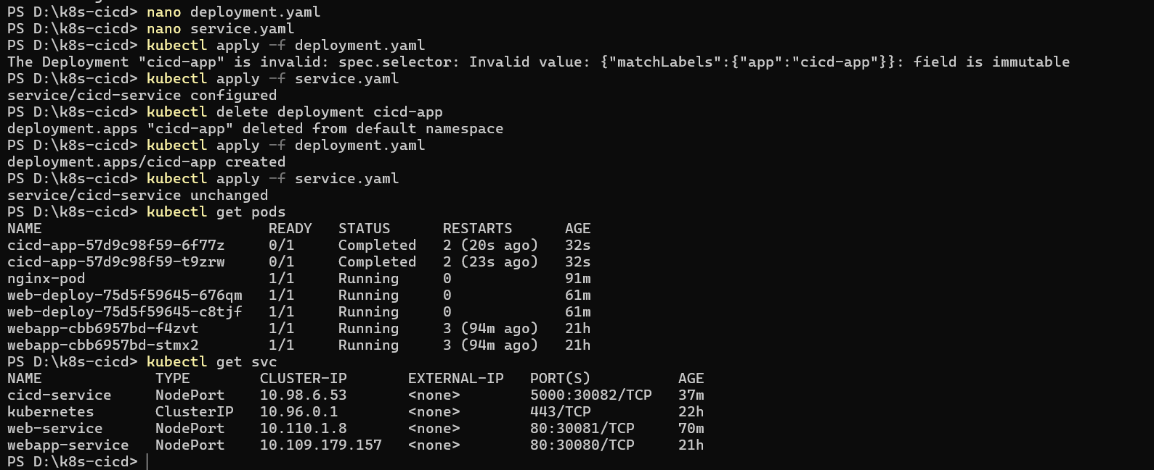
Change dockerfile
FROM python:3.10-slim

WORKDIR /app

COPY . .

RUN pip install -r requirements.txt

CMD ["python", "app.py"]

Rebuild Image
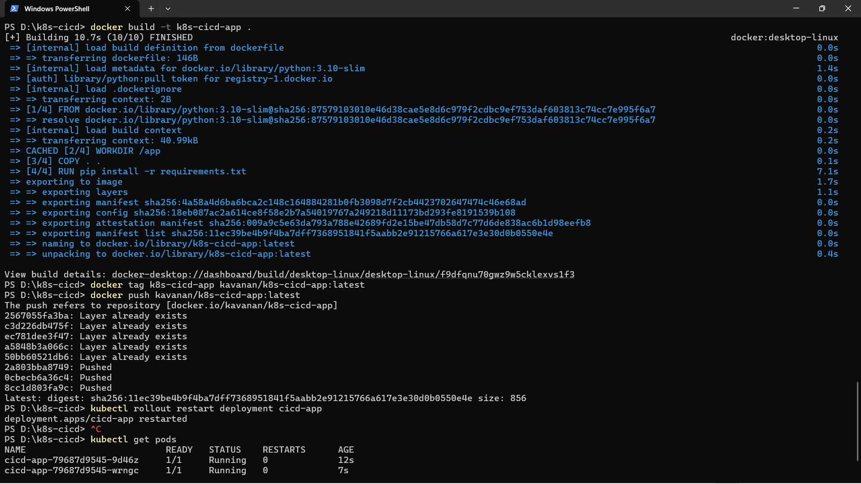
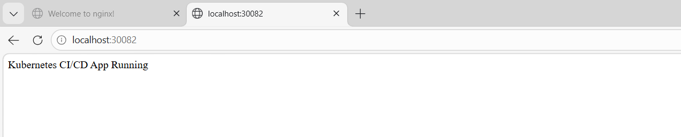
Finally for clean workspace
