Exercise 1.1
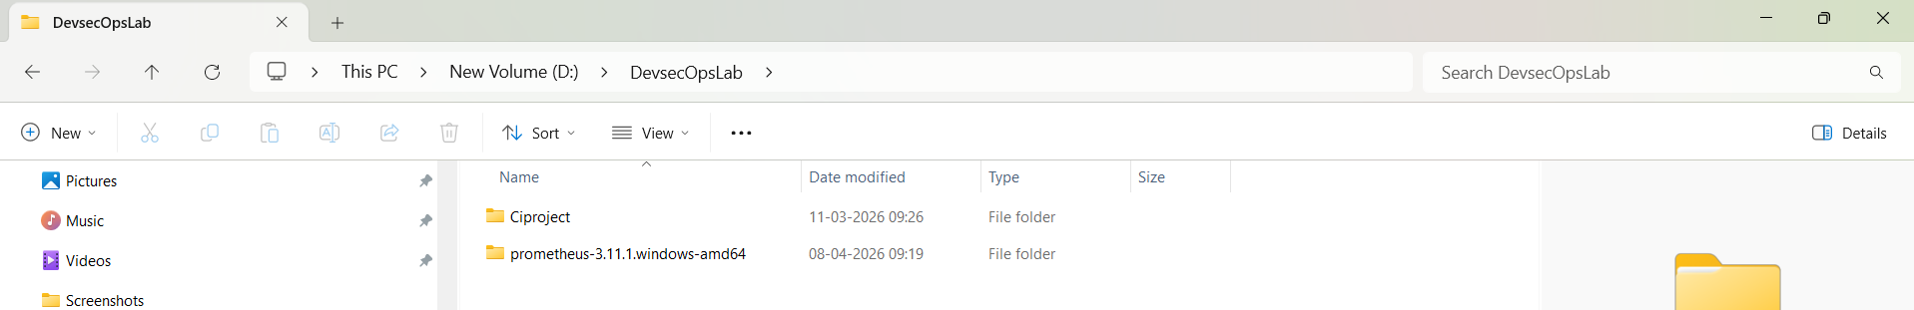
Download Prometheus for windows and unzip as shown,
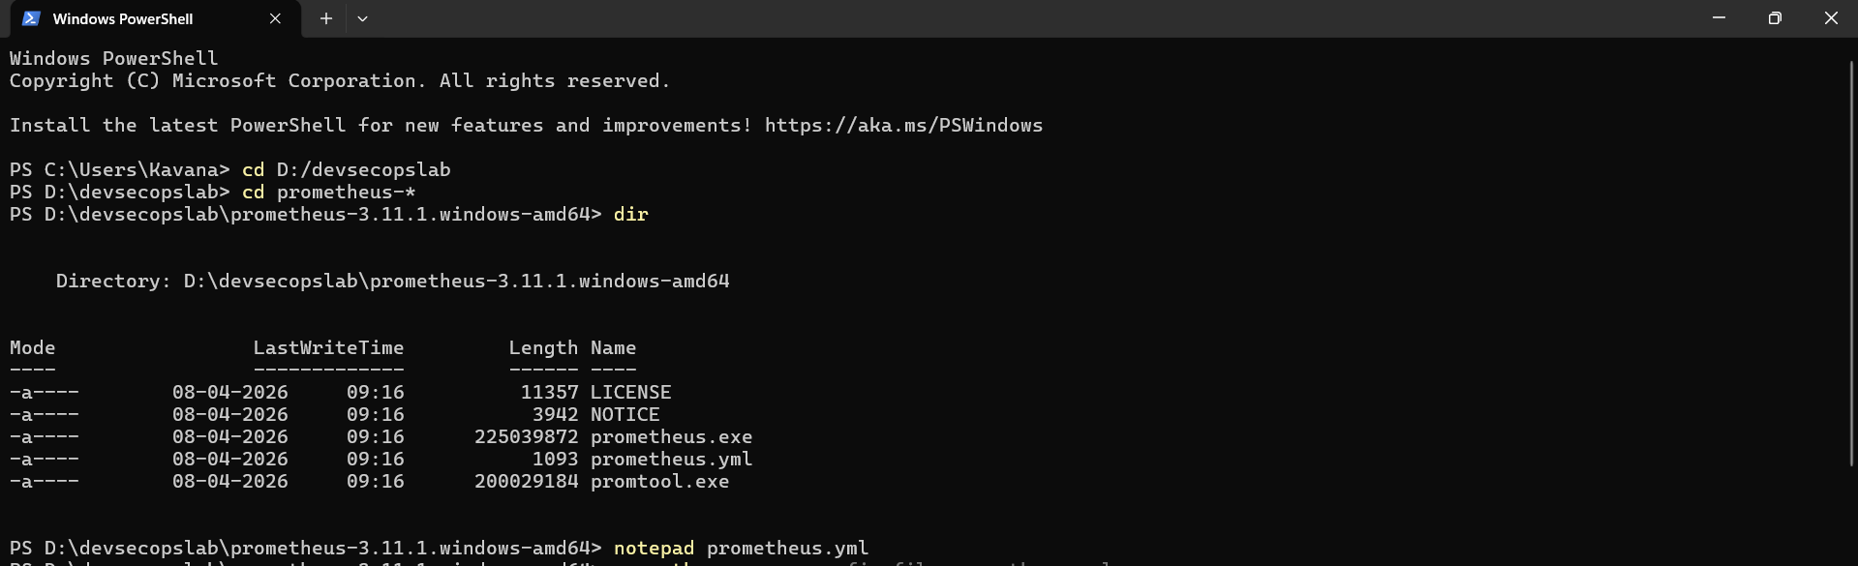
Run command: .\prometheus.exe --config.file=prometheus.yml
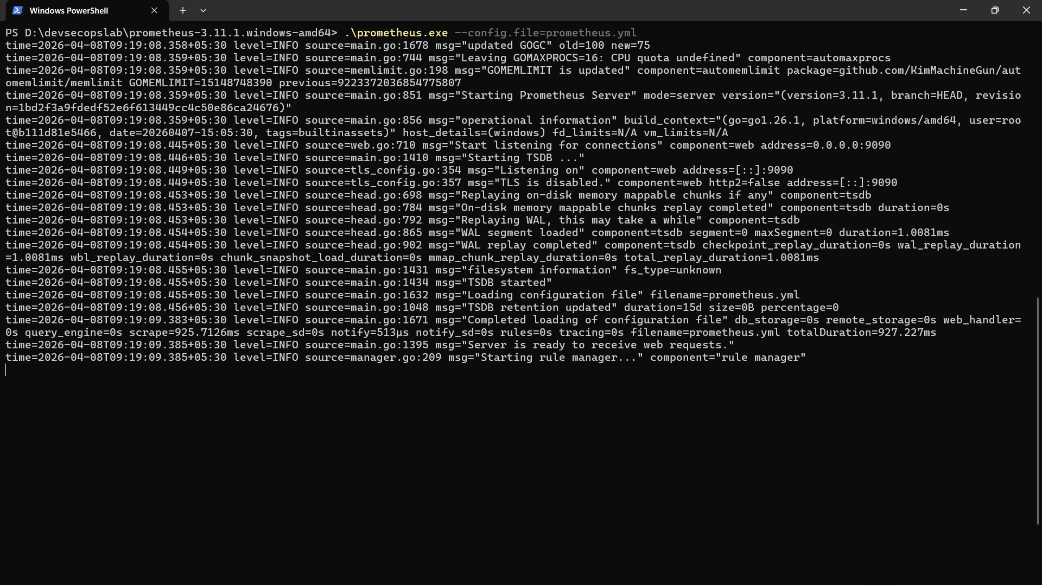
Open server: http://localhost:9090
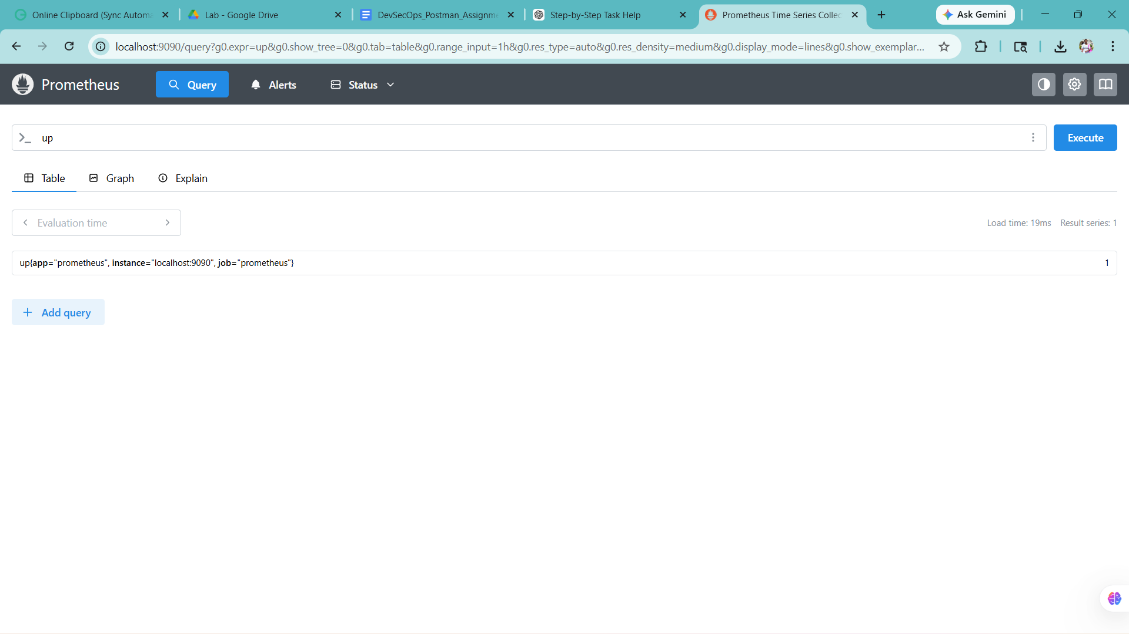
Download Windows Exporter : https://github.com/prometheus-community/windows_exporter/releases
Download the .msi : click more info, next,next,install—d drive
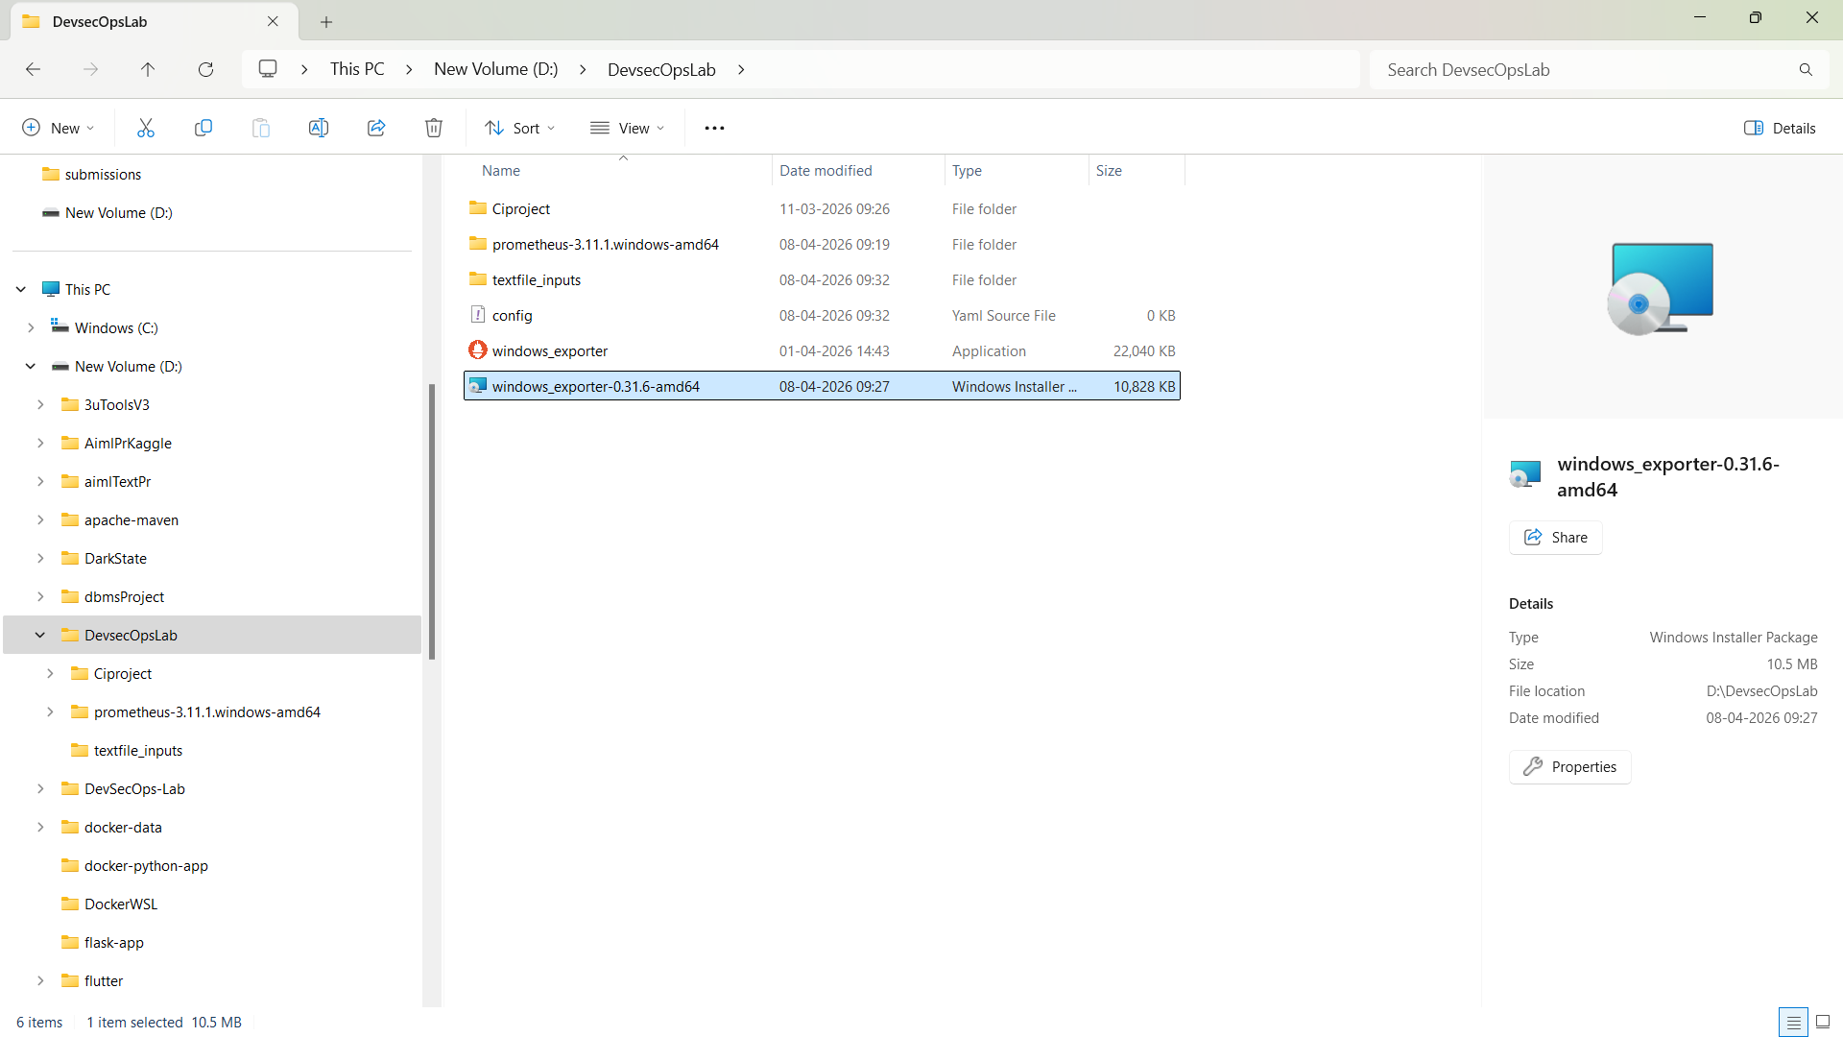
Open http://localhost:9182/metrics
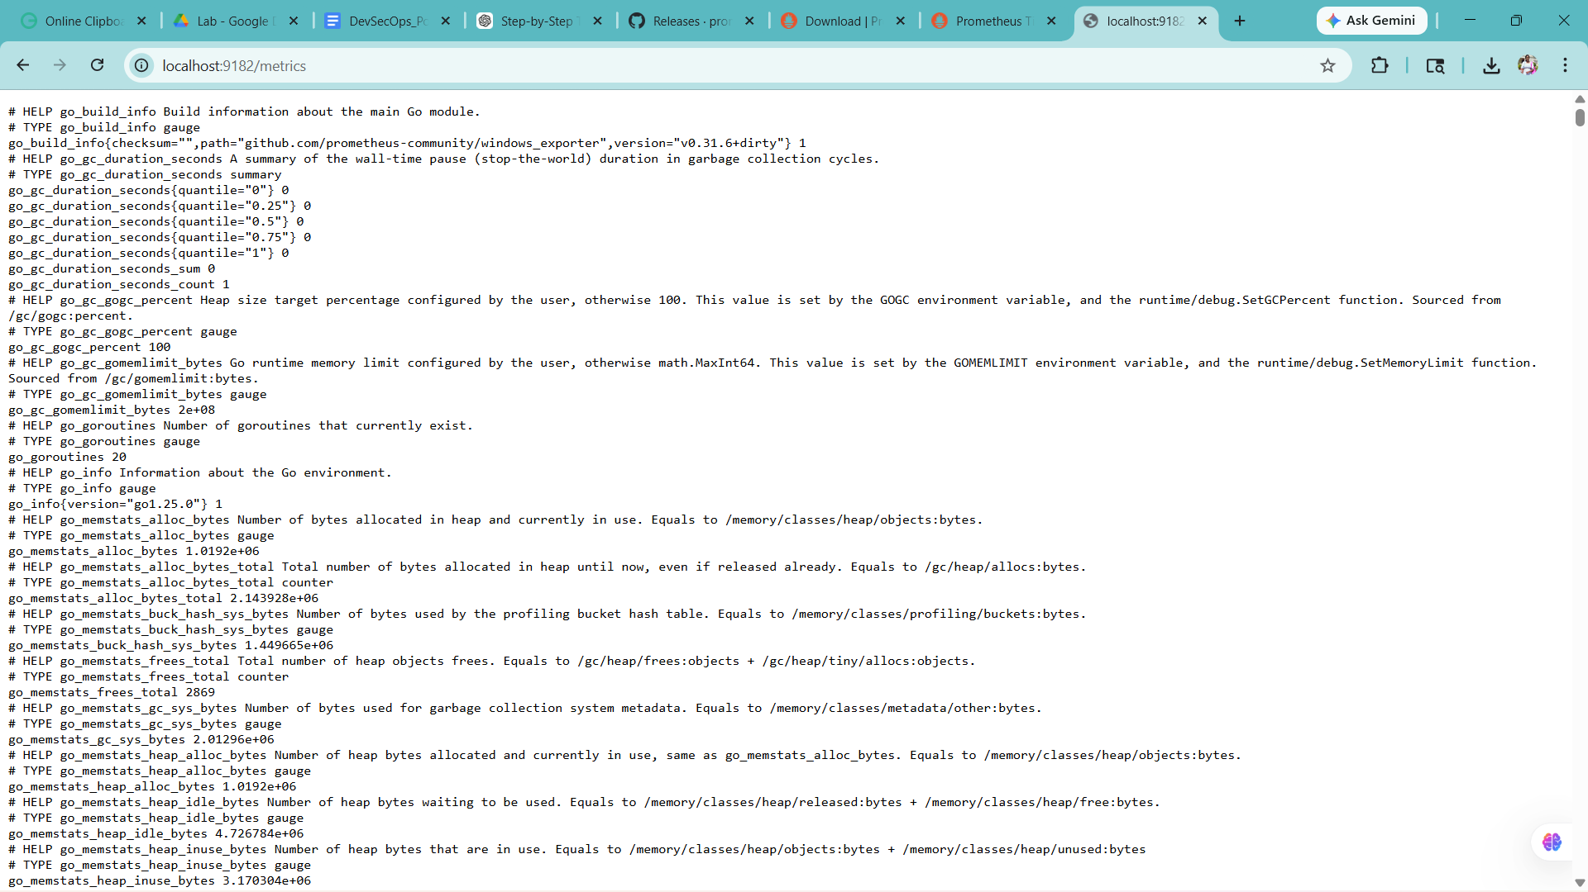
Add this BELOW existing config:
- job_name: "windows_exporter"
static_configs:
- targets: ["localhost:9182"]
Run again: .\prometheus.exe --config.file=prometheus.yml
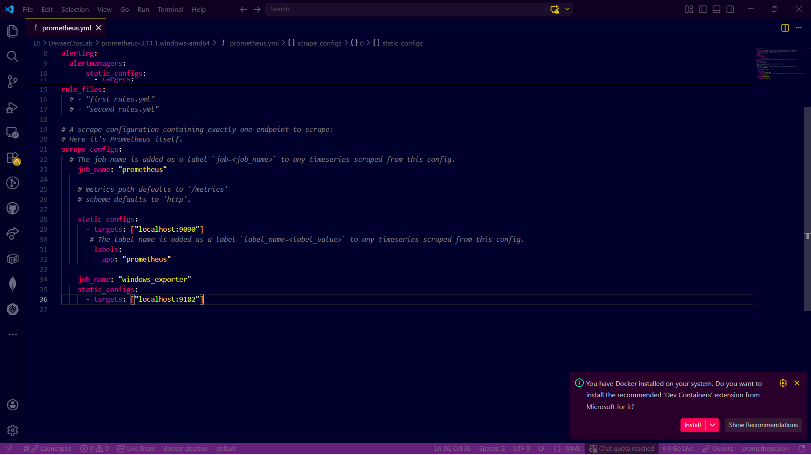

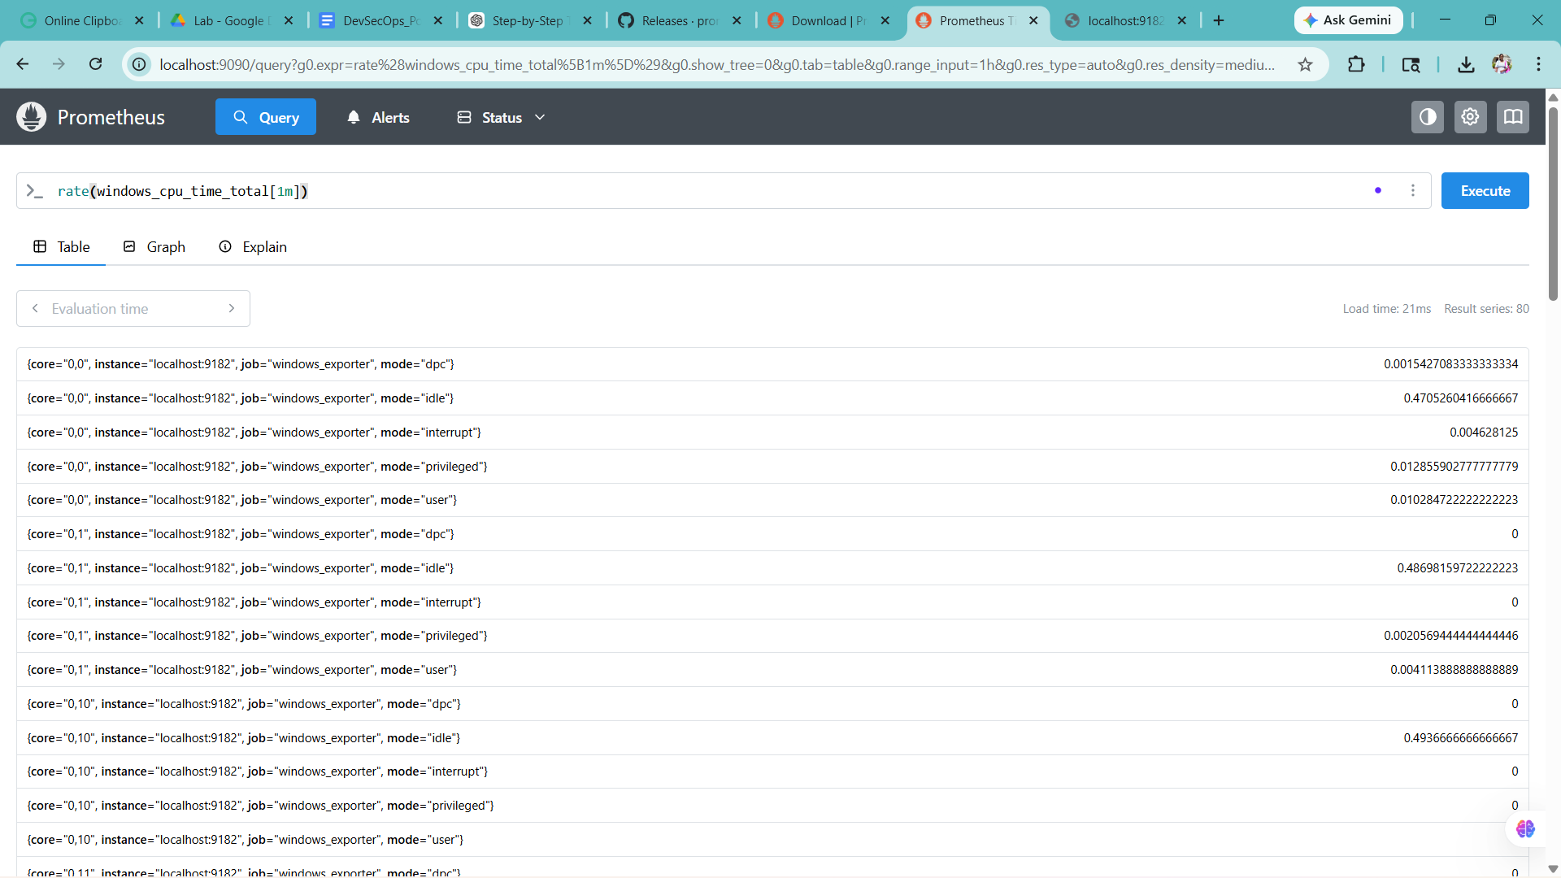
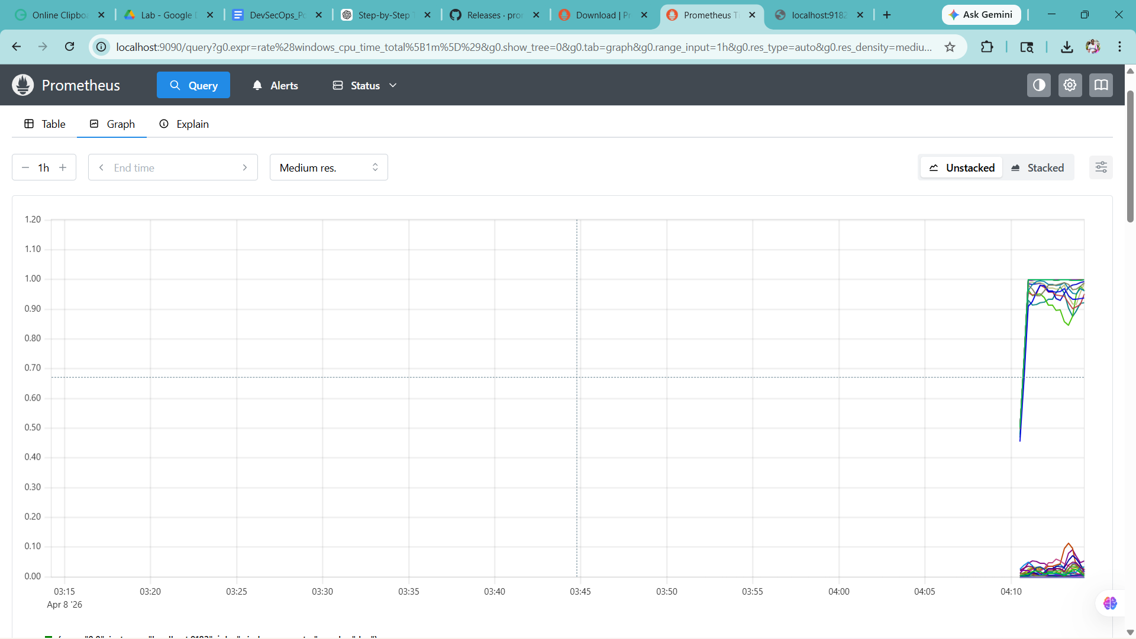

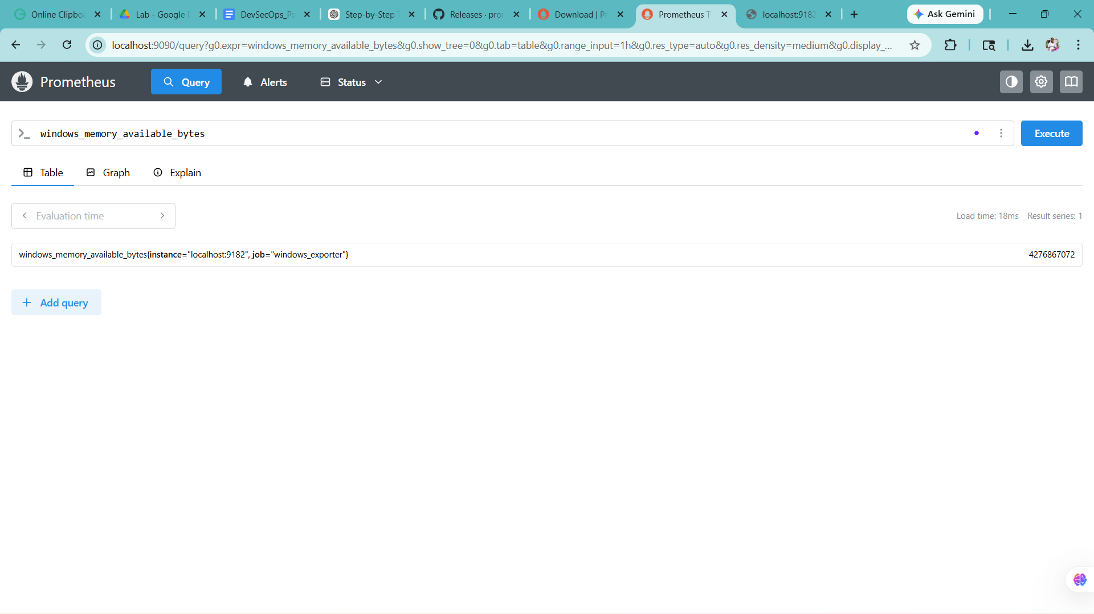
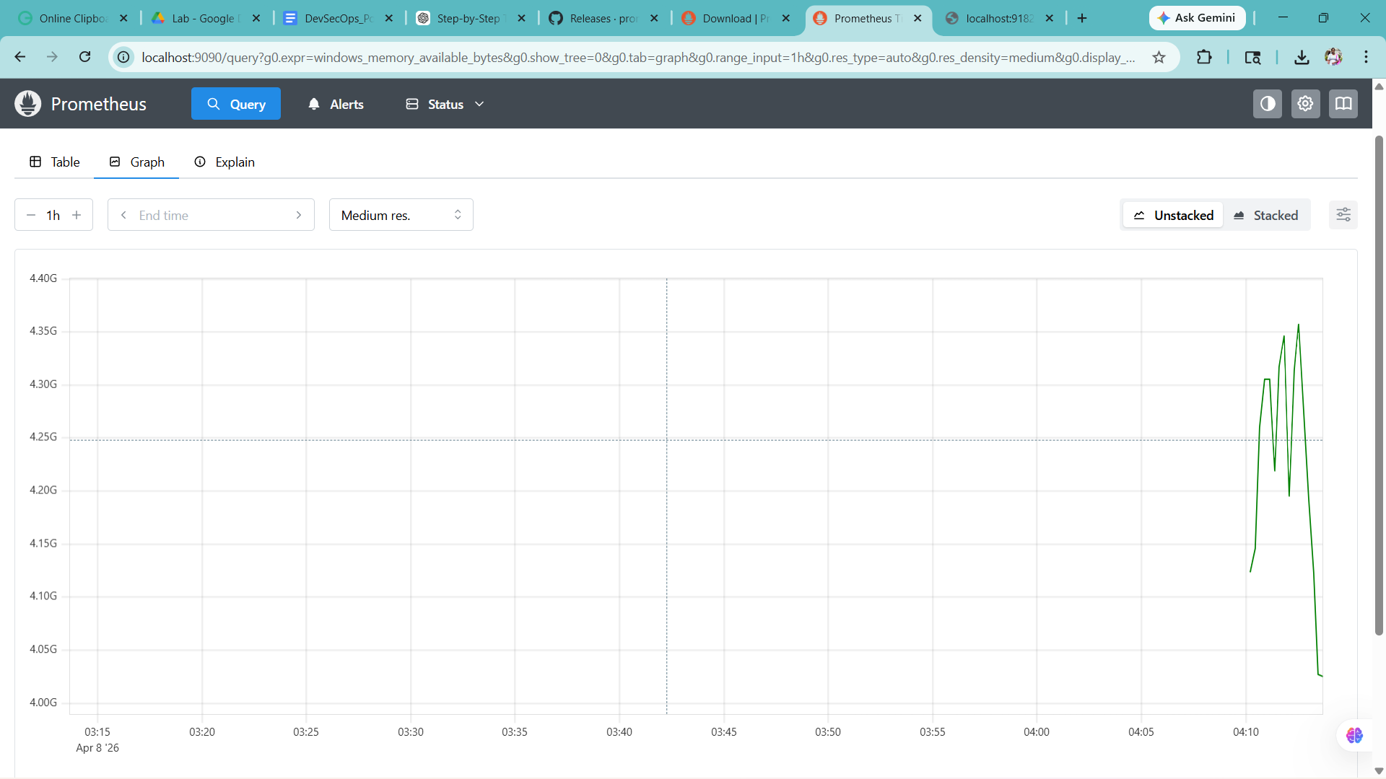
System is stable with no major bottlenecks.
No abnormal CPU spikes or memory shortages detected.

Q1: What is infrastructure monitoring?
Infrastructure monitoring is the process of continuously observing system resources such as CPU, memory, disk, and network to ensure system performance, availability, and reliability.

Q2: Difference between Nagios and Prometheus?
Nagios is a traditional monitoring tool focused on alerting and system checks, while Prometheus is a modern monitoring tool that uses time-series data, supports powerful queries, and provides better visualization and scalability.

Q3: What metrics are monitored?
Metrics such as CPU usage, memory usage, disk usage, network traffic, and system uptime are monitored.
Exercise 1.2:
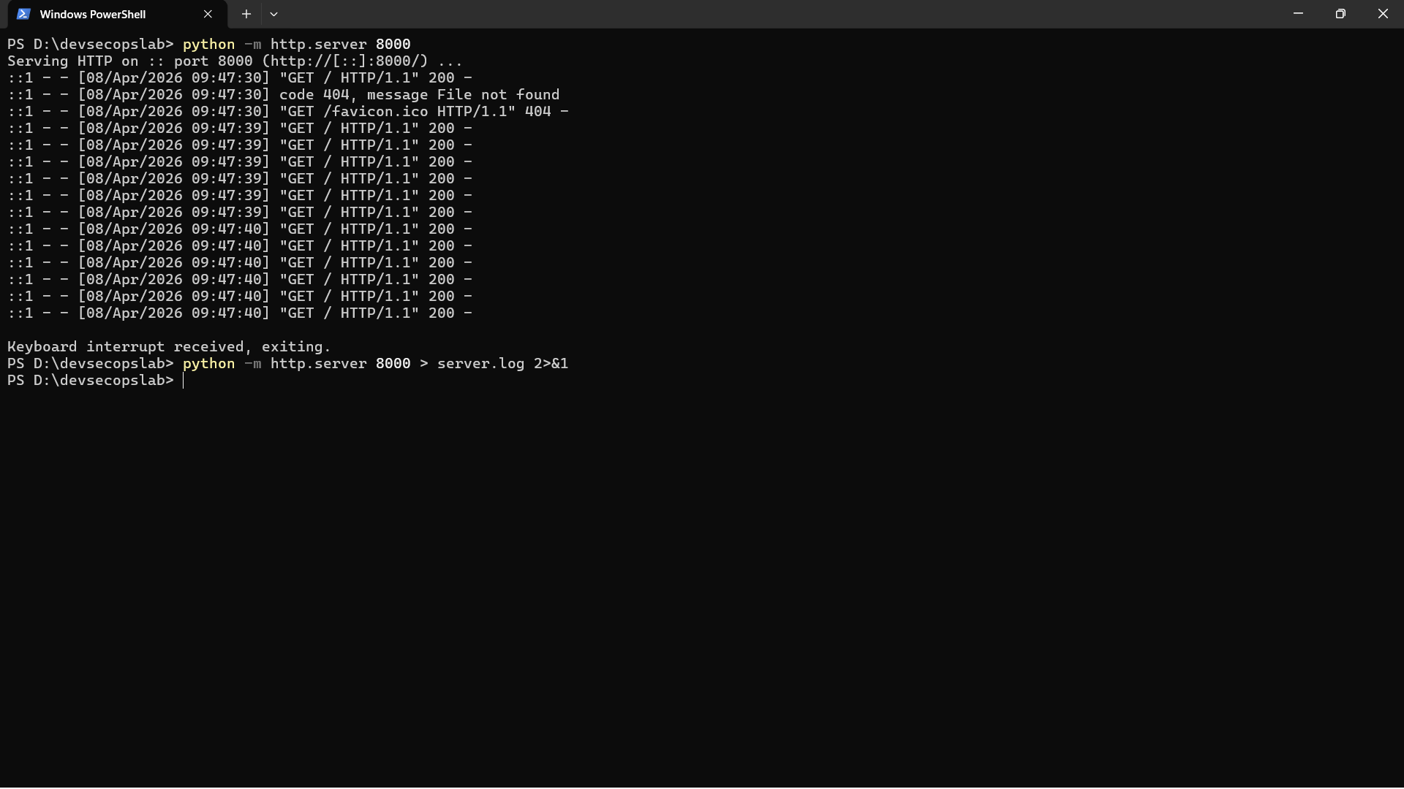
Refresh the http://localhost:8000/ multiple times for both, open server.log
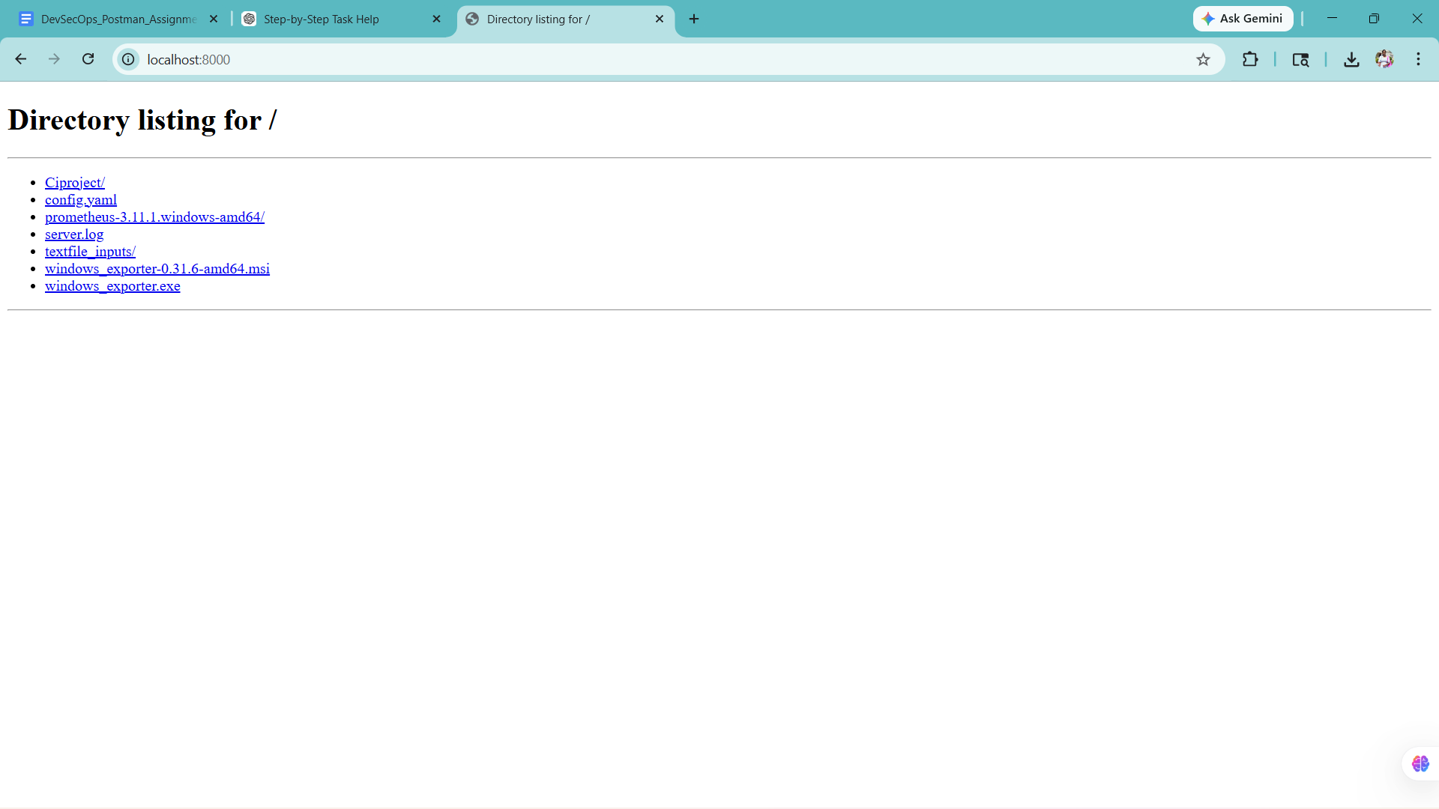
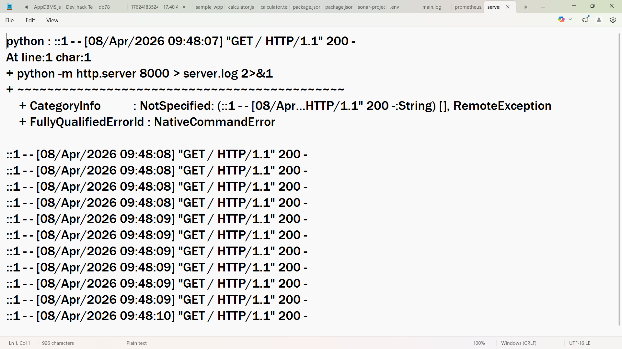
Now try running : http://localhost:8000/abc this will generate error

Check log:
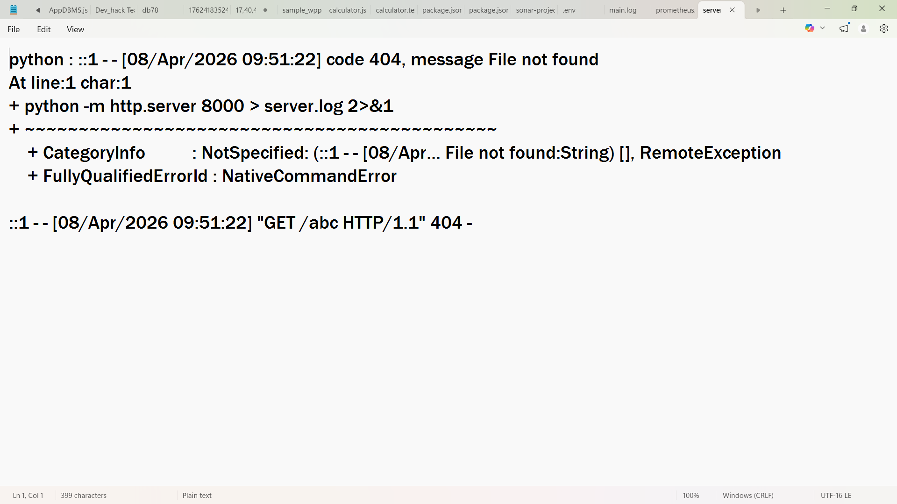
Logs showing HTTP requests and error responses were successfully generated and analyzed.
System behavior and performance were monitored using log data.

Q1: What is log monitoring?
Log monitoring is the process of collecting, analyzing, and reviewing logs generated by applications and systems to detect issues, errors, and performance problems.

Q2: What is APM?
APM (Application Performance Monitoring) is a tool or technique used to monitor application performance, response time, errors, and overall system behavior.

Q3: Why are logs important?
Logs help in debugging issues, identifying errors, tracking system activity, and improving performance and security.

Challenge 2:
Datadog/Splunk concepts were simulated using log file analysis.
The same monitoring principles were applied — log collection, error detection, and performance observation.
For: also visit cites in the browser
Application logs were generated successfully. Normal requests returned HTTP 200, while invalid routes returned HTTP 404. The logs helped identify request failures and can be used to troubleshoot response issues. Suggested fixes include better route handling, structured logging, and monitoring repeated errors.

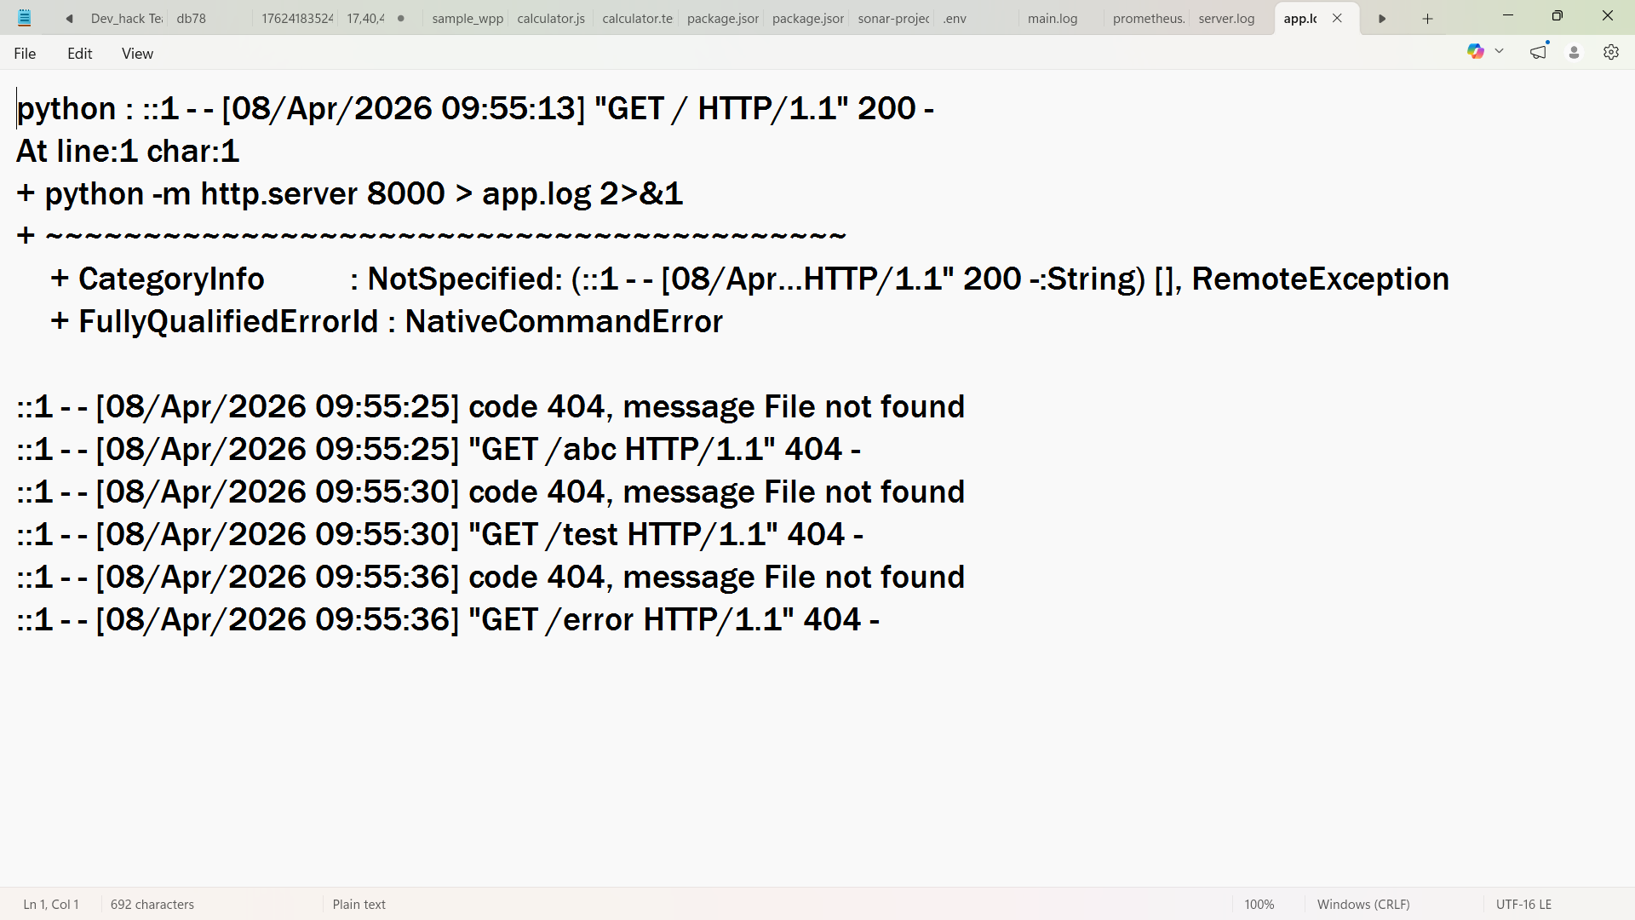
Error messages identified:
404 Not Found errors were observed for invalid URLs such as /abc, /test, and /error.
Response behavior identified:
Successful requests returned status code 200, while invalid requests returned 404. This shows how logs can be used to detect application issues and bad routes.
Suggested improvements:
Add custom error handling, validate routes properly, improve logging format, and monitor frequent failed requests to detect misuse or broken links.

Challenge 3:
Wireshark:
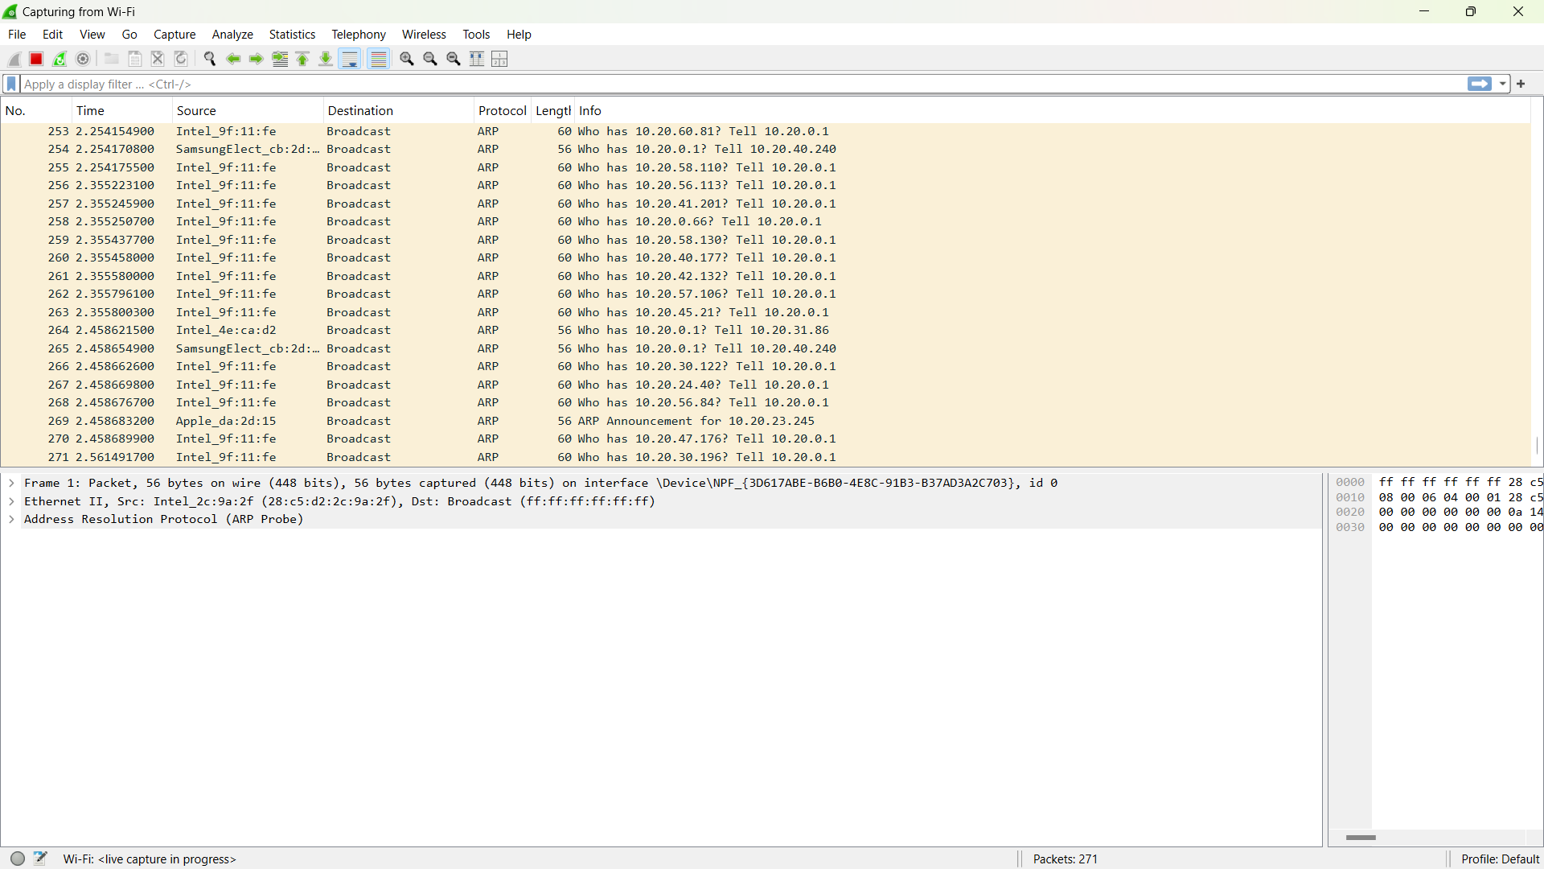
Download nmap:
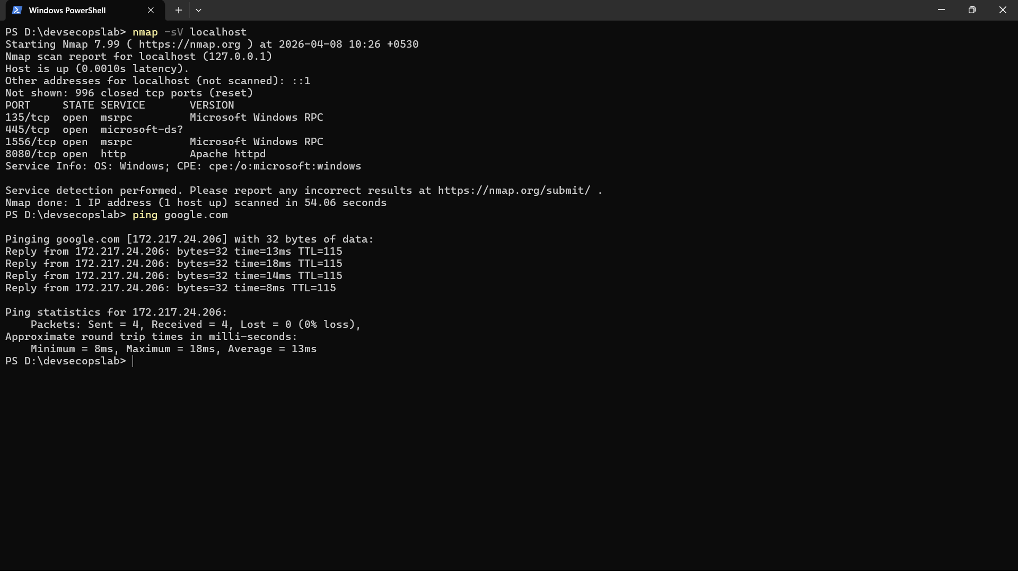
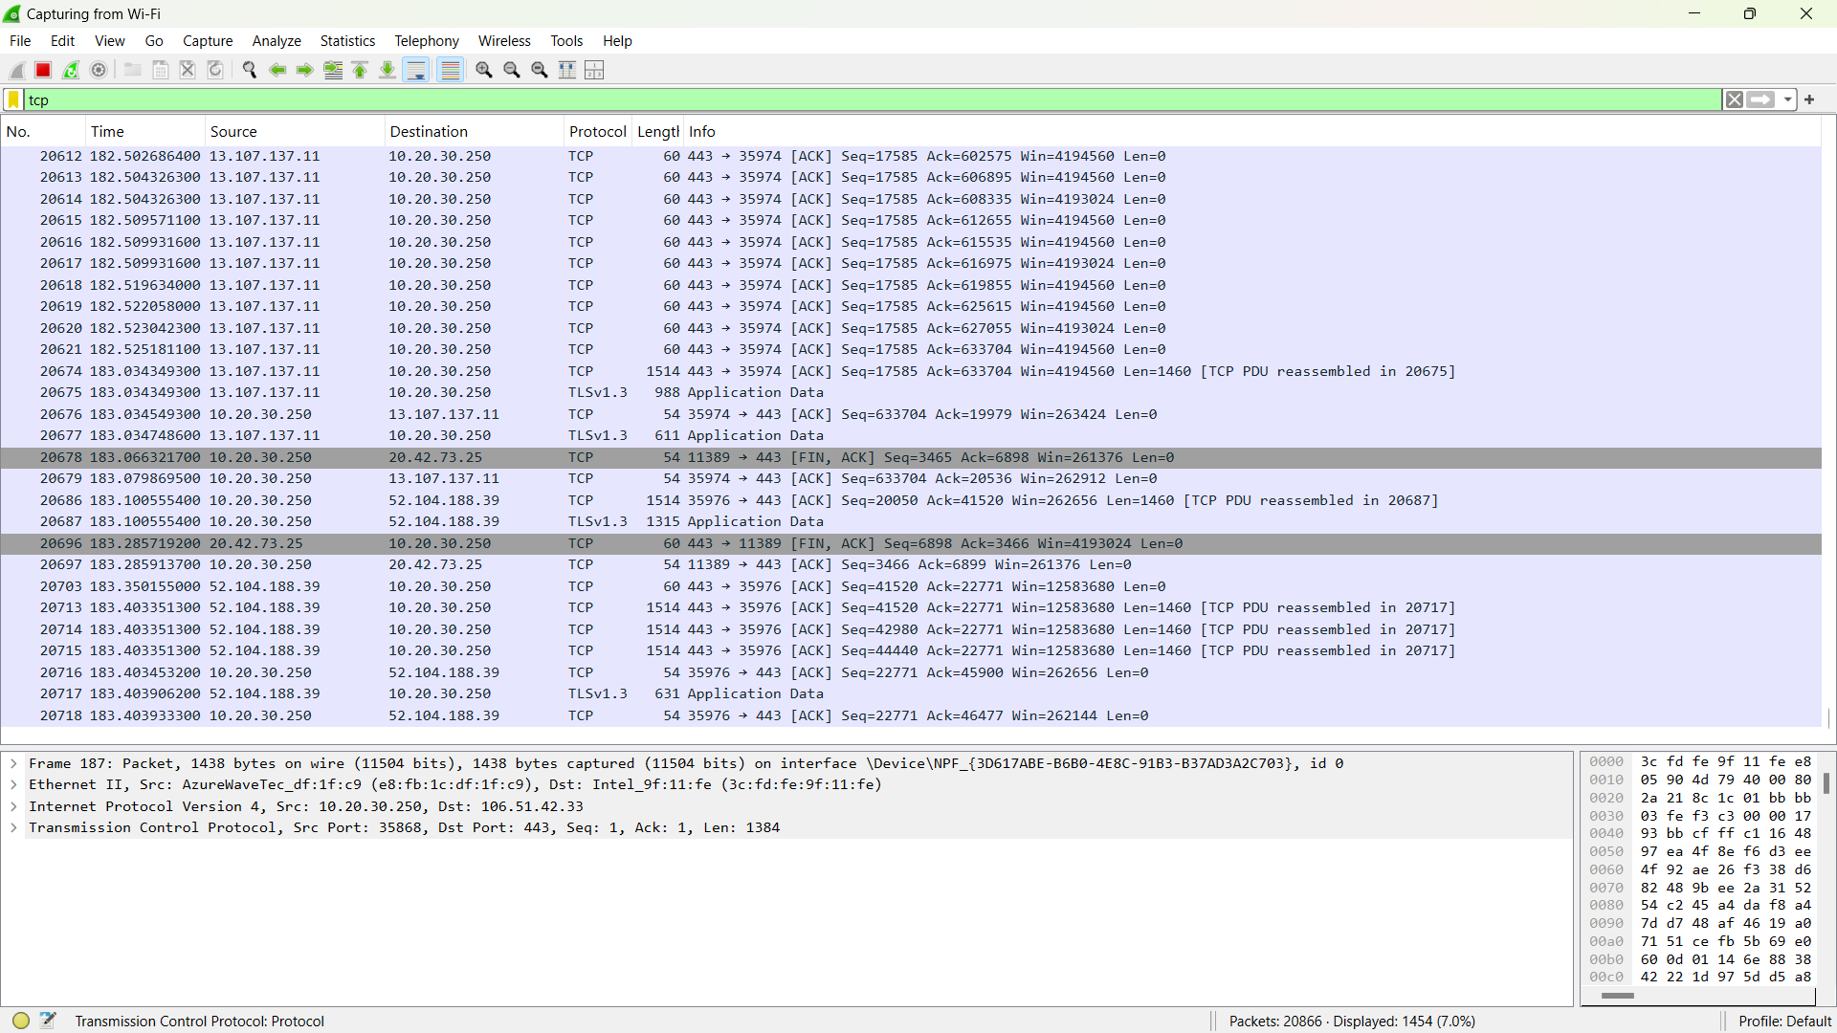

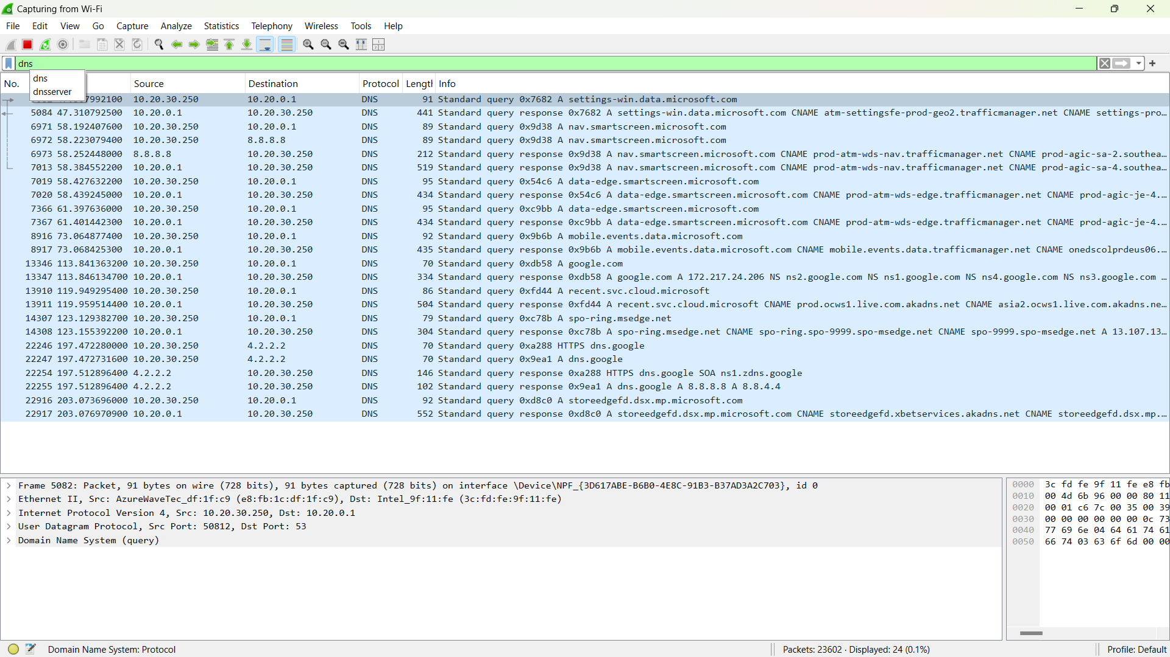

Open ports such as 135 (MSRPC), 445 (Microsoft-DS), and 8000 (HTTP server) were identified using Nmap scan.
TCP and DNS protocols were observed in the captured network traffic.
Port scanning activity was detected using Nmap, which indicates potential reconnaissance or security probing.
Finally:
- Network traffic was successfully captured using Wireshark.
- Open ports were identified using Nmap scan.
- TCP and DNS protocols were observed.
- Port scanning activity was detected, indicating potential security threats.

FULL DEVOPS MONITORING SETUP:
Monitoring Workflow: A complete DevOps monitoring setup was implemented using multiple tools.
- Prometheus was used for infrastructure monitoring to track CPU and memory usage in real time.
- Application monitoring was performed by analyzing logs generated from the Python server to identify errors and response behavior.
- Wireshark was used for network monitoring to capture packets and analyze traffic such as TCP and DNS.
- These tools together provide a complete monitoring solution covering system performance, application behavior, and network activity.
System Bottlenecks:
No major system bottlenecks were observed during monitoring. CPU usage was stable without significant spikes. Memory availability was sufficient and did not show critical drops.

Application Errors
Application logs showed HTTP 404 errors when invalid URLs were accessed.
These errors indicate improper or non-existing routes requested by users.

Network Issues
Network analysis using Wireshark showed normal TCP and DNS traffic.
Port scanning activity using Nmap was detected, which indicates possible security probing.

Improvements Suggested
Implement alerting mechanisms in Prometheus for high CPU usage. Use structured logging tools like Datadog or Splunk for real-time log monitoring.
Enhance network security by detecting and blocking suspicious scanning activities.
