Inside the Docker DesktopSettingsKubernatesApplyInstall and Run
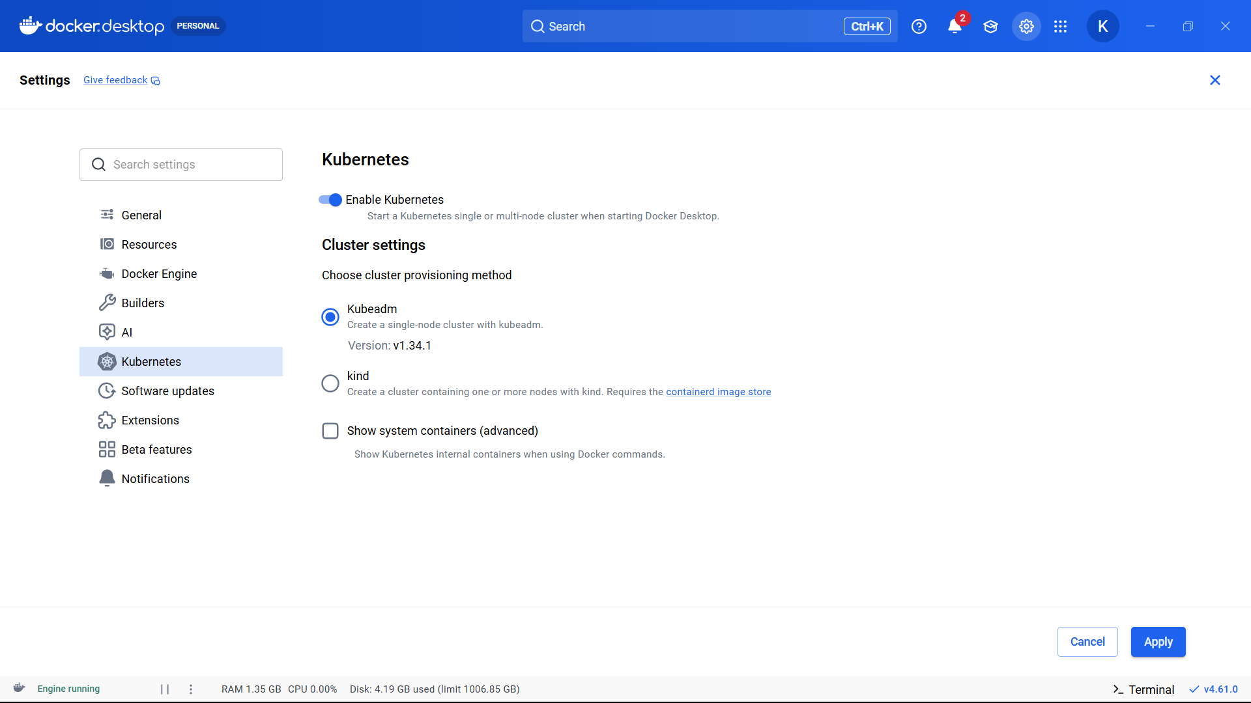

Docker downloads: kube-apiserver, etcd, controller-manager, scheduler
These are Kubernetes control plane components.
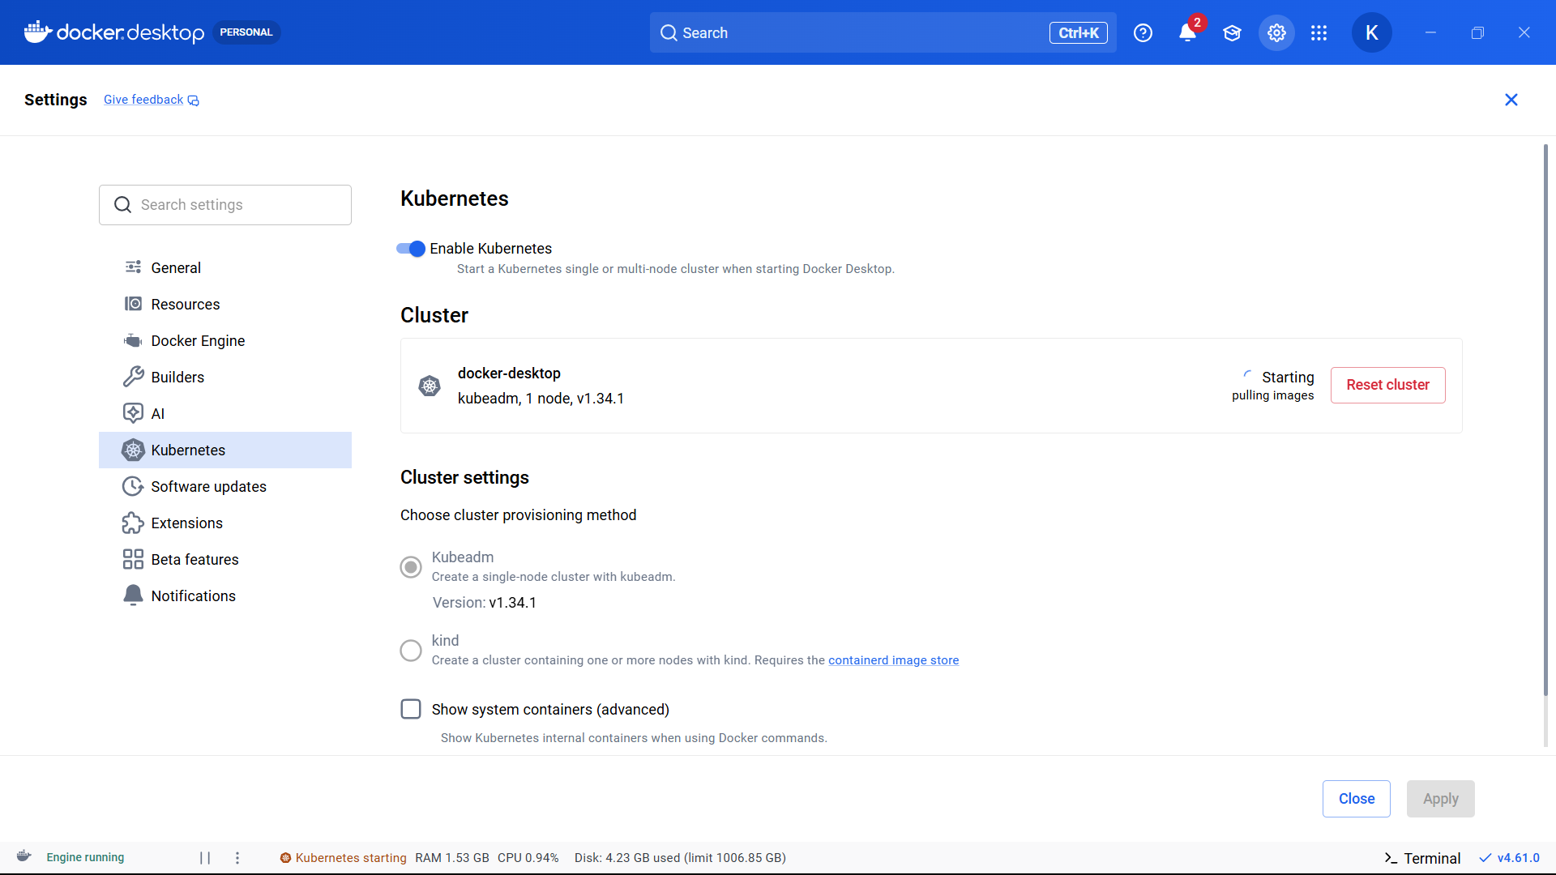
1-node Kubernetes cluster is Created
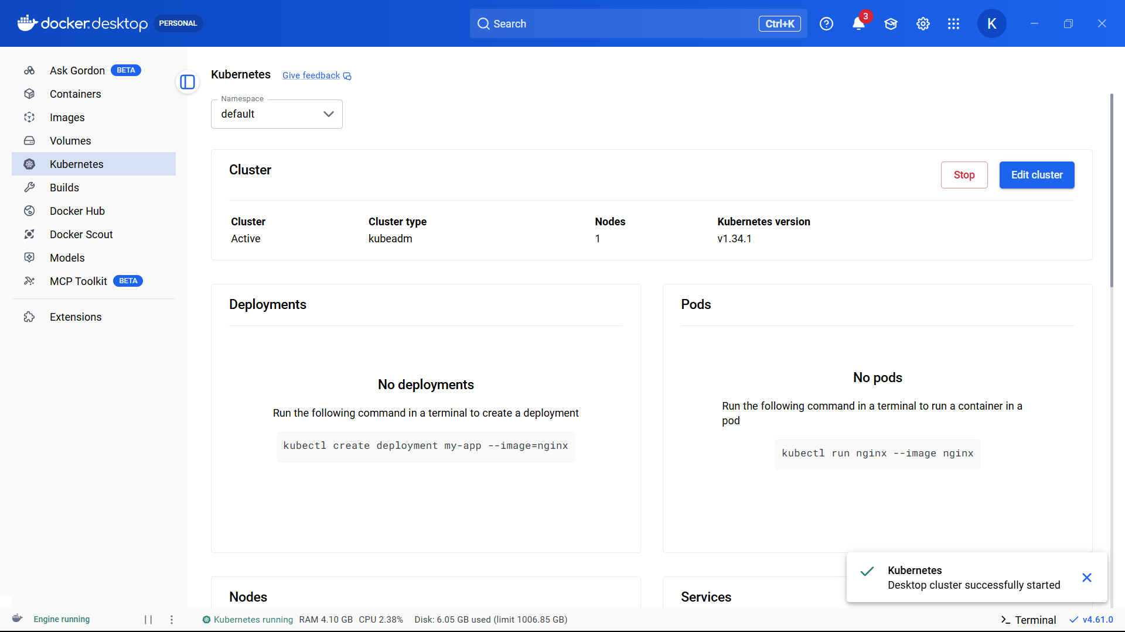

Follow the steps Exactly:
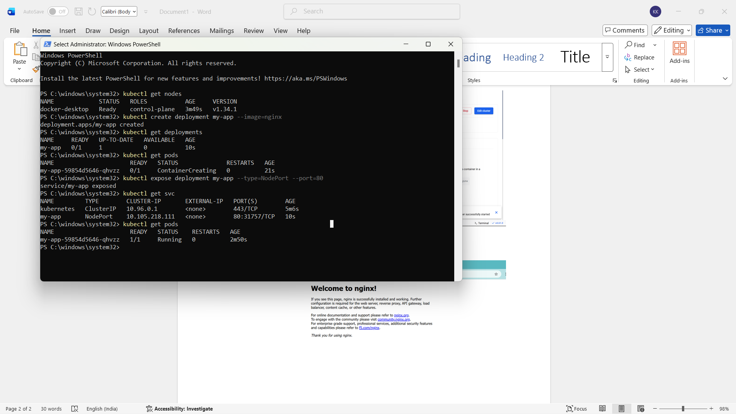
1. Deployment created
kubectl create deployment my-app --image=nginx
Meaning:
Kubernetes created:
- deployment object
- replica set
- pod

2. Pod created
Pod is smallest runnable unit in Kubernetes.
Inside pod:
- nginx container running
As your PPT explains: Pod = smallest deployable unit.

3. Service exposed
kubectl expose deployment my-app --type=NodePort --port=80
Meaning:
Kubernetes opened external port.

4. NodePort assigned
31757
This maps:
localhost:31757 → pod port 80
Exactly same concept as PPT NodePort service

The Localhost now is hosting the nginx
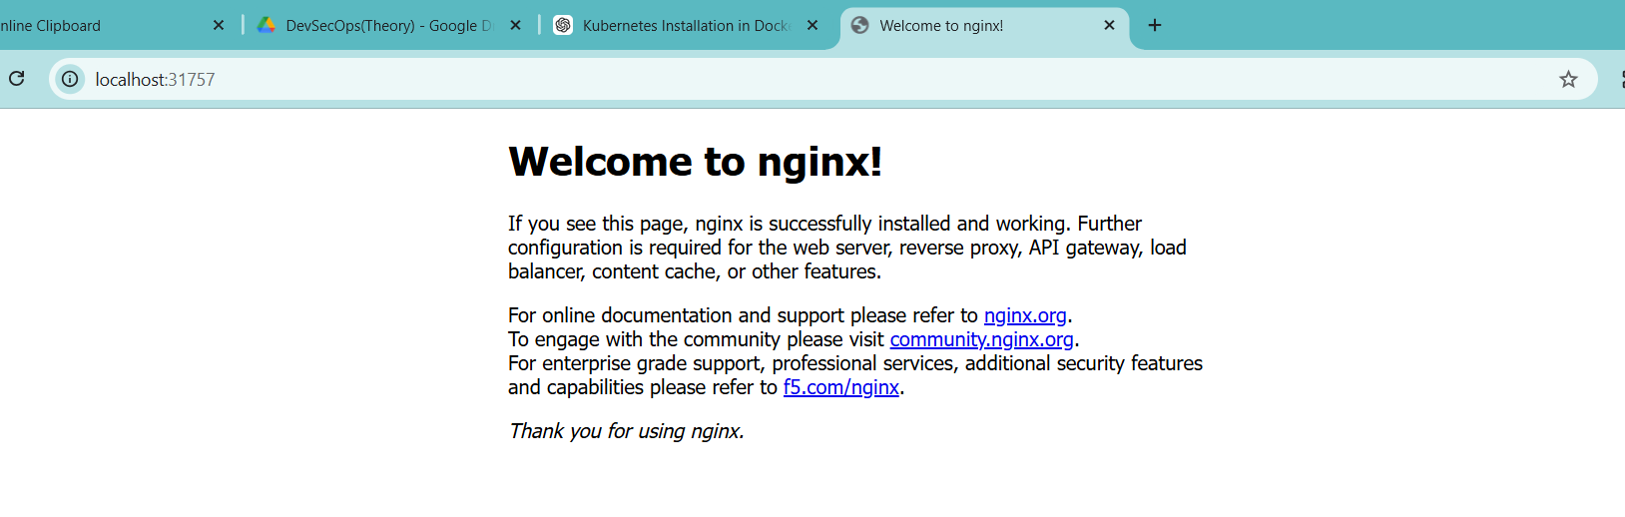
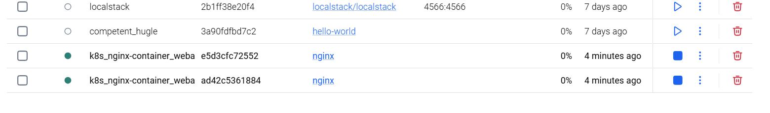
Now create a new project, delete this deployment
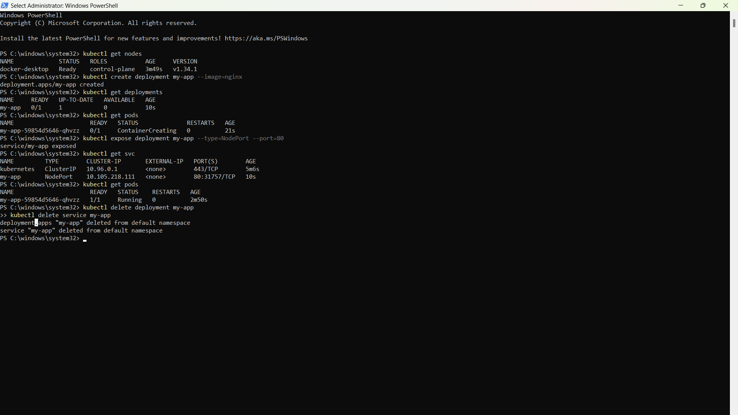
kubectl delete deployment my-app
kubectl delete service my-app
Start With New Project
First,
1. Create project folder in your location(D drive):
mkdir k8sproject
cd k8sproject

(Use VSCode)
Create File myapp-deployment.yml
apiVersion: apps/v1
kind: Deployment
metadata:
name: webapp

spec:
replicas: 2
selector:
matchLabels:
app: webapp

template:
metadata:
labels:
app: webapp

spec:
containers:
- name: nginx-container
image: nginx
ports:
- containerPort: 80

2. Create myapp-service.yml
apiVersion: v1
kind: Service

metadata:
name: webapp-service

spec:
type: NodePort
selector:
app: webapp

ports:
- port: 80
targetPort: 80
nodePort: 30080

3.
Run kubectl apply -f myapp-deployment.yml
And kubectl apply -f myapp-service.yml
Verify:
kubectl get pods
kubectl get svc

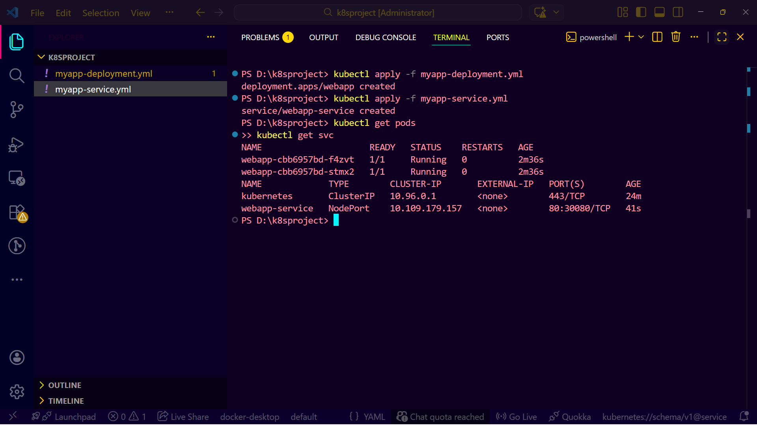
Running Sucessfully in 30080
Open http://localhost:30080
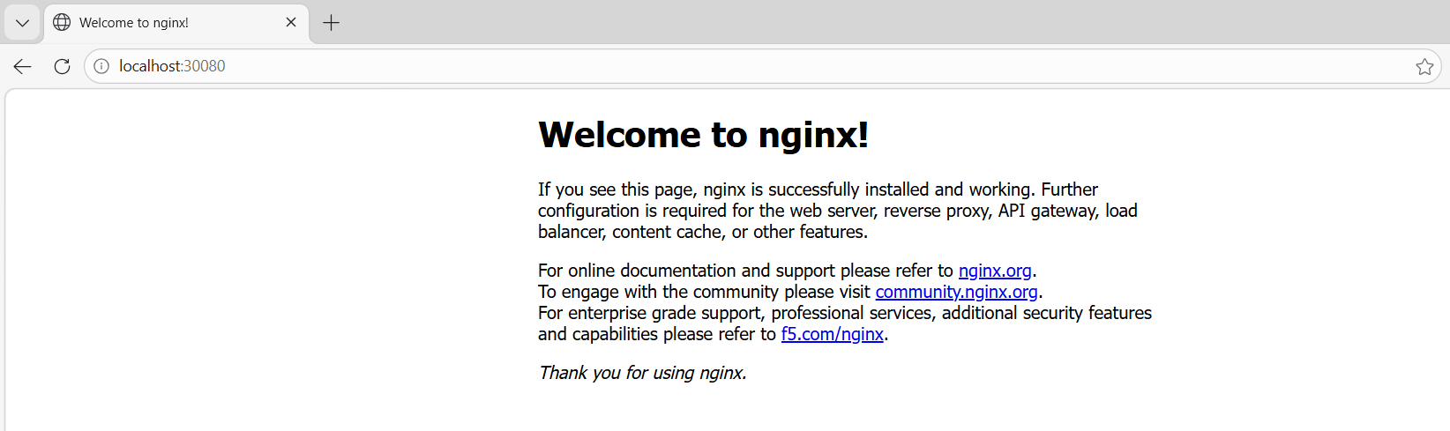

Now the project is Created and the Kubernates has deployed ngnix Sucessfully

kubectl get all

