Web Application Penetration testing

INTRODUCTION
The role of cybersecurity in protecting systems is higher and it protects from attacks from the attackers. This project if focused on the testing of web applications with considering ethical conditions in a controlled environment
OBJECTIVES
- Identify vulnerabilities in a web application
- Perform controlled exploitation to understand risks
- Analyze and document findings
- Suggest mitigation techniques
SCOPE
- Testing limited to:
  - DVWA (Damn Vulnerable Web Application)
  - Local test network
- No real-world systems were targeted
- All activities conducted ethically
TOOLS USED
- DVWA
- Browser Developer Tools
WEB APPLICATION PENETRATION TESTING
Web application pentesting focuses on identifying the vulnerabilities, and fixing those loopholes
Setup
Used kali as attacker machine
Used Metasploitable2 as victim machine
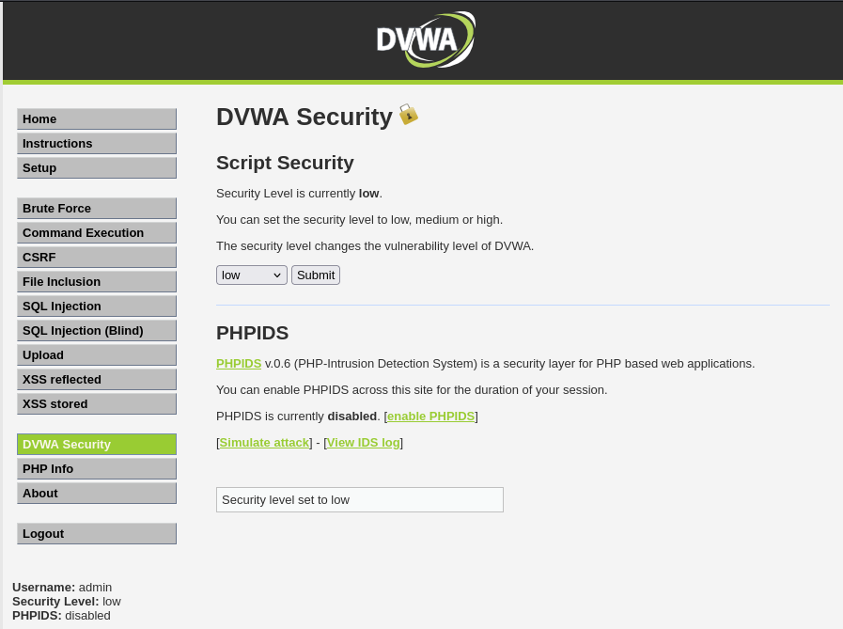

The vulnerabilities:
File upload:
The file upload is successful when the security is low.
If the security is high, then no malicious files can be easily uploaded to DVWA
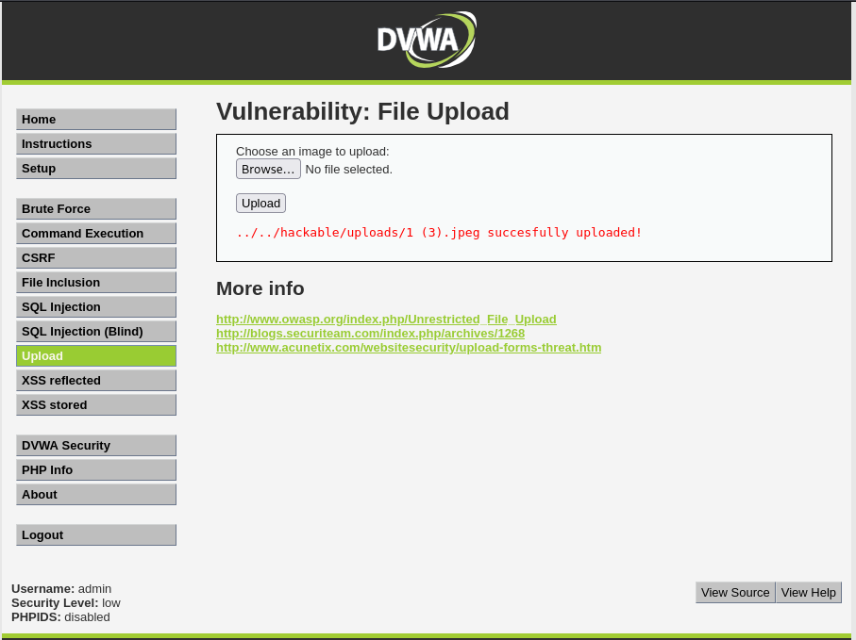

Command Injection:
DVWA helps us understand what happens when malicious commands are executed .
Ex: Ipaddress; ls gives the information of files in that directory of metasploitable2.
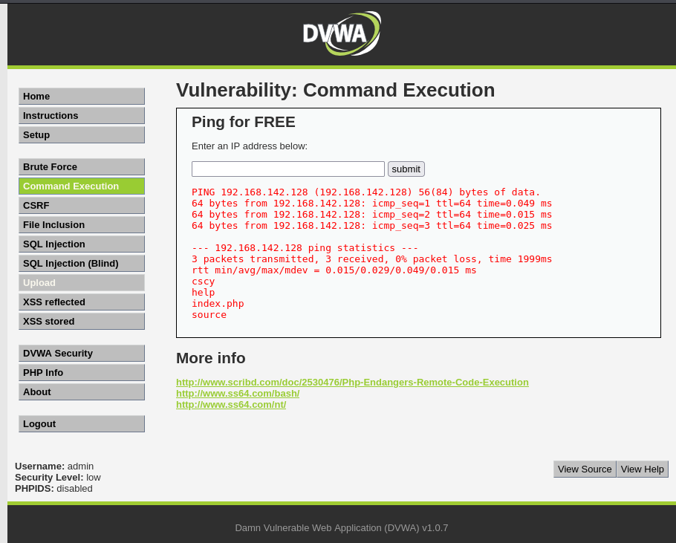

SQL Injection:
The attackers can manipulate the database queries
Ex:1' OR '1'='1 can give the details of such from the database.
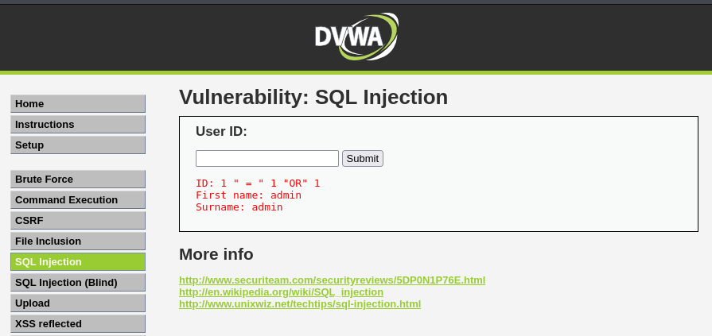

Cross-Site Scripting (XSS):
The attackers can execute malicious scripts in browser.
Ex:<script>alert("Hacked")</script> results into a popup alert.
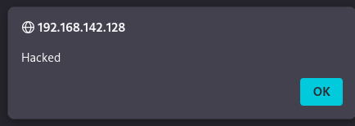

Mitigation Techniques
- Use prepared statements (SQL Injection)
- Implement input validation & sanitization (XSS)
- Restrict system command execution (Command Injection)
- Apply least privilege principle
ETHICAL CONSIDERATIONS
- Testing performed only on authorized systems
- No real-world systems targeted
- Followed ethical hacking guidelines

