Memora Product and Technical Plan
Adaptive strategic revision for durable learning

Version 1.1
Prepared October 2026

This plan defines the product, intelligence architecture, runtime knowledge graph, security model, classroom features, commercial model and staged delivery approach for the Memora mobile application.

Technology baseline
Flutter and Dart mobile application | FastAPI and Python backend | PostgreSQL with pgvector | LangGraph, LangChain and LangSmith | OpenRouter model access

Executive summary
Memora is a mobile learning system designed to reduce forgetting through strategically timed retrieval practice. Students continuously add what they learn across subjects and lectures. Memora transforms that material into a structured subject knowledge graph, identifies the concepts each student is likely to forget, delivers short quizzes, interprets the results and schedules the next review before recall deteriorates.
The central technical decision is a hybrid Adaptive Memory Intelligence Engine. A trainable memory model estimates difficulty, stability and retrievability. A versioned pedagogical rule engine applies expert knowledge, workload constraints and prerequisite reasoning. The runtime knowledge graph represents concepts and their relationships. LLM workflows interpret unstructured learning material, generate or select questions, evaluate open responses and diagnose misconceptions. Conventional software remains responsible for authorization, validation, storage, payments, audit and execution.
The student experience turns daily revision into care for one continuous underwater world. Each subject appears as its own coral reef on the same seabed. Reef health reflects the memory engine's current retention estimate, while permanent decorations, XP and Mora cosmetics record effort without disappearing when memory weakens. Daily Missions give students a short, clear reason to return without changing the evidence-based review schedule.
PostgreSQL with pgvector is the recommended initial system of record. It stores relational product data, the runtime node-and-edge graph, semantic embeddings and learner state in one transactional and security-controlled database. A dedicated graph database should only be introduced if measured production workloads require deep, graph-dominant traversal at scale.

Primary product outcomes
- Students retain more of what they learn with manageable daily revision effort.
- Students have a short daily goal and a visible world that responds to meaningful learning actions.
- Every review decision is personalized and explainable.
- Verified teacher-authored questions take priority over generated content.
- Teachers can create classrooms, contribute questions and monitor retention without accessing unrelated private study data.
- Uploaded files are temporary: validated knowledge is retained, while source files are deleted after successful processing.
- Security, privacy and traceability are part of the initial design rather than later additions.

Plan at a glance
Area | Decision
Mobile | Flutter and Dart for student and teacher experiences
Backend | A modular FastAPI application with background workers, not microservices at launch
Data | PostgreSQL plus pgvector as the only primary database for the first production release
Knowledge | Global, classroom and student-private graph layers with governed promotion
Memory | Adaptive prediction model plus pedagogical rule engine and knowledge-graph reasoning
Engagement | Daily Missions, one subject reef per seabed, personal progress and reversible reef health
Agents | Four controlled LangGraph workflows with typed tools and software validation
Models | OpenRouter behind a provider abstraction; models may change without domain rewrites
Operations | LangSmith for agent evaluation and tracing with sensitive content redacted
Files | Short-lived processing storage; delete originals after verified graph commit
Development | Ponytail for minimal implementation choices and Graphify for codebase understanding

1 Product definition

1.1 Problem
Learning normally accumulates faster than students can revise it. Without retrieval, memory strength decays and students often rediscover gaps only before examinations. Simple reminder applications treat every topic alike, while ordinary flashcard systems require manual card creation and generally lack subject structure, lecture context and teacher oversight.

1.2 Product thesis
Memora maintains a continuously updated model of what a student has learned and how well each concept is retained. It uses evidence from quizzes, time elapsed, response confidence, response speed, prerequisite knowledge and concept difficulty to choose the next useful revision activity.

1.3 Core learning loop
1. The student records or uploads what was learned during a lecture or study session.
2. Memora extracts concepts, facts, relationships, formulas and potential misconceptions.
3. The validated result updates the appropriate subject knowledge graph and the upload is deleted.
4. The memory engine schedules an initial retrieval opportunity, usually near the next day but adjusted by policy and context.
5. Memora presents a short quiz selected from verified human questions or grounded generated questions.
6. The answer becomes structured learning evidence rather than only a score.
7. The memory engine updates the learner state and schedules the next review.
8. New lecture content is merged into the same subject model without losing older revision obligations.

1.4 Product principles
Principle | Meaning in Memora
Retrieval before rereading | Quizzes and recall activities are the default intervention.
Concept level state | Each concept has its own memory state even when quizzes combine several lectures.
Evidence over confidence | Scheduling uses observable answers, delay and behaviour rather than an LLM guess.
Verified content first | Approved question banks and teacher keys override generated material.
Explainable personalization | The student and teacher can understand why an item was scheduled.
Private by default | Personal material remains student-private until explicitly promoted.
Bounded agents | Agents propose and interpret; validated services authorize and commit.
Storage discipline | Retain compact knowledge and evidence, not permanent copies of source uploads.
Honest game feedback | Visual rewards reflect learning evidence without hiding, distorting or overriding the memory schedule.

1.5 Initial non-goals
- A social feed, public profiles or follower system.
- Live video tuition or classroom conferencing.
- Institution-wide administration before individual teacher workflows are proven.
- An unrestricted general chatbot.
- A separate graph database or microservice fleet without measured need.
- Automated promotion of private student notes into shared academic knowledge.

2 Users and commercial model
User | Primary need | Initial paid value
Student | Remember growing material across multiple subjects | More subjects, larger monthly ingestion allowance, advanced analytics and higher quiz capacity
Teacher | Create classrooms and understand where students are forgetting | Classroom capacity, assignments, question authoring, retention analytics and exports
Content reviewer | Maintain trustworthy question banks | Internal role with approval, versioning and dispute tools
Administrator | Operate the platform safely | Audit, moderation, entitlement and model-cost controls

2.1 Monetization approach
Use entitlement-based subscriptions rather than scattering plan checks throughout the application. The billing provider records commercial events, while Memora stores the resulting plan and entitlements. Free access should demonstrate the complete learning loop with limits; paid plans should increase capacity and analytics rather than reduce learning correctness.
- Student subscription: subject limits, ingestion allowance, advanced progress views and higher AI usage.
- Teacher subscription: classroom and student limits, authoring tools, assignments and cohort analytics.
- Institution plans: deferred until teacher subscriptions and support requirements are validated.
- Never place security, data export, account deletion or essential learning-history access behind a premium tier.

3 Core product experiences

3.1 Student experience
Journey | Required behaviour
Create subject | Choose or create a subject, optionally linking a syllabus or classroom.
Add learning update | Enter text or temporarily upload a PDF, note photo, image or diagram after every lecture.
Verify extraction | Review uncertain concepts or relationships before the upload is deleted.
Daily Mission | Receive a short mission that mixes due, weak, prerequisite and newly learned concepts.
Review feedback | See the correct reasoning, relevant concept links, memories protected or repaired and why the next review was chosen.
Track progress | Explore the seabed, inspect each subject reef, and view retention confidence, workload and upcoming reviews.
Correct Memora | Report poor questions, incorrect graph facts or grading disagreements.

3.2 Teacher experience
- Create a classroom and invite students using a controlled code or invitation.
- Add lecture material and classroom-specific concepts without exposing student-private graphs.
- Create, import and approve questions with official answers and concept tags.
- Assign learning objectives or quiz windows while the memory engine still manages revision timing.
- View aggregated retention, prerequisite gaps, common misconceptions and ambiguous-question warnings.
- Inspect individual progress only within the classroom relationship and defined consent policy.

3.3 Question-bank operations
Memora's operator can hire qualified tuition teachers or subject experts to author MCQs for selected subjects. The resulting bank is versioned, reviewed and mapped to syllabus topics and knowledge-graph nodes. These verified questions are preferred over AI generation and are graded deterministically using their official answer keys.

3.4 Student engagement and game experience
Memora uses a game-like presentation to make a small amount of useful revision feel approachable each day. The game layer presents and rewards work chosen by the memory engine; it never changes due dates, grading, recall estimates or learning priorities to manufacture engagement.
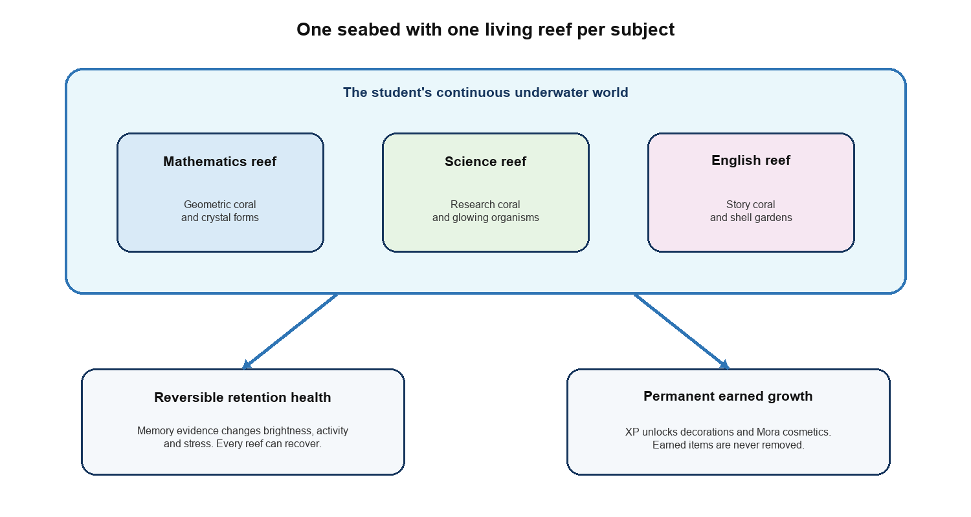
Figure 1 The seabed model connects subject identity, retention health and permanent rewards

3.4.1 Core world model
Every student has one continuous seabed. Each subject becomes a distinct coral reef within that world rather than a separate region or disconnected map. Reefs share the same underwater visual language but use different coral structures, landmarks and accent colours so subjects remain recognizable. The design can support Mathematics as a geometric reef, Science as a research reef and English as a story or shell garden without turning them into unrelated environments.
A new subject begins as a neutral sandy area with small coral sprouts. The reef grows as the student adds verified knowledge and retrieves it successfully. Retention risk affects the reef's current atmosphere, while accumulated learning unlocks permanent structures and decorations.

3.4.2 Daily Mission
The Home screen gives one dominant action called Today's Mission. It shows the number of due memories, an estimated duration, normally three to seven minutes, and the reward available for completing meaningful scheduled work. The mission remains bounded so the student can finish it and leave without an endless engagement loop.
Mission type | When it appears | Learning purpose
Protect | Concepts are due or approaching their review window | Retrieve memories before predicted recall falls too far
Repair | Recent evidence shows a forgotten concept or misconception | Rebuild weak knowledge with focused questions and feedback
Recover | A weak prerequisite blocks a current topic | Restore the prerequisite before continuing with dependent concepts
Discover | The student adds verified learning material | Introduce new concepts and schedule their first retrieval
Challenge | The engine has enough evidence for a mixed checkpoint | Test transfer and discrimination across related concepts

3.4.3 Reef health
Reef health is a presentation of current memory state, not a separate score invented by the game. The backend derives it from predicted recall, overdue workload, prerequisite risk and recent high-quality evidence. New, untested concepts remain neutral until the student produces retrieval evidence. The product should use reversible terms such as stressed, faded and dormant instead of dead or destroyed.
Health range | Visible state | Meaning
85 to 100 | Thriving | Bright coral, clear water and active sea life indicate strong current recall
65 to 84 | Healthy | The reef is stable, with small signs that some reviews are approaching
45 to 64 | Needs care | Reduced activity or colour points to a manageable revision need
25 to 44 | Stressed | Faded coral or cloudier water signals substantial overdue or weak knowledge
0 to 24 | Dormant | The reef is quiet and subdued, but remains recoverable through comeback missions

3.4.4 Actions and world feedback
Student action | Learning-system effect | World response
Add verified material | Create or update concepts and schedule first retrieval | New coral sprouts and path nodes appear; no major XP is awarded until retrieval
Complete a scheduled review | Record high-quality retrieval evidence | The reef becomes brighter and more active
Answer correctly | Increase evidence for the tested concepts | A small growth or restoration animation confirms the result
Answer incorrectly | Record weakness or a misconception and create repair work | The weak area is highlighted; the entire reef is not damaged by one answer
Leave reviews overdue | Reduce predicted retrievability over time | The reef gradually fades or becomes less active in proportion to real memory risk
Return after an absence | Reprioritize overdue work within a manageable workload | Mora offers a comeback mission; the world is never erased or permanently damaged

3.4.5 Rewards streaks and Mora
- XP is awarded for meaningful scheduled learning actions and verified progress, not for opening the app or repeatedly uploading material.
- The server calculates XP and applies rewards idempotently so retries cannot duplicate them.
- Permanent progression unlocks seabed decorations and cosmetic items for Mora. Cosmetics do not provide academic or scheduling advantages.
- A weekly streak includes one grace day. A missed day does not erase XP, decorations or cosmetics.
- Mora acts as an encouraging guide with states for greeting, explaining, celebrating, noticing risk and welcoming a returning student.

3.4.6 Interaction and emotional safety
- Hide the main navigation during an active quiz so the mission has one clear focus.
- Make timers optional unless speed is part of the assessed skill; time pressure must not be the default motivation tool.
- Treat wrong answers as useful memory evidence. Show what needs repair without punitive language or a large red failure state.
- End each mission with memories protected or repaired, XP earned, streak status, reef growth and any new unlocks.
- Send specific actionable notifications such as a short Protect Mission for a named subject, with quiet hours and frequency controls.
- Do not use loot boxes, paid academic advantages, public rankings, blocking lives, shame, artificial destruction or endless play loops.

3.4.7 Screen placement and visual identity
Screen | Role in the game experience
Home | Show Today's Mission as the dominant action, with a compact preview of the seabed, streak and XP
Learning paths | Show concept and mission progression inside the selected subject reef
Progress | Provide the full interactive seabed, reef health explanations and retention trends
Quiz | Use focused question states with Mora guidance, optional timing and no bottom navigation
Results | Translate evidence into protected and repaired memories, growth, XP and the next useful action
Profile | Show permanent achievements, unlocked decorations and Mora cosmetics

The final Flutter application should preserve the supplied Figma direction: pale blue rounded surfaces, cyan gradients, dark navy type, bright blue icons and the Mora shark character. Exact fonts, gradient stops, component dimensions and responsive constraints must be taken from the Figma source rather than inferred from PNG exports.

4 High level architecture
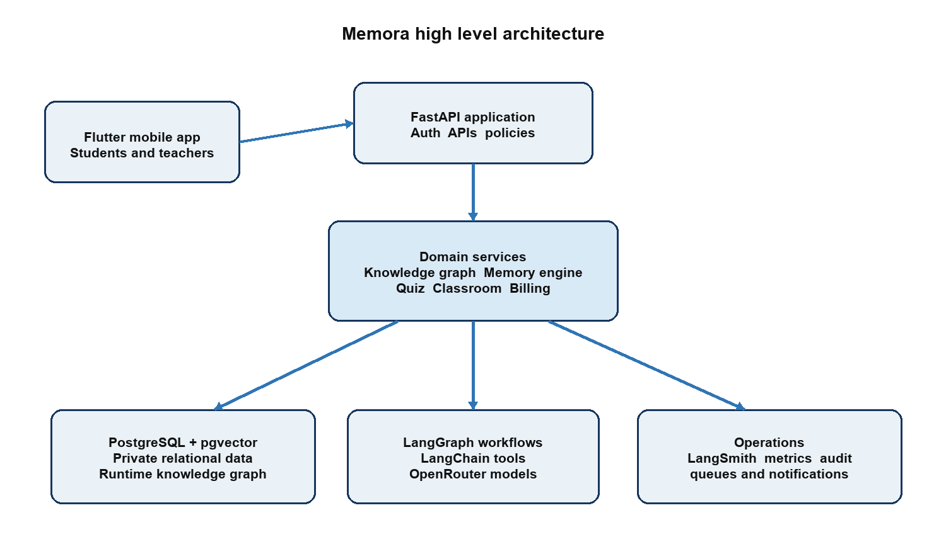
Figure 2 High level product architecture

4.1 Deployment shape
Begin with a modular monolith: one FastAPI application, one background-worker deployment and one PostgreSQL cluster. This preserves transactional simplicity while allowing clear module boundaries. Split services only when ownership, scaling or reliability measurements justify the operational cost.
Layer | Responsibilities
Flutter mobile | Authentication, subject management, upload capture, quizzes, feedback, teacher dashboards and offline-tolerant UI state
FastAPI | Typed APIs, authorization, orchestration, domain services, billing webhooks and audit
Background workers | OCR, extraction, graph proposals, embeddings, question generation, notifications and scheduled maintenance
PostgreSQL plus pgvector | Accounts, classrooms, graph nodes and edges, embeddings, questions, memory state, events and audit
AI platform | LangGraph workflow state, LangChain tools, OpenRouter models and LangSmith evaluation
Temporary object storage | Encrypted, short-lived upload processing with lifecycle deletion

4.2 Repository structure
A practical initial repository layout is:
Path | Purpose
apps/mobile | Flutter application
services/api | FastAPI application and domain modules
services/worker | Background jobs and LangGraph workflows
packages/contracts | Generated API contracts when needed
infrastructure/migrations | Database migrations and extensions
infrastructure/containers | Local and deployment containers
docs/product | Product decisions and user flows
docs/architecture | Architecture decisions, threat model and diagrams
tests/integration | Cross-module, security and migration tests

5 Intelligence architecture

5.1 AI and conventional software boundary
Capability | Responsible component | Reason
Interpret notes and diagrams | LLM workflow | Semantic and ambiguous input
Extract and link concepts | LLM proposal plus graph validation | Meaning requires AI; integrity requires software
Generate questions and distractors | LLM workflow | Creative semantic transformation
Mark verified MCQs | Conventional software | The official key is exact
Assess open answers | LLM with rubric and confidence | Meaning can differ from wording
Predict recall | Adaptive memory model | Requires calibrated numerical prediction
Apply teaching policies | Versioned rule engine | Expert knowledge and explainable exceptions
Authorize access and commit data | Conventional software | Security and transactional correctness
Payments and entitlements | Conventional software | Financial correctness and auditability
Teacher narrative insights | LLM over verified metrics | Readable explanation grounded in calculated data

The governing pattern is: AI proposes or interprets; software validates, authorizes, stores and executes.

5.2 Controlled agent workflows
LangGraph workflow | Purpose | Important controls
Ingestion | Turn temporary material into graph proposals | Schema validation, confidence gates, deduplication and user verification
Question | Retrieve verified questions or generate grounded alternatives | Source support, answer validation, duplication checks and trust labels
Evaluation | Interpret open responses and diagnose misconceptions | Rubrics, structured output, grading confidence and appeal path
Quiz planning | Choose useful concepts and question formats | Memory-engine output, workload caps, assignment rules and diversity constraints

LangChain provides loaders, structured model calls and tool interfaces. LangGraph coordinates stateful workflows. LangSmith supports traces, datasets and evaluations after sensitive content is redacted. OpenRouter is accessed through a provider interface so models, fallbacks and budgets can change without domain-logic rewrites.

5.3 What agents must never control directly
- Authentication, classroom authorization or row-level access policy.
- Arbitrary SQL or unrestricted database credentials.
- Subscriptions, payments, refunds or entitlement grants.
- Official answers for verified questions.
- Permanent graph changes without validation and audit.
- Deletion of accounts, evidence or knowledge without a software workflow.
- High-confidence grading when evidence or model confidence is insufficient.

6 Temporary material ingestion
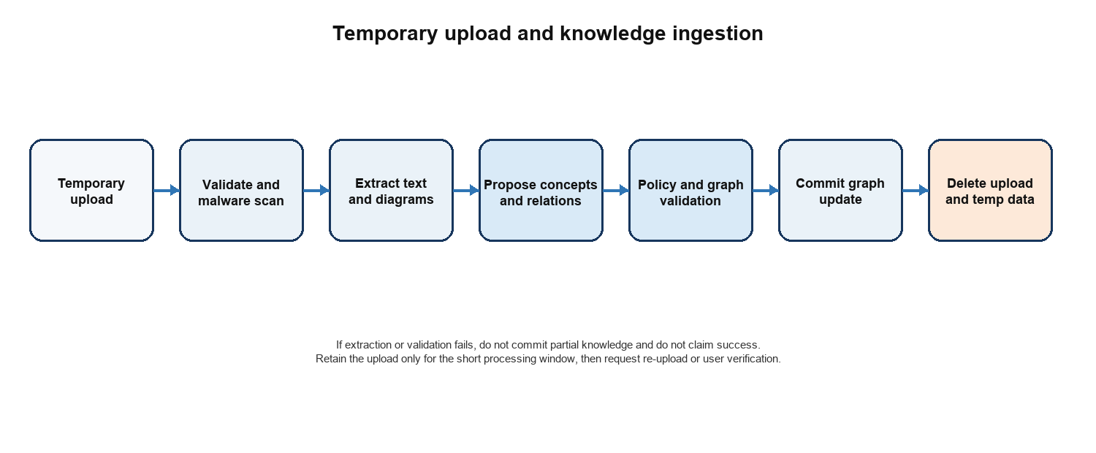
Figure 3 Uploads are temporary and retained knowledge is structured

6.1 Processing contract
1. Create an encrypted temporary object with a short expiration time and ownership metadata.
2. Validate size, declared type, detected type, malware status and processing limits.
3. Extract text, layout, diagram labels and mathematical expressions using the appropriate parser or vision model.
4. Generate typed proposals for concepts, facts, formulas, examples, relationships and uncertainty.
5. Search the existing graph using identifiers, normalized text and pgvector similarity.
6. Validate node types, edge types, ownership, visibility, duplicates, contradictions and confidence.
7. Ask the student to verify uncertain visual or handwritten extraction when necessary.
8. Commit the graph update and ingestion receipt atomically where possible.
9. Delete the original upload and derived temporary artifacts after successful commit; lifecycle rules provide a backup deletion guarantee.

6.2 What is retained
Retain | Do not retain by default
Normalized concepts, facts, formulas and relationships | Original PDF, photograph or diagram file
Compact supporting excerpt when required for verification | Full extracted document text when it adds no learning value
Source hash, original filename and processing receipt | OCR intermediate images and temporary crops
Extractor, prompt and model versions | Provider responses containing unnecessary raw content
Confidence, ownership, visibility and timestamps | Permanent duplicate embeddings for identical material

6.3 Failure behaviour
Deletion should occur only after graph validation and a durable processing receipt. If processing fails, Memora should present the error, avoid partial graph mutation and request a retry or re-upload. For visually uncertain content, deletion should wait for user verification within a bounded processing window.

7 Runtime knowledge graph
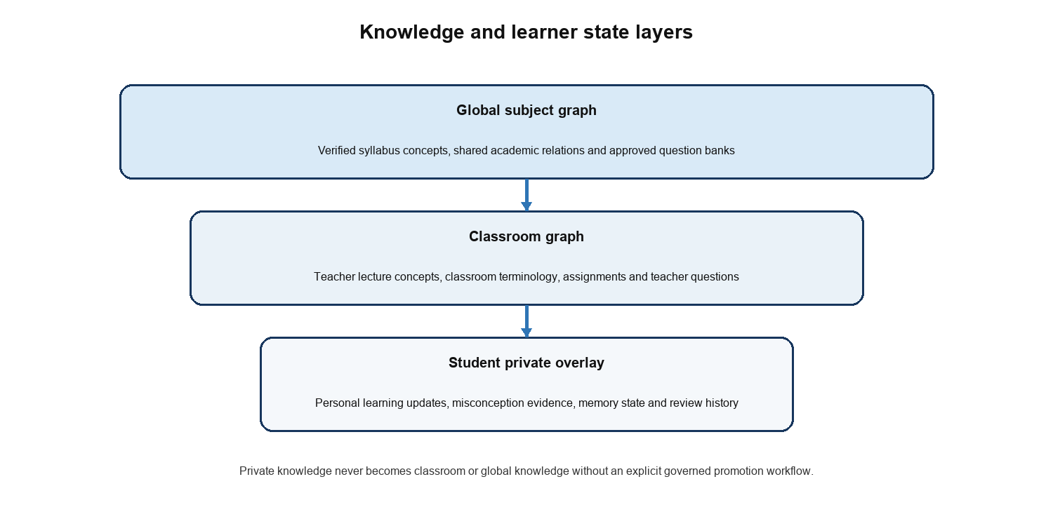
Figure 4 Shared academic knowledge and private learner state are separated

7.1 Graph model
Node examples | Relationship examples
Subject, topic, concept, fact, formula, example, misconception, learning objective and question | PART_OF, REQUIRES, HAS_FORMULA, EXPLAINS, CONTRASTS_WITH, COMMONLY_CONFUSED_WITH, TESTED_BY and DERIVED_FROM
Classroom lecture concept, assignment and teacher question | INTRODUCED_IN, ASSIGNED_BY and APPROVED_BY
Student memory state and learning evidence | LEARNED_IN, REVIEWED_BY, STRUGGLES_WITH and SUPPORTED_BY

7.2 Visibility and promotion
The data policy layer determines whether new knowledge is global, classroom-scoped or student-private. AI may recommend classification, but software policy makes the final decision. Private knowledge may be promoted only through an explicit governed workflow with teacher, reviewer or administrator approval.

7.3 Knowledge Graph Service
Agents and the memory engine never query storage directly. They call a Knowledge Graph Service that enforces authorization and selects one of three explicit query paths.
Request type | Query path | Example
Relational | Parameterized SQL | Reviews due, classroom membership or question key
Semantic | pgvector similarity plus exact validation | Find an equivalent concept expressed in different words
Graph traversal | SQL joins or recursive SQL | Find prerequisites and related weak concepts

PostgreSQL chooses the physical execution plan. Application services choose the authorized operation and query form. LLMs receive typed tools such as get_weak_concepts rather than raw SQL access.

8 Database and storage plan

8.1 Primary decision
Use PostgreSQL with pgvector as the primary and only durable database in the initial architecture. This is a good match because most Memora operations are transactional and relational: users, subjects, classrooms, attempts, entitlements, audit events and due reviews. Initial graph traversals are expected to be shallow, while pgvector provides semantic concept matching in the same system.

8.2 Core tables
Table group | Representative tables
Identity and access | users, identities, sessions, roles and audit_events
Learning organization | subjects, learning_updates, classrooms, classroom_members and assignments
Knowledge graph | knowledge_nodes, knowledge_edges, node_sources and graph_revisions
Questions | questions, question_options, question_concepts, question_versions and disputes
Memory | student_concept_states, learning_events, memory_decisions and review_schedule
Quiz execution | quiz_attempts, quiz_items and responses
Engagement | mission_runs, xp_events, unlocks, user_cosmetics and streak_state; reef health is derived rather than duplicated
Commercial | subscriptions, entitlements and billing_events
AI operations | workflow_runs, model_usage, evaluation_results and prompt_versions

8.3 Graph database decision gate
Do not add Neo4j or another graph database initially. Reassess only if production measurements show frequent deep variable-length traversals, large graph-algorithm workloads, or unacceptable SQL complexity and latency. If introduced, PostgreSQL remains the source of truth and the graph database receives a derived projection; avoid synchronous dual writes.

8.4 Apache AGE
Apache AGE may offer Cypher-style graph querying inside PostgreSQL, but it adds extension compatibility and operational work. Defer it until ordinary node-and-edge tables and recursive SQL have been measured and found insufficient.

9 Adaptive Memory Intelligence Engine
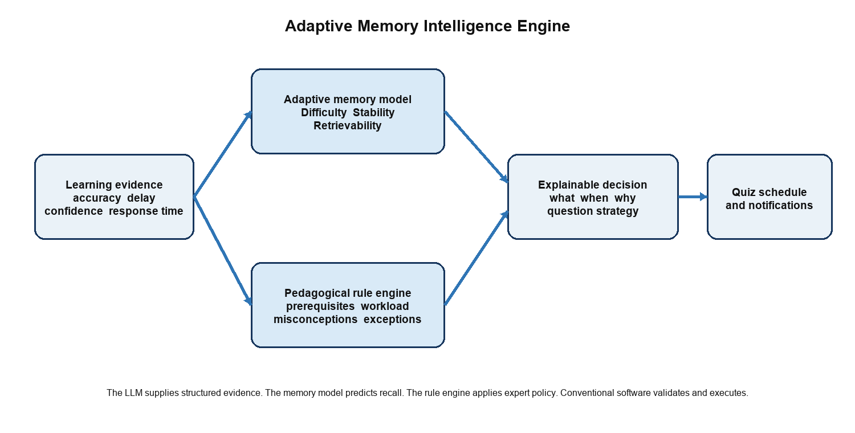
Figure 5 A hybrid memory engine is stronger than a pure expert system

9.1 Why not a pure expert system
A pure expert system would be explainable but brittle. Manually written rules do not naturally calibrate themselves to different students, subjects and item difficulties, and a large rule base would become difficult to maintain. Conversely, a black-box model without policy or explanation would be hard to trust. Memora should combine both strengths.

9.2 Memory model
Start with an FSRS-style Difficulty, Stability and Retrievability model for each student-concept pair. The model estimates current recall probability and the interval likely to meet a target retention level. Begin with validated population-level parameters and personalize only after sufficient evidence exists.
State | Meaning
Difficulty | How hard the concept is for this learner
Stability | How long the memory is likely to remain retrievable
Retrievability | Estimated probability of successful recall at the present time
Evidence quality | Reliability of the grading signal used to update the state
Next review | The selected date and target intervention

9.3 Pedagogical rule engine
A compact versioned rule engine applies expert-reviewed policies that are difficult to express through the memory curve alone.
Condition | Policy response
Incorrect answer with high confidence | Treat as likely misconception; schedule correction and test prerequisites
Correct but slow or uncertain | Increase stability conservatively and schedule confirmation earlier
Repeated failure | Reduce interval, change question format and consider concept decomposition
Weak prerequisite | Review the prerequisite before or alongside the target concept
Late review | Use actual elapsed time rather than the originally scheduled interval
Low AI-grading confidence | Limit the negative memory-state update and request confirmation
Similar concepts confused | Use contrastive and interleaved questions
Excessive backlog | Prioritize high-value and near-threshold concepts within a workload cap

9.4 Concept-aware evolution
FSRS-style models typically operate at item level. Memora should enhance this using knowledge-graph relationships and, after sufficient data exists, a multi-skill knowledge-tracing model. This allows evidence from a question to update several concepts at different strengths and accounts for prerequisite weaknesses and semantic interference.

9.5 Explainability record
Every memory decision records input evidence, model version, predicted recall, rules fired, graph relationships consulted, final interval and explanation. A user-facing explanation might state: Acceleration is scheduled tomorrow because the answer was incorrect with high confidence, indicating a possible misconception; velocity was included because it is a prerequisite.

10 Quiz and question system

10.1 Source priority
1. Verified human-authored question bank.
2. Questions created or approved by the student's teacher.
3. AI-generated questions grounded in authorized knowledge-graph evidence.
4. No question when the system cannot establish sufficient support.

10.2 Trust labels
Label | Meaning | Grading
Verified | Reviewed and approved by the platform's subject experts | Official answer key
Teacher authored | Created or approved by an authorized classroom teacher | Teacher answer key
AI generated | Created from authorized graph evidence and passed automated validation | Validated structured key or rubric
Under review | Reported, ambiguous or insufficiently supported | Excluded from high-impact memory updates

10.3 Quiz composition
The quiz planner chooses a bounded mixture of overdue concepts, recently forgotten concepts, weak prerequisites, new material and interleaved related concepts. Software constraints prevent duplicates, repeated exposure to the same wording, excessive daily load and violations of teacher assignments.

10.4 Answer evaluation
- Objective questions are graded deterministically against the stored key.
- Short answers use a stored rubric, relevant graph evidence and structured LLM output.
- Partial correctness, misconception classification and grading confidence are stored separately.
- Low-confidence or disputed grading has reduced influence on the memory state.
- Every generated explanation is grounded in the current authorized graph.

11 Classroom and teacher system
Capability | Plan
Classroom creation | Teacher creates a classroom with subject, syllabus and access policy.
Membership | Students join through invitation or expiring code; membership is auditable.
Content | Teacher material enters the classroom graph after validation.
Questions | Teachers create, import, revise and approve questions mapped to concepts.
Assignments | Teacher specifies objectives or windows; the memory engine determines personal practice.
Analytics | Calculated metrics show retention, coverage, prerequisites and misconceptions.
Privacy | Teachers see only classroom-authorized learning evidence, not unrelated private subjects.
Intervention | Teachers can recommend revision without silently rewriting student history.

11.1 Teacher insights
The backend calculates all metrics first. An LLM may then express grounded observations such as: most students remember the formula but struggle to apply it, or a question may be ambiguous. The insight must cite the metric window, affected concepts and confidence rather than inventing causal claims.

12 Security privacy and trust

12.1 Security baseline
Control area | Required controls
Identity | Argon2id password hashing, short-lived access tokens, refresh rotation, session revocation and optional MFA
Authorization | Role and relationship checks on every request, least privilege, scoped service accounts and row-level security where practical
Uploads | Type and size validation, malware scanning, encrypted temporary storage, signed access and lifecycle deletion
Application | Parameterized queries, schema validation, rate limits, idempotency and secure error handling
Secrets | Server-side secret storage, rotation and no API keys in Flutter
AI privacy | Provider allowlist, content minimization, prompt-injection resistance, trace redaction and retention controls
Audit | Immutable security-relevant events for access, graph promotion, question approval and administrative action
Recovery | Encrypted backups, restoration exercises, migration rollback plan and incident procedures

12.2 Tenant and classroom isolation
Every classroom, question, graph node and learner-state query must carry an explicit ownership or scope. Authorization is resolved before retrieval. Vector search must filter to the authorized subject and visibility scope; semantic similarity must never become a route around access control.

12.3 AI-specific threats
- Treat uploaded text as untrusted data, not instructions for the agent.
- Expose only allowlisted typed tools with minimal outputs.
- Validate all structured model responses against schemas and domain rules.
- Do not include secrets, unrelated student data or unrestricted identifiers in prompts.
- Record model, prompt and validator versions for consequential outputs.
- Use automated adversarial tests for prompt injection, data leakage and malicious documents.

12.4 Data lifecycle
Define retention separately for temporary uploads, normalized knowledge, learning history, audit events and billing records. Students need export and deletion workflows. Shared or classroom knowledge derived from a student's private upload requires explicit provenance and promotion consent before it can survive account deletion as shared content.

13 API and service boundaries
Module | Representative operations
Identity | register, login, refresh, logout, revoke sessions and manage MFA
Subjects | create subject, add learning update, inspect processing status and review graph changes
Knowledge graph | query concepts, propose update, validate update, traverse prerequisites and promote knowledge
Memory | record evidence, calculate state, explain decision and list due reviews
Engagement | compose Daily Mission, derive reef health, award idempotent XP, manage streak grace and list unlocks
Quiz | create attempt, fetch next item, submit response, appeal grading and complete attempt
Questions | author, version, approve, report and retrieve by concept
Classrooms | create, invite, join, assign, inspect authorized analytics and remove membership
Billing | receive webhook, calculate entitlements and expose current plan
Administration | review disputes, manage question banks, audit actions and monitor model costs

13.1 Background work
Long-running ingestion, embeddings and agent workflows should be jobs with explicit status, retry policy, idempotency key and dead-letter handling. API requests return a processing identifier instead of holding mobile connections open.

14 Evaluation and observability

14.1 Product metrics
Metric | Purpose
Recall calibration | When the engine predicts 80 percent recall, outcomes should approach that rate.
Retention at target horizon | Measures whether scheduled reviews preserve knowledge over the intended period.
Reviews per retained concept | Measures learning efficiency rather than engagement alone.
Daily workload completion | Shows whether the plan is realistic for students.
Daily Mission return rate | Measures whether students return for useful scheduled work rather than empty app opens.
Comeback completion | Measures whether students with overdue work can recover without being overwhelmed.
Reef health comprehension | Checks whether students correctly understand the visual state and know what action will improve it.
Question dispute rate | Monitors correctness and ambiguity.
Extraction correction rate | Measures knowledge-ingestion quality.
Teacher intervention value | Measures whether flagged gaps lead to improved outcomes.
Cost per active learner | Tracks model, storage and background-processing sustainability.

14.2 AI evaluation
- Maintain reviewed datasets for extraction, relationship creation, question generation and short-answer grading.
- Evaluate factual support, answer correctness, distractor quality, schema compliance and uncertainty calibration.
- Run candidate models through the same datasets before changing an OpenRouter route.
- Monitor failures by subject and content type; diagrams, handwriting and mathematics need separate slices.
- Use LangSmith traces for development and evaluation, with production content minimized and redacted.

14.3 Memory-model evaluation
Use time-based holdouts rather than random splits alone. Compare predicted recall with actual outcomes, evaluate by subject and learner cohort, and run controlled online experiments before changing scheduling policy. A model trained on historical schedules must be tested carefully because its data reflects the behaviour of the scheduler that produced it.

14.4 Operational observability
- Structured logs with request and workflow identifiers but no unnecessary content.
- Metrics for latency, error rate, queue age, model cost, deletion completion and failed graph commits.
- Traces across API, worker and model calls.
- Alerts for authorization anomalies, elevated dispute rates, stuck uploads and provider failures.

15 Delivery roadmap
Phase | Scope | Exit criteria
0 Foundation | Repository, CI, environments, auth skeleton, migrations, threat model, Graphify setup and coding standards | Repeatable builds, migration tests, baseline security checks and queryable code graph
1 Student loop | Subjects, manual learning updates, concept graph, basic questions, adaptive memory engine, Daily Missions and the initial seabed | A student can complete the learn-test-reschedule loop and see one subject reef respond to real memory evidence
2 Material intelligence | Temporary PDF/image ingestion, OCR, graph merge, pgvector, generated questions and deletion verification | Supported files produce reviewable graph updates and originals are reliably deleted
3 Verified banks | Expert authoring, review, syllabus taxonomy, versions, disputes and verified priority | Selected subjects can operate without generated questions for covered concepts
4 Classrooms | Teacher accounts, membership, assignments, questions and retention analytics | Teachers can manage a class without accessing unrelated private learning
5 Monetization | Student and teacher subscriptions, entitlements, usage accounting and billing recovery | Plans are enforceable, auditable and resilient to webhook retries
6 Intelligence improvement | Personalized model fitting, multi-concept knowledge tracing, richer interventions and controlled experiments | Improved calibrated retention without unacceptable workload or fairness regressions

15.1 MVP scope
- One mobile app serving student and basic teacher roles.
- Manual text updates plus a small supported set of PDF and image types.
- PostgreSQL node-and-edge graph and pgvector concept matching.
- FSRS-style memory state plus a compact expert-reviewed rule set.
- Verified-question priority with AI generation as a grounded fallback.
- Today's Mission, one reef per subject, explainable reef health, XP, one weekly streak grace day and permanent cosmetic rewards.
- Four LangGraph workflows, each using typed tools.
- Security controls, audit events, export and deletion from the beginning.

15.2 Deferred until evidence
- Neo4j, Apache AGE or another permanent graph technology.
- Microservices, event streaming infrastructure and multi-region active-active deployment.
- A custom neural scheduler trained before enough high-quality review data exists.
- Institution administration, social features, public content marketplaces and live tutoring.

16 Testing strategy
Test layer | Coverage
Unit | Memory calculations, rules, reef-health mapping, XP policy, validators, entitlement decisions and graph merge logic
Property based | Interval bounds, monotonicity expectations, idempotent XP, reversible reef health and graph invariants
Integration | API to PostgreSQL, migrations, background jobs, object deletion and provider adapters
Security | Authorization matrix, row isolation, upload attacks, prompt injection and rate limits
Agent evaluation | Extraction, generation, grading, refusal and confidence datasets
Mobile | Widget, state, accessibility, optional timer, quiz focus, seabed states, offline recovery and end-to-end mission flows
Load | Due-review queries, classroom dashboards, vector filters, ingestion queues and notification bursts
Recovery | Backup restore, job retry, provider outage, partial graph failure and billing webhook replay

16.1 Core acceptance scenario
1. A student adds two learning updates to one subject on the same day.
2. Memora merges overlapping concepts while preserving provenance and privacy.
3. The temporary upload is deleted only after a verified graph commit.
4. The next day's quiz mixes new concepts with an older weak prerequisite.
5. A verified MCQ is selected where available and graded deterministically.
6. An open answer is partially correct; the evaluator identifies a misconception with bounded confidence.
7. The memory engine records model output, fired policy rules and an explainable next review.
8. The student's subject reef changes from memory evidence, while previously earned decorations and Mora cosmetics remain intact.
9. A teacher sees the authorized classroom trend but cannot access unrelated personal notes.

17 Development workflow and Graphify

17.1 Graphify role
Graphify is a development-time knowledge graph for the Memora codebase, documentation and schemas. It is not the runtime student knowledge graph. Once the repository has meaningful code, build and maintain the project graph so developers and coding agents can query architecture before scanning the entire repository.
Command | Use
graphify extract . --code-only | Create the initial local code graph without sending code to a model
graphify codex install --project | Add project-scoped query-first guidance for Codex
graphify update . | Refresh the graph after meaningful code changes
graphify query question | Retrieve a bounded subgraph for an architectural question
graphify path A B | Trace how two components connect
graphify affected X | Inspect the likely impact of changing a component

17.2 Example development questions
- How is a quiz response converted into a memory decision?
- What validates an AI knowledge-graph proposal before commit?
- Which endpoints and workers are affected by changing student concept state?
- How are private graph nodes prevented from appearing in classroom analytics?

17.3 Ponytail engineering policy
Choose the smallest implementation that fully protects the learning loop. Reuse existing project patterns, keep validation at trust boundaries, avoid premature services and dependencies, and add focused tests for every non-trivial memory, security or parsing rule. Known limitations should be recorded as explicit shortcuts with an upgrade condition.

18 Major risks and mitigations
Risk | Impact | Mitigation
Incorrect extraction after source deletion | Knowledge may be unrecoverable | Require confidence gates, user verification for uncertain visuals and a clear re-upload path
Hallucinated questions or explanations | Students learn incorrect material | Prefer verified banks, require graph grounding, validate keys and support reporting
Biased memory updates from poor grading | Scheduler becomes inaccurate | Track evidence quality, cap low-confidence updates and maintain appeals
Private knowledge leaks into shared graphs | Serious privacy breach | Private default, explicit scopes, promotion approval, RLS and authorization tests
Rule-base growth | Conflicting or opaque behaviour | Keep the rule set compact, versioned, tested and subordinate to clear policy ownership
Model-provider instability | Interrupted workflows or cost spikes | Provider abstraction, timeouts, budgets, fallbacks and queued retries
Revision backlog overwhelms users | Abandonment despite accurate scheduling | Workload caps, prioritization and transparent rescheduling
Game system distorts learning | Students chase XP instead of retaining knowledge | Award meaningful scheduled actions, keep scheduling independent and test for exploit loops
Damaged reef causes shame | At-risk students avoid returning | Use reversible stressed or dormant states, gradual change, a grace day and welcoming comeback missions
Reef display misrepresents memory | Students trust a decorative score over evidence | Derive health from versioned memory metrics and explain the contributing factors
Premature architecture complexity | Slow delivery and fragile operations | Modular monolith, one database and measured evolution gates
Teacher analytics misinterpreted | Unfair conclusions about students | Show evidence windows, uncertainty and no unsupported causal claims
Graph duplication and contradiction | Poor retrieval and quiz selection | Canonicalization, embeddings plus exact checks, provenance and revision history

19 Decisions and open questions

19.1 Confirmed decisions
- Memora is a Flutter mobile application with a FastAPI backend.
- PostgreSQL with pgvector is the initial primary database.
- Uploaded learning files are temporary and are deleted after validated graph ingestion.
- Knowledge is separated into global, classroom and student-private layers.
- Agents use LangGraph, LangChain, LangSmith and OpenRouter through controlled interfaces.
- Memory management uses a hybrid adaptive model and pedagogical rule engine, not a pure expert system.
- Verified human questions are preferred over AI-generated questions.
- The game world is one continuous seabed with one visually distinct coral reef per subject.
- Reef health is reversible and derived from memory evidence; XP and earned cosmetic progression are permanent.
- Today's Mission is the daily return hook, with personal progress only and one weekly streak grace day.
- Security, privacy, provenance and explainability are initial requirements.
- Graphify is used for codebase intelligence; Ponytail guides implementation scope.

19.2 Product decisions still required
Decision | Why it matters | Recommended starting position
Target curriculum and first subjects | Determines ontology, question-bank investment and reviewers | Launch with one or two subjects with clear syllabus boundaries
Initial quiz formats | Affects grading confidence and mobile design | Verified MCQ, short answer and simple numeric response
Target recall level | Controls workload versus retention | Choose a product default, then allow bounded personalization
Teacher visibility policy | Defines consent and classroom trust | Classroom-only evidence with explicit notices and no unrelated private data
Upload verification UX | Balances friction with irreversible deletion | Require review only below confidence thresholds or for complex diagrams
Free and paid limits | Controls cost and acquisition | Keep the complete loop free with usage caps
Data residency and provider policy | Controls AI provider eligibility | Choose allowed regions and providers before production content processing

20 Recommended first implementation sequence
1. Write the product decision record, threat model and privacy scopes before domain code.
2. Create the monorepo, CI, FastAPI service, Flutter application, migrations and Graphify integration.
3. Implement identity, subject ownership, audit events and authorization tests.
4. Implement knowledge nodes, edges, provenance, visibility and the Knowledge Graph Service.
5. Implement manual learning updates and a deterministic graph update path without LLMs.
6. Implement memory state, an FSRS-style calculation, a small policy rule engine and decision explanations.
7. Implement verified questions, quiz attempts, response evidence and the full rescheduling loop.
8. Add Today's Mission, one subject reef per seabed, server-authoritative XP, permanent unlocks and reversible reef-health projection.
9. Add temporary file ingestion and the controlled LangGraph ingestion workflow.
10. Add grounded question generation and short-answer evaluation with offline evaluation datasets.
11. Add classrooms and teacher-authored questions after the student loop is stable.
12. Add subscriptions only after entitlements and real usage costs are understood.
13. Calibrate and extend the memory model using real, consented, quality-controlled review data.

References
1. Settles B and Meeder B. A Trainable Spaced Repetition Model for Language Learning. ACL 2016. https://aclanthology.org/P16-1174/
2. Reddy S, Labutov I, Banerjee S and Joachims T. Unbounded Human Learning Optimal Scheduling for Spaced Repetition. 2016. https://arxiv.org/abs/1602.07032
3. Choffin B, Popineau F, Bourda Y and Vie J. DAS3H Modeling Student Learning and Forgetting for Optimally Scheduling Distributed Practice of Skills. 2019. https://arxiv.org/abs/1905.06873
4. Open Spaced Repetition. FSRS algorithm and developer resources. https://github.com/open-spaced-repetition/fsrs4anki
5. Schill A. Interpretable Memory Models for Spaced Repetition. 2026. https://arxiv.org/abs/2610.10548
6. PostgreSQL documentation. Recursive queries and row security. https://www.postgresql.org/docs/current/
7. pgvector. Open source vector similarity search for PostgreSQL. https://github.com/pgvector/pgvector
8. Apache AGE. Graph database extension for PostgreSQL. https://age.apache.org/
9. Graphify Labs. Graphify codebase knowledge graph tooling. https://github.com/Graphify-Labs/graphify

