
BSc (Hons) in Information Technology
Year 4 Semester 2
IT4100 – SQA
Lab Exercise 03 – Cyclomatic Complexity
Group Details
Student Name | IT Number
Bhanuka K. Y | IT22563750
Eranga N.G.A.H | IT22604958
Hewamanna K. T | IT22584090
Vidurangi K.G. D | IT22258694
24.02.2026
1

Table of Contents
Question 1 ................................................................................................................ 3 What is CC ? ......................................................................................................... 3 Its Usage. .............................................................................................................. 3 Question 2 ................................................................................................................ 3 public void recQuickSort (int left, int right)................................................................ 3 public void setCurrentValue (float val) ...................................................................... 4 public void bubbleSort () ......................................................................................... 5 public float evaluateFormula (Node n) ...................................................................... 6 Question 03 .............................................................................................................. 7 public void recQuickSort(int left, int right) ................................................................ 7 public void setCurrentValue (float val) ...................................................................... 8 public void bubbleSort() ......................................................................................... 9 public float evaluateFormula(Node n) ..................................................................... 10 Question 04 ............................................................................................................ 11
2

Question 1
What is CC?
Code Coverage (CC) is a software testing metric that measures the extent to which the source code is exercised during software testing. Code coverage analysis is used to detect code that is not exercised during testing, assess the quality of tests, and enhance software reliability. Code coverage is widely used in automated testing and CI/CD pipelines, but high code coverage does not necessarily mean bug-free software.
Its Usage.
Code Coverage is employed to uncover areas of the code that are not yet tested, assess the efficiency of test cases, enhance code quality, minimize bugs, and ensure that the critical logic of code is tested before its release. Code Coverage also enables QA and development teams to track the progress of testing and ensure quality in automated testing.
Question 2
public void recQuickSort (int left, int right)
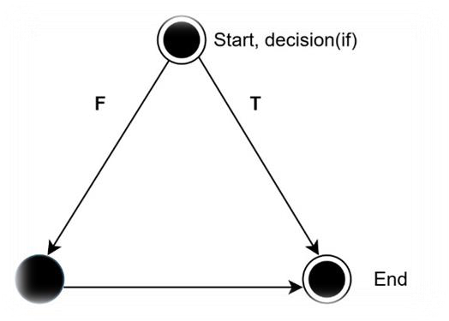
3

CC value
V(G) = e – n + 2 = 3 – 3 + 2 = 2
V(G) = d + 1
= 1 + 1 = 2
public void setCurrentValue (float val)
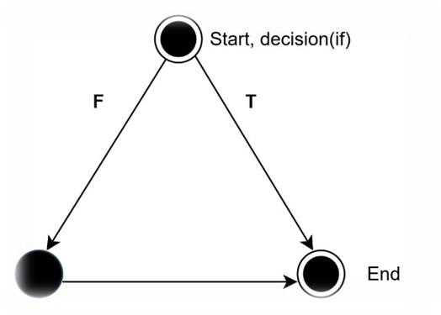
CC value
V(G) = e – n + 2
= 3 – 3 + 2
= 2
V(G) = d + 1
= 1 + 1
= 2
4

public void bubbleSort ()
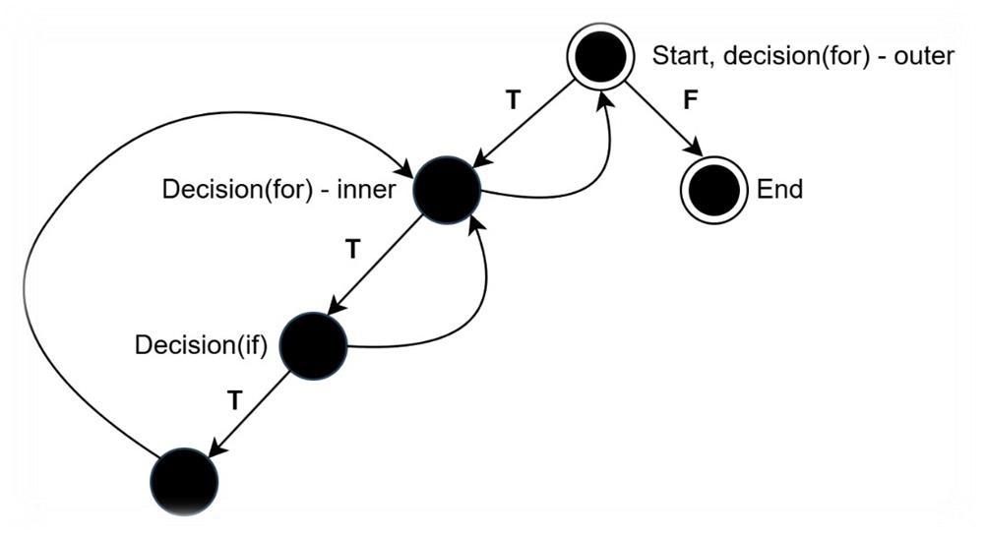
CC value
V(G) = e – n + 2
= 7 – 5 + 2
= 4
V(G) = d + 1
= 3 + 1
= 4
5

public float evaluateFormula (Node n)
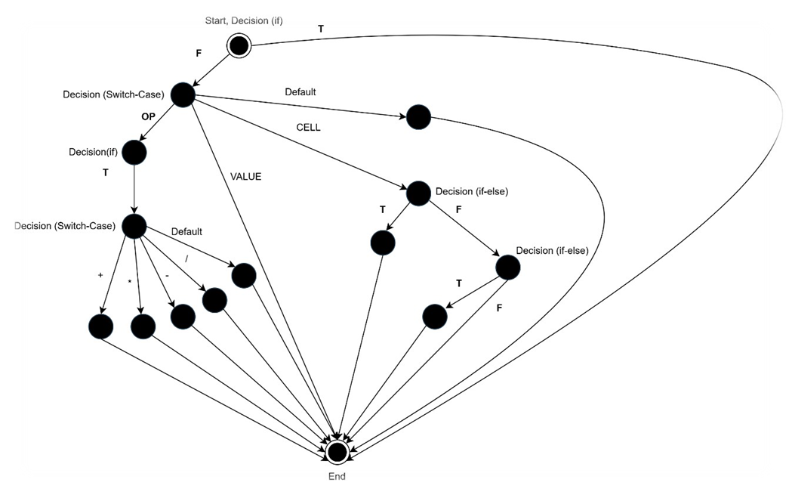
CC value
V(G) = e – n + 2
= 24 – 15 + 2
= 11
V(G) = d + 1
= 5 + 1
= 6
6

Question 03
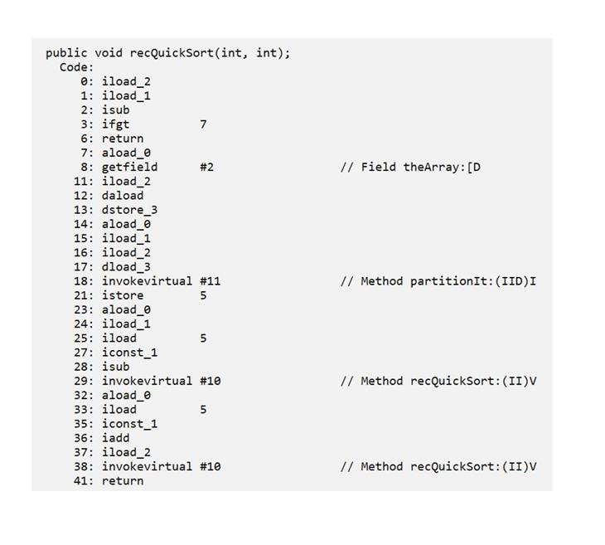
public void recQuickSort(int left, int right)
V(G) = d + 1
= 1 + 1
= 2
7

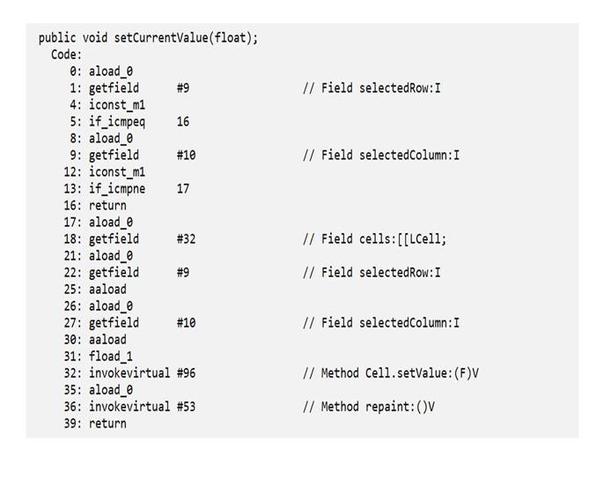
public void setCurrentValue (float val)
V(G) = d + 1
= 2 + 1
= 3
8

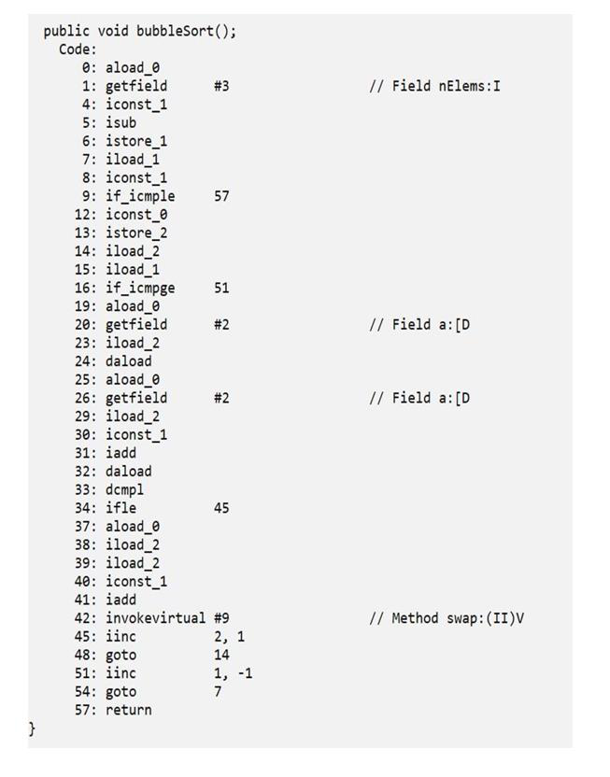
public void bubbleSort()
V(G) = d + 1
= 3 + 1
= 4
9

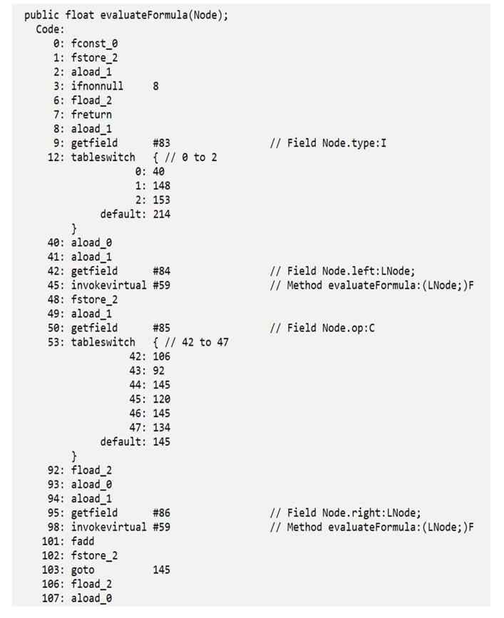
public float evaluateFormula(Node n)
V(G) = d + 1 = 5 + 1 = 6 | 10

 | Source Code | Byte Code
public void recQuickSort (int left, int right) | 2 | 2
public void setCurrentValue (float val) | 2 | 3
public void bubbleSort () | 4 | 4
public float evaluateFormula (Node n) | 11 | 6
Question 04
Explain why public void setCurrentValue(float val) and public float evaluateFormula (Node n) methods are reporting different values for source and byte codes.
1.Explanation for the CC value difference of the public void setCurrentValue (float val)
Since the ‘if’ condition being a compound condition, there are 2 separate decision statements in the byte code. Hence, the value reported by the byte code is higher than the value reported by the source code.
2.Explanation for the CC value difference of the public float evaluateFormula (Node n)
Usually, a decision node has a maximum of two outgoing edges for the true and false paths. However, a decision node which represent a switch condition has more than two outgoing edges. Hence, in such situations, the values reported by e – n + 2 and d + 1 are different from each other. In fact, the correct cyclomatic complexity (CC) value is reported by e – n + 2
11

--End of the Report--
12

