

BSc (Hons) in Information Technology
Year 4 Semester 2
Lab Exercise 04 – Resource Standard Metric

Group Details

Student Name | IT Number
Bhanuka K. Y | IT22563750
Eranga N.G.A.H | IT22604958
Hewamanna K. T | IT22584090
Vidurangi K.G. D | IT22258694

Table of Contents

RSM – Resource Standard Matrix 2
View the complete RSM documentation type ---- rsm –ha 2
View the basic commands and options type ----- rsm -hs 5
Get the source code details of the Student.java file on to the screen. 7
Get the source code details of the Student.java file to a text file. 7
Get the source code details of the Student.java file to a HTML file. 8
What is the purpose of the option – Tf? 9
Complexity (Param, Return, Cyclo vg, Total) 9
LOC (eLOC, lLoc, Comment, Lines) 10
Get quality notices for the Results.java file. 10
List three usages of the RSM. 14

RSM – Resource Standard Matrix

RSM (Resource Standard Matrix) is a tool used in the management of projects and in software engineering to identify the necessary resources to be used in the execution of the activities involved in the project.

View the complete RSM documentation type ---- rsm –ha

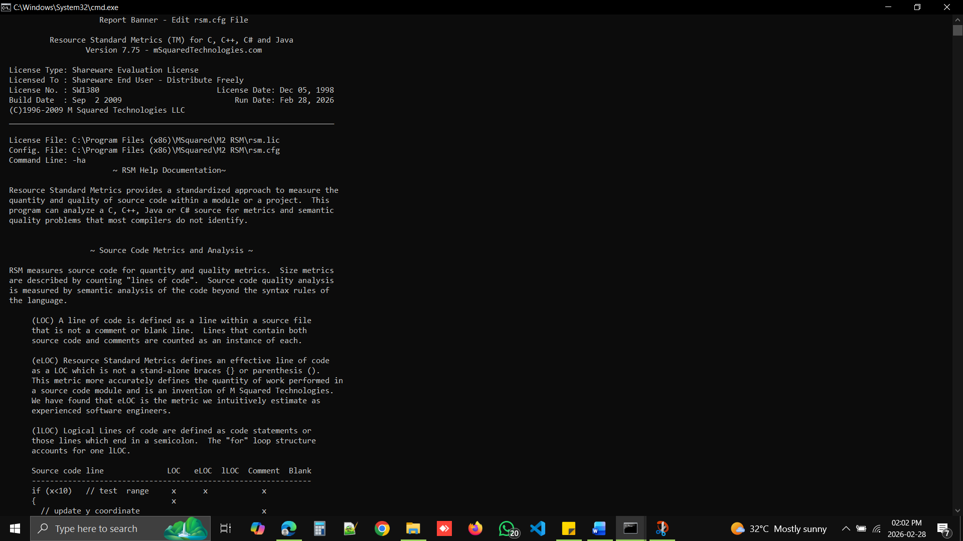

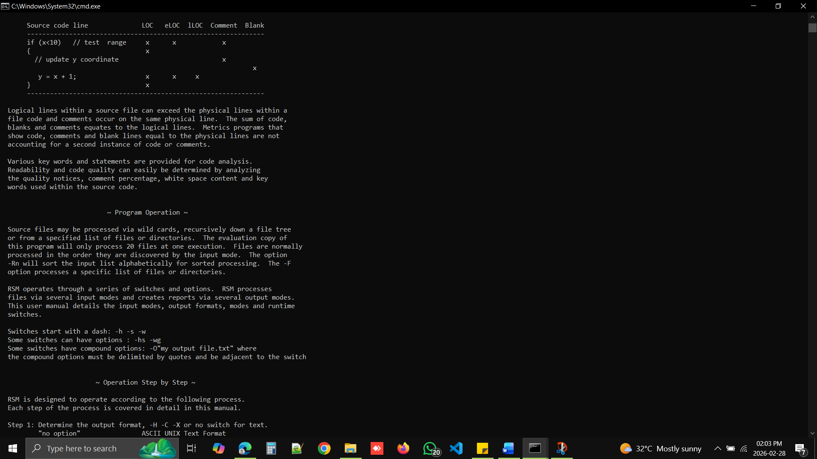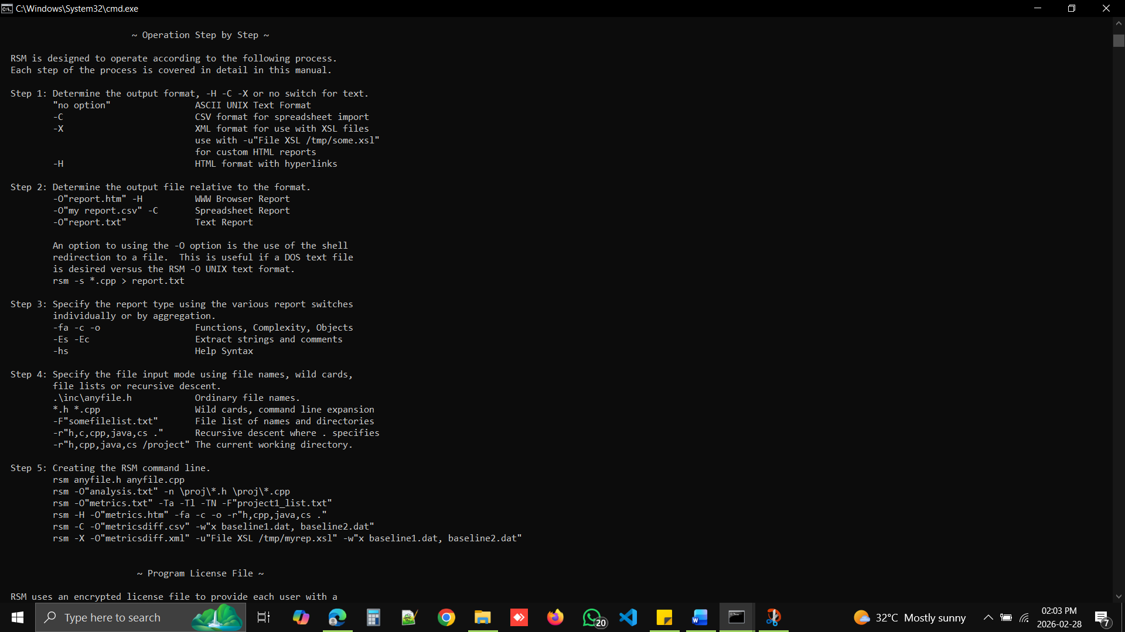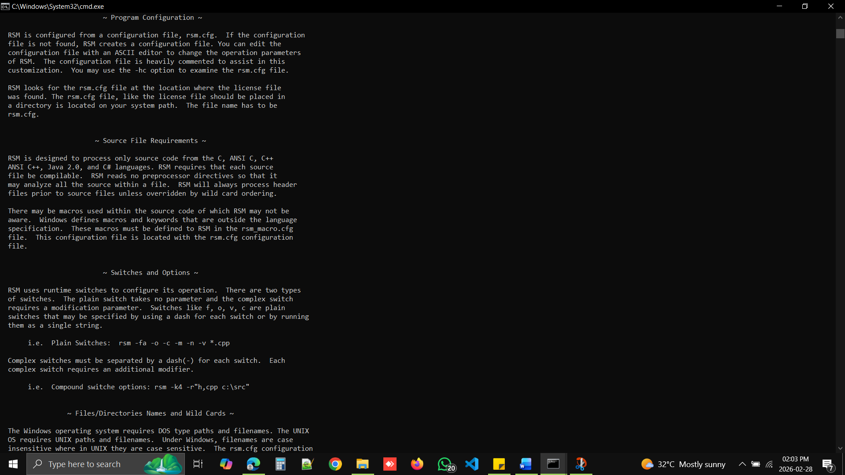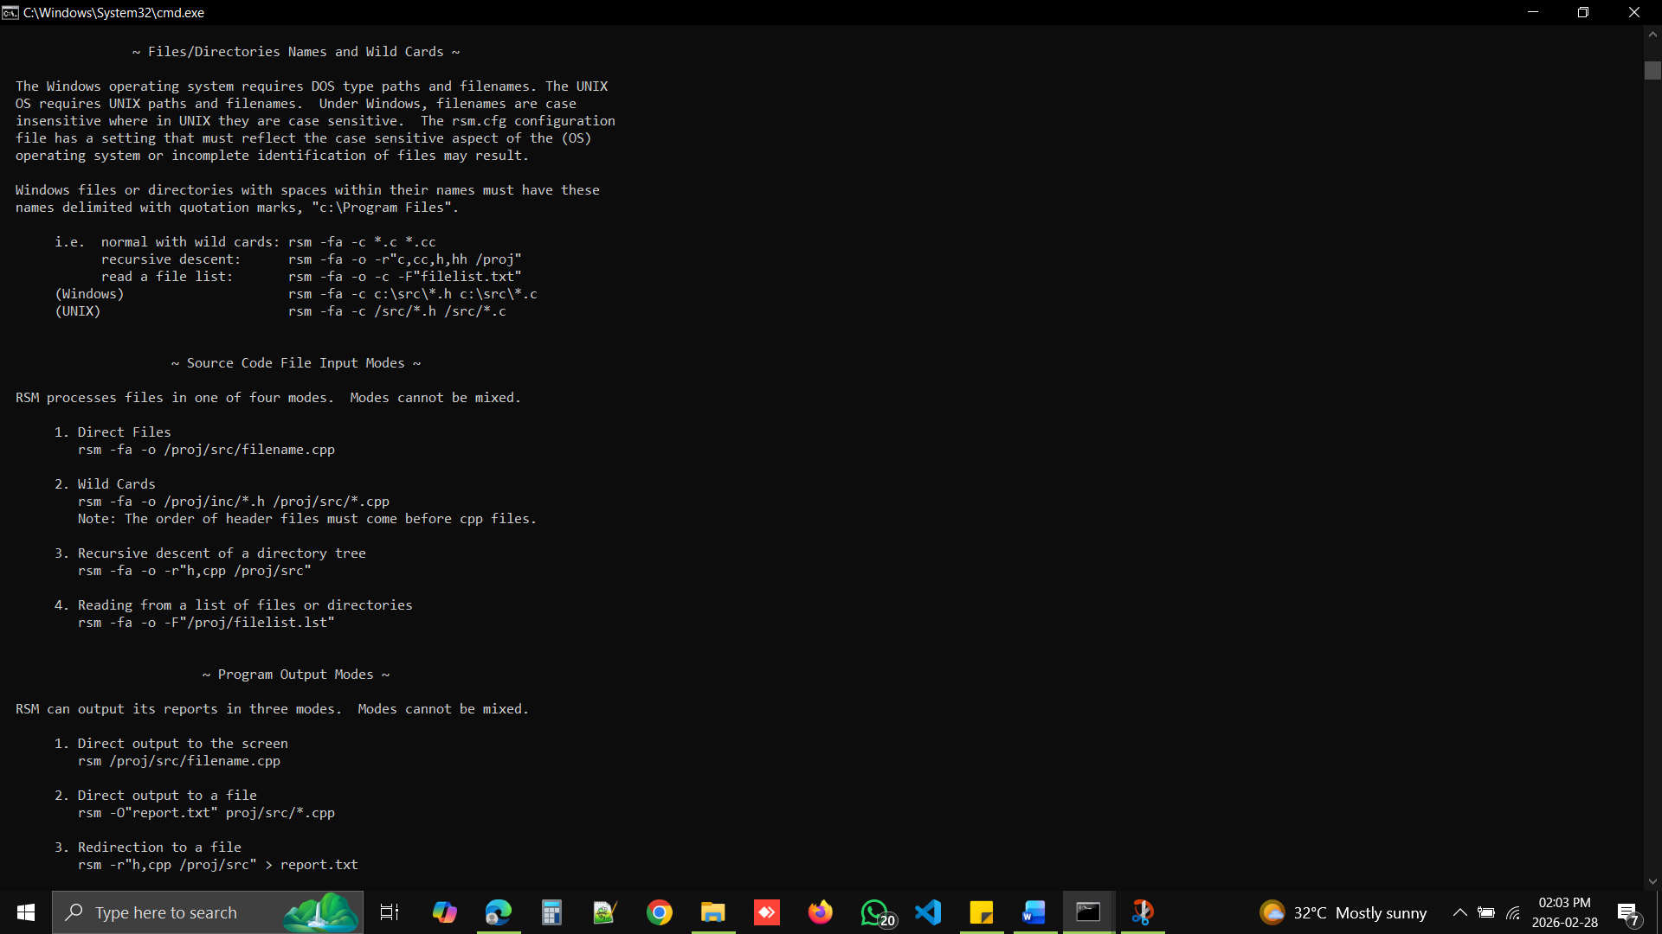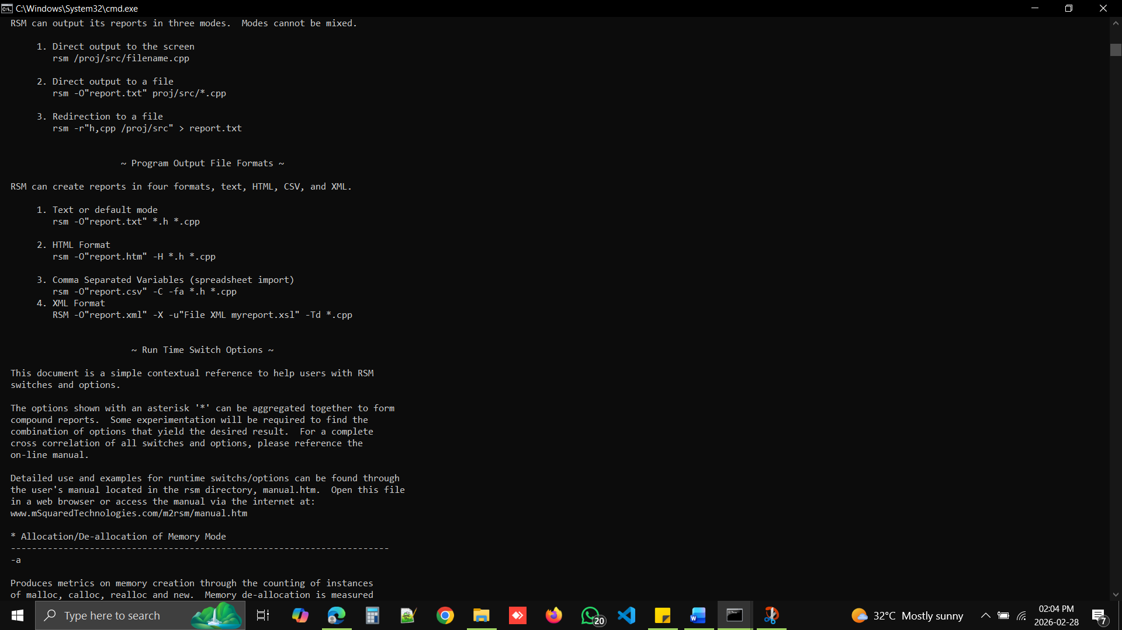

View the basic commands and options type ----- rsm -hs

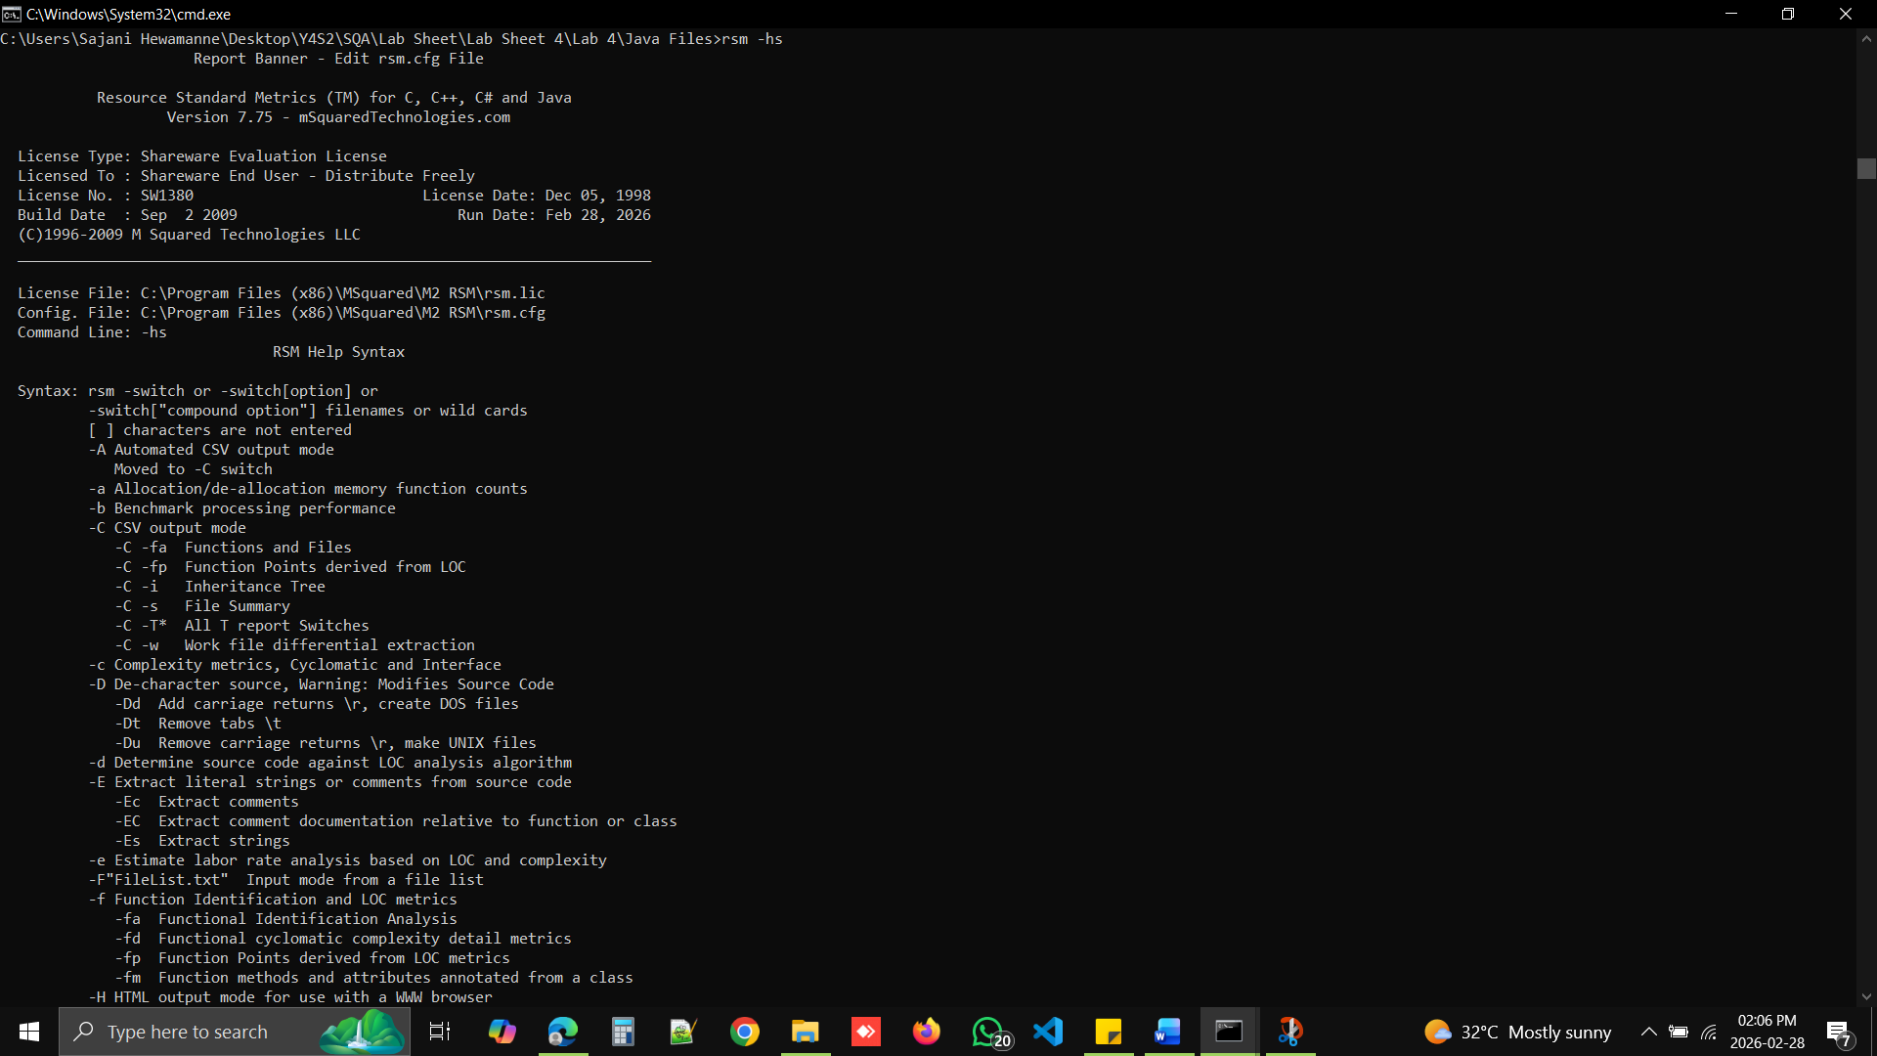
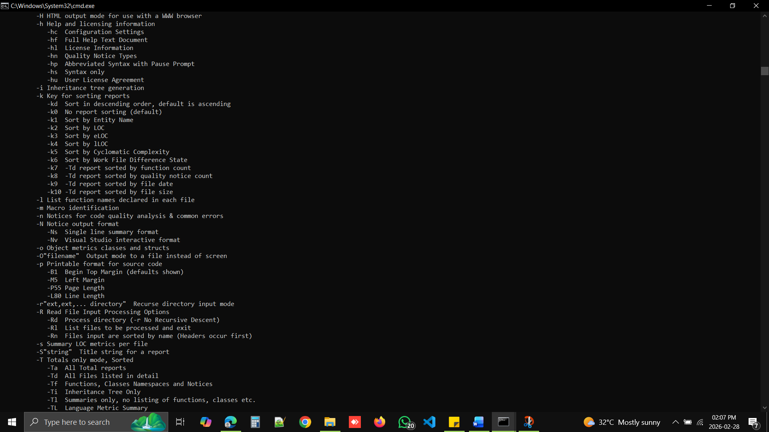

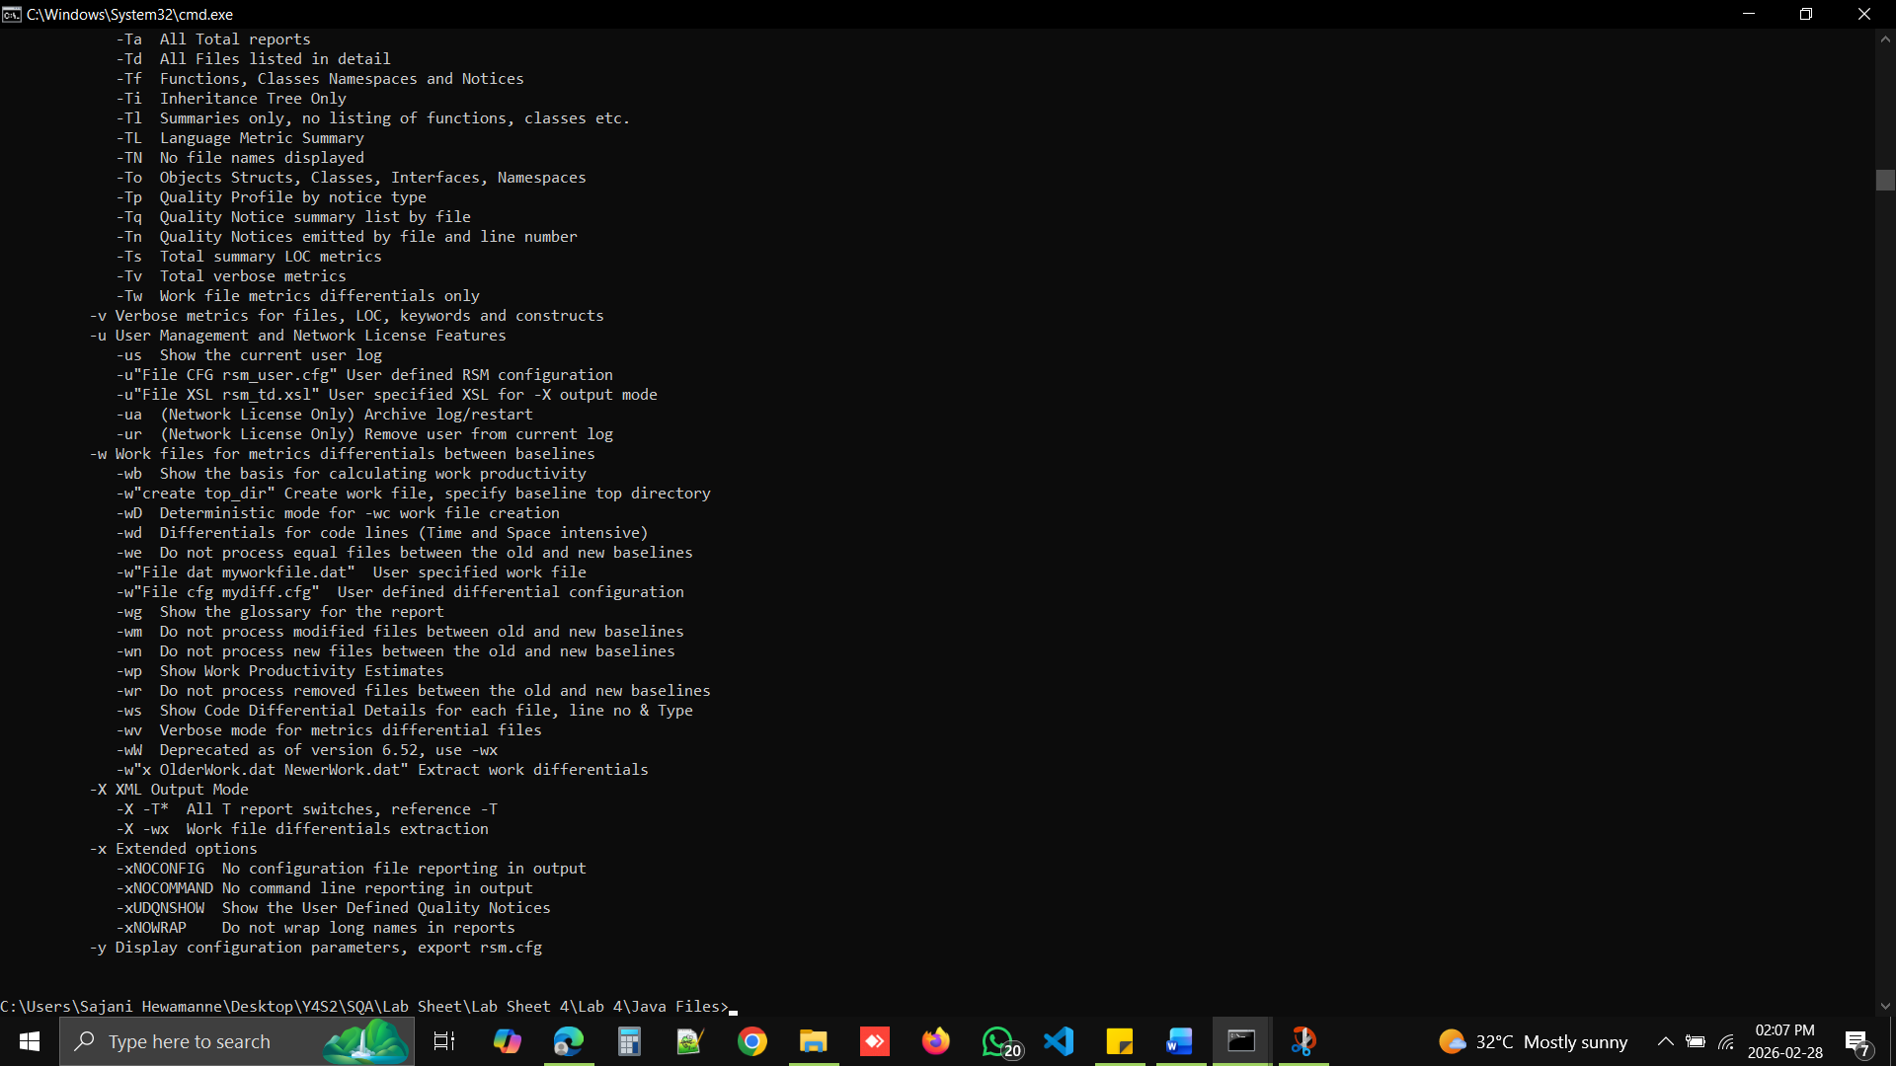

Get the source code details of the Student.java file on to the screen.

rsm NameOfFile
rsm Results.java

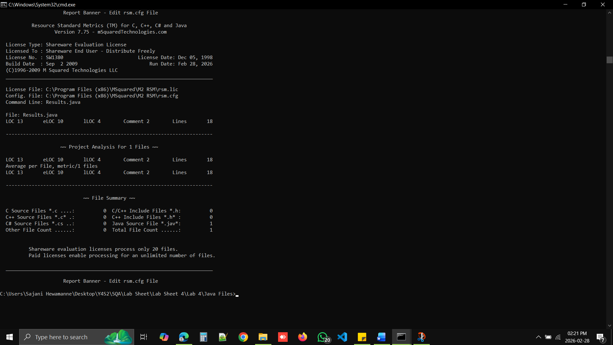

Get the source code details of the Student.java file to a text file.
rsm –O OutputFileName.txt NameOfFile

rsm –O ResultsDetails01.txt Results.java

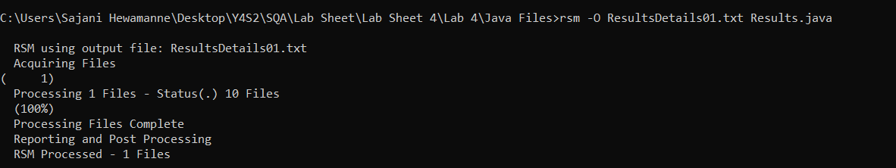

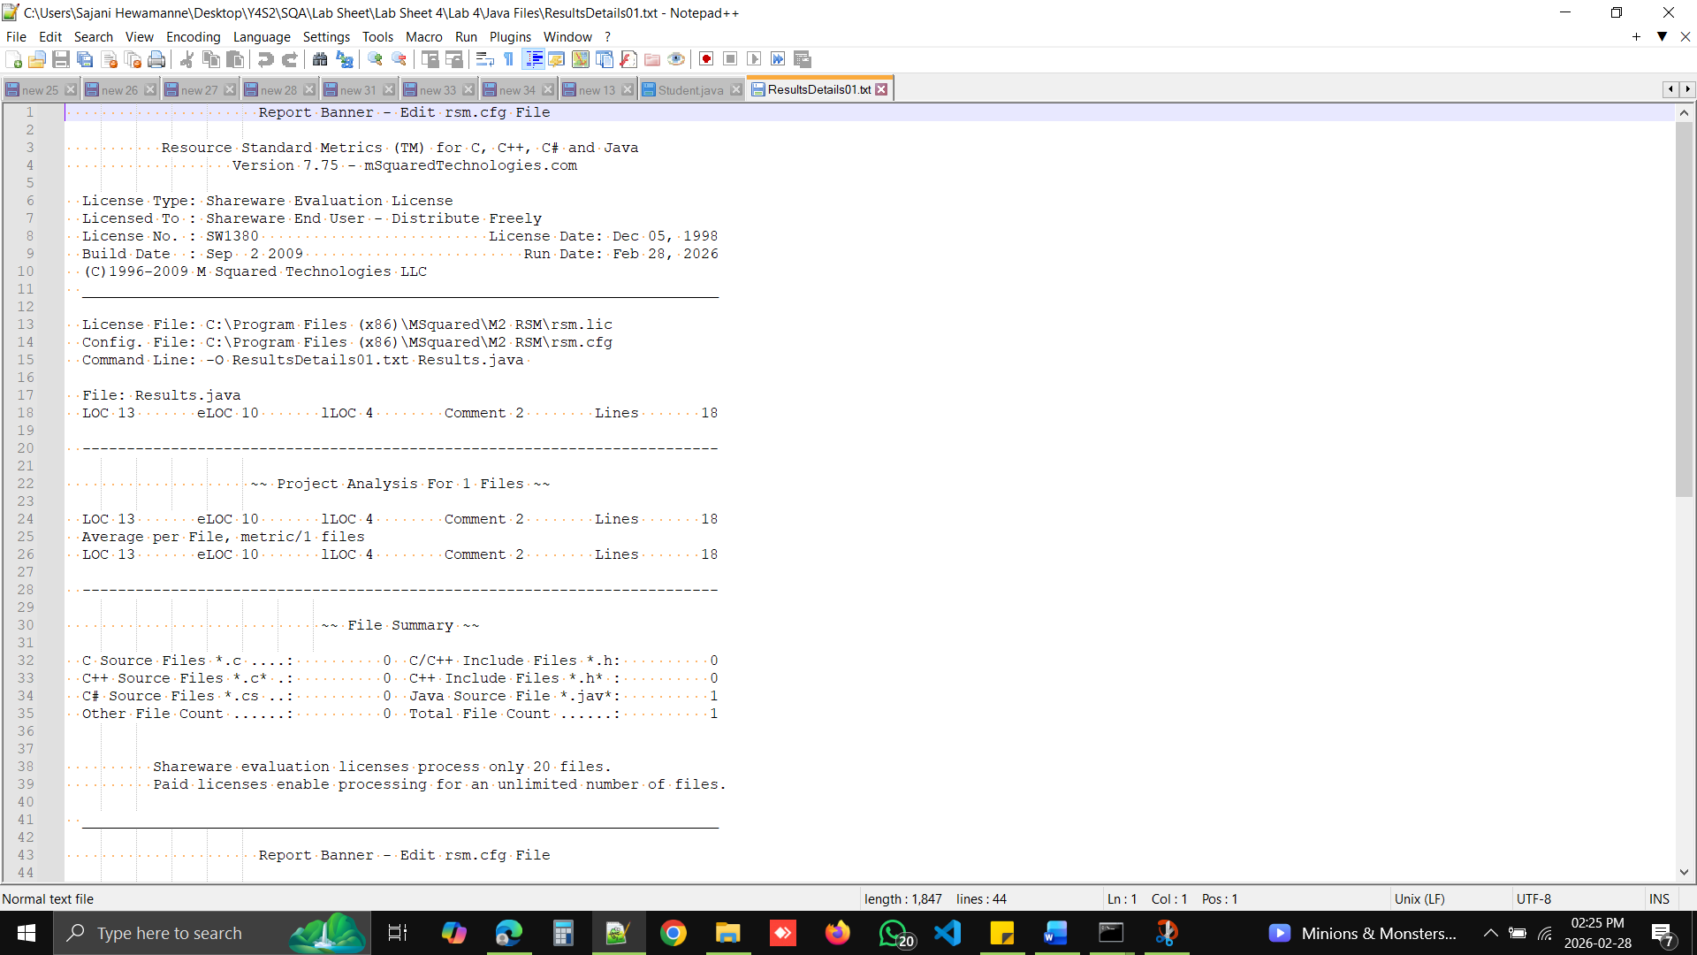

Get the source code details of the Student.java file to a HTML file.

rsm –H –O OutputFileName.htm NameOfFile

rsm –H –O ResultsDetailshtml.htm Results.java

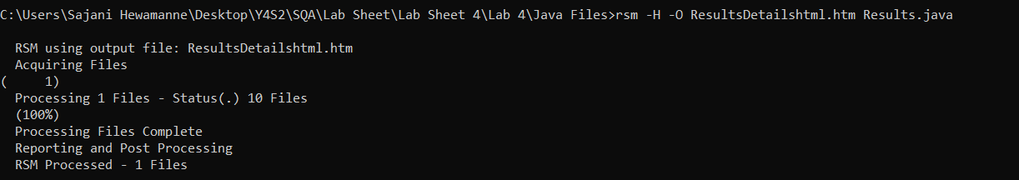
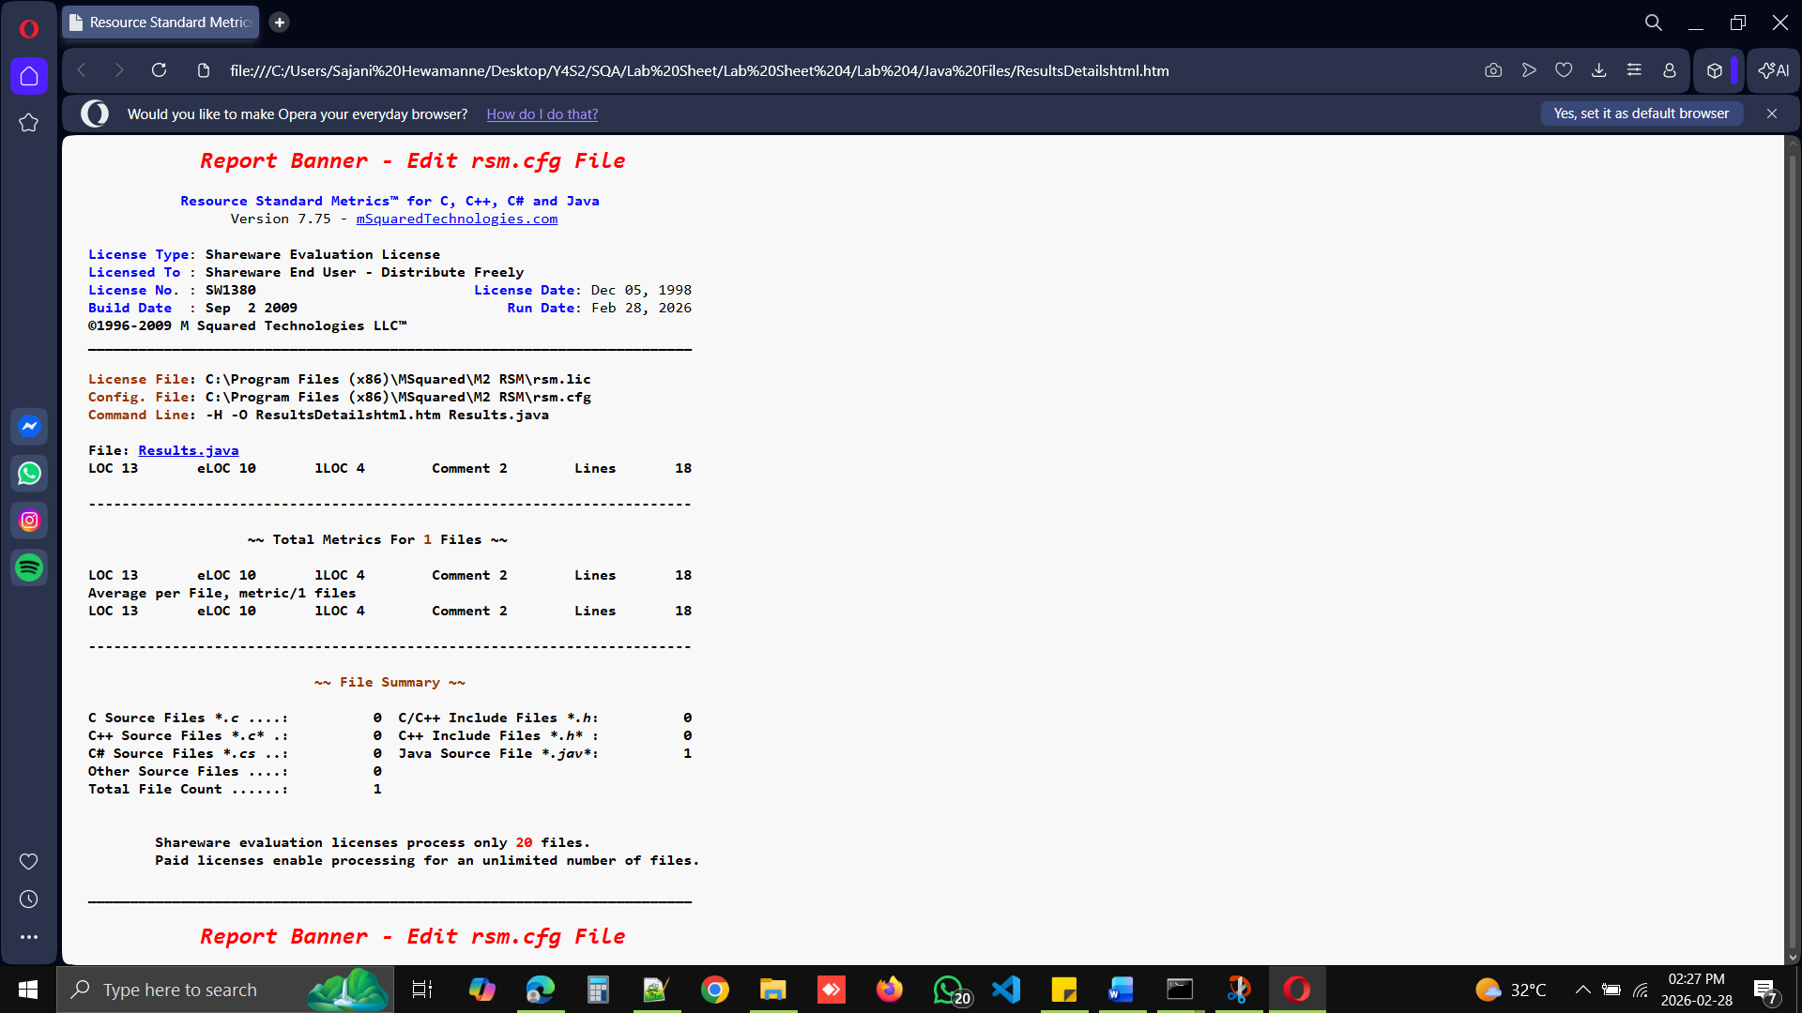

What is the purpose of the option – Tf?

Tf - Functions, Classes Namespaces and Notices

Complexity (Param, Return, Cyclo vg, Total)

Cyclo vg - Cyclomatic complexity - Number of linearly independent paths - Decision statements
Param = Parameter Count
Return = Number of return count
Cyclo vg = Cyclomatic complexity

Total = Param+ Return+ Cyclo vg
= 6 + 4 +1
= 11

LOC (eLOC, lLoc, Comment, Lines)

Function Points
(53) is a standard value

FP(LOC) = Function LOC
= 13/53
= 0.25

FP(eLOC) = Function eLOC
= 10/53
= 0.19

FP(ILOC) = Function ILOC
= 4/53
= 0.08

Get quality notices for the Results.java file.

-fa---->Functional Identification Analysis
-o ----> Object metrics classes and structs
rsm -H -O report1.htm -fa -o -n Results.java

rsm -H -O ResultsDetailshtml02.htm -fa -o -n Results.java

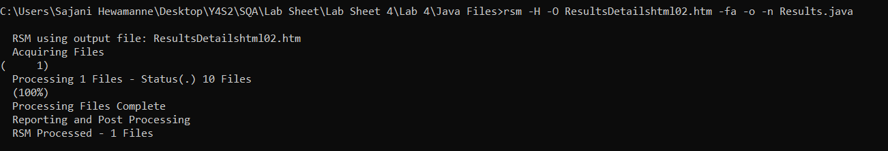

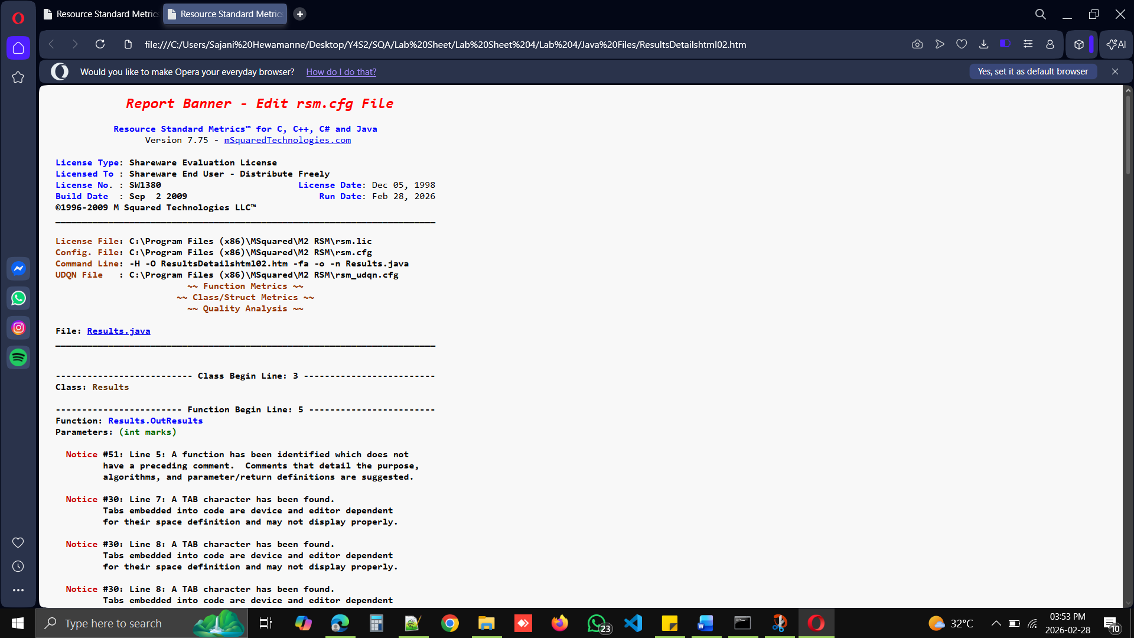

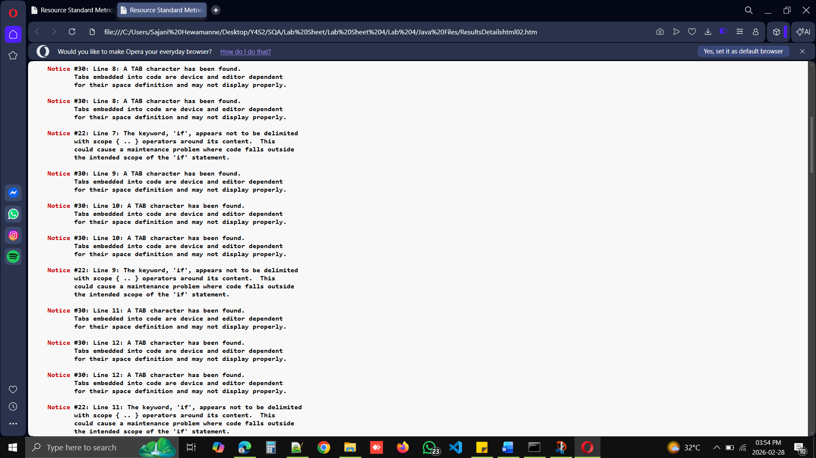

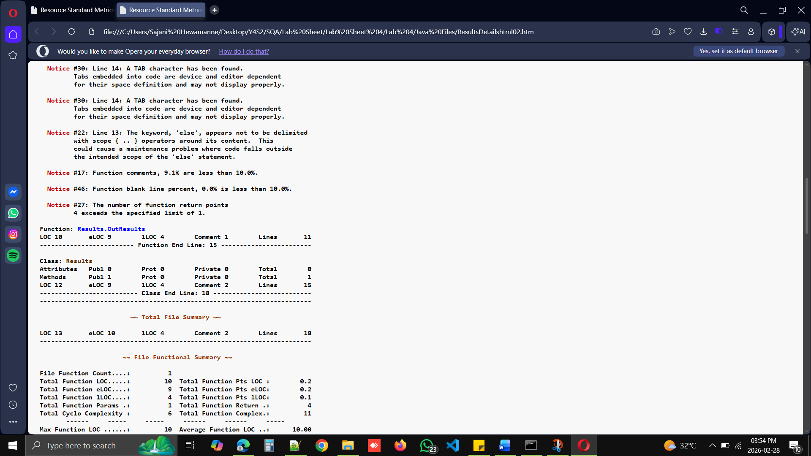
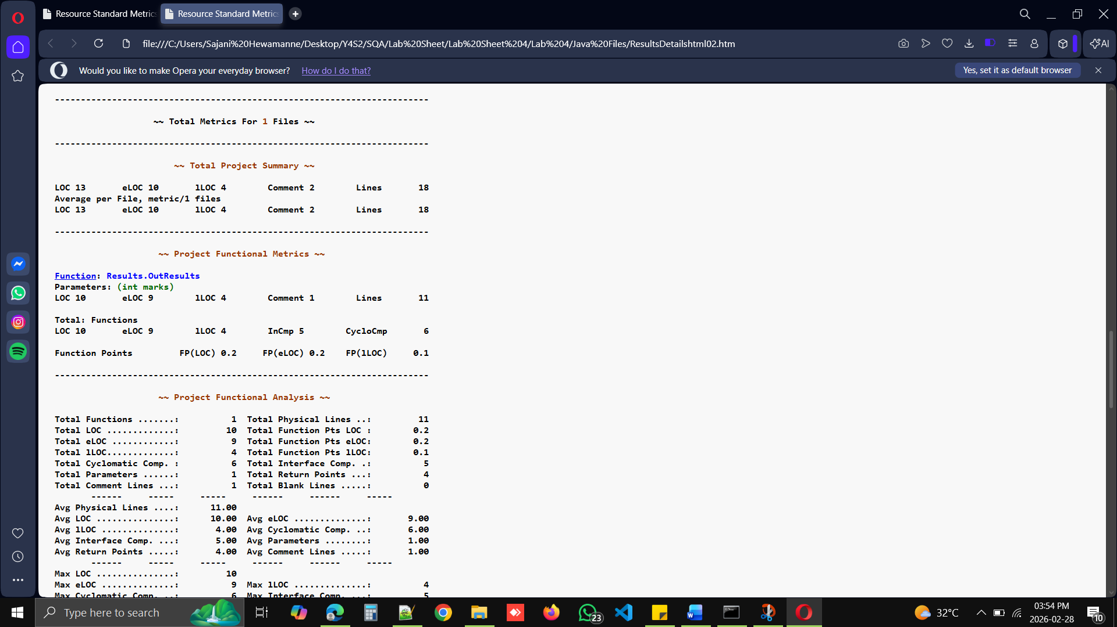
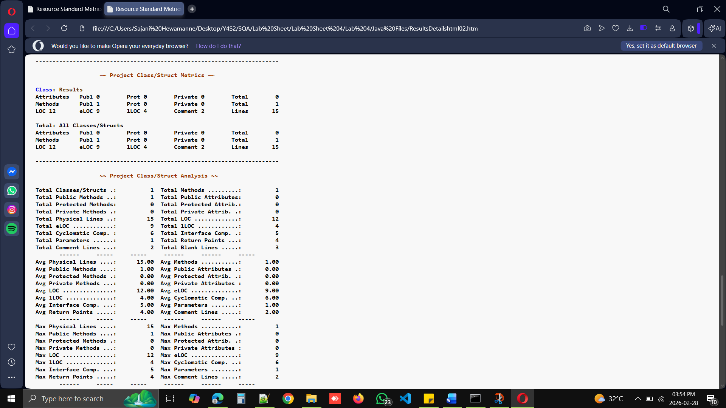

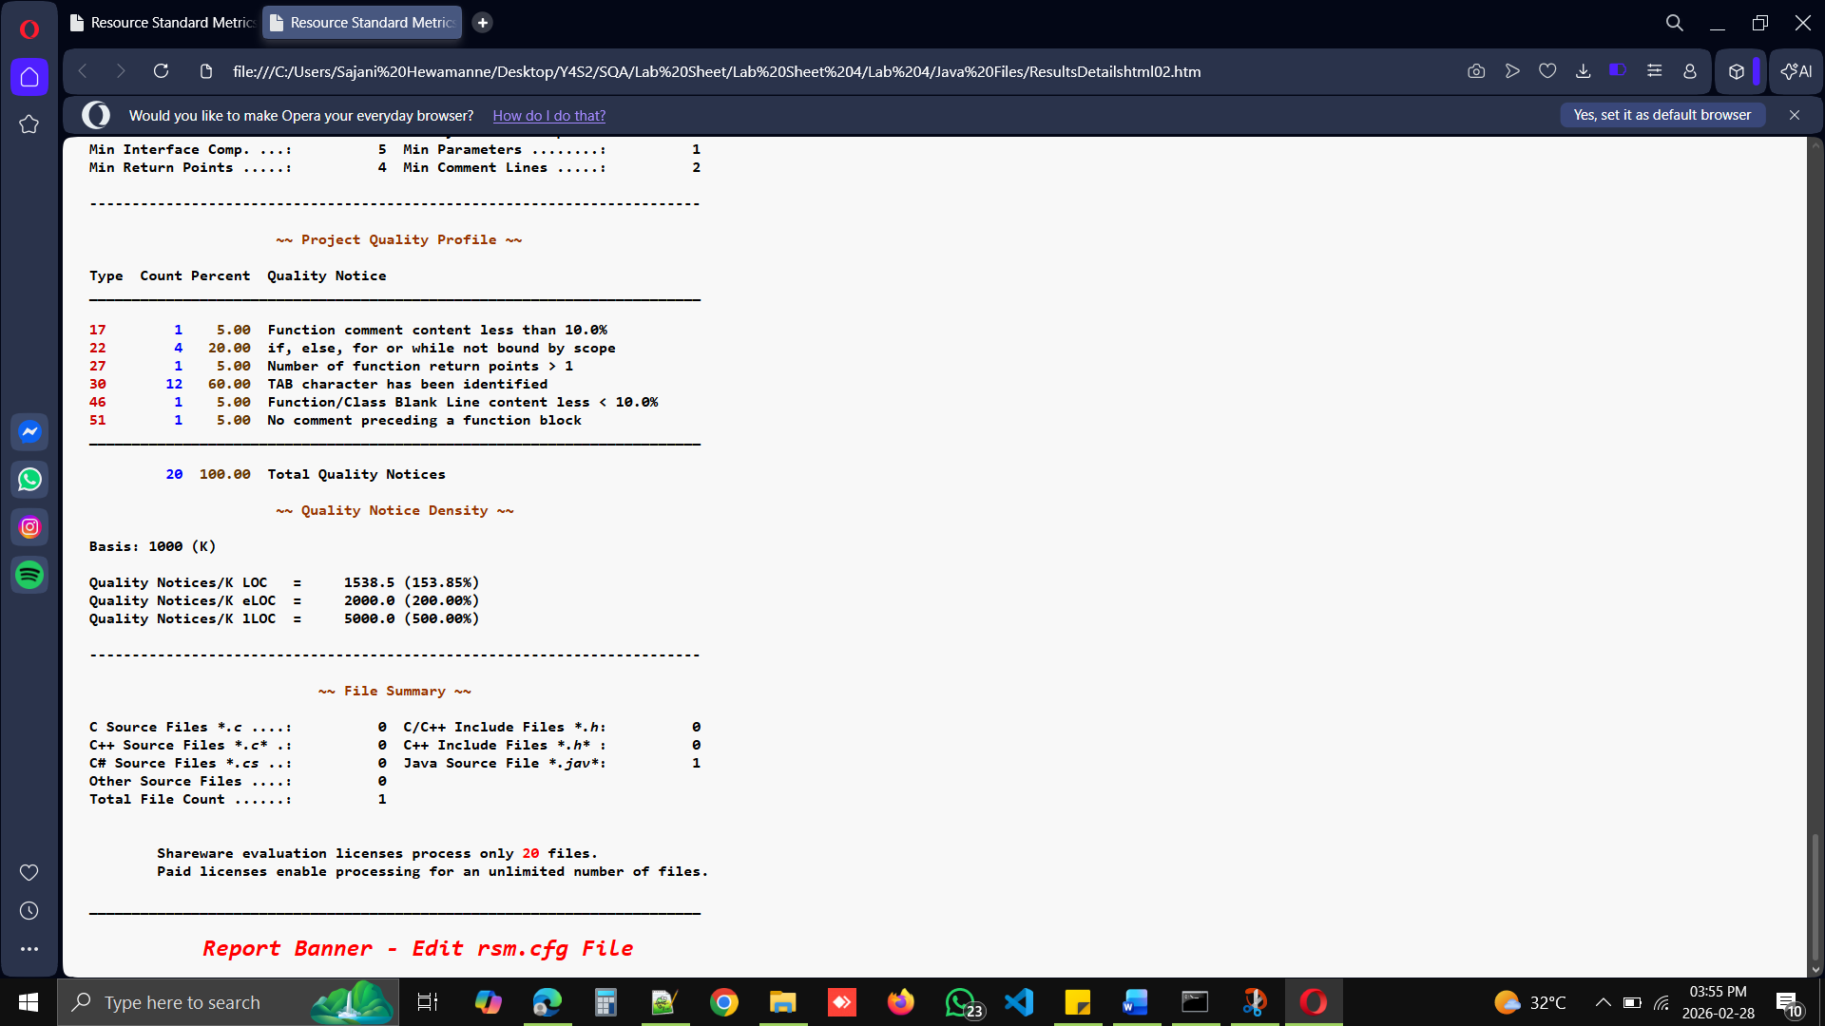

List three usages of the RSM.

- Requirement Documentation
RSM is employed to properly document the entire functional and non-functional needs of the system, ensuring that everyone understands what needs to be done.
- Communication Between Stakeholders
It serves as a reference tool that facilitates communication among clients, developers, designers, and testers concerning the system’s needs without any form of confusion.
- Basis for Testing and Validation
RSM is employed as a guideline to validate the system by ensuring that the software developed meets the needs that were identified.

--End of the Report--

