Assignment 7
Experiment 7: Arrays - 1D & 2D (Traversal, searching, sorting)
Instructions:
- Prepare a Word or PDF file containing all the given programs implemented in C language.
- Attach clear screenshots of the output for each program in the same Word/PDF file.
- Upload all C programs to your GitHub repository.
- Provide the GitHub repository link in the space given below.
Name:
SAP ID:
Batch:
GitHub link: --------------------
Course: B.Tech. CSE (Sem I)
Subject: Programming in C

- Array Traversal, Sum, and Average
Write a C program to input n elements into a one-dimensional array. Display all the elements of the array and calculate and display their sum and average.

- Search an element in an Array
Write a C program to search for a given element in an array. Display all its positions and total number of occurrences. If it is not found, display an appropriate message.
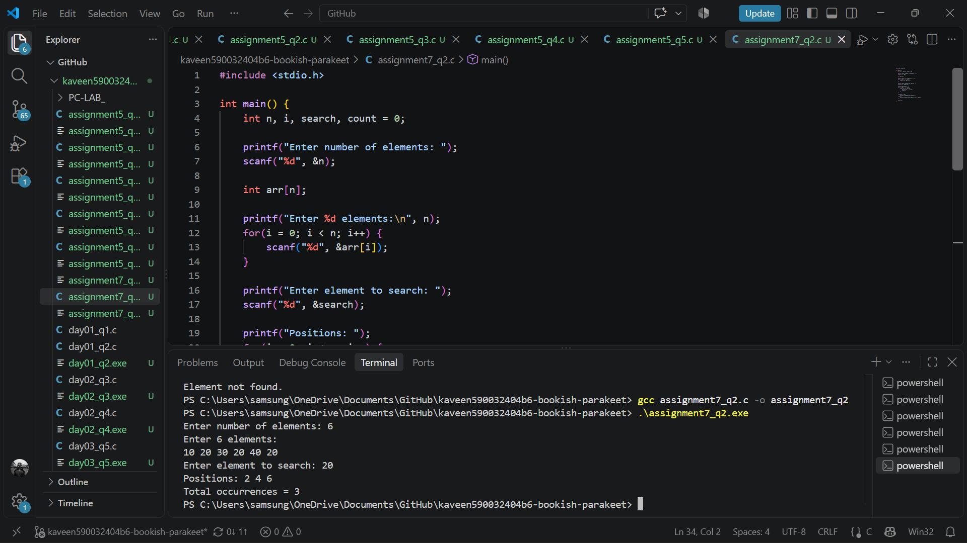
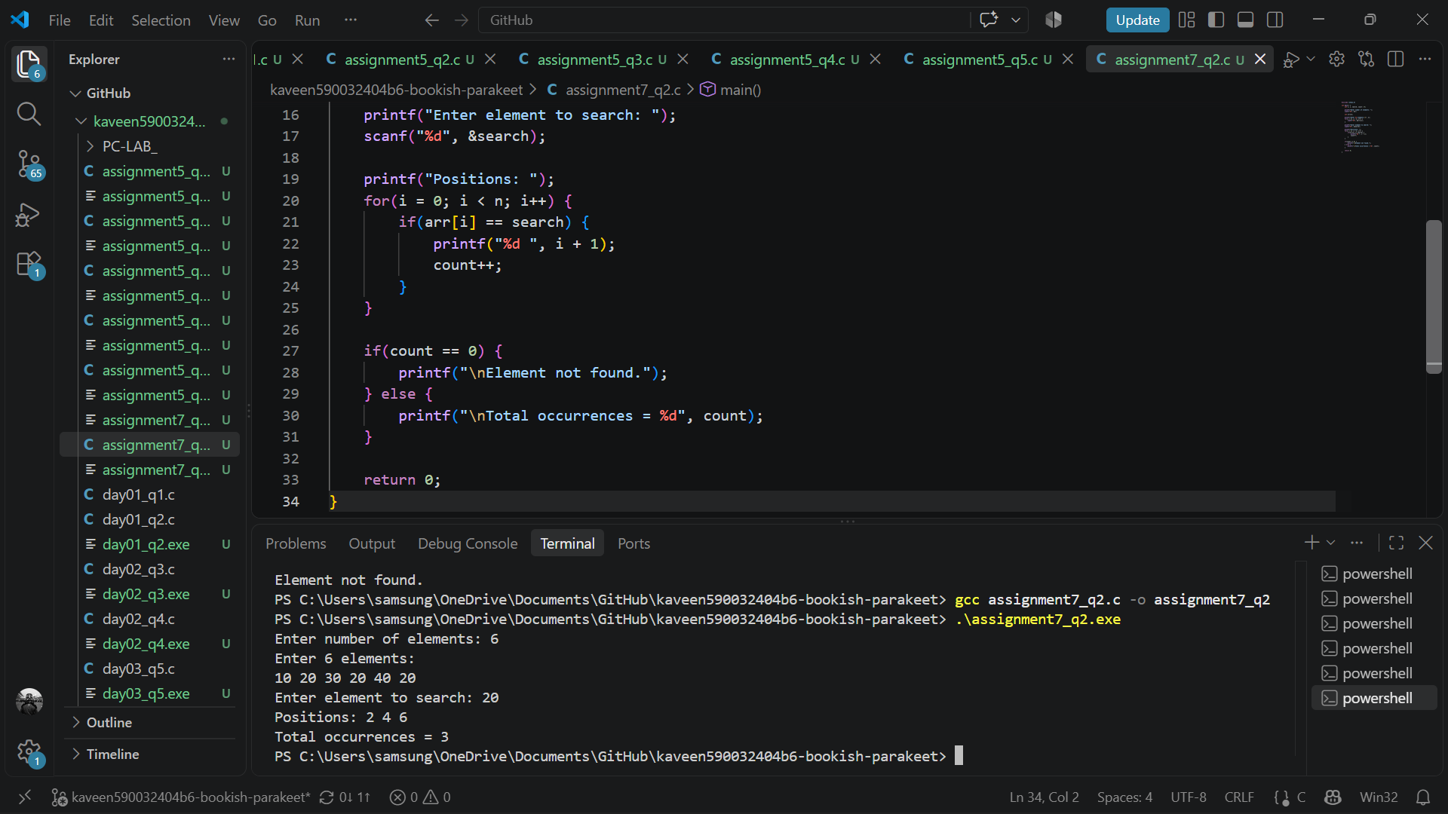

- Insert an Element at a Position
Write a C program to input n elements into an array. Input a new element and the position where it should be inserted. Insert the element at the given position by shifting the existing elements to the right. Display the updated array. If the entered position is invalid, display an appropriate message.
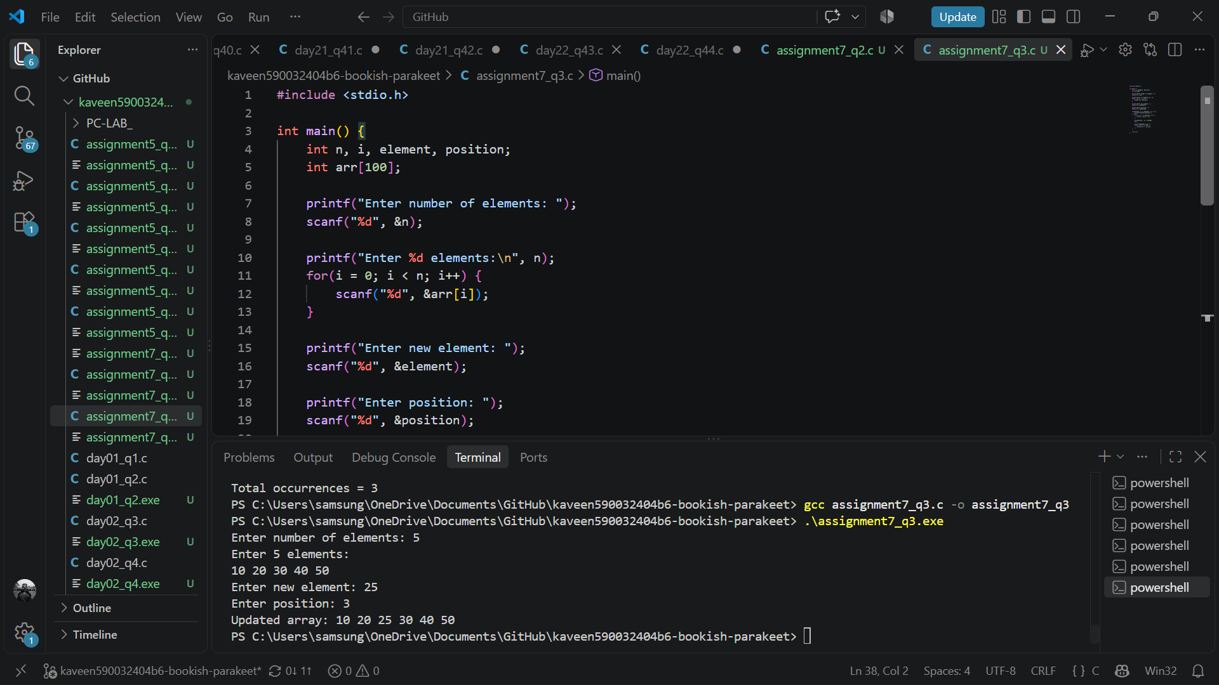
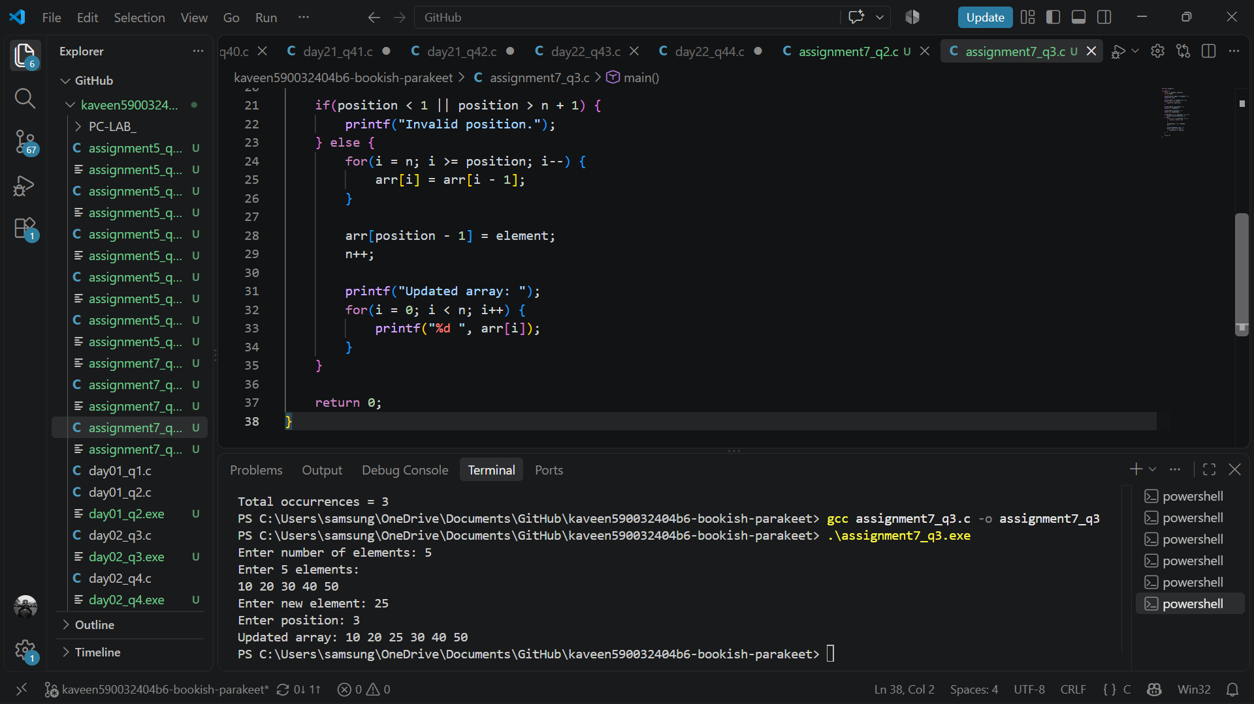

- Delete an Element from an Array
Write a C program to input n elements into an array. Input the position of the element to be deleted. Delete the element from the specified position by shifting the remaining elements to the left. Display the updated array. If the entered position is invalid, display an appropriate message.
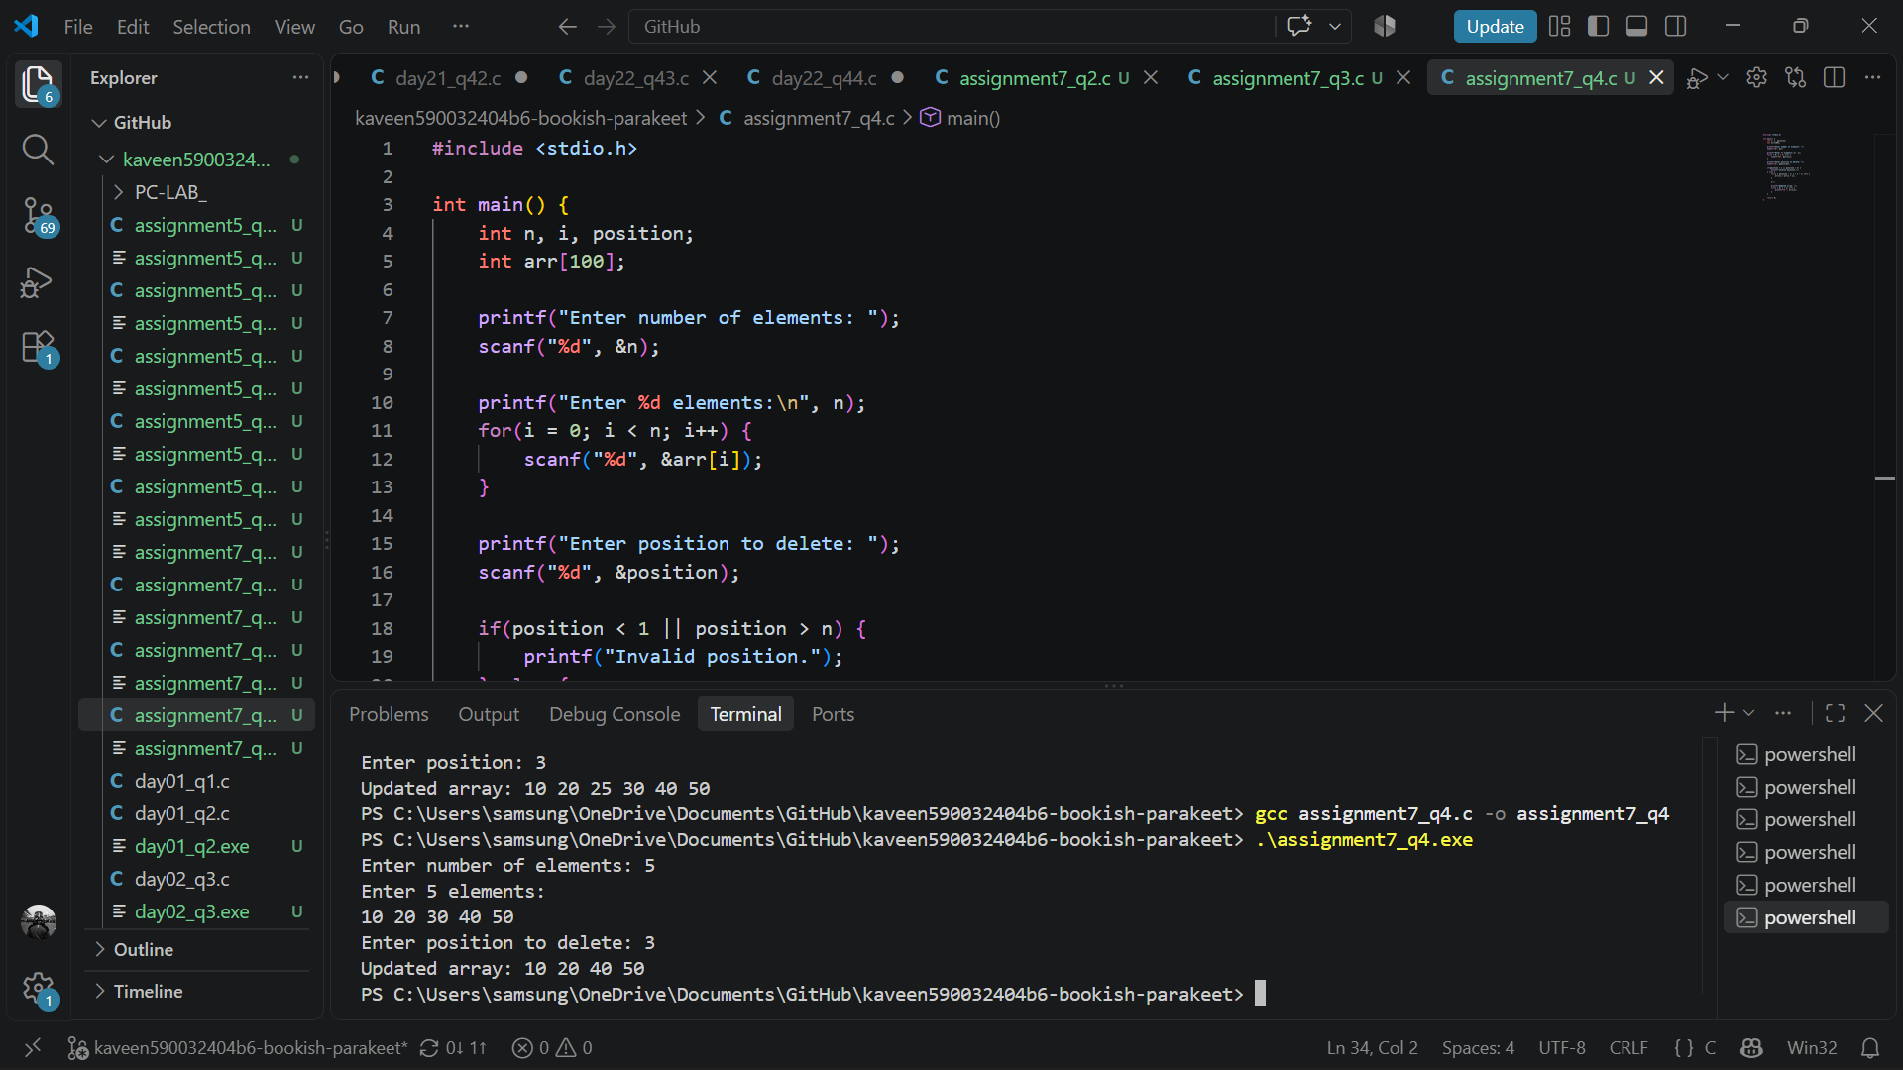
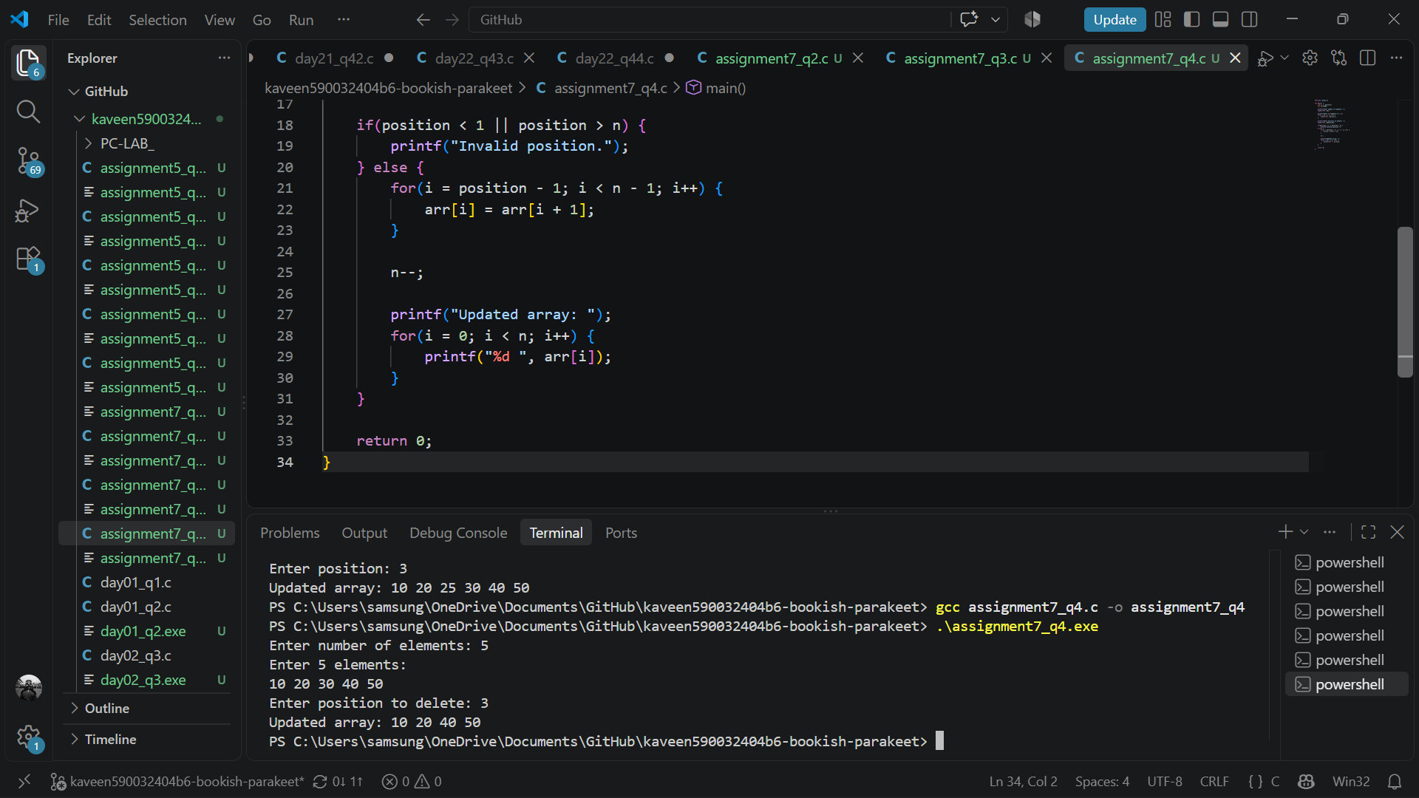

- Largest and Smallest Elements in an Array
Write a C program to find the largest, second-largest, smallest, and second-smallest elements in an array without sorting it
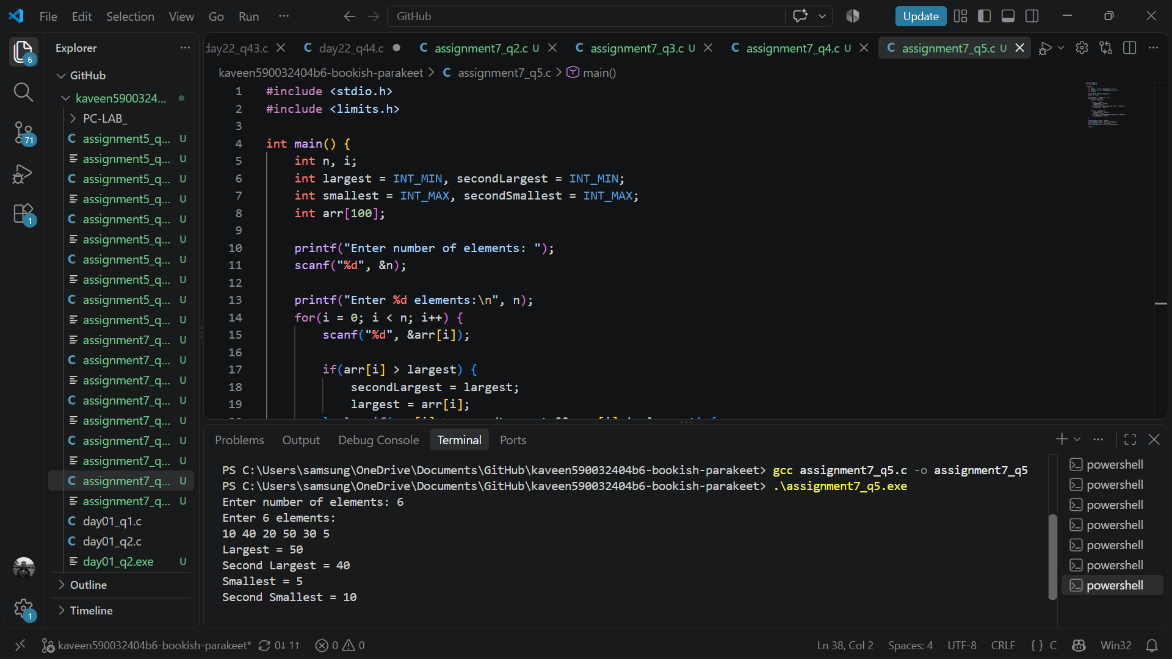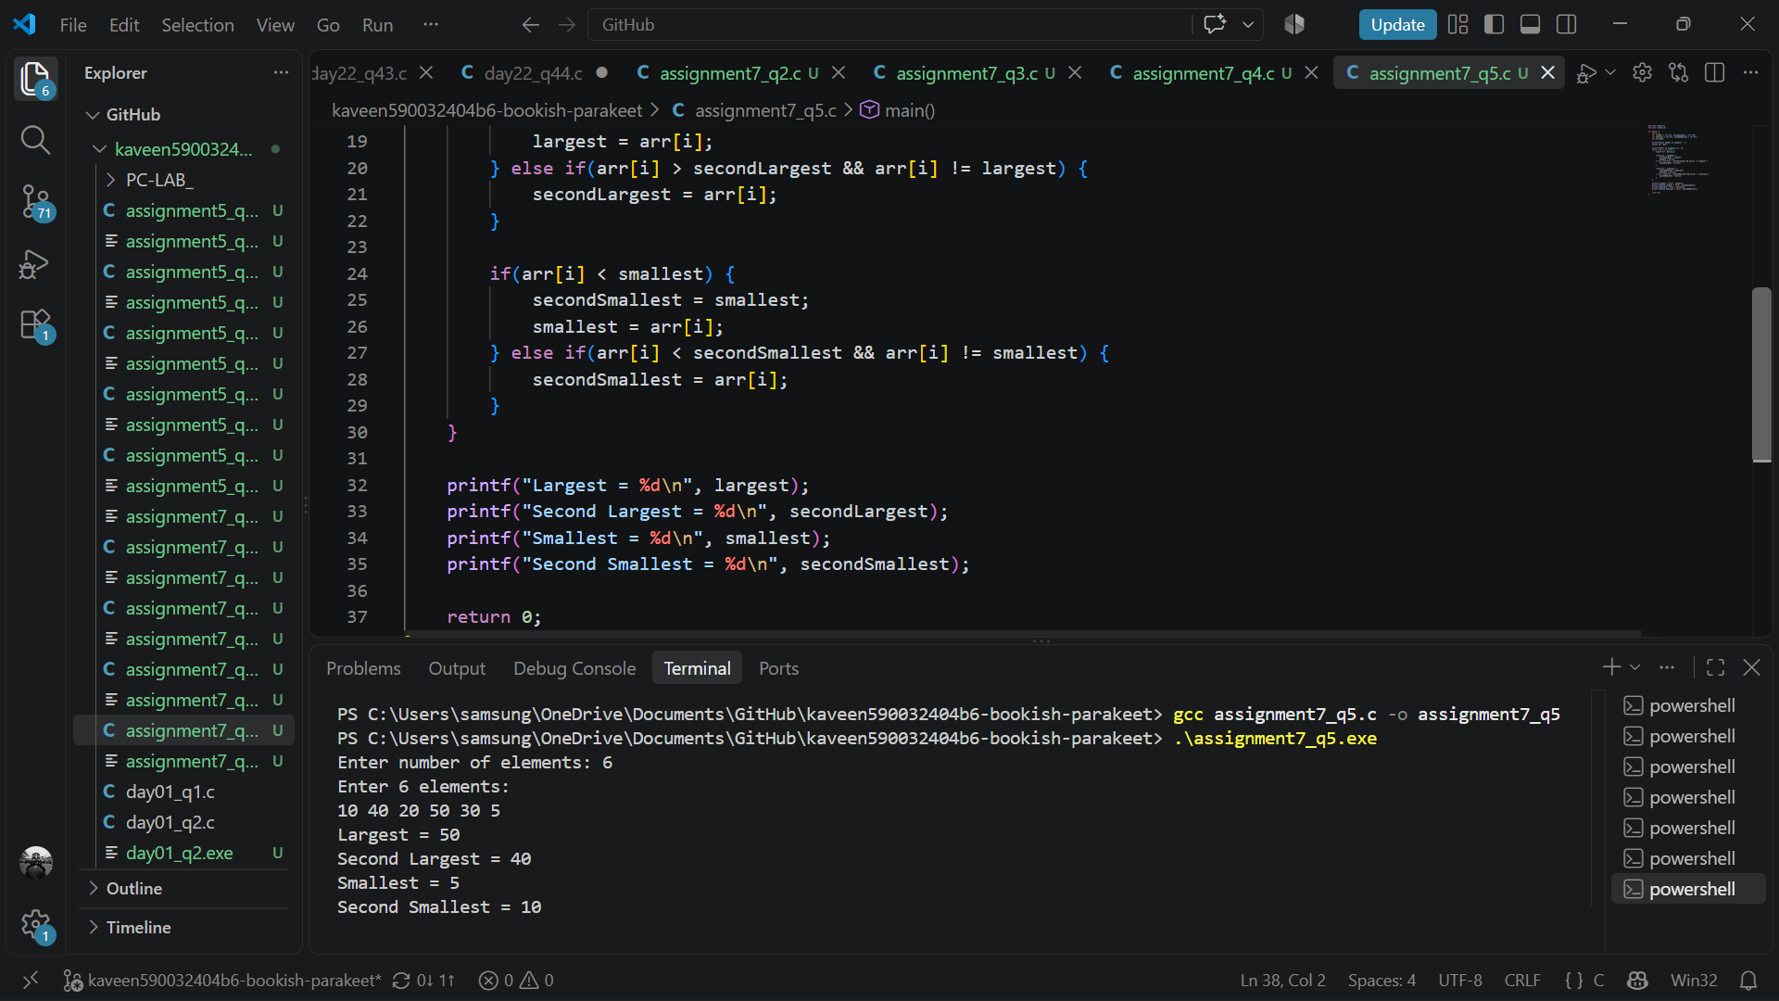
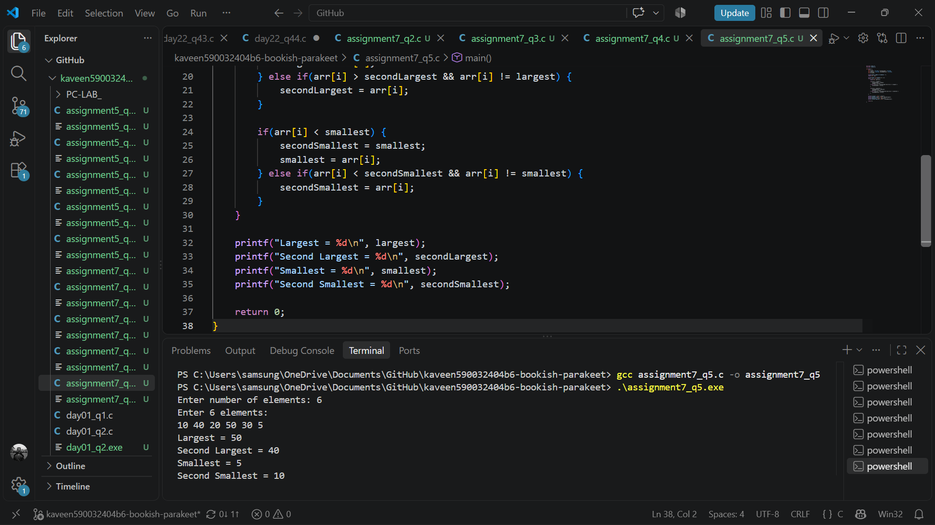

- Sorting an Array
Write a C program to input n elements into an array and arrange them in ascending order. Display the array before and after sorting.
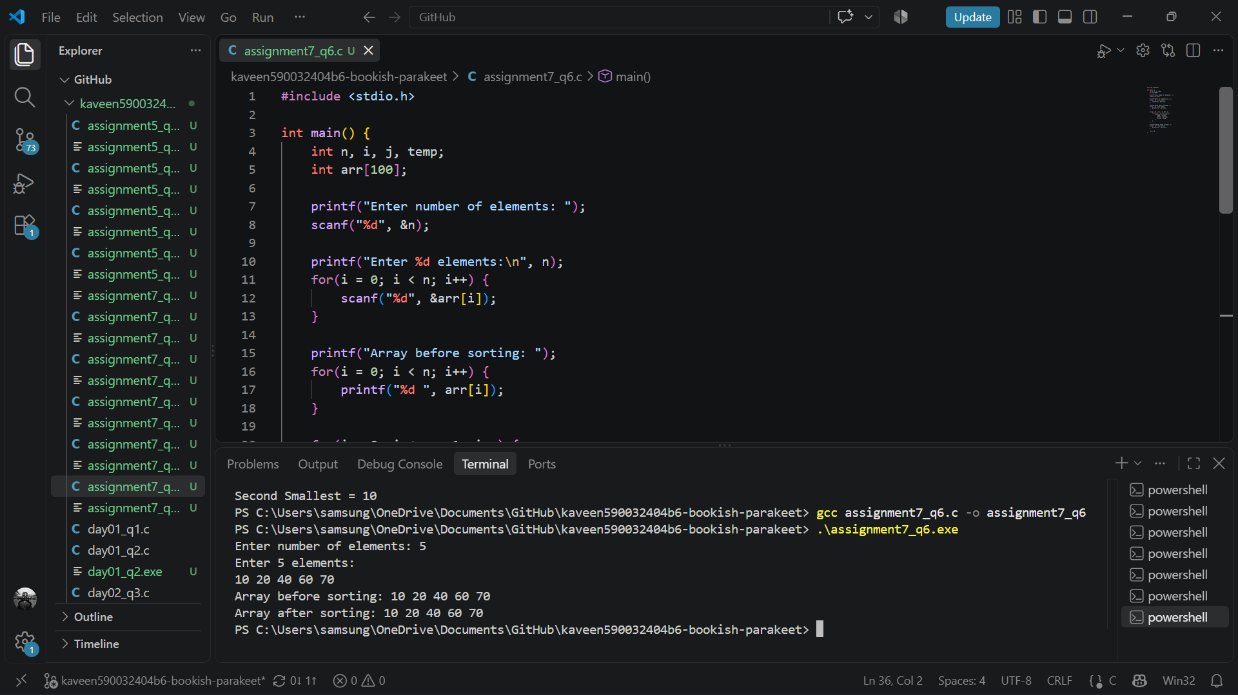
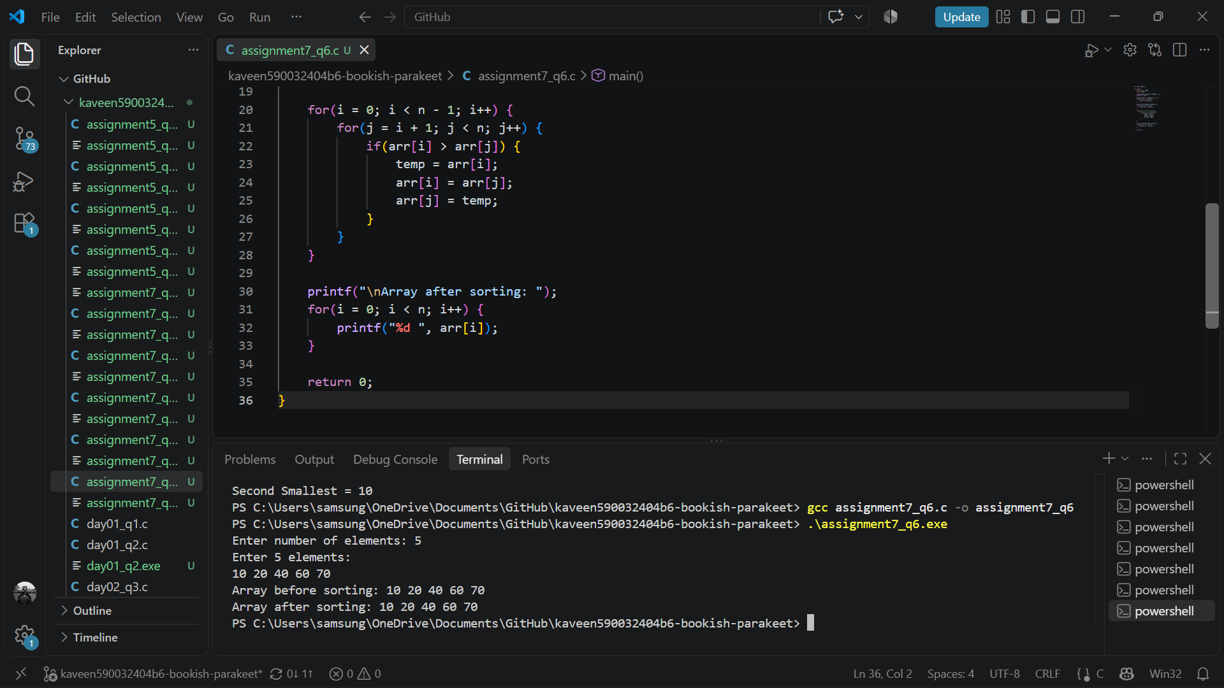

- Merging Two Arrays
Write a C program to input two arrays, merge their elements into a third array, and display the resulting merged array.
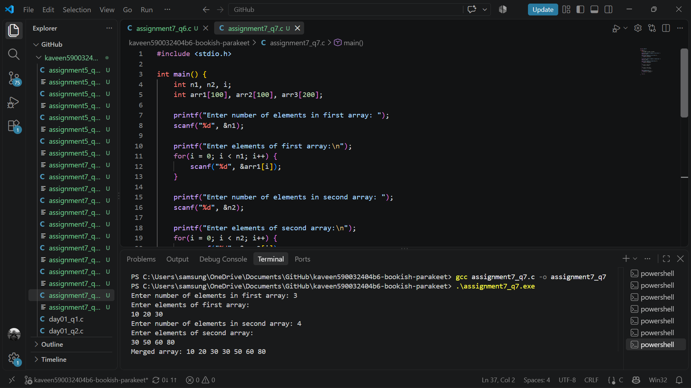
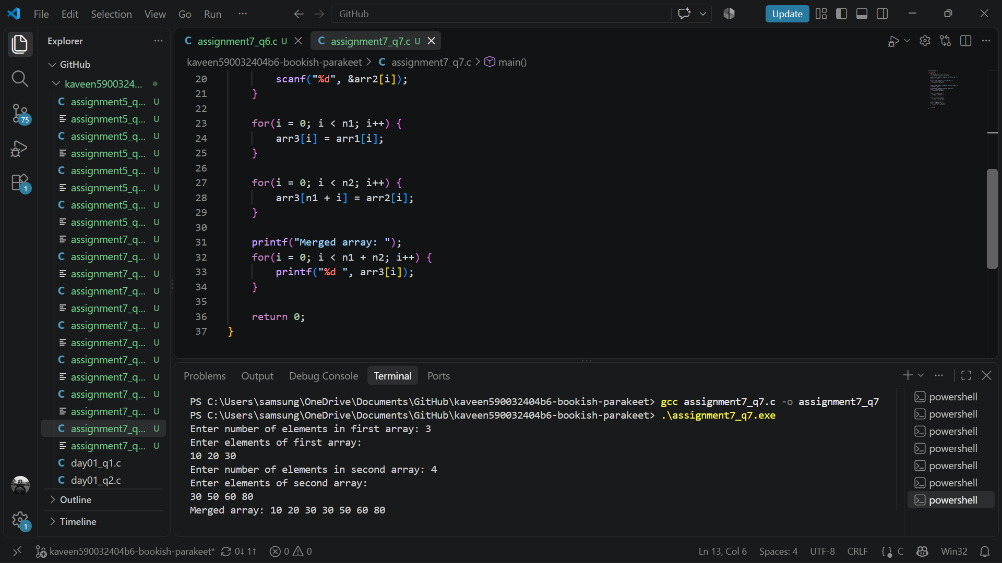

- Displaying a Two-Dimensional Array
Write a C program to input the number of rows and columns of a two-dimensional array. Enter its elements and display them in matrix form.
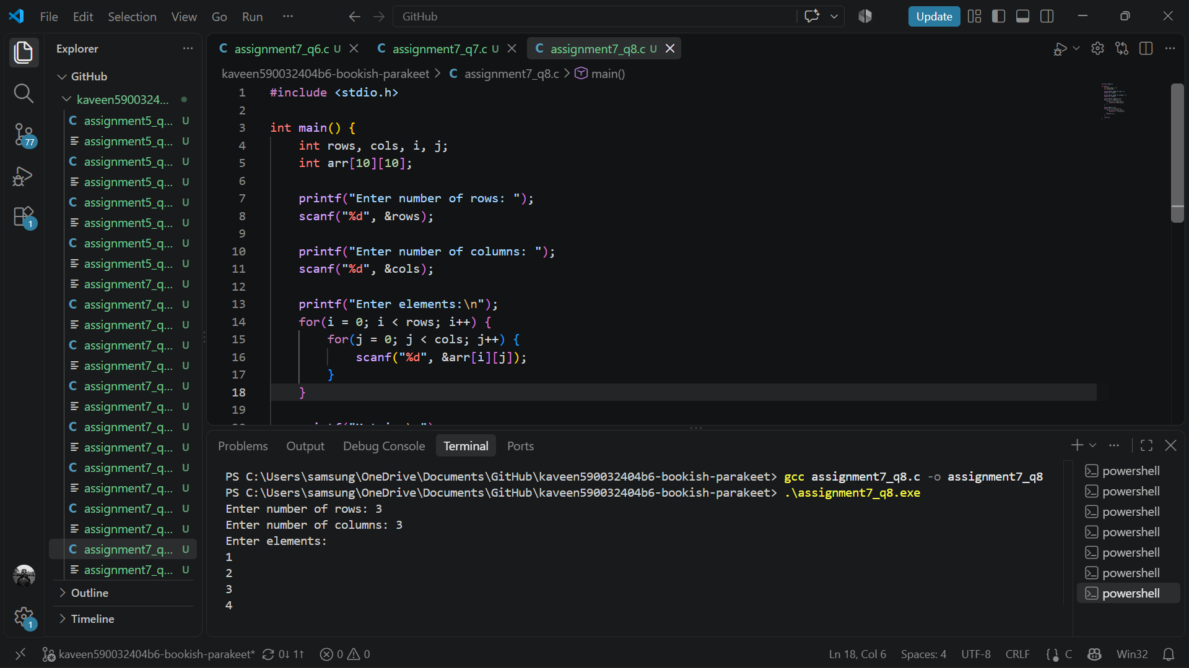
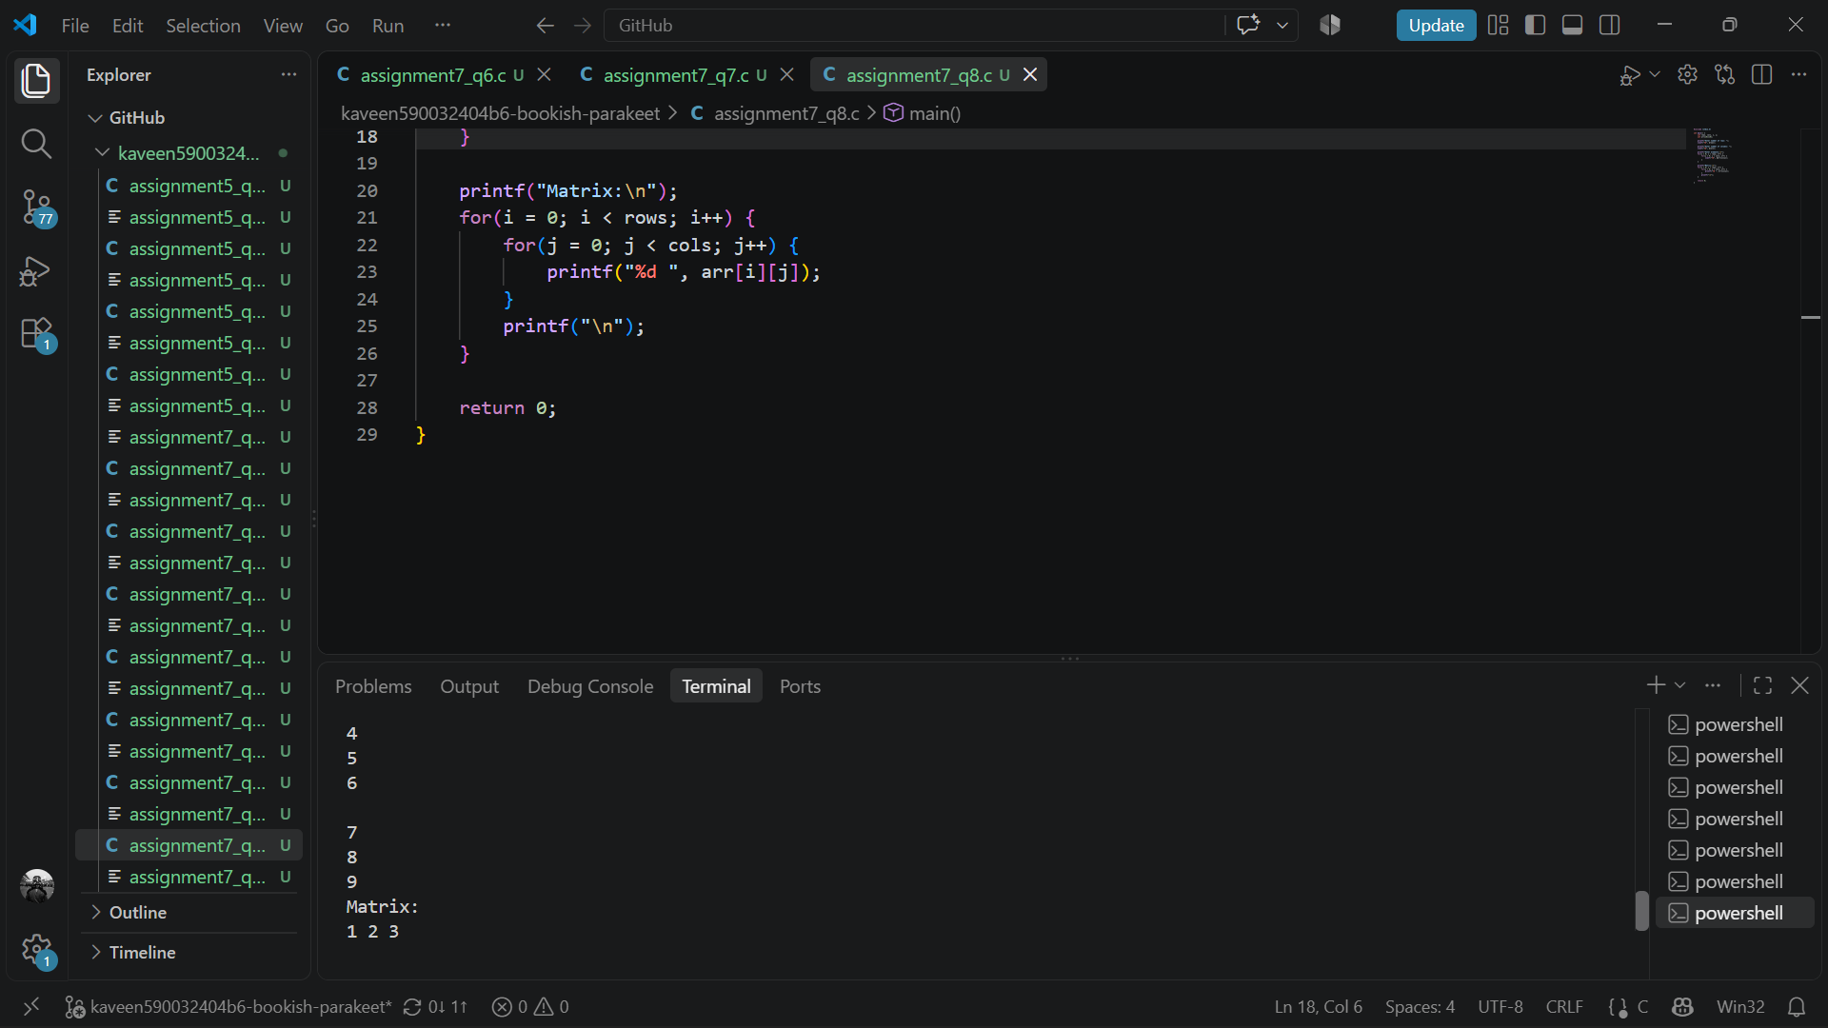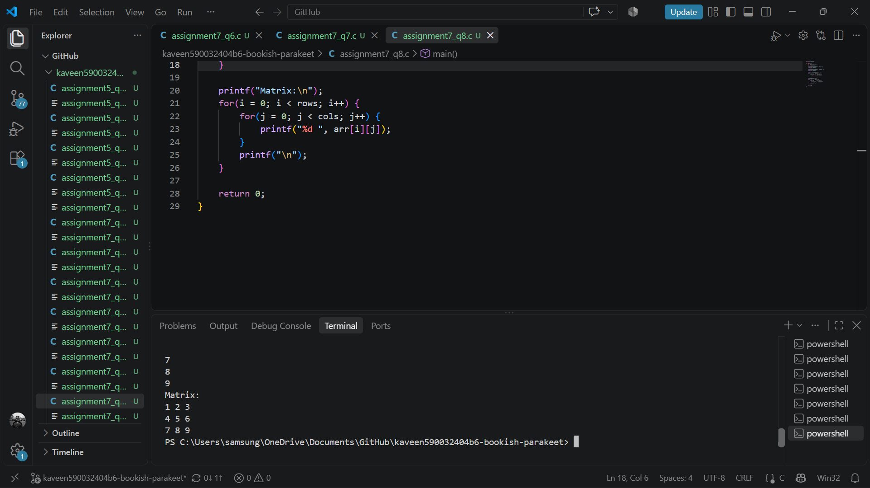

- Addition of Two Matrices
Write a C program to input two matrices of the same order. Calculate their sum and display the resulting matrix. If the matrices have different orders, display an appropriate message.
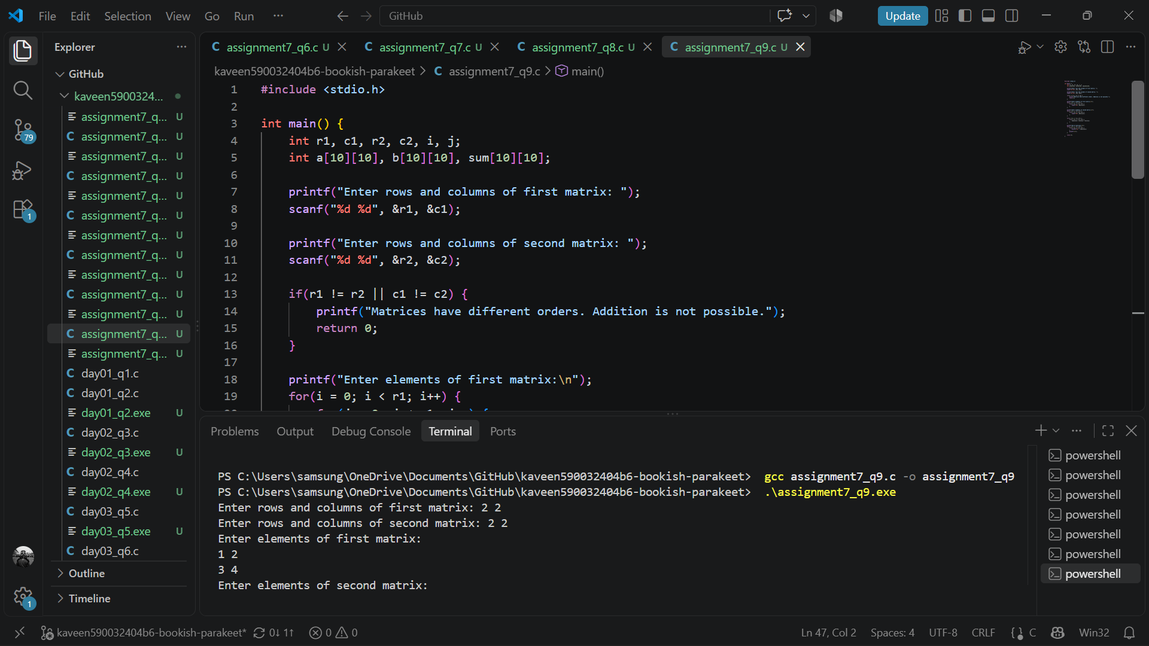
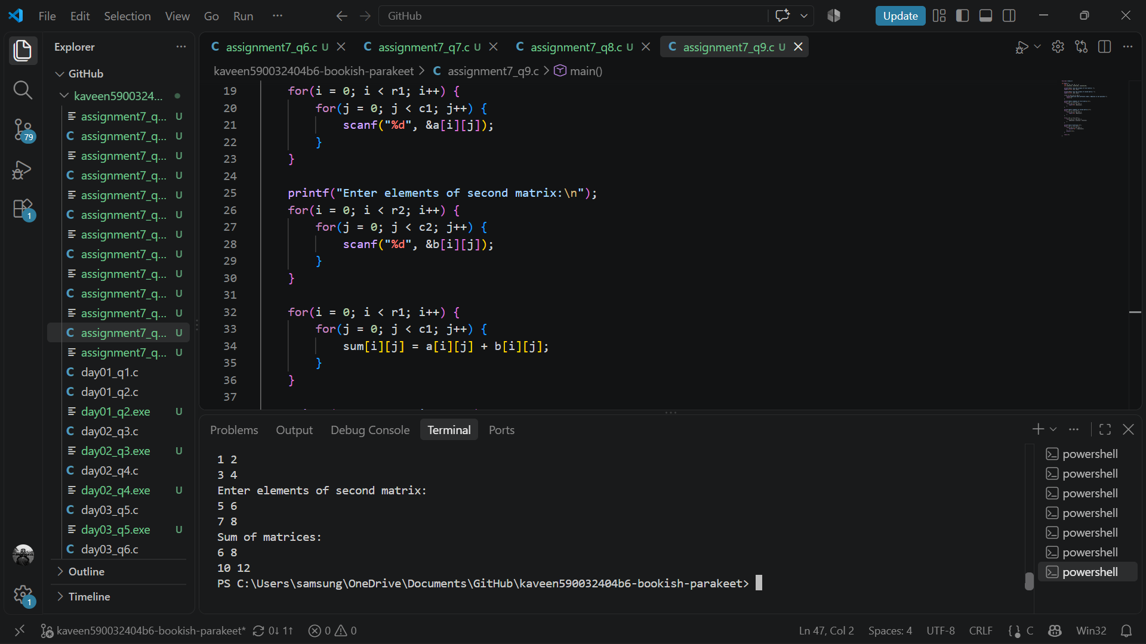
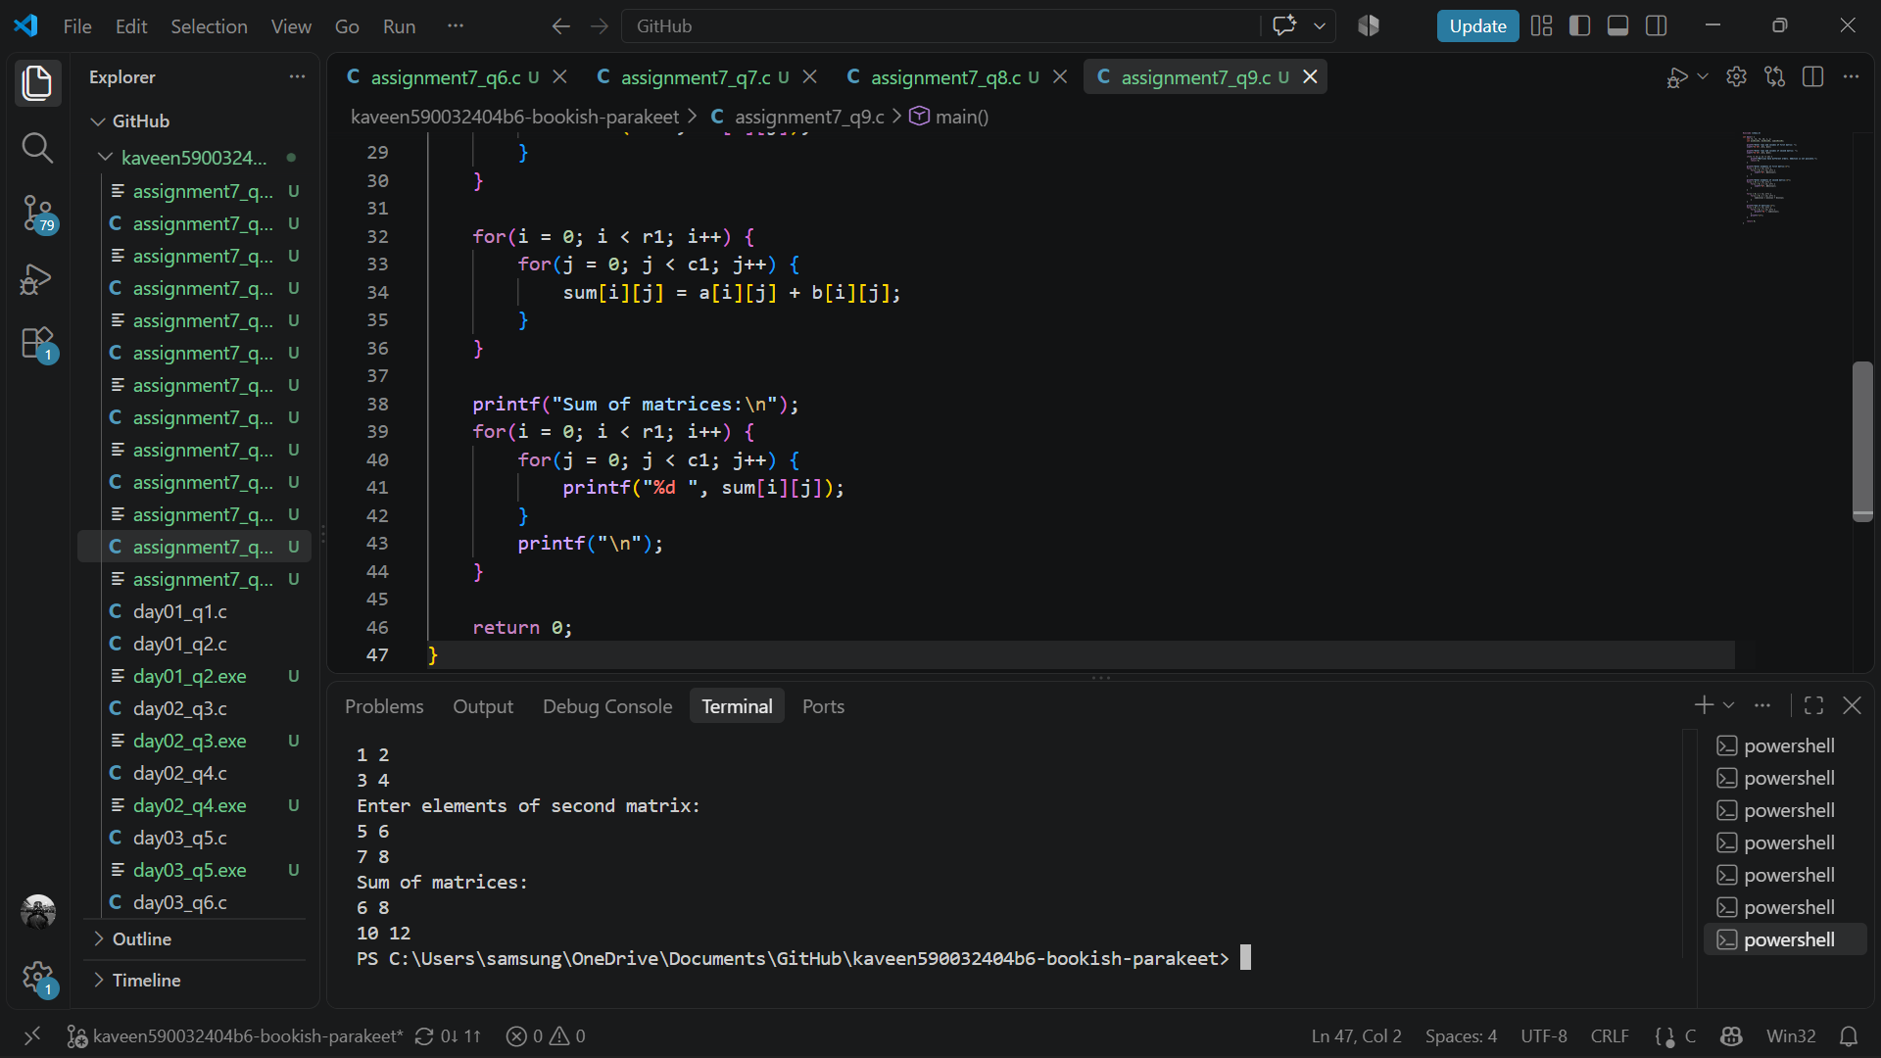

- Multiplication of Two Matrices
Write a C program to input two matrices. Check whether they can be multiplied. If multiplication is possible, calculate and display the product matrix; otherwise, display an appropriate message.
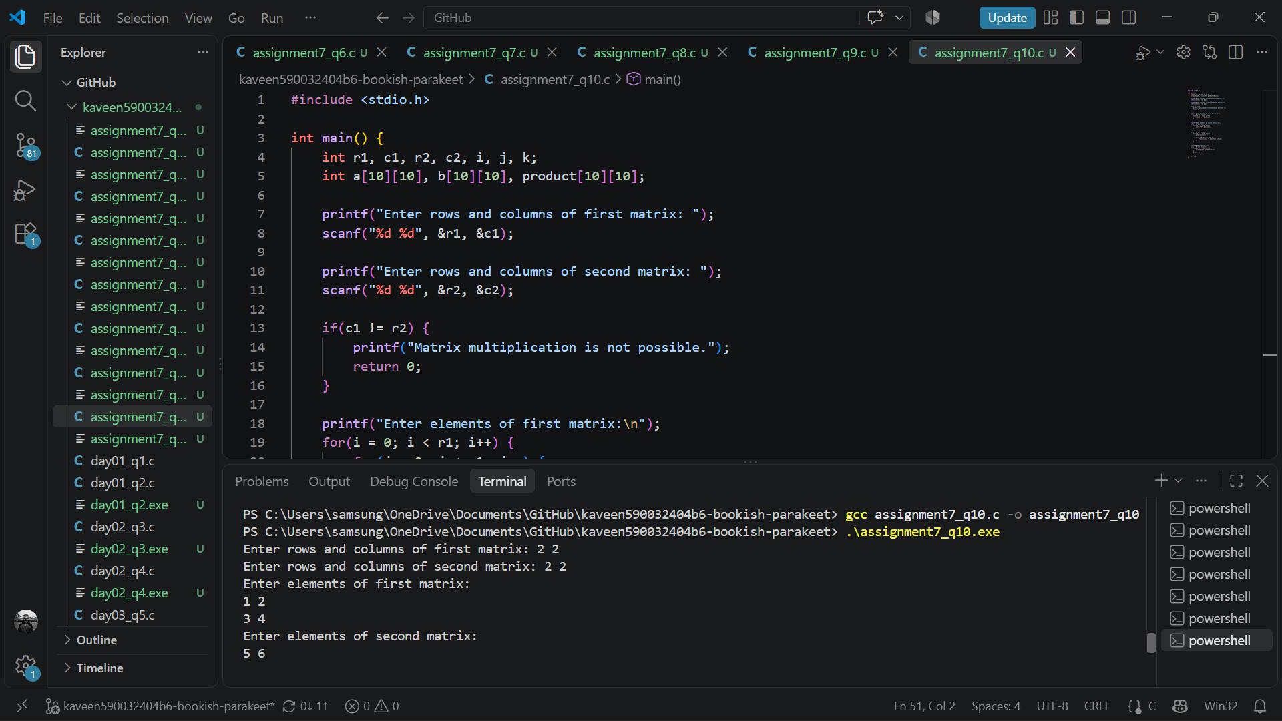
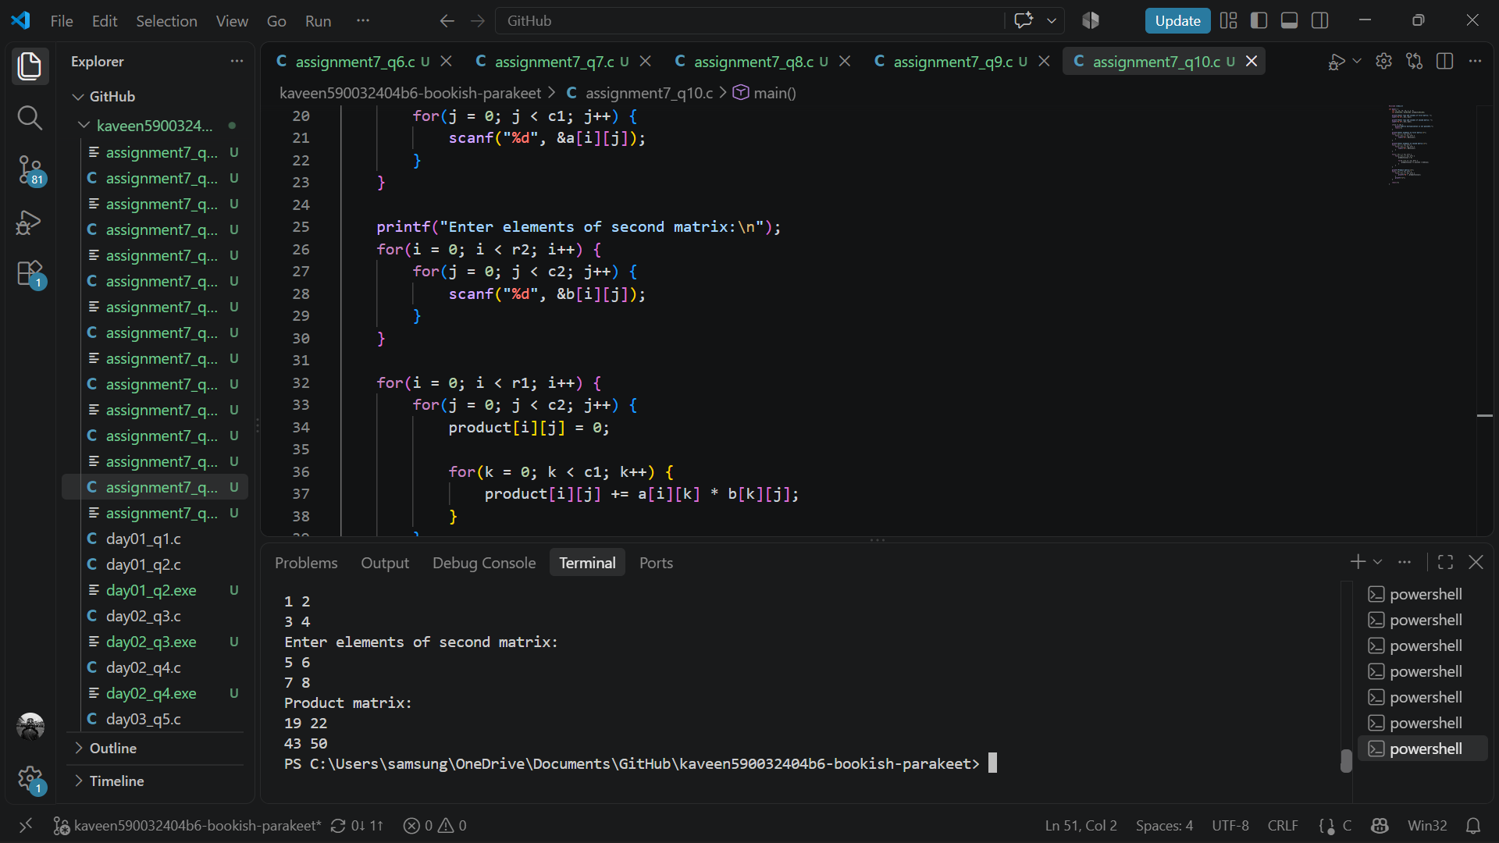
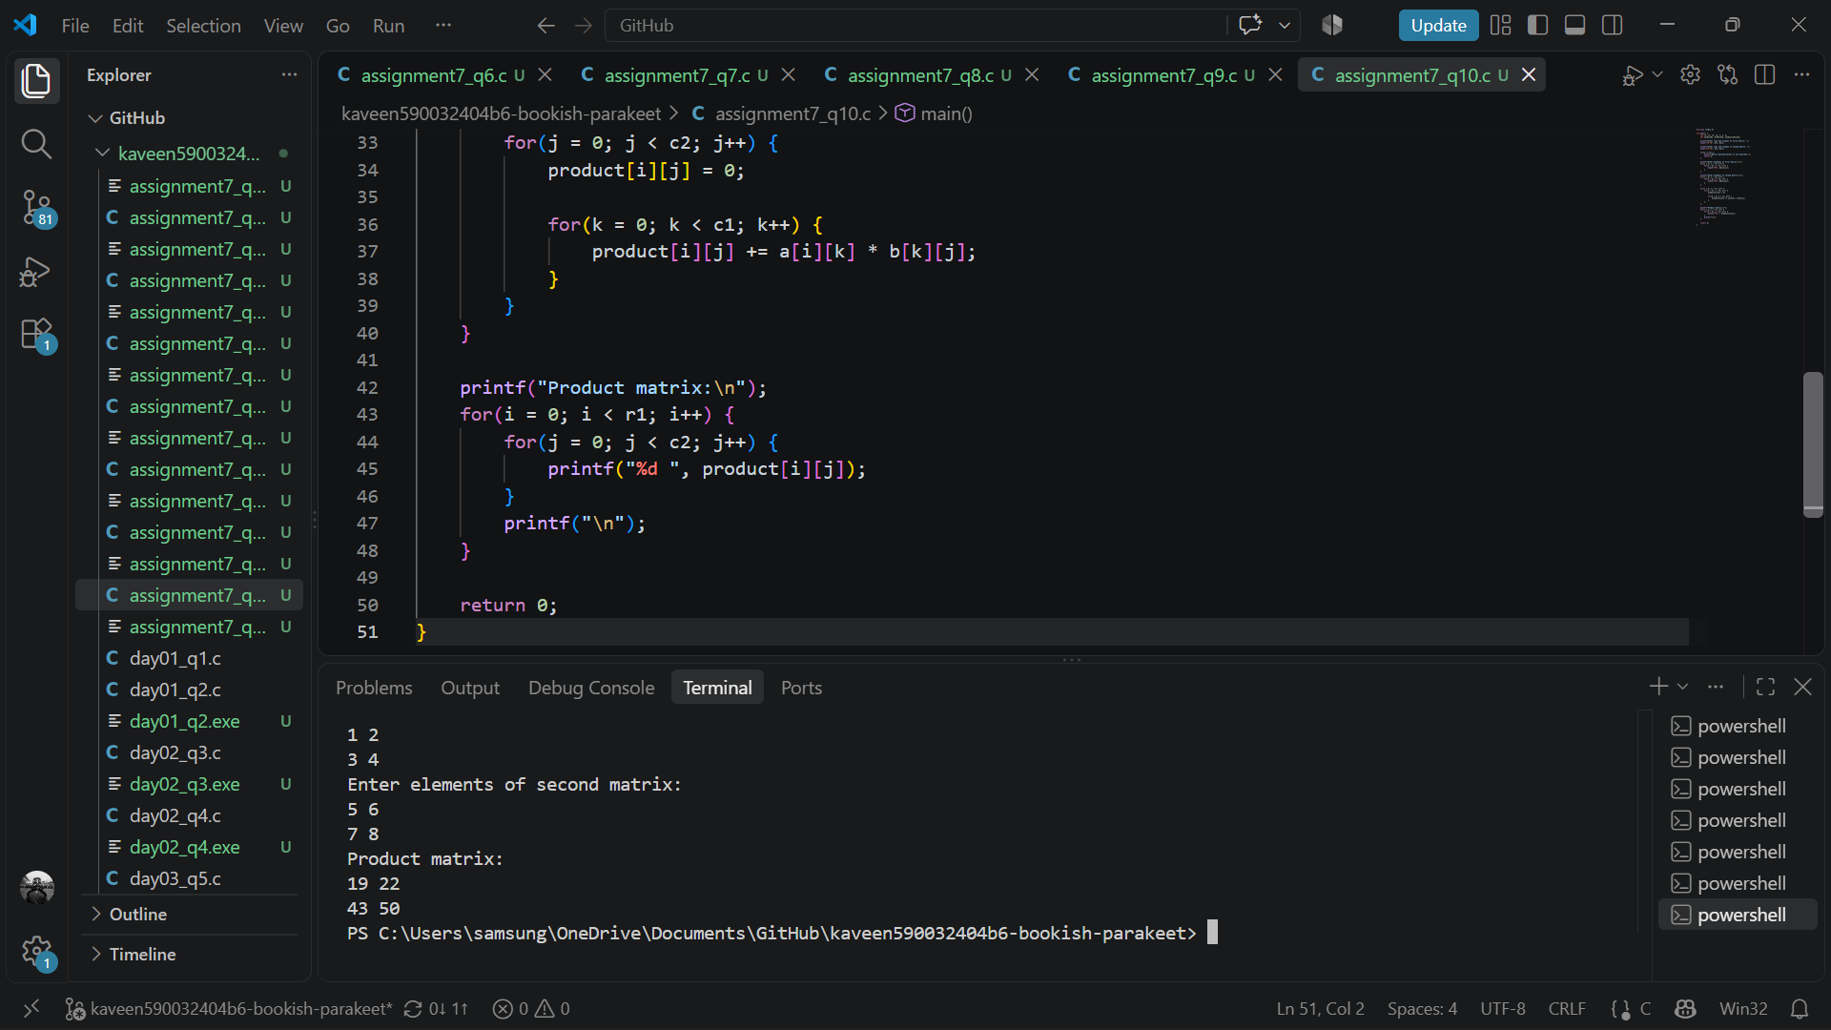

- Row-wise and Column-wise Sums
Write a C program to input an m by n matrix. Calculate and display the sum of the elements in each row and each column.
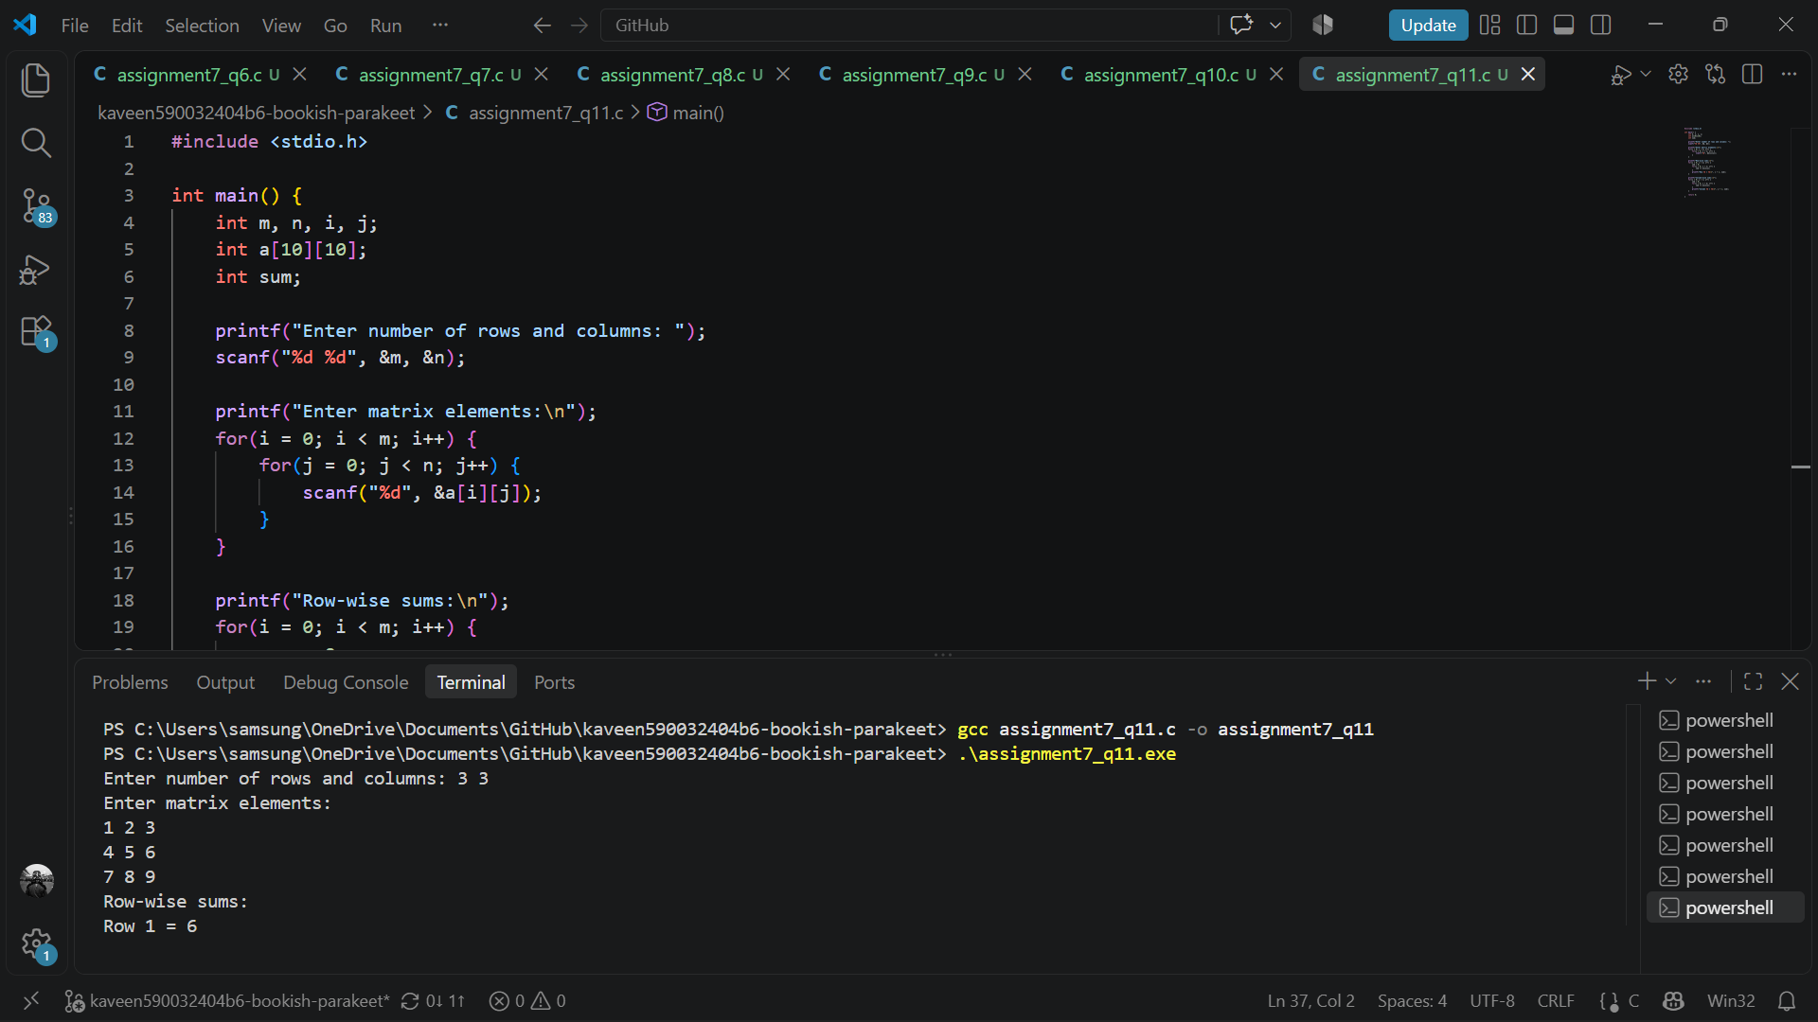
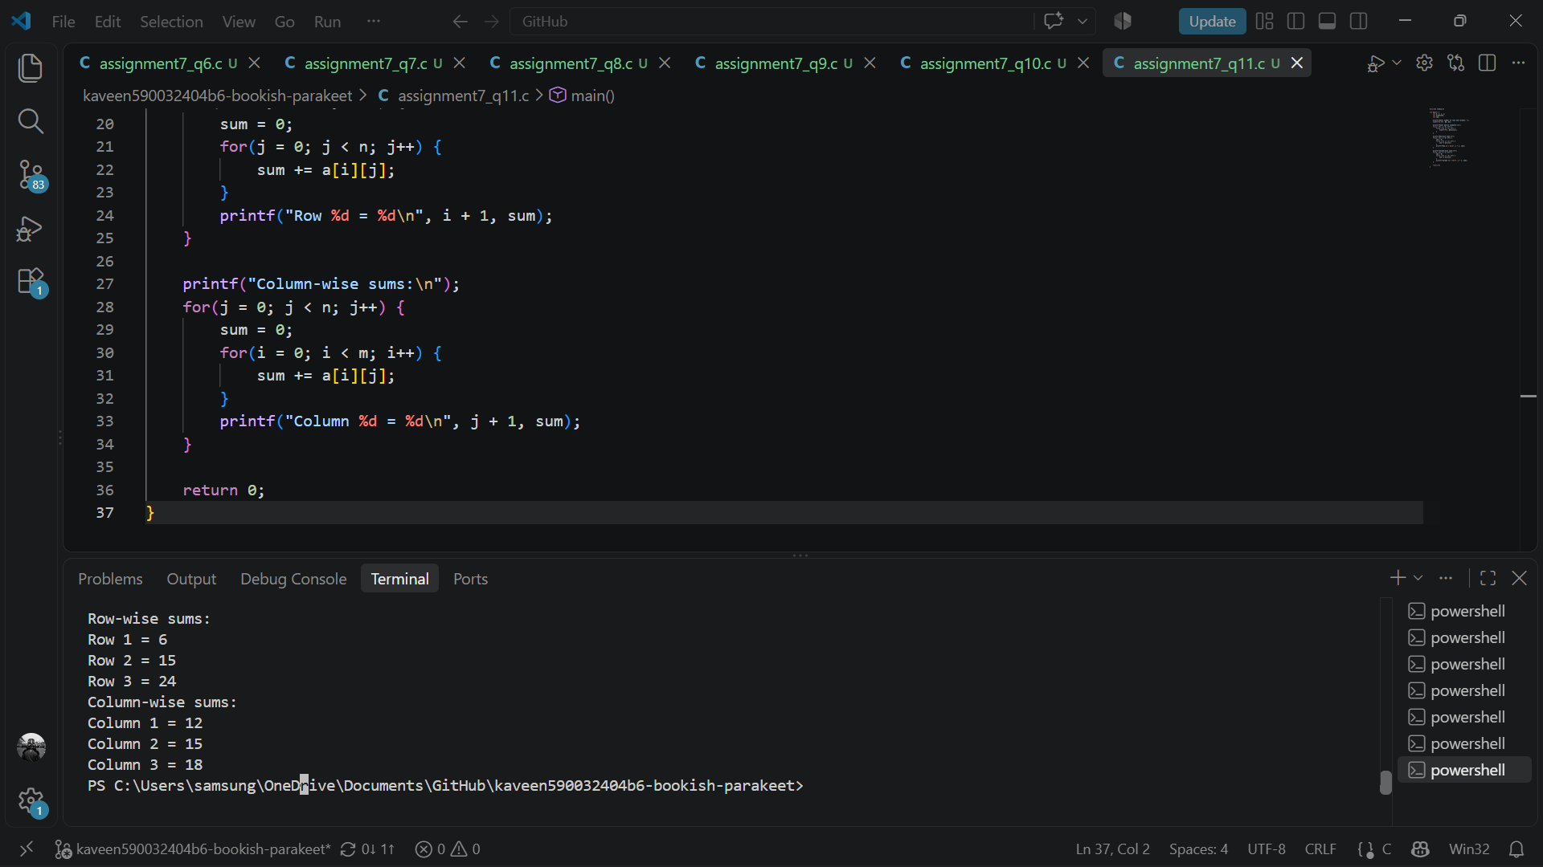

- Transpose and Symmetry of a Matrix
Write a C program to input a square matrix and find its transpose. Compare the original matrix with its transpose and determine whether the matrix is symmetric, skew-symmetric, or neither. Display the transpose and the result.
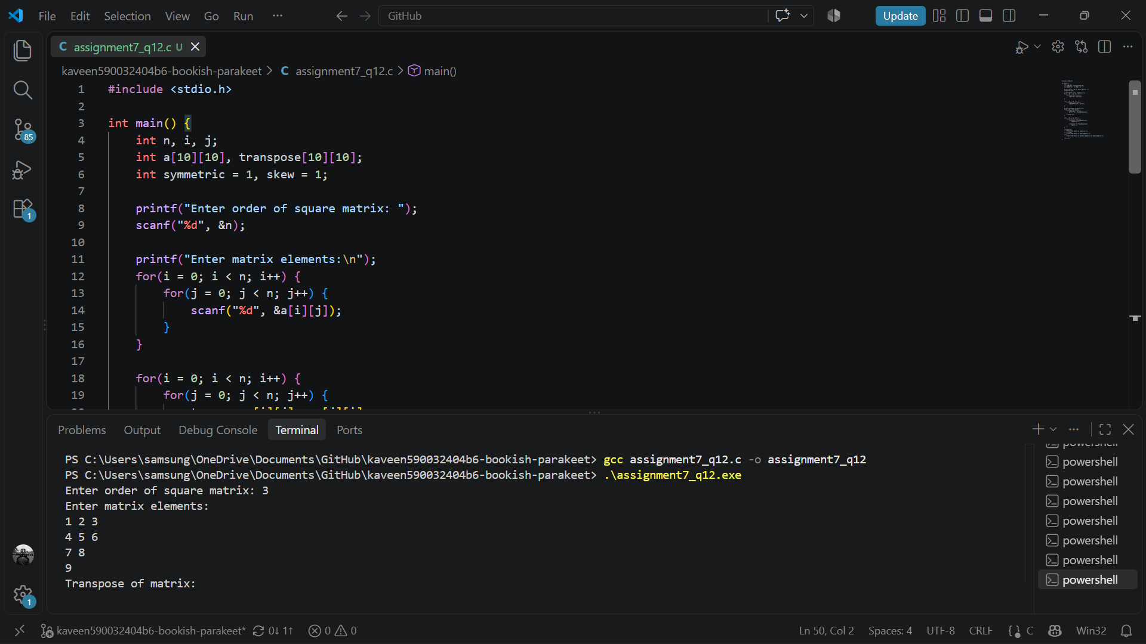
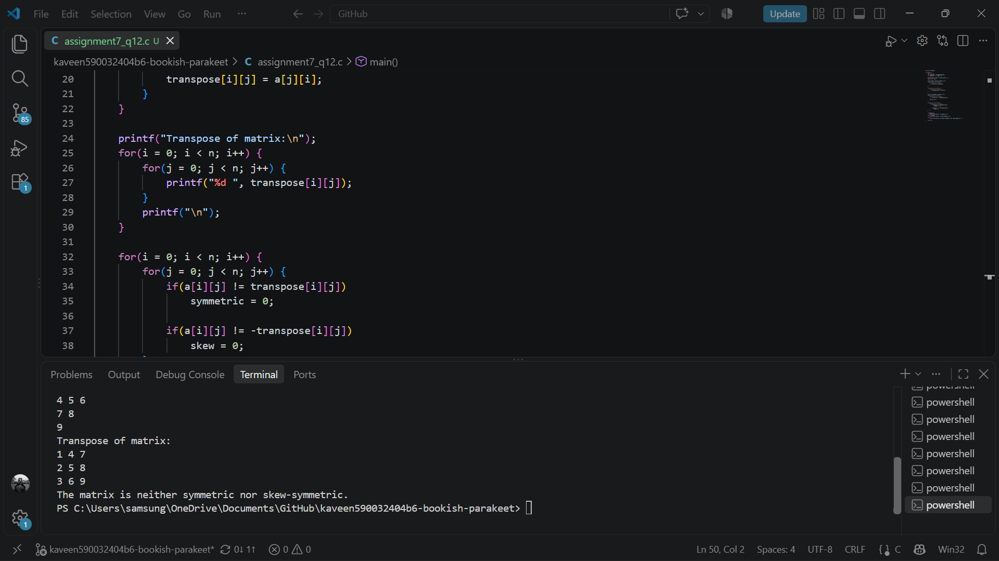
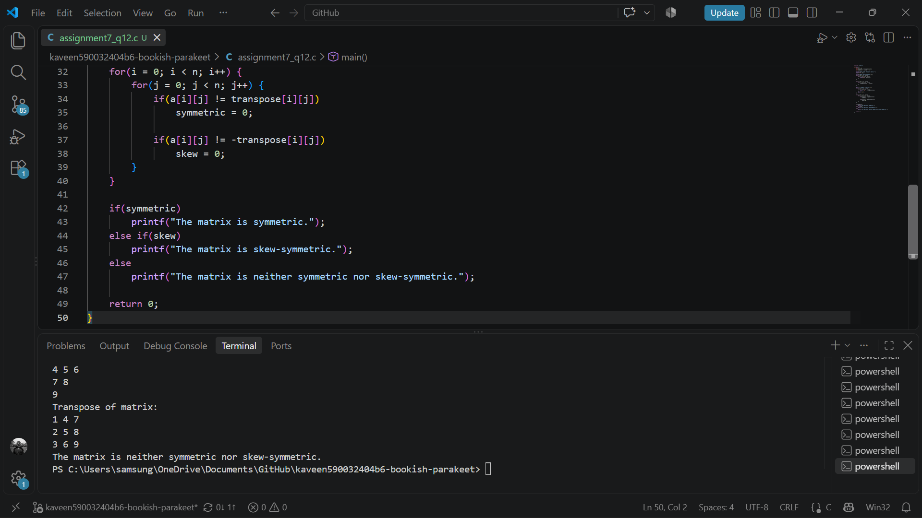

- Diagonal and Triangular Matrix
Write a C program to input a square matrix and calculate the sums of its main and secondary diagonal elements. Also determine whether the given matrix is upper triangular, lower triangular, diagonal, or none of these.
