Assignment 5
Experiment 6: Conditional Statements (if, else, switch-case, break, continue, goto)
Instructions:
- Prepare a Word or PDF file containing all the given programs implemented in C language.
- Attach clear screenshots of the output for each program in the same Word/PDF file.
- Upload all C programs to your GitHub repository.
- Provide the GitHub repository link in the space given below.
Name:
SAP ID:
Batch:
GitHub link: --------------------
Course: B.Tech. CSE (Sem I)
Subject: Programming in C

- Date Validation
Write a C program that accepts input as day, month, and year. Determine whether the date is valid. Consider:
- Months with 30 or 31 days
- February with 28 days
- February with 29 days in a leap year
- Invalid years, months, and days
Use nested if statements without switch-case.
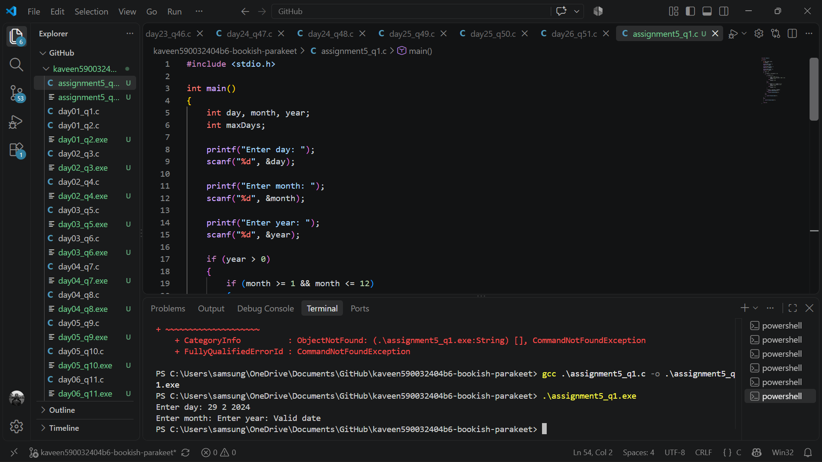
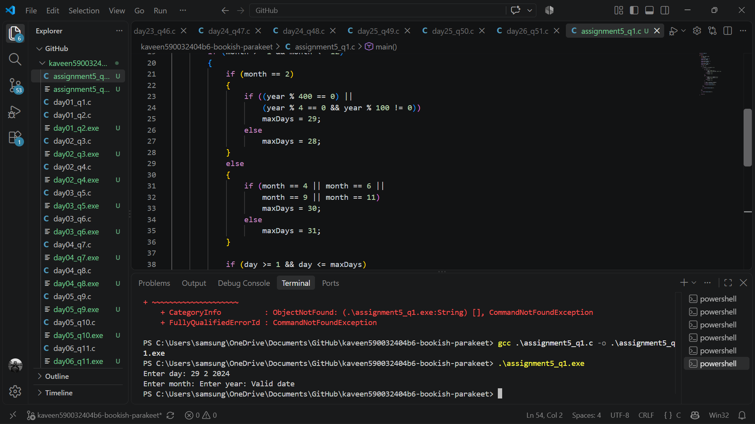
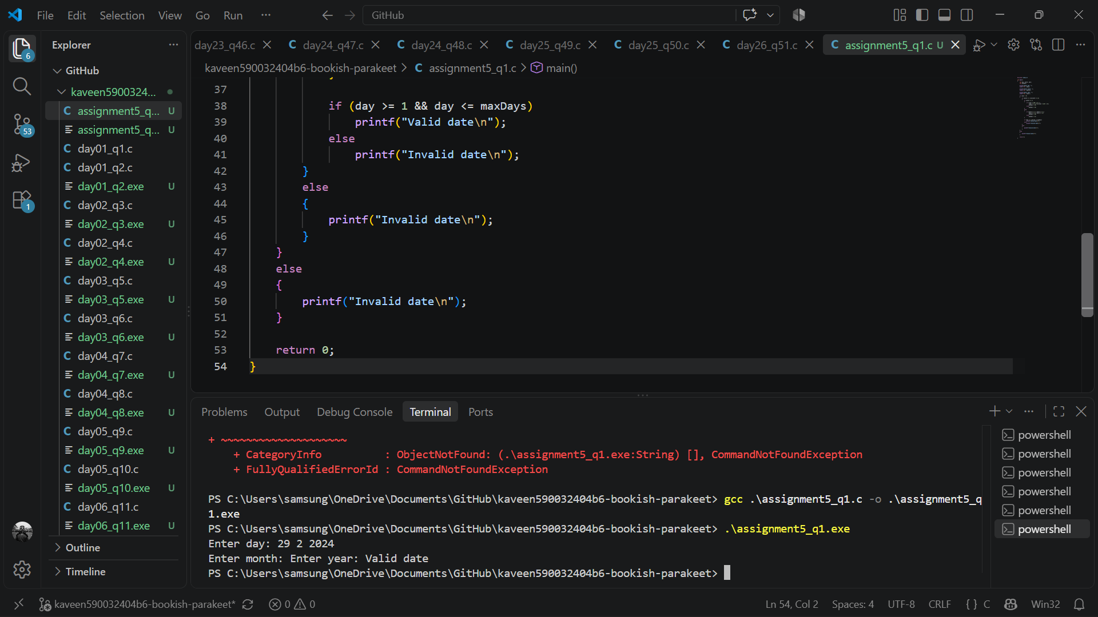

- Quadratic Equation Analysis
Write a C program that accepts input as coefficients a, b, and c of quadratic equation ax^2+bx+c=0. Your program must
- Reject a = 0.
- Calculate the discriminant.
- Determine whether the roots are real and distinct, real and equal, or imaginary.
- Calculate and display the roots whenever they are real.
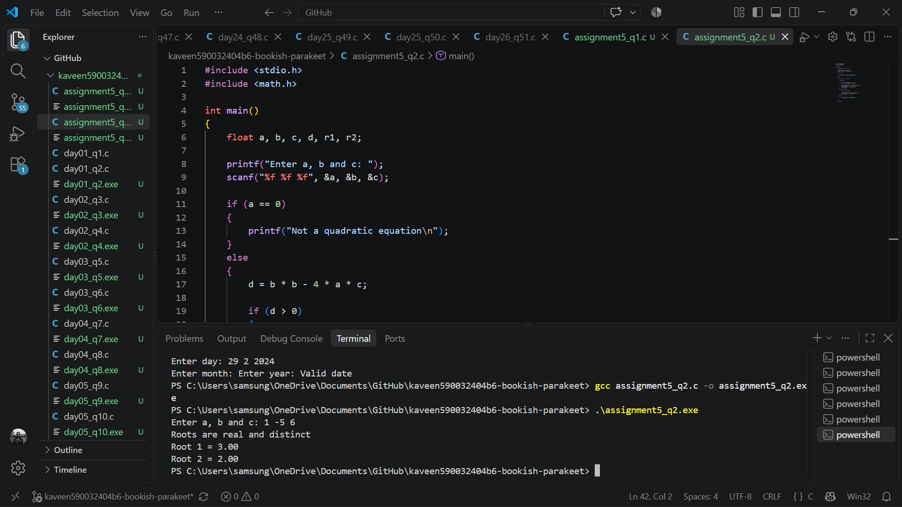
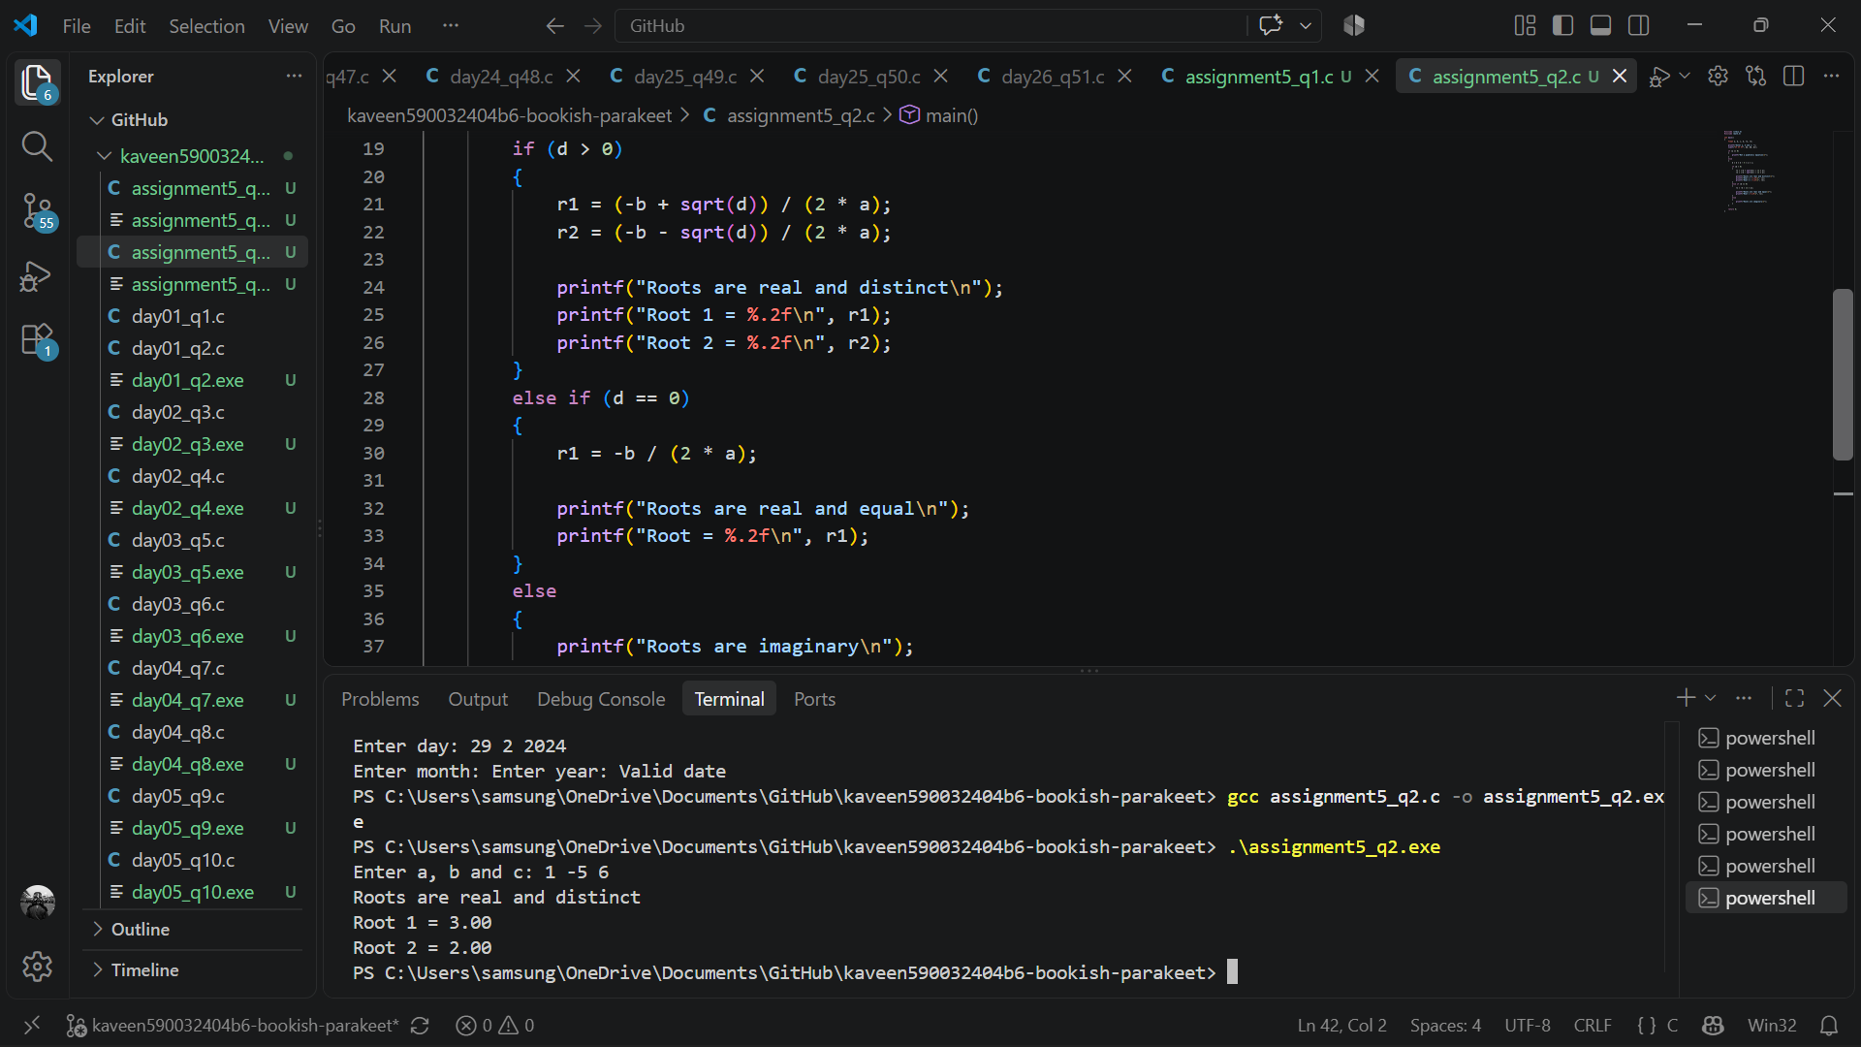
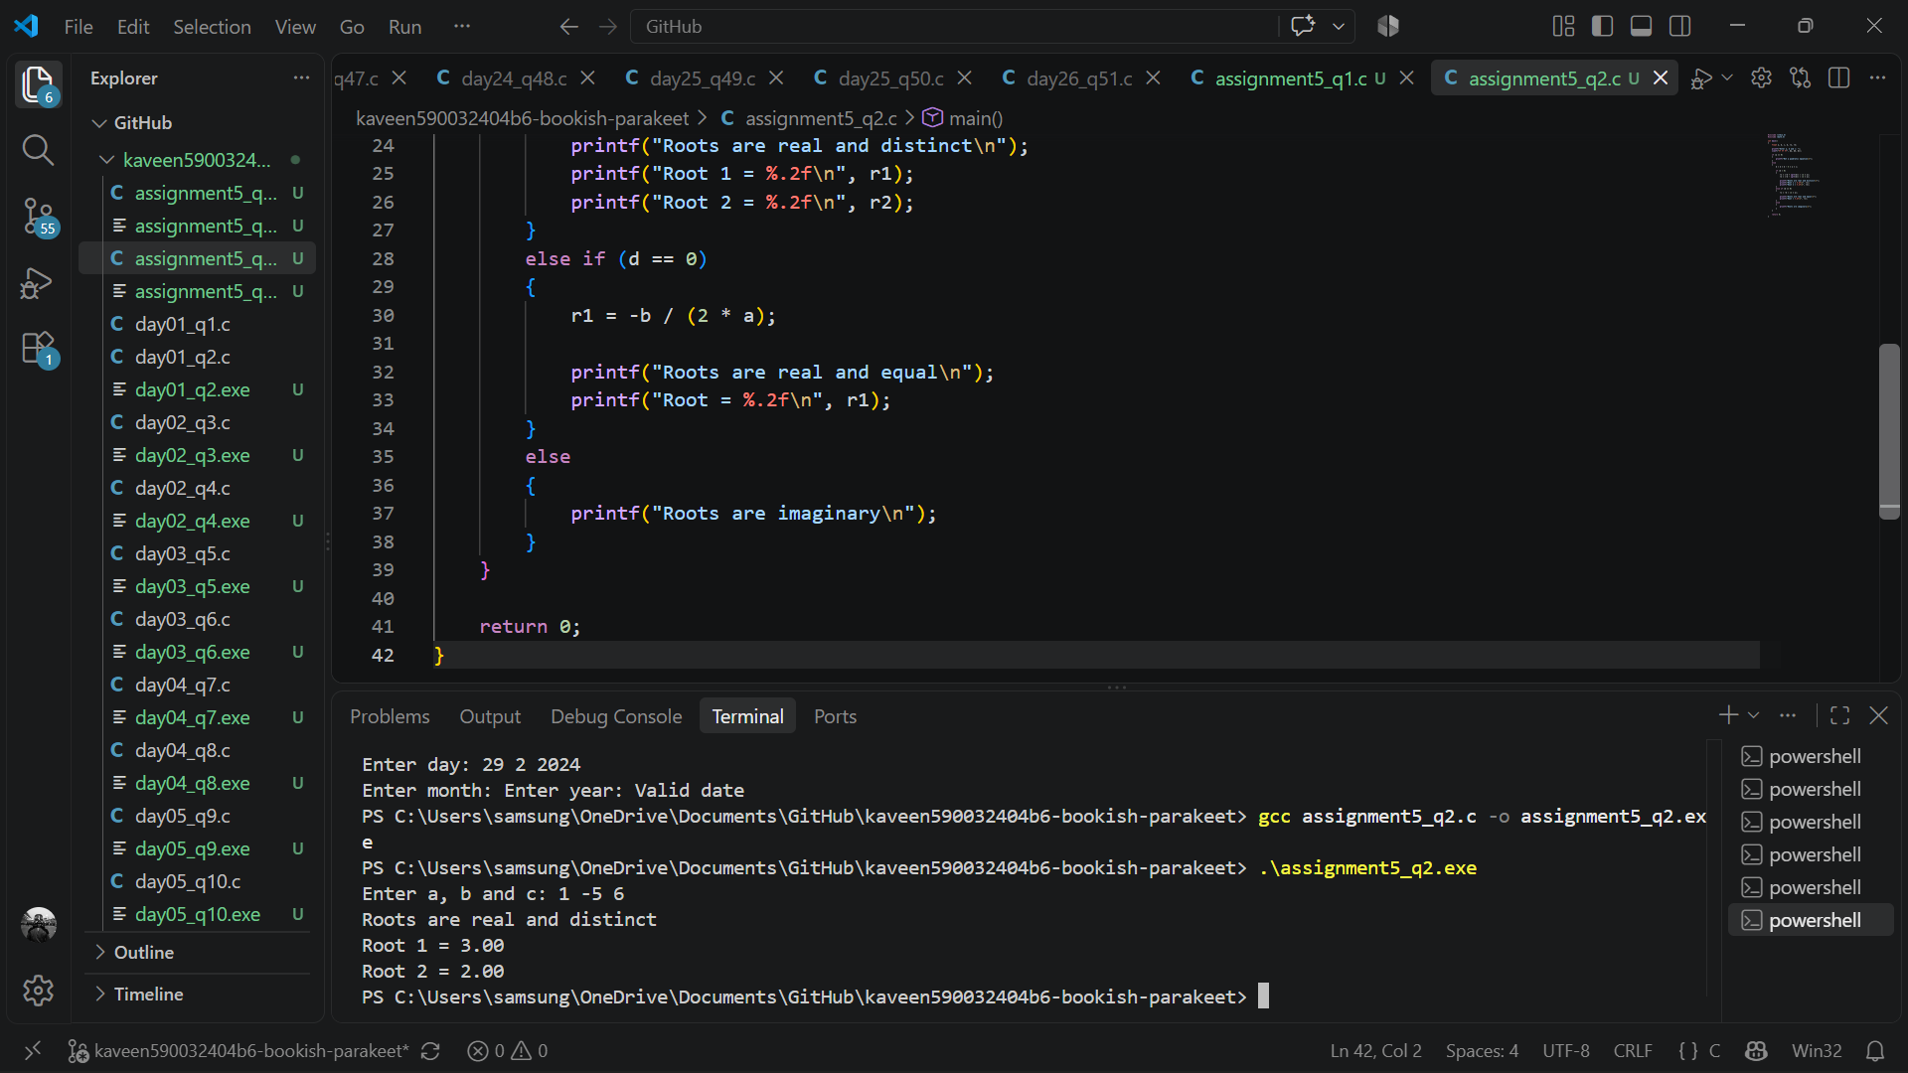
- BMI Classification
Write a C program that takes input as weight in kilograms and height in metres. Calculate BMI and classify it as:
- Underweight
- Normal
- Overweight
- Obesity Class I
- Obesity Class II
- Obesity Class III
Validate weight and height before calculating BMI.
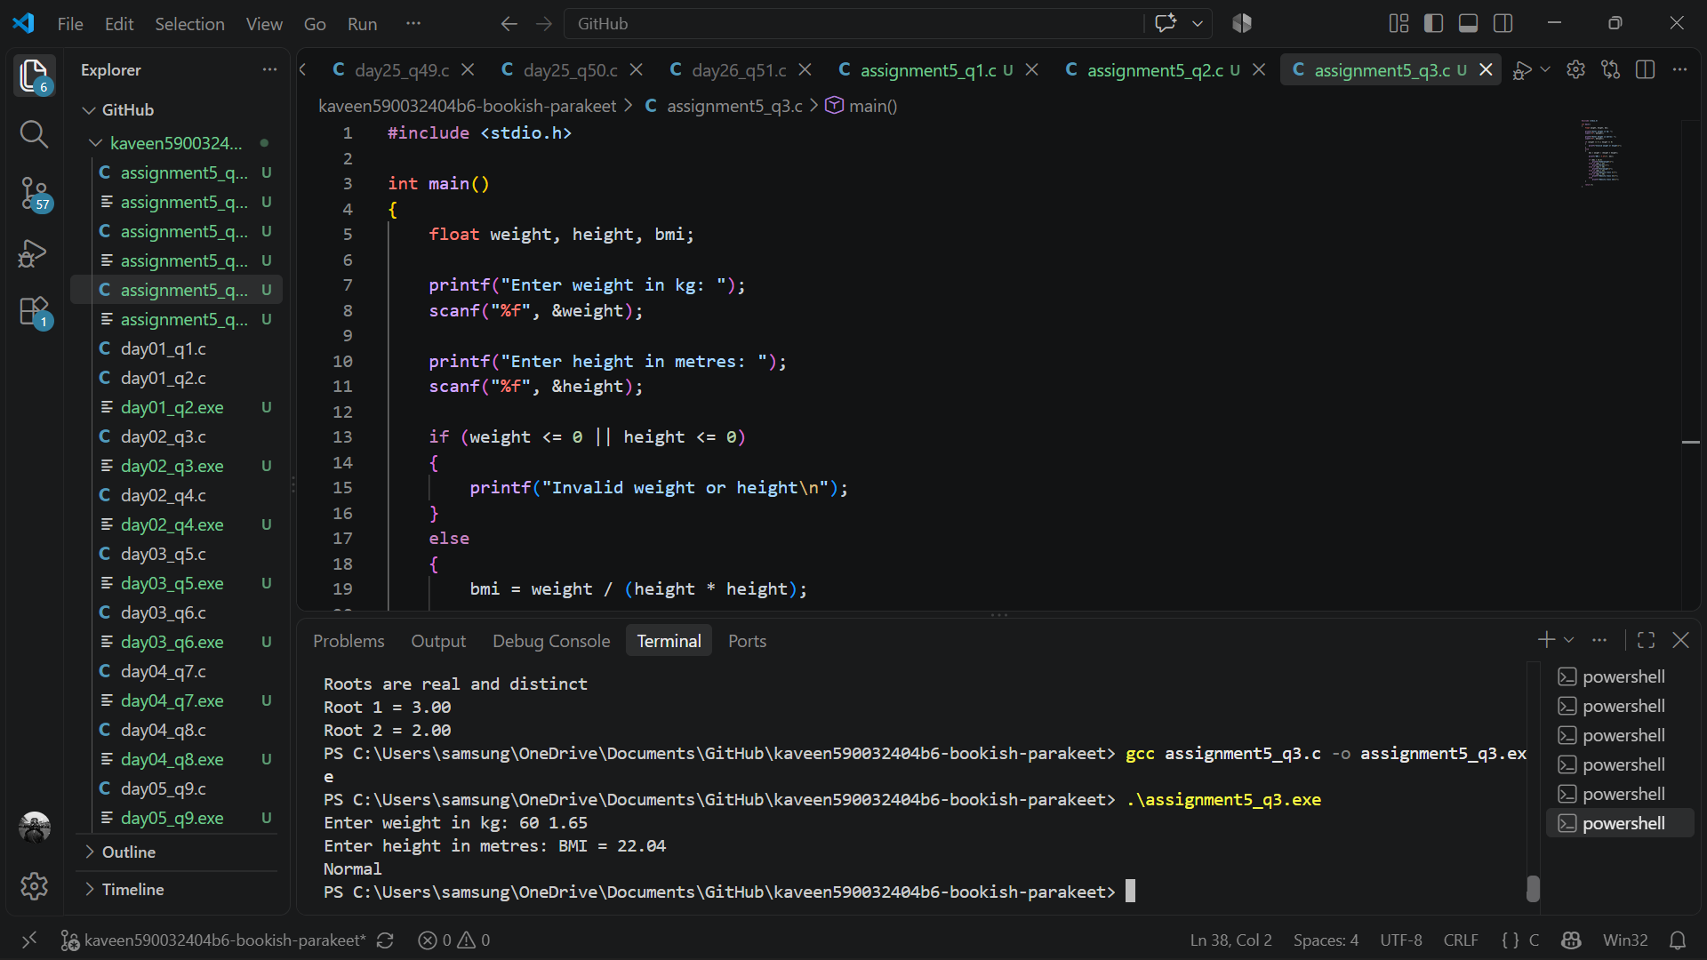
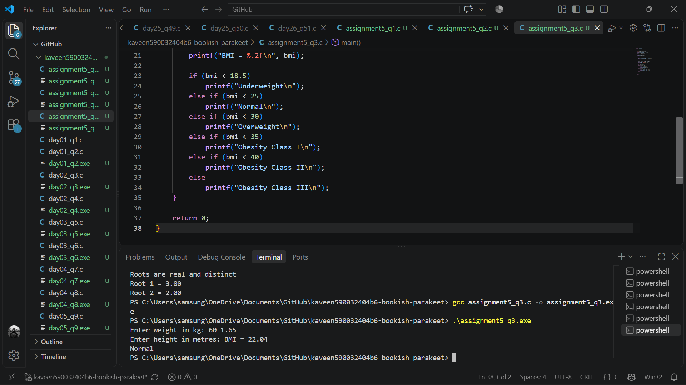
- Menu-Driven Calculator
Write a C program to create a menu-driven calculator that displays the following menu:
Addition, Subtraction, Multiplication, Division, Modulus, Power, Exit.
Requirements:
- Accept the user’s choice and perform the corresponding operation using a switch-case statement.
- Take two numbers as input for each calculation.
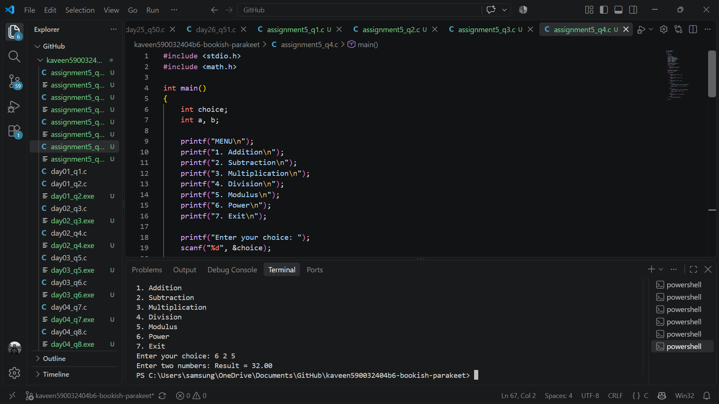
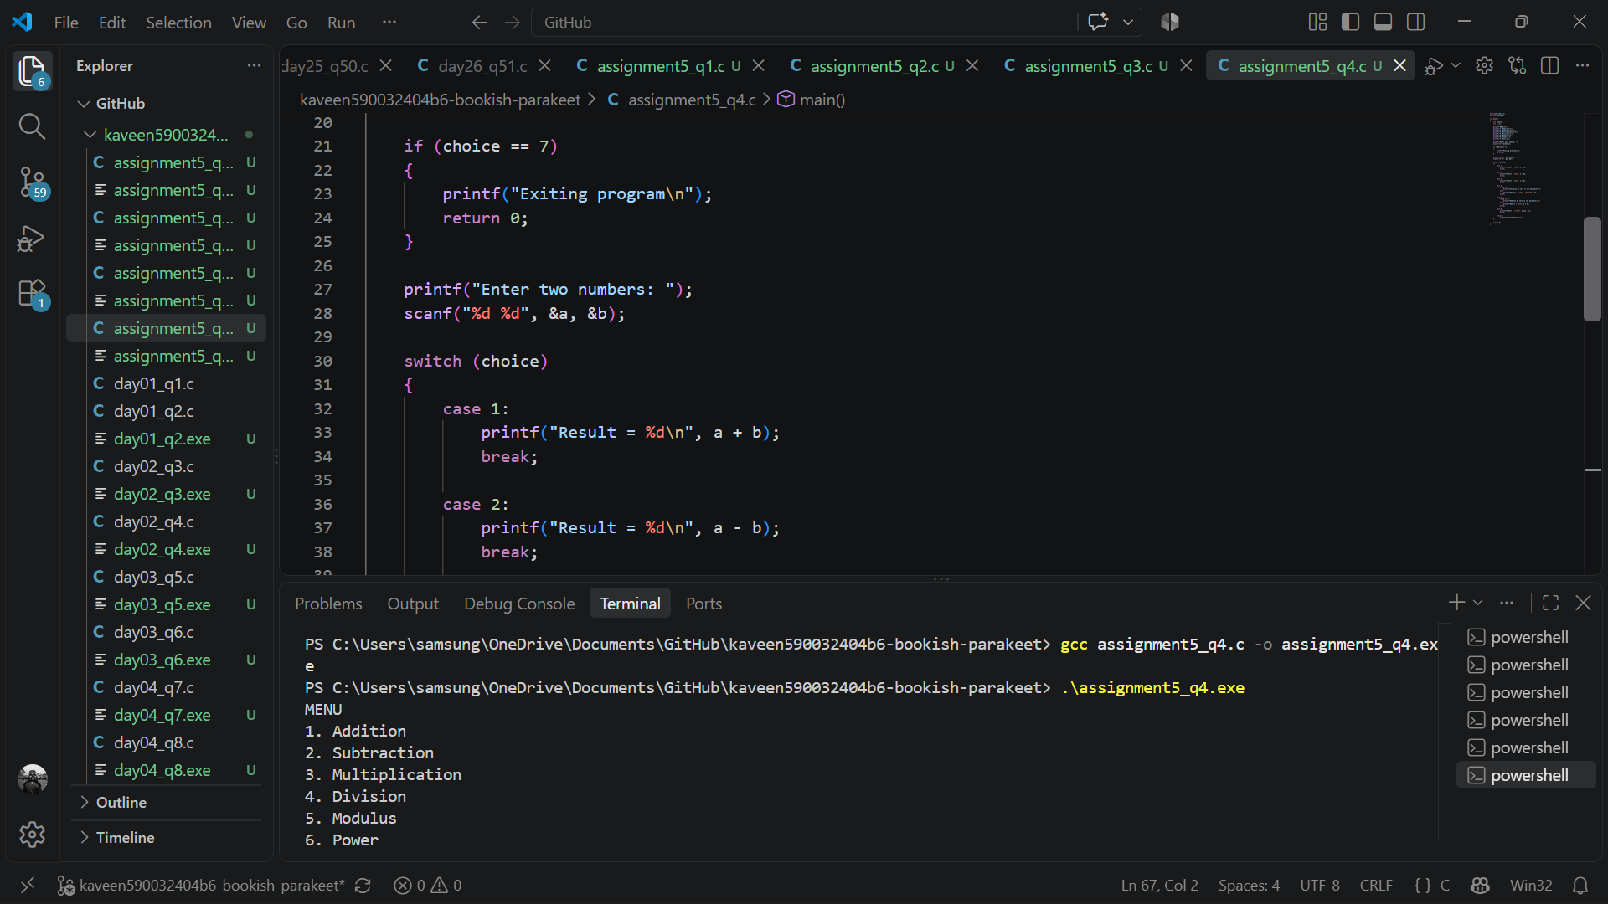
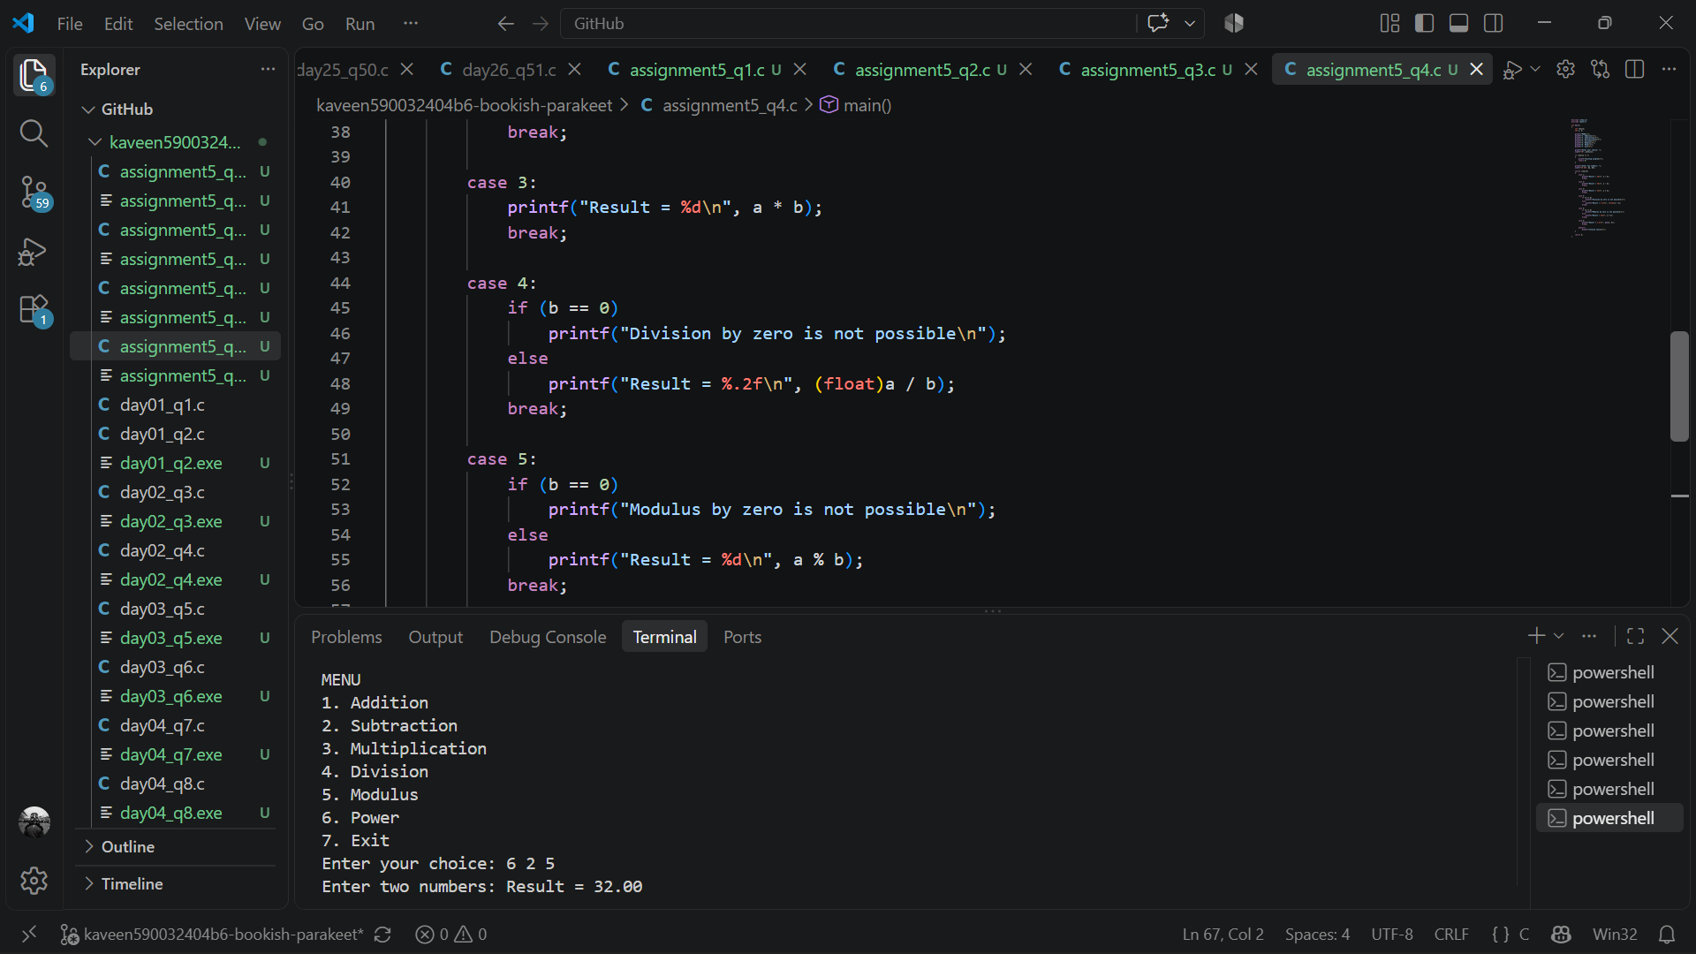
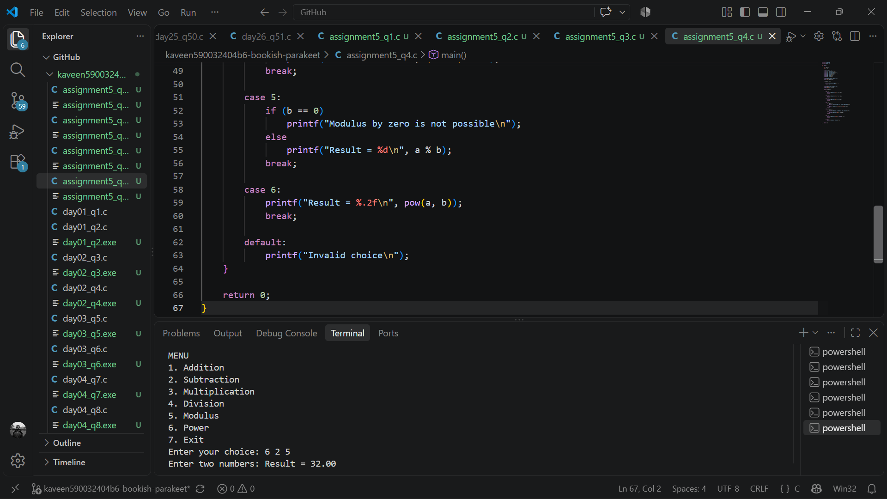

- Bank Transaction Menu
Write a C program to implement a menu-driven banking system with the following options:
- Check balance
- Deposit money
- Withdraw money
- Calculate annual simple interest
- Exit
Requirements
- Initialize the account with a balance of ₹5,000.
- Use a loop to display the menu repeatedly until the user selects Exit.
- Use a switch-case statement to perform the selected operation.
