Final Machine Learning Project Report
Using Customer Retail Dataset Implement Various Models and Compare Them

Student Name: Kaveen Amarasekara
Email: kaveenamarasekara2@gmail.com
University: University of Colombo
Date: 2026.05.29

GitHub Repo: KaveenAmarasekara/DevTown_Final_ML_Project
Google Colab Book: https://colab.research.google.com/drive/1hDQyz3qKMjSDGBAw_U5m8dy9A0ToiLUp?usp=sharing

1. Introduction
Machine Learning is a branch of Artificial Intelligence that enables computers to learn patterns from data and make predictions or decisions without being explicitly programmed. Retail datasets are widely used in Machine Learning because they contain valuable information about customer purchasing behavior, product sales, and transaction patterns.
In this project, a customer retail dataset was used to implement and compare multiple Machine Learning algorithms. The project demonstrates the complete Machine Learning workflow including data preprocessing, visualization, model training, prediction, evaluation, and performance comparison.

2. Project Objectives
- Understand the complete Machine Learning workflow.
- Perform data preprocessing and cleaning.
- Visualize customer retail data using graphs.
- Train multiple supervised Machine Learning models.
- Evaluate models using accuracy score and confusion matrix.
- Compare the performance of different algorithms.

3. Dataset Description
The dataset used in this project is a customer retail transaction dataset containing approximately 60,000 rows. The dataset is stored in CSV format and includes information related to customer purchases and transactions.
The following columns were included in the dataset:
- InvoiceNo – Unique invoice number
- StockCode – Product/item code
- Description – Product description
- Quantity – Number of items purchased
- InvoiceDate – Date of transaction
- UnitPrice – Price per item
- CustomerID – Unique customer identifier
- Country – Customer country

4. Technologies and Libraries Used
- Python Programming Language
- Google Colab
- Pandas
- NumPy
- Matplotlib
- Scikit-learn

5. Methodology
- Loaded the dataset using Pandas.
- Checked and handled missing values.
- Selected relevant columns for Machine Learning.
- Encoded categorical data using LabelEncoder.
- Visualized customer distribution using Matplotlib.
- Split the dataset into training and testing sets.
- Trained Logistic Regression model.
- Trained Decision Tree Classifier model.
- Trained K-Nearest Neighbors (KNN) model.
- Evaluated models using Accuracy Score and Confusion Matrix.
- Compared model performances using graphical visualization.

6. Machine Learning Models Used

6.1 Logistic Regression
Logistic Regression is a supervised Machine Learning algorithm commonly used for classification tasks. It predicts the probability of a categorical output based on input features.

6.2 Decision Tree Classifier
Decision Tree is a classification algorithm that creates a tree-like structure of decisions based on data features. It is simple to understand and effective for many classification problems.

6.3 K-Nearest Neighbors (KNN)
K-Nearest Neighbors is a supervised learning algorithm that classifies data based on the nearest neighboring data points. It is easy to implement and performs well on many datasets.

7. Evaluation Metrics
- Accuracy Score – Measures how many predictions were correct.
- Confusion Matrix – Shows the number of correct and incorrect predictions for each class.

8. Visualizations Included
- Customer Distribution Graph
- Confusion Matrix for Logistic Regression
- Confusion Matrix for Decision Tree
- Confusion Matrix for KNN
- Model Accuracy Comparison Graph

9. Results and Discussion
After training and testing the Machine Learning models, the performance of each algorithm was evaluated using accuracy score and confusion matrix. The comparison graph helped identify which algorithm performed best on the customer retail dataset.
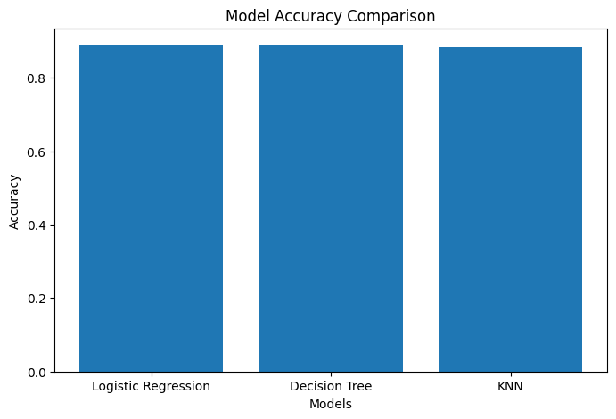

The project demonstrated that different algorithms may produce different results on the same dataset. Data preprocessing and feature selection significantly affect model performance.
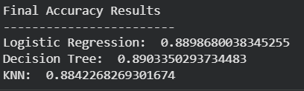

10. Learning Outcomes
- Understood the complete Machine Learning process.
- Learned how to preprocess and clean real-world datasets.
- Learned how to visualize data using graphs.
- Implemented supervised Machine Learning algorithms.
- Learned how to evaluate and compare model performances.
- Improved practical knowledge of Machine Learning using Python.

11. Conclusion
This project successfully implemented and compared multiple Machine Learning algorithms using a customer retail dataset. The project included preprocessing, visualization, model training, evaluation, and comparison of Logistic Regression, Decision Tree, and KNN models.
The project helped demonstrate the importance of data cleaning, feature selection, and model evaluation in real-world Machine Learning applications. It also provided practical experience using Python, Google Colab, and Scikit-learn for Machine Learning development.

12. Future Improvements
- Use additional features from the dataset for better prediction.
- Apply advanced Machine Learning models.
- Use larger datasets for improved accuracy.
- Implement Deep Learning techniques.
- Deploy the model as a web application.

