SCS2312 - Computational Models and Programming Language Concepts
Take-home Assignment
23000066 - Amarasekara A R M K T
Parser Implementation Report

1. Context-Free Grammar (CFG)
The following grammar represents the simple language implemented in my parser. The language supports integer variable declarations, addition expressions, and print statements.
Program → Statement*
Statement → Declaration | PrintStmt
Declaration → 'int' ID '=' Expression ';'
PrintStmt → 'print' '(' Expression ')' ';'
Expression → Term ('+' Term)*
Term → NUMBER | ID | '(' Expression ')'
Terminals: int, print, ID, NUMBER, =, +, ;, (, )
Non-terminals: Program, Statement, Declaration, PrintStmt, Expression, Term
Start symbol: Program
The grammar is simple and designed only to support addition. Since only '+' is supported, there is no need for multiple precedence levels like in full arithmetic grammars.

2. Token Categories
Before parsing, the source code is converted into tokens. The tokenize() function reads the source character by character and identifies tokens.
INT - keyword 'int'
PRINT - keyword 'print'
ID - variable names
NUMBER - integer values
ASSIGN - '='
PLUS - '+'
SEMICOLON - ';'
LPAREN - '('
RPAREN - ')'
END - end of input
The tokenizer skips whitespace, reads full words for identifiers or keywords, reads full digit sequences for numbers, and handles single-character operators directly.

3. Parser Implementation (Recursive Descent)
I used recursive descent parsing. Each grammar rule is implemented as a function. The parser starts from parseProgram() and continues until the END token is reached.
Main parser functions:
- parseProgram() > parses multiple statements.
- Statement() > decides whether it is a declaration or print statement.
- Declaration() > handles 'int ID = Expression ;'
- parsePrint() > handles 'print ( Expression ) ;'
- Expression() > handles addition operations.
- Term() → handles numbers, variables, and parenthesized expressions.
Helper functions such as peek(), advance(), and expect() are used to control token flow and check syntax correctness.

4. Symbol Table
The symbol table is implemented using a simple array of structures. Each entry stores the variable name and its integer value.
When a variable is declared, it is added to the table. When a variable is used in an expression, the program searches for it using linear search.
If the variable is not found, a semantic error is reported.

5. Error Handling
The program detects both syntax and semantic errors.
Syntax Errors:
- Missing semicolons
- Missing '='
- Invalid expressions
- Unexpected tokens
Semantic Errors:
- Using a variable without declaring it first
- Declaring the same variable more than once
When an error occurs, the program prints an error message and stops execution.

6. Example
Example Input:
int y = 5;
int x = 20;
int z = x + y;
print(z);
Output:
25
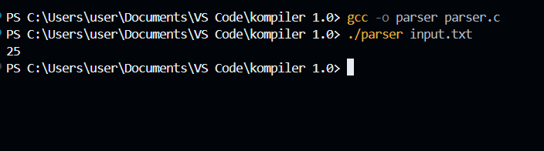
This shows that the parser correctly evaluates expressions and prints the result.

