Community Sports Facilities Booking System
Project Documentation
A web-based prototype for a municipal sports council, built with ASP.NET Core MVC and SQL Server.

Prepared by: Kaveesha Deshan
Module: Data and Web Application Development
Coursework: Community Sports Facilities Booking System

Table of Contents
This page lists the sections of this document. In Microsoft Word, right-click the list below and choose "Update Field" to display page numbers.
Table of Contents 2
1. Introduction 4
2. Problem Statement 4
3. Objectives 4
4. Technologies and Tools Used 4
4.1 Backend 5
4.2 Frontend 5
4.3 Tools 5
5. System Requirements 5
6. Project Setup and Installation 6
6.1 Database setup 6
6.2 Web application setup 6
7. How to Run the Project 6
7.1 Demo accounts 7
8. System Features Overview 7
8.1 Guest features 7
8.2 Member features 7
8.3 Administrator features 7
9. Module and Component Explanation 8
9.1 Controllers 8
9.2 Services 8
9.3 Data access 8
9.4 Authentication and Authorization 9
10. Main User Flows 9
10.1 Guest registration flow 9
10.2 Member search and booking flow 9
10.3 Review submission flow 9
10.4 Guest inquiry flow 10
10.5 Administrator management flow 10
11. Validation and Error Handling 10
11.1 Field-level validation 10
11.2 Business-rule validation 11
11.3 Error pages 11
12. Database Design 11
12.1 Entity-Relationship Diagrams 12
12.2 Table structures 12
12.3 Design notes 15
12.4 Concurrency and booking safety 15
13. External Services and Data Access 15
14. Testing 15
14.1 Automated testing 15
14.2 Manual functional testing 16
15. Test Cases and Results 16
15.1 Guest Module 16
15.2 Member Module 34
15.3 Administrator Module 54
16. Test Summary 68
17. Limitations 68
18. Application Source Code and Project Access 69
19. Conclusion 69

1. Introduction
The Community Sports Facilities Booking System is a web-based application built for a municipal sports council. It allows members of the public to find out about local sports facilities such as tennis courts, swimming pools, sports halls, football pitches, athletics tracks and cricket and volleyball grounds, and lets registered members book those facilities online.
The system was developed as a university coursework project. It is a working prototype rather than a full commercial product, but it implements a complete and genuinely functional set of features, including a proper database design, a secure member account system, real-time booking with conflict prevention, and an administration area for managing the system.
This document describes the purpose of the system, how it was designed and built, the technologies used, how to set it up and run it, its main features and modules, and the testing that was carried out on the finished application.

2. Problem Statement
A municipal sports council wants to make it easier for the local community to find and use public sports facilities. At present, booking a facility and finding out what is available is not centralised, which can lead to scheduling conflicts, wasted trips, and facilities being under-used because people do not know they exist or whether they are free at a given time.
The council needs an online system that lets the public browse and search for facilities, lets registered members book a facility for a specific date and time without double-booking, lets members share feedback through reviews, and gives the council a way to see and manage this activity. Guests who are not yet members should still be able to see basic information, read reviews, register, and get in touch with a question, without needing to create an account first.

3. Objectives
The main objectives of the project are:
- Design a normalised relational database that correctly represents members, sports, facilities, bookings, reviews and inquiries.
- Build a web application, using ASP.NET Core MVC with C#, that implements the case study's Guest and Member features.
- Allow a member to register with personal details and preferred sports, sign in securely, search for facilities, book a facility for a specific date and time, and leave a review after using it.
- Allow a guest (a visitor without an account) to browse and search facilities with limited detail, read reviews, register to become a member, and send an inquiry.
- Prevent double-booking of the same facility for an overlapping date and time, using database-level protection rather than relying on the application alone.
- Add simple administration tools so that the facilities, sports, members, bookings, reviews and inquiries in the system can be managed and reviewed.
- Test the finished system thoroughly, using both automated tests and real, manually driven tests of the running application, and document the results honestly.

4. Technologies and Tools Used
The technologies used follow the coursework's required stack: ASP.NET Core with C# for the web application, and SQL Server for the database.

4.1 Backend
- ASP.NET Core MVC (.NET 10) - the web application framework, using the Model-View-Controller pattern.
- C# - the programming language used for all server-side code.
- Entity Framework Core 10 - used to read and write data between the C# code and the SQL Server database.
- Microsoft SQL Server - the relational database that stores all application data.
- ADO.NET (Microsoft.Data.SqlClient) - used to call a SQL Server stored procedure directly for booking creation, in addition to Entity Framework Core.

4.2 Frontend
- Razor views (.cshtml) - used to generate the HTML pages on the server.
- HTML5 and CSS3 - the page structure and styling.
- Bootstrap 5 - the CSS framework used for layout, forms, buttons and the responsive navigation menu.
- Bootstrap Icons - the icon set used throughout the interface.
- JavaScript and jQuery, with jQuery Unobtrusive Validation - used for client-side form validation messages and small interactive features such as the quick time-slot picker.

4.3 Tools
- Oracle SQL Developer Data Modeler - used to build the entity-relationship diagram and the physical database model, as required by the coursework.
- SQL Server Management Studio and sqlcmd - used to create the database, run the SQL scripts, and inspect data during development.
- Git - used for version control of the source code.
- xUnit - the automated testing framework used for the C# test suite.
- A browser automation tool (Playwright, driving a real installed Chrome browser) - used during this documentation exercise to actually operate the running application and capture genuine screenshots of each test case.

5. System Requirements
To run this project, the following are required:
- Windows 10 or later (the project was developed and tested on Windows 11).
- .NET 10 SDK.
- Microsoft SQL Server (Developer or Express edition is sufficient), running locally or reachable over the network.
- A modern web browser, such as Microsoft Edge, Google Chrome or Firefox.
- Visual Studio 2022 or Visual Studio Code (optional, but recommended for editing and debugging).
- An internet connection the first time the project is built, so that NuGet can download the Entity Framework Core packages.

6. Project Setup and Installation
The steps below set up the database and the web application from a copy of the project source code.

6.1 Database setup
The SQL scripts in the database folder must be run once, in order, against a SQL Server instance. Each script is a plain .sql file and can be run using SQL Server Management Studio or sqlcmd.
- 01_CreateDatabase.sql - creates the CommunitySportsBookingDB database.
- 02_CreateTables.sql - creates the 8 application tables with their keys and constraints.
- 03_Indexes.sql - adds the indexes used for search and availability queries.
- 04_BookingOverlapProtection.sql - creates the usp_CreateBooking stored procedure and the trg_Booking_PreventOverlap trigger that prevent double-booking.
- 05_SeedData.sql - inserts sample members, sports, facilities, bookings, reviews and inquiries.
- 06_TestQueries.sql - a set of sample SELECT queries used to demonstrate and check the data.
- 07_AdminSupport.sql - adds the IsAdmin column used by the administration area.
- 08_BookingCancellation.sql - adds booking cancellation support (IsCancelled, CancelledDate) and updates the overlap checks to ignore cancelled bookings.

6.2 Web application setup
- Open a command prompt in the project folder (the folder containing CommunitySportsBooking.slnx).
- Check the connection string in src/CommunitySportsBooking.Web/appsettings.json. By default it points to a local SQL Server instance using Windows authentication: Server=localhost;Database=CommunitySportsBookingDB;Trusted_Connection=True;TrustServerCertificate=True;. Change this if a different server or authentication method is used.
- Run "dotnet restore" to download the required NuGet packages.
- Run "dotnet build" to compile the solution and confirm there are no errors.
- Run the seed hash update command once: "dotnet run --project src/CommunitySportsBooking.Web -- --update-seed-hashes". This replaces the placeholder password values in the seed data with real, securely hashed passwords.
- Run the admin account seed command once: "dotnet run --project src/CommunitySportsBooking.Web -- --seed-admin-account". This creates the dedicated administrator sign-in (email "admin", password "admin").

7. How to Run the Project
Once the database and application have been set up, the project can be started with:
dotnet run --project src/CommunitySportsBooking.Web --launch-profile http
The application starts on http://localhost:5233. Open this address in a web browser.

7.1 Demo accounts
The following accounts already exist in the sample data and can be used to try out the system:
- Member account - Email: alice.johnson@example.com, Password: Demo@Pass123. Four other sample members exist with the same password pattern (ben.carter@example.com, chloe.davies@example.com, daniel.evans@example.com, emma.foster@example.com).
- Administrator account - Email: admin, Password: admin. Signing in with this account leads straight to the Admin area.
New visitors can also register their own member account from the Register page.

8. System Features Overview
The system supports three types of user: Guest (not signed in), Member (a registered, signed-in user), and Administrator (a member with management rights).

8.1 Guest features
- View the home page, which introduces the sports council and shows popular sports and a sample of active facilities.
- Browse the full list of active facilities and view a facility's details.
- Run a restricted search of facilities by type/sport and location, without seeing live date/time availability.
- Search and read member reviews of facilities.
- Register to become a member, including choosing preferred sports.
- Send an inquiry (a contact message) to the sports council.

8.2 Member features
- Sign in and out of a personal account.
- Search facilities with a specific date and time window and see real-time availability.
- Book a facility for a chosen date and time, protected against double-booking.
- View "My Bookings", grouped into Upcoming, Completed and Cancelled.
- Cancel an upcoming booking that has not yet started.
- Submit a review, with a rating and comment, for a completed booking.
- View and edit personal profile details, and manage preferred sports.

8.3 Administrator features
- View a dashboard of live statistics about the whole system.
- Search, view and activate/deactivate member accounts.
- Add, edit, and view sports, and delete a sport that is not in use.
- Add, edit, activate/deactivate and view facilities, assign the sports a facility supports, and delete a facility with no booking history.
- Search and filter all bookings across every member, view booking details, and cancel a booking on a member's behalf.
- View and update the status of guest inquiries (New, Reviewed, Closed).
- View all member-submitted reviews across every facility.

9. Module and Component Explanation
The application follows the standard ASP.NET Core MVC structure: Controllers handle web requests, Models and ViewModels represent data, Views display HTML pages, and a small number of Services hold shared business logic so that it is written once and reused wherever it is needed.

9.1 Controllers
- HomeController - the home page, the generic error page, and the branded page shown for HTTP error codes such as 404.
- AccountController - member registration, login, logout, and the "access denied" page.
- ProfileController - viewing and editing a member's own profile and preferred sports.
- FacilityController - browsing facilities, viewing facility details, and the shared Guest/Member facility search.
- BookingController - creating a booking, viewing "My Bookings", and cancelling a booking.
- ReviewController - submitting a review for a completed booking, and the public review search.
- InquiryController - the guest contact/inquiry form.
- Areas/Admin/Controllers - a separate set of controllers (Dashboard, Members, Sports, Facilities, Bookings, Inquiries, Reviews) that only an administrator can reach, kept in their own "Admin" area of the project.

9.2 Services
A small number of static service classes hold logic that more than one controller needs, so that the same rule is never implemented twice:
- BookingService - creates a booking by calling the usp_CreateBooking stored procedure, and works out whether a booking is Upcoming, Completed or Cancelled.
- FacilityAvailabilityService - checks whether a facility is free for a requested date and time window (used by both search and booking).
- SportsPreferenceService and FacilitySportsService - save a member's preferred sports or a facility's supported sports, working out which rows to add and remove.
- ReviewService - looks up reviews for a facility or across a search.
- LoginAttemptTracker - keeps track of recent failed login attempts in memory, and temporarily locks out an email address after 5 failures in a row.
- ImageResolver - chooses a suitable picture or icon for a facility or sport based on its type or name.

9.3 Data access
Entity Framework Core is used to read and write the 8 database tables (Member, Sport, MemberSport, Facility, FacilitySport, Booking, Review, Inquiry) through an AppDbContext class. The database schema itself is owned entirely by the SQL scripts described in Section 6.1 - Entity Framework Core is only used to map to that existing schema; it never creates or changes the database structure automatically. Booking creation is the one exception that goes around Entity Framework Core's normal insert path: it calls the usp_CreateBooking stored procedure directly, so that the database-level locking and overlap checks inside that procedure are always used.

9.4 Authentication and Authorization
Member accounts and passwords are stored in the application's own Member table, not in a separate identity system. Passwords are never stored as plain text: they are hashed using ASP.NET Core's PasswordHasher class before being saved, and a login only succeeds if the submitted password hashes to the same value. After a successful login, the browser is given a secure cookie that identifies the member for future requests. An administrator is simply a member whose IsAdmin flag is set to true; when such a member logs in, an extra "Admin" role is added to their session, and every controller inside the Admin area requires that role before it will respond.

10. Main User Flows

10.1 Guest registration flow
- A visitor opens the Register page.
- They enter their name, email, phone number, address, city and a password, and optionally select one or more preferred sports.
- The system checks that all required fields are filled in correctly and that the email is not already registered.
- If everything is valid, a new Member record is created, the password is hashed and stored, the chosen sports are saved, and the visitor is signed in automatically.

10.2 Member search and booking flow
- A signed-in member opens Search Facilities and enters a sport/type, a location, and optionally a date and time window.
- The system returns matching active facilities. If a date and time were given, each result also shows whether that facility is free for that window.
- The member opens a facility and clicks "Book This Facility", then confirms a date and start/end time.
- The system checks that the date is not in the past and that the start time is before the end time, then checks whether the slot is still free.
- If the slot is free, the booking is created through the usp_CreateBooking stored procedure, which uses a database lock and a safety-net trigger to guarantee that two people cannot book the same facility for an overlapping time, even if they submit at the same moment.
- The member is shown their new booking under "My Bookings".

10.3 Review submission flow
- A member opens "My Bookings" and finds a booking in the Completed section that has not yet been reviewed.
- They click "Leave a Review", choose a star rating from 1 to 5, and write a comment.
- The system checks that the booking belongs to that member, that it is genuinely completed, and that it has not already been reviewed.
- If all checks pass, the review is saved and linked to that booking.

10.4 Guest inquiry flow
- A visitor opens the Contact Us page.
- They enter their name, email, a subject and a message.
- The system checks that all fields are filled in and that the email looks valid.
- The inquiry is saved with a status of "New" so that an administrator can review it later.

10.5 Administrator management flow
- An administrator signs in and is taken straight to the Admin Dashboard.
- From the sidebar, they can open Members, Sports, Facilities, Bookings, Reviews or Inquiries.
- Each management page lets the administrator search or filter, view details, and carry out the actions appropriate to that area (for example, deactivating a member, cancelling a booking, or updating an inquiry's status).
- Actions that would remove information the system depends on, such as deleting a sport that is still used by a facility, or deleting a facility that already has bookings, are blocked with a clear explanation.

11. Validation and Error Handling
Every form in the system is validated on the server before any data is saved, in addition to the immediate feedback shown by client-side JavaScript. The main validation and business rules are summarised below.

11.1 Field-level validation
Form | Field | Rule
Register | First name, Last name | Required, 1-50 characters.
Register | Email | Required, must be a valid email format, must not already be registered.
Register | Phone | Required, 7-20 characters, digits/spaces/+/-/() only.
Register | Password | Required, at least 8 characters, must contain at least one letter and one digit.
Register | Confirm Password | Required, must match Password.
Login | Email, Password | Both required. The Email field also accepts the non-email administrator identifier ("admin").
Profile Edit | Phone | Same rule as registration. Email cannot be changed once registered.
Booking | Date | Required, cannot be in the past, cannot be more than 90 days ahead.
Booking | Start/End Time | Both required, start time must be before end time.
Review | Rating | Required, whole number from 1 to 5.
Review | Comment | Required, 1-1000 characters.
Inquiry | Name, Subject, Message | Required, with a maximum length for each field.
Inquiry | Email | Required, must be a valid email format.

11.2 Business-rule validation
- Booking overlap prevention - a facility cannot be booked twice for the same or an overlapping time on the same day. This is enforced in three layers: an application-level check for quick feedback, a database lock inside the usp_CreateBooking stored procedure that closes the race condition between two simultaneous requests, and a database trigger that acts as a final safety net regardless of how a booking row was created.
- Login lockout - after 5 failed login attempts for the same email address, further attempts are blocked for 5 minutes. This applies whether or not the email belongs to a real account, so the lockout itself cannot be used to guess which emails are registered.
- Generic login errors - a wrong password, an unrecognised email, and a deactivated account all show the same message ("Invalid email or password."), so a visitor cannot use the error message to work out which of these is true.
- Guest search restriction - if a visitor who is not signed in tries to send date/time search parameters directly (bypassing the search form), the server ignores them rather than trusting them, so a guest can never see live availability without logging in.
- Ownership checks - a member can only view, cancel or review their own bookings. Requests for a booking that does not exist or does not belong to the current member are treated the same way (a standard "not found" response), so the error message never reveals whether the booking exists at all.
- Referential protection - the database refuses to delete a sport that is still used by a facility or preferred by a member, and refuses to delete a facility that already has bookings. The administration pages detect this in advance and explain it, rather than showing a technical database error.

11.3 Error pages
If a page is not found, or another HTTP error occurs, the application shows a branded error page instead of a plain server error. Unexpected server errors are caught and shown as a friendly error page rather than exposing technical details to the user.

12. Database Design
The database has 8 tables: Member, Sport, MemberSport, Facility, FacilitySport, Booking, Review and Inquiry. MemberSport and FacilitySport are bridge tables that record a many-to-many relationship (which sports a member prefers, and which sports a facility supports) without repeating data.
An entity-relationship diagram and a physical database model were produced separately using Oracle SQL Developer Data Modeler, as required by the coursework. Both are shown below, followed by the same design described as text tables.

12.1 Entity-Relationship Diagrams
The logical model below shows the entities and their relationships at a conceptual level.
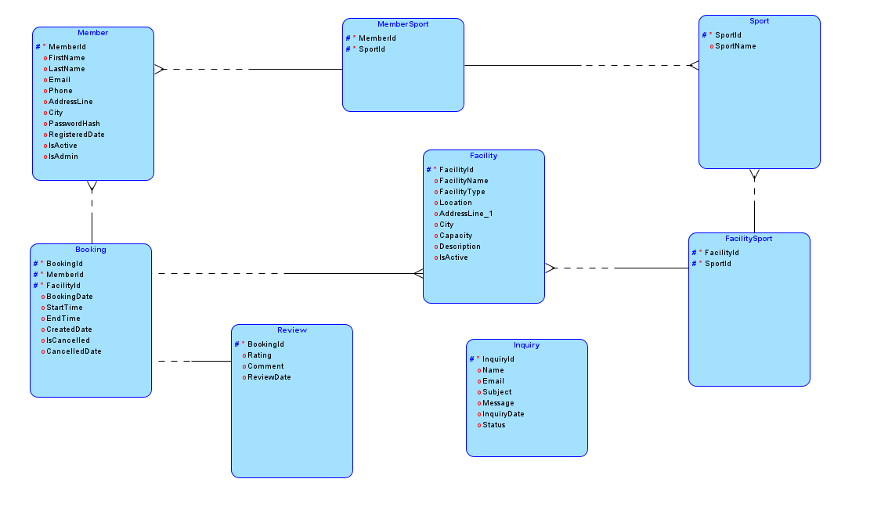
Logical entity-relationship model, produced in Oracle SQL Developer Data Modeler.
The relational (physical) model below shows the same design engineered into tables, columns, data types and keys for the SQL Server RDBMS site.
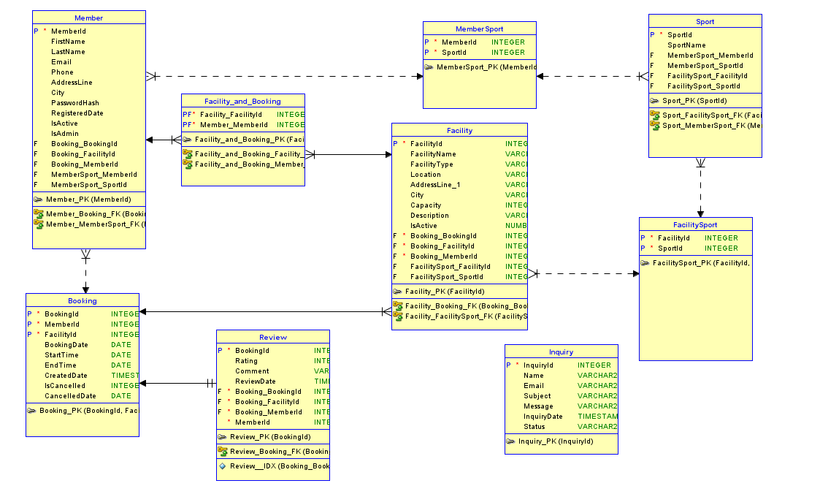
Relational (physical) model, produced in Oracle SQL Developer Data Modeler.

12.2 Table structures

Member
Column | Type | Notes
MemberId | INT, identity | Primary key.
FirstName, LastName | NVARCHAR(50) | Required.
Email | NVARCHAR(256) | Required, unique.
Phone | NVARCHAR(20) | Required.
AddressLine, City | NVARCHAR | Required.
PasswordHash | NVARCHAR(MAX) | Hashed password, never plain text.
RegisteredDate | DATETIME2 | Defaults to the current date and time.
IsActive | BIT | Defaults to 1 (active). Set to 0 to deactivate a member.
IsAdmin | BIT | Defaults to 0. Set to 1 to give administrator rights.

Sport
Column | Type | Notes
SportId | INT, identity | Primary key.
SportName | NVARCHAR(50) | Required, unique (e.g. "Tennis", "Swimming").

MemberSport
Column | Type | Notes
MemberId | INT | Part of the primary key. Foreign key to Member, cascades on delete.
SportId | INT | Part of the primary key. Foreign key to Sport.

Facility
Column | Type | Notes
FacilityId | INT, identity | Primary key.
FacilityName | NVARCHAR(100) | Required.
FacilityType | NVARCHAR(50) | Required (e.g. "Tennis Court", "Sports Hall").
Location | NVARCHAR(100) | Required. Area name used for search.
AddressLine, City | NVARCHAR | Required.
Capacity | INT | Optional.
Description | NVARCHAR(1000) | Optional.
IsActive | BIT | Defaults to 1. Inactive facilities are hidden from search and booking.

FacilitySport
Column | Type | Notes
FacilityId | INT | Part of the primary key. Foreign key to Facility, cascades on delete.
SportId | INT | Part of the primary key. Foreign key to Sport.

Booking
Column | Type | Notes
BookingId | INT, identity | Primary key.
MemberId | INT | Foreign key to Member. Never deleted, to preserve history.
FacilityId | INT | Foreign key to Facility. Never deleted, to preserve history.
BookingDate | DATE | Required. Cannot be in the past (application-enforced).
StartTime, EndTime | TIME | Required. Start must be before End (database constraint).
CreatedDate | DATETIME2 | Defaults to the current date and time.
IsCancelled | BIT | Defaults to 0. Set to 1 when a booking is cancelled.
CancelledDate | DATETIME2, optional | Set when a booking is cancelled.

Review
Column | Type | Notes
BookingId | INT | Primary key and foreign key to Booking. This design means a booking can have at most one review.
Rating | TINYINT | Required, 1 to 5.
Comment | NVARCHAR(1000) | Required.
ReviewDate | DATETIME2 | Defaults to the current date and time.

Inquiry
Column | Type | Notes
InquiryId | INT, identity | Primary key.
Name, Email, Subject, Message | NVARCHAR | Required.
InquiryDate | DATETIME2 | Defaults to the current date and time.
Status | NVARCHAR(20) | Defaults to "New". Must be "New", "Reviewed" or "Closed".

12.3 Design notes
- The Review table's primary key is the same column as its foreign key to Booking (BookingId). This is a deliberate design choice: it guarantees that a booking can never have more than one review, without needing a separate rule to enforce it.
- Review does not store the member or facility directly. Both can always be found by following the booking it belongs to, which avoids storing the same information in two places.
- MemberSport and FacilitySport have no extra column beyond the two foreign keys that make up their primary key. This is a standard way to represent a many-to-many relationship and automatically prevents the same preference or support relationship being saved twice.
- A booking's Member and Facility are never deleted from the database, even if the member is deactivated or the facility is later removed from search, so that booking history is preserved.
- No BookingStatus column exists. Whether a booking is "Completed" is worked out from its date and end time compared to the current time, so it is always accurate and never goes out of date.

12.4 Concurrency and booking safety
Booking two members into the same facility for an overlapping time is prevented using three layers of protection, so that the system is safe even if two people try to book the same slot at exactly the same moment:
- Application check - before saving, the web application checks whether the slot looks free, so the member gets a fast, friendly message if it obviously is not.
- Database lock - the usp_CreateBooking stored procedure takes an exclusive lock for that facility and date before checking availability and inserting the booking, so that two simultaneous requests cannot both pass the check at the same time.
- Database trigger - a trigger on the Booking table checks for overlaps after any insert or update and cancels the change if one is found, as a final safety net that applies no matter how the row was written.

13. External Services and Data Access
This project does not call any third-party web API or external online service. All data is stored in the local SQL Server database described in Section 12.
The one notable piece of server-side logic beyond ordinary Entity Framework Core reads and writes is the usp_CreateBooking stored procedure. Rather than inserting a booking row directly through Entity Framework Core, the application calls this stored procedure using a direct SQL command, so that the database-level locking described in Section 12.3 is always used for every booking, with no way to accidentally bypass it.

14. Testing
Testing was carried out in two ways: an automated test suite that checks the application's code and database behaviour, and manual functional testing of the real, running application through an actual web browser.

14.1 Automated testing
The project includes an xUnit test suite (in tests/CommunitySportsBooking.Tests) with 185 automated tests. These tests run against a real SQL Server database, not a simulated one, so that database constraints and stored procedures are genuinely exercised rather than assumed. The suite covers, among other things: reading and writing all 8 tables, member registration and login (including the administrator sign-in), profile and sports-preference updates, facility search and booking (including overlap rejection and a genuine concurrent-booking test), booking cancellation, review submission, guest inquiries, and every Admin area feature (dashboard, member/sport/facility/booking/inquiry/review management).
The automated suite was run again as part of preparing this document. The result was:
dotnet test: Passed! - Failed: 0, Passed: 185, Skipped: 0, Total: 185.

14.2 Manual functional testing
In addition to the automated suite, the running application was operated directly through a real web browser to check that the finished system actually behaves correctly from a user's point of view, and to capture genuine evidence of that behaviour. This was done using a browser automation tool driving an installed Chrome browser against the application running on http://localhost:5233, connected to the same SQL Server database used for normal development.
42 test cases were carried out this way, covering the Guest, Member and Administrator modules, including normal ("positive") use, invalid input ("negative"/validation) cases, and error-handling and access-control cases. Every test case below was actually executed against the running application; none of the results were assumed or invented. A real screenshot was captured for each test case that produces a visible page result (40 of the 42; the remaining 2 reuse the same redirect mechanism already shown with a screenshot elsewhere and are explained in the notes for that test case).
Two pieces of temporary test data were created specifically to demonstrate certain Admin features (a sport named "Table Tennis" and a facility named "Hillcrest Multi-Sport Hall", used in TC36 and TC38). Both were removed again after their screenshots were captured, so that the reference data used for grading is unchanged from the original sample data. This is noted individually against those two test cases.

15. Test Cases and Results
Each test case below shows the feature being tested, the scenario, what was needed before the test, the exact steps and input used, the expected result, the actual result observed when the test was run, its pass/fail status, and a reference to the supporting screenshot.

15.1 Guest Module

TC01 - Home page loads and shows facility and sport information
Test Case ID | TC01
Feature / Module | Home Page (Guest)
Test Scenario | Home page loads and shows facility and sport information
Preconditions | The application is running. The user has not logged in (Guest).
Test Steps | 1. Open the application in a web browser.  2. Observe the home page content.
Test Input / Data | None (navigate to the home page URL).
Expected Result | The home page loads successfully and shows a welcome banner, a "Popular Sports" section, and a "Featured Facilities" section with the number of active facilities.
Actual Result | Home page rendered with Popular Sports and Featured Facilities sections.
Test Status | Pass
Evidence | Screenshot: TC01_Home_Page.png
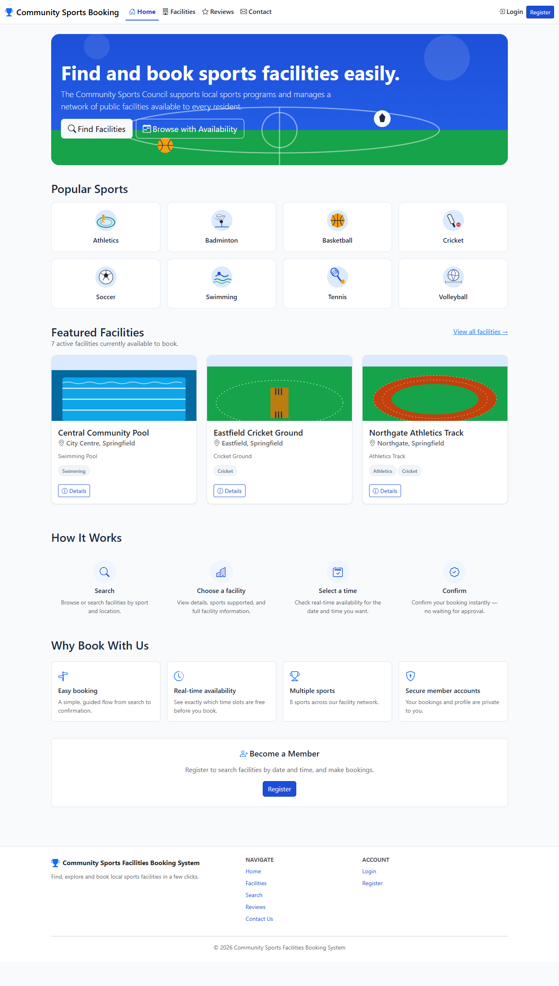
Home page showing popular sports and featured facilities for a guest visitor.

TC02 - Guest browses the list of active facilities
Test Case ID | TC02
Feature / Module | Facility Browsing (Guest)
Test Scenario | Guest browses the list of active facilities
Preconditions | The application is running. The user has not logged in (Guest).
Test Steps | 1. Click "Facilities" in the navigation bar.  2. Review the list of facilities shown.
Test Input / Data | None.
Expected Result | Only active facilities are listed. The inactive facility ("Old Mill Badminton Courts") must not appear.
Actual Result | Active facilities listed; inactive "Old Mill Badminton Courts" correctly excluded.
Test Status | Pass
Evidence | Screenshot: TC02_Guest_Facility_Browse.png
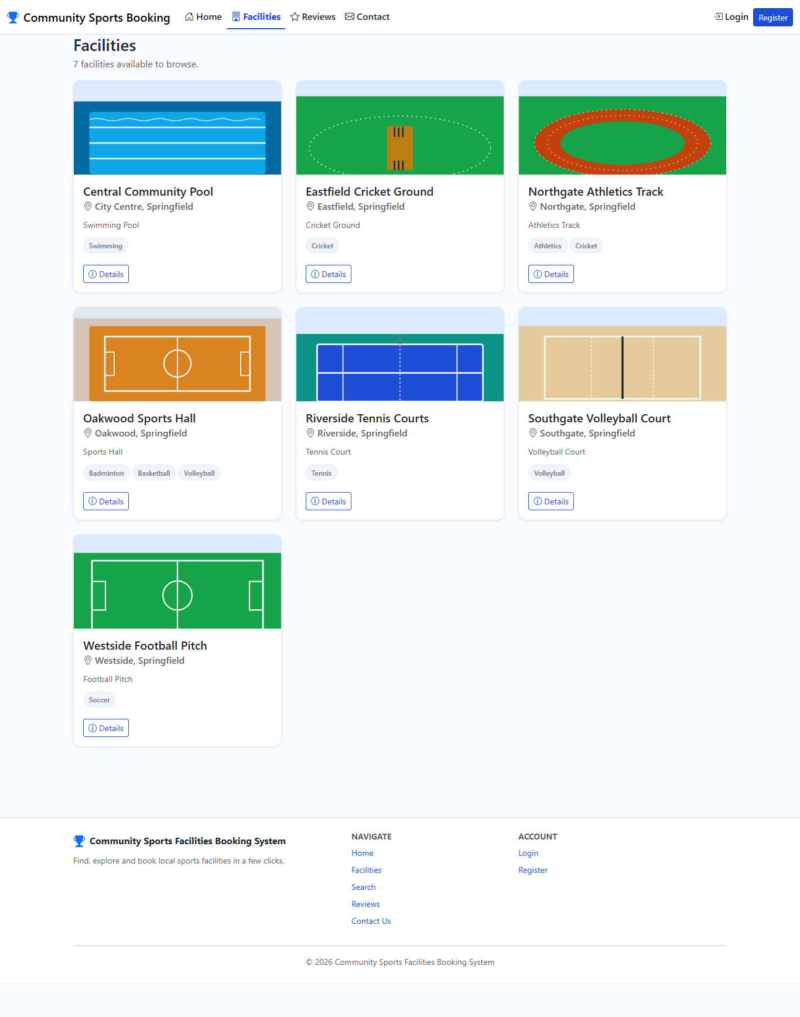
Facility list page showing only active facilities.

TC03 - Guest views a facility details page
Test Case ID | TC03
Feature / Module | Facility Details (Guest)
Test Scenario | Guest views a facility details page
Preconditions | The application is running. The user has not logged in (Guest).
Test Steps | 1. Open the "Riverside Tennis Courts" facility from the facility list.  2. Review the details page.
Test Input / Data | FacilityId = 1 (Riverside Tennis Courts).
Expected Result | The page shows facility information and existing reviews. Because the visitor is not logged in, a "Sign in to Book" button is shown instead of a booking button.
Actual Result | Facility details rendered with "Sign in to Book" prompt and Reviews section.
Test Status | Pass
Evidence | Screenshot: TC03_Guest_Facility_Details.png
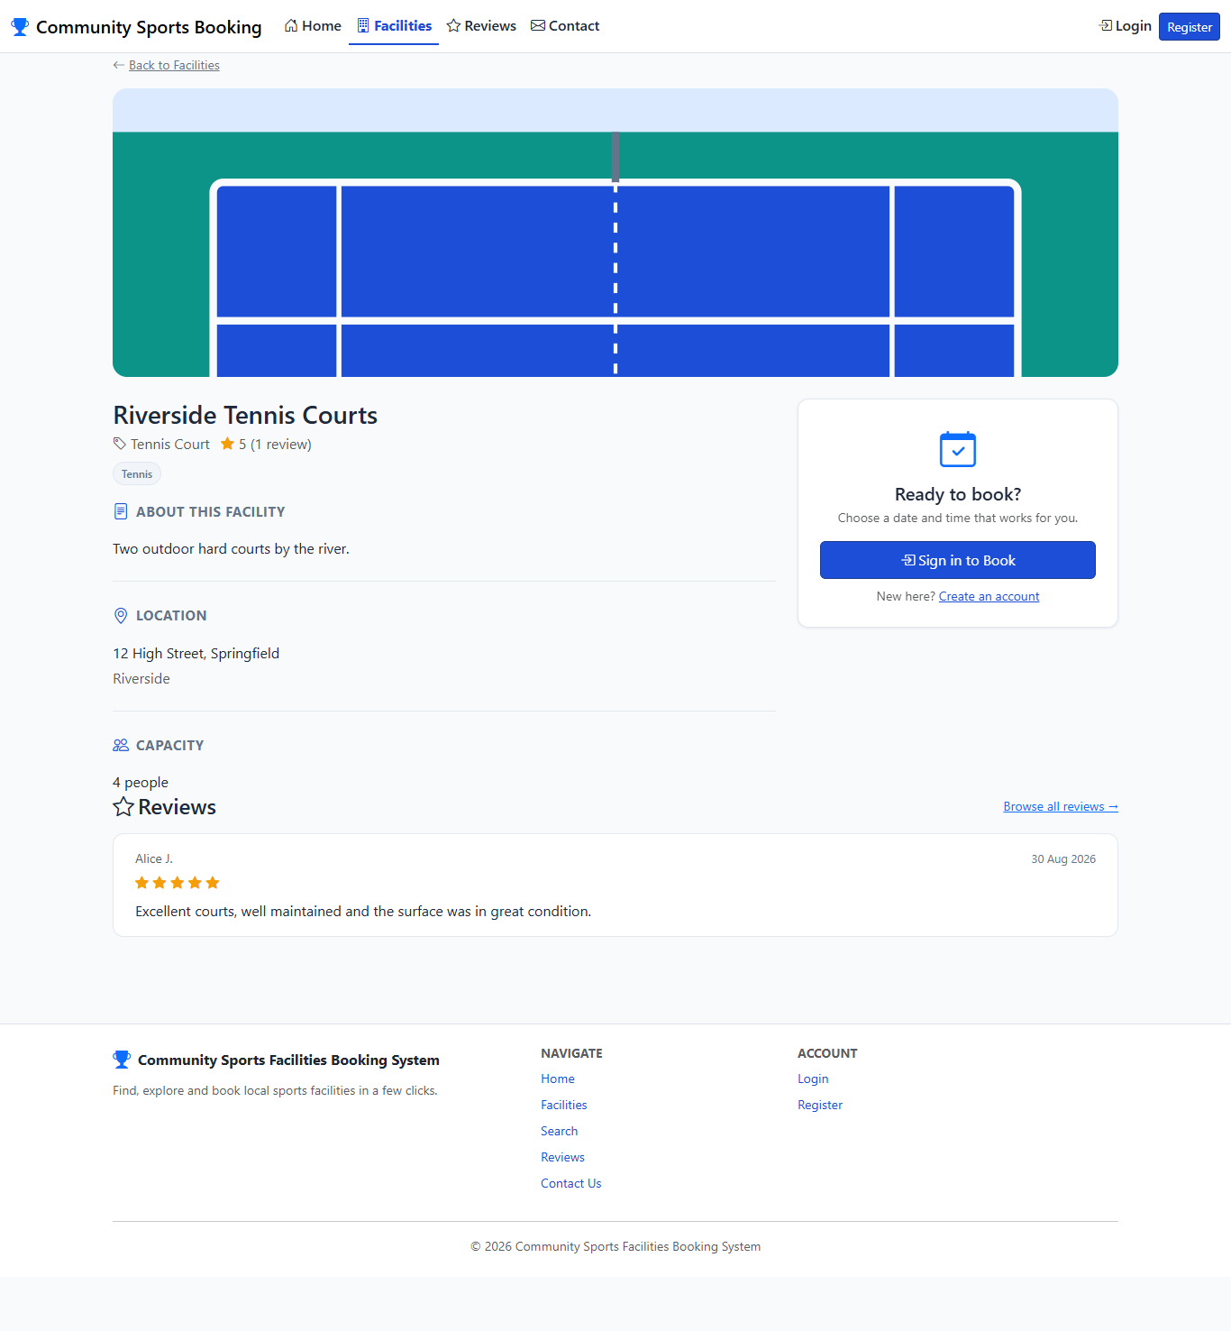
Facility details page for a guest, with reviews visible and a sign-in prompt instead of a booking button.

TC04 - Guest performs a restricted facility search (no date or time)
Test Case ID | TC04
Feature / Module | Restricted Search (Guest)
Test Scenario | Guest performs a restricted facility search (no date or time)
Preconditions | The application is running. The user has not logged in (Guest).
Test Steps | 1. Open the Search Facilities page.  2. Confirm that no date or time fields are shown.  3. Enter "Tennis" in the search box and submit the search.
Test Input / Data | Facility type / sport = "Tennis".
Expected Result | The search form does not show date or time fields for a guest. The search returns "Riverside Tennis Courts" as a match.
Actual Result | Date/time fields absent (found 0); search for "Tennis" returned matching facility.
Test Status | Pass
Evidence | Screenshot: TC04_Guest_Restricted_Search.png
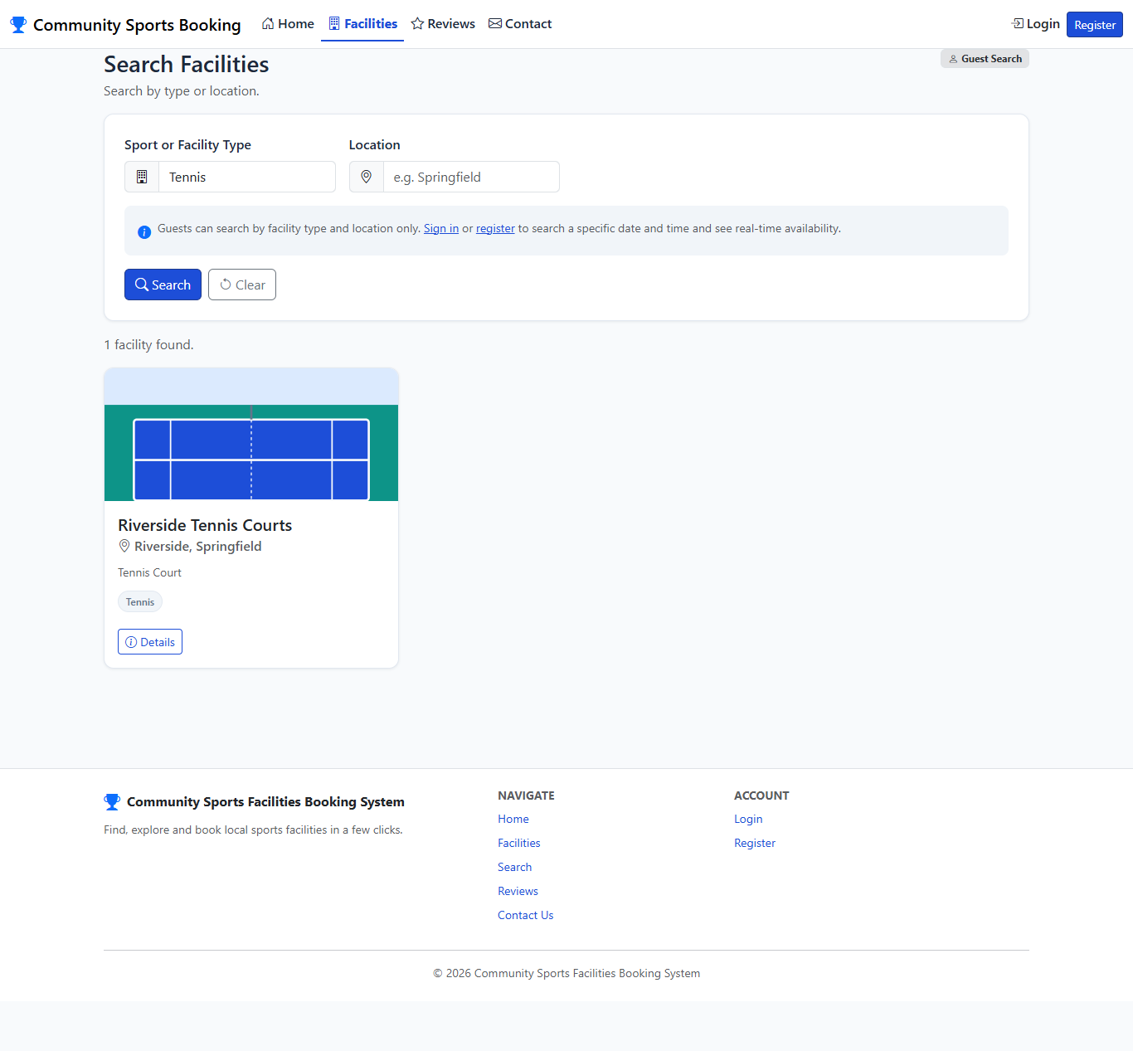
Guest search form with only type and location fields, showing a matching result.

TC05 - Guest searches facility reviews without logging in
Test Case ID | TC05
Feature / Module | Review Search (Guest)
Test Scenario | Guest searches facility reviews without logging in
Preconditions | The application is running. The user has not logged in (Guest).
Test Steps | 1. Open the Reviews page.  2. Enter "Riverside" as the facility name and submit.
Test Input / Data | Facility name = "Riverside".
Expected Result | Reviews for "Riverside Tennis Courts" are displayed without requiring the visitor to log in.
Actual Result | Review(s) for "Riverside Tennis Courts" returned without requiring authentication.
Test Status | Pass
Evidence | Screenshot: TC05_Guest_Review_Search.png
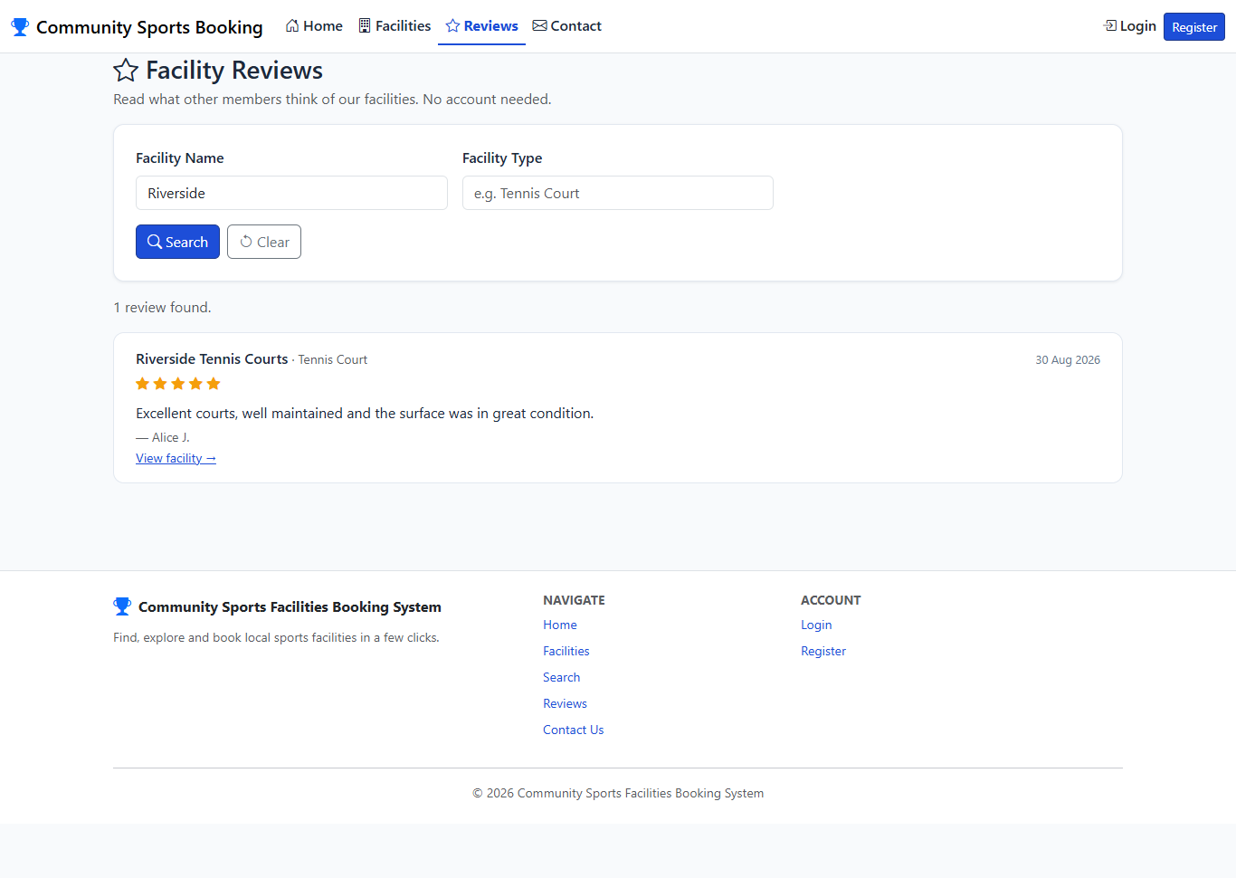
Guest review search results for Riverside Tennis Courts.

TC06 - Guest is blocked from the booking page and redirected to Login
Test Case ID | TC06
Feature / Module | Access Control (Guest)
Test Scenario | Guest is blocked from the booking page and redirected to Login
Preconditions | The application is running. The user has not logged in (Guest).
Test Steps | 1. Try to open the booking page directly (Book Facility, FacilityId = 1) without logging in.
Test Input / Data | URL: /Booking/Create?facilityId=1
Expected Result | The request is redirected to the Login page, with a ReturnUrl pointing back to the booking page so the user returns there after logging in.
Actual Result | Final URL: http://localhost:5233/Account/Login?ReturnUrl=%2FBooking%2FCreate%3FfacilityId%3D1
Test Status | Pass
Evidence | Screenshot: TC06_Guest_Blocked_From_Booking.png
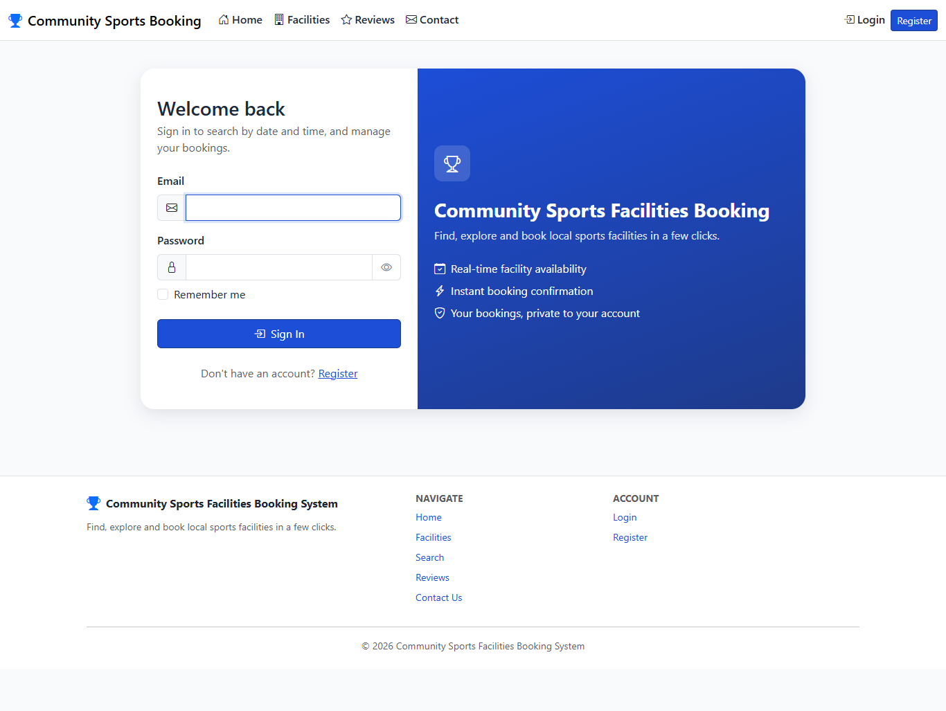
Guest redirected to the Login page after attempting to book a facility directly.

TC07 - Guest is blocked from Profile and My Bookings pages
Test Case ID | TC07
Feature / Module | Access Control (Guest)
Test Scenario | Guest is blocked from Profile and My Bookings pages
Preconditions | The application is running. The user has not logged in (Guest).
Test Steps | 1. Try to open the Profile page (/Profile) directly.  2. Try to open the My Bookings page (/Booking/MyBookings) directly.
Test Input / Data | URLs: /Profile and /Booking/MyBookings
Expected Result | Both pages redirect an unauthenticated visitor to the Login page.
Actual Result | /Profile blocked: true; /Booking/MyBookings blocked: true.
Test Status | Pass
Evidence | No screenshot taken. This check uses the same login-redirect mechanism already shown with a screenshot in TC06, so a second image was not needed.
Note: No screenshot taken. This check uses the same login-redirect mechanism already shown with a screenshot in TC06, so a second image was not needed.

TC08 - Guest submits a contact inquiry successfully
Test Case ID | TC08
Feature / Module | Inquiry (Guest)
Test Scenario | Guest submits a contact inquiry successfully
Preconditions | The application is running. The user has not logged in (Guest).
Test Steps | 1. Open the Contact Us page.  2. Fill in Name, Email, Subject and Message.  3. Submit the form.
Test Input / Data | Name = "Nadia Perera", Email = "nadia.perera.test@example.com", Subject = "Question about membership fees", Message = "Hello, could you tell me if there is an annual membership fee...".
Expected Result | A confirmation message is shown and the inquiry is saved with Status = "New".
Actual Result | Success confirmation message displayed.
Test Status | Pass
Evidence | Screenshot: TC08_Guest_Inquiry_Success.png
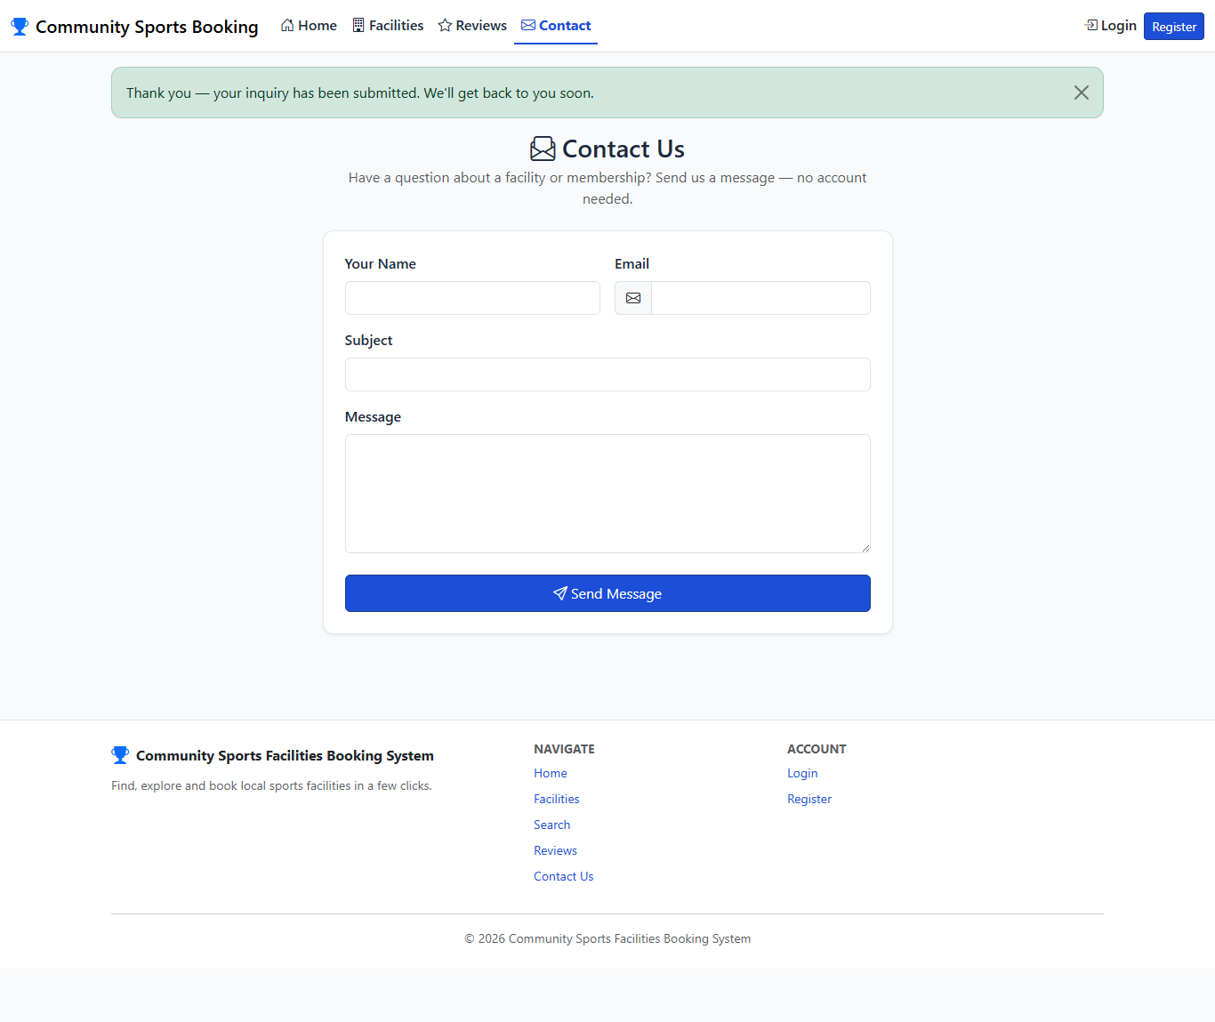
Confirmation message shown after a guest successfully submits an inquiry.

TC09 - Inquiry form rejects an empty submission
Test Case ID | TC09
Feature / Module | Inquiry (Guest)
Test Scenario | Inquiry form rejects an empty submission
Preconditions | The application is running. The user has not logged in (Guest).
Test Steps | 1. Open the Contact Us page.  2. Leave all fields empty.  3. Click "Send Message".
Test Input / Data | Name, Email, Subject and Message all left blank.
Expected Result | The form is not submitted. Required-field validation messages are shown for each field.
Actual Result | Required-field validation messages displayed; no record created.
Test Status | Pass
Evidence | Screenshot: TC09_Guest_Inquiry_Validation.png
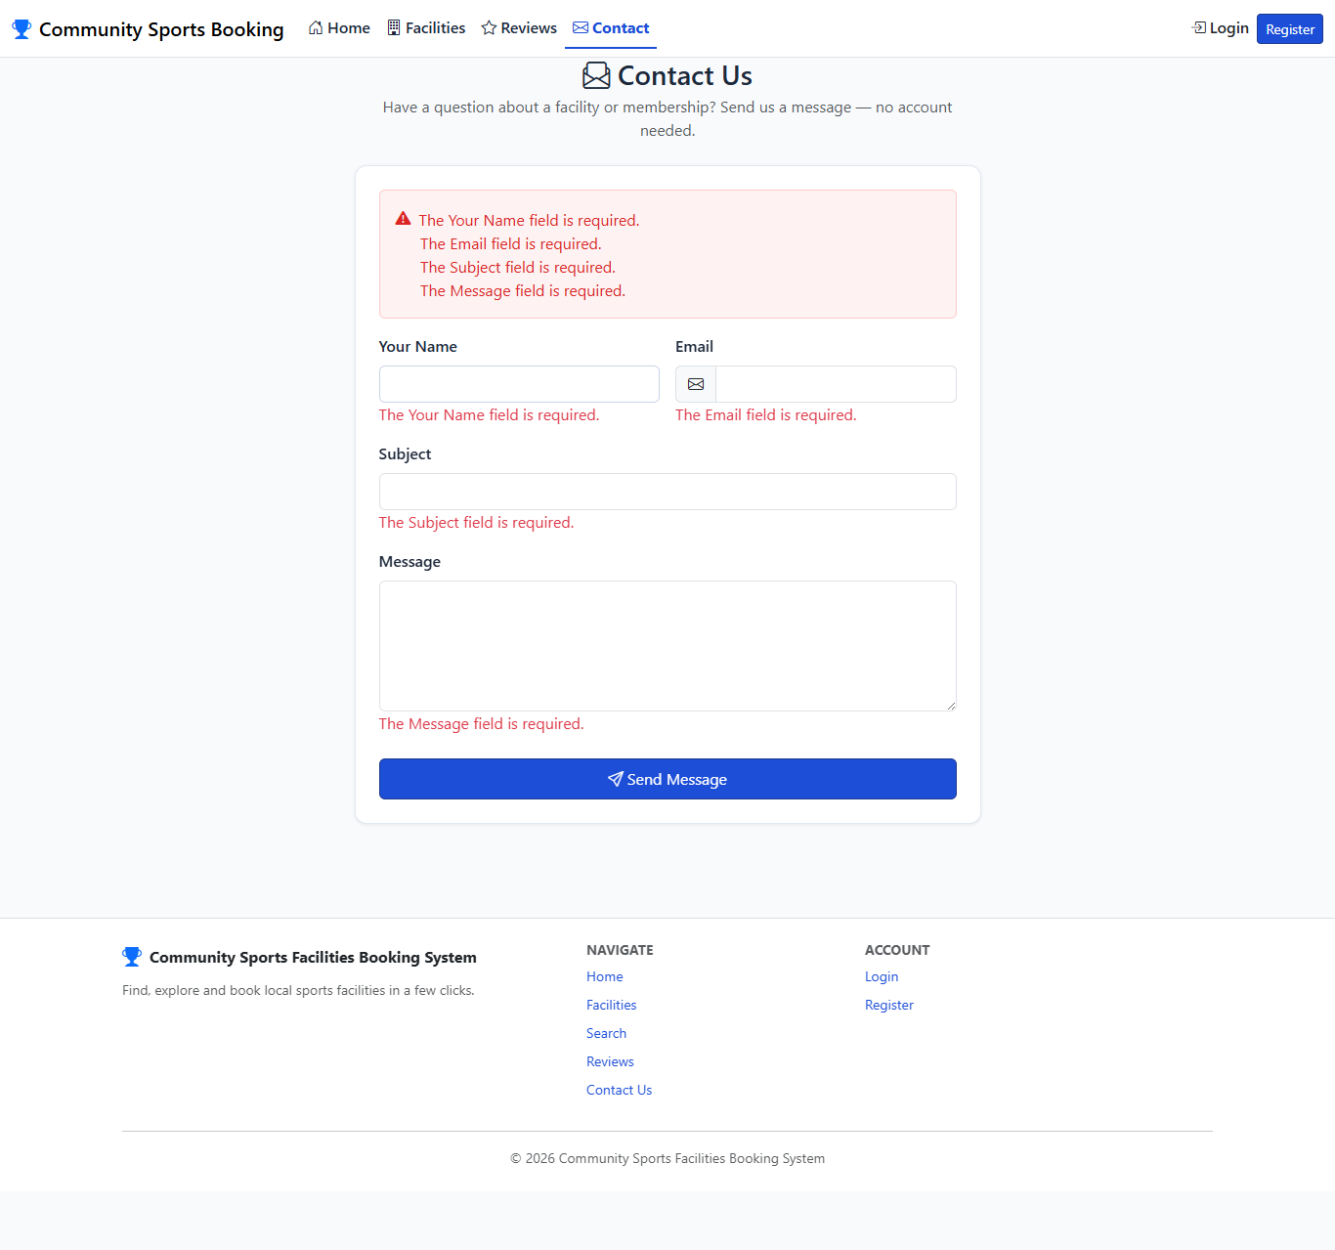
Validation messages shown when the inquiry form is submitted empty.

TC10 - Registration is rejected for an email already in use
Test Case ID | TC10
Feature / Module | Registration (Guest)
Test Scenario | Registration is rejected for an email already in use
Preconditions | The application is running. The user has not logged in (Guest).
Test Steps | 1. Open the Register page.  2. Fill in the form using an email address that already belongs to an existing member (alice.johnson@example.com).  3. Submit the form.
Test Input / Data | Email = "alice.johnson@example.com" (already registered), all other fields valid.
Expected Result | The registration is rejected with the message "This email is already registered." No new account is created.
Actual Result | Error "This email is already registered." displayed.
Test Status | Pass
Evidence | Screenshot: TC10_Registration_Duplicate_Email.png
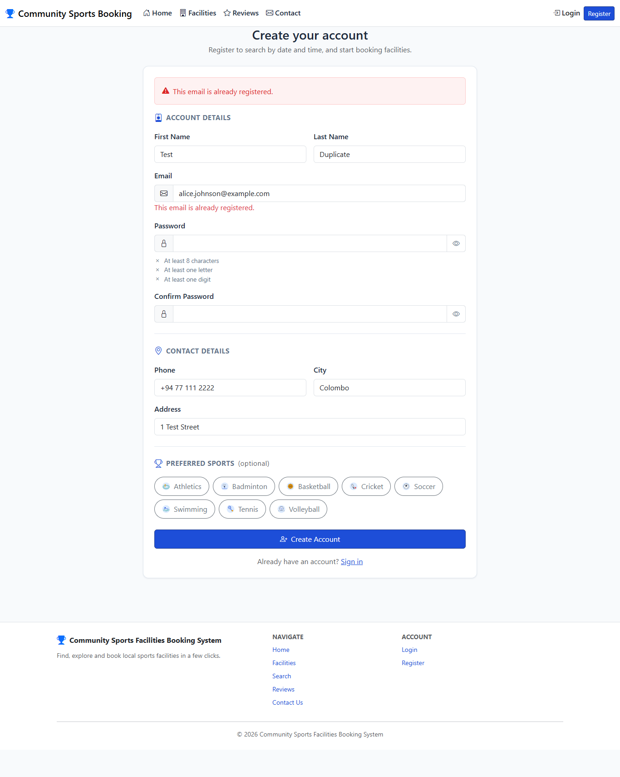
Registration form showing the duplicate-email error.

TC11 - Registration is rejected for a weak password and mismatched confirmation
Test Case ID | TC11
Feature / Module | Registration (Guest)
Test Scenario | Registration is rejected for a weak password and mismatched confirmation
Preconditions | The application is running. The user has not logged in (Guest).
Test Steps | 1. Open the Register page.  2. Fill in the form using Password = "abc" and Confirm Password = "xyz".  3. Submit the form.
Test Input / Data | Password = "abc", Confirm Password = "xyz".
Expected Result | The form is rejected. Validation messages are shown for the password (too short / must contain a letter and a digit) and for the mismatched confirmation.
Actual Result | 2 field-level validation message(s) displayed ("Password must contain at least one letter and one digit.", "Passwords do not match.").
Test Status | Pass
Evidence | Screenshot: TC11_Registration_Weak_Password_Mismatch.png
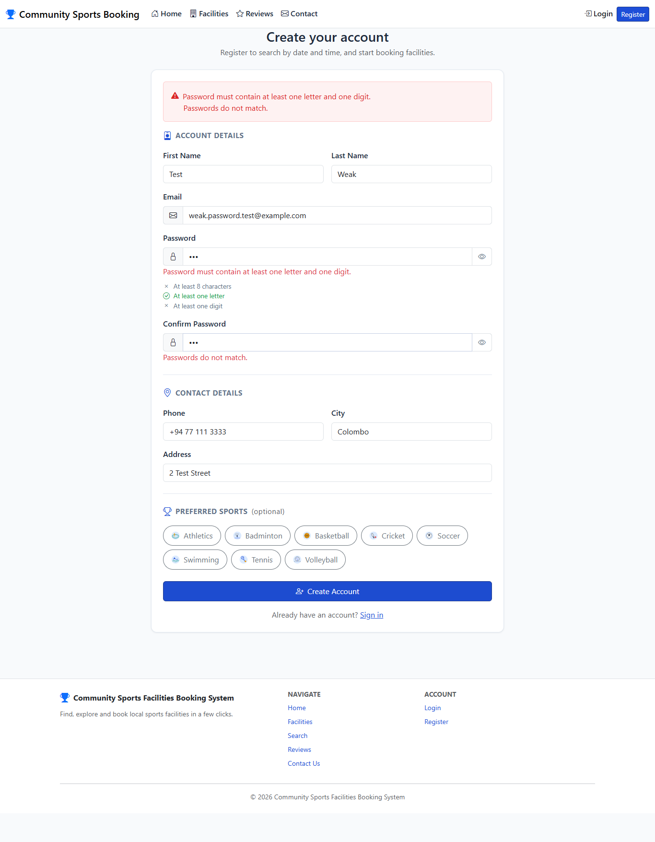
Registration form showing password strength and confirm-password validation errors, with the live password requirement checklist.

TC12 - Guest registers successfully as a new member
Test Case ID | TC12
Feature / Module | Registration (Guest)
Test Scenario | Guest registers successfully as a new member
Preconditions | The application is running. The user has not logged in (Guest).
Test Steps | 1. Open the Register page.  2. Fill in valid personal details and a valid password.  3. Select preferred sports (Tennis and Swimming).  4. Submit the form.
Test Input / Data | First Name = "Nadia", Last Name = "Perera", Email = "nadia.perera.test@example.com", Phone = "+94 71 234 5678", Address = "12 Lake Road", City = "Colombo", Password = "Test@1234", Preferred Sports = Tennis, Swimming.
Expected Result | The account is created, the member is automatically signed in, and the browser is redirected to the home page.
Actual Result | Redirected to http://localhost:5233/ after successful registration.
Test Status | Pass
Evidence | Screenshot: TC12_Registration_Success.png
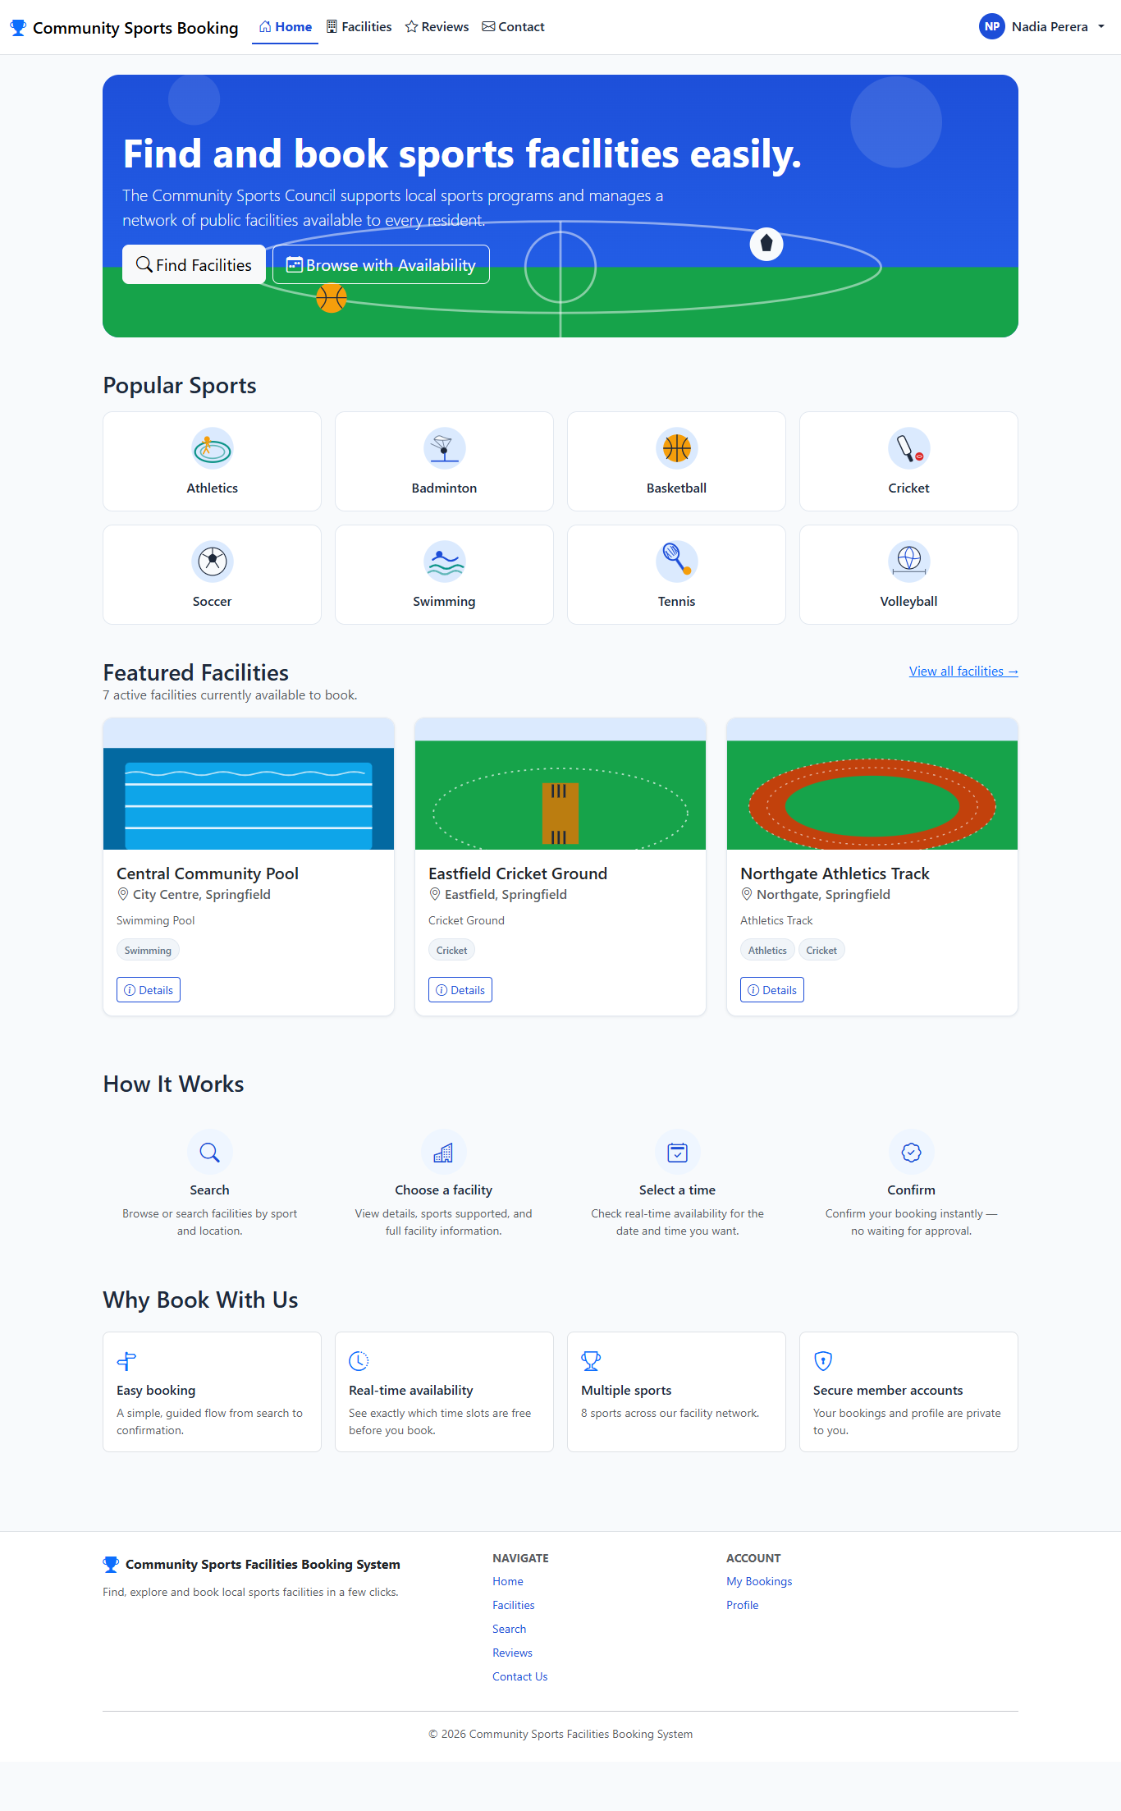
Home page shown immediately after a successful registration, with the new member signed in.

15.2 Member Module

TC13 - Registered member logs in with correct credentials
Test Case ID | TC13
Feature / Module | Login (Member)
Test Scenario | Registered member logs in with correct credentials
Preconditions | The application is running. The member account from TC12 already exists.
Test Steps | 1. Open the Login page.  2. Enter the correct email and password.  3. Submit the form.
Test Input / Data | Email = "nadia.perera.test@example.com", Password = "Test@1234".
Expected Result | Login succeeds. The user is redirected to the home page and the navigation bar shows the member's name.
Actual Result | Redirected to http://localhost:5233/; nav shows signed-in member name.
Test Status | Pass
Evidence | Screenshot: TC13_Member_Login_Success.png

Home page after a successful member login, with the member's name shown in the navigation bar.

TC14 - Login is rejected for a valid email with the wrong password
Test Case ID | TC14
Feature / Module | Login (Member)
Test Scenario | Login is rejected for a valid email with the wrong password
Preconditions | The application is running. The member account from TC12 already exists.
Test Steps | 1. Open the Login page.  2. Enter the correct email but an incorrect password.  3. Submit the form.
Test Input / Data | Email = "nadia.perera.test@example.com", Password = "WrongPassword1".
Expected Result | Login is rejected with a generic message ("Invalid email or password.") that does not reveal whether the email or the password was wrong.
Actual Result | Generic "Invalid email or password." message shown.
Test Status | Pass
Evidence | Screenshot: TC14_Member_Login_Wrong_Password.png
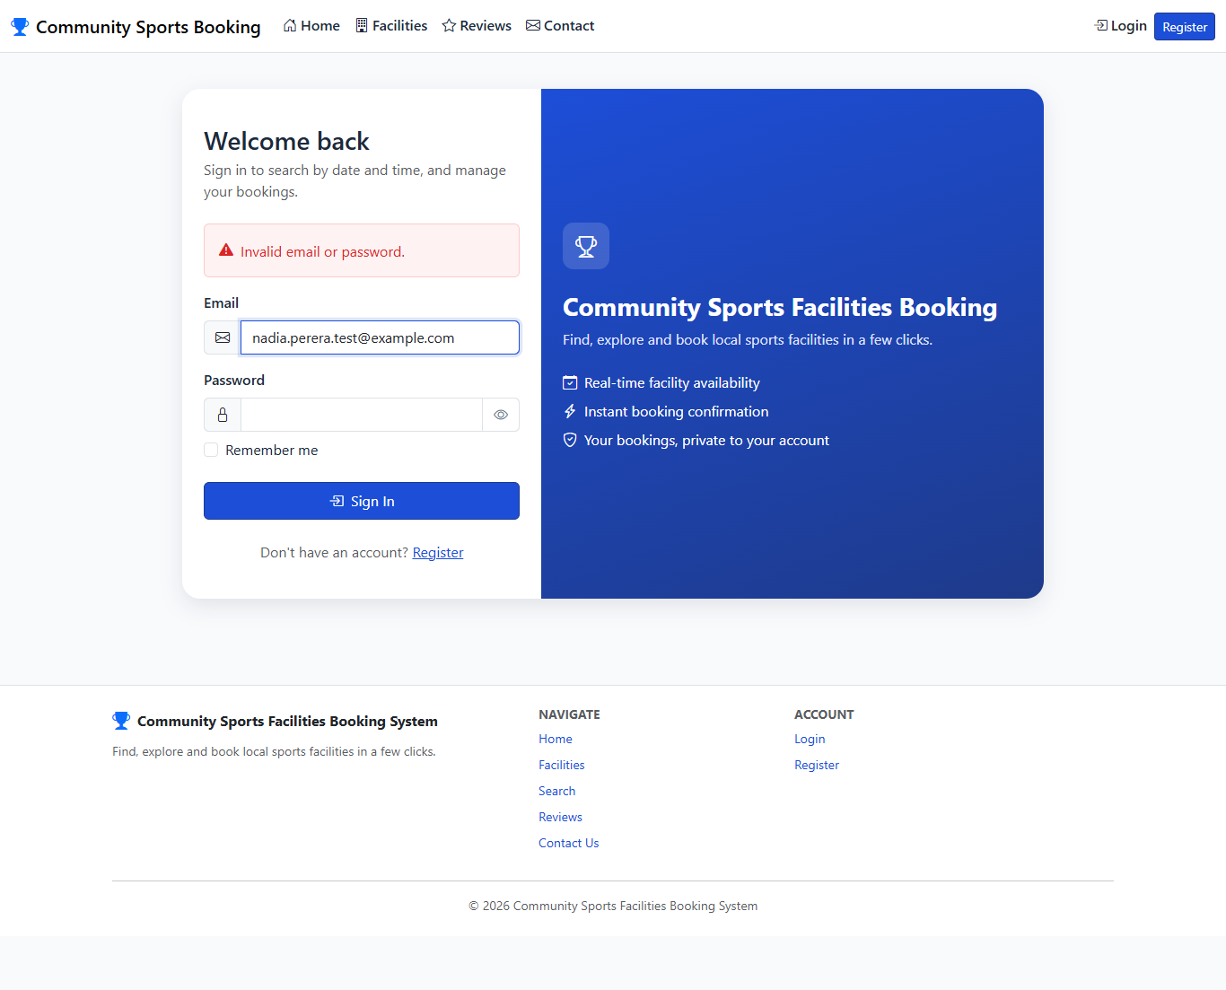
Login page showing the generic invalid-credentials error.

TC15 - Account is temporarily locked out after repeated failed logins
Test Case ID | TC15
Feature / Module | Login (Member)
Test Scenario | Account is temporarily locked out after repeated failed logins
Preconditions | The application is running. A non-existent email address is used, to show that lockout applies equally whether or not the email belongs to a real account.
Test Steps | 1. Submit the login form with the wrong password 6 times in a row, using the same email address.
Test Input / Data | Email = "lockout.demo.test@example.com", Password = "WrongPassword1" (submitted 6 times).
Expected Result | After 5 failed attempts the account is temporarily locked. The 6th attempt shows "Too many failed login attempts. Please try again in a few minutes." instead of the normal invalid-credentials message.
Actual Result | Lockout message shown starting on the 6th attempt (the 5th failed attempt reaches the internal threshold but still shows the generic error; the following attempt is blocked before credentials are even checked).
Test Status | Pass
Evidence | Screenshot: TC15_Member_Login_Lockout.png
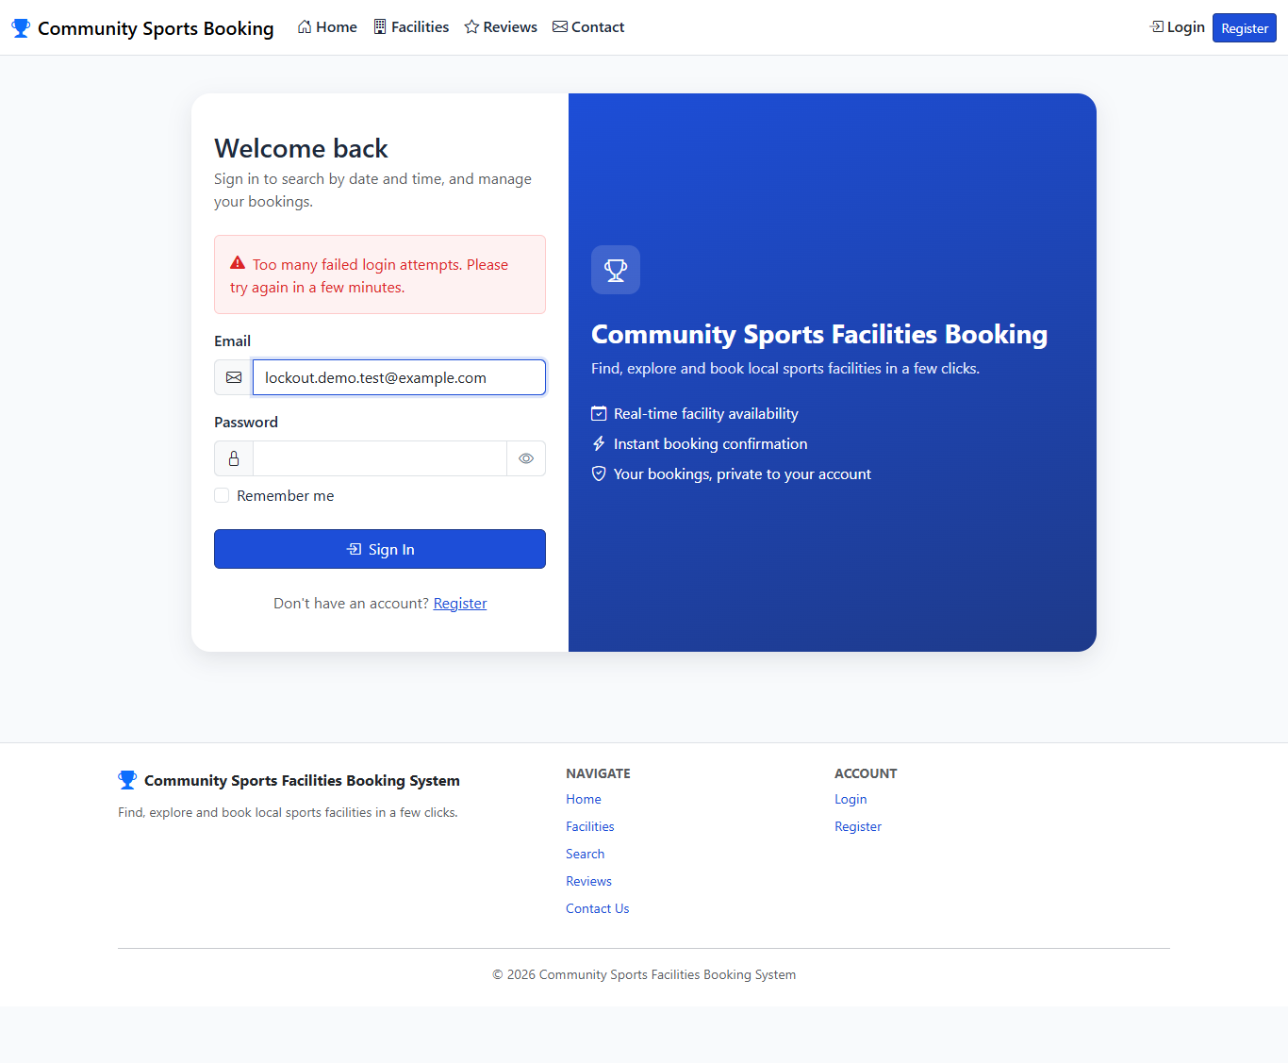
Login page showing the temporary lockout message after repeated failed attempts.

TC16 - Member views their own profile
Test Case ID | TC16
Feature / Module | Profile (Member)
Test Scenario | Member views their own profile
Preconditions | The application is running. The user is logged in as a Member.
Test Steps | 1. Open the Profile page.
Test Input / Data | None.
Expected Result | The page shows the member's personal details, their email address as read-only, and their preferred sports.
Actual Result | Profile shows correct email (read-only) and preferred sports.
Test Status | Pass
Evidence | Screenshot: TC16_Member_Profile_View.png
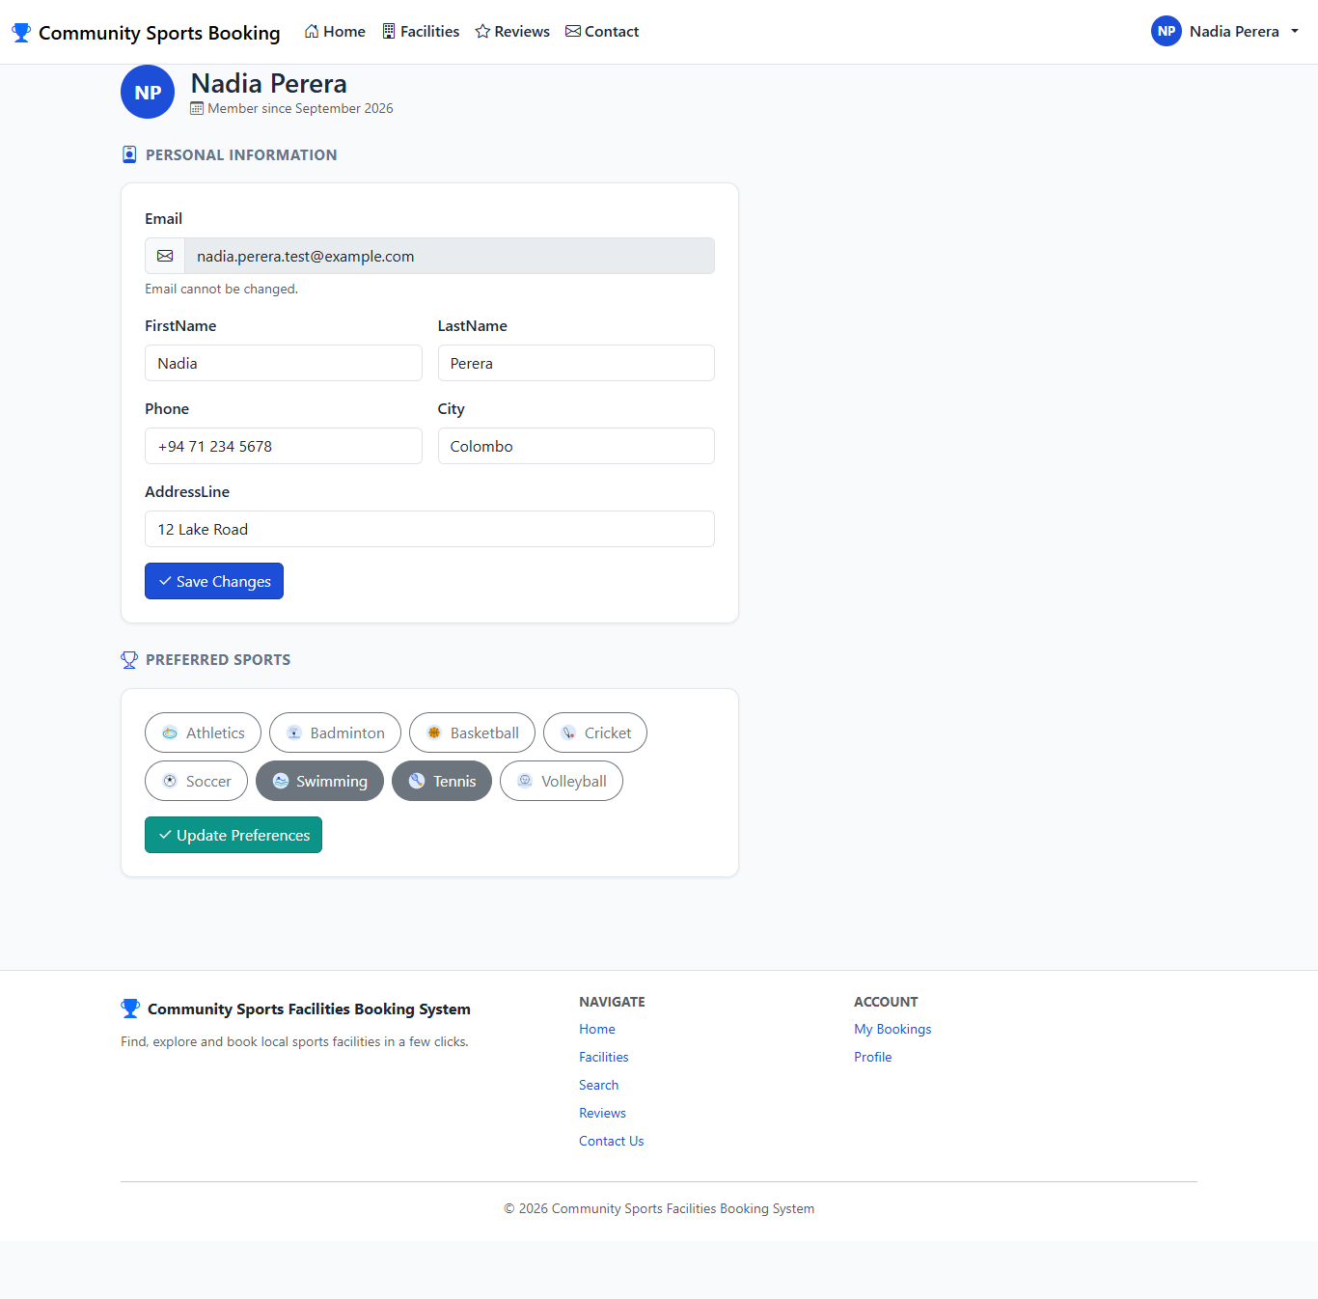
Member profile page showing personal details and preferred sports.

TC17 - Member updates their personal information
Test Case ID | TC17
Feature / Module | Profile (Member)
Test Scenario | Member updates their personal information
Preconditions | The application is running. The user is logged in as a Member.
Test Steps | 1. Open the Profile page.  2. Change the phone number and address.  3. Click "Save Changes".
Test Input / Data | Phone = "+94 71 999 8888", Address = "45 Galle Road", City = "Colombo".
Expected Result | The updated details are saved and shown back on the profile page. The email address cannot be changed.
Actual Result | Updated address and phone number now shown on profile.
Test Status | Pass
Evidence | Screenshot: TC17_Member_Profile_Edit_Success.png
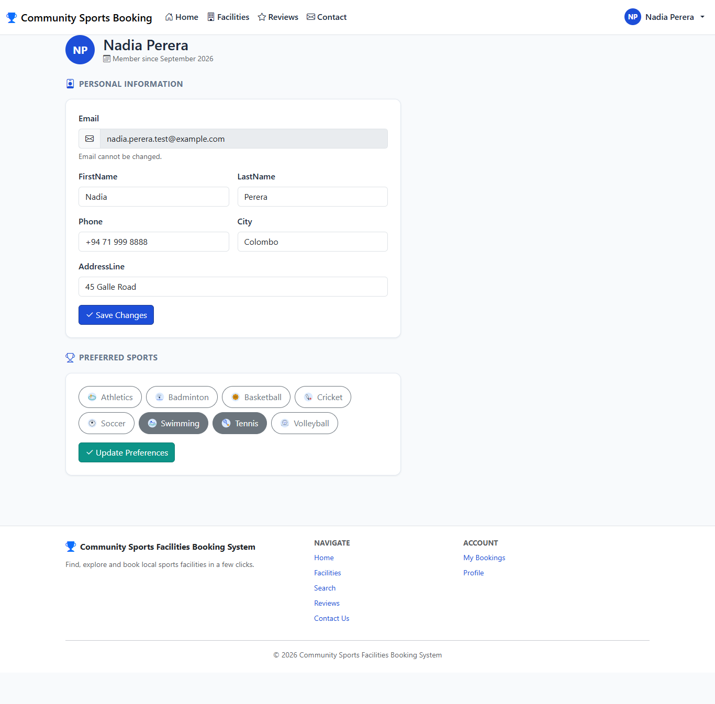
Profile page showing the updated address and phone number after saving.

TC18 - Profile update is rejected for an invalid phone number
Test Case ID | TC18
Feature / Module | Profile (Member)
Test Scenario | Profile update is rejected for an invalid phone number
Preconditions | The application is running. The user is logged in as a Member.
Test Steps | 1. Open the Profile page.  2. Enter an invalid phone number containing letters and symbols.  3. Click "Save Changes".
Test Input / Data | Phone = "not-a-phone-###".
Expected Result | The update is rejected with a validation message explaining that the phone number may only contain digits, spaces, +, - and parentheses. The invalid value is not saved.
Actual Result | 2 field validation message(s) displayed; invalid value not saved.
Test Status | Pass
Evidence | Screenshot: TC18_Member_Profile_Validation.png
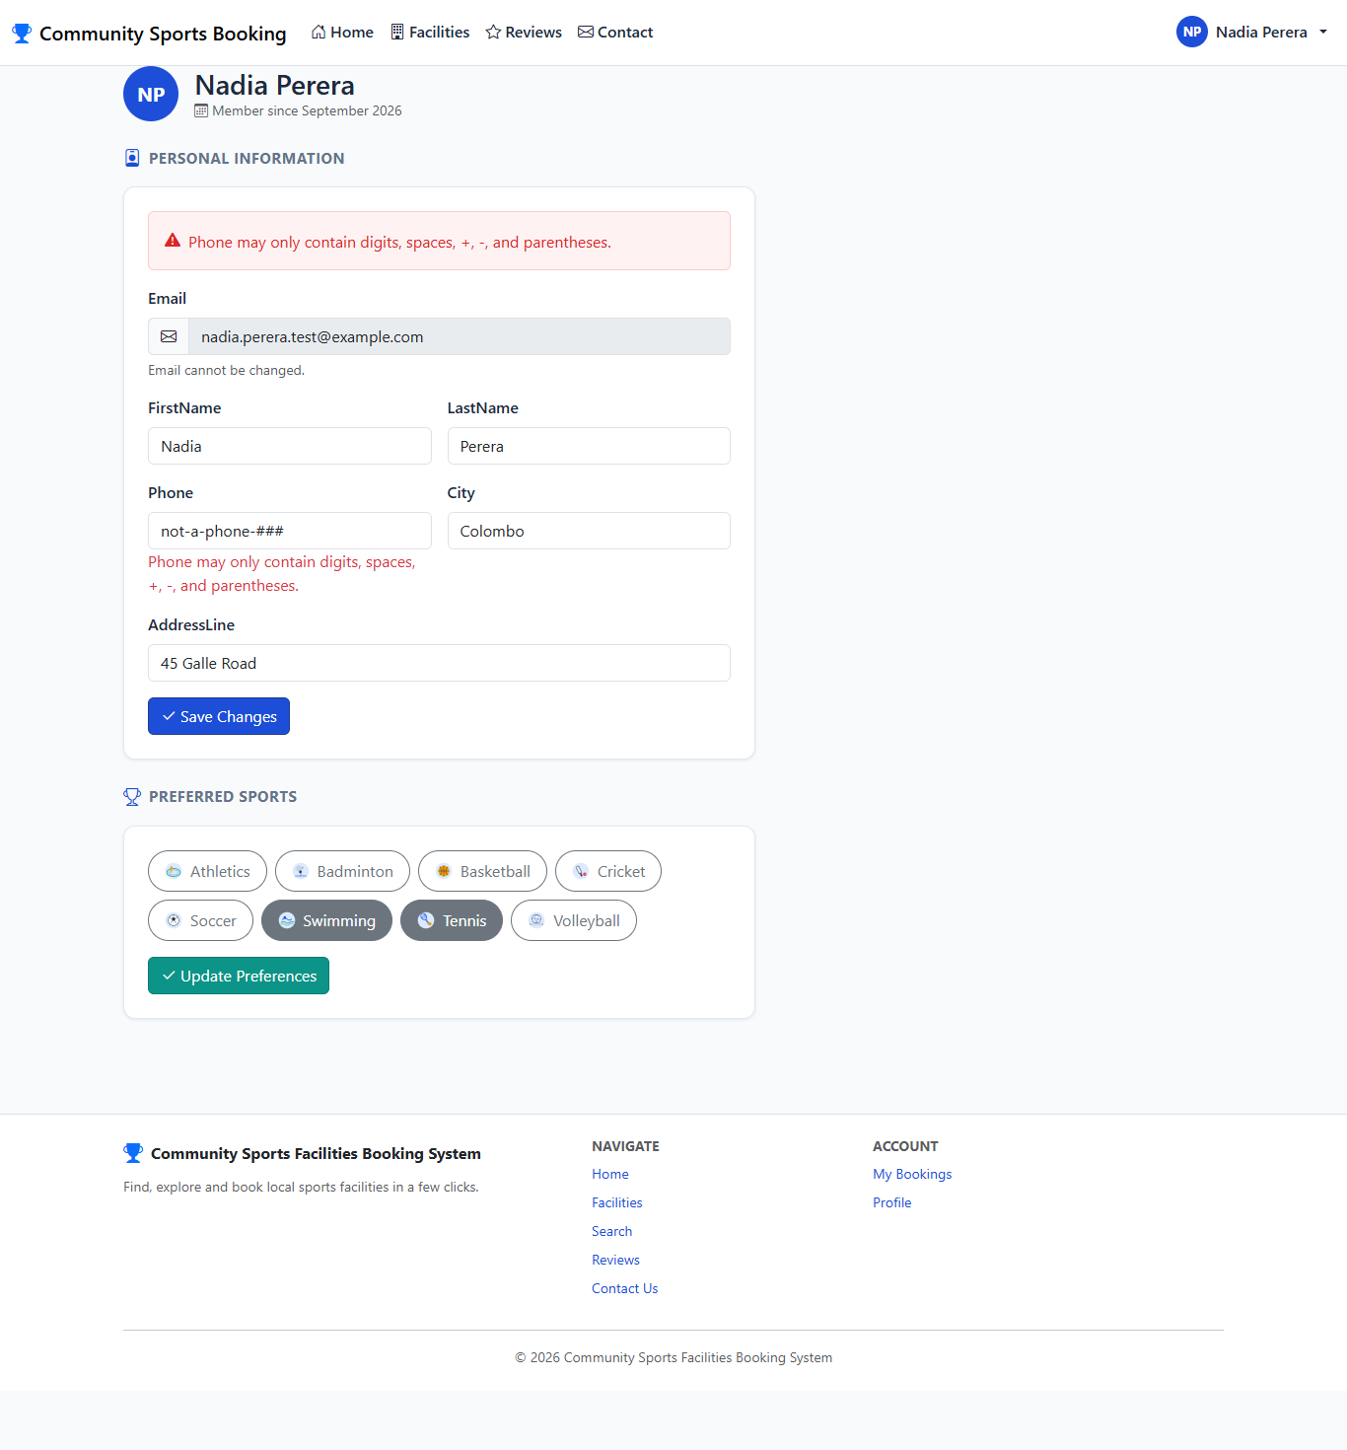
Profile page showing the phone number validation error.

TC19 - Member adds an additional preferred sport
Test Case ID | TC19
Feature / Module | Sports Preferences (Member)
Test Scenario | Member adds an additional preferred sport
Preconditions | The application is running. The user is logged in as a Member.
Test Steps | 1. Open the Profile page.  2. Select "Basketball" in the Preferred Sports section, in addition to the sports already selected.  3. Click "Update Preferences".
Test Input / Data | Selected sports = Tennis, Swimming, Basketball.
Expected Result | The preference list is saved. Basketball is now shown as selected alongside the previous sports.
Actual Result | Basketball now shown among preferred sports.
Test Status | Pass
Evidence | Screenshot: TC19_Member_Sports_Preferences_Updated.png
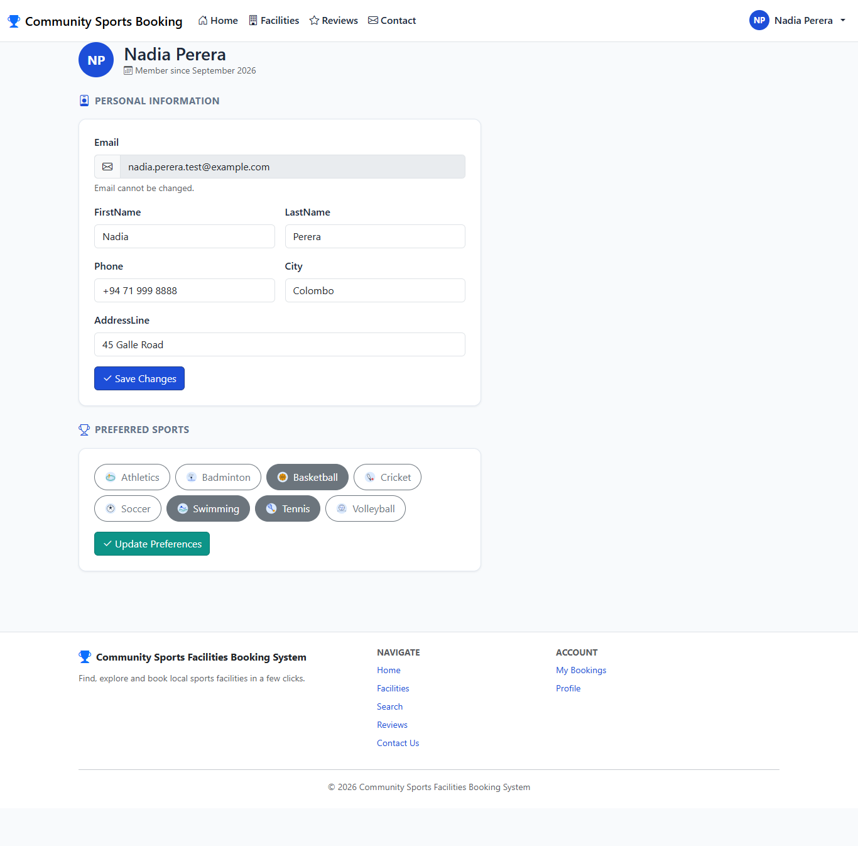
Profile page showing Basketball added to the member's preferred sports.

TC20 - Signed-in member searches with a specific date and time window
Test Case ID | TC20
Feature / Module | Facility Search (Member)
Test Scenario | Signed-in member searches with a specific date and time window
Preconditions | The application is running. The user is logged in as a Member.
Test Steps | 1. Open the Search Facilities page.  2. Confirm that date and time fields are shown (unlike the guest search).  3. Enter "Tennis" and a future date/time window.  4. Submit the search.
Test Input / Data | Facility type = "Tennis", Date = 16 Sep 2026, Start = 09:00, End = 10:00.
Expected Result | The date and time fields are available to a signed-in member. The matching facility is returned, annotated with real-time availability for the requested window.
Actual Result | Date/Time fields present for a member; matching facility returned with availability annotation.
Test Status | Pass
Evidence | Screenshot: TC20_Member_Search_With_Availability.png
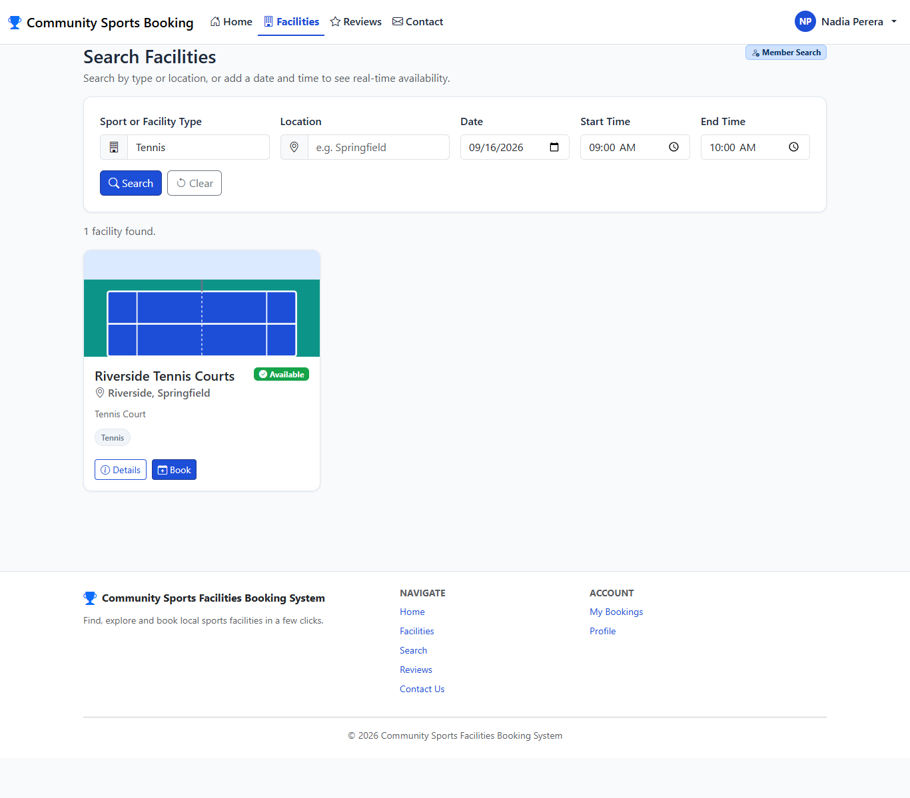
Member search results showing availability for the requested date and time.

TC21 - Member books an available facility
Test Case ID | TC21
Feature / Module | Booking (Member)
Test Scenario | Member books an available facility
Preconditions | The application is running. The user is logged in as a Member.
Test Steps | 1. Open the booking page for "Riverside Tennis Courts".  2. Enter a future date and time.  3. Click "Confirm Booking".
Test Input / Data | Facility = Riverside Tennis Courts, Date = 16 Sep 2026, Start = 09:00, End = 10:00.
Expected Result | The booking is created successfully. The user is redirected to My Bookings, where the new booking appears under "Upcoming".
Actual Result | Redirected to My Bookings; new booking visible under Upcoming.
Test Status | Pass
Evidence | Screenshot: TC21_Member_Booking_Created.png
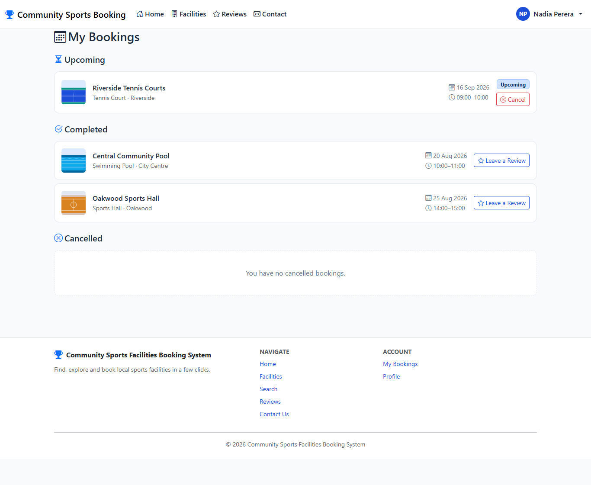
My Bookings page showing the newly created upcoming booking.

TC22 - Booking form rejects a past date
Test Case ID | TC22
Feature / Module | Booking Validation (Member)
Test Scenario | Booking form rejects a past date
Preconditions | The application is running. The user is logged in as a Member.
Test Steps | 1. Open the booking page for "Riverside Tennis Courts".  2. Try to enter a date that has already passed.  3. Click "Confirm Booking".
Test Input / Data | Date = 01 Sep 2026 (in the past relative to the test date).
Expected Result | The browser itself blocks the submission, since the date field will not accept a value earlier than today. This front-end rule mirrors the same rule enforced on the server.
Actual Result | Browser displayed a native "value must be on or after 2026-09-08" validation message; the form was not submitted.
Test Status | Pass
Evidence | Screenshot: TC22_Booking_Past_Date_Rejected.png
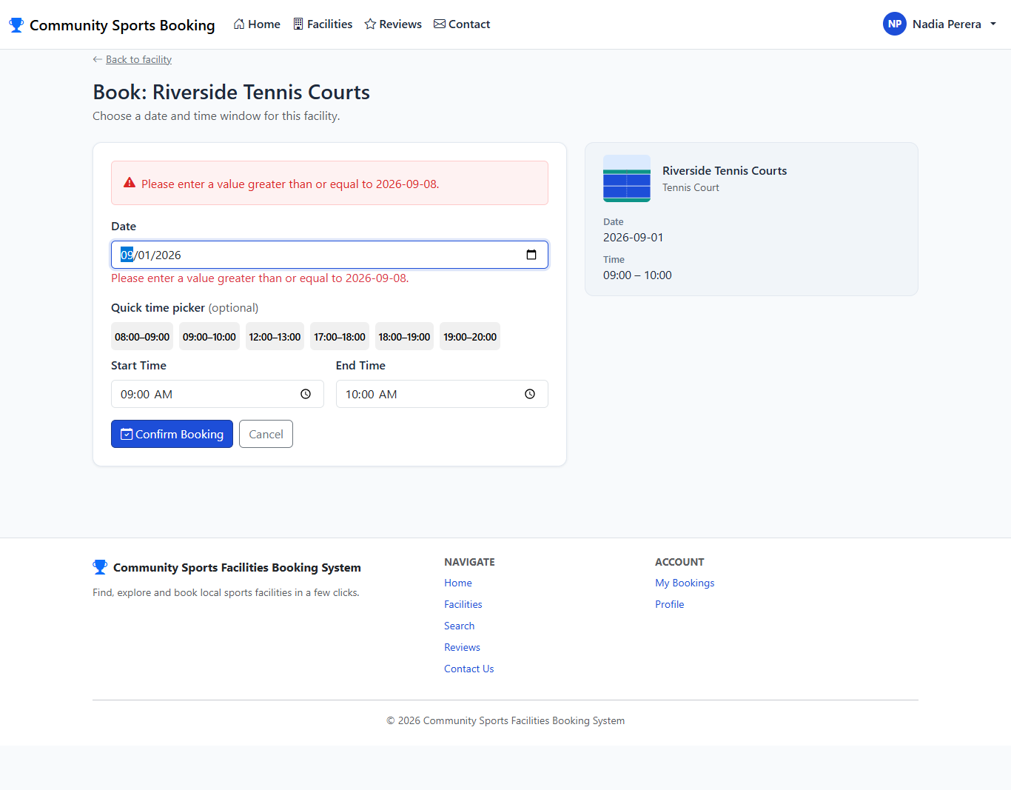
Booking form showing the browser's built-in validation message for a past date.

TC23 - Booking is rejected when it overlaps an existing booking
Test Case ID | TC23
Feature / Module | Booking Validation (Member)
Test Scenario | Booking is rejected when it overlaps an existing booking
Preconditions | The application is running. The user is logged in as a Member. A booking already exists for Riverside Tennis Courts on 16 Sep 2026, 09:00-10:00 (created in TC21).
Test Steps | 1. Open the booking page for "Riverside Tennis Courts".  2. Enter the same date and time as the existing booking.  3. Click "Confirm Booking".
Test Input / Data | Facility = Riverside Tennis Courts, Date = 16 Sep 2026, Start = 09:00, End = 10:00 (same slot as TC21).
Expected Result | The booking is rejected with the message that the facility is no longer available for the selected time.
Actual Result | Error "This facility is no longer available for the selected time — please choose another slot." displayed.
Test Status | Pass
Evidence | Screenshot: TC23_Booking_Overlap_Rejected.png
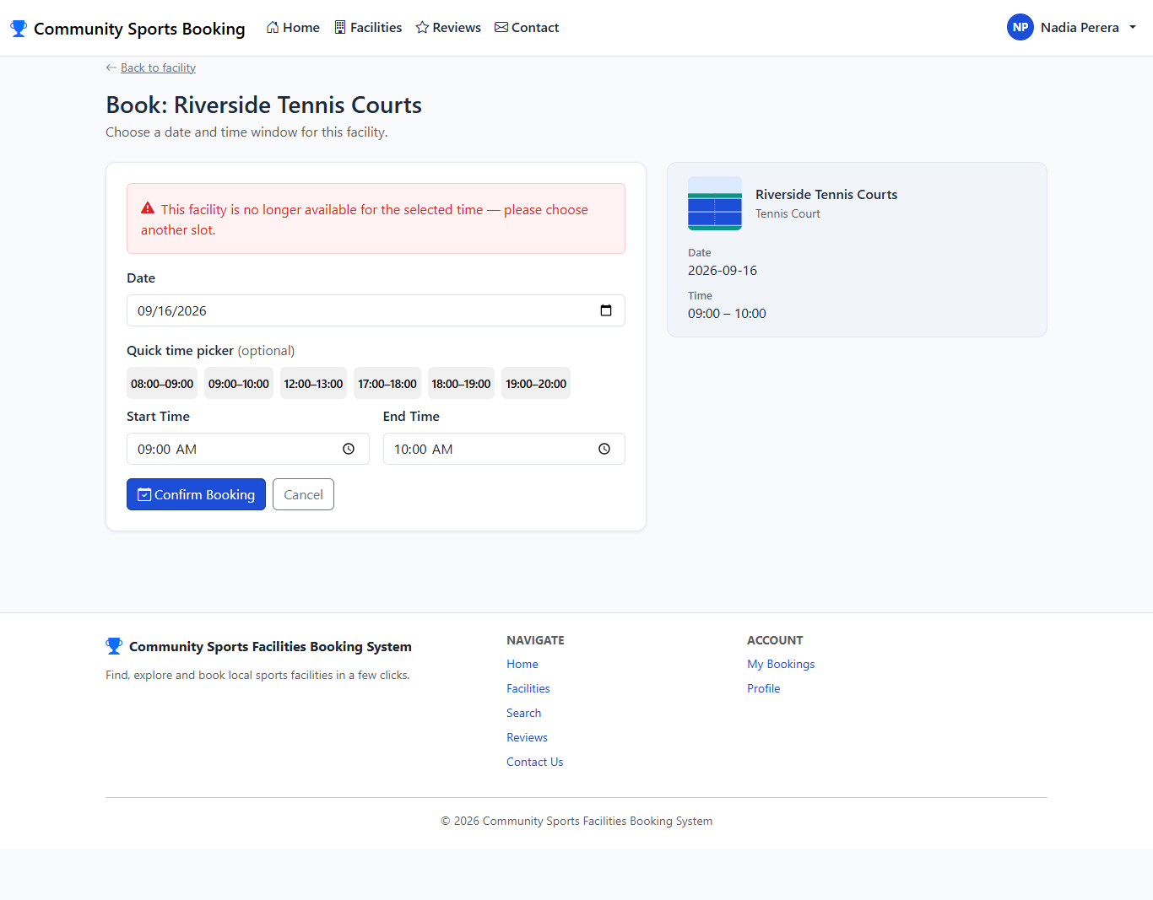
Booking form showing the overlap-rejection error for a slot that is already booked.

TC24 - Member views their bookings grouped by status
Test Case ID | TC24
Feature / Module | My Bookings (Member)
Test Scenario | Member views their bookings grouped by status
Preconditions | The application is running. The user is logged in as a Member. The member has more than one upcoming booking.
Test Steps | 1. Open the My Bookings page.
Test Input / Data | None.
Expected Result | Bookings are grouped into Upcoming, Completed and Cancelled sections, with each booking showing the correct facility, date and time.
Actual Result | Both upcoming bookings listed under the Upcoming section.
Test Status | Pass
Evidence | Screenshot: TC24_Member_MyBookings.png
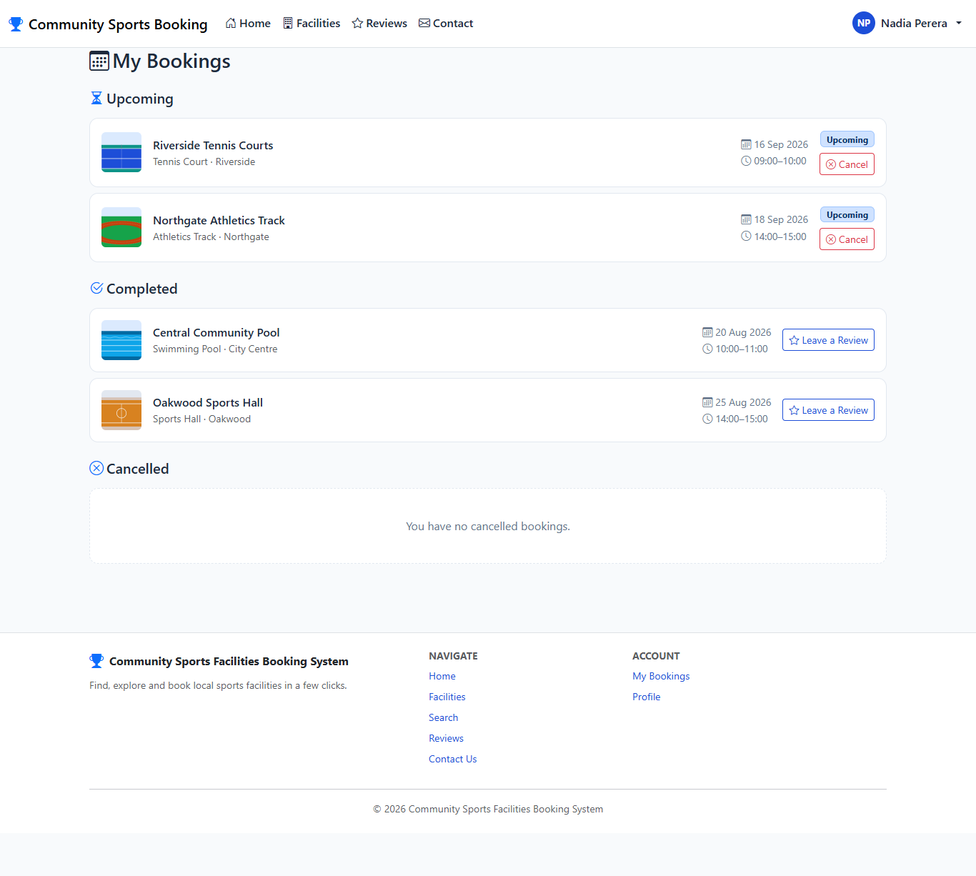
My Bookings page showing bookings grouped under Upcoming, Completed and Cancelled.

TC25 - Member cancels their own upcoming booking
Test Case ID | TC25
Feature / Module | Booking Cancellation (Member)
Test Scenario | Member cancels their own upcoming booking
Preconditions | The application is running. The user is logged in as a Member.
Test Steps | 1. Open the My Bookings page.  2. Click "Cancel" on the Riverside Tennis Courts booking.  3. Confirm the cancellation.
Test Input / Data | Booking = Riverside Tennis Courts, 16 Sep 2026, 09:00-10:00.
Expected Result | A confirmation message is shown and the booking moves from Upcoming to the Cancelled section, instead of being deleted.
Actual Result | Success message shown and booking moved to Cancelled section.
Test Status | Pass
Evidence | Screenshot: TC25_Member_Booking_Cancelled.png
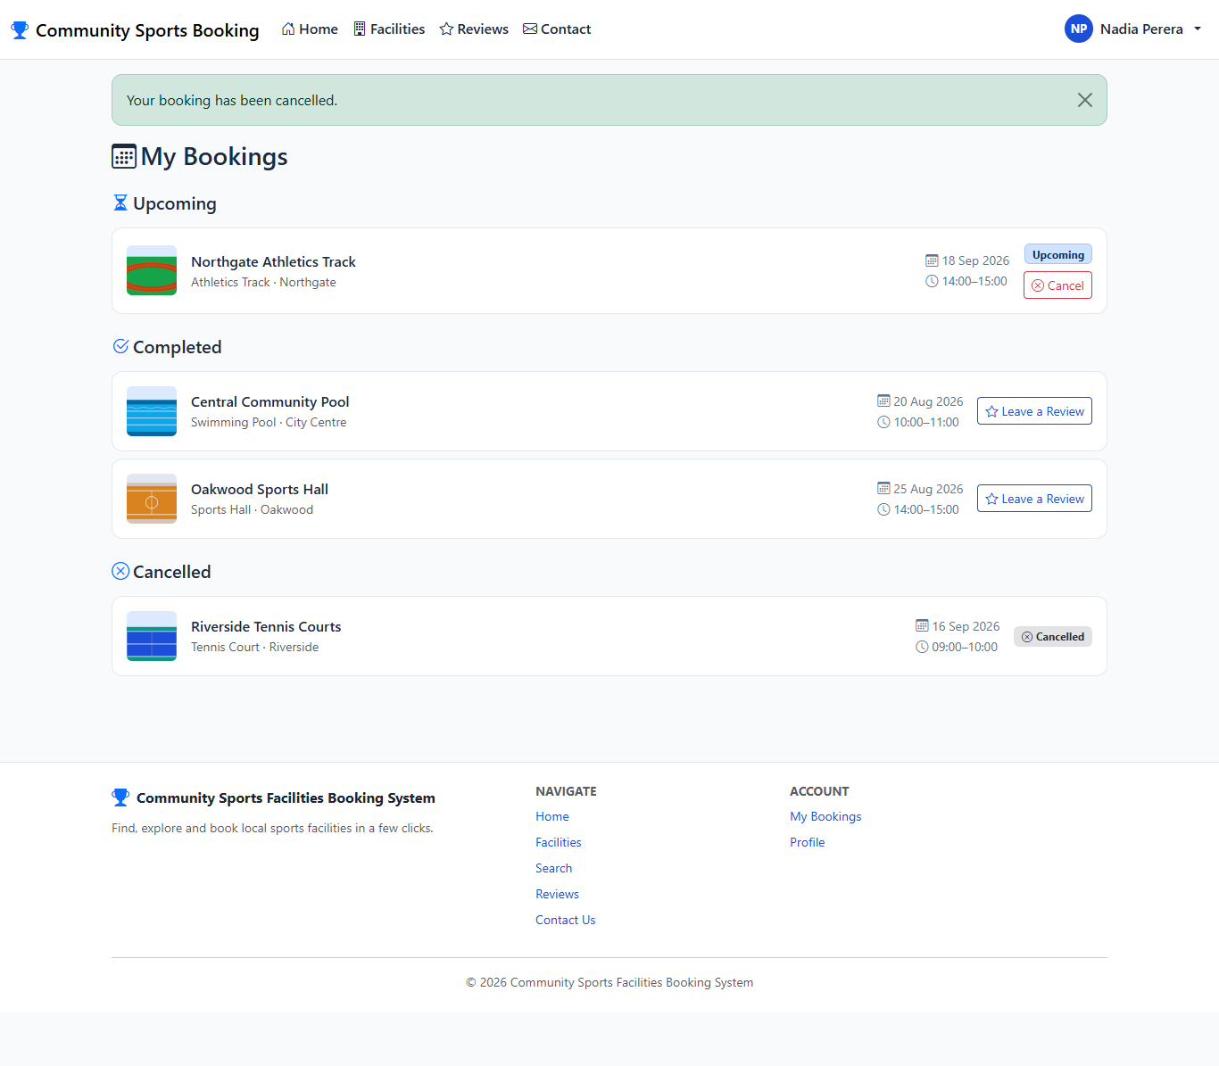
My Bookings page showing the booking moved to the Cancelled section after cancellation.

TC26 - Member submits a review for a completed booking
Test Case ID | TC26
Feature / Module | Review Submission (Member)
Test Scenario | Member submits a review for a completed booking
Preconditions | The application is running. The user is logged in as a Member. A completed booking exists for Central Community Pool, 20 Aug 2026, with no review yet.
Test Steps | 1. Open the My Bookings page.  2. Click "Leave a Review" on the completed Central Community Pool booking.  3. Select a rating and enter a comment.  4. Click "Submit Review".
Test Input / Data | Rating = 4 stars, Comment = "Clean and well-maintained pool with friendly staff. Would visit again."
Expected Result | The review is saved. A confirmation message is shown and the booking is now marked "Reviewed".
Actual Result | Success message shown; booking now marked Reviewed.
Test Status | Pass
Evidence | Screenshot: TC26_Member_Review_Submitted.png
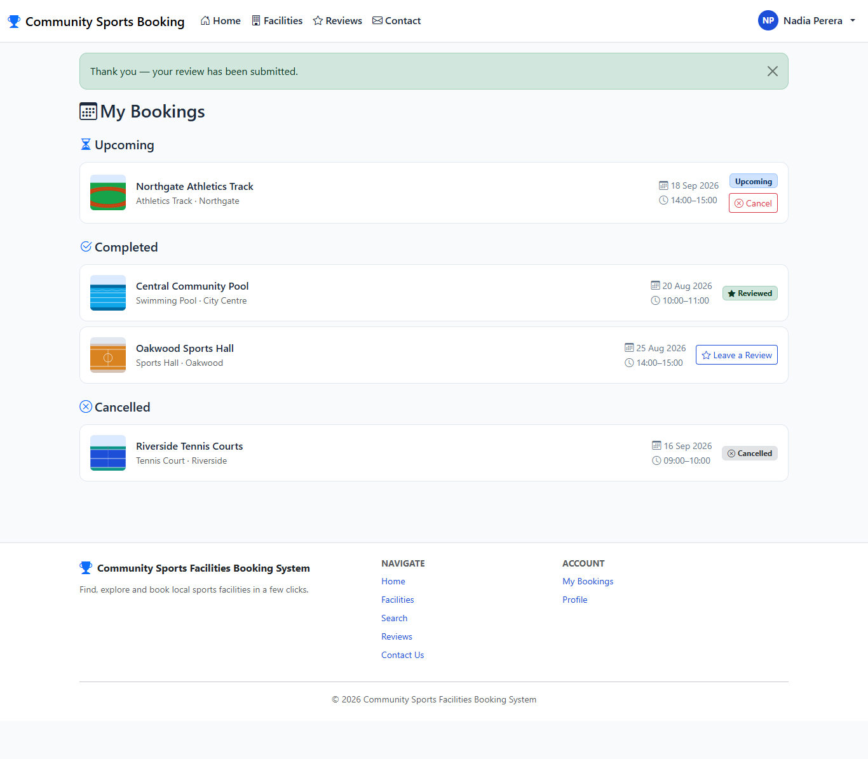
My Bookings page showing the confirmation message and the booking marked as Reviewed.

TC27 - Review submission is rejected when rating and comment are missing
Test Case ID | TC27
Feature / Module | Review Validation (Member)
Test Scenario | Review submission is rejected when rating and comment are missing
Preconditions | The application is running. The user is logged in as a Member. A second completed, unreviewed booking exists for Oakwood Sports Hall.
Test Steps | 1. Open the review page for the Oakwood Sports Hall booking.  2. Leave the rating and comment empty.  3. Click "Submit Review".
Test Input / Data | Rating = (none selected), Comment = (empty).
Expected Result | The review is rejected. Validation messages are shown for the missing rating and the missing comment.
Actual Result | 2 field validation message(s) displayed ("Please select a rating.", "Please enter a comment."); no review saved.
Test Status | Pass
Evidence | Screenshot: TC27_Review_Validation_Missing_Fields.png
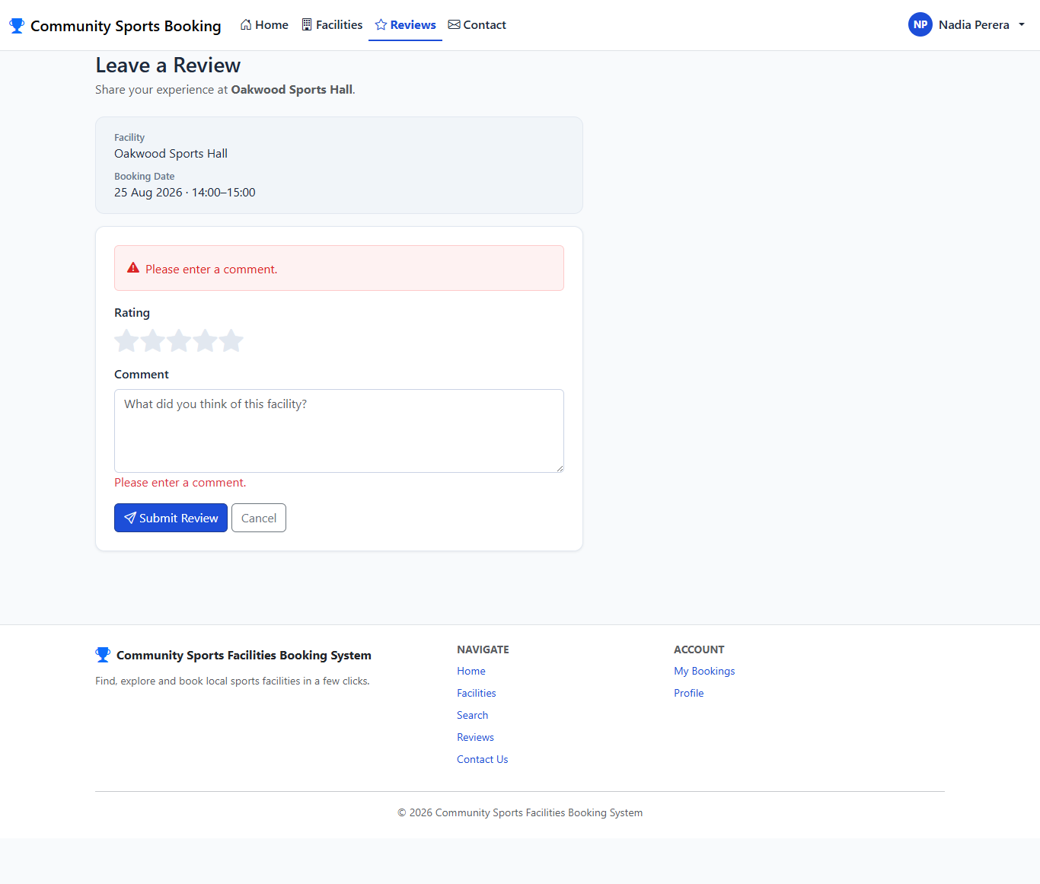
Review form showing validation messages for a missing rating and comment.

TC28 - Signed-in member logs out
Test Case ID | TC28
Feature / Module | Logout (Member)
Test Scenario | Signed-in member logs out
Preconditions | The application is running. The user is logged in as a Member.
Test Steps | 1. Click the member's name in the navigation bar.  2. Click "Logout".
Test Input / Data | None.
Expected Result | The session ends and the navigation bar reverts to showing "Login" and "Register" links.
Actual Result | Nav shows Login/Register; member-only session ended.
Test Status | Pass
Evidence | Screenshot: TC28_Member_Logout.png

Home page navigation bar after logout, showing Login and Register links again.

15.3 Administrator Module

TC29 - A signed-in, non-admin member is denied access to the Admin area
Test Case ID | TC29
Feature / Module | Access Control (Admin)
Test Scenario | A signed-in, non-admin member is denied access to the Admin area
Preconditions | The application is running. A member without administrator rights is logged in.
Test Steps | 1. While logged in as an ordinary member, try to open the Admin area (/Admin) directly.
Test Input / Data | URL: /Admin
Expected Result | The member is redirected to an "Access denied" page rather than being shown the admin dashboard.
Actual Result | Redirected to Access Denied page.
Test Status | Pass
Evidence | Screenshot: TC29_NonAdmin_Access_Denied.png
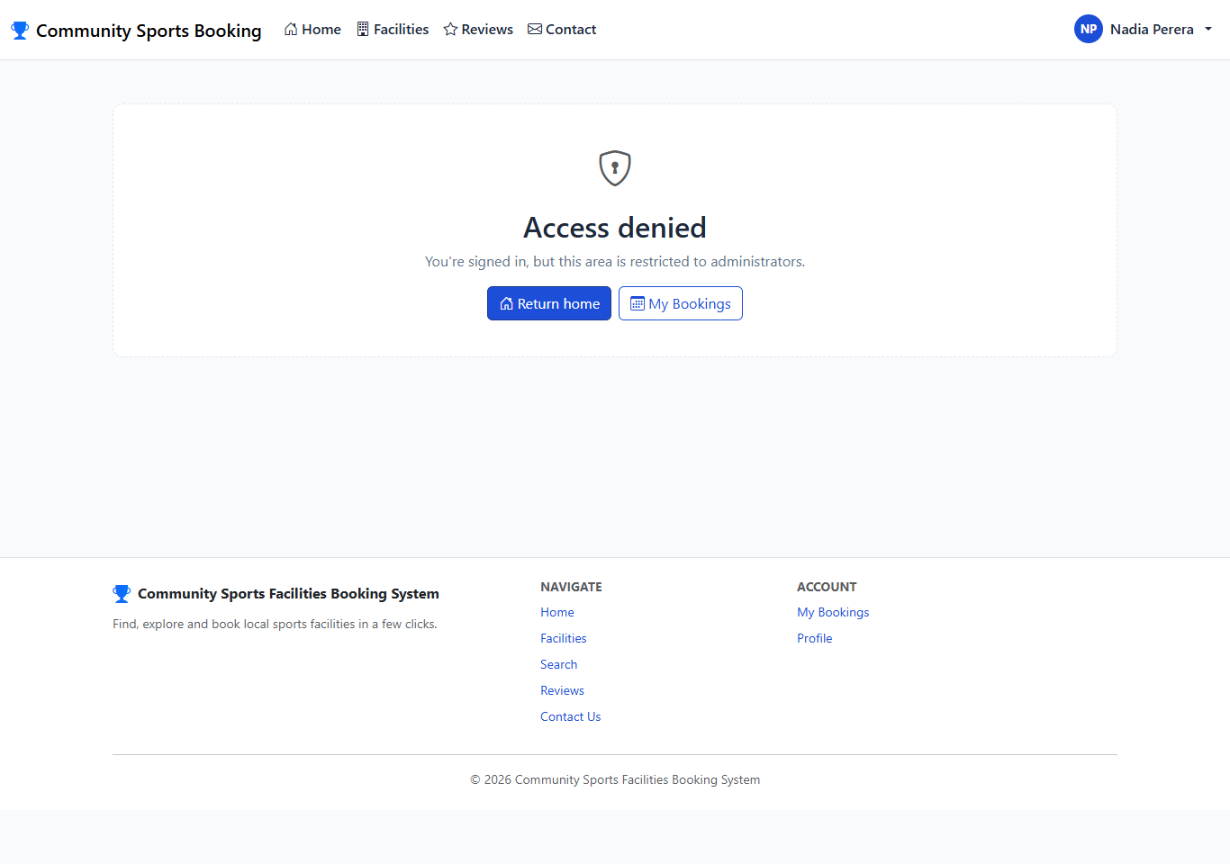
Access denied page shown to a signed-in member without administrator rights.

TC30 - The dedicated administrator account logs in and is sent to the Dashboard
Test Case ID | TC30
Feature / Module | Login (Admin)
Test Scenario | The dedicated administrator account logs in and is sent to the Dashboard
Preconditions | The application is running. The user is not logged in.
Test Steps | 1. Open the Login page.  2. Enter the administrator credentials.  3. Submit the form.
Test Input / Data | Email = "admin", Password = "admin".
Expected Result | Login succeeds and the browser is redirected straight to the Admin Dashboard rather than the public home page.
Actual Result | Redirected to http://localhost:5233/Admin.
Test Status | Pass
Evidence | Screenshot: TC30_Admin_Login_Redirect.png
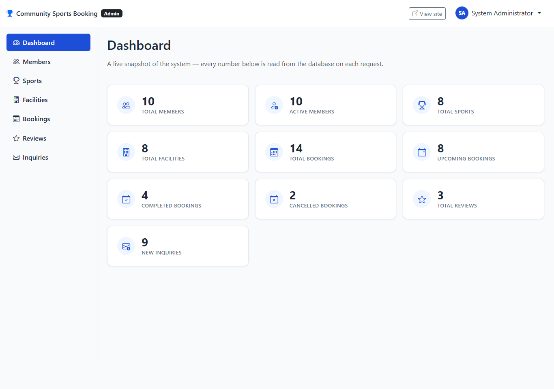
Admin Dashboard shown immediately after the administrator logs in.

TC31 - Admin Dashboard displays live system statistics
Test Case ID | TC31
Feature / Module | Dashboard (Admin)
Test Scenario | Admin Dashboard displays live system statistics
Preconditions | The application is running. The user is logged in as the System Administrator (Admin area).
Test Steps | 1. Open the Admin Dashboard.
Test Input / Data | None.
Expected Result | The dashboard shows live counts read from the database, including total and active members, total sports, total and active facilities, total/upcoming/completed/cancelled bookings, total reviews, and new inquiries.
Actual Result | Dashboard rendered member/booking/facility/review/inquiry statistic cards with real counts.
Test Status | Pass
Evidence | Screenshot: TC31_Admin_Dashboard.png

Admin Dashboard showing live statistic cards for members, facilities, bookings, reviews and inquiries.

TC32 - Admin searches for a member and views their details
Test Case ID | TC32
Feature / Module | Member Management (Admin)
Test Scenario | Admin searches for a member and views their details
Preconditions | The application is running. The user is logged in as the System Administrator (Admin area).
Test Steps | 1. Open Admin > Members.  2. Search for "Nadia".  3. Open the matching member's details page.
Test Input / Data | Search text = "Nadia".
Expected Result | The search returns the matching member. The details page shows their profile information, bookings and reviews.
Actual Result | Search returned Nadia Perera; details page shows profile, bookings and reviews.
Test Status | Pass
Evidence | Screenshot: TC32_Admin_Member_Search_Details.png
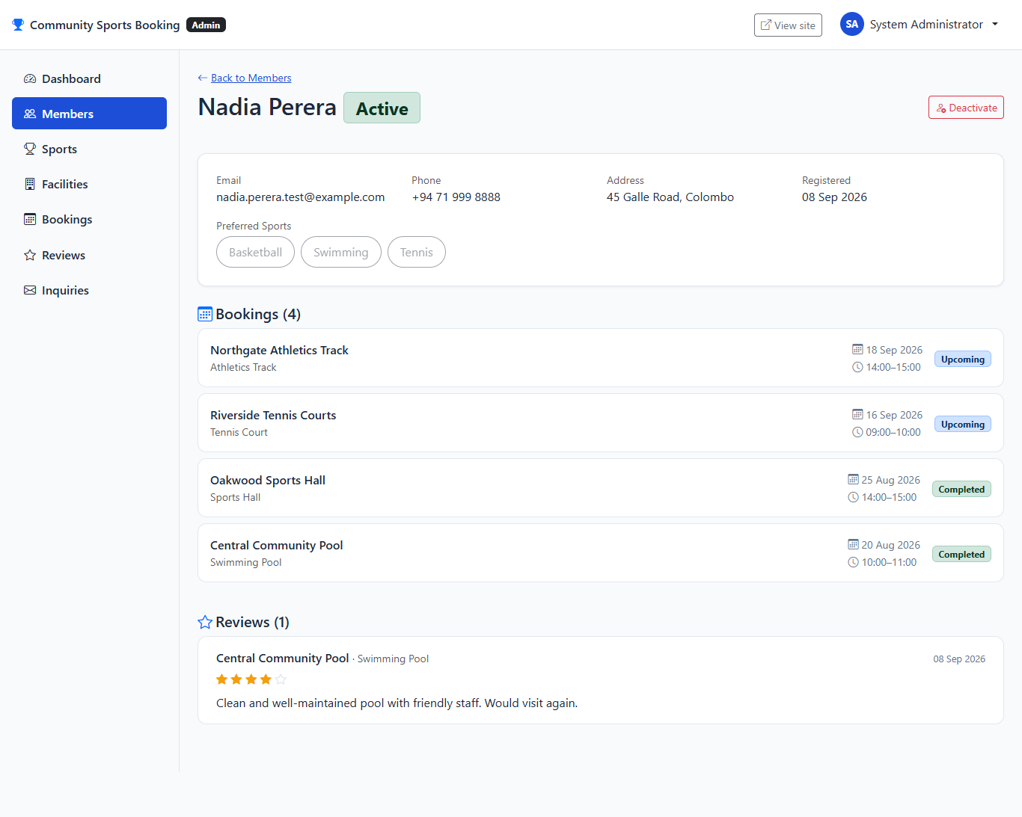
Admin member details page showing profile, booking history and reviews for the searched member.

TC33 - Admin deactivates a member account
Test Case ID | TC33
Feature / Module | Member Management (Admin)
Test Scenario | Admin deactivates a member account
Preconditions | The application is running. The user is logged in as the System Administrator (Admin area).
Test Steps | 1. Open the member's details page.  2. Click "Deactivate".  3. Confirm the action.
Test Input / Data | Member = Nadia Perera.
Expected Result | The member is marked Inactive and a confirmation message is shown.
Actual Result | Success message shown; member now shows an Inactive badge.
Test Status | Pass
Evidence | Screenshot: TC33_Admin_Deactivates_Member.png
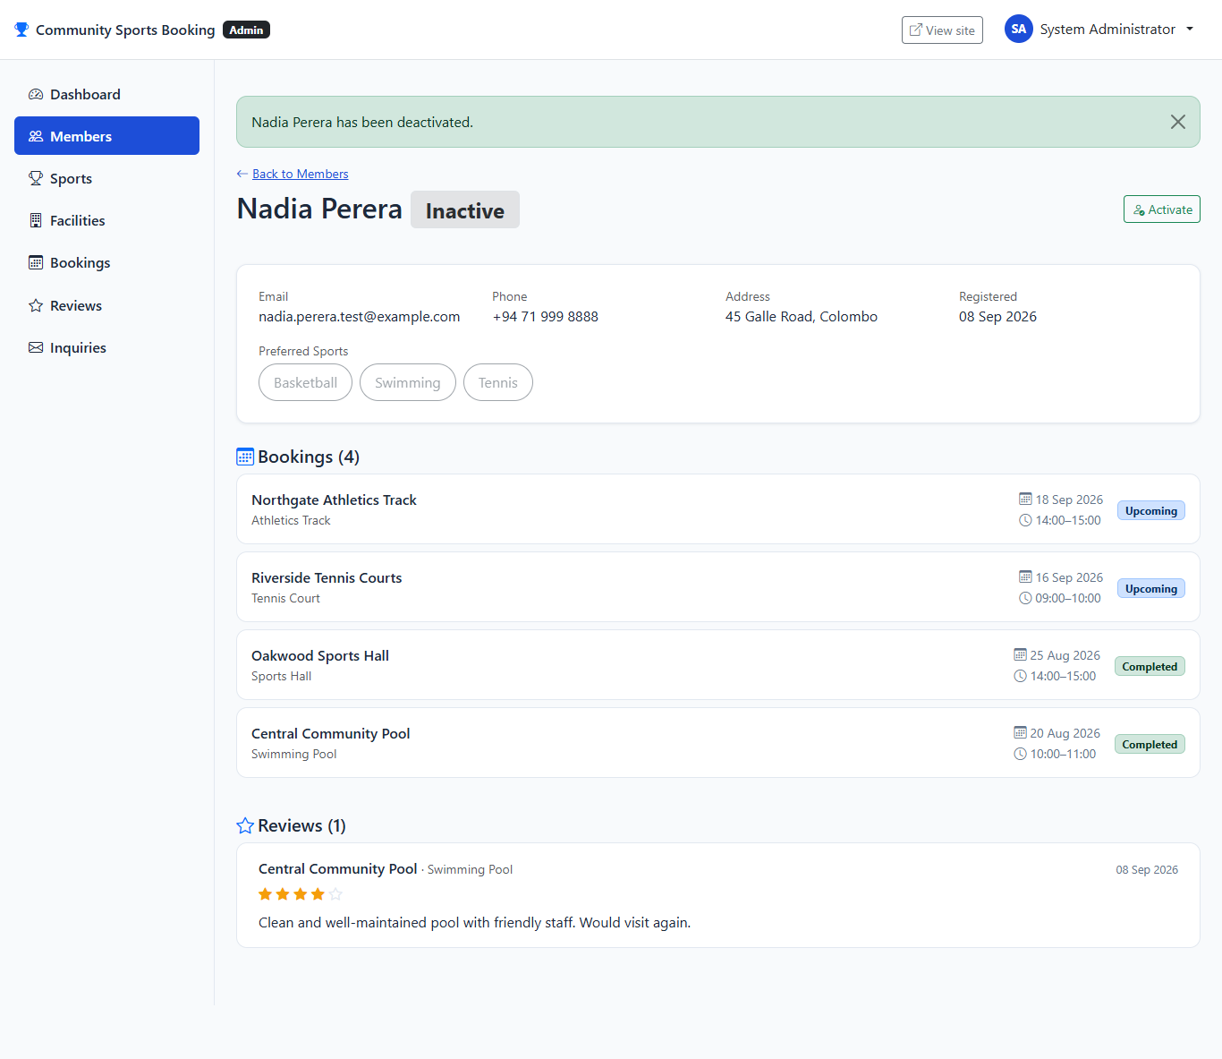
Member details page showing the Inactive badge and confirmation message after deactivation.

TC34 - Admin cannot deactivate their own account
Test Case ID | TC34
Feature / Module | Member Management (Admin)
Test Scenario | Admin cannot deactivate their own account
Preconditions | The application is running. The user is logged in as the System Administrator (Admin area).
Test Steps | 1. Open the administrator's own member details page.  2. Observe that the deactivate control is disabled ("This is your account").  3. Send the deactivation request directly to the server (bypassing the disabled button) to confirm the rule is also enforced server-side.
Test Input / Data | Member = System Administrator (the currently signed-in account).
Expected Result | The account cannot be deactivated by any route. The account remains Active and, if attempted directly, the server responds with "You cannot deactivate your own account."
Actual Result | Admin account remains Active after the direct request; server message "You cannot deactivate your own account." was shown.
Test Status | Pass
Evidence | Screenshot: TC34a_Admin_Self_Deactivate_Button_Disabled.png, TC34b_Admin_Self_Deactivate_Blocked.png
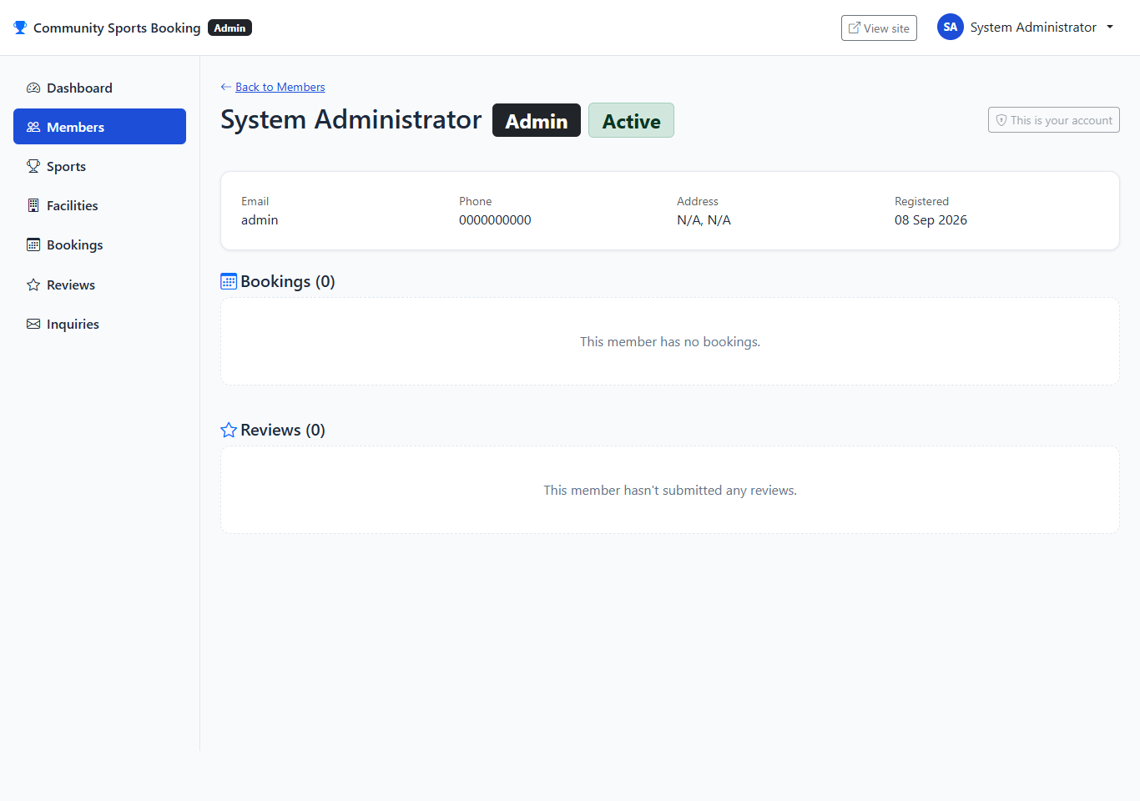
Administrator details page showing the "This is your account" disabled control instead of a Deactivate button.
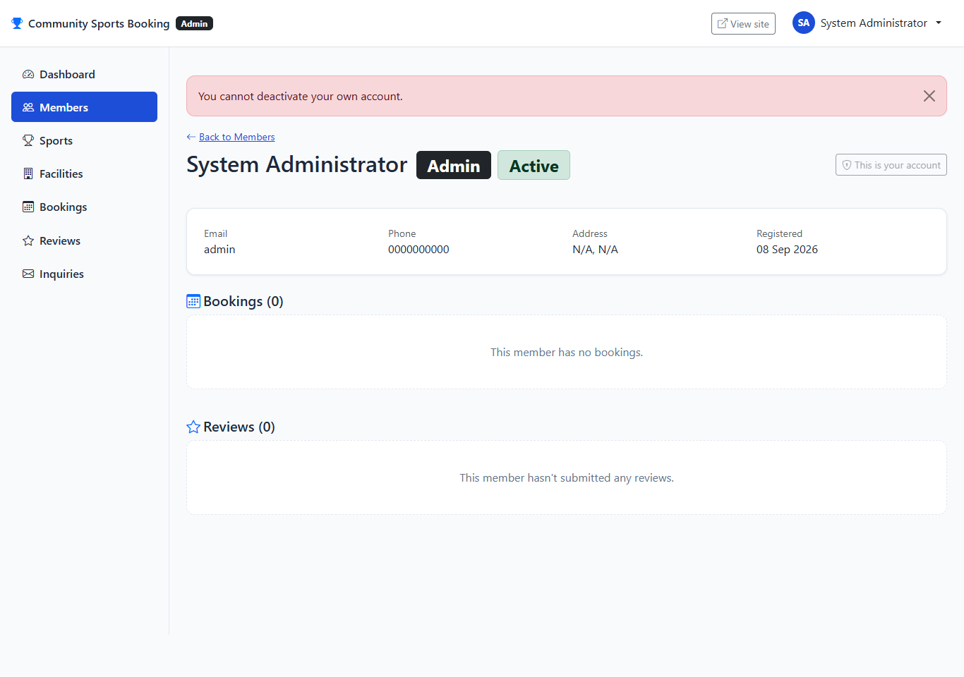
Same page after a direct request to the endpoint, confirming the account remains Active and showing the self-deactivation error message.

TC35 - A deactivated member can no longer log in
Test Case ID | TC35
Feature / Module | Login (Member)
Test Scenario | A deactivated member can no longer log in
Preconditions | The member account was deactivated by an administrator in TC33.
Test Steps | 1. Open the Login page.  2. Enter the deactivated member's correct email and password.  3. Submit the form.
Test Input / Data | Email = "nadia.perera.test@example.com", Password = "Test@1234".
Expected Result | Login is rejected using the same generic message as a wrong password, so a deactivated account cannot be distinguished from a wrong password by a visitor.
Actual Result | Login rejected with the standard generic "Invalid email or password." message.
Test Status | Pass
Evidence | Screenshot: TC35_Deactivated_Member_Login_Blocked.png

Login page showing that a deactivated member is rejected with the same generic error as any other failed login.

TC36 - Admin adds a new sport
Test Case ID | TC36
Feature / Module | Sport Management (Admin)
Test Scenario | Admin adds a new sport
Preconditions | The application is running. The user is logged in as the System Administrator (Admin area).
Test Steps | 1. Open Admin > Sports > Add Sport.  2. Enter a new sport name.  3. Click "Add Sport".
Test Input / Data | Sport Name = "Table Tennis".
Expected Result | The sport is added to the catalogue and a confirmation message is shown.
Actual Result | Success message shown; "Table Tennis" now listed.
Test Status | Pass
Evidence | Screenshot: TC36_Admin_Sport_Created.png
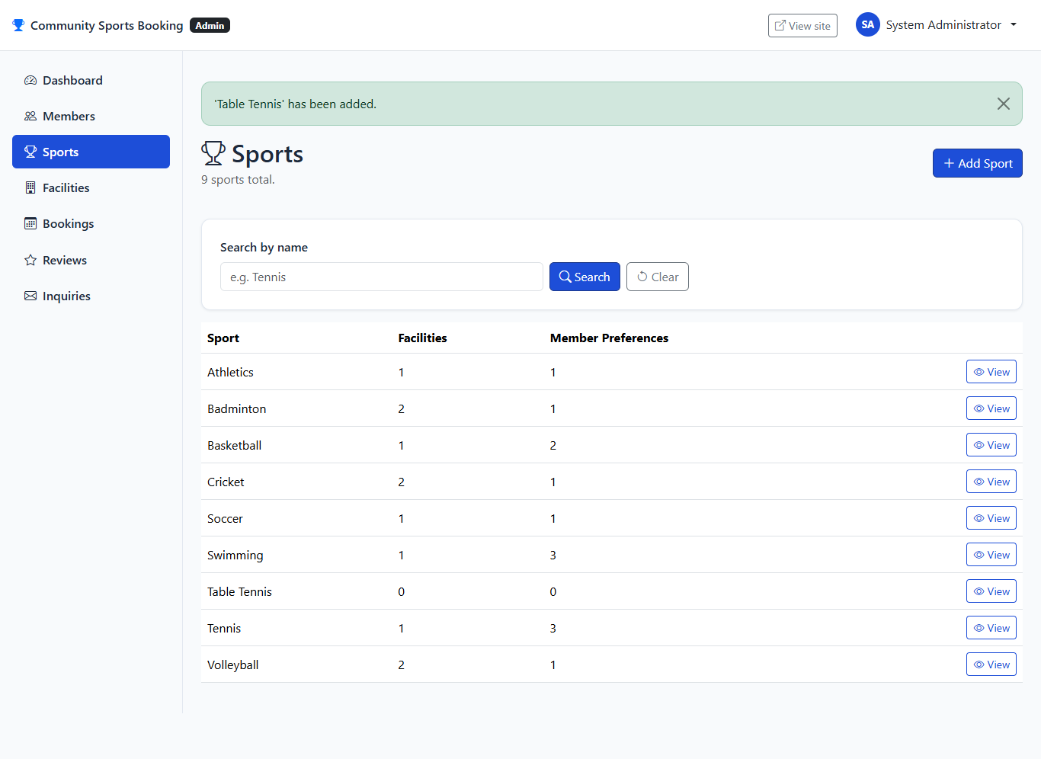
Sports list showing the new "Table Tennis" entry after creation.
Note: This sport was a disposable test entry and was removed after verification to keep the reference data unchanged for grading, in the same way the temporary test member and facility below were removed.

TC37 - Admin cannot delete a sport that is still in use
Test Case ID | TC37
Feature / Module | Sport Management (Admin)
Test Scenario | Admin cannot delete a sport that is still in use
Preconditions | The application is running. The user is logged in as the System Administrator (Admin area).
Test Steps | 1. Open the details page for "Tennis" (a sport used by an active facility and preferred by members).  2. Observe the Delete control.
Test Input / Data | Sport = Tennis.
Expected Result | The Delete control is disabled and an explanation is shown that the sport cannot be deleted while it is used by a facility or preferred by a member.
Actual Result | Delete control disabled; on-page explanation confirms the sport is still in use.
Test Status | Pass
Evidence | Screenshot: TC37_Admin_Sport_Delete_Blocked.png
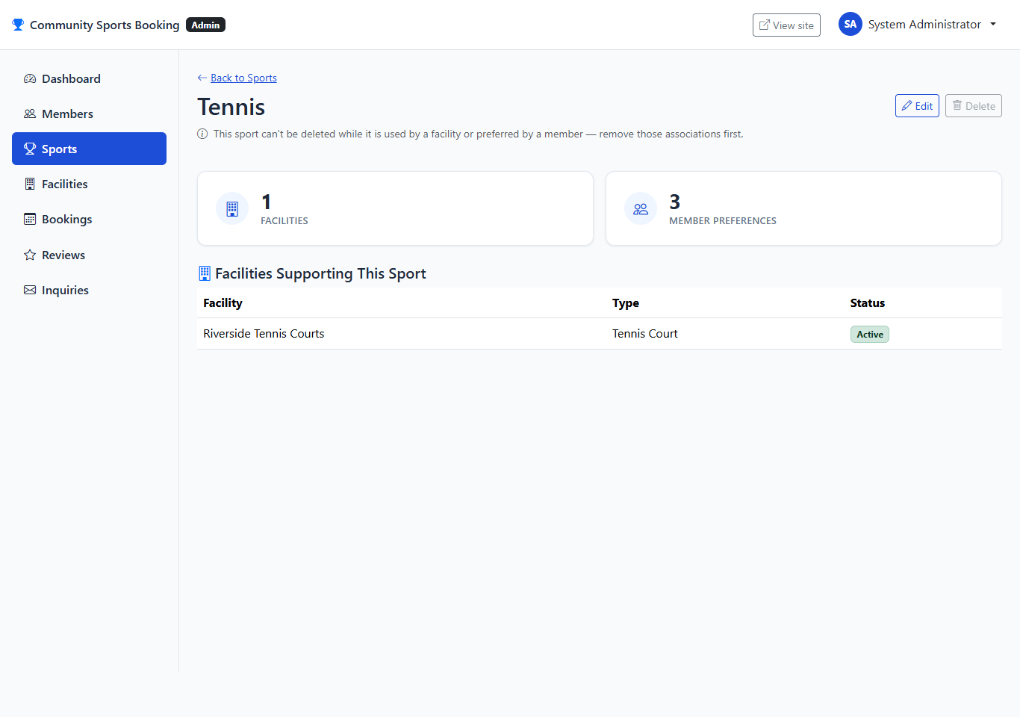
Sport details page showing the disabled Delete control and explanation for Tennis.

TC38 - Admin creates a facility and assigns supported sports
Test Case ID | TC38
Feature / Module | Facility Management (Admin)
Test Scenario | Admin creates a facility and assigns supported sports
Preconditions | The application is running. The user is logged in as the System Administrator (Admin area).
Test Steps | 1. Open Admin > Facilities > Add Facility.  2. Fill in the facility details.  3. Save the facility.  4. On the facility's details page, select Basketball and Badminton as supported sports.  5. Click "Save Sports".
Test Input / Data | Facility Name = "Hillcrest Multi-Sport Hall", Type = "Sports Hall", Location = "Hillcrest", City = "Colombo", Address = "8 Hillcrest Avenue", Capacity = 80, Supported Sports = Basketball, Badminton.
Expected Result | The facility is created and the selected sports are saved as its supported sports.
Actual Result | Facility created; Basketball and Badminton assigned as supported sports.
Test Status | Pass
Evidence | Screenshot: TC38_Admin_Facility_Created_Sports_Assigned.png
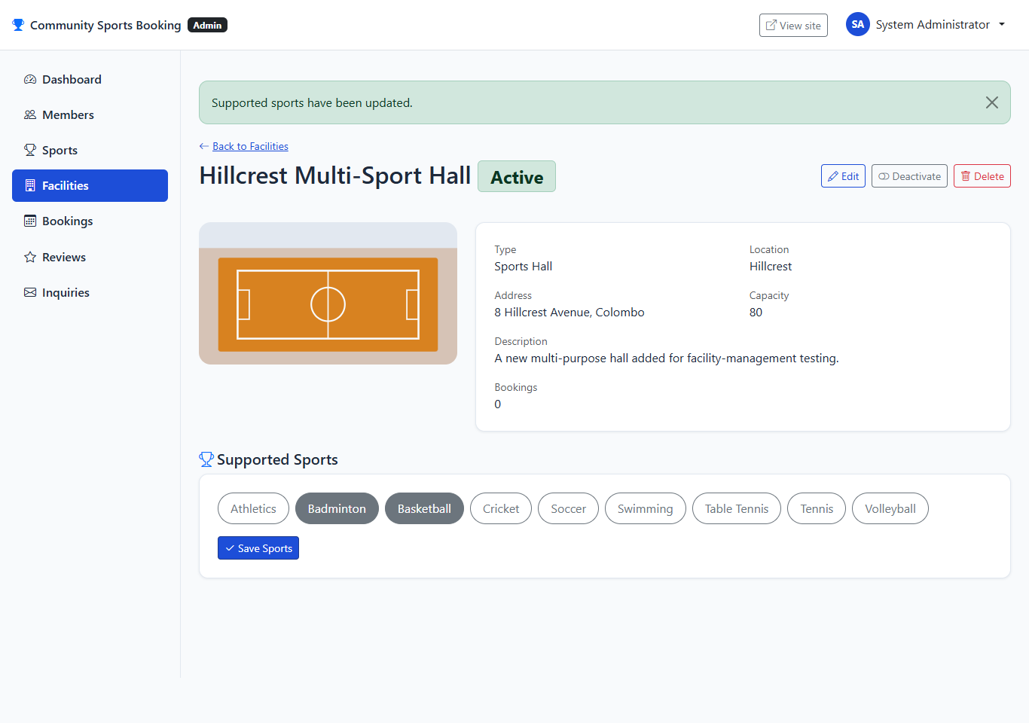
New facility details page showing Basketball and Badminton assigned as supported sports.
Note: This facility was a disposable test entry and was removed after verification, for the same reason described for TC36.

TC39 - Admin cannot delete a facility with existing booking history
Test Case ID | TC39
Feature / Module | Facility Management (Admin)
Test Scenario | Admin cannot delete a facility with existing booking history
Preconditions | The application is running. The user is logged in as the System Administrator (Admin area).
Test Steps | 1. Open the details page for "Riverside Tennis Courts" (a facility with existing bookings).  2. Observe the Delete control.
Test Input / Data | Facility = Riverside Tennis Courts.
Expected Result | The Delete control is disabled and an explanation is shown that the facility has booking records that must be preserved, and should be deactivated instead.
Actual Result | Delete control disabled; on-page explanation confirms booking history must be preserved.
Test Status | Pass
Evidence | Screenshot: TC39_Admin_Facility_Delete_Blocked.png
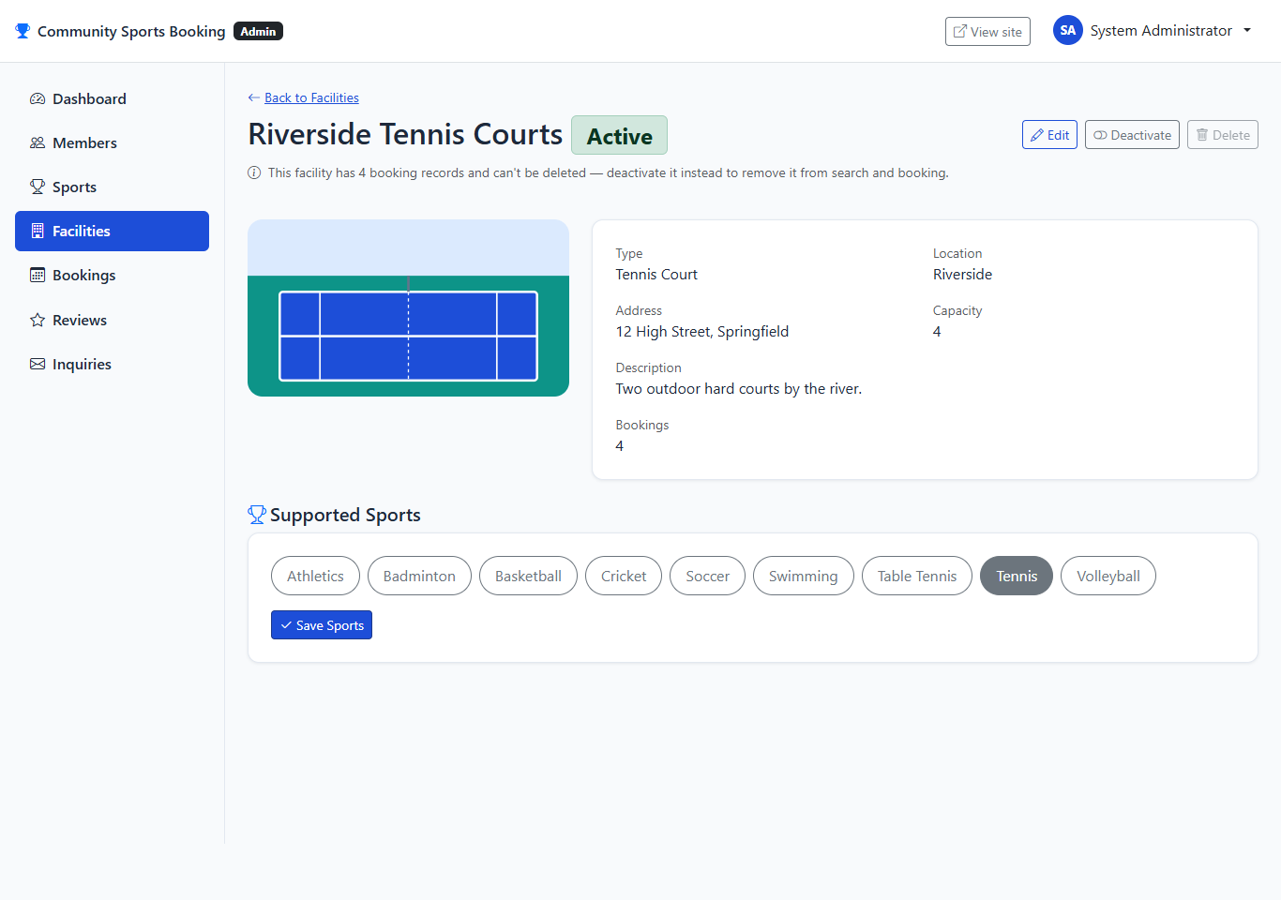
Facility details page showing the disabled Delete control and explanation for Riverside Tennis Courts.

TC40 - Admin filters bookings by member and cancels one
Test Case ID | TC40
Feature / Module | Booking Management (Admin)
Test Scenario | Admin filters bookings by member and cancels one
Preconditions | The application is running. The user is logged in as the System Administrator (Admin area).
Test Steps | 1. Open Admin > Bookings.  2. Filter by member name "Nadia".  3. Click "Cancel" on the matching booking.  4. Confirm the cancellation.
Test Input / Data | Member filter = "Nadia".
Expected Result | The filtered list shows the matching booking. After cancelling, the booking status changes to Cancelled and the cancellation date is recorded.
Actual Result | Filtered list showed the matching booking; cancellation succeeded and status updated.
Test Status | Pass
Evidence | Screenshot: TC40_Admin_Booking_Filter_Cancel.png
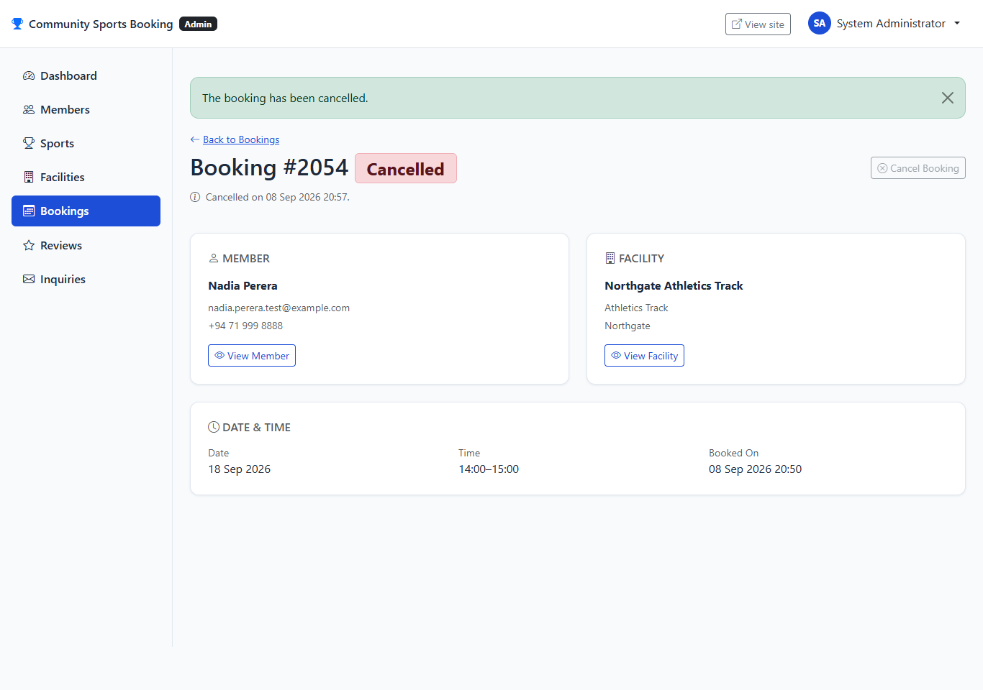
Booking details page showing the Cancelled status and cancellation confirmation.

TC41 - Admin reviews and updates the status of a guest inquiry
Test Case ID | TC41
Feature / Module | Inquiry Management (Admin)
Test Scenario | Admin reviews and updates the status of a guest inquiry
Preconditions | The application is running. The user is logged in as the System Administrator (Admin area). The inquiry submitted in TC08 exists with Status = "New".
Test Steps | 1. Open Admin > Inquiries.  2. Search for "membership".  3. Open the matching inquiry.  4. Change its status to "Reviewed".  5. Save the change.
Test Input / Data | Inquiry = "Question about membership fees", New Status = "Reviewed".
Expected Result | The inquiry status changes from New to Reviewed and a confirmation message is shown.
Actual Result | Inquiry found by search; status changed from New to Reviewed.
Test Status | Pass
Evidence | Screenshot: TC41_Admin_Inquiry_Status_Updated.png
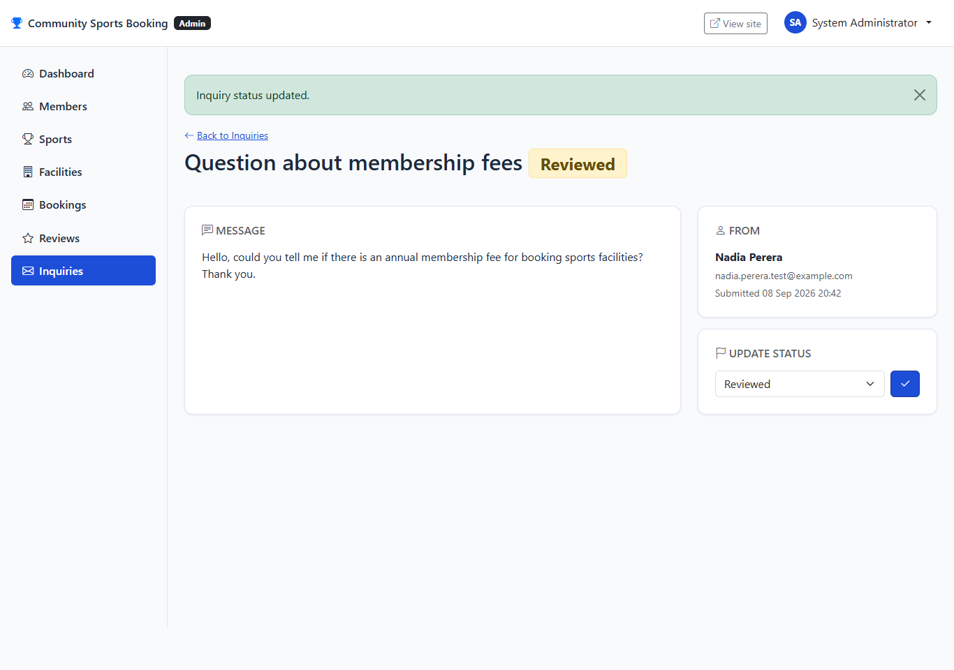
Inquiry details page showing the status updated to Reviewed.

TC42 - Admin views all member-submitted reviews
Test Case ID | TC42
Feature / Module | Review Management (Admin)
Test Scenario | Admin views all member-submitted reviews
Preconditions | The application is running. The user is logged in as the System Administrator (Admin area).
Test Steps | 1. Open Admin > Reviews.
Test Input / Data | None.
Expected Result | The full list of reviews across all facilities is shown, including the review submitted in TC26.
Actual Result | Review list includes Nadia's new review for Central Community Pool alongside seeded reviews.
Test Status | Pass
Evidence | Screenshot: TC42_Admin_Review_List.png
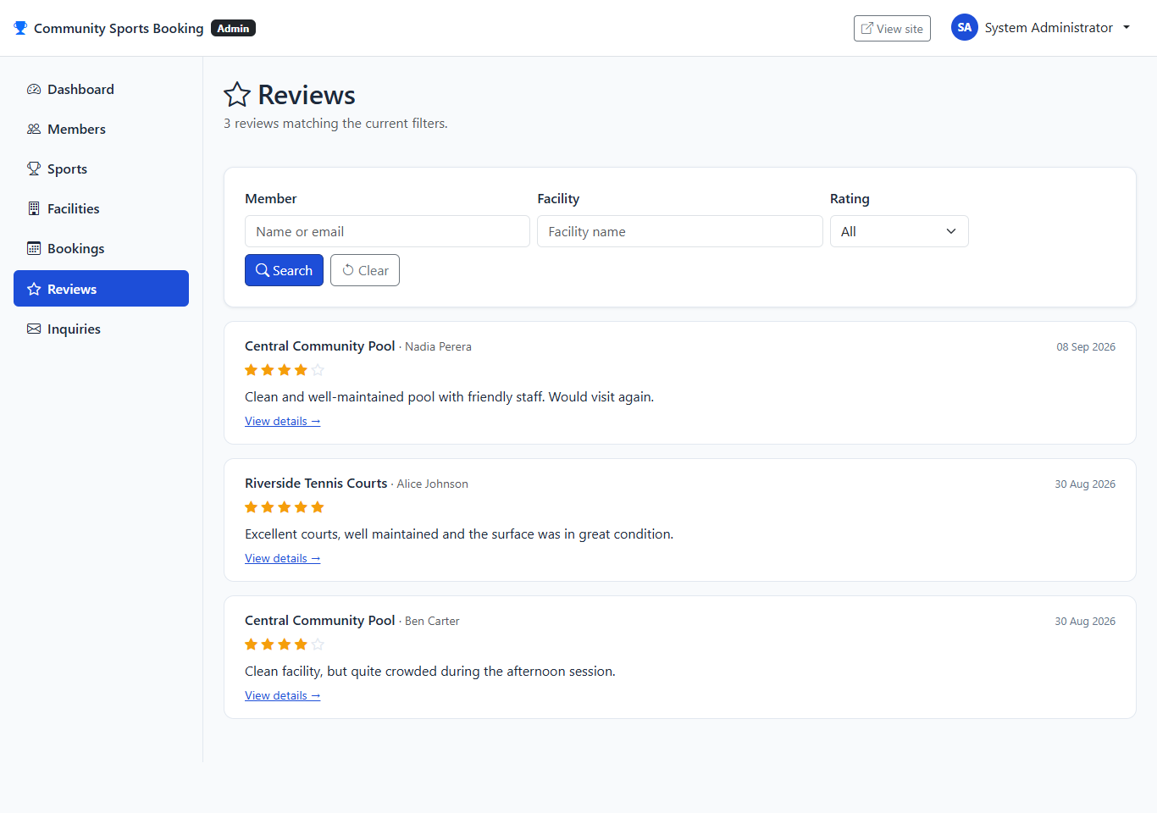
Admin review list showing all member-submitted reviews.

16. Test Summary
Test Group | Test Cases | Passed | Failed
Guest Module | 12 (TC01-TC12) | 12 | 0
Member Module | 16 (TC13-TC28) | 16 | 0
Administrator Module | 14 (TC29-TC42) | 14 | 0
Manual functional testing total | 42 | 42 | 0
Automated xUnit test suite | 185 | 185 | 0
All 42 manually executed test cases passed, and all 185 automated tests passed. No test case in either set was marked as passed without actually being run; where a result depended on a specific piece of prepared data (for example, a completed booking for the review tests), this is stated in the test case's preconditions rather than left unexplained.

17. Limitations
- The relational (physical) model image in Section 12.1 was engineered inside Oracle SQL Developer Data Modeler and should be checked against the actual SQL Server tables in Section 12.2 before submission. On a visual comparison, a few details in that image do not currently match the implemented database: the Booking table appears with a composite key (BookingId, MemberId, FacilityId) rather than the single BookingId key the database actually uses, the Member and Facility tables show incoming foreign key columns from Booking and MemberSport/FacilitySport (the reverse of the intended direction), and an extra "Facility_and_Booking" table appears that has no equivalent in the real schema. These look like they come from how a couple of relationships were drawn in the logical model before the relational model was engineered from it, and are worth reviewing in Data Modeler alongside the table structures in Section 12.2, which do match the real database exactly.
- The login lockout described in Section 11.2 is held in the web server's memory. It resets if the application is restarted, and would not be shared automatically across more than one running copy of the application.
- There is no "forgot password" or password reset feature. A member who forgets their password cannot currently recover their account without administrator help.
- There is no email notification when a booking is made, cancelled, or when an inquiry is answered.
- Search results for facilities and reviews are not paginated. This is not a problem at the current amount of sample data, but a much larger number of facilities or reviews would benefit from paging.
- An administrator can view submitted reviews but cannot remove or edit one; review moderation was not part of the requested scope.
- While capturing evidence for TC33, a real inconsistency was noticed: the Admin > Members > member details page shows every booking as either "Upcoming" or "Completed" only. It does not yet check whether a booking has been cancelled, so a cancelled booking can appear there as "Upcoming" (or "Completed") instead of "Cancelled". The correct Cancelled status is shown properly everywhere else this information appears - the member's own My Bookings page, and the Admin > Bookings list and details pages - so this is a display gap on that one specific page rather than a problem with cancellation itself.
- The system was tested on a single local development environment. Its behaviour when deployed to a live hosting environment, or under many simultaneous users, has not been separately tested.

18. Application Source Code and Project Access
The complete Community Sports Facilities Booking System project, including the ASP.NET Core MVC application, source code, database scripts, and other required project files, is available through the following Google Drive link.
Google Drive Link:
[PASTE GOOGLE DRIVE LINK HERE]
The Google Drive folder contains the complete project files required to run and review the Community Sports Facilities Booking System. The project includes the ASP.NET Core MVC application source code, SQL Server database scripts, configuration files, and other supporting files required for the system.

19. Conclusion
The Community Sports Facilities Booking System meets the requirements set out in the case study. It provides a working home page, a complete set of Guest features (browsing, restricted search, review search, registration and inquiries), a complete set of Member features (search with availability, booking with genuine double-booking protection, booking history, cancellation, reviews and profile management), and an Administrator area for managing members, sports, facilities, bookings, reviews and inquiries.
The database was designed with normalisation in mind, and important rules - such as one review per booking, and no overlapping bookings for the same facility - are enforced by the database itself rather than only by the application. The finished system was tested with both an automated test suite and genuine manual testing of the running application, and every result recorded in this document reflects what was actually observed when the tests were run.
Overall, the project demonstrates a complete, working example of a database-backed web application, built using the technologies required by the coursework, and documents its design, features and testing honestly and in full.

