LifeCare Hub Hospital Management System

1. Introduction

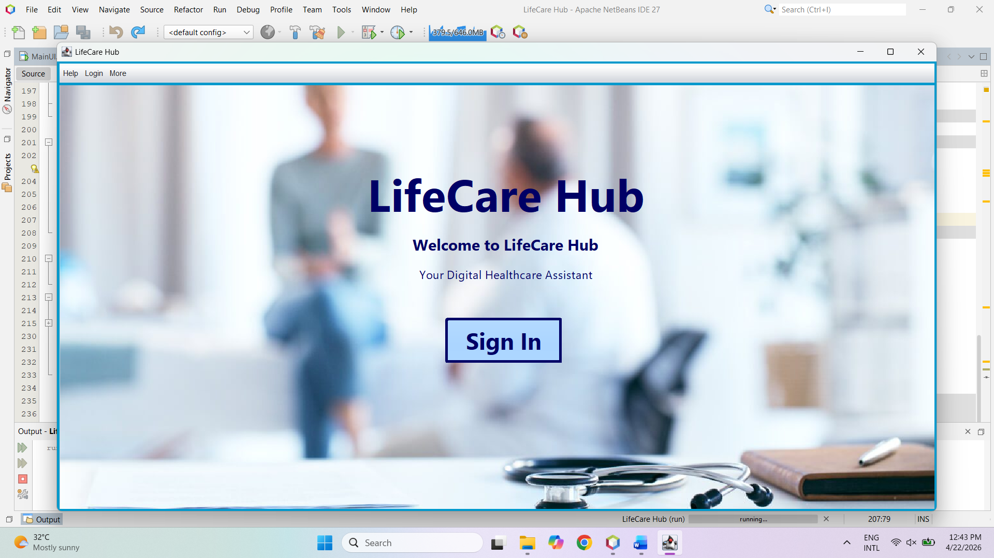
The Hospital Patient Management System (HPMS) helps hospitals manage patient registration, prioritize treatment, and store patient history efficiently.

2. System Features

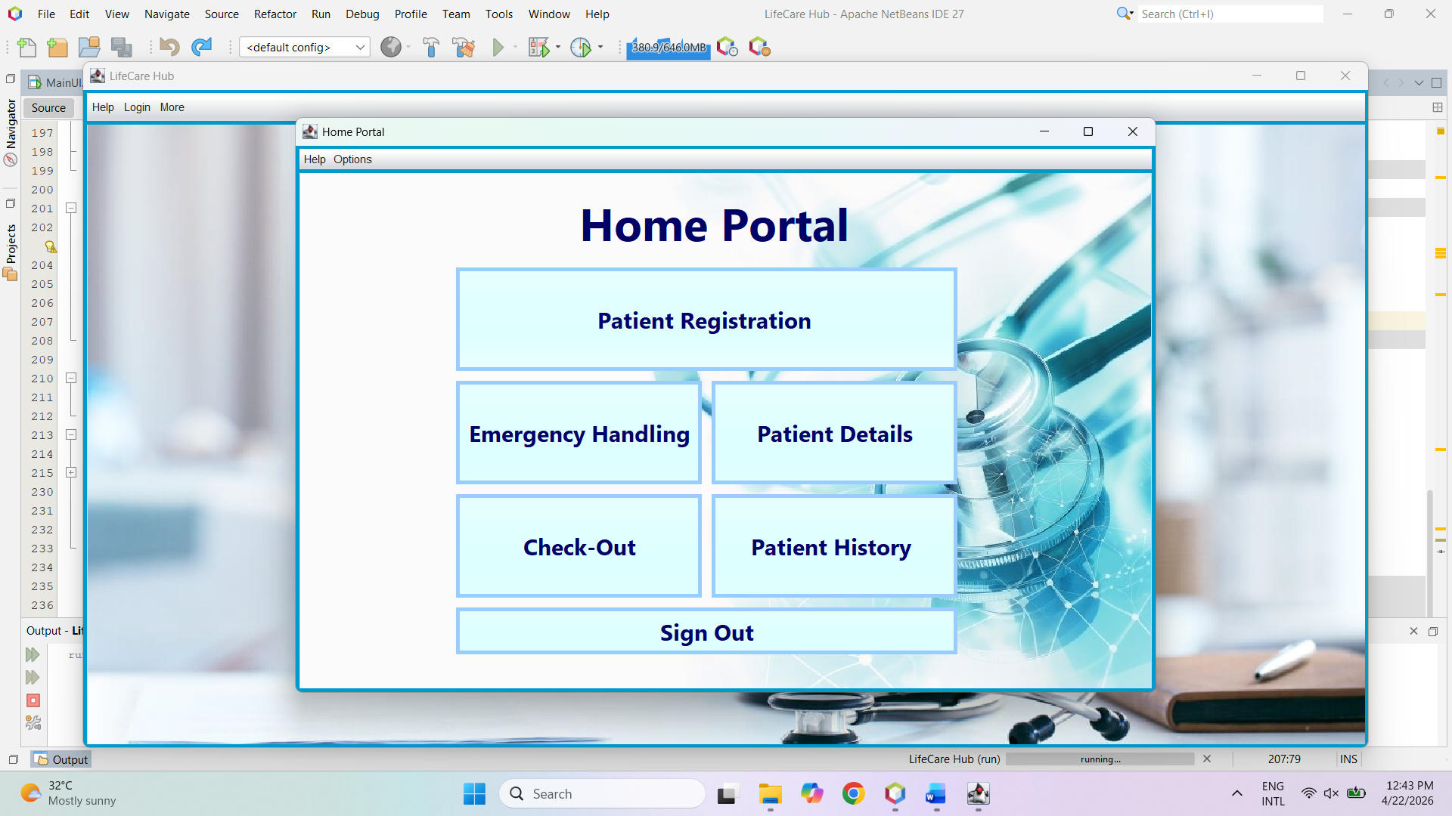

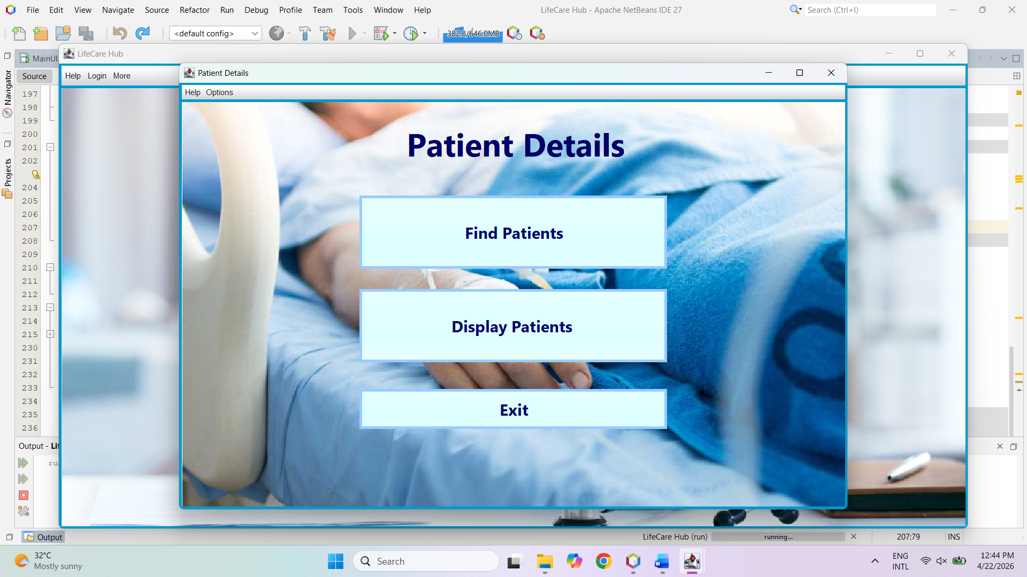

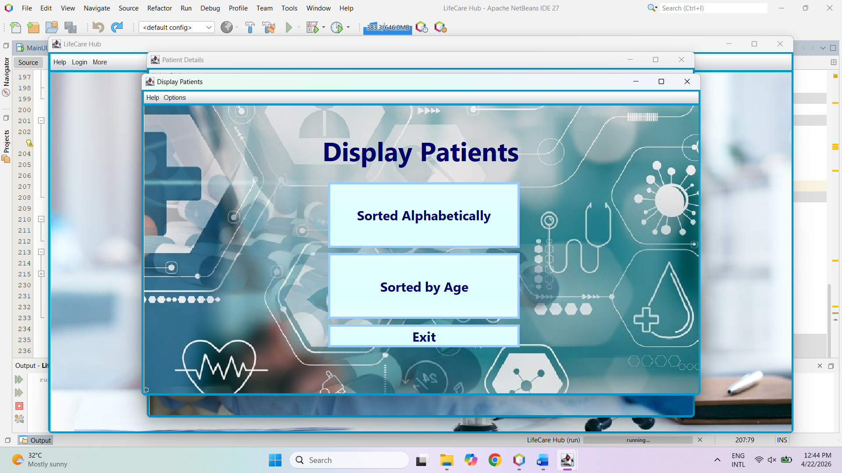

3. Getting Started

1. Run the program.
2. The main menu will appear.
3. Click the buttons for the desired operation.

4. System Behavior

- Queue uses Linked List.
- Priority handled using Heap.
- History stored using Hash Table.

5. Tips

- Use unique Patient IDs.
- Enter correct severity.
- Discharge patients regularly.

6. Error Handling

- Duplicate ID → Error message.
- Invalid input → Try again.
- ID not found → Message shown.

9. Conclusion

HPMS improves efficiency by organizing patients, handling emergencies, and enabling quick record access.

