Test Document

Contents

1. Test Plan 3
2. Test Case 6
3. Test Conclusion 13
3.1 Test Results 13
3.2 Recommendations 14
3.3 User Feedback 15
References 16
Appendix T 17

Test Document

1. Test Plan
- Project Name: Hospital Management System (MediCare Hospital)
- Duration: November 22, 2025 – December 28, 2025
- Objective: To check MediCare Hospital Management System’s functionalities, reliability and provide better user experience.
- Scope:
- Login Option
- Logout option
- User-friendly GUIs
- Registration Processes
- Manage Records
- Schedule Appointments
- Billing Process
- File Handling
- Exception Handling
- Tester: Developer
- When writing Test Cases:
After development (December 29, 2025 – January 8, 2026)
- Testing Environment:
- Device: Aspire E5-576G
- Operating System: Windows 11
- Platform: Apache NetBeans
- Others: Admin.txt, Appointment.txt, Doctor.txt, Lab.txt, MedicalRecord.txt, MedicalStaff.txt, Notes.txt, Patient.txt and UserManual.doc

- Approach:

This software project is tested by using the Top-Down approach. The chart below represents the hierarchy to test the software. Therefore, the system is designed to test scenarios for separate user roles (Simplilearn, 2025).
Figure 1: Top-Down Approach
- Methods:
- Unit Testing
- Black Box Testing
Black Box Testing is focused on testing user inputs and outputs
(Robinson & Heusser, 2024).

- Integration Testing
- Use scenario Testing
Test each separate role scenario, such as doctor, nurse, lab technician and administrator. That ensures execution of the expected results (Qalified, 2023).

2. Test Case

The MediCare Hospital Management System followed the test plan and executed with the following test results.

Test Case 01: Check Login Main Screen
Field | Details
Description | Check that the Login Main Screen’s buttons and menus work correctly.
Expected Result | Achieve each option successfully
Actual Result | Achieve each option successfully
Correction Made | No correction needed
Status | Pass

Test Case 02: System login as a doctor
Field | Details
Description | Input User Name and Password into the Doctor Login Portal
Expected Result | Direct to the Doctor Portal
Actual Result | Direct to the Doctor Portal
Correction Made | No correction needed
Status | Pass
System testing evidence is included in Appendix T

Test Case 03: Check the Medical Records interface as a doctor
Field | Details
Description | Check all button options in the Medical Records interface
Expected Result | The system successfully works with add, display, find, update and delete functions.
Actual Result | The system shows all confirmation messages as successful
Correction Made | No correction needed
Status | Pass
System testing evidence is included in Appendix T

Test Case 04: System login as a nurse using an invalid User Name
Field | Details
Description | Input an invalid User Name and a valid Password into the Nurse Login Portal
Expected Result | Get a message “Incorrect User Name or Password”
Actual Result | Get a message “Incorrect User Name or Password”
Correction Made | No correction needed
Status | Pass
System testing evidence is included in Appendix T

Test Case 05: Check the Medical Records interface as a nurse
Field | Details
Description | Check all button options in the Medical Records interface
Expected Result | The system successfully works with add, display, find, update and delete functions.
Actual Result | The system shows all confirmation messages as successful
Correction Made | No correction needed
Status | Pass

Test Case 06: System login as a lab Technician
Field | Details
Description | Input User Name and Password into the Lab Technician Login Portal
Expected Result | Direct to the Lab Tech Portal
Actual Result | Direct to the Lab Tech Portal
Correction Made | No correction needed
Status | Pass

Test Case 07: Check Lab Technician Portal
Field | Details
Description | Check all button options in the Lab Technician Portal
Expected Result | Direct to the Lab Records interface, the Add Notes interface and the Main Login Screen.
Actual Result | Direct to the Lab Records interface, the Add Notes interface and the Main Login Screen.
Correction Made | No correction needed
Status | Pass
System testing evidence is included in Appendix T

Test Case 08: Check Admin Portal Menu Bar
Field | Details
Description | Check the Help menu shortcuts in the Admin Portal
Expected Result | Opens the UserManual.doc and directs to the Main Login Screen
Actual Result | Opens the UserManual.doc and directs to the Main Login Screen
Correction Made | No correction needed
Status | Pass
System testing evidence is included in Appendix T

Test Case 09: Find a patient in the Create Patient Profile interface
Field | Details
Description | Click the Find Patient button and enter Person ID as 1002 in the dialog box
Expected Result | The details will appear in the relevant fields.
Actual Result | Other fields are correct, but the Email field displays as the Address.
Correction Made | The error is found in the PatientProfile.java class. It is a logical error.
Status | Fail
System testing evidence and corrections are included in Appendix T

Test Case 10: Check the Create Doctor Profile
Field | Details
Description | Click the Display Doctor Info Button to get existing records
Expected Result | The details should appear in the relevant fields on the table.
Actual Result | The License Number column has an error.
Correction Made | The error is found in the DoctorFileDB.java class. It is a logical error.
Status | Fail
System testing evidence and corrections are included in Appendix T

Test Case 11: Check the Medical Staff Profile interface.
Field | Details
Description | Check all button options in the Medical Staff Profile interface
Expected Result | The system successfully works with add, display, find, update and delete functions.
Actual Result | The system shows all confirmation messages as successful.
Correction Made | No correction needed
Status | Pass
See Appendix T to the test case execution video link

Test Case 12: Check the Send Reminder button
Field | Details
Description | Click the Send Reminder Button in the Medical Portal interface
Expected Result | 102 appointment ID details should appear in the dialog box as a reminder.
Actual Result | Missing notes in the dialog box as a reminder.
Correction Made | The error is found in the AppointmentUI.java class.
Status | Fail
System testing evidence and corrections are included in Appendix T

Test Case 13: Print the bill
Field | Details
Description | Print a bill in the Payment Process interface by using the Print button
Expected Result | Add all the charges and deduct the insurance coverage.
Actual Result | The total amount is corrected.  (Manual Total Amount = System Total Amount)
Correction Made | No correction needed
Status | Pass
System testing evidence is included in Appendix T

Test Case 14: Check Exit Button in the Payment Process
Field | Details
Description | After printing a bill in the Payment Process interface and return to the Admin Portal by using the Exit button
Expected Result | Direct to the Admin Portal
Actual Result | Direct to the Admin Portal
Correction Made | No correction needed
Status | Pass

(Browserstack, 2025)

3. Test Conclusion

3.1 Test Results

The MediCare Hospital Management System utilized ten test cases in the testing process by the developer. The following table represents the progress of the test cases.
Total Test Cases | Passed | Failed
14 | 11 | 03

As a result, the software system fulfils the expected requirements, such as Login Options, Logout options, User-friendly GUIs, Registration Processes, Manage Records, Schedule Appointments, Billing Process, and File Handling.

3.2 Recommendations
- The system can use more icons, colour themes for different roles and add background visuals. That will improve the system's user-friendliness.
- The system can include more secure methods.
- When the user attempts to log in several times to the Login Portal and the system will automatically lock. Then the user can unlock it by using the verification method.
- The Medicare hospital management system uses a role-based User Name and Password. Then, there are four pairs of User Name and Password. Therefore, the system can be improved by the more pairs of User Names and Passwords by using a file handling method.
- In the scheduled appointment section, the system can send a reminder SMS or email to a patient using APIs.
- If the patient registers the system, it will send a welcome message via SMS or email.
- When the system can recover deleted data and the updated data, it will be more useful for users and avoid data missing issues.
- Avoid accidental system deletion by providing permission. That will be implemented, giving an authorized person to delete the system record by entering the User Name and Password.
- If the system can summarize the data, it will generate separate files for the lab test results and appointment status and appointments on a date-by-date and doctor-wise wise.
- The system can be used outside of the hospital, such as for patients. That will support users to directly schedule appointments through the system.
- The system does not have a file system for the billing process. If the system includes a file to save the payment details, it will be more useful for the accounting process.
- The system data can be saved in the cloud database such as MySQL, AWS and Azure. It will provide better security (Google, 2025).
- If the system can generate Excel documents using the system inputs, it will be more understandable and shareable. The Apache POI library can be used for this improvement (Hazra, 2022).
- The system can be converted into we application instead of a Java desktop application using a framework such as Spring Boot (IBM, 2025). CSS, HTML and JavaScript can be used for front-end. REST APIs can be used to communicate between the front-end and back-end (Robinson, et al., 2025). It will allow access to the system without installing the software.

3.3 User Feedback
The following user feedback was collected from the two peer users after testing the system by the developer.
- The user-friendly graphical user interfaces are used in the system, such as visuals, buttons, tables, text areas and text fields. That supports users in working on the system efficiently.
- Each role has a separate main login screen. That is more user-friendly and does not cause confusion for users.
- The well-prepared user manual can be opened through the system. That helps users get instructions that are clear about the issues.
- The system involves shortcuts. That navigates the user easily.
- The system time and date are more useful for users since time management is more important in that field.
- The user can get proper instructions through the messages when working with the system incorrectly.
- The system allows for a quick response. When a user adds data to the file, it is found quickly through the system by using the button options.
- The system supports navigating with different interfaces without losing entered data.
- Use proper exception handling using a try-catch block in the source code. It avoids conflicts and errors.
- The billing system is more accurate and transparent. It will generate a receipt including all services and charges by deducting insurance coverage and provide the total amount.
- The system has a test document including a test plan, test cases and test results. This ensures the system's reliability and accuracy.
- The system is easier for to learn new users.

References
Browserstack, 2025. How to write Test Cases in 2026. [Online]
Available at: https://www.browserstack.com/guide/how-to-write-test-cases
[Accessed 2 January 2026].
Google, 2025. What is a Cloud Database?. [Online]
Available at: https://cloud.google.com/learn/what-is-a-cloud-database
[Accessed 5 January 2025].
Hazra, S., 2022. Apache POI – Download and Installation. [Online]
Available at: https://talent500.com/blog/apache-poi-download-and-installation/
[Accessed 9 January 2026].
IBM, 2025. What is Java Spring Boot?. [Online]
Available at: https://www.ibm.com/think/topics/java-spring-boot
[Accessed 4 January 2026].
Qalified, 2023. Integration Testing: What is it, Types and Examples. [Online]
Available at: https://qalified.com/blog/integration-testing-what-is-it/
[Accessed 3 January 2026].
Robinson, S., Bigelow, S. & Gillis, A., 2025. What is a REST API? Benefits, Uses, Examples. [Online]
Available at: https://www.techtarget.com/searchapparchitecture/definition/RESTful-API
[Accessed 9 January 2026].
Robinson, S. & Heusser, M., 2024. What is black box testing?. [Online]
Available at: https://www.techtarget.com/searchsoftwarequality/definition/black-box
[Accessed 25 December 2025].
Simplilearn, 2025. Top Down and Bottom Up Approach: Comparison, Examples & Use Cases. [Online]
Available at: https://www.simplilearn.com/top-down-approach-vs-bottom-up-approach-article
[Accessed 2 January 2026].

Appendix T
This system includes System testing evidence and corrections related to the test document of the MediCare Hospital Management System.
Test Case 02: System login as a doctor
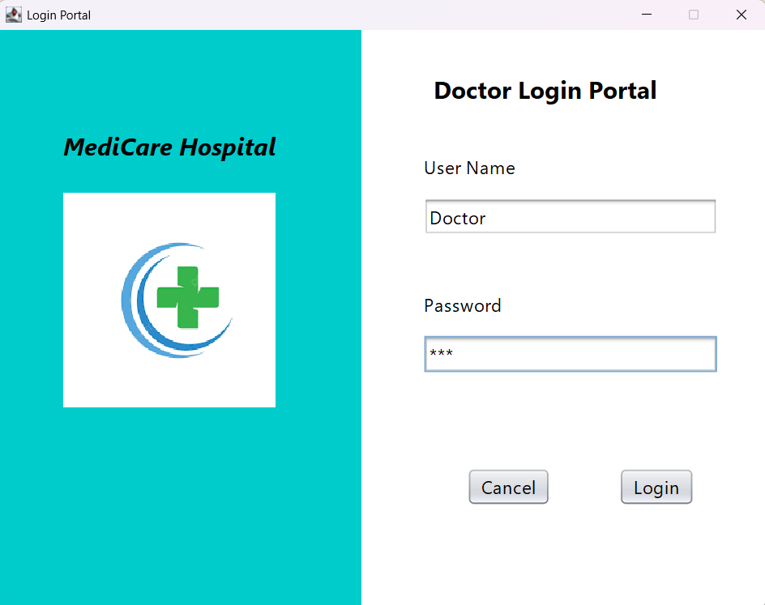
Figure 78: Input

Figure 78: Input

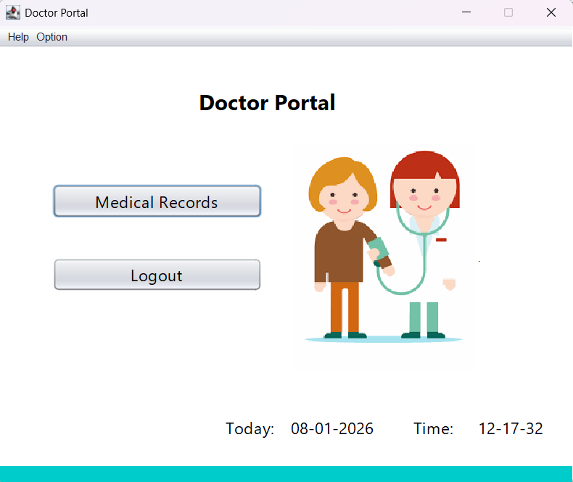
Figure 79: Result

Test Case 03: Check Medical Records interface

- Add Record button option
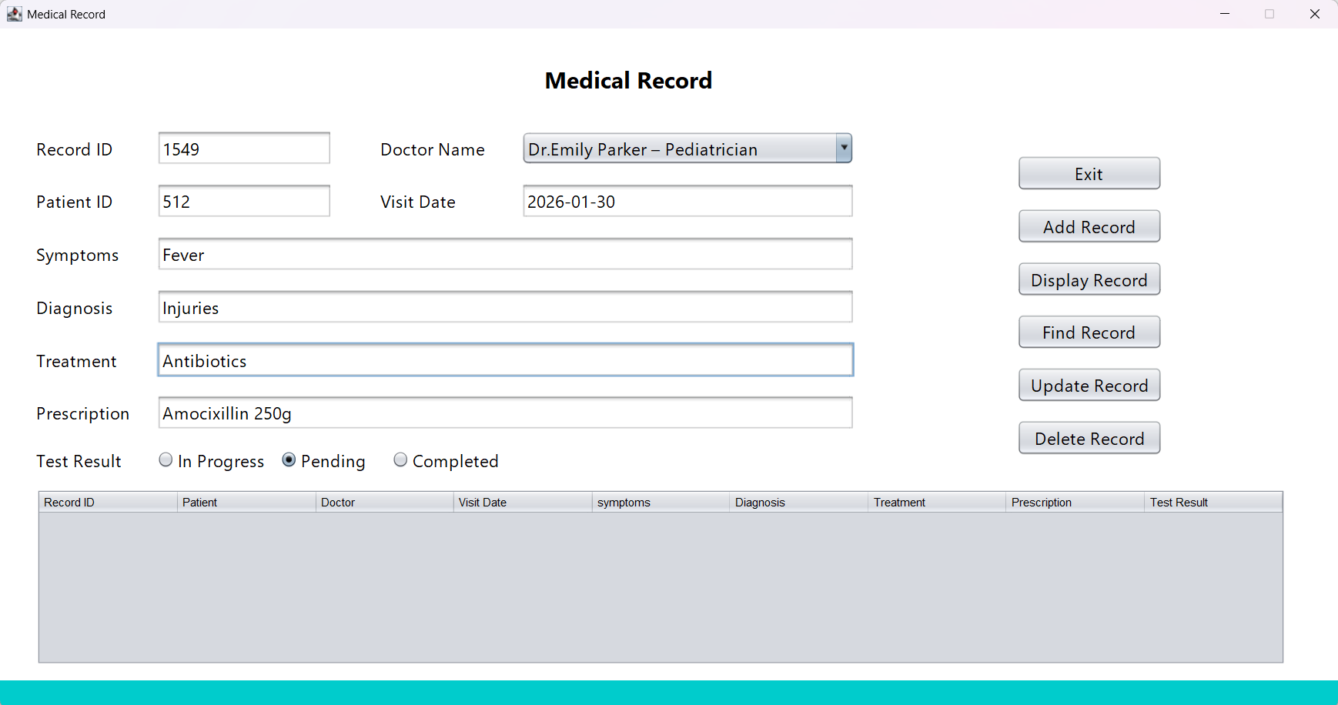
Figure 80: Inputs for Medical Records fields

Figure 80: Inputs for Medical Records fields
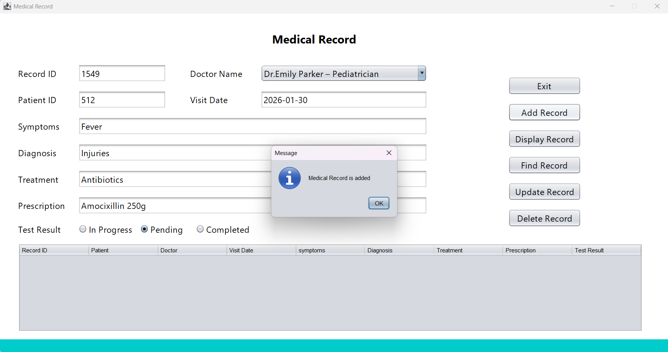
Figure 81: Add Record button result

Figure 81: Add Record button result

- Display Record button option
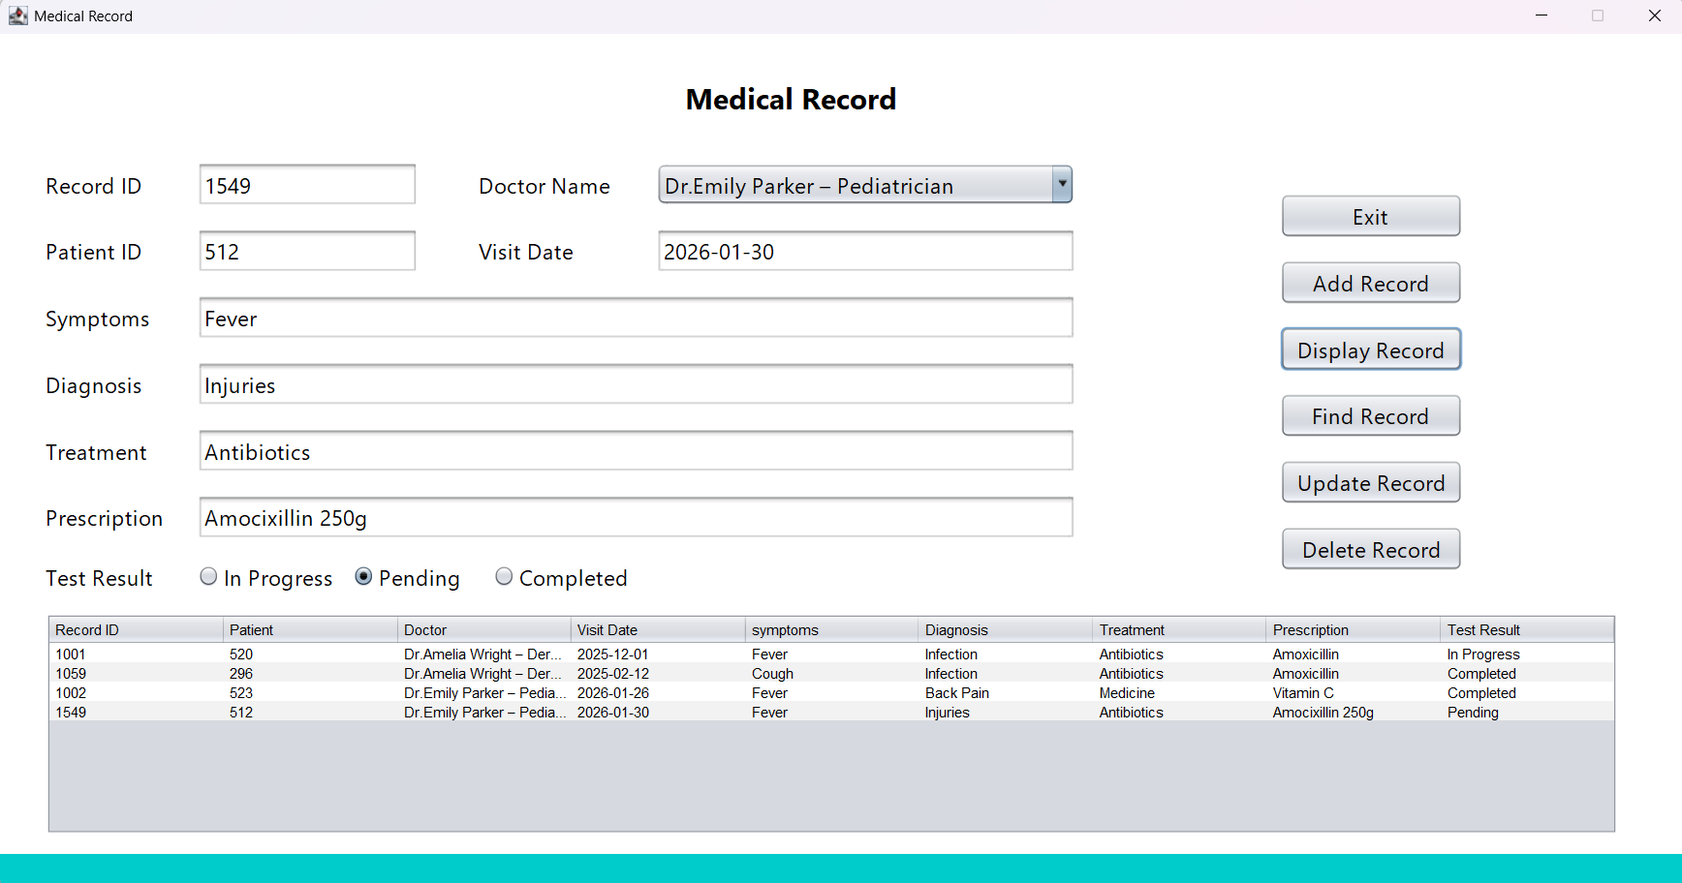
Figure 82: Display Record button result

- Find Record button option
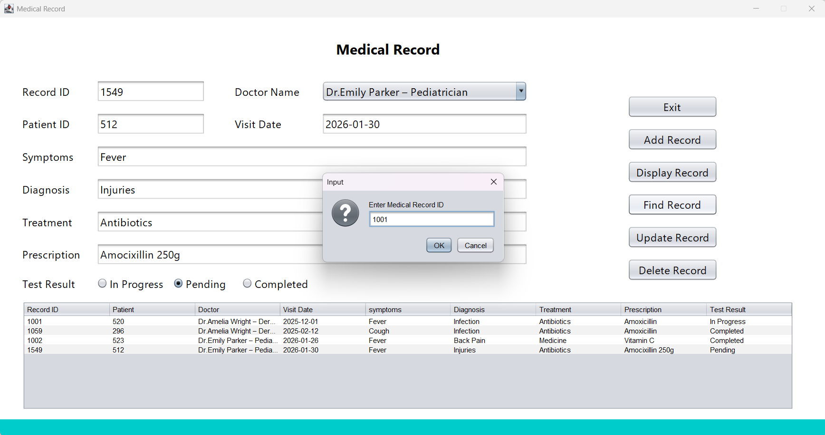
Figure 83: Input for Find Record button dialog box.

Figure 83: Input for Find Record button dialog box.

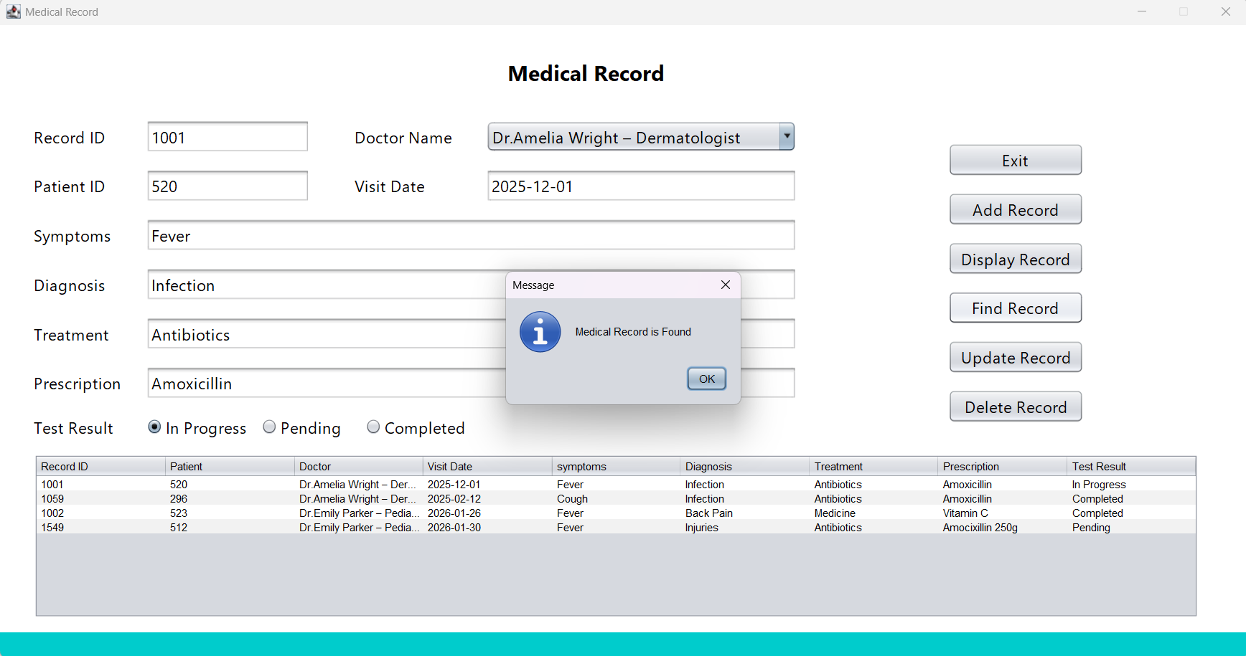
Figure 84: Output of Find Record button

Figure 84: Output of Find Record button

- Update Record button
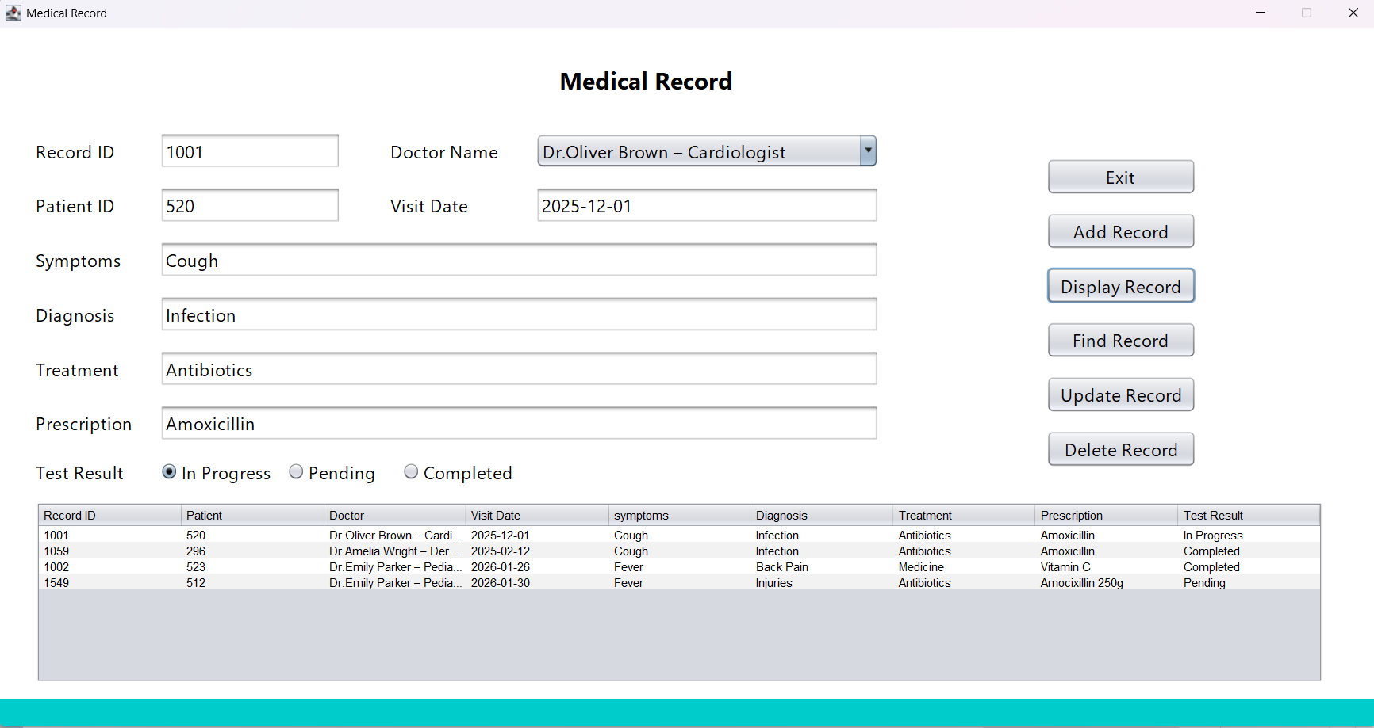
Figure 85: Update the fields

Figure 85: Update the fields

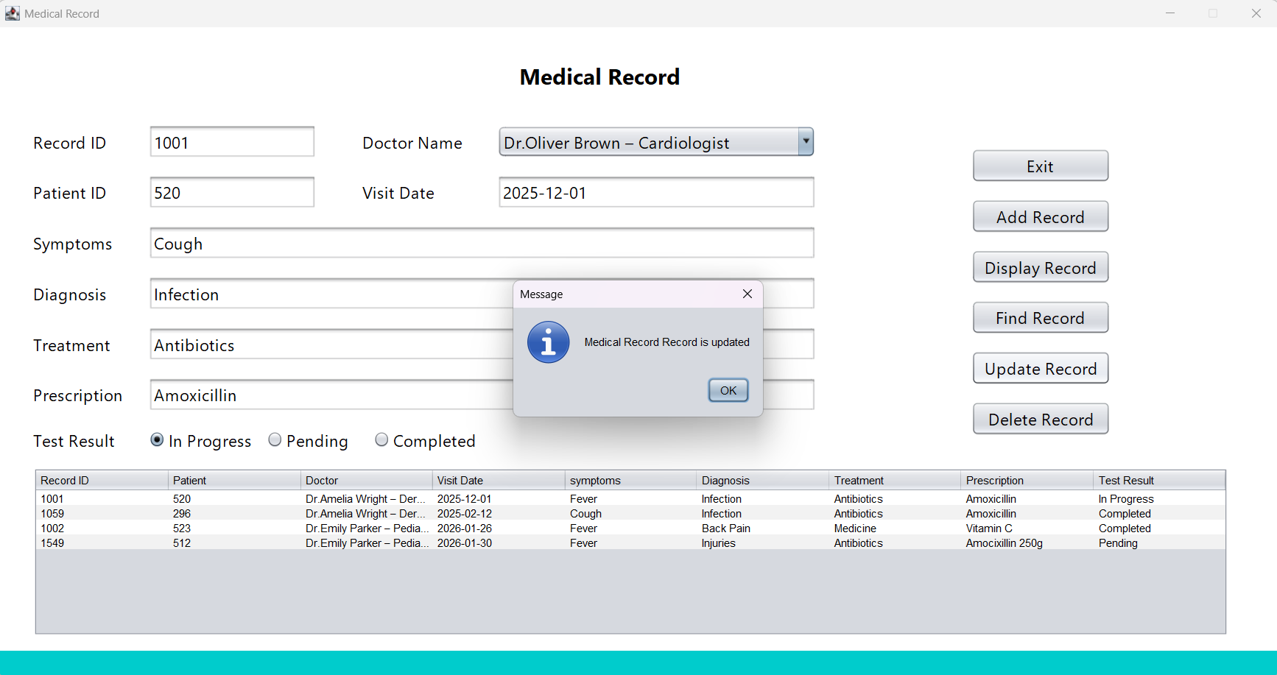
Figure 86: Result of Update Record button


Figure 87: Update the table

- Delete Record button
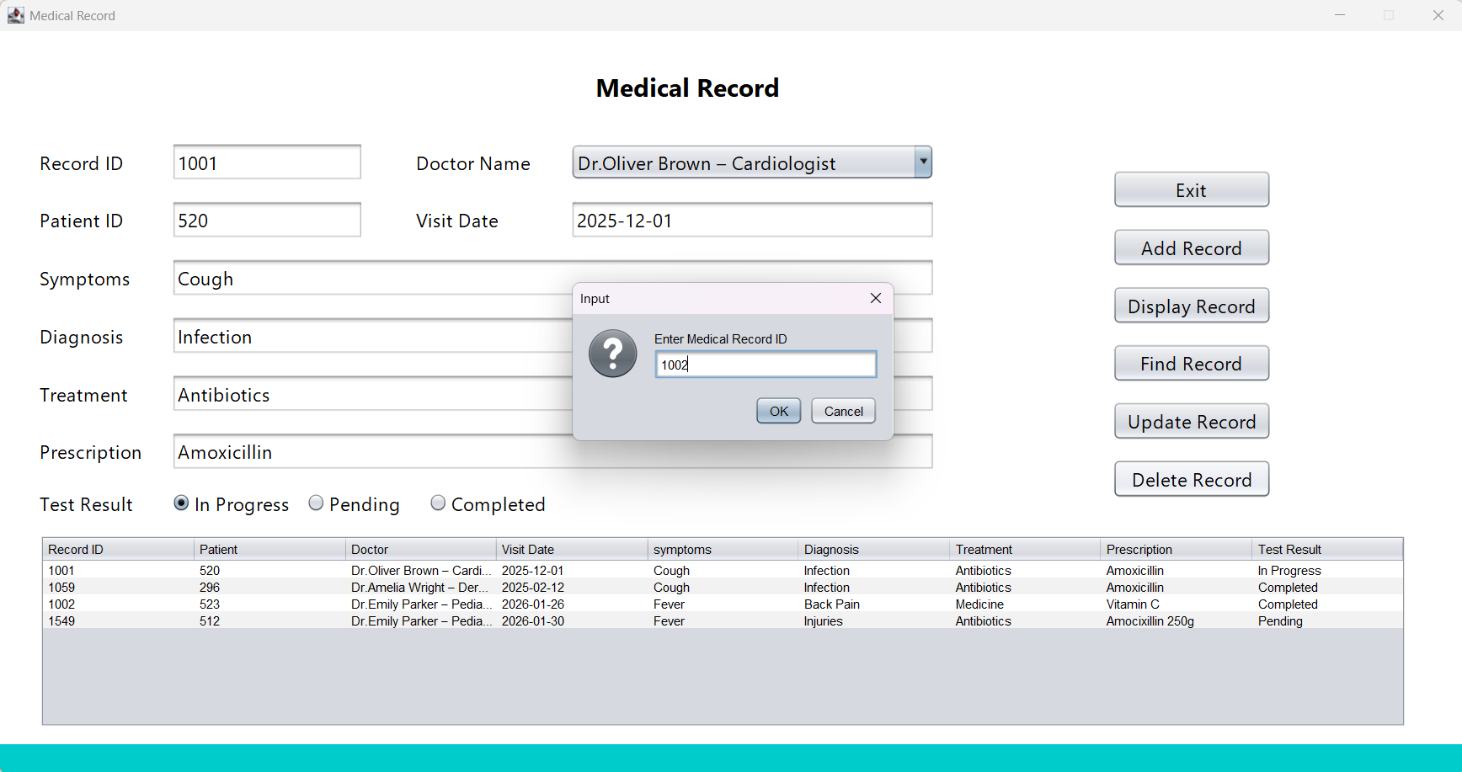
Figure 88: Input of Delete Record button

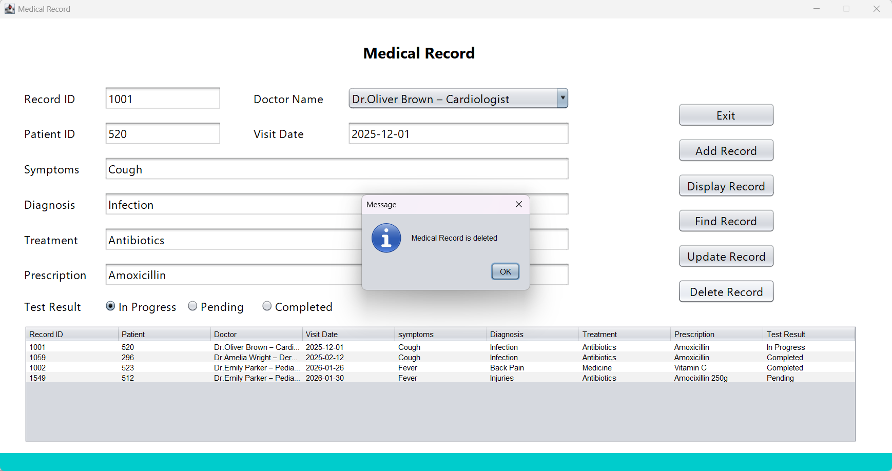
Figure 89: Confirmation dialog box of Delete Record button

Figure 89: Confirmation dialog box of Delete Record button

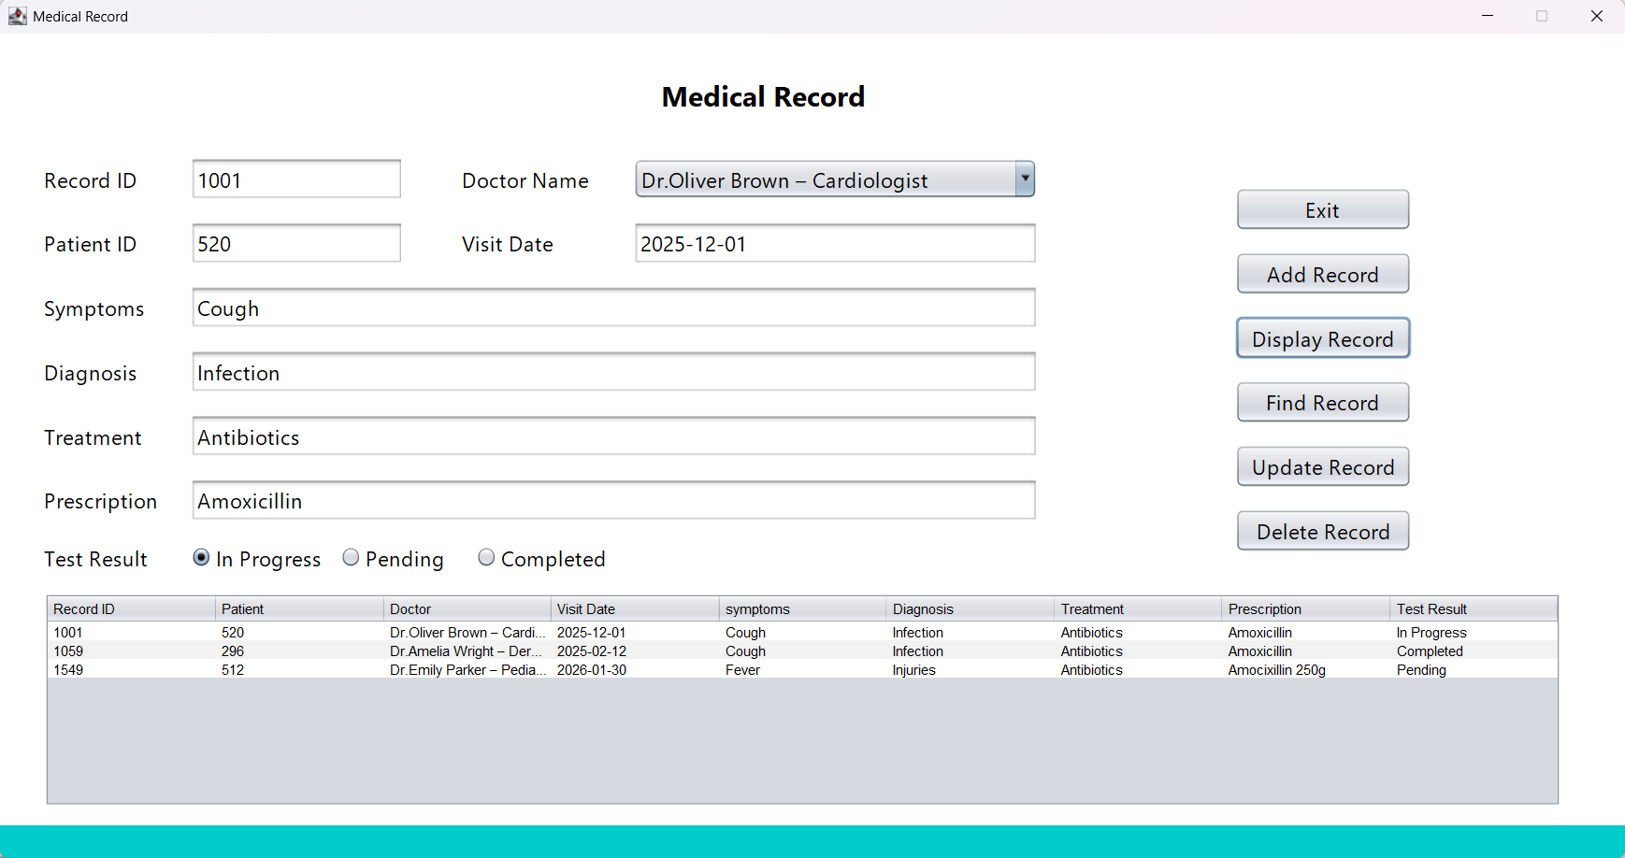
Figure 90: Before the record deleted

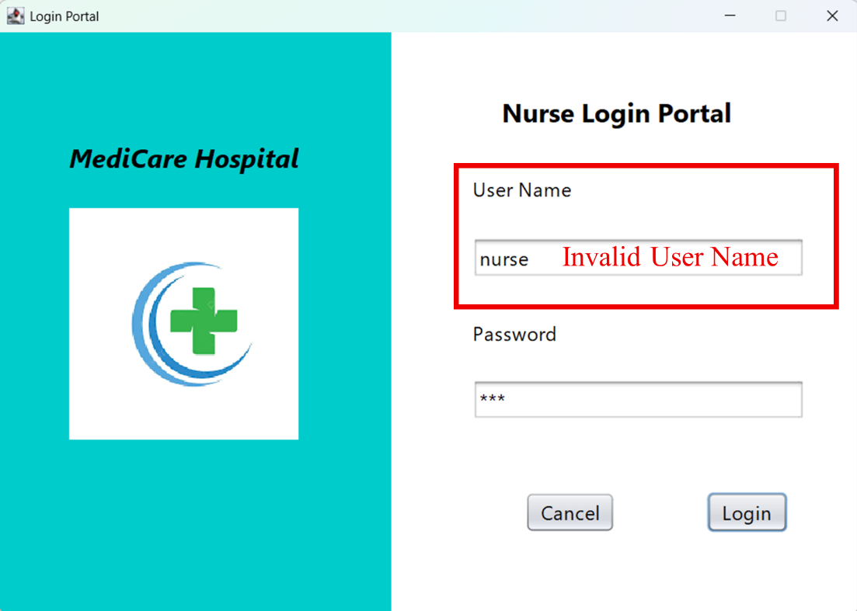
Test Case 04: System login as a nurse using an invalid User Name
Figure 91: User input

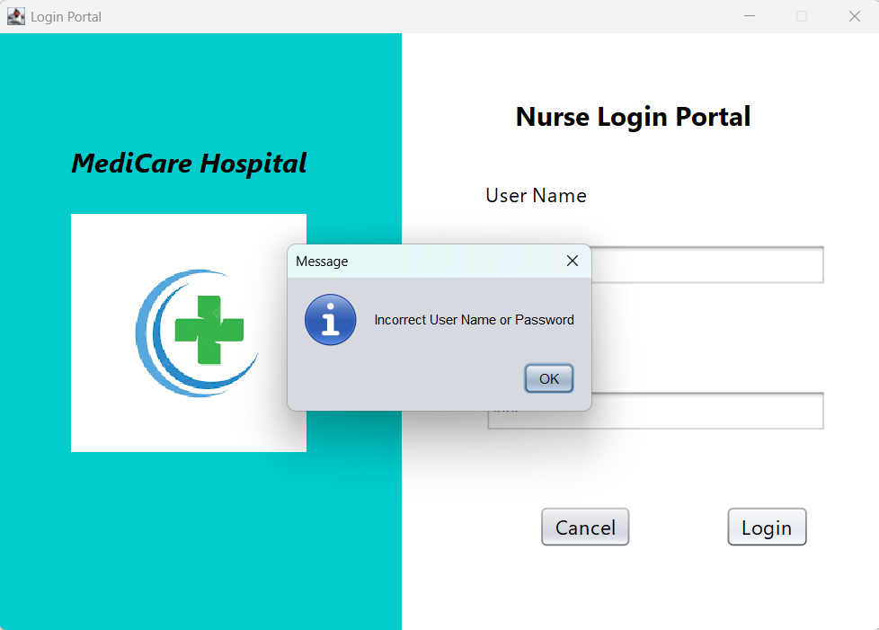
Figure 92: Result

Test Case 07: Check Lab Technician Portal
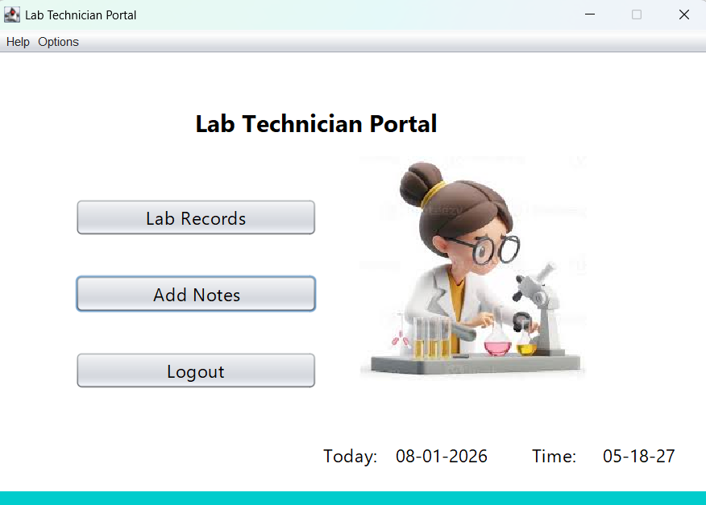
Figure 93: Click each button

Figure 93: Click each button

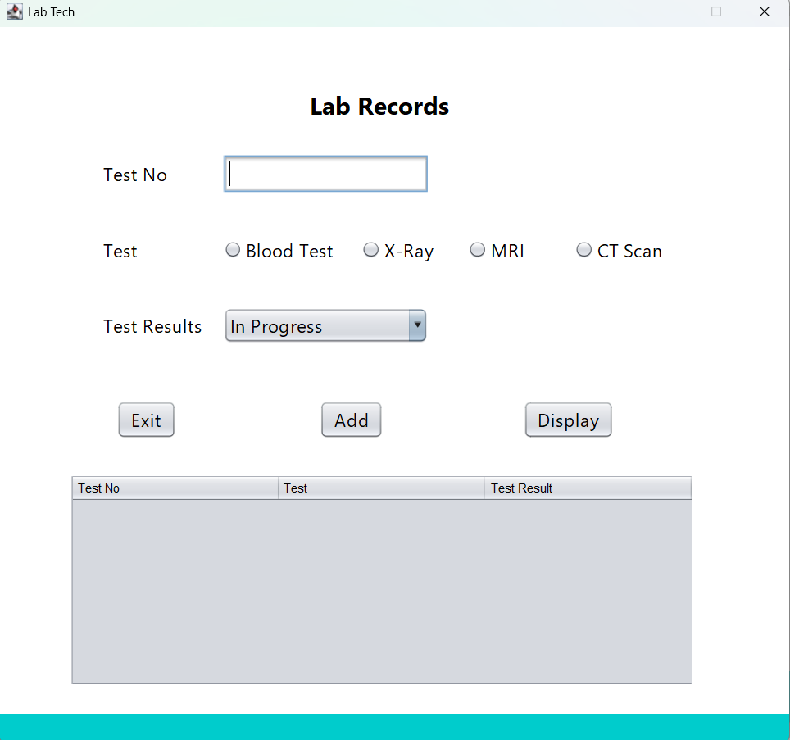
Figure 94: The Lab Records button is directed to the Lab Records Portal

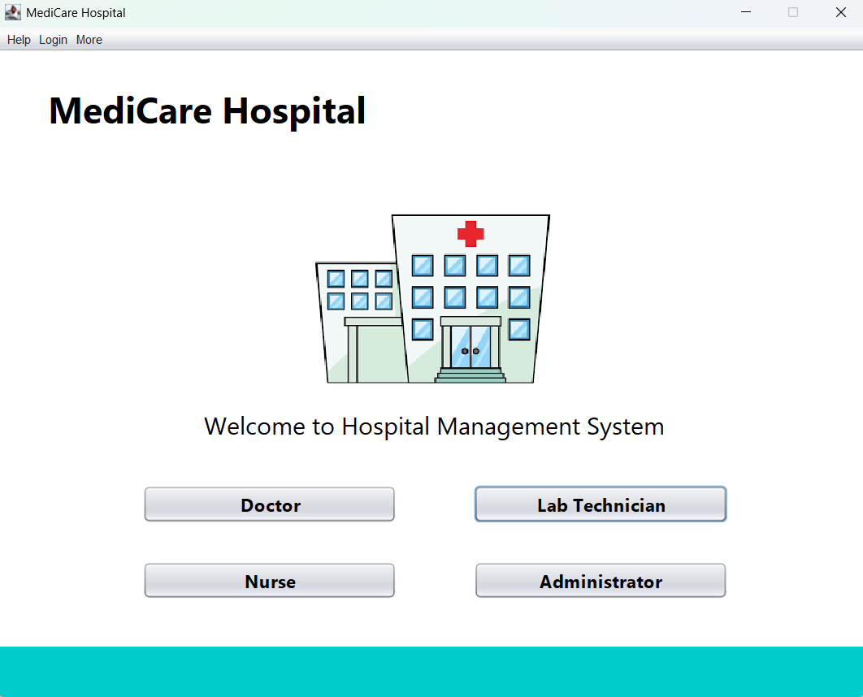
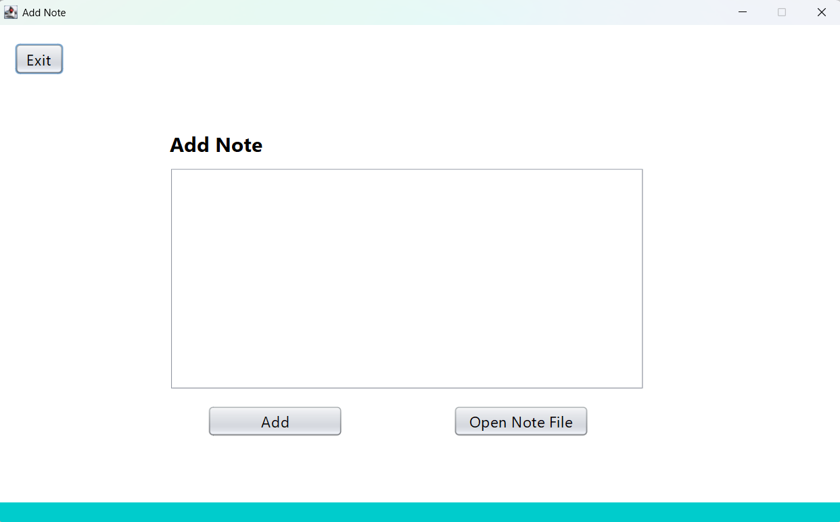
Figure 27: The Logout button is directed to the Main Login screen
Figure 26: The Add Notes button is directed to the Add Note Portal

Figure 26: The Add Notes button is directed to the Add Note Portal

Test Case 08: Check Admin Portal Menu Bar
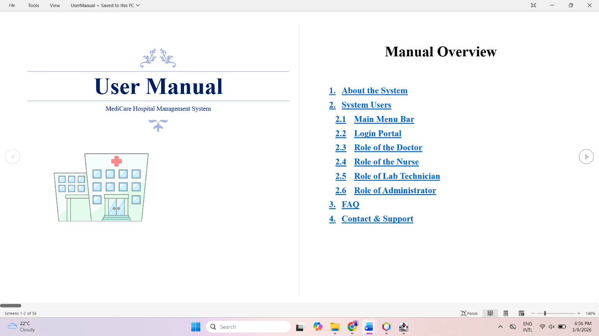
Figure 95: Ctrl+H directed to the UserManual.doc

Test Case 09: Find a patient in the Create Patient Profile interface
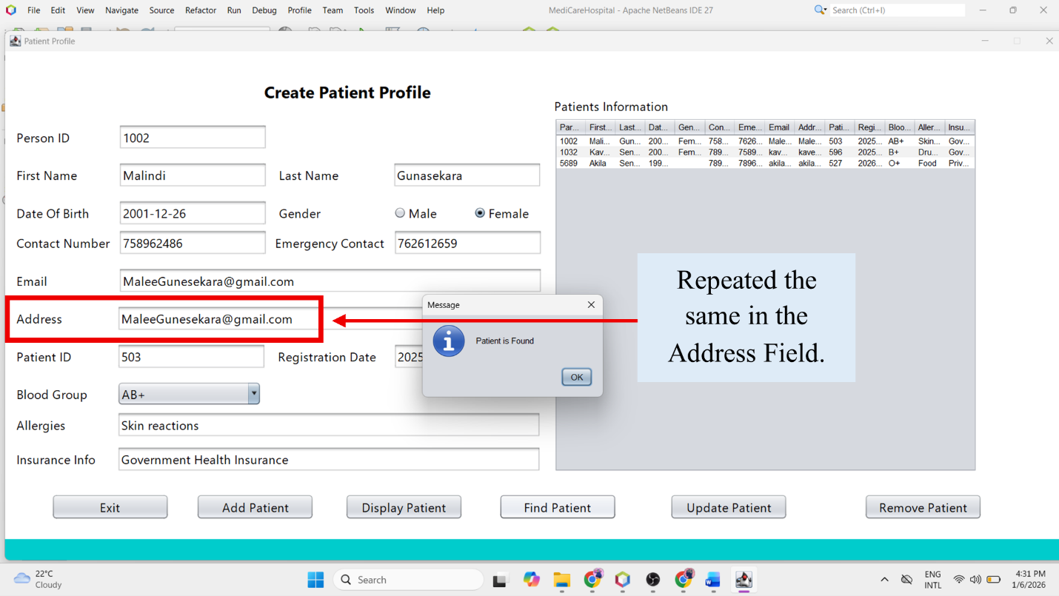
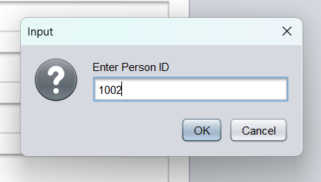
Figure 97: Actual Result
Figure 98: Input

Figure 98: Input


Figure 96: Ctrl+Shift+L directed to the Main Login Screen

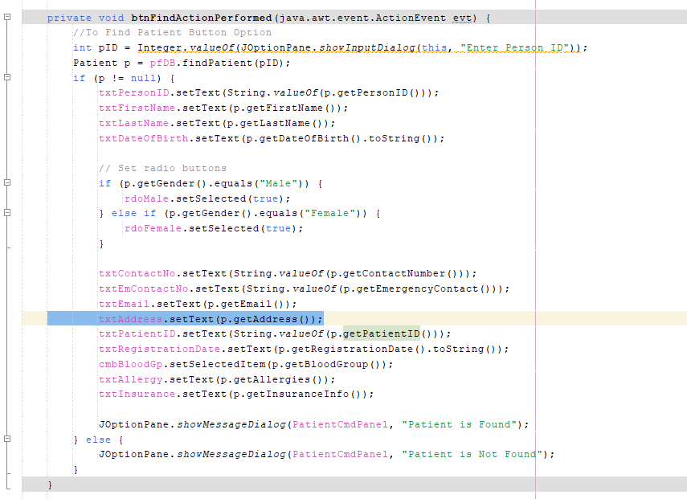
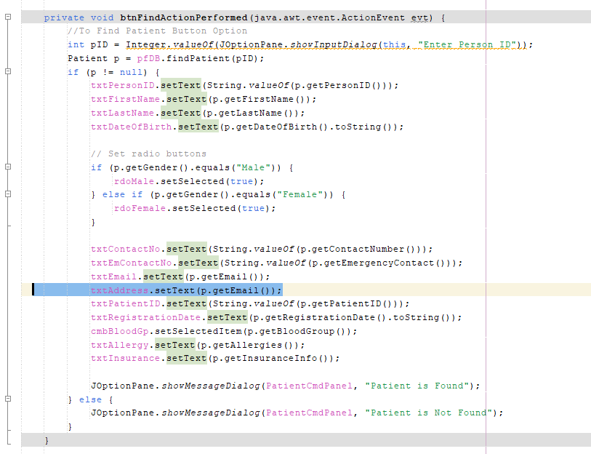
The error was found in the PatientProfile.java class. It was a logical error.
Figure 99: Error Corrected
Figure 100: Error

Figure 100: Error

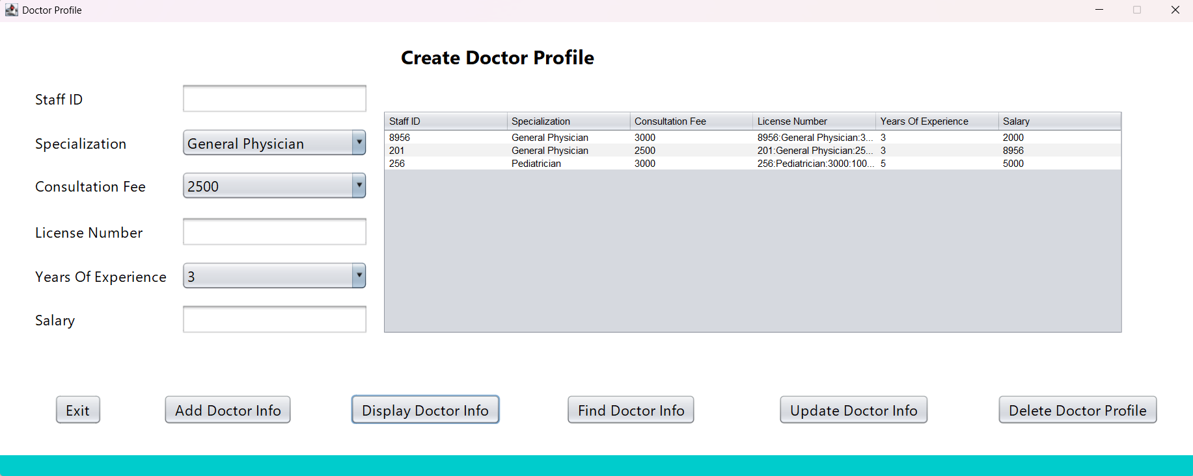
Test Case 10: Check the Create Doctor Profile
Figure 101: Actual Result

Figure 101: Actual Result

The error was found in the DoctorFileDB.java class. It was a logical error.
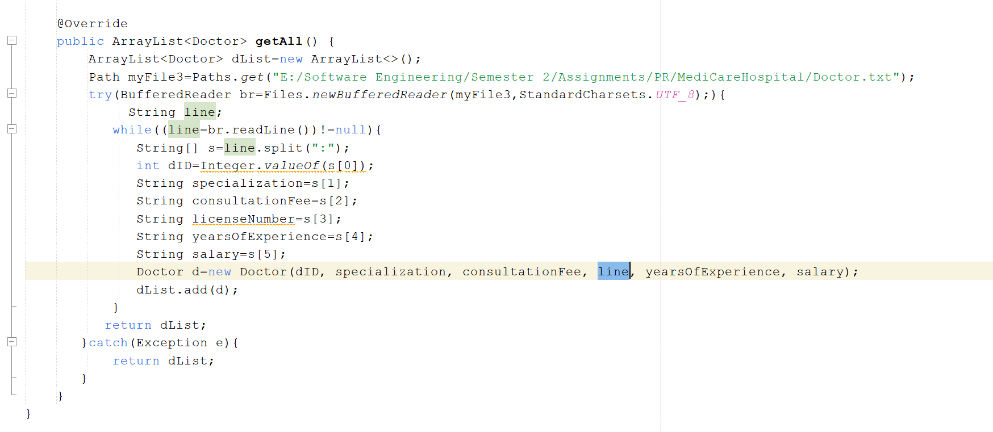
Figure 102: Error

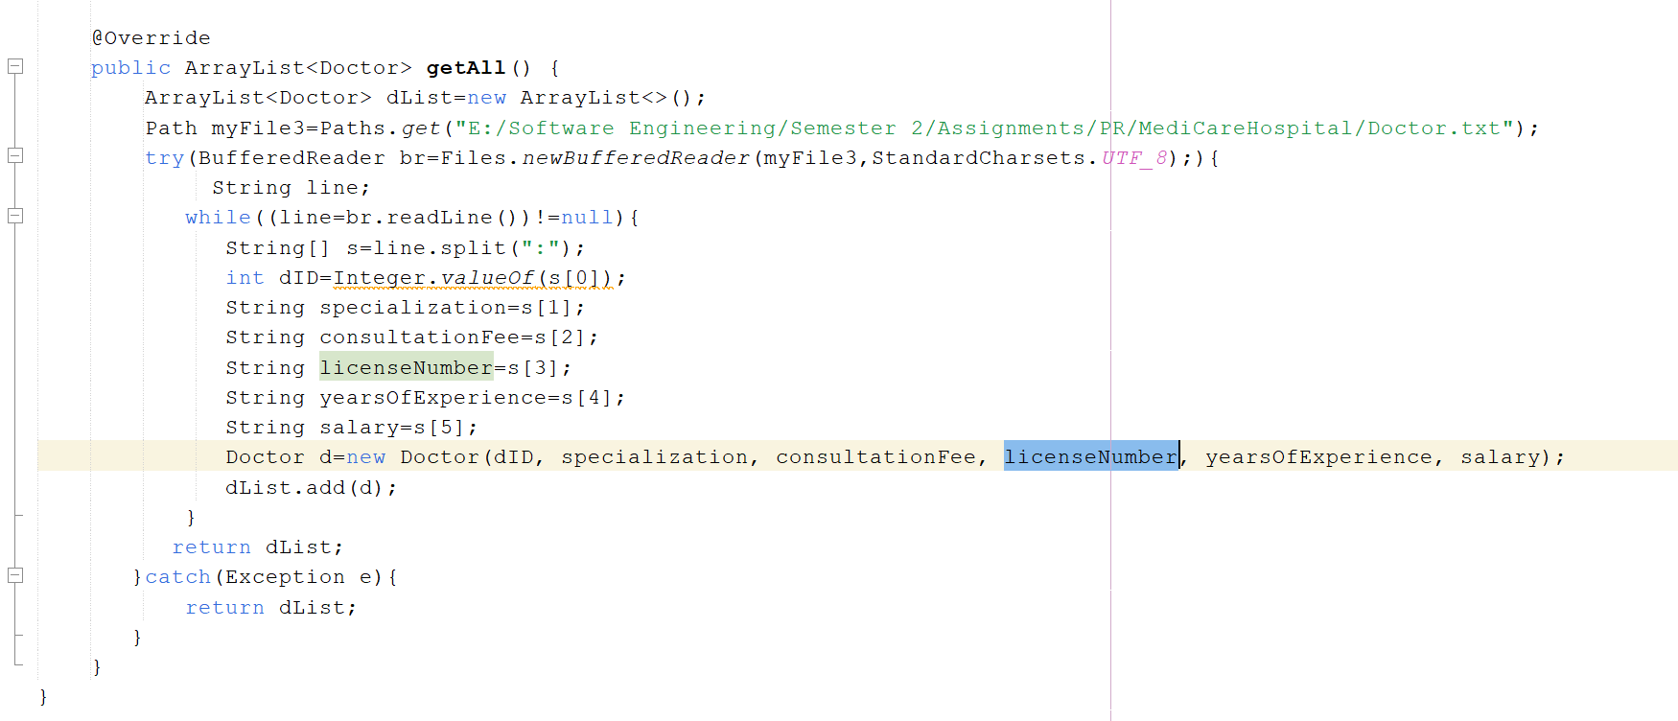
Figure 103: Error Corrected

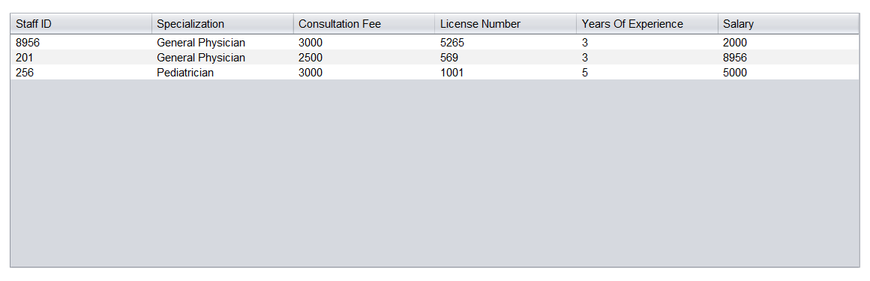
Figure 104: Final Result

Test Case 11: Check the Medical Staff Profile interface.
Refer to the Test case 11 execution video.

Test Case 12: Check the Send Reminder button
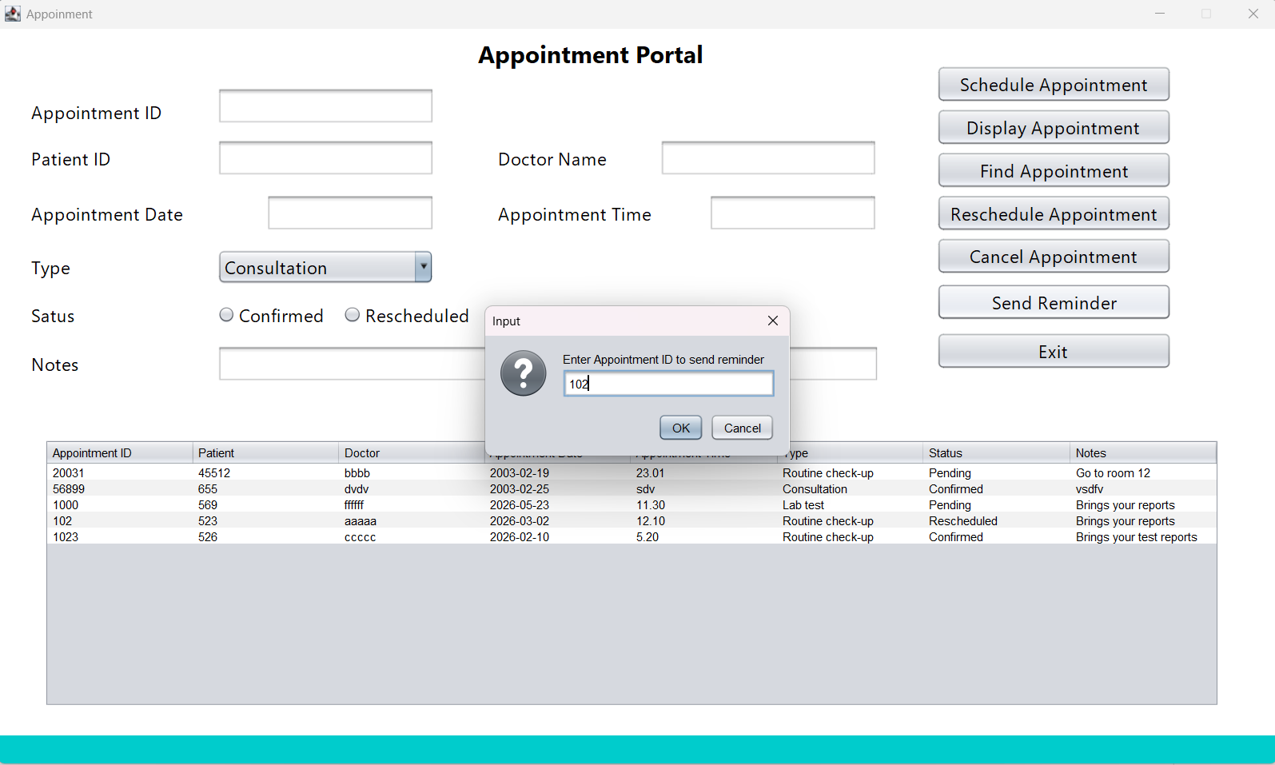
Figure 105: Input Appointment ID as 102 to send reminder

Figure 105: Input Appointment ID as 102 to send reminder

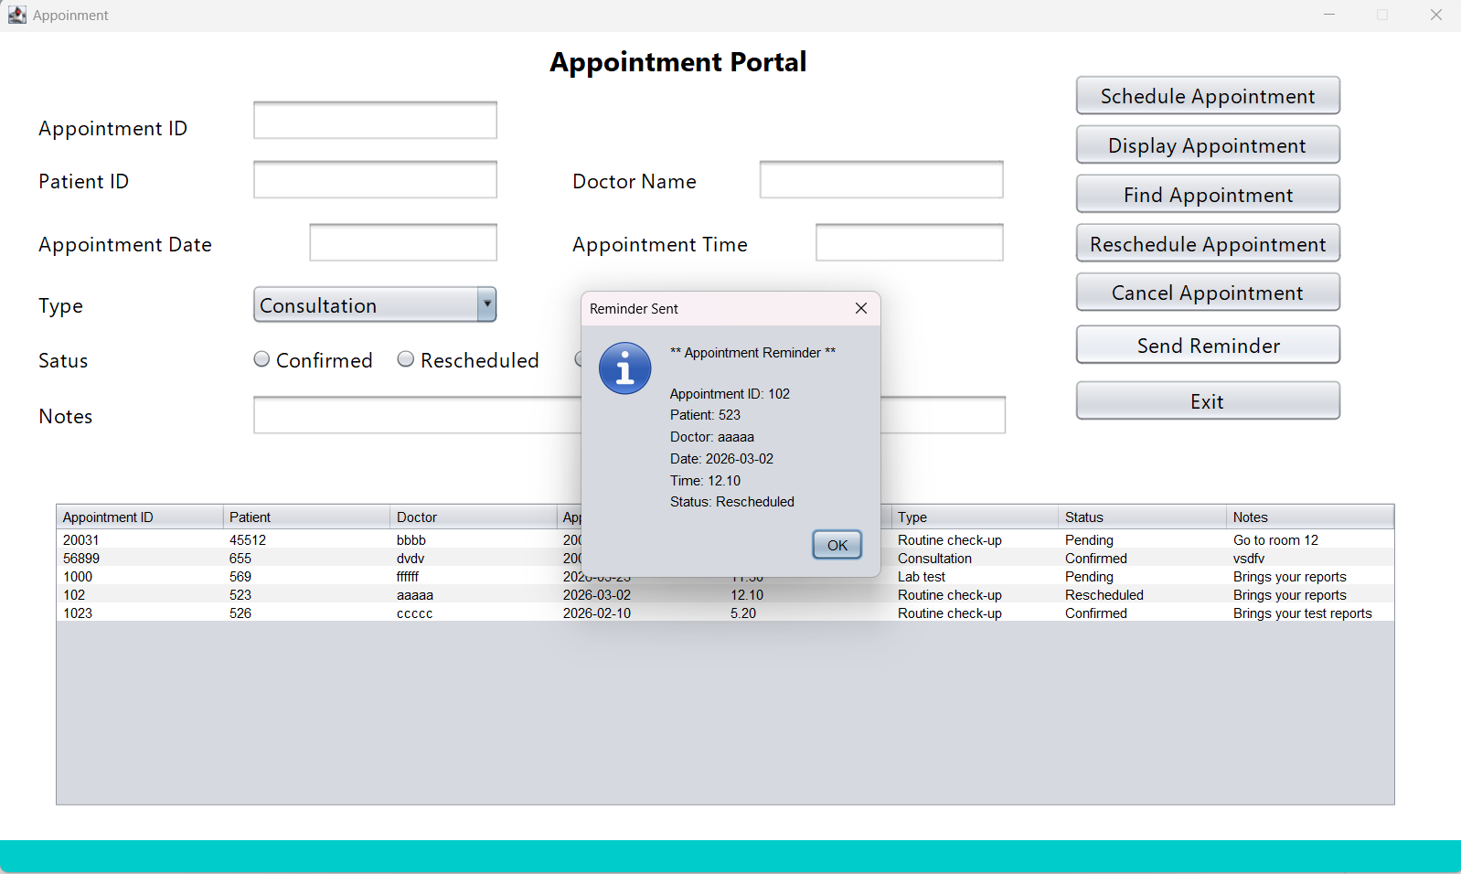
Figure 106: Missing Notes in the reminder

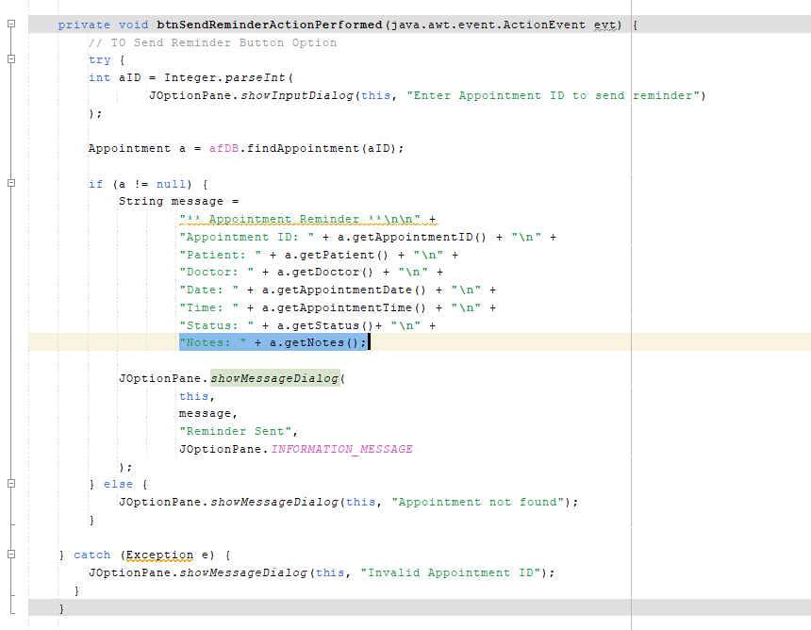
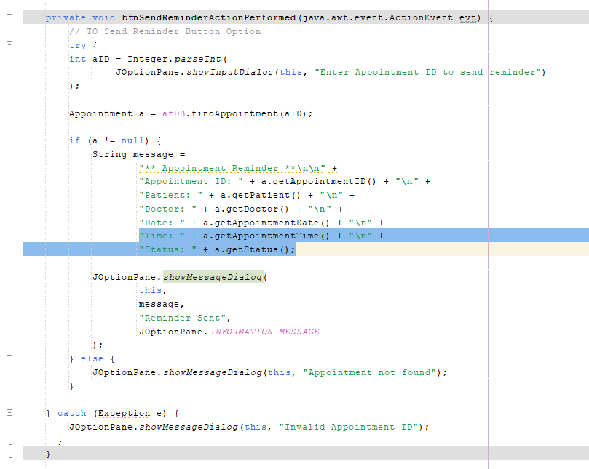
Figure 107: Error fixed
Figure 108: Error is found in the AppointUI.java class

Figure 108: Error is found in the AppointUI.java class
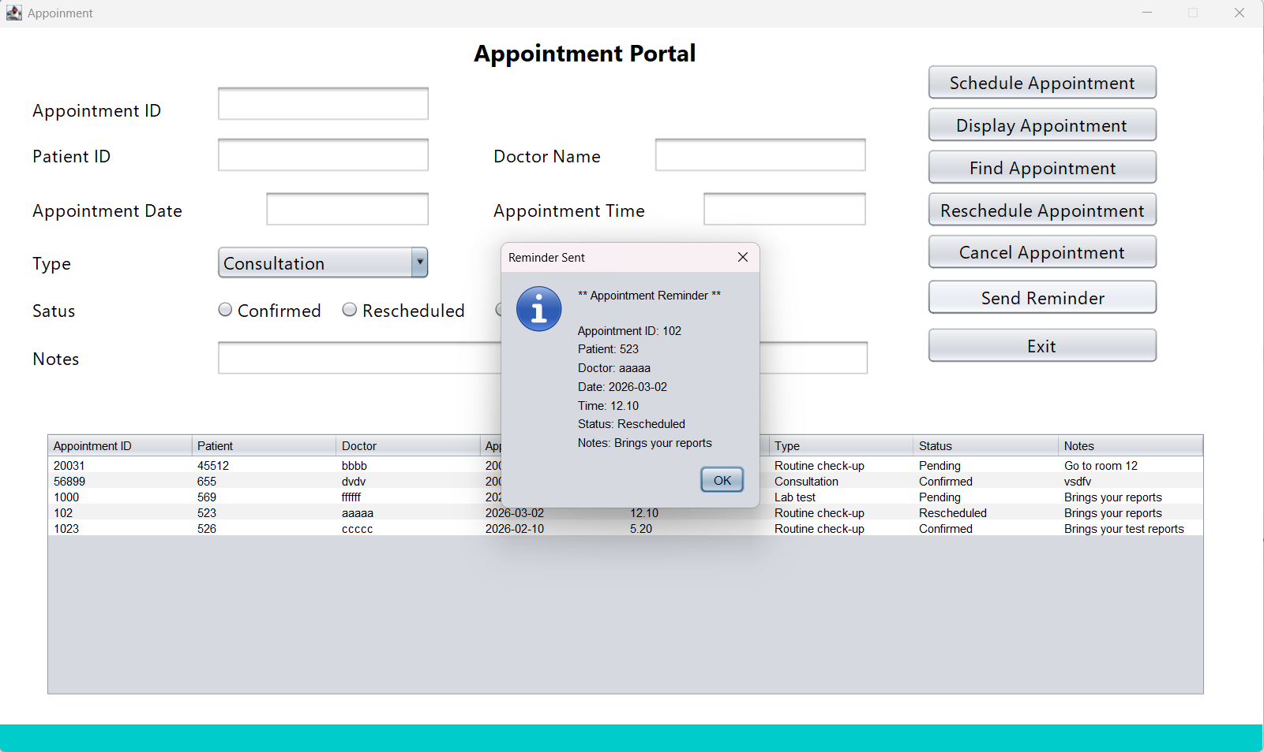
Figure 109: Final result

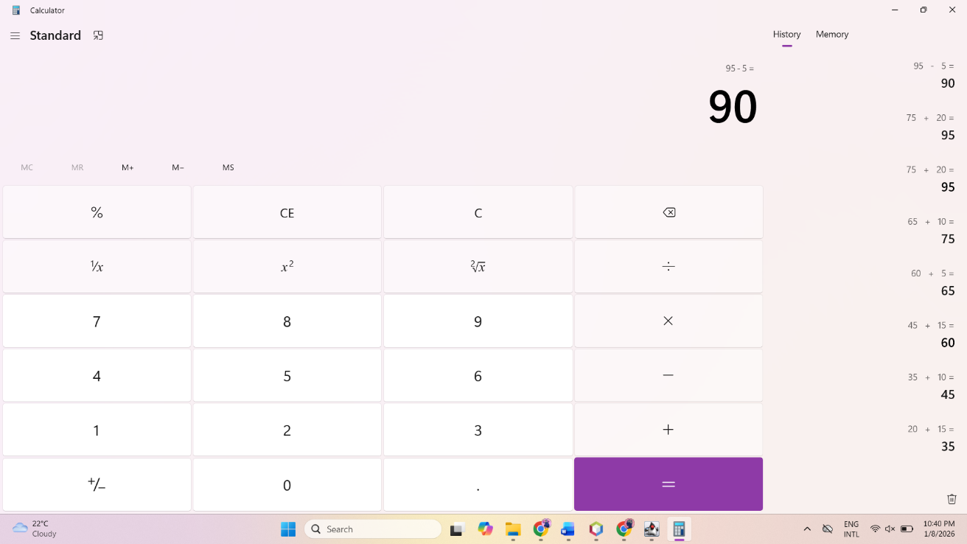
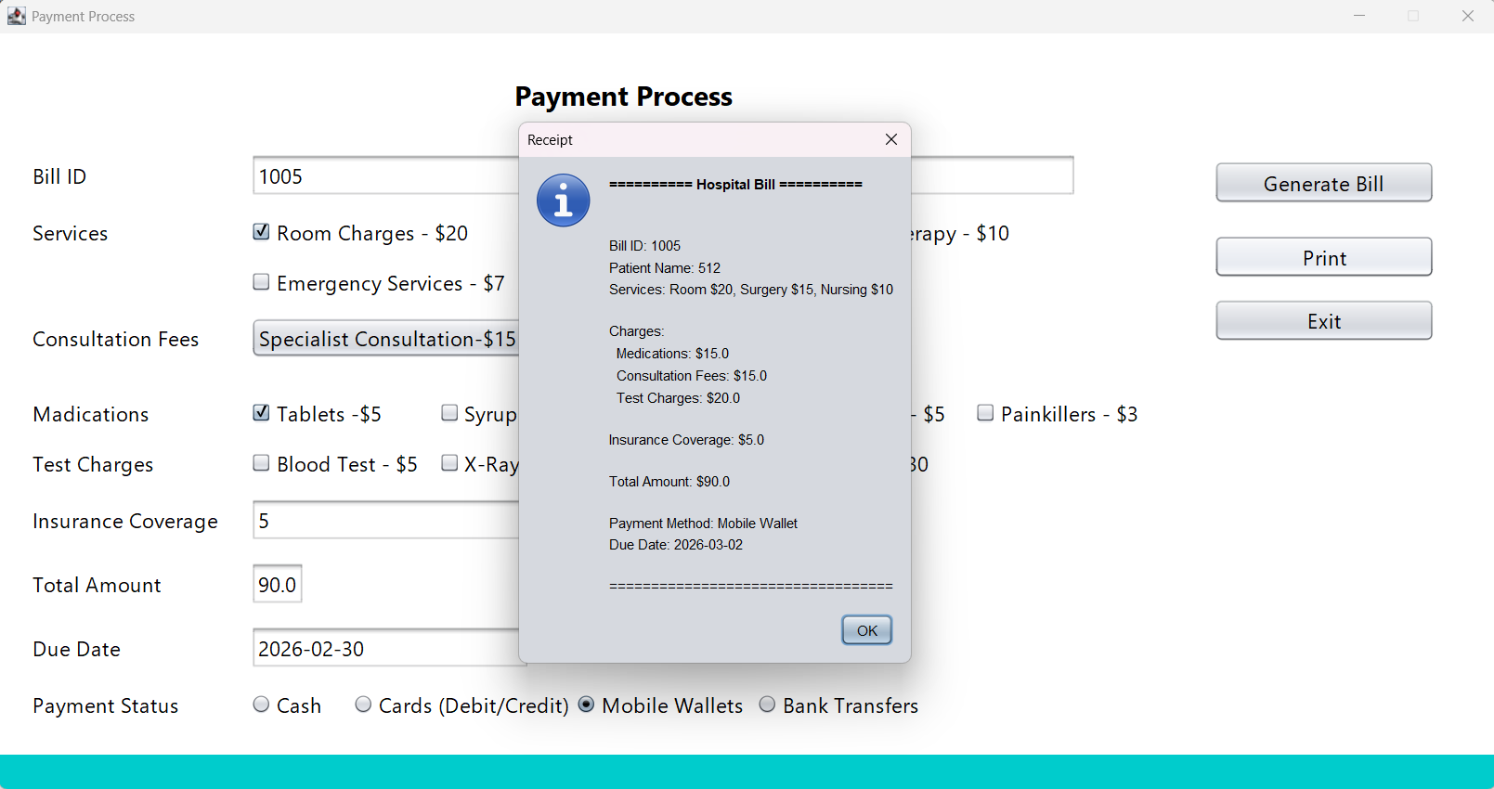
Test Case 13: Print the bill
Figure 110: Manual Total Amount
Figure 111: System Total Amount

Figure 111: System Total Amount

