Excercise:
Take an interger array of 10*4, 105, 10*6 elements.
Try accessing the array elements using np 1,2,4 and tell me the run total run_time for this accessing elements.

nano taskmpi.c
#include <stdio.h>
#include <stdlib.h>
#include <mpi.h>
int main(int argc, char *argv[]) {
int rank, size;
long N = atol(argv[1]); // Take array size from command line
MPI_Init(&argc, &argv);
MPI_Comm_rank(MPI_COMM_WORLD, &rank);
MPI_Comm_size(MPI_COMM_WORLD, &size);
long local_n = N / size;
int *arr = (int*) malloc(local_n * sizeof(int));
// Initialize local array
for(long i = 0; i < local_n; i++)
arr[i] = 1;
long long local_sum = 0;
double start = MPI_Wtime();

// Access elements
for(long i = 0; i < local_n; i++)
local_sum += arr[i];
double end = MPI_Wtime();
double local_time = end - start;
double total_time;
MPI_Reduce(&local_time, &total_time, 1, MPI_DOUBLE, MPI_MAX, 0, MPI_COMM_WORLD);
if(rank == 0) {
printf("Array Size = %ld, Processes = %d, Total Run Time = %f seconds\n",
N, size, total_time);
}
free(arr);
MPI_Finalize();
return 0;
}
OUTPUT
10**4
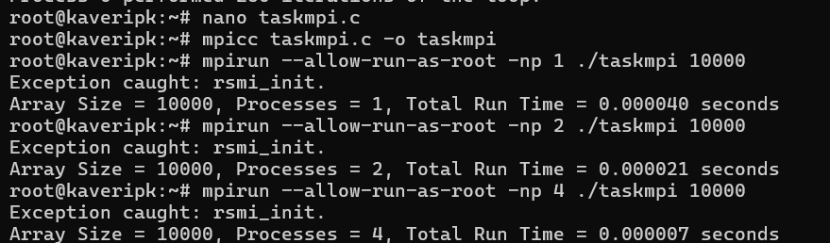
10**5
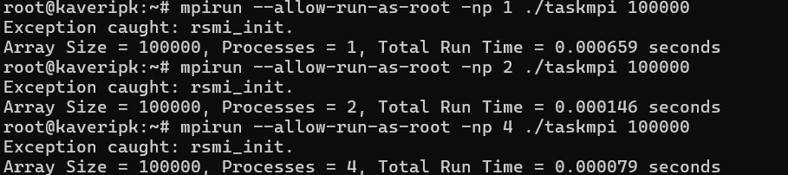
10**6
