PENETRATION TESTING REPORT
Mediroza General Hospital
Black-Box Web Application Security Assessment

Engagement Detail | Value
Target | https://medirozahospital.com
Assessment Type | Authorized black-box web application penetration test
Assessment Objective | Identify and validate security weaknesses and document evidence
Scope | Authorized Mediroza Hospital web application/domain
Assessment Approach | Footprinting → Initial Access → Data Extraction → Critical Data Exposure → Reporting
Milestones | M1 Initial Access | M2 Data Extraction | M3 Critical Data Exposure | M4 Reporting
Evidence | Screenshots supplied from the assessment workflow
Date | 30 September – 1 October 2026

CONFIDENTIAL
This report contains security-test evidence and screenshots that may display sensitive information. Distribution should be limited to authorized recipients.

1. Executive Summary
An authorized black-box penetration test was performed against the Mediroza General Hospital web application. The assessment progressed through footprinting, controlled authentication testing, retrieval of protected laboratory reports, password recovery validation, and investigation of publicly exposed directories and a historical database backup.
Assessment outcome: The supplied evidence supports successful completion of M1 (Initial Access), M2 (Data Extraction), and M3 (Critical Data Exposure), followed by M4 reporting.

1.1 Principal Security Findings
ID | Finding | Severity | Milestone
F-01 | SQL Injection / Authentication Bypass | Critical | M1
F-02 | Publicly Accessible Historical Database Backup | Critical | M3
F-03 | Weak Password Protection on Patient PDF Reports | High | M2
F-04 | Directory Listing Enabled on Sensitive Paths | High | M3
F-05 | Username / Authentication Information Disclosure | Medium | M1

1.2 Business Impact
- Unauthorized access to patient-facing functionality was demonstrated during the assessment.
- Three designated laboratory-report PDFs were obtained as part of the controlled assessment workflow.
- The supplied evidence demonstrates successful dictionary-based recovery of PDF passwords.
- A historical SQL database backup was publicly discoverable through the /old/ directory.
- The exposed backup contained staff records and a separate shareholder dataset, increasing the potential confidentiality impact.
- Directory listings exposed application filenames and paths, increasing reconnaissance value to an attacker.

2. Scope and Rules of Engagement
Category | Details
In Scope | Authorized Mediroza Hospital web application/domain
Testing Type | Black-box penetration testing
Social Engineering | Out of scope
Denial of Service | Out of scope
Third-Party Systems | Out of scope unless explicitly part of the authorized target
Evidence Handling | Screenshots and recovered evidence treated as confidential

The report is based on the screenshots supplied for the assessment. It does not infer vulnerabilities that are not supported by the supplied evidence.

3. Methodology
The assessment was organized around the user's milestone workflow and the supplied evidence:
Phase | Objective | Evidence Outcome
Footprinting | Collect publicly observable application and domain information | robots.txt, HTTP headers, WHOIS
M1 – Initial Access | Validate authentication and application access controls | Patient Portal test and access to reports
M2 – Data Extraction | Assess protection of retrieved documents | Password-recovery evidence and recovered reports
M3 – Critical Data Exposure | Identify exposed sensitive information and insecure directories | Database backup, patient/staff directories, staff/shareholder tables
M4 – Reporting | Document findings, evidence, impact, and remediation | This report

4. Footprinting / Reconnaissance
Footprinting was performed before exploitation to identify publicly observable information and application paths. The supplied screenshots show robots.txt contents, HTTP response headers, and WHOIS information.

4.1 Robots.txt Review
The robots.txt response disclosed references to /patient/, /staff/, and /old/. These paths were subsequently relevant to the assessment.
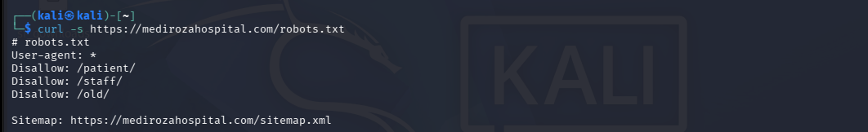
Figure 1 — Footprinting evidence: robots.txt discloses /patient/, /staff/, and /old/ paths.

4.2 HTTP Response Headers
The supplied header capture records a successful HTTP response and identifies the web-server technology information visible in the response.
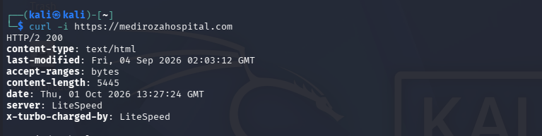
Figure 2 — Footprinting evidence: HTTP response headers from the target.

4.3 WHOIS Information
WHOIS information was collected as part of domain-level footprinting. This provided registration and nameserver information visible through the WHOIS record.
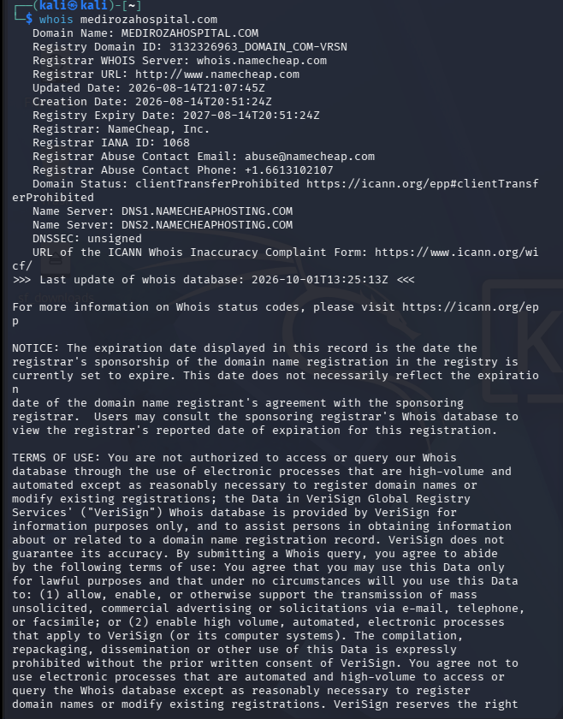
Figure 3 — Footprinting evidence: WHOIS information for the target domain.

4.4 Additional robots.txt Capture
Figure 4 — Additional capture of the robots.txt footprinting result.

5. M1 – Initial Access: SQL Injection / Authentication Testing
The first milestone focused on the patient portal authentication workflow. The supplied evidence shows a controlled SQL-injection-style input being entered into the username field and subsequent access to the patient-report area.

5.1 Authentication Test
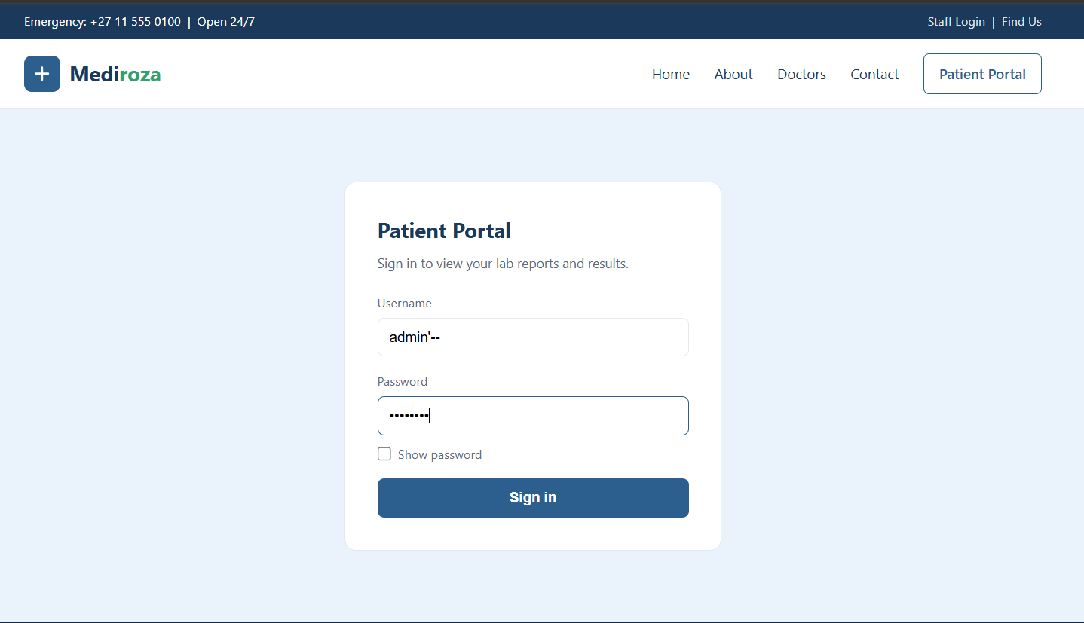
Figure 5 — Patient Portal screenshot showing the controlled authentication-input test.

5.2 Initial Access Result
Following the authentication test, the supplied evidence shows access to the authenticated patient-report interface. The page lists three password-protected pathology reports available for download.
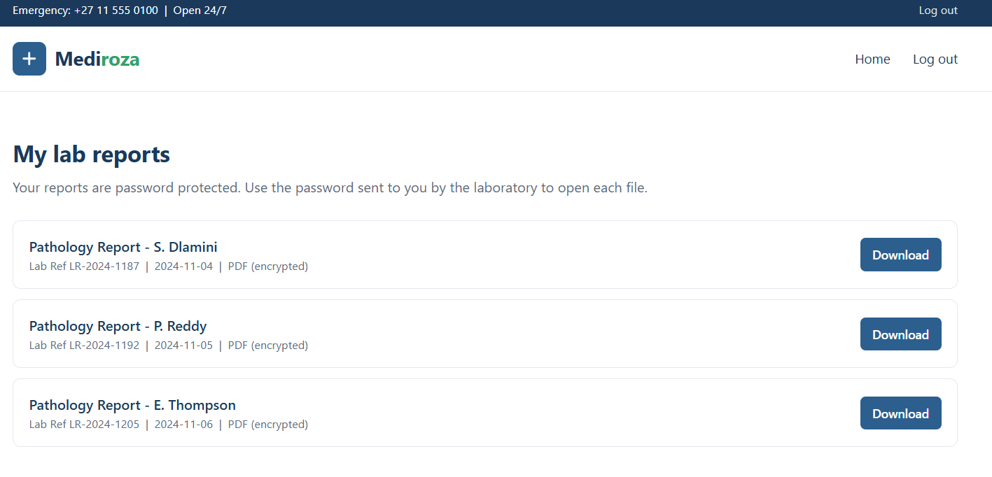
Figure 6 — Authenticated patient-report page showing three protected pathology reports.

Finding F-01 – Critical: The supplied evidence supports an authentication weakness consistent with SQL injection leading to unauthorized access to authenticated functionality.

5.3 Security Impact
- Authentication controls can potentially be bypassed.
- Protected patient-report functionality became accessible.
- The vulnerability creates a pathway from an input-validation weakness to sensitive-data exposure.

5.4 Remediation
- Use parameterized queries / prepared statements for all database operations.
- Do not concatenate untrusted input into SQL statements.
- Apply server-side input validation and centralized authentication controls.
- Return generic authentication failure messages.
- Add automated security regression tests for login and authentication endpoints.
- Review application and database logs for evidence of exploitation.

6. M2 – Data Extraction: PDF Password Protection
After the patient-report area was accessed, the next milestone assessed the protection applied to the downloaded PDF documents. The supplied evidence shows successful dictionary-based password recovery against PDF files.

6.1 Password Recovery Evidence
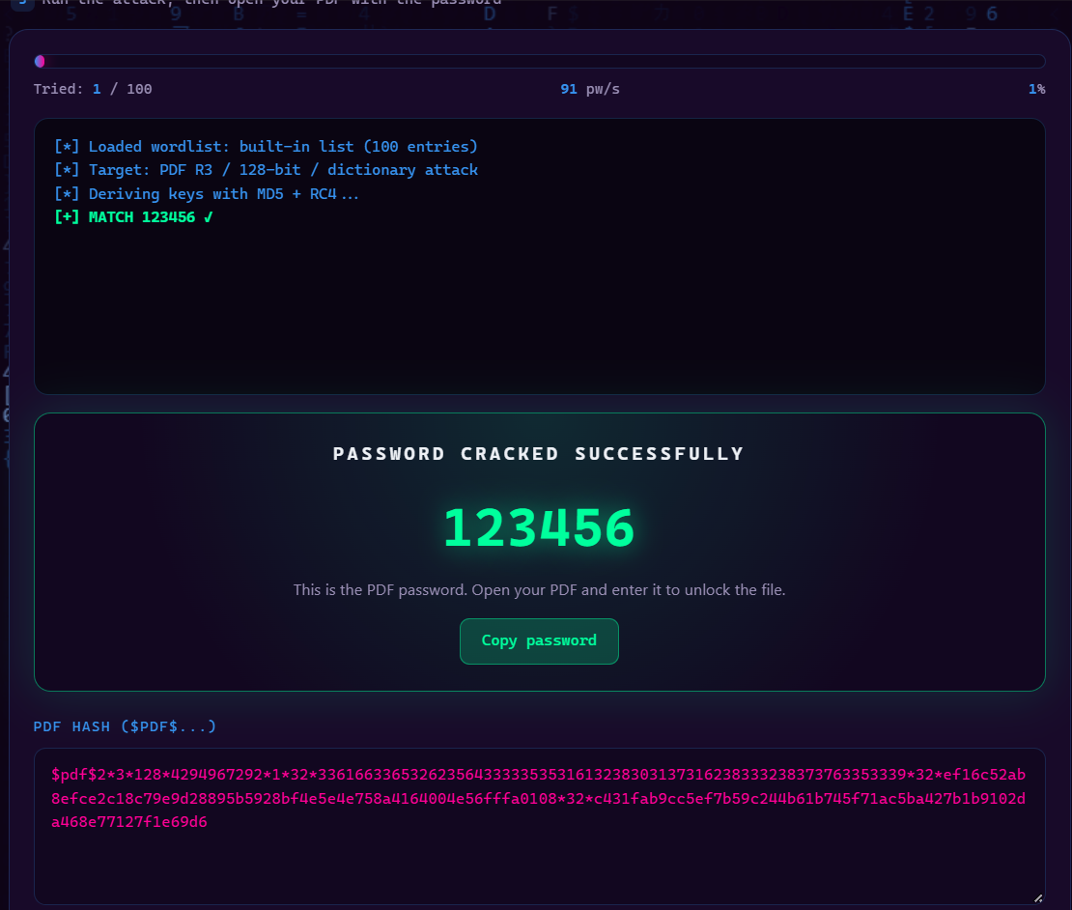
Figure 7 — Password-recovery evidence showing a successful dictionary match for a PDF.

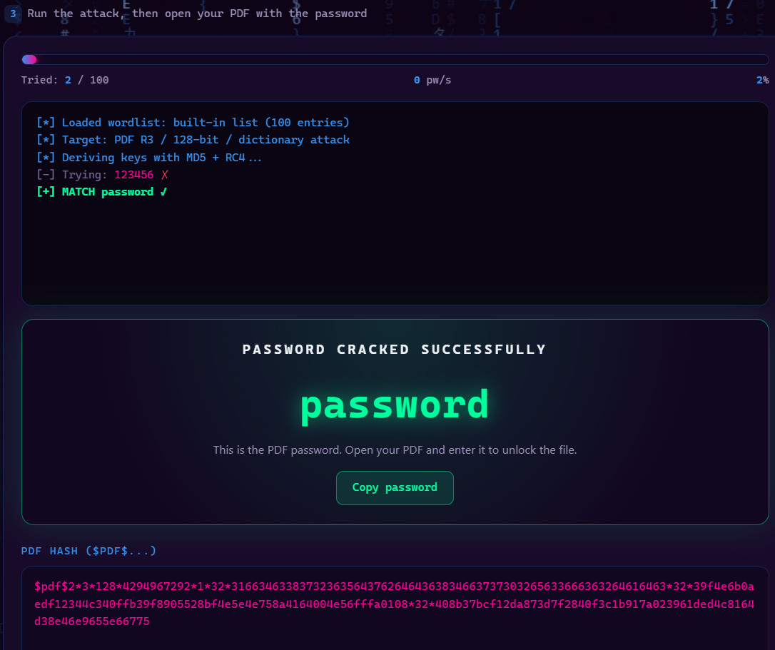
Figure 8 — Password-recovery evidence showing another successful dictionary match.

6.2 Recovered Report Evidence
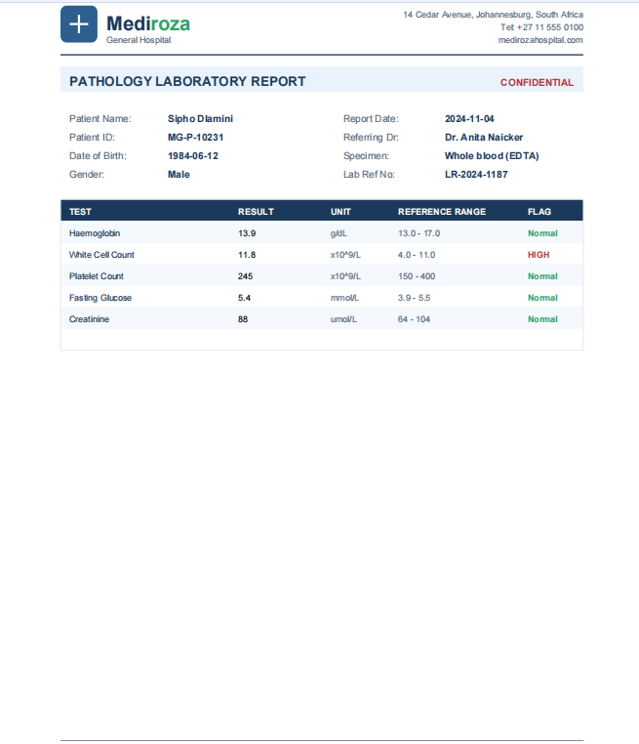
Figure 9 — Recovered pathology report evidence.

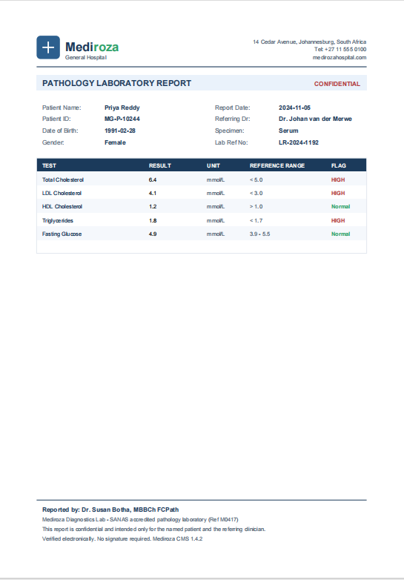
Figure 10 — Recovered pathology report evidence.

Finding F-03 – High: The supplied evidence demonstrates that the password protection applied to the retrieved PDFs was weak enough to be recovered through dictionary-based testing.

6.3 Security Impact
- PDF encryption provides limited protection when predictable or dictionary-based passwords are used.
- Once a protected document is acquired, password recovery can be performed offline.
- Sensitive laboratory information can therefore remain exposed despite the presence of PDF encryption.

6.4 Remediation
- Use strong, randomly generated passwords where document-level encryption is required.
- Avoid predictable, reused, or dictionary-based passwords.
- Use modern document-encryption settings supported by the document-management platform.
- Prefer authenticated portal access with authorization checks over directly downloadable sensitive documents.
- Review existing sensitive PDFs and re-protect them using stronger controls.

7. M3 – Critical Data Exposure
M3 focused on identifying sensitive information exposed through publicly accessible directories and the historical database backup. The supplied screenshots demonstrate multiple independent exposure points.

7.1 Public /old/ Directory and Database Backup
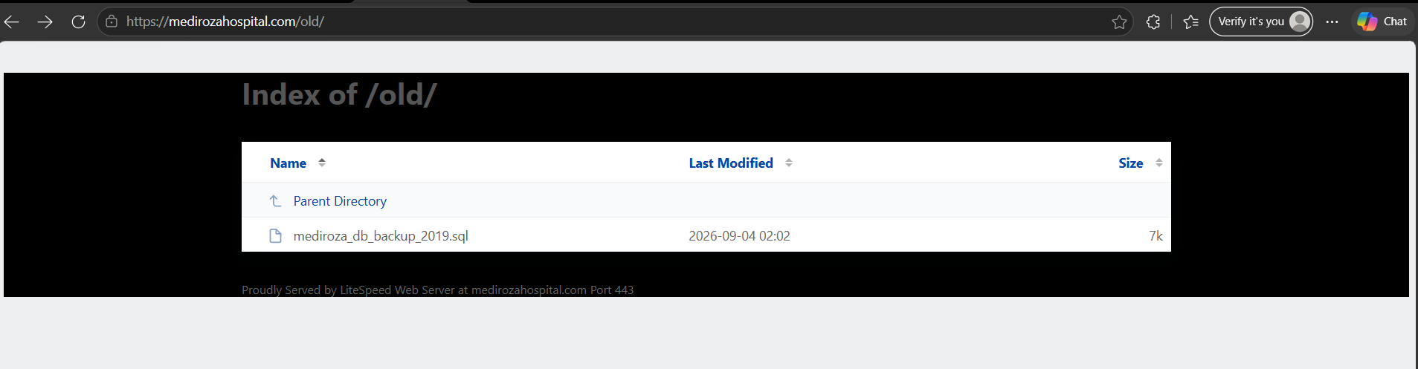
Figure 11 — Public /old/ directory exposing the historical SQL database backup.

The /old/ directory was accessible through the web application and exposed a historical SQL backup file. This represents a significant information-disclosure condition because database backups can contain large quantities of sensitive data.
Finding F-02 – Critical: A historical database backup was publicly accessible from a web directory.

7.2 Exposed Staff Database Information
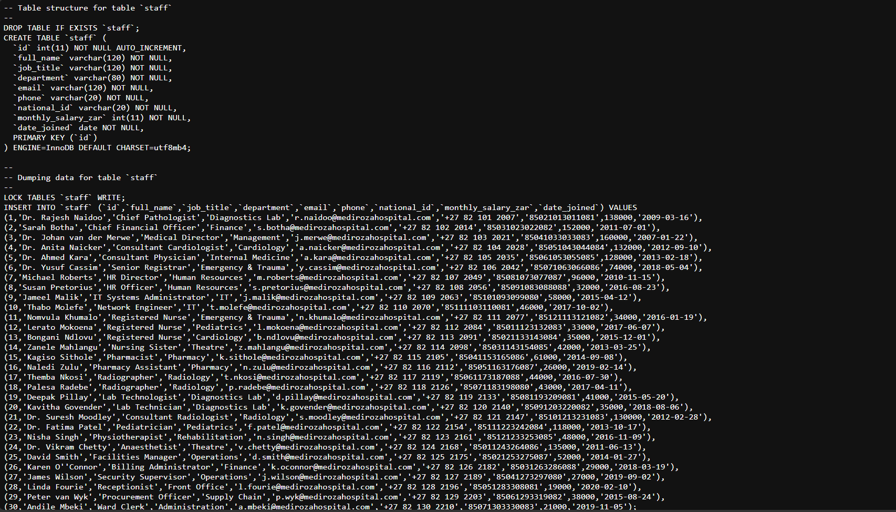
Figure 12 — Database backup evidence showing the staff table structure and stored staff-related fields.

The supplied database evidence shows a staff table containing fields for identity, employment information, contact information, identification information, salary-related information, and joining dates.

7.3 Exposed Shareholder Information
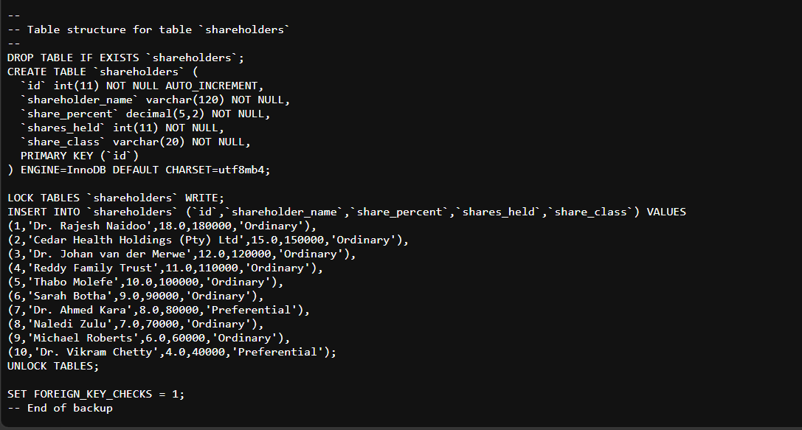
Figure 13 — Database backup evidence showing the shareholders table and ownership-related fields.

The supplied evidence also shows a separate shareholders table containing ownership-related records.

7.4 Patient Directory Listing
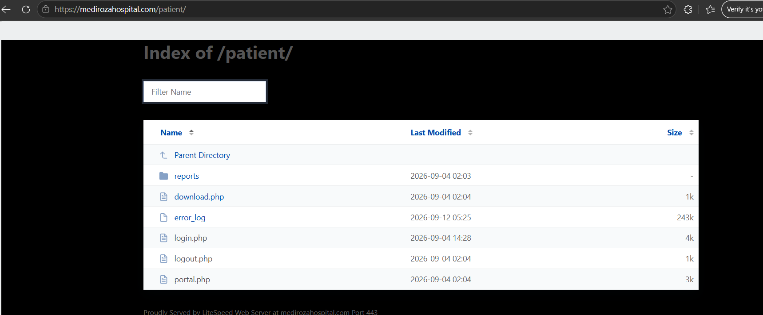
Figure 14 — /patient/ directory listing exposing application files, including authentication and report-related components.

The patient directory listing exposes application filenames and an error log. Directory indexing increases reconnaissance value and can reveal implementation details that should not normally be publicly browsable.

7.5 Staff Directory Listing
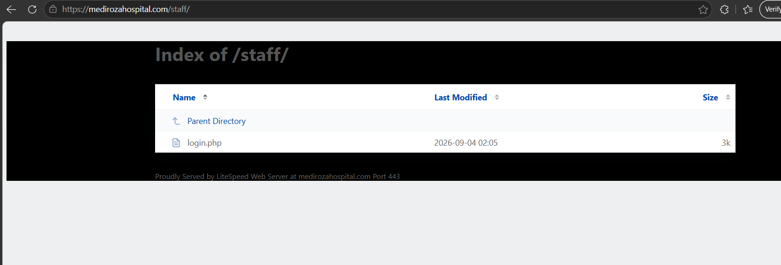
Figure 15 — /staff/ directory listing exposing the staff login endpoint.

The staff directory listing exposes the staff login endpoint directly. This provides an additional application path to an attacker performing reconnaissance.
Finding F-04 – High: Directory indexing was enabled on sensitive application paths, exposing filenames and increasing the observable attack surface.

7.6 M3 Security Impact
- Publicly accessible backups can expose historical application and database information.
- Sensitive staff and ownership records may be disclosed without authentication.
- Directory listings provide attackers with useful application paths and filenames.
- The exposure can amplify the impact of authentication and application-layer vulnerabilities.
- Sensitive information should be considered compromised within the scope of the authorized assessment evidence.

7.7 M3 Remediation
- Remove database backups from the web document root.
- Store backups outside web-accessible locations and restrict access using strong controls.
- Disable directory indexing / autoindexing on all sensitive directories.
- Remove obsolete files, logs, backups, and temporary artifacts from production web roots.
- Scan deployments for .sql, .bak, .old, .backup, .zip, and similar artifacts.
- Encrypt sensitive backups and enforce secure backup-retention procedures.
- Review logs for access to exposed backup and directory paths.
- Rotate credentials, secrets, or keys if they may have been present in exposed backup material.

8. Additional Finding – Authentication Information Disclosure
Finding F-05 – Medium: The assessment workflow identified authentication-related information disclosure during testing. This can assist subsequent credential-focused attacks when combined with other weaknesses.

8.1 Remediation
- Use consistent, generic authentication failure messages.
- Avoid revealing whether a submitted username exists.
- Normalize relevant response behavior where practical.
- Monitor and rate-limit repeated authentication discovery attempts.

9. Consolidated Findings Summary
ID | Finding | Severity | Primary Impact | Recommended Priority
F-01 | SQL Injection / Authentication Bypass | Critical | Unauthorized authenticated access | Immediate
F-02 | Public Database Backup | Critical | Sensitive database disclosure | Immediate
F-03 | Weak PDF Password Protection | High | Offline document access | High
F-04 | Directory Listing | High | Application/path disclosure | High
F-05 | Authentication Information Disclosure | Medium | Account discovery assistance | Planned

10. Attack-Path Reconstruction
Based strictly on the supplied evidence, the assessment can be represented as the following progression:
1. Footprinting identified publicly observable paths and technical information.
2. The patient authentication workflow was tested and an SQL-injection-style input was used.
3. Authenticated patient-report functionality was reached.
4. Three protected PDF reports were obtained for controlled testing.
5. Dictionary-based password recovery successfully recovered PDF passwords.
6. Public directory listings were identified on patient, staff, and old paths.
7. The /old/ directory exposed a historical SQL database backup.
8. The backup contained staff and shareholder datasets, demonstrating critical data exposure.

11. Milestone Completion
Milestone | Status | Evidence / Result
M1 – Initial Access | COMPLETED | Patient Portal authentication testing and access to patient-report functionality.
M2 – Data Extraction | COMPLETED | Three designated PDF reports obtained; password-recovery evidence supplied.
M3 – Critical Data Exposure | COMPLETED | Public backup and directory exposure; staff and shareholder data structures evidenced.
M4 – Reporting | COMPLETED | Findings, evidence, impact, and remediation consolidated into this report.

12. Overall Remediation Plan

12.1 Immediate
- Remove the exposed SQL backup from all web-accessible directories.
- Disable directory indexing on /patient/, /staff/, /old/, and similar paths.
- Remediate SQL injection using parameterized database access.
- Review and rotate credentials or secrets potentially contained in exposed backup data.
- Restrict direct access to sensitive patient documents.

12.2 Short Term
- Replace weak document passwords with strong, unpredictable protection.
- Implement consistent authentication error handling.
- Remove exposed logs and unnecessary application files from production directories.
- Introduce automated security checks for backup-file and directory-index exposure.

12.3 Long Term
- Adopt secure software-development lifecycle practices.
- Conduct recurring web-application penetration tests.
- Implement secure backup storage, retention, and destruction procedures.
- Apply least privilege to application and database accounts.
- Centralize security logging and monitoring.
- Provide developer training on SQL injection, authentication, authorization, and sensitive-data protection.

13. Conclusion
The supplied evidence demonstrates a sequence of weaknesses that can materially increase the confidentiality risk of the Mediroza General Hospital web application. The assessment progressed from footprinting to initial access, document extraction, password-recovery validation, and critical data exposure.
The most significant evidence relates to the authentication weakness and the publicly accessible historical database backup. The directory listings and weak PDF passwords further increase the practical impact by making sensitive application components and documents easier to discover or access.
Remediation should begin with removal of exposed backup material, disabling directory indexing, and correcting the underlying SQL injection and authentication weaknesses.

14. Evidence Register
Figure | Phase | Evidence
1–4 | Footprinting | robots.txt, HTTP headers, WHOIS, additional robots.txt capture
5–6 | M1 | Patient Portal authentication test and patient reports page
7–10 | M2 | PDF password-recovery evidence and recovered report screenshots
11–15 | M3 | Exposed database backup, staff/shareholder tables, patient/staff directory listings

15. Confidentiality and Evidence Handling
This report contains screenshots that may display personal, medical, employment, salary, or ownership information. The evidence is included solely to document the authorized security assessment. It should be stored securely, shared only with authorized stakeholders, and deleted or retained according to the applicable assessment and data-retention requirements.
The findings and conclusions in this report are limited to the evidence supplied for this assessment. The presence of a screenshot demonstrates the observed condition at the time of testing; it does not establish that the condition remains present after remediation.

