/*Basic Employee Management System*/
Create database CRUD_DB;
use CRUD_DB;
CREATE TABLE employees (
id INT PRIMARY KEY,
name VARCHAR(50),
department VARCHAR(50),
salary DECIMAL(10, 2)
);
INSERT INTO employees (id, name, department, salary) VALUES
(1, 'Alice', 'Engineering', 70000),
(2, 'Bob', 'Marketing', 60000),
(3, 'Charlie', 'HR', 55000);

SELECT * FROM employees;

UPDATE employees
SET salary = 75000
WHERE name = 'Alice';

DELETE FROM employees
WHERE name = 'Bob';

SELECT * FROM employees;

OUTPUT:

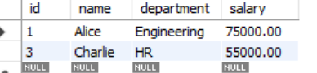

Use CRUD_DB;

/*Sales Data Querying*/
CREATE TABLE sales (
order_id INT PRIMARY KEY,
product VARCHAR(50),
quantity INT,
price DECIMAL(10, 2),
region VARCHAR(50)
);

INSERT INTO sales (order_id, product, quantity, price, region) VALUES
(101, 'Laptop', 3, 1200, 'East'),
(102, 'Laptop', 10, 1200, 'East'),
(103, 'Laptop', 2, 1250, 'West'),
(104, 'Monitor', 5, 300, 'West'),
(105, 'Monitor', 6, 300, 'East'),
(106, 'Monitor', 4, 280, 'North'),
(107, 'Keyboard', 12, 50, 'North'),
(108, 'Keyboard', 7, 50, 'East'),
(109, 'Mouse', 15, 25, 'South'),
(110, 'Mouse', 10, 25, 'East'),
(111, 'Headset', 8, 80, 'East'),
(112, 'Headset', 5, 75, 'West');

Select * from sales;

SELECT SUM(quantity * price) AS total_revenue
FROM sales;

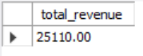

SELECT *
FROM sales
WHERE region = 'East' AND quantity > 5
ORDER BY price DESC;

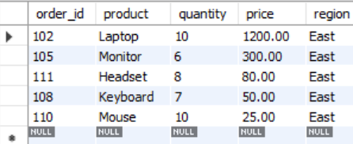

SELECT product, AVG(price) AS avg_price
FROM sales
GROUP BY product;
OUTPUT:

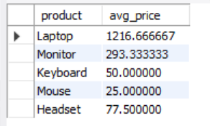
/* Inventory Management*/

Use CRUD_DB;
CREATE TABLE products (
product_id INT PRIMARY KEY,
product_name VARCHAR(50),
stock INT,
price DECIMAL(10, 2)
);
INSERT INTO products (product_id, product_name, stock, price) VALUES
(1, 'Laptop', 20, 1200),
(2, 'Monitor', 15, 300),
(3, 'Keyboard', 30, 50),
(4, 'Mouse', 40, 25),
(5, 'Headset', 10, 80);

Select * from products;

SELECT product_id, product_name, stock
FROM products;

Select * from products;

UPDATE products
SET stock = stock - 5
WHERE product_name = 'Laptop';

Select * from products;

INSERT INTO products (product_id, product_name, stock, price) VALUES
(6, 'Webcam', 25, 70);

Select * from products;

OUTPUT:

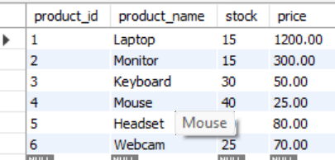
/* Customer Segmentation*/

use CRUD_DB;

CREATE TABLE customers (
order_id INT PRIMARY KEY,
customer_id INT,
customer_name VARCHAR(50),
product VARCHAR(50),
quantity INT,
price DECIMAL(10,2)
);

INSERT INTO customers (order_id, customer_id, customer_name, product, quantity, price) VALUES
(101, 1, 'Alice', 'Laptop', 1, 1200),
(102, 1, 'Alice', 'Mouse', 2, 25),
(103, 2, 'Bob', 'Monitor', 1, 300),
(104, 2, 'Bob', 'Keyboard', 3, 50),
(105, 3, 'Charlie', 'Laptop', 2, 1200),
(106, 3, 'Charlie', 'Headset', 1, 80),
(107, 4, 'David', 'Mouse', 5, 25),
(108, 4, 'David', 'Monitor', 2, 300),
(109, 5, 'Eva', 'Laptop', 1, 1250),
(110, 5, 'Eva', 'Keyboard', 2, 50),
(111, 6, 'Frank', 'Monitor', 3, 280),
(112, 6, 'Frank', 'Headset', 2, 75);

SELECT customer_name, SUM(quantity * price) AS total_spending
FROM customers
GROUP BY customer_name
ORDER BY total_spending DESC
LIMIT 5;

OUTPUT:

