DAY 11- SQL Joins & Subqueries
/*Employee and Department Analysis*/
Create database DAY11_DB;
Use day11_db;
CREATE TABLE departments (
department_id INT PRIMARY KEY,
department_name VARCHAR(50)
);
Use day11_db;
CREATE TABLE employees1 (
employee_id INT PRIMARY KEY,
employee_name VARCHAR(50),
department_id INT,
salary DECIMAL(10,2),
FOREIGN KEY (department_id) REFERENCES departments(department_id)
);
-- Departments
INSERT INTO departments (department_id, department_name) VALUES
(1, 'HR'),
(2, 'IT'),
(3, 'Finance'),
(4, 'Marketing');
-- Employees
INSERT INTO employees1 (employee_id, employee_name, department_id, salary) VALUES
(101, 'Alice', 1, 50000),
(102, 'Bob', 2, 60000),
(103, 'Charlie', 2, 65000),
(104, 'David', 3, 55000),
(105, 'Eve', 1, 52000);
-- Query 1 – Inner Join
SELECT e.employee_name, d.department_name
FROM employees1 e
INNER JOIN departments d ON e.department_id = d.department_id;
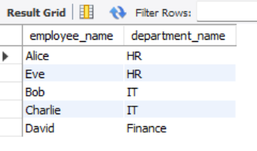
-- Query 2 – Left Join
SELECT d.department_name, e.employee_name
FROM departments d
LEFT JOIN employees1 e ON d.department_id = e.department_id;
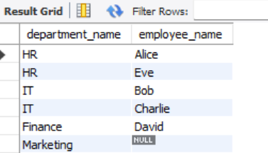

-- Query 3 – Join with Aggregation
SELECT d.department_name, AVG(e.salary) AS avg_salary
FROM employees1 e
JOIN departments d ON e.department_id = d.department_id
GROUP BY d.department_name;
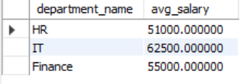
/* Customer Segmentation using Subqueries */
use day11_db;
CREATE TABLE orders (
order_id INT PRIMARY KEY,
customer_id INT,
order_date DATE
);

CREATE TABLE ratings (
rating_id INT PRIMARY KEY,
customer_id INT,
product_id INT,
rating INT
);
-- Insert into orders table
INSERT INTO orders (order_id, customer_id, order_date) VALUES
(1, 101, '2025-10-01'),
(2, 102, '2025-10-02'),
(3, 103, '2025-10-03'),
(4, 104, '2025-10-04'),
(5, 105, '2025-10-05');
-- Insert into ratings table
INSERT INTO ratings (rating_id, customer_id, product_id, rating) VALUES
(1, 101, 1001, 5),
(2, 103, 1002, 4),
(3, 105, 1003, 3);
-- Query 1 — Using Subquery
SELECT customer_id
FROM orders
WHERE customer_id NOT IN (SELECT customer_id FROM ratings);
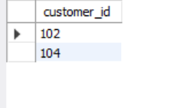
-- Query 2 — Using LEFT JOIN
SELECT o.customer_id
FROM orders o
LEFT JOIN ratings r ON o.customer_id = r.customer_id
WHERE r.customer_id IS NULL;
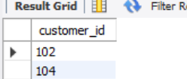
/*Product-Sales Analysis*/
use day11_db;
CREATE TABLE products (
product_id INT PRIMARY KEY,
product_name VARCHAR(50),
category VARCHAR(50),
price DECIMAL(10,2)
);
CREATE TABLE sales (
sale_id INT PRIMARY KEY,
product_id INT,
quantity INT,
sale_date DATE,
FOREIGN KEY (product_id) REFERENCES products(product_id)
);
-- Insert into products table
INSERT INTO products (product_id, product_name, category, price) VALUES
(1, 'Laptop', 'Electronics', 60000.00),
(2, 'Headphones', 'Electronics', 3000.00),
(3, 'Shirt', 'Clothing', 1500.00),
(4, 'Shoes', 'Clothing', 2500.00),
(5, 'Mixer Grinder', 'Home Appliances', 4000.00);
select * from products;
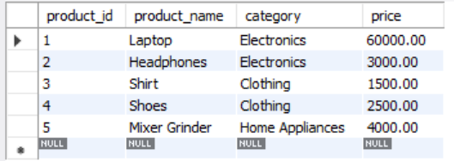
-- Insert into sales table
INSERT INTO sales (sale_id, product_id, quantity, sale_date) VALUES
(1, 1, 3, '2025-10-01'),
(2, 2, 10, '2025-10-02'),
(3, 3, 5, '2025-10-03'),
(4, 4, 4, '2025-10-04'),
(5, 5, 6, '2025-10-05');
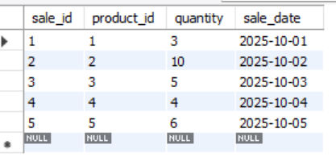
-- Query — Calculate Total Sales Revenue per Category
SELECT
p.category,
SUM(p.price * s.quantity) AS total_revenue
FROM
products p
JOIN
sales s ON p.product_id = s.product_id
GROUP BY
p.category;
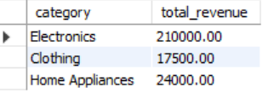

/*Employee Performance with Subqueries*/
use day11_db;
CREATE TABLE employees (
emp_id INT PRIMARY KEY,
emp_name VARCHAR(50),
department VARCHAR(50),
performance_score DECIMAL(5,2)
);
INSERT INTO employees (emp_id, emp_name, department, performance_score) VALUES
(1, 'Asha', 'HR', 78.5),
(2, 'Rahul', 'IT', 92.0),
(3, 'Meena', 'Finance', 84.5),
(4, 'Kiran', 'Marketing', 69.0),
(5, 'Vijay', 'IT', 88.0),
(6, 'Priya', 'HR', 73.5);
Select * from employees;
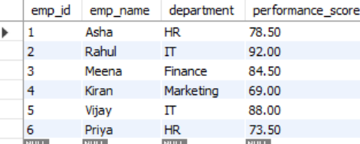
-- Query — Employees Above Company-Wide Average
SELECT emp_id, emp_name, department, performance_score
FROM employees
WHERE performance_score > (
SELECT AVG(performance_score) FROM employees
)
