Day 12- SQL Aggregations, Window Functions
/*Sales Performance by Region*/
use day12_db;
CREATE TABLE sales1 (
sale_id INT PRIMARY KEY,
region VARCHAR(50),
amount DECIMAL(10,2)
);
INSERT INTO sales1 (sale_id, region, amount) VALUES
(1, 'North', 50000.00),
(2, 'South', 30000.00),
(3, 'East', 40000.00),
(4, 'West', 25000.00),
(5, 'North', 45000.00),
(6, 'South', 35000.00),
(7, 'East', 20000.00),
(8, 'West', 30000.00);
select * from sales1;
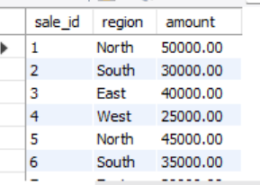
-- Query — Aggregate Sales by Region
SELECT region, SUM(amount) AS total_sales
FROM sales1
GROUP BY region;
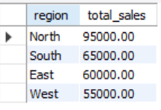
-- Add Ranking Using a Window Function
SELECT *,
RANK() OVER (ORDER BY total_sales DESC) AS sales_rank
FROM (
SELECT region, SUM(amount) AS total_sales
FROM sales1
GROUP BY region
) AS regional_sales;
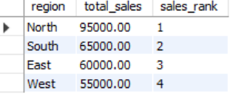
/* Customer Purchase History Analysis*/
use day12_db;
CREATE TABLE orders (
order_id INT PRIMARY KEY,
customer_id INT,
order_date DATE
);
INSERT INTO orders (order_id, customer_id, order_date) VALUES
(1, 101, '2025-10-01'),
(2, 101, '2025-10-05'),
(3, 101, '2025-10-12'),
(4, 102, '2025-10-03'),
(5, 102, '2025-10-08'),
(6, 103, '2025-10-07');
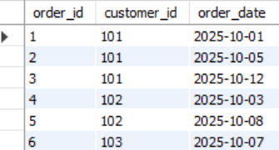
-- Find Last Order Date for Each Customer
SELECT
customer_id,
order_date,
MAX(order_date) OVER (PARTITION BY customer_id) AS last_order_date
FROM orders;
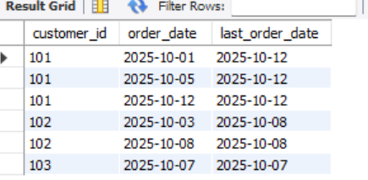
-- Find Difference Between First Two Orders
WITH ordered_orders AS (
SELECT
customer_id,
order_date,
ROW_NUMBER() OVER (PARTITION BY customer_id ORDER BY order_date) AS rn,
LAG(order_date) OVER (PARTITION BY customer_id ORDER BY order_date) AS prev_order_date
FROM orders
)
SELECT
customer_id,
MAX(order_date) AS last_order_date,
MIN(DATEDIFF(order_date, prev_order_date)) AS first_two_diff_days
FROM ordered_orders
WHERE rn <= 2 -- only consider first two orders
GROUP BY customer_id;
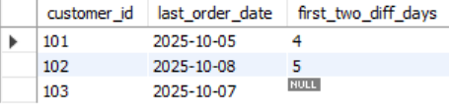
/* Employee Ranking Dashboard */
use day12_db;
CREATE TABLE employees (
emp_id INT PRIMARY KEY,
emp_name VARCHAR(50),
department VARCHAR(50),
performance_score DECIMAL(5,2)
);
INSERT INTO employees (emp_id, emp_name, department, performance_score) VALUES
(1, 'Asha', 'HR', 78.5),
(2, 'Rahul', 'IT', 92.0),
(3, 'Meena', 'Finance', 84.5),
(4, 'Kiran', 'Marketing', 69.0),
(5, 'Vijay', 'IT', 88.0),
(6, 'Priya', 'HR', 73.5),
(7, 'Ramesh', 'Finance', 91.0),
(8, 'Sita', 'IT', 92.0);
select * from employees;
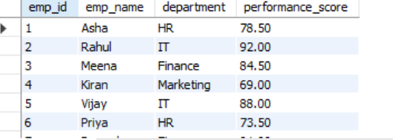
-- Query — Rank Employees Within Departments
SELECT
emp_id,
emp_name,
department,
performance_score,
DENSE_RANK() OVER (
PARTITION BY department
ORDER BY performance_score DESC
) AS dept_rank
FROM employees
ORDER BY department, dept_rank;
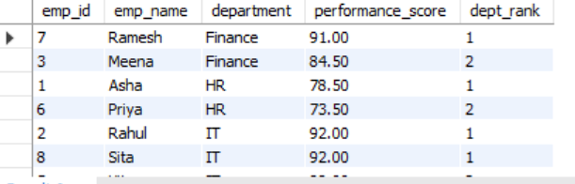
/* Customer Churn Analysis */
use day12_db;
CREATE TABLE cust_orders (
order_id INT PRIMARY KEY,
customer_id INT,
order_date DATE
);
INSERT INTO cust_orders (order_id, customer_id, order_date) VALUES
(1, 101, '2025-10-01'),
(2, 101, '2025-10-05'),
(3, 101, '2025-10-20'),
(4, 102, '2025-10-03'),
(5, 102, '2025-10-10'),
(6, 103, '2025-10-07'),
(7, 103, '2025-10-25');
select * from cust_orders;
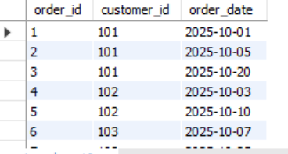
-- Calculate Gaps Between Orders
SELECT
customer_id,
order_id,
order_date,
LAG(order_date) OVER (PARTITION BY customer_id ORDER BY order_date) AS prev_order_date,
DATEDIFF(order_date, LAG(order_date) OVER (PARTITION BY customer_id ORDER BY order_date)) AS gap_days
FROM cust_orders;
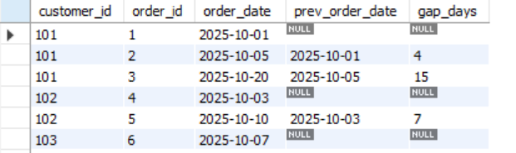
-- Filter for Large Gaps -For example, consider gaps ≥ 10 days as large:
SELECT
customer_id,
order_id,
order_date,
prev_order_date,
gap_days
FROM (
SELECT
customer_id,
order_id,
order_date,
LAG(order_date) OVER (PARTITION BY customer_id ORDER BY order_date) AS prev_order_date,
DATEDIFF(order_date, LAG(order_date) OVER (PARTITION BY customer_id ORDER BY order_date)) AS gap_days
FROM cust_orders
) AS order_gaps
WHERE gap_days >= 10;
