A machine learning-based ensemble model for securing the IoT network

Abstract :

The rapidly growing number of Internet of Things (IoT) devices has led to a rise in data transfers, which has raised security concerns. Due to the devices limited processing capabilities and vulnerability to many Cyber attacks, securing IoT communication is challenging. Security threats mainly Distributed Denial of Service (DDoS) attacks take a toll on the network in the form of increased communication overhead. This paper is about detection of DDoS attacks using a machine learning based ensemble model with the help of Software Defined Networking (SDN). The model uses various machine learning algorithms such as Logistic Regression (LR) , K-Nearest Neighbors (KNN) , Naive Bayes (NB) , Extra-Tree (ET) , Decision Tree Classifier (DT) and XGBoost (XGB). Various metrics including Accuracy,F1,precision and recall were used to evaluate the model performance. The ensemble method with stacking classifier proved a classification accuracy of 99.98%.

Dataset :

The dataset used in this paper is developed in mininet emulator. The mininet framework creates 10 topologies with switches coupled to ryu controller. The network simulation includes benign traffic like TCP, UDP and ICMP , as well as malicious traffic including TCP syn attacks, UDP flood attacks, and ICMP attacks. The network is simulated for 250 minutes and 1,04,345 samples were collected The dataset has 23 features and are listed in the below table.

Dt | Switch | Source | Destination | Packet count
Byte count | Duration | Duration(nanosecond) | Tot duration | Flows
Packet ins | Packet per flow | Byte per flow | Packet rate | Pair flow
Protocol | Port no | Transmitting bytes | Receive bytes | Transmitting Kilobytes
Receive Kilobytes | Total Kilobytes | Label

Data Preprocessing :

The dataset contains both numerical and categorical data. To have a data which is not biased by any or a group of features. The numerical data are normalized using a minimum maximum scalar.

The categorical data is converted to labels using the label encoder, so that machine learning models can understand the data.

The dataset has a total of 23 features to reduce the no of features I used chi² method to find the features which has less impact on the labels and removed those features. The features are byte per flow, packetins, port_no, tx_kbps, rx_kbps, packetperflow, packetrate.

Model Performance :

The models were trained and tested with a set of test sized from 0.55 to 0.8 with each increment step of 0.05 and the following results are tabulated below.

Model accuracy with varying test size
Model | Test Size
Model | .55 | .6 | .65 | .7 | .75 | .8
LR | .61055 | .60891 | .611215 | .61052 | .61032 | .61098
KNN | .85193 | .86031 | .867543 | .87066 | .87943 | .88458
GB | .61055 | .60891 | .611215 | .61379 | .61032 | .61098
ET | .999187 | .999928 | .999422 | .99974 | 1.00 | .99980
DT | .90759 | .90044 | .912283 | .91207 | .90462 | .90201
XGB | .99897 | .999734 | .998982 | .99926 | .99973 | .99951

Model precision with varying test size
Model | Test Size
Model | .55 | .6 | .65 | .7 | .75 | .8
LR | 1.00 | .448 | - | .618 | .442 | -
KNN | .825 | .841 | .852 | .861 | .871 | .873
GB | - | - | - | - | - | -
ET | .999 | .999 | .999 | .999 | .999 | 1.00
DT | .899 | .879 | .896 | .898 | .854 | .881
XGB | .998 | .999 | .999 | .999 | .999 | .999

Model F1 with varying test size
Model | Test Size
Model | .55 | .6 | .65 | .7 | .75 | .8
LR | .001 | .045 | - | .029 | .055 | -
KNN | .799 | .808 | .823 | .832 | .840 | .850
GB | - | - | - | - | - | -
ET | .998 | .999 | .999 | .999 | .999 | .999
DT | .849 | .874 | .865 | .884 | .854 | .860
XGB | .997 | .999 | .999 | .999 | .999 | .999

Model recall with varying test size
Model | Test Size
Model | .55 | .6 | .65 | .7 | .75 | .8
LR | .000 | .024 | - | .015 | .029 | -
KNN | .776 | .778 | .796 | .805 | .811 | .829
GB | - | - | - | - | - | -
ET | .998 | .999 | .999 | .999 | .999 | .999
DT | .849 | .869 | .837 | .872 | .854 | .840
XGB | .997 | .999 | .999 | .999 | .999 | 1.00

XGBoost performs better compared to other algorithms with an accuracy of 99.8%

Cross validation were also performed for the models with the factor from a range of 4 to 10. The results are given below :

Model recall with varying test size
Model | No of Folds:
Model | 4 | 5 | 6 | 7 | 8 | 9 | 10
LR | .609 | .596 | .608 | .609 | .609 | .614 | .609
KNN | .596 | .533 | .544 | .532 | .534 | .543 | .545
GB | .609 | .609 | .609 | .609 | .609 | .609 | .609
ET | .586 | .669 | .712 | .662 | .722 | .786 | .794
DT | .553 | .625 | .691 | .641 | .677 | .716 | .774
XGB | .644 | .701 | .724 | .695 | .718 | .774 | .777

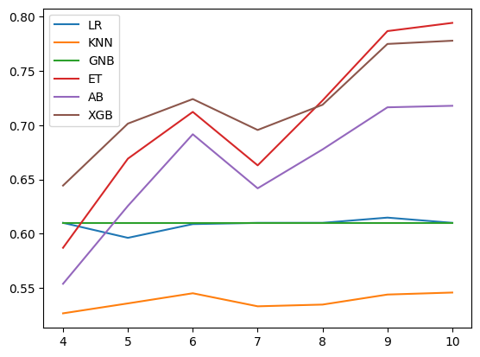

The ensemble models were trained and tested for two algorithms which are Voting and Stacking Classifier with different train sizes. The metrics are given below:

Model Accuracy with varying test size
Ensemble model | Test Size
Ensemble model | .55 | .6 | .65. | .7 | .75 | .8
Voting Classifier | .869 | .861 | .882 | .872 | .881 | .889
Stacking Classifier | .998 | .9996 | .9994 | .9995 | .9999 | .9998

Model Precision with varying test size
Ensemble model | Test Size
Ensemble model | .55 | .6 | .65. | .7 | .75 | .8
Voting Classifier | 1.00 | .999 | 1.00 | .999 | 1.00 | 1.00
Stacking Classifier | .998 | .9997 | .9993 | .9993 | .9999 | .9998

Model F1 with varying test size
Ensemble model | Test Size
Ensemble model | .55 | .6 | .65. | .7 | .75 | .8
Voting Classifier | .799 | .781 | .821 | .805 | .820 | .836
Stacking Classifier | .9985 | .9995 | .9993 | .9994 | .9999 | .9998

Model Recall with varying test size
Ensemble model | Test Size
Ensemble model | .55 | .6 | .65. | .7 | .75 | .8
Voting Classifier | .666 | .641 | .696 | .674 | .696 | .718
Stacking Classifier | .9985 | .9993 | .9992 | .9995 | 1.00 | 1.00

Stacking Classifier:

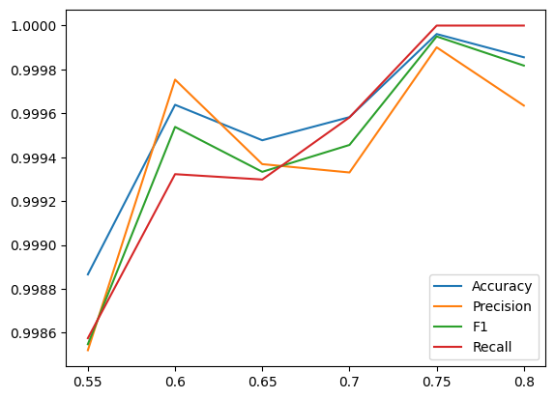
Voting Classifier:
From the obtained results stacking classifier performs best with an accuracy of 99.99%.

