NLU Assignment 1 - Corpus Analysis, Language Models & POS Tagging
Zipf's Law · N-gram Language Models · HMM POS Tagger with Viterbi
Corpus: Brown (NLTK), ~1.16M tokens · 80/20 train-test · Seed 1007 (reproducible)
Corpus statement. All three parts use the Brown corpus from NLTK (≈1.16M tokens). Part 3 requires Brown; Part 1 permits any English corpus ≥1M tokens, so using Brown throughout keeps the analysis consistent and reuses one loading path. Part 1 tokenizes to lower-cased alphabetic word types; Parts 2–3 use NLTK's sentence segmentation and (for Part 3) the Universal tagset.

Part 1 — Zipf's Law and Corpus Analysis
Q1. Top-10 word types by frequency
Rank | Word | Frequency | Class
1 | the | 69,971 | determiner
2 | of | 36,412 | preposition
3 | and | 28,853 | conjunction
4 | to | 26,158 | preposition/inf.
5 | a | 23,195 | determiner
6 | in | 21,337 | preposition
7 | that | 10,594 | complementizer
8 | is | 10,109 | verb (copula)
9 | was | 9,815 | verb (copula)
10 | he | 9,548 | pronoun

Corpus totals: N = 1,005,119 tokens and |V| = 48,052 types (alphabetic, lower-cased). Every one of the top-10 is a closed-class function word.
Q2. Zipf log-log fit
Fitting a least-squares line to log₁₀(rank) vs log₁₀(frequency) over all types gives slope = −1.315 and intercept = 6.053. Zipf's law predicts a slope near −1; our fit is steeper, so the corpus deviates from the ideal. The deviation comes from the tails: the very top ranks are slightly flatter and the long tail of hapax words (≈20k words occurring once) is steeper than a pure −1 line, pulling the global fit below −1. A Zipf–Mandelbrot fit or fitting only the mid-range ranks would land closer to −1.
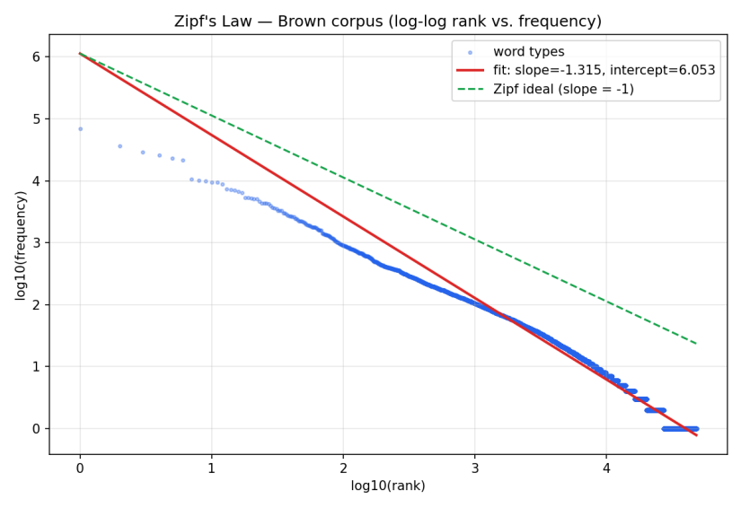
Figure 1 — Log-log rank/frequency for Brown. Blue: word types; red: fitted line (slope −1.315); green dashed: the ideal Zipf slope −1.
Q3. Top-20 vs bottom-20 and the type/token distinction
Top-20: the, of, and, to, a, in, that, is, was, he, for, it, with, as, his, on, be, at, by, i.
Bottom-20 (freq 1): hubris, plumbed, bathos, besmirched, extremis, pityingly, horoscope, sidle, bodhisattva, hors, yaws, fluke, bilharziasis, perelman, exhaling, aviary, olive-flushed, coral-colored, boucle, stupefying.
The top is entirely closed-class (determiners, prepositions, conjunctions, pronouns, copulas): a tiny fixed set of TYPES that generates a huge share of TOKENS. The bottom is open-class content words (rare nouns, verbs, adjectives), almost all hapax legomena — many TYPES, each contributing very few TOKENS. This is the type/token distinction in action: frequency is dominated by a few function-word types, while the vocabulary is dominated by many rare content-word types.
Q4/Q5. TTR and MATTR vs corpus size
Tokens | Raw TTR | MATTR (w=1000) | |V| grows sub-linearly?
10,000 | 0.2576 | 0.4590 | —
50,000 | 0.1726 | 0.4807 | yes
100,000 | 0.1345 | 0.4826 | yes
500,000 | 0.0683 | 0.4655 | yes
1,000,000 | 0.0477 | 0.4476 | yes

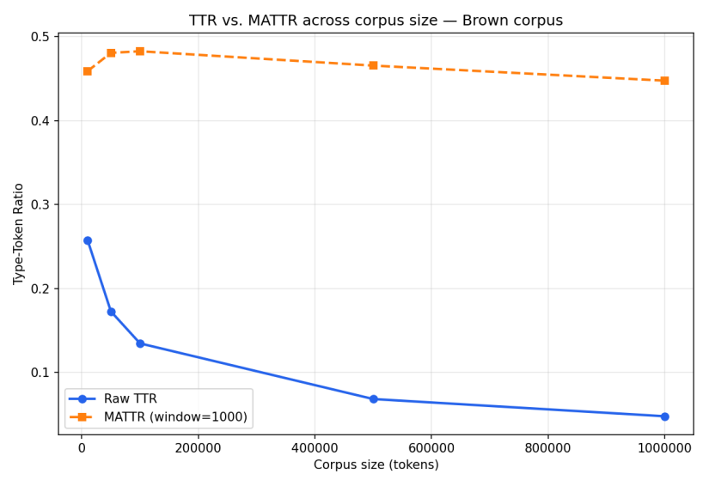
Figure 2 — Raw TTR collapses as the corpus grows, while MATTR (fixed 1000-token window) stays roughly flat, giving a length-controlled diversity measure.
Why raw TTR falls: as tokens accumulate, vocabulary grows sub-linearly (Heaps' law) while token count grows linearly, so |V|/N shrinks — new tokens are increasingly repeats of already-seen types. Raw TTR is therefore length-dependent and unfair for comparing texts of different sizes. MATTR averages TTR over a fixed 1000-token sliding window, decoupling it from total length: it stays near 0.45–0.48 across all sizes, so it can compare lexical diversity fairly regardless of corpus size.

Part 2 — N-gram Language Models
Setup: sentences shuffled and split 80/20 (seed 1007); every sentence wrapped with <s> … </s>; words seen <2× in training mapped to <unk>. Vocabulary |V| = 24,738 (incl. <s>, </s>, <unk>); training tokens ≈1.02M.
Q6. MLE unigram & bigram
Unigram P(w) = count(w)/N and bigram P(wᵢ|wᵢ₋₁) = count(wᵢ₋₁,wᵢ)/count(wᵢ₋₁) are estimated from training counts (implemented in part2_lm.py).
Q7. Why raw MLE fails; what Laplace fixes
Raw MLE assigns probability 0 to any bigram unseen in training. Since the test set almost always contains unseen bigrams, a single zero makes the whole sentence probability 0 and perplexity infinite — MLE is unusable on held-out data. Add-1 (Laplace) smoothing adds 1 to every bigram count and |V| to each denominator, so no bigram is zero; it redistributes a little mass to unseen events, at the cost of over-discounting frequent ones.
Q8. Perplexity — unigram vs bigram
Model | Perplexity
Unigram (add-1) | 726.47
Bigram (Laplace, add-1) | 1,674.15
Bigram (add-k, k=0.01) | 471.68

Important observation (and the correct explanation). In principle the bigram should beat the unigram because conditioning on the previous word captures local structure. Here the add-1 bigram (1,674) is actually WORSE than the unigram (726). This is a well-known artifact of Laplace smoothing on a large vocabulary (|V| ≈ 24.7k): the denominator count(w₁)+|V| is dominated by |V|, draining mass from seen bigrams and smearing it across ~|V| unseen ones per context — severe over-smoothing. Reducing to add-k (k=0.01) restores the expected ordering: the bigram falls to 472, well below the unigram. So the bigram's conditioning IS informative; crude add-1 smoothing, not the model order, caused the inversion.
Q9. Five sentences by ancestral sampling (bigram)
1. in a chapel .
2. the home appliances and often visit that he gaped at no .
3. and no better nor was confronted in short period .
4. clerfayt of sea , madison place .
5. `` early .
Sampling starts at <s> and draws the next word from P(w | previous) until </s>. Outputs are locally plausible (short function-word runs, valid bigrams) but globally incoherent — expected for a bigram, which has no memory beyond one word.
Q10. Unigram / bigram / trigram perplexity
Model | Perplexity
Unigram (add-1) | 726.47
Bigram (Laplace, add-1) | 1,674.15
Trigram (Laplace, add-1) | 11,843.85

Yes — the add-1 trigram perplexity (11,844) is HIGHER than the bigram. Discussion by the three factors: (i) Sparsity — trigram space is |V|³, so observed trigrams are extremely rare and most test trigrams are unseen. (ii) Smoothing — add-1 over that vast space is catastrophic: it hands almost all probability mass to unseen trigrams, so seen ones are heavily under-weighted. (iii) Longer history — conditioning on two words is genuinely more informative, but that benefit is swamped by (i) and (ii) under crude smoothing. Better smoothing (interpolation, backoff, Kneser–Ney) is precisely what lets a trigram overtake a bigram; with add-1 alone, higher order makes perplexity worse.

Part 3 — HMM POS Tagger with Viterbi
Brown with the Universal tagset, 80/20 split (seed 1007). Transition A = P(tᵢ|tᵢ₋₁) and emission B = P(wᵢ|tᵢ) are estimated by MLE with add-1 smoothing. The Viterbi decoder is implemented from scratch in log-space with explicit score and backpointer matrices — no library HMM/Viterbi is used.
Q11. Top-5 NOUN transitions and VERB emissions
P(tᵢ | NOUN) | P(w | VERB)
NOUN → . P = 0.2831 | VERB → is P = 0.0423
NOUN → ADP P = 0.2441 | VERB → was P = 0.0414
NOUN → VERB P = 0.1590 | VERB → be P = 0.0267
NOUN → NOUN P = 0.1499 | VERB → had P = 0.0214
NOUN → CONJ P = 0.0596 | VERB → are P = 0.0187

Both are linguistically sensible: nouns are most often followed by punctuation, a preposition, or a verb; the highest-probability verbs are the copulas/auxiliaries (is, was, be, had, are), which are by far the most frequent verb tokens.
Q12. Viterbi from scratch
For each sentence the decoder fills a score matrix (best log-probability of reaching each tag at each position) and a backpointer matrix (which previous tag achieved it). Initialization uses the <s>→tag transition times the emission; the recursion maximizes score[i−1][k] + log A(k→j) + log B(j→wᵢ) over previous tags k; termination adds the tag→</s> transition; the best final tag is then backtracked through the pointers to recover the full sequence. Working in log-space avoids underflow on long sentences.
Q13. Accuracy — overall, seen, OOV
Category | Tokens | Accuracy
Overall | 231,975 | 93.88%
Seen (in vocab) | 226,856 | 94.99%
Unseen (OOV) | 5,119 | 44.62%

Seen-word accuracy (95.0%) hugely exceeds OOV accuracy (44.6%). For seen words the emission P(w|tag) sharply constrains the tag; for OOV words every emission collapses to the add-1 floor 1/(count(tag)+|V|+1), nearly uniform across tags, so the tagger must rely on transitions alone and defaults toward frequent open classes (usually NOUN). The 50-point gap is the direct cost of having no lexical signal for unseen words.
Q14. Ten mis-tagged tokens and the dominant error type
Token | Gold | Pred | Reason
jesus | NOUN | ADP | OOV/rare — no emission signal, tagged from transitions
as | ADP | ADV | lexical ambiguity — 'as' is valid as ADP and ADV
that | DET | ADP | lexical ambiguity — DET vs complementizer/ADP
people's | NOUN | DET | rare possessive form — sparse emission
down | PRT | ADP | lexical ambiguity — particle vs preposition
much | ADV | ADJ | ambiguity — ADV vs ADJ in context
british | NOUN | ADJ | denominal ambiguity — noun vs adjective use
tipped | VERB | ADP | sparse context — rare verb form mis-transitioned
stacy | NOUN | PRT | OOV proper noun — no emission signal
essential | NOUN | ADJ | ambiguity — nominal vs adjectival use

Error-type summary: of 14,190 total errors, 80.0% are on seen words and 20.0% on OOV words. By raw count the most frequent error type is seen-word lexical ambiguity — words like ‘that’, ‘as’, ‘down’ that are valid under several tags, where a sparse or mis-estimated transition picks the wrong one. By error RATE, however, OOV tokens are far worse (55% wrong vs 5% for seen words), since they carry no emission signal. So ambiguity dominates the error count while OOV dominates the error rate.

Reproducibility & Disclosures
- Single-command runs: each part is one script — python part1_zipf.py / part2_lm.py / part3_hmm.py — with a requirements.txt; NLTK data auto-downloads on first run.
- Reproducible: a fixed seed (1007) governs the train/test split and all sampling.
- From scratch (Part 3): transition/emission estimation and the Viterbi decoder are implemented directly; no built-in HMM or Viterbi is used. NLTK is used only to load the corpus/tagset.
- No pre-trained models: all counts and probabilities are estimated from the Brown training split.

