INTERVIEW QUESTIONS

1. **What are types of operators used in python?**

* Arithmetic Operators
* Comparison Operators
* Python Assignment Operators
* Logical Operators or Bitwise Operators
* Membership Operators
* Identity Operators

**2.What is difference between list and tuple?**

| SR.NO. | LIST | TUPLE |
| --- | --- | --- |
| 1 | Lists are mutable | Tuples are immutable |
| 2 | The implication of iterations is Time-consuming | The implication of iterations is comparatively Faster |
| 3 | The list is better for performing operations, such as insertion and deletion. | Tuple data type is appropriate for accessing the elements |
| 4 | Lists consume more memory | Tuple consumes less memory as compared to the list |
| 5 | Lists have several built-in methods | Tuple does not have many built-in methods. |
| 6 | The unexpected changes and errors are more likely to occur | In tuple, it is hard to take place |

### 3. What is slicing in Python?

* As the name suggests, ‘slicing’ is taking parts of.
* Syntax for slicing is **[start : stop : step]**
* **start** is the starting index from where to slice a list or tuple
* **stop** is the ending index or where to sop.
* **step** is the number of steps to jump.
* Default value for **start** is 0, **stop** is number of items, **step** is 1.
* Slicing can be done on **strings, arrays, lists**, and **tuples**.

4. **What are the disadvantages of using a for loop in Python?**

The for-loop is one of the most basic constructs in programming. However, this construct has its own disadvantages.

1. If you don't know the upper-bound of your loop, you have to keep track of it by hand or break out of your loop early.
2. You can't use a break statement to escape from a nested loop.

### 5. ****What are functions in Python?****

Functions in Python refer to blocks that have organized, and reusable codes to perform single, and related events. Functions are important to create better modularity for applications that reuse a high degree of coding. Python has a number of built-in functions like print(). However, it also allows you to create user-defined functions.

### 6. What are the common built-in data types in Python?

Python supports the below-mentioned built-in data types:

**Immutable data types:**

* Number
* String
* Tuple

**Mutable data types:**

* List
* Dictionary
* Set

### 7. ****What are local variables and global variables in Python?****

**Local variable**: Any variable declared inside a function is known as Local variable and it’s accessibility remains inside that function only.

**Global Variable**: Any variable declared outside the function is known as Global variable and it can be easily accessible by any function present throughout the program.

### 8. ****s python case sensitive?****

Yes, Python is a case sensitive language. This means that Function and function both are different in pythons like SQL and Pascal.

### 9.****What are negative indexes and why are they used?****

To access an element from ordered sequences, we simply use the index of the element, which is the position number of that particular element. The index usually starts from 0, i.e., the first element has index 0, the second has 1, and so on.

### 10. ****What does len() do?****

len() is an inbuilt function used to calculate the length of sequences like list, [python string](https://intellipaat.com/blog/tutorial/python-tutorial/python-strings/), and array.

**11. What is recursion?**

When a function makes a call to itself, it is termed [***recursion***](https://data-flair.training/blogs/recursion-in-python/). But then, in order for it to avoid forming an infinite loop, we must have a base condition.

**12. What do you know about relational operators in Python.**

[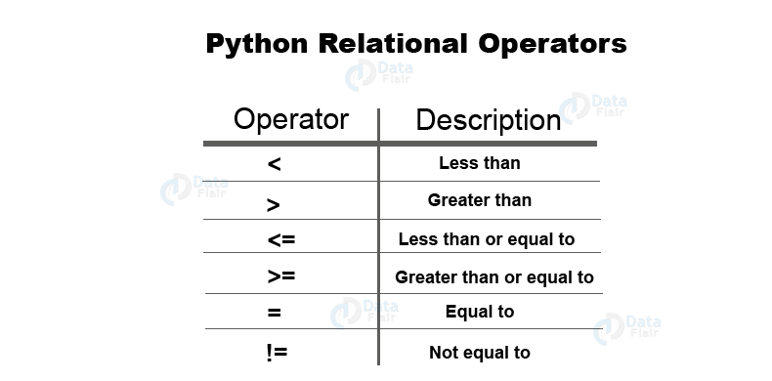](https://data-flair.training/blogs/wp-content/uploads/sites/2/2019/09/Python-interview-questions-and-answers-Relational-Operators.png)

**13. What are the limitations of Python?**

There are limitations to Python, which include the following:

1. It has design restrictions.
2. It is slower when compared with C and C++ or Java.
3. It is inefficient for mobile computing.
4. It consists of an underdeveloped database access layer.

**14.what is the use of while loop?**

The while loop in Python is used **to iterate over a block of code as long as the test expression (condition) is true**. We generally use this loop when we don't know the number of times to iterate beforehand.

**15. What are basic functions in Python?**

**Python Built-in Functions**

* print( ) function.
* type( ) function.
* input( ) function.
* abs( ) function.
* pow( ) function.
* dir( ) function.
* sorted( ) function.
* max( ) function.

**16. How many values can a function return?**

To that end, a function can only return **one object**.

**17.what are few applications of python??**

* System Scripting
* Web Development
* Game Development
* Software Development
* Complex Mathematics

18. **What is the difference between Set and Dictionary?**

Set is an unordered collection of data type that is iterable, mutable, and has no duplicate elements.  
Dictionary in Python is an unordered collection of data values, used to store data values like a map.

**19. What is a lambda function?**

A lambda function is an anonymous function. This function can have any number of parameters but, can have just one statement.

20. **What is zip function?**

Python zip() function returns a zip object, which maps a similar index of multiple containers. It takes an iterable, converts into iterator and aggregates the elements based on iterables passed. It returns an iterator of tuples.