**Design Principles and Pattern**

**Exercise 1: Implementation Of Singleton Pattern**

**Code:**

public class Singleton {

    static class Logger {

        private static Logger instance;

        private Logger() {

            System.out.println("Logger initialized.");

        }

        public static Logger getInstance() {

            if (instance == null) {

                instance = new Logger();

            }

            return instance;

        }

        public void log(String message) {

            System.out.println("LOG: " + message);

        }

    }

    public static void main(String[] args) {

        Logger logger1 = Logger.getInstance();

        Logger logger2 = Logger.getInstance();

        logger1.log("Starting application...");

        logger2.log("Application is running.");

        if (logger1 == logger2) {

            System.out.println("Both logger1 and logger2 are the same instance.");

        } else {

            System.out.println("Different instances.");

        }

    }

}

**Output:**

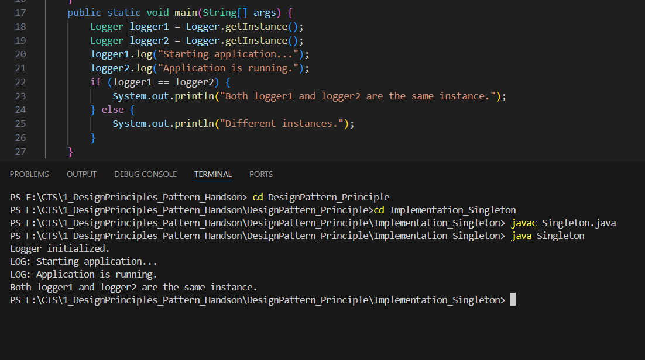

**Exercise 2 : Implementation of Factory Method Pattern**

**Code:**

public class FactoryMethodPattern{

    interface Document {

        void open();

    }

    static class WordDocument implements Document {

        public void open() {

            System.out.println("Opening a Word document...");

        }

    }

    static class PdfDocument implements Document {

        public void open() {

            System.out.println("Opening a PDF document...");

        }

    }

    static class ExcelDocument implements Document {

        public void open() {

            System.out.println("Opening an Excel document...");

        }

    }

    abstract static class DocumentFactory {

        public abstract Document createDocument();

    }

    static class WordDocumentFactory extends DocumentFactory {

        public Document createDocument() {

            return new WordDocument();

        }

    }

    static class PdfDocumentFactory extends DocumentFactory {

        public Document createDocument() {

            return new PdfDocument();

        }

    }

    static class ExcelDocumentFactory extends DocumentFactory {

        public Document createDocument() {

            return new ExcelDocument();

        }

    }

    public static void main(String[] args) {

        DocumentFactory wordFactory = new WordDocumentFactory();

        Document word = wordFactory.createDocument();

        word.open();

        DocumentFactory pdfFactory = new PdfDocumentFactory();

        Document pdf = pdfFactory.createDocument();

        pdf.open();

        DocumentFactory excelFactory = new ExcelDocumentFactory();

        Document excel = excelFactory.createDocument();

        excel.open();

    }

}

**Output:**

