**PL/SQL programming**

**Exercise 1: Control Structures**

**Scenario 1:** The bank wants to apply a discount to loan interest rates for customers above 60 years old.

**Question:** Write a PL/SQL block that loops through all customers, checks their age, and if they are above 60, apply a 1% discount to their current loan interest rates

**Code:**

DELIMITER $$

CREATE PROCEDURE ApplyInterestDiscountVerbose()

BEGIN

DECLARE done INT DEFAULT 0;

DECLARE cust_id INT;

DECLARE cust_name VARCHAR(100);

DECLARE cust_age INT;

DECLARE loan_id INT;

DECLARE old_interest DECIMAL(5,2);

DECLARE new_interest DECIMAL(5,2);

DECLARE cur CURSOR FOR

SELECT c.CustomerID, c.Name, TIMESTAMPDIFF(YEAR, c.DOB, CURDATE()) AS Age

FROM Customers c;

DECLARE CONTINUE HANDLER FOR NOT FOUND SET done = 1;

OPEN cur;

read_loop: LOOP

FETCH cur INTO cust_id, cust_name, cust_age;

IF done THEN

LEAVE read_loop;

END IF;

IF cust_age > 60 THEN

-- Direct inner SELECT without cursor

SELECT LoanID, InterestRate INTO loan_id, old_interest

FROM Loans

WHERE CustomerID = cust_id

LIMIT 1;

IF loan_id IS NOT NULL THEN

UPDATE Loans

SET InterestRate = InterestRate - 1

WHERE LoanID = loan_id;

SELECT InterestRate INTO new_interest FROM Loans WHERE LoanID = loan_id;

SELECT CONCAT(

'Updated Customer ID: ', cust_id,

', Name: ', cust_name,

', Old Interest Rate: ', old_interest,

', New Interest Rate: ', new_interest

) AS Message;

END IF;

END IF;

END LOOP;

CLOSE cur;

END$$

DELIMITER ;

CALL ApplyInterestDiscountVerbose();

**Output:**

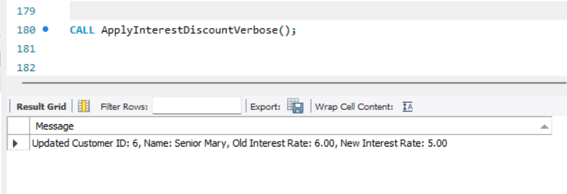

**Scenario 2:** A customer can be promoted to VIP status based on their balance.

**Question:** Write a PL/SQL block that iterates through all customers and sets a flag IsVIP to TRUE for those with a balance over $10,000.

**Code:**

DELIMITER $$

CREATE PROCEDURE PromoteVIPCustomers()

BEGIN

DECLARE done INT DEFAULT 0;

DECLARE cust_id INT;

DECLARE cust_name VARCHAR(100);

DECLARE cust_balance DECIMAL(10,2);

DECLARE cur CURSOR FOR

SELECT CustomerID, Name, Balance FROM Customers WHERE Balance > 10000;

DECLARE CONTINUE HANDLER FOR NOT FOUND SET done = 1;

OPEN cur;

read_loop: LOOP

FETCH cur INTO cust_id, cust_name, cust_balance;

IF done THEN

LEAVE read_loop;

END IF;

UPDATE Customers

SET IsVIP = 'TRUE'

WHERE CustomerID = cust_id;

SELECT CONCAT(

'Promoted to VIP -> Customer ID: ', cust_id,

', Name: ', cust_name,

', Balance: ', cust_balance

) AS Message;

END LOOP;

CLOSE cur;

END$$

DELIMITER ;

CALL PromoteVIPCustomers();

**Output:**

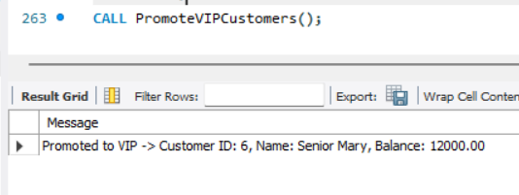

**Scenario 3:** The bank wants to send reminders to customers whose loans are due within the next 30 days.

**Question:** Write a PL/SQL block that fetches all loans due in the next 30 days and prints a reminder message for each customer.

**Code:**

DELIMITER $$

CREATE PROCEDURE SendLoanReminders()

BEGIN

DECLARE done INT DEFAULT 0;

DECLARE cust_id INT;

DECLARE cust_name VARCHAR(100);

DECLARE loan_id INT;

DECLARE due_date DATE;

DECLARE days_left INT;

DECLARE cur CURSOR FOR

SELECT l.LoanID, l.CustomerID, l.EndDate, c.Name

FROM Loans l

JOIN Customers c ON l.CustomerID = c.CustomerID

WHERE l.EndDate BETWEEN CURDATE() AND DATE_ADD(CURDATE(), INTERVAL 30 DAY);

DECLARE CONTINUE HANDLER FOR NOT FOUND SET done = 1;

OPEN cur;

read_loop: LOOP

FETCH cur INTO loan_id, cust_id, due_date, cust_name;

IF done THEN

LEAVE read_loop;

END IF;

SET days_left = DATEDIFF(due_date, CURDATE());

-- Display reminder message

SELECT CONCAT(

'Reminder: Loan ID ', loan_id,

' for Customer ID ', cust_id,

' (', cust_name, ') is due on ',

DATE_FORMAT(due_date, '%Y-%m-%d'),

' (', days_left, ' days left).'

) AS Message;

END LOOP;

CLOSE cur;

END$$

DELIMITER ;

call SendLoanReminders();

**Output:**

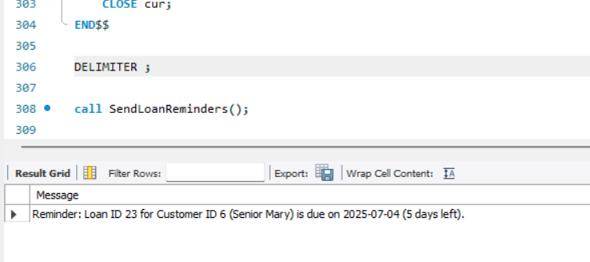

**Exercise 3: Stored Procedures**

**Scenario 1:** The bank needs to process monthly interest for all savings accounts.

**Question:** Write a stored procedure ProcessMonthlyInterest that calculates and updates the balance of all savings accounts by applying an interest rate of 1% to the current balance.

**Code:**

DELIMITER $$

CREATE PROCEDURE ProcessMonthlyInterest()

BEGIN

DECLARE done INT DEFAULT 0;

DECLARE acc_id INT;

DECLARE acc_balance DECIMAL(10,2);

DECLARE new_balance DECIMAL(10,2);

DECLARE cur CURSOR FOR

SELECT AccountID, Balance FROM Accounts WHERE AccountType = 'Savings';

DECLARE CONTINUE HANDLER FOR NOT FOUND SET done = 1;

OPEN cur;

read_loop: LOOP

FETCH cur INTO acc_id, acc_balance;

IF done THEN

LEAVE read_loop;

END IF;

SET new_balance = acc_balance * 1.01;

UPDATE Accounts SET Balance = new_balance, LastModified = CURDATE() WHERE AccountID = acc_id;

-- Display the updated row

SELECT CONCAT(

'Interest Applied -> AccountID: ', acc_id,

', Old Balance: ', acc_balance,

', New Balance: ', new_balance

) AS Message;

END LOOP;

CLOSE cur;

END$$

DELIMITER ;

call ProcessMonthlyInterest();

**Output:**

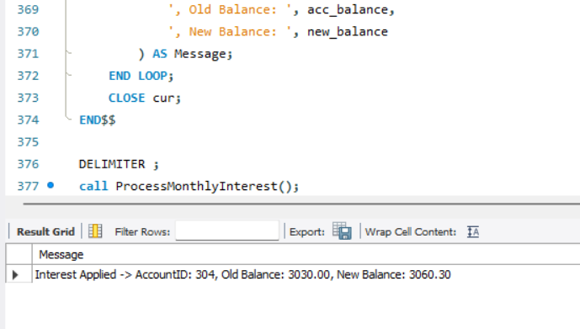

**Scenario 2:** The bank wants to implement a bonus scheme for employees based on their performance.

**Question:** Write a stored procedure **UpdateEmployeeBonus** that updates the salary of employees in a given department by adding a bonus percentage passed as a parameter.

**Code:**

DELIMITER $$

CREATE PROCEDURE UpdateEmployeeBonus(IN dept_name VARCHAR(50), IN bonus_percent DECIMAL(5,2))

BEGIN

DECLARE done INT DEFAULT 0;

DECLARE emp_id INT;

DECLARE emp_name VARCHAR(100);

DECLARE old_salary DECIMAL(10,2);

DECLARE new_salary DECIMAL(10,2);

DECLARE cur CURSOR FOR

SELECT EmployeeID, Name, Salary FROM Employees WHERE Department = dept_name;

DECLARE CONTINUE HANDLER FOR NOT FOUND SET done = 1;

OPEN cur;

read_loop: LOOP

FETCH cur INTO emp_id, emp_name, old_salary;

IF done THEN

LEAVE read_loop;

END IF;

SET new_salary = old_salary * (1 + bonus_percent / 100);

UPDATE Employees SET Salary = new_salary WHERE EmployeeID = emp_id;

SELECT CONCAT(

'Bonus Applied: EmployeeID: ', emp_id,

', Name: ', emp_name,

', Old Salary: ', old_salary,

', New Salary: ', new_salary

) AS Message;

END LOOP;

CLOSE cur;

END$$

DELIMITER ;

CALL UpdateEmployeeBonus('IT', 10);

**Output:**

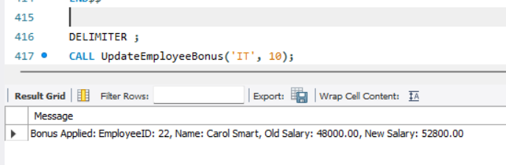

**Scenario 3:** Customers should be able to transfer funds between their accounts.

**Question:** Write a stored procedure TransferFunds that transfers a specified amount from one account to another, checking that the source account has sufficient balance before making the transfer.

**Code:**

DELIMITER $$

CREATE PROCEDURE TransferFunds(

IN from_account_id INT,

IN to_account_id INT,

IN transfer_amount DECIMAL(10,2)

)

BEGIN

DECLARE from_balance DECIMAL(10,2);

DECLARE to_balance DECIMAL(10,2);

-- Fetch current balances

SELECT Balance INTO from_balance FROM Accounts WHERE AccountID = from_account_id;

SELECT Balance INTO to_balance FROM Accounts WHERE AccountID = to_account_id;

-- Check sufficient balance

IF from_balance >= transfer_amount THEN

-- Update balances

UPDATE Accounts SET Balance = Balance - transfer_amount, LastModified = CURDATE() WHERE AccountID = from_account_id;

UPDATE Accounts SET Balance = Balance + transfer_amount, LastModified = CURDATE() WHERE AccountID = to_account_id;

SELECT CONCAT(

'Transfer Successful: ', transfer_amount,

' transferred from AccountID ', from_account_id,

' to AccountID ', to_account_id,

'. New From Balance: ', from_balance - transfer_amount,

', New To Balance: ', to_balance + transfer_amount

) AS Message;

ELSE

SELECT CONCAT(

'Transfer Failed: Insufficient funds in AccountID ', from_account_id,

'. Available: ', from_balance,

', Required: ', transfer_amount

) AS Message;

END IF;

END$$

DELIMITER ;

CALL TransferFunds(604, 605, 2000);

**Output:**

