**Mockito exercises**

**Exercise 1: Mocking and Stubbing**

**Scenario:** You need to test a service that depends on an external API. Use Mockito to mock the external API and stub its methods.

Steps: 1. Create a mock object for the external API.

2. Stub the methods to return predefined values.

3. Write a test case that uses the mock object

**Code:**

**ExternalAPI.java**

package org.example;  
  
public interface ExternalAPI {  
 String getData();  
}

**MyService.java**

package org.example;  
  
public class MyService {  
 private final ExternalAPI api;  
  
 public MyService(ExternalAPI api) {  
 this.api = api;  
 }  
  
 public String fetchData() {  
 return api.getData();  
 }  
}

**MyServiceTest.java**

package org.example;  
  
import org.junit.jupiter.api.Test;  
import static org.mockito.Mockito.*;  
  
public class MyServiceTest {  
 @Test  
 public void testVerifyInteraction() {  
 ExternalAPI mockApi = *mock*(ExternalAPI.class);  
 MyService service = new MyService(mockApi);  
 service.fetchData();  
 *verify*(mockApi).getData();  
 }  
}

**Output:**

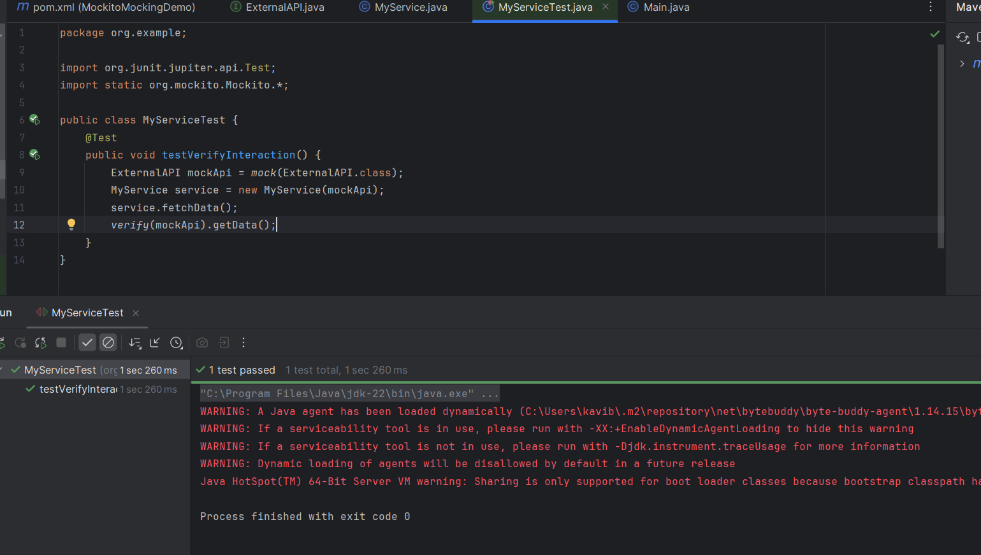

**Exercise 2: Verifying Interactions Scenario**

You need to ensure that a method is called with specific arguments.

Steps: 1. Create a mock object.

2. Call the method with specific arguments.

3. Verify the interaction.

**Code:**

**ExternalAPI.java**

package org.example;  
  
public interface ExternalAPI {  
 void getData();  
}

**MyService.java**

package org.example;  
public class MyService {  
 private final ExternalAPI api;  
  
 public MyService(ExternalAPI api) {  
 this.api = api;  
 }  
  
 public void fetchData() {  
 api.getData();  
 }  
}

**MockexternalAPI.java**

package org.example;  
  
public class MockexternalAPI implements ExternalAPI {  
 boolean getDataCalled = false;  
  
 @Override  
 public void getData() {  
 getDataCalled = true;  
 System.*out*.println("getData() was called");  
 }  
  
 public boolean wasGetDataCalled() {  
 return getDataCalled;  
 }  
}

**MyServiceTest.java**

package org.example;  
  
import org.junit.jupiter.api.Test;  
import static org.mockito.Mockito.*;  
 import static org.junit.jupiter.api.Assertions.*;  
  
public class MyServiceTest {  
 public static void main(String[] args) {  
 MockexternalAPI mockApi = new MockexternalAPI();  
 MyService service = new MyService(mockApi);  
 service.fetchData();  
  
 if (mockApi.wasGetDataCalled()) {  
 System.*out*.println("Test Passed: getData() was called.");  
 } else {  
 System.*out*.println("Test Failed: getData() was NOT called.");  
 }  
 }  
}

**Output:**

